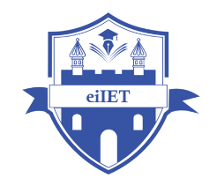

PLANNING AND MANAGEMENT OF SUSTAINABLE TOURISM SPACES

ASSIGNMENT 3

Table of Contents
1- Evaluating significance of natural and cultural resources in Cologne for planning and managing tourism development along with key recommendations 3
2- Assessing key elements in contributing to successful destination development in Cologne 6
References 8

1- Evaluating significance of natural and cultural resources in Cologne for planning and managing tourism development along with key recommendations
Utilisation of natural and cultural resources in Cologne
Community can be considered as one of the most important natural resources for Cologne to foster structured tourism development. Resource-Based View (RBV) theory has conceptualised resource utilisation as an important paradigm of structured tourism development to maintain a high standard of economic activity, diversity and environmental responsibility (Matiku et al. 2021, p.526). Furthermore, the tourism paradigm of Cologne is considered to have the presence of an amalgamation of diversity and tourism experience, concerning rapid growth in community development. Compared to the disruptions of the pandemic, Cologne encountered a growth in tourism activities acquiring 4.2 million guests through the presence of sustainability, digitalisation and MICE (meetings, incentives, conferences and exhibitions) (Cologne-tourism, 2025). In line with the theorisation of RBV, community can be considered as an important resource for Cologne to maintain balance between tourism operations and tourism experience. Thus, community has been conceptualised as an important natural resource for Cologne to develop a structured foundation of tourism development.
Cultural heritage can be conceptualised as an important cultural resource for Cologne, concerning the stances of robust and sustainable tourism development. Community Empowerment Theory (CET) has theorised the essentiality of cultural heritage in terms of fostering a structured foundation of tourism development through the amalgamation of political, economic, and cultural systems (Hu et al. 2022, p.3). Consequently, “Cologne Convention Bureau (CCB)” has emerged as an influential governing body of the tourism sector, intensifying authenticity through the channels of knowledge hub and optimisation (Cologne-tourism, 2025). The figure below has addressed the significance of community empowerment in relation to the incorporation of structured development among three key levels of tourism including macroscale, mesoscaleope and microscale. Furthermore, from the theoretical perspective of CET, cultural heritage can be described as an essential metric for Cologne’s tourism to create a balanced and structured tourism experience. Thus, the management of cultural heritage can be considered as an important perspective of Cologne’s tourism, concerning tourism development through the incorporation of cultural heritage.
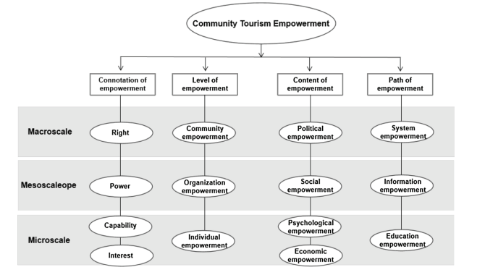
Figure 1: Conceptual framework of “Community Empowerment Theory (CET)”
(Source: Hu et al. 2022, p.4)
Recommendations for improvement
Recommendation 1: Enhancing the existing digital ecosystem to ensure immersive tourism experience in Cologne
Enhanced digital ecosystem can be considered as a feasible solution for Cologne’s tourism in terms of creating an immersive tourism experience. A study by Li et al. (2022, p.1) has addressed the significance of digitalisation in creating robust tourism experience through the dialectical relationship between reasonable coexistence and fair distribution, concerning protection of cultural heritage. For instance, VisitKölnGPT has emerged as an important AI solution for Cologne’s tourism to blend data-driven operations concerning locations, living spaces and tourism (Cologne-tourism, 2025). Fundamentally, controlled utilisation of advanced technologies including AI, AR and cloud computing can be feasible in integrating the stances of smart tourism within Cologne’s tourism. The figure below has addressed four different attributes of smart tourism, concerning the development of enhanced tourism experience including people oriented, comprehensive sensing, integration and self-innovation. Thus, the enhancement of Cologne’s existing digital ecosystem can be considered as feasible in ensuring immersive tourism experience.
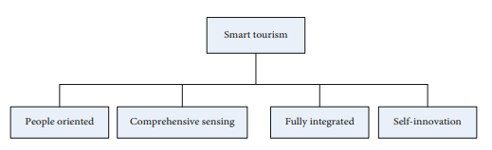
Figure 2: Key attributes of smart tourism
(Source: Li et al. 2022, p.5)
Recommendation 2: Strengthening the foundation of “climate action” to expand sustainability footprint for Cologne’s tourism
“Climate change mitigation” can be considered as an important climate action for Cologne’s tourism in terms of expanding the existing sustainability footprint. Fundamentally, the “Paris Agreement” has emerged as an important sustainability framework for tourism in terms of acquiring reduced zero-emissions (Peeters et al. 2024, p.2). In line with “Paris Agreement”, climate change action can be considered as an important construct for Cologne’s tourism paradigm, concerning environmental responsibility. For instance, increased utilisation of electric vehicle for public transportation has emerged as an important paradigm for sustainable footprint in Cologne, strengthening carbon footprint (TTW, 2025). Thus, climate change mitigation can be regarded as an important control measure for Cologne’s tourism to expand and strengthen their existing sustainability footprint through carbon neutrality.

2- Assessing key elements in contributing to successful destination development in Cologne
Elements | Assessment | Implications on Cologne’s tourism
Attractions | Attractions can be considered as an important element to foster enhanced tourism experience, concerning the visit towards a destination. As mentioned by Hu et al. (2022) “community participation” can be considered as an important attribute to ensure a high standard of tourism experience, curated through attractions and heritage. Thus, a vibrant presence of attractions including natural, cultural and artificial resources can be considered as feasible to develop robust tourism experience for a destination. | Cultural heritage can be considered as the most important attraction for Cologne’s tourism to foster structured tourism experience. Structurally, Kölner Dom, Roman-Germanic Museum, and Cologne Zoo can be regarded as key attractions for Cologne in relation to the formulation of successful destination development.
Accessibility | Accessibility is considered as another important element to develop flexible tourism experience within a nation. Structurally, external accessibility (seaports, airports and road), internal accessibility (mobility and local transport) and digital accessibility (online booking) can be three key channels of accessibility. | “Visit Cologne” can be regarded as the most important digital accessibility in relation to the stances of virtual tourism experience (Cologne-tourism, 2025). The aforementioned channel becomes effective to create a centralised tourism experience based on tourist information and public transport.
Amenities | In the context of tourism, amenities can have different categories such as hotels, home-stays, and eco-lodges. | In Cologne, a long range of amenities are available including hotels, restaurants, bars & pubs and coffee shops (Tripadvisor, 2025).
Image | Image can be regarded as an important element to create tourists’ perception about a destination. | 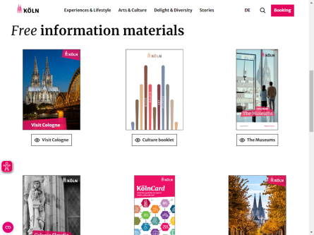  Figure 3: Images related to Cologne’s tourism  (Source: Cologne-tourism, 2025)  As illustrated in the figure above, Cologne tourism is considered to have used images as an important ledger to create an immersive tourism experience through digital accessibility.
Ancillary services | Structured and robust tourism operations can be considered as significant ancillary services for a tourist destination. | Cologne tourism has a long range of ancillary services including visitor support and amenities. VisitKölnGPT can be outlined as an important tool for developing a high-quality ancillary service in the form of data-driven visitor support (Cologne-tourism, 2025).
Table 1: Key elements related to successful destination development
(Source: Self-developed)

References
Cologne-tourism. (2025). Results for 2024: Cologne's tourism on the path to success. Available at: https://www.cologne-tourism.com/service/press/news/detail/results-for-2024-colognes-tourism-on-the-path-to-success [Accessed on: 27 September 2025].
Hu, B., He, F. and Hu, L., (2022). Community empowerment under powerful government: A sustainable tourism development path for cultural heritage sites. Frontiers in Psychology, 13, p.752051. https://www.frontiersin.org/journals/psychology/articles/10.3389/fpsyg.2022.752051/pdf
Li, D., Du, P. and He, H., (2022). Artificial Intelligence‐Based Sustainable Development of Smart Heritage Tourism. Wireless Communications and Mobile Computing, 2022(1), p.5441170. https://onlinelibrary.wiley.com/doi/pdf/10.1155/2022/5441170
Matiku, S.M., Zuwarimwe, J. and Tshipala, N., (2021). Sustainable tourism planning and management for sustainable livelihoods. Development Southern Africa, 38(4), pp.524-538. https://www.tandfonline.com/doi/pdf/10.1080/0376835X.2020.1801386
Peeters, P., Çakmak, E. and Guiver, J., (2024). Current issues in tourism: Mitigating climate change in sustainable tourism research. Tourism Management, 100, p.104820. https://www.sciencedirect.com/science/article/pii/S0261517723001024
Tripadvisor. (2025). Cologne, Germany. Available at: https://www.tripadvisor.in/Tourism-g187371-Cologne_North_Rhine_Westphalia-Vacations.html [Accessed on: 27 September 2025].
TTW. (2025). Clean, Green, and Seen: Cologne’s Electric Sightseeing Buses Bring Eco-Tourism to Life. Available at: https://www.travelandtourworld.com/news/article/clean-green-and-seen-colognes-electric-sightseeing-buses-bring-eco-tourism-to-life/ [Accessed on: 27 September 2025].

