

Planning and Management of Sustainable Tourism Spaces

Table of Contents
Introduction 3
1. Values and Significance of the Site 3
2. Threats Facing the Site 4
3. Proposed Adaptive Re-use Strategy 4
4. How the Adaptive Re-use Maintains the Site’s Values 4
5. Benefits to the Local Community 5
Conclusion 5
References 7

Introduction
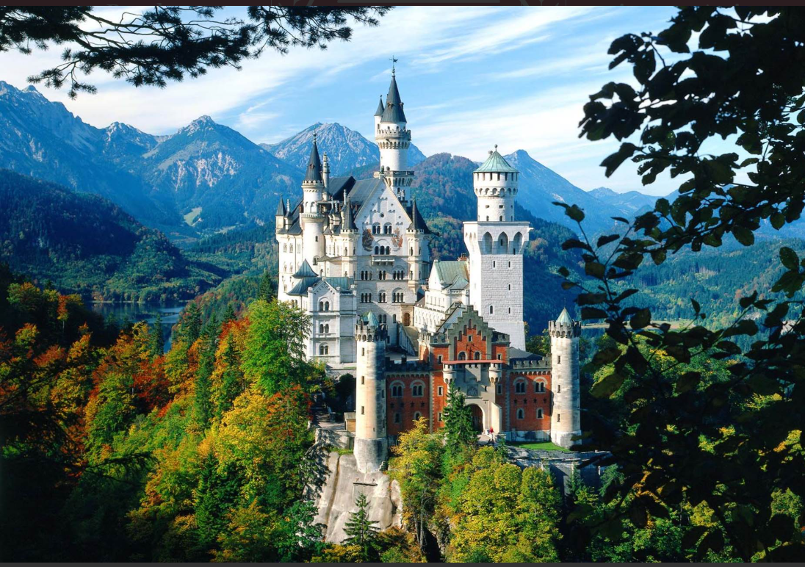
Figure 1: Schloss Neuschwanstein
The Schloss Neuschwanstein in Bavaria, Germany can be considered to be one of the most symbolic architectural locations in Europe (World, 2018). The castle was commissioned by King Ludwig II in the late nineteenth century and is a Romantic reinterpretation of medieval architecture, both in dramatic location on the cliff-top and lavish interior design with references to Germanic mythology, Wagnerian opera, and royal symbolism (World, 2018). The examination of its values, weaknesses and adaptive reuse possibilities provides information on the possibilities to preserve the value of internationally significant monuments and maintain their benefit to the local communities.

1. Values and Significance of the Site
Historical/Cultural Value: Schloss Neuschwanstein is a historically important site that has a lot of historical meaning as a representation of Bavarian royalty and the personal fantasy of the King Ludwig II. Built in 1869-1886, it portrays the political intricacies of the post-unification Germany and the revived romanticism behind the medieval chivalric concept (Britannica, 2025). Its architecture is strongly based on the myths of the Holy Grail as well as the motifs of the operas of Richard Wagner, which is why it is a physical expression of the German Romanticism of the nineteenth century.
Architectural and Aesthetic Value: The Neuschwanstein was constructed in the 1800s, yet its architecture is dominated by a highly stylised neo-medieval architectural vocabulary, having Romanesque, Gothic and Byzantine influences (Britannica, 2025). Its dramatic towers, perched position on the cliff, and lavish interiors have become a landmark of popular culture in the world, as well as being enjoyed as a prototype by Disney in the Sleeping Beauty Castle.
Symbolic and Identity Value: To most Germans (especially Bavarians) the castle symbolizes regional identity, pride as well as continuity in culture. It is a national icon that is commonly employed in tourism promotions and across the international media and this has been part of Germany cultural diplomacy.
Economic and Touristic Value: Since every year there are more than a million visitors, the site becomes a part of the touristic industry in Bavaria.
Environmental and Landscape Value: The place of Neuschwanstein within the Alpine foothills, overlooking the Hohenschwangau valley and the clean and pure forests contributes to the ecological and scenic worth (World, 2018).

2. Threats Facing the Site
Over-tourism: The castle is subjected to extreme pressure of mass tourism. The large pedestrian traffic increases the process of wear on interior decorations, flooring, and constituents (Rappler, 2025).
Environmental and Climatic Hazards: Climate change, with an escalation in weather conditions, rainfall, and unstable freeze-thaw conditions, endangers the limestone veneer, wooden structures, and landscaping (Rappler, 2025). The steep slopes also pose a threat to stability due to rockslides and soil erosion.
Maintenance and Structural Stress: Because of its age and modes of construction, the Neuschwanstein has to be under continuous restoration. The castle was not completed entirely and there are still exposed parts that are structurally weak (Rappler, 2025).
Commercialisation Threats: Commercial pressures to over-develop the surrounding areas as tourism infrastructure will threaten the natural environment of the site, and also to reduce the value of the landscape.

3. Proposed Adaptive Re-use Strategy
An adaptive re-use proposal, which is sensitive to Schloss Neuschwanstein, must be centered on increased cultural, educational and environmental activities without any changes in the basic architectural fabric. Strategic plan A is feasible:
This adaptive re-use approach includes
- Producing immersive virtual exhibitions in empty or not historically decorated rooms with the help of augmented reality (AR) and projection mapping to describe the life of Ludwig II, Romanticism, and the history of the Bavarian culture (Machupicchu, 2025).
- Creating a research and conservation centre focused on castle preservation, landscape conservation and heritage science.
- Implementing guided-access themed tours (e.g., artisanship, opera-based rooms, castle engineering) to balance and manage visitor numbers.

4. How the Adaptive Re-use Maintains the Site’s Values
Maintenance of Architectural Integrity: The plan does not involve incurable physical modifications in the guarded rooms. Digital exhibitions are based on reversible technology with no physical contact of the original surfaces so that originality is preserved (Britannica, 2025).
Greater Cultural and Educational Significance: With the expansion of areas of interpretations, the visitors will learn more about Romanticism, the vision of Ludwig II and German culture- enhancing intellectual engagement with the site.
Reduction of Over-tourism: Dispersing the visitors across new-curated paths is one means of splitting the congestion and damages. Digital exhibitions and other thematic experiences can be timed and taken care of to cater to peak demand.
Environmental Stewardship: The proposal of environmentally friendly transport and environmental research is also in accordance with the stewardship of environment of the castle landscape and helps preserve natural landscape of the environment.

5. Benefits to the Local Community
Results in Economic Development and New Jobs: New employment in such areas as research laboratories, digital exhibition employees, conservation specialists, tour guides, and sustainability workers can be used to engage in new, and permanent, competitive employment. This is a way of diversifying the local economy as opposed to the seasonal tourism (Rappler, 2025).
Sustainable Tourism Model: this assists in reducing the overcrowding therefore promoting the environmentally friendly tourism that minimises the effects on the environment and maintains the revenue unchanged.
Cultural Identity: It will enhance the heritage of the Bavarian by providing a better knowledge of the heritage to enable the residents to endeavour more ownership and pride to result in continuity in the culture.
Increased Local Infrastructure: Sustainable mobility initiatives, visitor information system, and environmental improvements will be offered to the local people in terms of roads, services, and environmental (World, 2018).

Conclusion
One of the reflections of the Bavarian culture, architectural fantasy and Romanticism is Schloss Neuschwanstein. Albeit under tourism, the pressure of environmental change and structural vulnerability, a properly developed adaptive re-use strategy founded on interpretation, sustainability and research would be able to save its values besides improving the local community. Through conservation and innovativeness, Neuschwanstein will be regarded as a world heritage and a sustainable cultural investment by the future generations.

References
Britannica (2025). Neuschwanstein Castle | History, Description, & Facts. In: Encyclopædia Britannica. [online] Available at: https://www.britannica.com/topic/Neuschwanstein-Castle.
Machupicchu (2025). Neuschwanstein Castle 2026: Complete World Heritage Guide. [online] Machupicchu.org. Available at: https://www.machupicchu.org/neuschwanstein-castle-2026-complete-world-heritage-guide.htm [Accessed 18 Nov. 2025].
Rappler (2025). Bavaria’s fairy-tale palaces granted world heritage status. [online] RAPPLER. Available at: https://www.rappler.com/life-and-style/travel/bavaria-palaces-granted-unesco-world-heritage-status/ [Accessed 18 Nov. 2025].
World, U. (2018). The Palaces of King Ludwig II of Bavaria: Neuschwanstein, Linderhof, Schachen and Herrenchiemsee. [online] Unesco.org. Available at: https://whc.unesco.org/en/list/1726/.

