STRATEGIC MARKETING MANAGEMENT AND COMPETITIVE ADVANTAGE: THE ROLE OF MARKETING STRATEGY IN ORGANIZATIONAL SUCCESS

Student Name: Gagandeep
Abstract
The purpose of this report is to analyse the importance of strategic marketing management in achieving organizational success and competitiveness in today's business world. The study reviews the concepts of marketing management and the role it plays in some of the objectives set by business organisations. Certainly, focus is on certain marketing concepts such as Segmentation, Targeting and Positioning (STP), Branding, Value Proposition Development, Customer Acquisition, Return of Customer and Competitive Advantage.
Secondary data analysis was chosen as the approach for this research. Academic literature, industry publications, company results and marketing 'case' studies were used to assess theoretical literature and practice of strategic marketing. Key themes concerning customer-oriented marketing, brand-building and customer relationship management, and competitive positioning were identified through the analysis.
The results of this study show that good marketing strategies contribute to better performance in an organization in terms of having more customers involved and retained, boosting its brand value, and improving profitability. Finally, the study shows that companies with a better understanding and reaction to their customers' expectations have greater ability to build and sustain competitive advantages in dynamic markets.
The report draws to a conclusion that strategic marketing management is a vital organizational ability which helps firms to generate value for their customers, adjust in an evolving environment, and long-term growth. In a more and more complex environment marketing strategies that are aligned with the customer's needs are important to keep businesses competitive and successful.

Table of Contents
1. Introduction 5
1.1 Background of Marketing Management 5
1.2 Problem Statement 5
1.3 Research Aim and Objectives 5
1.4 Structure of the Report 6
2. Literature Review 6
2.1 Strategic Marketing Management 6
2.2 Role of Marketing Management in Achieving Business Objectives 7
2.3 Segmentation, Targeting and Positioning (STP) Framework 7
2.4 Branding and Value Proposition Development 9
2.5 Customer Acquisition and Retention Strategies 11
2.6 Marketing Strategy and Competitive Advantage 11
3. Methodology 13
3.1 Research Design 13
3.2 Data Collection Method 13
3.3 Data Analysis Method 13
3.4 Justification of Methodology 13
4. Findings 14
4.1 Marketing Management and Organizational Success 14
4.2 Segmentation, Targeting and Positioning in Practice 14
4.3 Branding and Value Proposition Development 15
4.4 Marketing Strategy and Customer Acquisition 15
4.5 Marketing Strategy and Customer Retention 15
4.6 Marketing Strategy and Profitability 16
4.7 Marketing Strategy and Competitive Advantage 16
4.8 Comparative Analysis of Real-World Organizations 16
5. Discussion 17
5.1 Interpretation of Findings 17
5.2 Critical Evaluation 17
5.3 Implications for Managers 18
6. Conclusion 19
References 20
Appendices 23
Appendix A: Segmentation, Targeting and Positioning (STP) Framework 23
Appendix B: Components of Brand Equity 23
Appendix C: Comparison of Customer Acquisition and Retention Metrics 23
Appendix D: Comparative Analysis of Marketing Strategies and Competitive Advantages 24

1. Introduction

1.1 Background of Marketing Management
The emphasis of the marketing management process has shifted from a transactional business-oriented perspective to a relationship perspective in which the long-term value of customers and managing customer relationships are the priorities. As was pointed out by Grönroos (2004), relationship marketing aims to provide organisations and customers with ongoing interaction, communication and trust building relationships, and to maintain a relationship instead of a sporadic and one-off business exchange. As companies look to adapt to evolving ways in meeting customer needs with the use of custom products as well as services, customer-centric approaches have been growing in importance. Globalization and the digital revolution has transformed the marketing landscape, which has not only produced new avenues for communication, but new opportunities for data-driven marketing. In today's competitive business landscape, digital technologies are crucial for organisations to improve the customer experience and boost customer loyalty (Pereira et al., 2025). The likes of Apple, Nike, Amazon and others are examples of companies with successful strategic marketing.

1.2 Problem Statement
Living in an environment of growing competition and ever-changing technology and customer expectations. Purchasing choices are now more dynamic and complicated with more information and options for the consumers. Value creation provides a service dominant view of value creation that claims value is created in a collaborative manner through interactions with the firm and customer and not just products (Vargo and Lusch, 2004). So, companies need to constantly fine-tune their marketing efforts to align them with changing tastes and preferences, as well as maintain their positioning. The challenge is to build marketing competences to preserve customer loyalty, the profitability of the company and maintain a long-term competitive advantage in a digitally-dominated business environment (Kamyabi et al., 2025).

1.3 Research Aim and Objectives
Aim
To assess the importance of strategic marketing management for achieving the competitive advantage and success within an organization.
Objectives
- To discuss the importance of marketing management towards business goals.
- To understand the different aspects of Segmentation, Targeting, Positioning and Branding.
- To examine how marketing affects business to acquire, retain and make a profit from customers.
- To analyse the contribution of marketing in achieving competitive advantage.
- To look at examples of organisations to explain how to use strategic marketing.

1.4 Structure of the Report
This report comprises six main chapters. This literature review covers important theories and concepts in marketing management that define important market concepts. The methodology details the sources of data and approach for the research. The findings assess their responsibility of marketing strategies towards organizational performance with the help of real-life example. They critically interpret their results in the light of the literature. Lastly, the Final Summary is made to highlight the key insights and implications for strategic marketing management.

2. Literature Review

2.1 Strategic Marketing Management
Strategic marketing management is the process to analyse market opportunities, understanding the needs and applying long-term methods that value customers and organisations. It brings together the different marketing activities with the organisational goals for sustainable growth and competitiveness. Market orientation is a major element of strategic marketing management that involves developing intelligence about markets and reacting to it to provide an appropriate product for those markets. Market Orientation theory implies that companies that constantly scan customers' needs, tastes and attitudes, as well as their rivals' moves are more likely to perform better. Another important principle is customer focus; today's organizations need to be customer oriented and know what the customers want or need solutions that have value to them. Strategic planning helps firms to understand the opportunities of the market, and allocate and set up marketing programs to effectively use those resources. As more organizations are competing in customer experience and building relationships with their customers rather than simply their products, value creation continues to be a key marketing focus (Vargo and Lusch, 2004). Interactive value creation through enterprises and customers has become a relevant source of differentiation for delimitation in the context of today's markets (Payne et al., 2008).

2.2 Role of Marketing Management in Achieving Business Objectives
Marketing management plays to a significant role in the success of the organization by supporting in the creation of revenue, development of the brand image, making customers feel great, and expanding the markets. Effective marketing strategies assist an organization to see the proper level of customers that will yield profit and deliver an idea that will elicit buying behaviour. By improving the customer satisfaction, customer retention and better relations with customers thus positively affect long-term profitability. In addition, marketing activities contribute to increasing the brand awareness, by providing recognition and positive perceptions to the goal groups. High brand loyalty and being able to withstand challenges in competitive markets are often hallmarks of a strong brand. Moreover, marketing management helps in securing the market share using the strategies defined in the marketing campaigns and offers new products and services to the market.
The Marketing Planning Process offers a marketing strategy that is methodical to attain business goals. Situation analysis can be done in the internal (ability) condition and external market (condition) whole market area. Goal setting sets exactly what the organization and the marketing needs to achieve, and provides measurable objectives. What has to happen - strategy formulation - is how objectives are going to be accomplished; how to turn plans into action - implementation. Control mechanisms assess performance and aid continuous improvement. They have high agency expressions and positive effects on customers' interactions in this process, which results in better business performance and sustainability (Verhoef et al., 2010). Value co-creation has the additional effect of improving organizational results, both by increasing the involvement of customers as well as improving their sense of loyalty to the organization (Payne et al., 2008).

2.3 Segmentation, Targeting and Positioning (STP) Framework
STP (Segmentation, Targeting and Positioning) is one of the most frequently used models in marketing that uses it to identify the following: attractive groups of clients with matching marketing strategies. Segmentation means breaking up large markets into smaller ones with these smaller ones claiming certain characteristics. The bases for segmentation are: geographical, demographic, psychographic and behavioural. This process helps organizations gain insights into the varying needs of customers, thereby creating more relevant products/services (Ali et al., 2024).
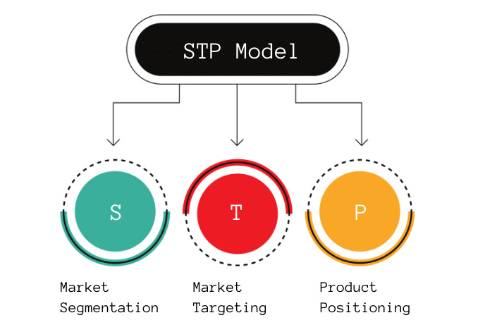
Figure 1: STP Model
(Source: Ali et al., 2024)
Targeting means choosing the most interesting target groups for a marketing campaigns. The strategies that an organization can choose are the undifferentiated, differentiated, concentrated and micromarketing strategies, depending on the market situation and organizational capacities. Proper targeting can make better use of resources and mean a more effective marketing campaign. The job of positioning is to get a unique image message into customers' minds about a business or product compared to the competitor. Maps and value positioning tools position companies to help determine their competitive advantages and reveal unique benefits. By getting consumers positioned in the right way, they actually have their brand name reinforced and an effect on the decisions they make in purchasing a product (Gusmao, 2025). The Coca-Cola Company is a good example of how the STP approach is applied in practice. The company sells a variety of products to their various customers who have different preferences, lifestyles and consumption patterns. There are several brands with a foothold in various markets targeting different categories which helps the organisation to have a very strong position at the global markets.

2.4 Branding and Value Proposition Development
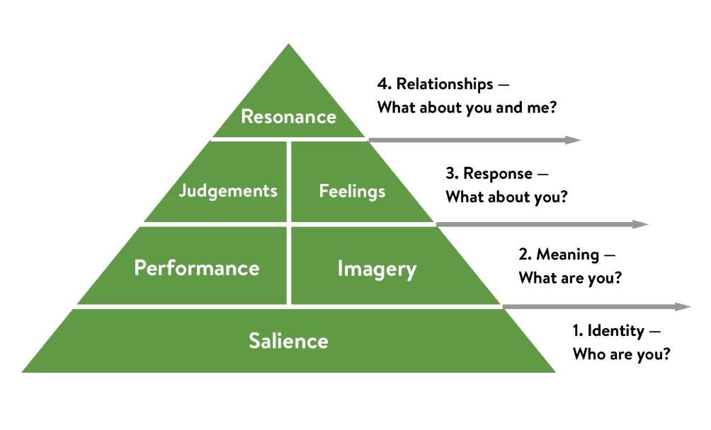
Figure 2: Keller’s Customer-Based Brand Equity Model
(Source: Prahalad and Ramaswamy, 2004)
Branding is a strategic process, which provides a unique individuality and associations in the mind of consumers. Brand equity is the value created as a result of favorable customer's perceptions and experiences with a brand. Keller's Customer Based Brand Equity (CBBE) Model puts emphasis on awareness, associations, perceived quality, and loyalty to determine the strength of the brand (Prahalad and Ramaswamy, 2004). Likewise, the Aaker Brand equity model emphasizes on the need of brand recall and brand loyalty to gain competitive advantage.
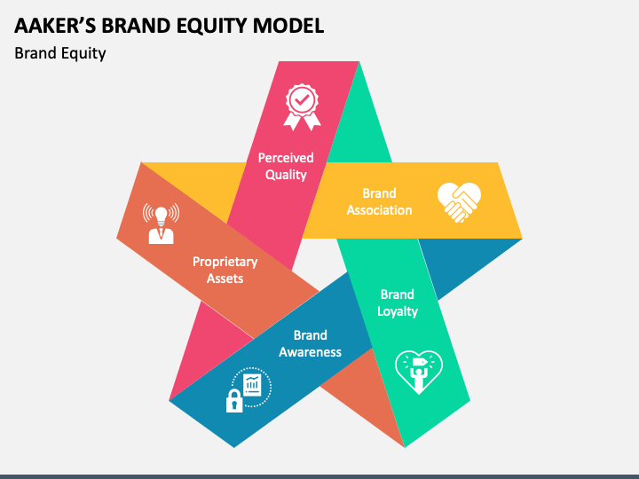
Figure 3: Aaker’s Brand Equity Model
(Source: Payne et al., 2008)
The Value Proposition conveys the value that customers gain from a product or a service. Diverse customer expectations are fulfilled through the combination of functional value, emotional value and social value in effective value propositions. Those who do successfully provide meaningful value are more likely to get customer loyalty and differentiate the market. The Customers are Co-Creators of Value implies a forethought of their involvement with organizations through their interaction and experiences, and in such a way that they create value themselves (Prahalad and Ramaswamy, 2004). Managing customers experiences strategically also enhances value creation and customer relationships (Payne et al., 2008). Tesla, Inc. is an example, where innovation, sustainability, and high performance technology is at the core of its value proposition. These many features set it apart and add to the company's brand value in the international marketplace.

2.5 Customer Acquisition and Retention Strategies
Customer acquisition encompasses all the other disciplines associated with attracting a user to your business, including advertising, social media, search engine marketing, referrals and more. These are activities which boost market awareness and stimulate customer's first time involvement. Digital channels have also been making a huge impact as they allow organizations to target specific audiences within a specific time frame. Customer retention aims to initiate and sustain ongoing customer relationships with the help of loyalty programs, customer relationship management (CRM), customer relationship marketing-related and customer personalisation programs. Based on the theory of Relationship Marketing, there are three aspects that are important to maintain customer relationships, namely interaction, trust and commitment (Hidayat et al., 2023). Personalized experience and data-driven engagement strategies are very important elements for enhancing customer loyalty, and consequently, retention, in the digital age (Pereira et al., 2025).

2.6 Marketing Strategy and Competitive Advantage
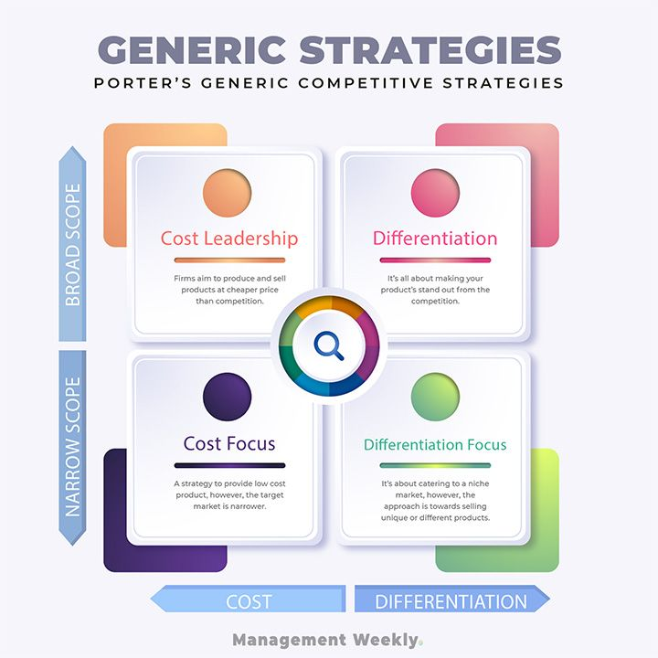
Figure 4: Porter’s Generic Strategies
(Source: Vargo and Lusch, 2004)
Marketing strategy is one component of the competitive advantage - it allows an organization to be different from its rivals and provide customers with better value. Porter's Generic Strategies reveal that the three strategies through which an organisation can have competitive success are cost based, differentiation and focus. Organisations can compete in terms of their lower costs, the differential products they provide or specialisation of the market segments.
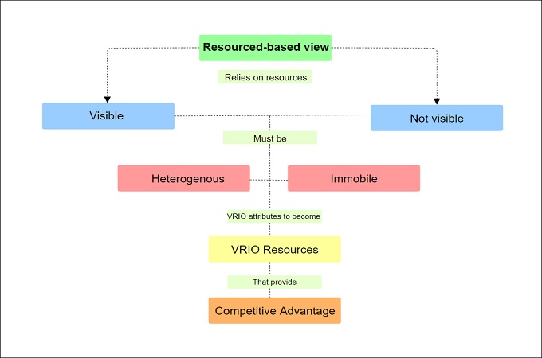
Figure 5: Resource-Based View (RBV)
(Source: Kamyabi et al., 2025)
According to the Resource-Based View (RBV), the ability to generate sustainable competitive advantage is from valuable and hard to imitate resources. In order to improve the performance of an organization, its marketing assets like brand reputation, customer relationship and market knowledge are considered as strategic assets (Kamyabi et al., 2025). Consistent and continual creation of value and its delivery are a key source of long term competitiveness (Vargo and Lusch, 2004).

3. Methodology

3.1 Research Design
This research is approached by qualitative research which will reflect on the contribution of strategic marketing management to the success of the company and competitive advantage. Qualitative design is the most suitable design since interpretation of the same business evidence and literature will enable understanding of the concepts and strategic framework of marketing in depth. The method allows investigation of the correlations between marketing strategy and organisation results without needing any numerical measurement.

3.2 Data Collection Method
The study has been carried out through secondary source of data from a variety of credible academic and industry sources. These include peer-reviewed journal articles, academic books and publications, industry reports, company annual reports and published marketing case studies. Secondary data helps to gain in-depth understanding about existing marketing theories and current practices. Practical application of strategic marketing programmes and strategies is analysed in the context of Annual Reports of companies like Apple (2025) and Nike (2025) to explore its role in improving market performance.

3.3 Data Analysis Method
A thematic analysis is used to analyse the collected data. This approach entails the identification, classification and interpretation of the themes that are embodied in the literature and evidence found in the organisation. Marketing management, segmentation, targeting and positioning (STP), customer retention, competitive advantage and branding are the major issues explored in this study. Thematic analysis is helpful for systematically comparing results of the theory and marketing applications systematically.

3.4 Justification of Methodology
This study could be a secondary one with the advantage of it being possible to access a lot of scholarly knowledge and documented organizational experiences in different industries. It allows the assessment of marketing strategies from many points of view and is still cost effective and time efficient. Furthermore, the range of secondary sources utilised validates and implements theory and practice in the analysis, making the analysis credible and comprehensive.

4. Findings

4.1 Marketing Management and Organizational Success
Results show that the effective management of marketing can greatly increase the profitability of an organization, making it more responsive towards the market and allocating its resources efficiently while planning for the customer. By marketing activities that are only in line with what customers want, it could identify opportunities that would be better able to respond to changes occurring in the market. Strategic planning assists businesses in determining which resource to allocate to which activity that is most valuable, and increases client relationships. In addition, studies have shown that involving customers in value creation enhances organisation performance and business outcomes in the long run (Payne et al., 2008).
One such organisation is Amazon.com, Inc., which is a customer centric business model. This exceptional level of client satisfaction has helped to drive continuous growth for the company, thanks to their personalized advice, user-friendly processes and ongoing innovation. In addition, having digital marketing skills helps with being responsive and competitive in a dynamic market (Kamyabi et al., 2025).

4.2 Segmentation, Targeting and Positioning in Practice
The results shows that the STP framework is still fundamental in creating effective marketing strategies. Market segmentation helps an organization to discover new segments or groups of customers, who have different needs and preferences. Targeting is used to help concentrate the resources on the most attractive segment (s) and positioning is used to establish a specific image for the company in the market. With efficient implementation of STP, marketing efficiency and customer engagement can be enhanced (Ali et al., 2024).
For instance, Nike, Inc. divides its market into three segments: athletes, fitness enthusiasts, and lifestyle consumers. The company's line of business centres on the themes of performance, achievement and inspiration, thus establishing a strong emotional connection with users. This has helped to develop brand loyalty and worldwide recognition. For example, McDonald's Corp. uses varying marketing approaches in the various countries. Product selection, promotion and communication message is localized to match local tastes and preferences. This market sensitivity helps in making customers feel relevant and achieving a competitive performance level (Gusmao, 2025).

4.3 Branding and Value Proposition Development
Brand and powerful value proposition were found as some key determinants of customer preference and to differentiate. When the customer's experience with a brand is one of high-quality, trust, and good experiences, brand equity is generated. Firms, which continuously manage to communicate their values are prone to making firmly set market positions. Customers' involvement in the creation of value also increases brand relationships and the perceived value (Prahalad and Ramaswamy, 2004).
How Apple Inc. has succeeded in its brand management through emphasis of simplicity, innovation and premium quality. These values form a unique identity which sets the firm aside from other firms. Similarly, Starbucks Corporation has created a value proposition that is based on the experience provided to its customer, the quality of service it provides and the degree of customer engagement. Customers sticking with your brand is an outcome of consistent experiences, and can help build long-term brand equity (Payne et al., 2008).

4.4 Marketing Strategy and Customer Acquisition
The results show that Digital Marketing channels are very important to the customer acquisition. There are various techniques to help organizations become discoverable as well as attract new customers, such as search engine optimization, social media marketing, affiliate marketing through an influencer and content marketing. These correspondences make it possible to reach the masses as well as communicate with them selectively. Content-driven involvement is a more influential determinant of the attitudes towards product procurement decision of consumers (Nagy and Hajdu (2022). A major one of these is Netflix, Inc. that's generating leads with digital marketing campaigns and individualized recommendations. Data-driven marketing can boost relevance, enhance customer acquisition, and deliver better results in competitive online marketing landscapes (Kamyabi et al., 2025).

4.5 Marketing Strategy and Customer Retention
Results in customer retention have shown that CRM systems as well as loyalty programmes and personalised engagement are all crucial. Regular communication and value contributes to the customer maintenance. This relationship marketing leads to the development of trust and loyalty, which helps to establish long-term relationships and decrease switching behaviour (Hidayat et al., 2023). Amazon.com, Inc. has a strong membership system consisting of one click, and personalized recommendations that help users retain their business with the company. These efforts improve the convenience and satisfaction of customers. Good CRM practices can also lead to improved retention results as well as enhanced long-term loyalty (Dwivedi et al., 2024).

4.6 Marketing Strategy and Profitability
The results show that there is a high correlation between customer retention and profitability. An improvement in customer lifetime value, return purchases as well as a decrease in customer acquisition rates all directly affect revenue growth. The long-term advantages of retaining people can include better overall financial performance for the organization (Pereira et al., 2025). For instance, Costco Wholesale Corporation has a membership-based approach to its business which would allow it to acquire repeat customers over time and provide a recurring stream of income. Healthy relationships with customers can enable sustainable profitability (Dwivedi et al., 2024).

4.7 Marketing Strategy and Competitive Advantage
Marketing strategy is one of the factors that builds a competitive advantage. Differentiation strategies also provide ways for organizations to be unique and build customer loyalty. As per the service-dominant perspective, sustainable advantage is realized in the more successful creation of the value and customer relationships (Vargo and Lusch, 2004). These companies can leverage their innovation and differentiation to charge premium prices, establish brand loyalty, and gain market share like Apple Inc. or Tesla, Inc. The skills improve long-term competitiveness (Kamyabi et al., 2025).

4.8 Comparative Analysis of Real-World Organizations
Successful organizations have different Marketing Strategies in order to obtain competitive advantage. Comparative Analysis reveals that. Apple is known for its high-end branding, and for building loyalty among its customers, while Nike is known for creating a sense of emotional branding across the world. Amazon has a customer orientation and convenience, Tesla is about position and tech and Starbucks is about experience marketing and customer engagement. What may vary among organisations is the way it is done, however, all of them have customer value creation and strategic marketing skills as their primary objectives to ensure market leadership and competitiveness.

5. Discussion

5.1 Interpretation of Findings
The results revealed that the strategic marketing management has a significant influence in improving an organization's performance and developing a competitive advantage. The findings validate concepts of service-dominant logic, which focus value creation on relationships between the organizations and customers, and not only products. The results revealed that customer relationships are a key component of customer satisfaction and business success if it is planned and treated as customers, personalized experiences and constant communication are provided. That's in line with the reasoning that companies deliver value through acknowledging customers' needs and enabling customer experiences along the customer journey (Vargo and Lusch, 2004).
The results also indicate the ongoing importance and relevance of relationship marketing in the contemporary business landscape. Companies that invest in building trust, engaging their customers and keeping them for the long-term, gain long-term retention results and improved loyalty. As seen with Amazon and Starbucks, allot business-friendly approaches and philosophies can reinforce client dedication and inspire repeat business. Thus, relationship marketing still plays an important role as a mechanism in order to produce sustainable value for the customer and reduce the phenomenon of customer switching (Grönroos, 2004).
Moreover, the findings indicate that to develop a brand and value proposition, opinions are essential. Familiar brands are a way to distinguish organizations from others and foster a positive association and emotion in consumer minds. The success of brand vision champions like Apple and Tesla demonstrates the power of strong brand values to improve retention, higher price points, and market dominance. Branding can thus not only be a communication tool, but it is also a strategic asset that can impact the future performance of an organization.

5.2 Critical Evaluation
The results indicated a number of benefits of marketing management. Unquestionably, customer-centred marketing strategies foster customer loyalty by offering personal touches and preserving important engagement. Secondly, more robust customer relationships can help to foster repeat purchasing and empower better customer lifetime value, thus boosting revenue. Third, sufficient positioning helps organizations to stand out from competitors, effectively enabling them to create a deeper positioning in the market. These tell us how effective marketing efforts can be in an organisation for its success and sustainability.
However, there are some issues to overcome. The current digital climate is a constantly morphing landscape, with new technologies and market trends evolving rapidly and dramatically, and forcing organisations to rapidly keep pace. Many of the industries are saturated and it's hard to differentiate because there are products and services that are similar competing. Consumer privacy issues are another challenge, as organizations need to rely on consumer information to facilitate with personalisation and targeted marketing activities. But, as the customer's requirements are further enhanced, the business pressure to ensuring that the seamless experience to them is received becomes further elevated. The inability to effectively manage these challenges threatens the competitiveness and the trust of consumers by the organisations (Pereira et al., 2025). However, with increasing reliance on digital technologies, businesses need to prioritize the development of their marketing capabilities and innovation to stay relevant in a rapidly evolving market (Kamyabi et al., 2025).

5.3 Implications for Managers
The results have a number of practical implications for managers. Investing in data analytics will provide insights into customer behaviour and inform decision-making to help make accurate choices. It is also necessary to implement a Customer-centric Organizational Culture with the key requirements being to satisfy and retain customers. Digital Marketing skills should be developed as well learning of new technologies, using digital communication to involve and make more responsive. Lastly, it is essential to have ethical marketing practices such as managing data privacy and transparency, which can help ensure customer trust and safeguard brand reputation. Effective customer segmentation, customized marketing, plus the right data application, can drive strategic decision-making. Strategically, customer segmentation and personalized marketing campaigns can also provide a further optimization of strategic decisions to help boost the competition performance, making optimal use of data (Gopalakrishnan et al., 2026). In today's rapidly changing business landscape, the capacity to continuously innovate and develop digital capabilities is crucial to maintain marketing effectiveness (Kamyabi et al., 2025).

6. Conclusion
This report was created on the relevance of Strategic Marketing management to the success of the organisation as well as its competitive advantage. Results show the very importance of the marketing management as a vital function of any business which enables to connect the business goals with customer needs and contributes to the business's future development. Organizations gain an advantage in the marketplace through marketing by recognising the market opportunities, reacting to the shift in customer tastes and preferences and developing a better customer value. Through this analysis, it was explicitly pointed out how the Segmentation, Targeting and Positioning (STP) strategy can aid a company to find lucrative segments and their marketing strategies. Development of a brand and value proposition was identified as key to differentiation, perception and brand equity creation as well. It is evident in the example of market leaders like Apple, Nike, Amazon, Tesla and Starbucks that strategic branding plays a vital role to be a leader in the market and to gain customer loyalty.
The study also revealed that customer acquisition and customer retention is important in the organizational performance. Relationship marketing, customer engagement and personalisation facilitate customer loyalty and decrease switching behaviours (Hidayat et al., 2023). Good relations with customers can lead to profitability due to repeat buying, increased customer lifetime value and an opportunity for ongoing profits. In general, strategic marketing management is key organizational capabilities in the contemporary competitive world. The constant changing and embracing digital marketing facilities alongside the concentration on value creation for the clients is more likely to result in sustainable competitive advantage and long-term success of the business entity (Kamyabi et al., 2025).

References
Akbar, M.A., Siregar, A.R. and Asnawi, A., 2024. The effects of relationship marketing on customer loyalty through customer retention. International Journal of Agriculture and Biosciences, 13(3), pp.378-389. Available at: https://www.ijagbio.com/pdf-files/24-632.pdf
Alamsyah, D.P., Aryanto, R. and Othman, N.A., 2024. Relationship marketing and customer retention: a systematic literature review. ResearchGate Preprint, pp.1-20. Available at: https://www.researchgate.net/publication/377346943_Relationship_Marketing_and_Customer_Retention_-_A_Systematic_Literature_Review
Ali, H., Saputra, F., and Widodo, A., 2024. Marketing strategy: segmenting, targeting and positioning for digital business literature review. ResearchGate Preprint, pp.1-18. Available at: https://www.researchgate.net/publication/396325030_Marketing_Strategy_Segmenting_Targeting_and_Positioning_for_Digital_Business_Literature_Review
Amazon.com, Inc., 2025. Annual Report 2025. Seattle, WA: Amazon.com Inc. Available at: https://www.aboutamazon.com/investor-relations
Apple Inc., 2025. Form 10-K Annual Report 2025. Cupertino, CA: Apple Inc. Available at: https://investor.apple.com/sec-filings/default.aspx
Dwivedi, R.K., Sharma, V., Kumar, S. and Singh, R., 2024. The customer loyalty versus customer retention: the impact of customer relationship management. Webology, 21(1), pp.1-18. Available at: https://journals.sagepub.com/doi/10.3233/WEB-230098
Gopalakrishnan, K., Dong, T., Ho, C., Arora, Y., Biswas, T., Cho, J., Kumar, S. and Achan, K., 2026. Latent customer segmentation and value-based recommendation leveraging a two-stage model. arXiv Preprint. Available at: https://arxiv.org/abs/2602.12485
Grönroos, C., 2004. The relationship marketing process: communication, interaction, dialogue and value. Journal of Business and Industrial Marketing, 19(2), pp.99-113. Available at: https://www.researchgate.net/publication/235268407_The_relationship_marketing_process_communication_interaction_dialogue_value
Gusmao, J., 2025. The effect of segmentation, targeting and positioning on consumer loyalty. International Journal of Economics and Management Research, 4(2), pp.15-29. Available at: https://ijemr.asia/index.php/ijemr/article/view/561
Hidayat, K., Fauzi, D.H.A., Suyadi, I., and Ardyan, E., 2023. The effect of relationship marketing towards switching barriers, customer satisfaction, customer trust, and customer retention. Frontiers in Psychology, 14, Article 1180845. Available at: https://pmc.ncbi.nlm.nih.gov/articles/PMC10161170/
Jeunen, O., Hanna, E. and Wheeler, S., 2026. Sustained impact of agentic personalisation in marketing: a longitudinal case study. arXiv Preprint. Available at: https://arxiv.org/abs/2604.08621
Kamyabi, M., Ghasemi, A., Gholizadeh, H. and Karimi, S., 2025. Sustaining digital marketing strategies to enhance customer engagement and brand promotion. Sustainability, 17(7), Article 3270. Available at: https://www.mdpi.com/2071-1050/17/7/3270
Nagy, S. and Hajdu, G., 2022. The relationship between content marketing and traditional marketing communication tools. arXiv Preprint. Available at: https://arxiv.org/abs/2301.01279
Nike, Inc., 2025. Annual Report 2025. Beaverton, OR: Nike Inc. Available at: https://investors.nike.com/investors/news-events-and-reports/default.aspx
Payne, A.F., Storbacka, K. and Frow, P., 2008. Managing the co-creation of value. Journal of the Academy of Marketing Science, 36(1), pp.83-96. Available at: https://www.researchgate.net/publication/225085168_Managing_the_Co-Creation_of_Value
Pereira, M.S., Rodrigues, P., Duarte, P. and Costa, C.J., 2025. Factors of customer loyalty and retention in the digital transformation era. Journal of Theoretical and Applied Electronic Commerce Research, 20(2), pp.1-26. Available at: https://www.mdpi.com/0718-1876/20/2/71
Prahalad, C.K. and Ramaswamy, V., 2004. Co-creation experiences: the next practice in value creation. Journal of Interactive Marketing, 18(3), pp.5-14. Available at: https://www.researchgate.net/publication/222551379_Co-creation_Experiences_The_Next_Practice_in_Value_Creation
Starbucks Corporation, 2025. Annual Report 2025. Seattle, WA: Starbucks Corporation. Available at: https://investor.starbucks.com
Tesla, Inc., 2025. Annual Report 2025. Austin, TX: Tesla Inc. Available at: https://ir.tesla.com
Vargo, S.L. and Lusch, R.F., 2004. Evolving to a new dominant logic for marketing. Journal of Marketing, 68(1), pp.1-17. Available at: https://www.researchgate.net/publication/228003474_Evolving_to_a_New_Dominant_Logic_for_Marketing
Verhoef, P.C., Reinartz, W.J. and Krafft, M., 2010. Customer engagement as a new perspective in customer management. Journal of Service Research, 13(3), pp.247-252. Available at: https://www.researchgate.net/publication/254121246_Customer_Engagement_as_a_New_Perspective_in_Customer_Management

Appendices

Appendix A: Segmentation, Targeting and Positioning (STP) Framework
Stage | Purpose
Segmentation | Subsegment the total market into smaller segments having common attributes, needs or behaviours.
Targeting | Analyse the market segments and decide the most promising customer segments for marketing efforts.
Positioning | Develop a unique and attractive attitude towards the product or brand among the target customers.

Appendix B: Components of Brand Equity
Component | Description
Awareness | The degree to which consumers are able to identify and remember brands when buying them. A high level of awareness means it will be more visible and be considered by more customers.
Associations | Consumer thoughts, feelings, images and perceptions attributed to a brand. Positive associations can be a means of distinction for a brand from competitors and purchase behaviour.
Loyalty | Customer willingness to do repeat business and stand by brands. High loyalty is a factor to curbing customer switches and long-term profitability.
Quality | Customer's impression of a company's performance, reliability and excelling overall compared to a competitor. Sense of quality gives premium pricing, and enhances brand reputation.

Appendix C: Comparison of Customer Acquisition and Retention Metrics
Acquisition Metrics | Description | Retention Metrics | Description
Customer Acquisition Cost (CAC) | Provides a metric to see how much it costs on average to attract a new customer via marketing/sales efforts. | Retention Rate | The percentage of customers that return to the organization during a certain time period.
Leads Generated | The number of lead customers that are obtained from marketing and promotion activities. | Churn Rate | Proportion of customers that end their relationship with the organization in a certain period of time.
Conversion Rate | The proportion of leads or Web visitors that actually take some action, such as a sale. | Repeat Purchase Rate | Determines how often the existing customers buy more from the company.
Website Traffic | Someone that comes to a company's web page, often as a measure of how well a company's awareness and acquisition are going. | Customer Lifetime Value (CLV) | Predicted overall spend of a particular customer over a period of time.

Appendix D: Comparative Analysis of Marketing Strategies and Competitive Advantages
Company | Segmentation | Positioning | Key Advantage
Apple | Subscribers who prioritize high tech and inserted digital experience. | Innovation, simplicity, and premium quality | High Customer Loyalty and Brand Equity
Nike | The athletes, fitness consumers and lifestyle consumers | Performance, inspiration, and athletic excellence | Maximum brand loyalty and emotional bonding with the customers on global scale.
Amazon | Mass-market Consumers looking for convenience, diversity and competitive prices | Customer-centricity, convenience, and reliability | Improved customer experience and efficiencies
Tesla | With an eye to the environment and concerned about technology consumers and buyers | Innovation, sustainability, and high performance | Technological leadership, strong market differentiation.
Starbucks | Professionals and consumers of the city | Premium coffee experience and customer engagement | There is emotional connection; and there is high customer loyalty.

