Tourism Distribution Channels: Evolution, Online Intermediaries, and Customer Experience

Student ID: DE240138
Student Name: Kewal Kumar

Table of Contents
1. Introduction 4
2. Literature review 5
3. Methodology 7
4. Findings 9
4.1The Evolution of Tourism Distribution Channels 9
4.1.1 Traditional Distribution Channels 10
4.1.2 Impact Of Digital Technology 10
4.1.3 Role Of OTAs 11
4.1.4 Direct Booking Channels 11
4.1.5 Impact of Social Media 12
4.2 The Role of Online Travel Agencies (OTAs) in Tourism Distribution 13
4.2.1 Role of Online Travel Agencies (OTAs) in the tourism distribution landscape 13
4.2.2 market share and influence on consumer behaviour 13
4.2.3 Advantages and Disadvantages of OTAs 14
4.2.4 Advantages for consumers and suppliers 14
4.2.5 Disadvantage for suppliers and consumers 14
4.2.6 Relationship between OTAs and tourism service providers 14
4.2.7 Challenges OTAs present to traditional distribution channels 15
4.2.8 Case studies of leading OTAs 16
4.3 Tourism Distribution Channels and Customer Experience 17
4.3.1 Impact of Different Distribution Channels on Customer Experience 17
4.3.2 Importance of Seamless Integration Across Various Channels 18
4.3.3 Role of Personalization in Distribution Channels 18
4.3.4 Role of Customer Reviews and User-Generated Content 19
4.3.5 Examples of Successful Multi-Channel Tourism Businesses 20
5. Discussion 20
6. Conclusion 22
References 23

1. Introduction
Tourism industries are the most rapidly growing industries worldwide, contributing to global economic development. In this industry, the distribution channel system plays an important role, reflecting the connection between travel agencies and customers. These tourism distribution channels have partnerships with different platforms and services related to traveling, like transportation, hotel accommodations, and tour packages, which are provided to the customer. Over the past few years, these tourism channels have changed drastically by using new advanced technologies to understand customer preferences. In traditional tourism distribution, they need to heavily rely on travelling agencies and tour operations, which play a mediator role in selling and organizing the services. These channels are facing limited access to the information because they only interact with the customers face-to-face.
After the use of advanced technologies, it has totally changed the distribution of the landscape. Due to the growth of the internet, it helps online platforms to improve their accessibility, create an easy booking system, and also helps their business reach out to customers effectively. Due to the involvement of new technologies, the tourism industry, like digital distribution channels, has achieved prominence due to the rise of online travel agencies and online booking platforms. Also, these industries are rising due to the heavy influence of social media, mobile applications, and some data-related marketing strategies, which are used to influence customers. These technologies not only create a good impact on these industries, but also create a negative impact too, such as increasing competition among the travel agencies. This research paper's main motive is to explore the development of the tourism distribution channels and to understand the changes from the traditional system to modern digital platforms. Also, this research focuses on how the agencies are adapting themselves in order to survive in this competitive market in the digital age.

2. Literature review
According to Correia et al. (2022), researchers analyse that today's world of online tourism is one of the most popular subjects. The travel agencies can analyse how the distribution system changed over the periods of a time, whether the evaluation of Online Travel Agencies or Online Websites. When the Online Travel Agencies are analysed, it is found that online travel is the only way that can satisfy the customer more than traditional traveling. When customer are following Online Travel Agencies, people see how beautiful the hotels are and how much rent the hotels. The Distribution of the Online Travel Agencies Channels have some partnerships with different Platforms provide package tours, hotel recommendations, and a tour guide. In recent years, the tourism channels have changed rapidly around the world. Many Big Travel Distribution Channels provide tour packages that can satisfy the customer, and customers give some feedback in OTA Distribution Channels. Nowadays, people are booking in their respective homes, which makes it easier to book some tickets and some book hotels, and also agencies provide airline facilities.
Kontis et al. (2022), To mention that analysing today’s market distribution channels predicts how the world will change in the Travel Tourism Platforms. The main thing is that travel agencies provide full customer satisfaction based on people's satisfaction. Online travel agencies take some feedback. Feedback is one of the most important things in Distribution Travel Channels for travel ratings, where the traveller sees that this online travel agency is good for a tour. One of the crucial things is to reduce the timing and Good things at low prices. Hotel agencies are rising on social media networks such as Facebook, YouTube, and Instagram. Many agencies are making some videos on social media platforms to promote their websites, and eventually those platforms are rising. Promoting their websites is most important because when hotel agencies create an online travel website. The main motive is to explore the travel websites and understand how travel agencies are moving from traditional to digital mobile platforms.
Creating an online travel agency's distribution channels main motive, which is the relationship between OTAs and tourism service providers, including hotels, airlines, and tour operators. Relationships between online travel agencies and service providers, and customer satisfaction are more emphasised as one of the main things in Hotels Agencies. Nowadays, some hotel agencies provide food, clothes, and AI features. Some days ago, researchers followed humans providing food and water in respective hotels room that are time consuming behalf of human hotel agencies provide Humanoid robots. Humanoid robots are more attractive to the customer, which is one of the key reasons those companies profit. The researcher's main motive is to digitalize the whole system rather than the traditional method. Researchers found that if a modern travel agency is building a company’s follow how other companies stay in the modern era (Raab et al. 2018).
Sampson et al. (2020), To mention that analysing the importance of seamless integration across various channels, including online platforms, call centres, and in-person interactions at travel agencies, is one of the key reasons that online agencies need to satisfy customers. Travel Agencies platform and customers interactions are to satisfy both the company and customers. Traditional travel agencies and call centres share a human centric experiences. For a complex and long tour, people often want to go with a flexible plan made with their scheduled. This human system helps to ensure reliability and helps the traveller to discuss freely about specific needs. Organizations are implementing a personalized structure that can provide customer services with their interest.
According to Garcia et al. (2022), Online Travel Agencies (OTAs) in the tourism distribution landscape focus on their market share and influence on consumer behaviour. The modern era of online travel agencies shares its business based on market sharing, work sharing, and customer analysis per days. Due to the involvement of new technologies, the tourism industry, like digital distribution channels, has achieved prominence due to the rise of online travel agencies and online booking platforms. Shameless integrations have helped in maintaining the smooth transactions and the consistency of the service. Customers often uses there previous travel history for planning the upcoming trips across different platforms. If the traveller has to re-enter their personal data and preferences every time, it can lead to a frustrating experience. The researcher's main motive was to digitalize the whole Online Travel Agencies Distribution System.

3. Methodology
This research paper uses a quantitative research method to understand the development of the distribution channels and their effect on tourism industries. The quantitative research method is suitable for this research because it helps to do an in-depth analysis to identify the trends, patterns, and changes in the tourism industry. This research is mainly based on secondary data, which includes some trusted and credible academic sources such as Google Scholar, IEEE, and MDPI. Due to the use of secondary data, which allows them to understand the theoretical framework and empirical findings, which tells them that the analysis is very good. Studies are selected based on their relevance that meets the research objectives, and it specially focus on the digital changes in the tourism market and the role of the online distribution system.
Integration of digital platforms creates a great impact on tourism marketing channels by enhancing accessibility and transparency, and it also helps them to enhance their efficiency in the booking process (Kontis & Skoultsos, 2022). However, the development of tourism marketing channels creates a great impact using digital platforms compared to traditional methods, because it reduces the involvement of middlemen and becomes more direct to reach out to the customers (Moon-Jeong & Woo-Je, 2024). The data is gathered and analysed using a comparative and descriptive method. Descriptive analysis is used to summarize the characteristics and functionalities of the traditional and modern distribution channels.
On the other hand, comparative analysis is used to identify the difference between online and offline systems, especially in terms of efficiency, availability, and customer engagement. Past studies show that online travel agencies play a vital role in changing the distribution of the network by providing a centralized platform that helps them to connect with customers (Garcia et al, 2022). Due to the use of digital platforms, research shows that the rapid increment of loyalty and satisfaction of customers in digital distribution channels, which helps them to offer personalized services and also easily access to the information of the customers (Maraña et al, 2023). To write this research paper, it takes only the recently published research papers to ensure the validity and reliability of the research.
This methodology gives a very structured and systematic framework to understand the development of the tourism industry, and also it talkies relevant information using recent research papers and doing market analysis. Additionally, for maintaining the focus on relevant scopes, this paper uses a selective inclusion method when reviewing the secondary data. This research paper takes sources directly related to tourism distribution channels, digital transformation, and consumer behaviour, which indicates that the analysis is aligned with the topics. However, this study shows that the changing nature of the consumer’s behaviour is responsible for the advancement of technologies. Due to the rising availability of information and a user-friendly interface, which helps the consumer to make better decisions (Maraña et al, 2023).

4. Findings

4.1The Evolution of Tourism Distribution Channels
Researchers analyse the evolution of distribution channels, which is phenomenal. Digital Tourism booking systems are easier and more cost-effective than traditional tourism booking systems. The difference between the offline and online booking systems is that one provides service in an office booking system, and the other is a digital home booking system. This research paper analyses how these channels are facing limited access to information because they only interact with customers face-to-face. After the use of advanced technologies, it has totally changed the distribution of the landscape. Due to the growth of the internet, it helps the online platforms to improve their accessibility, make an easy booking system, and also help their business reach out to customers effectively.
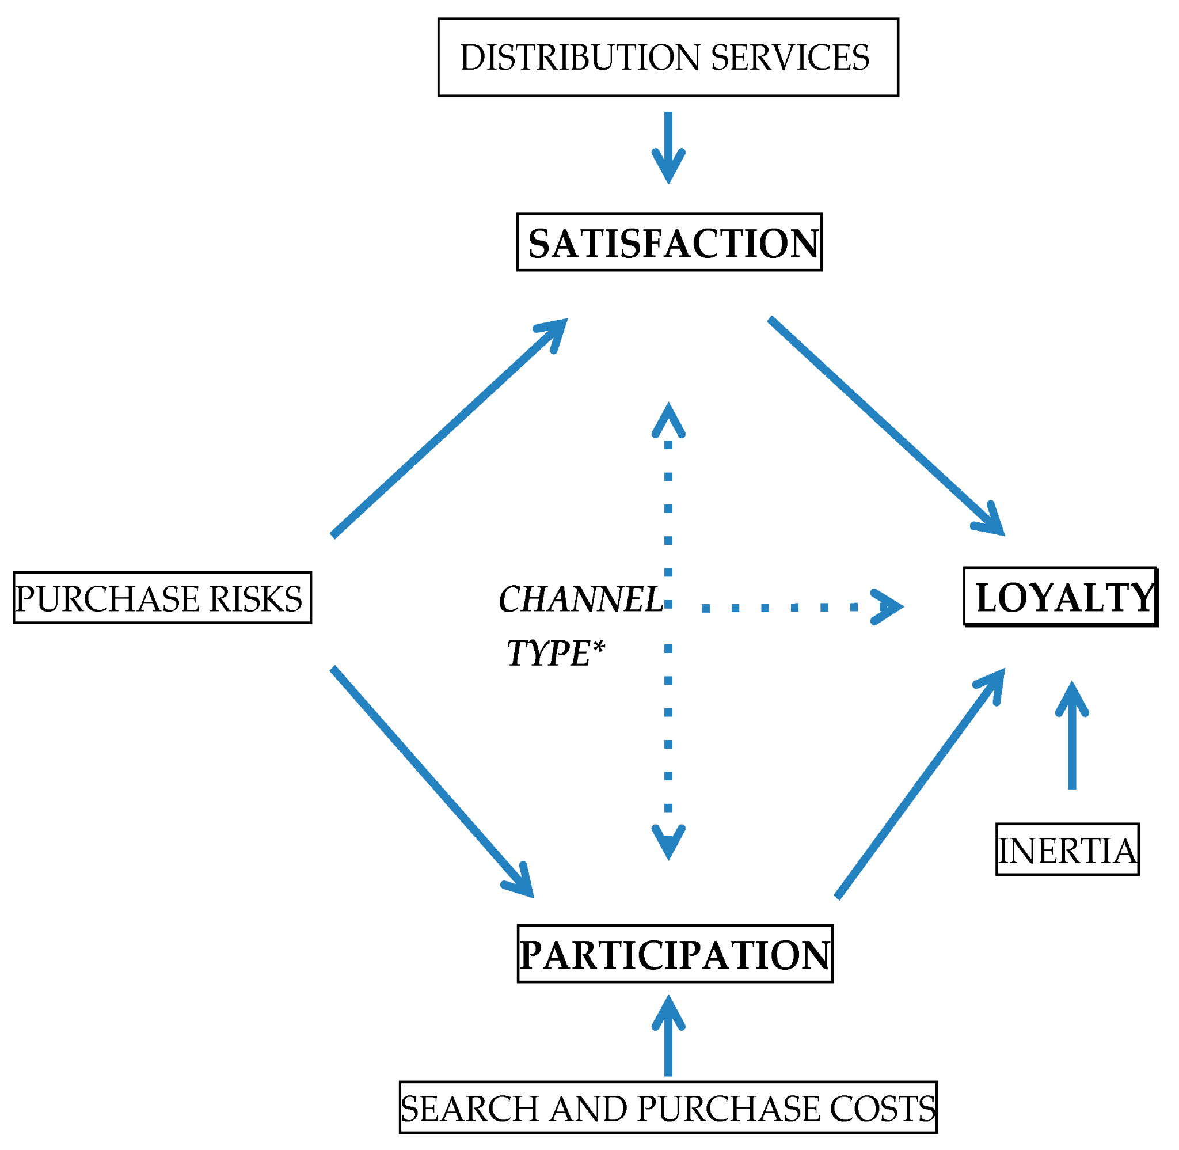
Figure 4.1: Direct and indirect distribution flowchart
(Source: Lee et al. 2022)
Figure 4.1 shows how different direct and indirect distribution among the tourism channel.

4.1.1 Traditional Distribution Channels
Traditional distribution systems are lazier than the Online Booking System because traditional systems are manual and offline. This Research paper analyse today’s world is moving in the direction of the digital era. Traditional distribution channels are more time-consuming and more costly because of intermediary dependence traditional system are heavy dependency on intermediaries, such as travel agents (Choi et al. 2025). Traditional channels(Travel agencies and call centres) are playing an important role in easing access by using human interactions for customers with low digital literacy. The traditional system is not effective in today’s world because the world is moving into digital technology or digital platforms to easily buy hotel and airline tickets.

4.1.2 Impact Of Digital Technology
Digital Technology provides the booking system in an online system in their respective locations. Digital technology is an e-travel booking system that can ensure that travellers book and buy tickets over the internet in an online travel booking system. This research paper analyses that digital platforms are not manual, so platforms are less time-consuming and cost-effective. The impact of digital technology has reduced travel agencies as intermediaries, as it helps the online platforms to improve their accessibility, create an easy booking system, and also helps their business reach out to customers effectively. Online Travel Agencies are focused on efficiency and cost-effectiveness. One of the most crucial things is that online agencies show their price transparency, and the competition in the market.

4.1.3 Role Of OTAs
OTAs is an Online Travel Agents that can compare prices and provide services. Online Travel Agencies focus on the tourism distribution landscape in their market share and influence on consumer behaviour. The modern era of online travel agencies shares its business based on market sharing, work sharing, and customer analysis per days. That research paper motive is OTAs and tourism service providers, including hotels, airlines, and tour operators. Relationships between online travel agencies and service providers, and customer satisfaction are more emphasised as one of the main things. OTAs provide real-time monitoring in their platforms because customers can continuously check their platforms. Check the room rent provided by the airlines, food deliveries, and many more things. Here work on one more thing, which is the GDS, which checks the real-time room availability and price of the room (Almeida et al. 2024).

4.1.4 Direct Booking Channels
Digital platforms like Airbnb have improved accessibility and service with features like recommendations till unable to replace the need for human interactions (Li et al. 2023). Customers still rely on the agents for personalised and custom tour plans according to their need. For the lower prices and better customer relationship, it matters more in direct booking channels. Online travel agencies are converting into direct booking channels company websites are a reliable key factor. Direct Booking also provides exclusive offers for customers to attract their online app or websites. The impact of digital technology has reduced travel agencies as intermediaries, as it helps the online platforms to improve their accessibility, create an easy booking system, and also helps their business reach out to customers effectively.

4.1.5 Impact of Social Media
According to Limniou et al. (2022), Social media is one of the key factors, such as Facebook and Instagram. User-friendly interfaces,24/7 accessibility, easy booking, and secure payments are creating positive responses from customers. Tourism businesses must ensure that their platforms are easily accessible to the different level of people. Social media apps provide a detailed description with media such as images and videos, and customer reviews, which play a crucial role in decision-making. When hotel agencies create a website like MakemyTrip, then companies make promotional videos and raise their brand promotion. Researchers analyse that without promotion; the companies' growth is slow. So the Brand Promotion is one of the key factors to run the company (Fayvishenko et al. 2023).
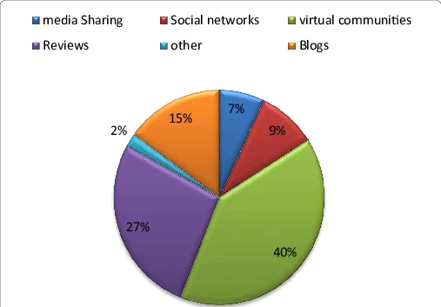
Figure 4.2: Percentage of reviews of blogs, media, and virtual communities
(Source: Sharma et al. 2022)
Fig 4.1.5: This figure recommends the percentage of social media, blogs, and other things

4.2 The Role of Online Travel Agencies (OTAs) in Tourism Distribution

4.2.1 Role of Online Travel Agencies (OTAs) in the tourism distribution landscape
Online travel agencies(OTAs) play a crucial role in the modern distribution system, which shows how tourism services and products are consumed by customers. Due to the heavy use of digital technologies, which helps online travel agencies to act as mediators, acting as a bridge between the service providers like hotels, airlines, and tour operators, with the global customers. Due to the integration of digital technologies, the traditional offline booking system has changed to an online booking system, which is very effective and easy to book services, leading to an increase in sales, accessibility, and the growth of the company (Kontis & Skoultsos, 2022). It changes the structure of tourism distribution by allowing real-time interaction with the customers.

4.2.2 market share and influence on consumer behaviour
Online travel agencies capture an adequate amount of share in the tourism market by offering a wide range of services using a centralized platform by partnering with service providers like hotels, airplanes, etc. the customers are shifting to the online travel agencies now a days because they give various discounts on the bookings, they provide price comparison systems which helps the customers to compare with the other travel agencies and helps them to choose the right options for them, they also provide past customer reviews and instant booking system which helps the customer to make better decision. Due to these features, they can gain customers' trust and encourage them to purchase from them using their platforms (Garcia et al, 2022). Additionally, the online platforms are changing customers' preferences towards speed and convenience, which makes online travel agencies the best choice for travel planning. The heavily dependencies on online says that the online travel agencies are changing the customers' expectations by prioritizing accessibility and personalized services (El Archi & Benbba, 2022). Due to this influence, it helps them to make storing presence in the tourism market.

4.2.3 Advantages and Disadvantages of OTAs

4.2.4 Advantages for consumers and suppliers
OTAs give valuable benefits to the consumers; their main benefits are accessibility and convenience. They help users to make better decisions by giving them the ability to compare multiple options using some key terms like area, price, and services. They use a customer review system, which helps other customers to build trust by reviewing the rating, reviews, and real-time availability, which helps consumers to build trust and loyalty (Garcia et al,2022).
On the other hand, in service providers, OTAs give an increase in visibility and access to customer preferences. Now a days business are listing themselves in the online travel agencies, which will help them to reach the international market without doing their own marketing campaign. By doing this, it will help them to reach international customers, which will help them to increase their booking volume and increase their business growth (Abatayo et al, 2025).

4.2.5 Disadvantage for suppliers and consumers
OTAs have lots of advantages, but there are some disadvantages. OTAs give lots of options to choose from according to their needs, but sometimes lots of options may lead to confusing the customer. For suppliers, the use of online platforms increases the commission fee, which reduces the profit margin for the suppliers. Heavily depending on the intermediary will also affect the brand identity and control over the identity strategy (Ciftci et al, 2022).

4.2.6 Relationship between OTAs and tourism service providers
The relationship between online travel agencies and tourism service providers involves both collaboration and dependencies, which shows that the OTAs act as an intermediary by providing all the facilities, which gives more profit to the service providers. These platforms offer hotels, airlines, and travel operations to the customers. However, this relationship is very much complex, because the service providers are heavily dependent on these online travel agencies for their bookings. These limitations will impact their availability and also affect their marketing strategies, which will lead to the loss of customer trust. Research shows that while online travel agencies are spreading their network, they create standardized pricing to increase their market transparency (Ciftci et al, 2022).

4.2.7 Challenges OTAs present to traditional distribution channels
Due to the rise of online travel agencies, it affects the traditional distribution channels, because if the companies cannot adapt to the market trends, they will lose their business. The demand for physical travel agencies is reduced because the online travel agencies are more convenient, faster than offline travel agencies, and more cost-efficient than offline travel agencies. Traditional offline service providers are facing serious challenges in this competitive market due to the increase in online travel agencies, as they are less effective.

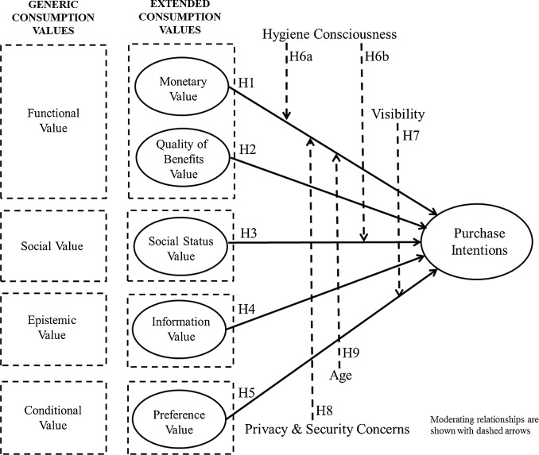
Figure 4.1: Challenges of OTAs
(Source- Talwar et al. 2020 )
Figure 4.1 shows the challenges of OTAs, which shows the problem the consumers are facing when using OTAs.

4.2.8 Case studies of leading OTAs
- Expedia
It is an online travel agencies which offers an affordable range of travel services, which include flight tickets, hotel accommodations, and vacation packages. Due to its user-friendly interface and trusted presence makes it more attractive in the market.
- Booking.com
It is one of the most widely popular online travel agencies in the world, and it is more famous for its comprehensive packages and transparent pricing lists, which help customers to choose better options for them. It also has a customer review section, which helps customers to judge the agencies and gives them trust.
- Airbnb
Airbnb is now more trending among online travel agencies among travellers, as it introduces a new concept that is peer-to-peer platforms, which connects hotels with travellers. This new approach increases the number of scopes for tourism by giving them more reliable options to personalize their travel experience.

4.3 Tourism Distribution Channels and Customer Experience
Tourism distribution plays an important role in shaping the customer experiences and their satisfaction. The channels are divided into different parts, like online social platforms, travel agencies, and call centres. This channel provides quality services and constant connections for facilitating transactions in today's digital era. This discussion examines the impact of different channels on customer satisfaction, accessibility, and service quality with the shameless and convenient experiences.

4.3.1 Impact of Different Distribution Channels on Customer Experience
Different tourism distribution channels have different impacts on customer experiences with their well-defined ways. Different online platforms, such as Booking.com and Airbnb, have shaped the travel industry with convenient and reliable services. Customers can check the prices and availability in real time and compare two services with an instant booking feature. This platform provides a detailed description with media (images and videos) and customer reviews, which play a crucial role in decision-making. On the other side, the traditional travel agencies and call centres share a human centric experiences. For a complex and long tour, people often want to go with a flexible plan made with their scheduled. This human system helps to ensure reliability and helps the traveller to discuss freely about specific needs.
Thus, while digital channels are focused on efficiency and fast services, offline channels remain important to plan a personalised travel. The combination of this both can match the diverse customer needs and enhance the level of their satisfaction.

4.3.2 Importance of Seamless Integration Across Various Channels
Different distribution channels are integrated together for better services in the travel industry, and to enhance the satisfaction level. Travellers always try to analyse multiple options before they choose a booking for the trip. For example, a customer can search on different platforms and mobile apps to find the best match for their needs, and finalize the booking through a call centre. Shameless integrations have helped in maintaining the smooth transactions and the consistency of the service. Customers often uses there previous travel history for planning the upcoming trips across different platforms. If the traveller has to re-enter their personal data and preferences every time, it can lead to a frustrating experience. Tourism that implements different channels together to enhance user satisfaction is the better version and is able to deliver a unified experience. These strategies align perfectly with service quality, where the keys are consistency and reliability for customer satisfaction. That's why integration of different channels is not only a technical upgrade but a strategic implementation.

4.3.3 Role of Personalization in Distribution Channels
Personalised channel distributions help in the upgrading of tourism distribution channels, where the customer data can be analysed for improvement in the system. Organisations can use data analysis to find the customer needs and can implement a personalised approach for the enhancement in customer service with their interest. Personalization can be used in different fields, with the travel package and the customer's budget. As frequent travelling includes more costs, the travellers are satisfied with the recommendation of cost-effective plans with different facilities. Also, it helps in managing a recommendation system for similar places, which can increase the customer experience. It focuses on long-term customer relations over one-time transactions to build better customer satisfaction by addressing their feelings and values during the process. Ease of access is another important factor influencing the customer experience, as many apps have on-the-go bookings and real-time upgradations. User-friendly interfaces,24/7 accessibility, easy booking, and secure payments are creating positive responses from customers.
Tourism businesses must ensure that their platforms are easily accessible to the different level of people. Traditional channels(Travel agencies and call centres) are playing an important role in easing access by using human interactions for customers with low digital literacy. Customer service quality is a key to maintaining customer satisfaction across different channels with its attributes. High-quality customer services include prompt response, high-quality problem-solving, and communications, and understanding. The integrations of artificial intelligence, like the chat bots has improved the response time and advanced feedback, but a human touch is still needed for the complicated solutions.

4.3.4 Role of Customer Reviews and User-Generated Content
Customer reviews and user-generated content play a crucial role in shaping decision-making with tourist satisfaction, where platforms like TripAdvisor allow users to share experiences. UGC enhances transparency and trust, as travellers often go through the reviews rather than any promotional content. Positive reviews can increase bookings, while negative reviews can decrease customer bookings, which reflects that people's decisions are influenced by others' experiences. Moreover, reviews also give feedback, which helps in learning about areas of improvement. The main challenges, like fake reviews and biased ratings, should be analysed carefully and need effective monitoring.

4.3.5 Examples of Successful Multi-Channel Tourism Businesses
Several tourism businesses have successfully applied multi-channel distribution to enhance customer satisfaction. Airbnb combines a user-friendly digital design with personalised recommendations and customer reviews, which mainly focus on trust building. Booking.com is known for affordable pricing, 24/7 accessibility, and customer support with flexible policies. MakeMyTrip helps in traveling in India with its seamless connections throughout the mobile app and website, with effective customer support. Expedia Group combined the personalised and omnichannel concept to make flexible and consistent services across its different platforms. These companies are examples of how the effective use of multi-channel in combination can increase user satisfaction and their experience.

5. Discussion
The analysis of tourist distribution channels' evolution from a simple booking system to critical customer-centric applications. In today's competitive tourism scenarios, businesses need to work beyond simple travel channels, but also the efficient integration of those business channels. The interaction between online platforms, call centres, and physical travel agencies makes a complex travel ecosystem where coordination is the key focus. Digital platforms such as Booking.com and Airbnb have improved accessibility and service with features like recommendations till unable to replace the need for human interactions. Customers still rely on the agents for personalised and custom tour plans according to their need. This leads to the omnichannel approach, where the technological enhancement does not replace humans. Another important approach is personalised traveling is a major focus area for the young travellers. Platforms like Expedia Group explain how data-driven insights can improve customer engagement with different recommendations. Also, user-generated content helps in attracting more users and creates positive reviews for traveling to places with the help of TripAdvisor. Overall, this discussion highlights that interrogating multiple different channels and customer-centric strategies are the key concepts of improving the tourism business.
Researchers analyse what is needed to run a travel company behalf off traditional method come into a digital online booking system. Due to the growth of the internet, it helps the online platforms to improve their accessibility, make an easy booking system, and also help their business reach out to customers effectively. Due to the involvement of new technologies, the tourism industry, like digital distribution channels, has achieved prominence due to the rise of online travel agencies and online booking platforms. Personalization can be used in different fields, with the travel package and the customer's budget. As frequent travelling includes more cost, the travellers are satisfied with the recommendation of cost-effective plans with different facilities. OTAs give an increase in visibility and access to customer preferences. Now a days business are listing themselves in the online travel agencies, which will help them to reach the international market without doing their own marketing campaign. This research paper analyses that the online booking agencies system in the modern era is more effective, with more customer satisfaction and real-time monitoring, which is why customers are moving to digital platform than the traditional platform. One more crucial thing is that headache travel agents and personalized travel to ensure that when customers book those tickets, like hotel tickets and airline tickets, digital agencies can track customer behaviour and provide customer satisfaction. The effect of those distribution systems makes the personal structures. Online Travel Agencies satisfy the customer and receive some reviews from the customer. Those reviews are converting to ratings on the respective companies' websites. The evaluation of tourism distribution channels identifies how the world is changing in the modern era. Impact of Digital Travel Method on the easy-to-use customer, reliable time, cost, and real-time monitoring. Nowadays, various agencies to create those type of online travel agencies, such as MakeMyTrip, Airnob. This research paper's main motivation is to understand how the world is moving from online travel agencies and how different normal or traditional booking system into digital online booking systems.

6. Conclusion
This study indicates the significant changes in tourism distribution channels from traditional systems to digital platforms. This study tells that the development or rise of the internet and digital tools has significantly changed the tourism industry. In the past few years, the traditional systems have dominated the market, but now they are challenged by the more efficient and easily accessible online platforms. This study shows the vital role of online travel agencies in modern tourism. OAT enhances its market reach by partnering with the service provider, which helps them to give accessibility and provides transparency and convenience to the customers. They help consumers to make better choices by providing them with features such as price comparison, customer reviews, and personalized recommendations, which help them to strengthen their position in this competitive market. These digital platforms provide new opportunities to the service providers to increase their market presence an helps them to reach the global market. This study indicates that there are some challenges related to the increasing dominance of the online travel agencies(OTAs). Due to the increase in high commission rates, which increases the competitiveness in the market.

References
Abas, S. M., Rasheed, B. H., Abas, S. S. A., & Kumar, K. S. (2023). A Review on Utilization of Business Analytics strategy in Tourism Industry. IIRJET, 9(2). http://iirjet.org/index.php/home/article/view/299
Abatayo, B., Digao, J. M. T., Estores, E. A., & Froilan, L. F. M. (2025). Efficiency of Online Travel Agency [OTA] Towards Increasing the Occupancy Rate among Hotels in Cebu. American Journal of Multidisciplinary Research & Development (AJMRD), 7(12), 103-116. https://www.ajmrd.com/wp-content/uploads/2025/12/K712103116.pdf
Almeida, S., & Ivanov, S. (2024). Generative AI in hotel marketing–a reality check. Tourism: An International Interdisciplinary Journal, 72(3), 422-455. https://hrcak.srce.hr/clanak/457772
Choi, Y., & Choi, E. K. (2025). Quality competition between traditional and online sellers. The World Economy, 48(2), 402-413. https://onlinelibrary.wiley.com/doi/abs/10.1111/twec.13660
Ciftci, O., Berezina, K., & Cobanoglu, C. (2022). Online Travel Agencies in Hotel Distribution: Game on!. Journal of Hospitality & Tourism Cases, 10(2), 26-32. https://journals.sagepub.com/doi/abs/10.1177/216499872201000201
Correia, A., & Kozak, M. (2022). Past, present and future: Trends in tourism research. Current issues in tourism, 25(6), 995-1010. https://www.tandfonline.com/doi/abs/10.1080/13683500.2021.1918069
El Archi, Y., & Benbba, B. (2022). The role of OTAs in the transformation of tourism: A study on customer satisfaction in the digital era. https://www.academia.edu/download/95291565/Communication_FORO_MAS_PALOMAS_2022_pdf_1.pdf
Fayvishenko, D., Cherniavska, L., Bondarenko, I., Sashchuk, T., Sypchenko, I., & Lebid, N. (2023). The impact of brand social media marketing on the dynamics of the company’s share value. Business: Theory and Practice, 24(1), 24-32. https://www.ceeol.com/search/article-detail?id=1106763
Garcia, G., Dos Anjos, S., & Doğan, S. (2022). Online travel agencies and their role in the tourism industry. Advances in Hospitality and Tourism Research (AHTR), 10(3), 361-386.https://dergipark.org.tr/en/pub/ahtr/issue/72454/865546
Garcia, G., Dos Anjos, S., & Doğan, S. (2022). Online travel agencies and their role in the tourism industry. Advances in Hospitality and Tourism Research (AHTR), 10(3), 361-386.
https://dergipark.org.tr/en/pub/ahtr/issue/72454/865546
https://link.springer.com/article/10.1007/s41347-021-00229-z
Kontis, A. P., & Skoultsos, S. (2022). Digital evolution in tourism marketing channels: Greek tourism industry and Online Travel Agencies. European Journal of Tourism Research, 30, 3004-3004 https://ejtr.vumk.eu/index.php/about/article/view/2591
Kontis, A. P., & Skoultsos, S. (2022). Digital evolution in tourism marketing channels: Greek tourism industry and Online Travel Agencies. European Journal of Tourism Research, 30, 3004-3004. https://ejtr.vumk.eu/index.php/about/article/view/2591
Kontis, A. P., & Skoultsos, S. (2022). Digital evolution in tourism marketing channels: Greek tourism industry and Online Travel Agencies. European Journal of Tourism Research, 30, 3004-3004. https://ejtr.vumk.eu/index.php/about/article/view/2591
Lee, S. H., Deale, C. S., & Lee, J. (2022). Does it pay to book direct?: Customers’ perceptions of online channel distributors, price, and loyalty membership on brand dimensions. Journal of Revenue and Pricing Management, 21(6), 657. https://pmc.ncbi.nlm.nih.gov/articles/PMC9117995/
Li, J., So, K. K. F., & Hudson, S. (2023). Customer responses to the Airbnb platform: the role of Airbnb experience and memorability. International Journal of Contemporary Hospitality Management, 35(3), 1068-1086. https://www.emerald.com/ijchm/article/35/3/1068/123548
Limniou, M., Ascroft, Y., & McLean, S. (2022). Differences between Facebook and Instagram usage in regard to problematic use and well-being. Journal of technology in behavioral science, 7(2), 141-150.
Maraña, P. A., Regaliza, J. C. P., Val, P. A., & Castillo, S. A. (2023). Examining the relationship between online distribution channels and tourist satisfaction and loyalty. Tourism & Management Studies, 19(4), 7-20. https://dialnet.unirioja.es/servlet/articulo?codigo=9236027
Moon-Jeong, K. I. M., & Woo-Je, C. H. O. (2024). The history of tourism distribution channels and future prospects in the tourism service industry. Journal of Distribution Science, 22(6), 107-11https://accesson.kr/jds/assets/pdf/51073/journal-22-6-107.pdf
Moon-Jeong, K. I. M., & Woo-Je, C. H. O. (2024). The history of tourism distribution channels and future prospects in the tourism service industry. Journal of Distribution Science, 22(6), 107-114.https://accesson.kr/jds/assets/pdf/51073/journal-22-6-107.pdf
Polo Peña, A. I., Andrews, H., & Morales Fernández, V. (2023). Can online travel agencies contribute to the recovery of the tourism activity after a health crisis?. Journal of Humanities and Applied Social Sciences, 5(4), 271-292. https://www.emerald.com/jhass/article/5/4/271/224011
Raab, C., Berezan, O., Christodoulidou, N., Jiang, L., & Shoemaker, S. (2018). Creating strategic relationships with online travel agents to drive hotel room revenue: An OTA perspective. Journal of Hospitality and Tourism Technology, 9(1), 125-140. https://www.emerald.com/jhtt/article/9/1/125/217430
Sampson, S. E., & Chase, R. B. (2020). Customer contact in a digital world. Journal of Service Management, 31(6), 1061-1069. https://www.emerald.com/josm/article/31/6/1061/511460
Sharma, M. P., Meena, U., & Sharma, G. K. (2022). Intelligent data analysis using optimized support vector machine based data mining approach for tourism industry. ACM Transactions on Knowledge Discovery from Data (TKDD), 16(5), 1-20. https://dl.acm.org/doi/abs/10.1145/3494566
Talwar, S., Dhir, A., Kaur, P., & Mäntymäki, M. (2020). Why do people purchase from online travel agencies (OTAs)? A consumption values perspective. International Journal of Hospitality Management, 88, 102534. https://www.sciencedirect.com/science/article/pii/S0278431920300864

