

Cultural Heritage Management

Cultural Heritage Management: Museum Island Berlin

Introduction

Heritage management protects cultural sites through its required activities which guarantee their continued significance for both current and future generations. The process includes three activities which together protect and educate about heritage resources while allowing their responsible use.

Germany possesses advanced heritage management systems which operate through its established legal framework and research activities while building public involvement. UNESCO has designated Museum Island as a World Heritage Site which serves as one of Berlin's most significant cultural landmarks. The Museum Island complex contains five major museums which showcase more than 100 years of architectural and cultural and intellectual progress. The public can access knowledge through this system which UNESCO recognized as an Enlightenment concept (UNESCO, 2021).

This essay conducts a critical examination of the heritage management plan at Museum Island through three main elements which include its vision statement and objectives and value statement. The evaluation process assesses each element of modern heritage management practices to determine their strengths and their weaknesses.
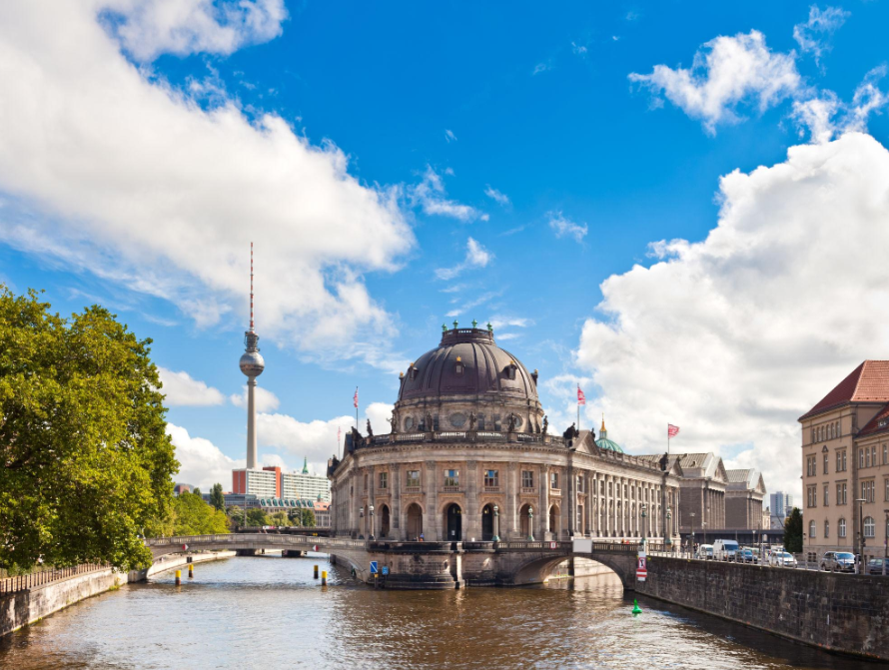
Figure 1: Museum Island Berlin – UNESCO World Heritage Site located in central Berlin, representing a cultural and architectural heritage complex.

Vision Statement
The vision statement for Museum Island aims to maintain the site as a complete cultural and architectural heritage site while boosting its function as a contemporary educational research and tourist destination. The space creates a dynamic cultural environment which allows visitors to experience historical and cultural elements. The vision succeeds because it maintains an equal relationship between protecting existing assets and implementing new developments.

Modern heritage management now focuses on making historical sites relevant through active public participation (Paddison, 2023). The vision maintains site activity through education and tourism while creating a permanent historical value for people to experience at the site.

The efforts to achieve this equilibrium lead to multiple obstacles. The installation of new infrastructure and exhibition spaces for modernization work clashes with efforts to preserve historical authenticity. Heritage sites will undergo fundamental changes because of extensive development projects (Tan, 2020). The process of adding modern architectural elements to historical buildings demands detailed design work which creates conflicts among different interest groups.

Heritage management practices today depend on inclusive methods which let local communities participate in decision-making processes (Smith 2021). The vision needs better integration of this component.

Objectives
Make it easier for visitors to enjoy themselves at Museum Island by making improvements to visitor accessibility, signage, and exhibition fora throughout the development of Museum Island.

Maintain all of the architectural and cultural elements at each of the five museums at Museum Island in a way that meets UNESCO heritage preservation guidelines.

Join together all of the five museums to create a unified museum/institution system for service delivery, maximizing opportunities for improved coordination, interpretation, and management of all five museums.
Promote education and research opportunities through greater opportunities for public involvement and academic collaboration regarding Heritage and Museum Collections.

Continue to manage sustainable tourism through balancing the number of visitors with the need for conservation of the property while minimizing the environmental impact on and structural integrity and viability of the property.

Value Statement

The value statement of Museum Island establishes its standing as an exceptional instance of museum architectural design which demonstrates cultural development. The structure maintains educational functions while distributing research capabilities to support its worldwide cultural value.

The value statement demonstrates its main strength when it extends beyond describing physical sites to describe their intellectual and cultural value. The site connects to Enlightenment principles which transform Museum Island into a place for knowledge acquisition and cultural interchange (Paddison, 2023). The World Heritage Site status receives stronger support through this explanation.

The site functions as a cultural ensemble which includes multiple buildings instead of treating each building as a separate entity. This heritage management approach supports current practices which assess the entire context and connections among various components (Zhang, 2024).

The value statement contains two main advantages. The document primarily presents Western ideas about knowledge and Western cultural practices. The statement needs to incorporate more cultural perspectives from African and Asian regions because many collections originate from these areas (Huang, 2023).

The statement emphasizes essential site characteristics while protecting its delicate attributes. The site faces different threats which include climate change and urban development and mass tourism. A more complete value statement needs to present essential details which protect the site and sustain its existence throughout time (Grazianova, 2022).

Conclusion
The heritage management plan of the Museum is an essential document that shows how to protect cultural heritage at the museum. The vision discusses in what ways the museum can keep historical elements from being lost, and the need to add modern design elements to old buildings, and how to provide a long term framework on how to reach that goal. The value statement provides a clear picture of what the museum represents in terms of cultural, architectural and intellectual contributions.

The organization must address multiple existing obstacles. The organization faces difficulties in balancing modernization with authentic historical preservation while managing both tourism activities and project expenses. The plan needs to develop a stronger focus on inviting all community members to participate in its activities, which includes addressing ethical matters that involve people returning their ancestral belongings.

References
Grazianova, M. and Mesaros, P., 2024. Cultural heritage management from traditional methods to digital systems: A review from bim to digital twin. In E3S Web of Conferences (Vol. 550, p. 01015). EDP Sciences.
Huang, Y.Y., Yu, S.S., Chu, J.J., Fan, H.H. and Du, B.B., 2023. Using knowledge graphs and deep learning algorithms to enhance digital cultural heritage management. Heritage Science, 11(1), pp.1-26.
Paddison, B. and Hall, J., 2023. Tourism policy, spatial justice and COVID-19: lessons from a tourist-historic city. Journal of Sustainable Tourism, 31(12), pp.2809-2824.
Tan, K., Wu, Y., Liu, Y. and Zeng, H., 2025. A Multidimensional AI-powered Framework for Analyzing Tourist Perception in Historic Urban Quarters: A Case Study in Shanghai. arXiv preprint arXiv:2509.03830.
UNESCO (2021) World Heritage Sustainable Tourism Toolkit. Paris: UNESCO. Available at: https://whc.unesco.org
Zhang, Y., Ikiz Kaya, D., van Wesemael, P. and Colenbrander, B.J., 2024. Youth participation in cultural heritage management: a conceptual framework. International Journal of Heritage Studies, 30(1), pp.56-80.

