

A Study on Planning and Management of Sustainable Tourism Spaces

Student Name: Anhaddeep Singh

Executive summary
This study analyses how smart technologies are incorporated into sustainable urban tourism spaces. It highlights the implementation of Internet of Things, Artificial Intelligence and digital twins to control tourist flows, optimise resource allocation, and improve the environmental, social and economic aspects of sustainability. It examines how data analytics are used to improve waste management, transportation and energy, in addition to identifying global best practice processes, highlighting the effective implementation of those processes. Limitations identified, including financial limitations, technical limitations and also privacy aspects of data use, are critically assessed. The implications for developing cities with limited budgets are highlighted with recommendations. The report presents the study of both the theoretical and practical implications of technology on tourism and its sustainability output using a Triple Bottom Line approach.
Table of Contents
1. Introduction 4
2. Literature Review 5
2.1 Role of smart city technologies in managing visitor flows and resource efficiency 5
2.2 Optimisation of waste, transport, and energy use using data analytics 6
2.3 Case studies of Barcelona, Singapore, or Amsterdam 7
2.4 Recommendations for developing cities with limited budgets 8
2.5 Theoretical perspectives 9
3. Methodology 10
3.1 Data collection 10
3.2 Data analysis 11
3.3 Research ethics 11
4. Findings 12
5. Discussion 14
5.1 Impact of Smart Technologies on Urban Tourism Sustainability 14
5.2 Challenges in Implementing Smart Tourism Solutions 15
5.3 Comparative Analysis of Global Smart Tourism Practices 16
6. Conclusion 18
References 19

1. Introduction
Cities have been the core of international travel with a wide variety of cultural, economic and recreational activities that are receiving millions of tourists each year. The high rate at which tourism is growing in urban areas has resulted in the growing environmental demands, social congestion and the depletion of resources and hence the urgent need to have sustainable spatial planning and management. With the trend of urban tourism that keeps rising, cities are tasked with the responsibility of balancing between cities and the environment in terms of economic development and community welfare (Ivars-Baidal et al., 2023). Destination sustainability is a transformative opportunity to overcome these challenges and improve the sustainability of destinations, that is offered by the integration of technology through smart city concepts.
Smart tourism places are a new tendency in municipal design, where advanced technologies are employed to optimise tourism systems' efficacy, resilience, and sustainability. The technologies allow to track at all times in real time visitor flows, forecast the potential for maintenance of infrastructures, and possible uses of resources (energy, water) (Medina et al., 2020) The synergism between the technological innovation and the strategic planning with a higher degree of orientation to the sustainability, contributes to the development of adaptive, inclusive, and intelligent urban spaces for tourism.
Some cities in the world (Barcelona, Singapore and Amsterdam) are pioneers in the use of intelligent city structures for the management of tourism. Barcelona uses networks of IoT for tracking traffic and other environmental factors, Singapore experiences with AI and analytical systems in the mobility and waste systems, and Amsterdam develops digital systems to face overtourism with the use of data for decision making (Obersteiner et al., 2021). These are only some examples of how the digital transformation can be successfully integrated with the sustainability objectives, enhancing not only the efficiency of the operations but also the social and environmental performance.
Though these successes have occurred, most developing and mid-size cities are constrained by such conditions as limited financial resources, poorly developed infrastructure, and the lack of digital systems of government. The necessity to seek out economical and scalable solutions for the implementation of smart technologies is evident if the benefits of sustainable urban tourism are to be equitably shared. This study seeks to present a critical analysis of how smart city technologies can be implemented in the development of sustainable urban tourism areas (Day et al., 2021). It will address how IoT, AI, and data analytics can be used to control the inflow and outflow of visitors and efficiency of resources, discuss the real use cases in major destinations worldwide and provide recommendations that can be implemented in developing cities.

2. Literature Review

2.1 Role of smart city technologies in managing visitor flows and resource efficiency
Real-Time Visitor Management and Internet of Things (IoT)
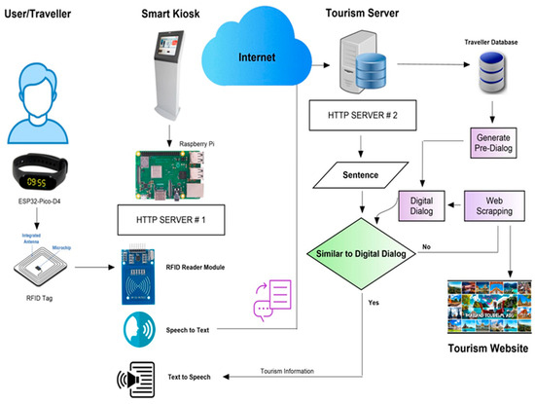
Figure 1: Real-Time Visitor Management and Internet of Things (IoT)
Source: (Suanpang & Pothipassa, 2024)
The IoT is the basis of smart tourism spaces as it bridges the gap between non-digital infrastructure and digital intelligence. The IoT sensors and devices will gather data on real-time information regarding visitor movement, transportation use, and the environment, allowing the cities to track the number of people and manage traffic flows. For example, the smart cameras and beacons in tourist areas will identify when overcrowding is present and send mobile notifications or electronic signs to make people go to less crowded spots (Vujko et al., 2025). Environmental sensors based on IoT applications assist in checking air quality, noise, and garbage collection to ensure the development of tourism does not cause conflicts with the sustainability goal.
Artificial Intelligence (AI) for Predictive and Adaptive Resource Use
Artificial Intelligence (AI) promotes tourism management by developing predictive analytics and automation. With the huge amount of tourism and environmental information, AI algorithms will be able to predict visitor numbers, high seasons and bottlenecks. This will help the tourism authorities to plan their resources, including energy, water, and transportation, more effectively. The lighting and HVAC energy use in hotels, attractions, and other public areas can also be optimised by AI-driven systems, depending on the level of occupancy (Olena et al., 2025). In the adaptive learning practice, AI can ensure that the decision-makers make tourism plans more refined to ensure that the relationship between visitor satisfaction and environmental protection remains balanced.
Simulation and Sustainable Planning Using Digital Twins
The use of digital twins (computerised versions of the physical surroundings) is transforming the way the spaces of urban tourism are planned and controlled. They enable city planners to make simulations and analyses of the effects of tourism-related activities on infrastructures, transportation networks and natural resources before making changes in reality. Digital twins facilitate sustainable urban development using scenarios to address questions on visitor flows and energy consumption patterns (Ivars-Baidal et al., 2023). For example, cities can simulate the impact of new attractions of transport routes in terms of congestion and emissions, having evidence-based interventions.

2.2 Optimisation of waste, transport, and energy use using data analytics
Optimising Waste Management through Data Analytics
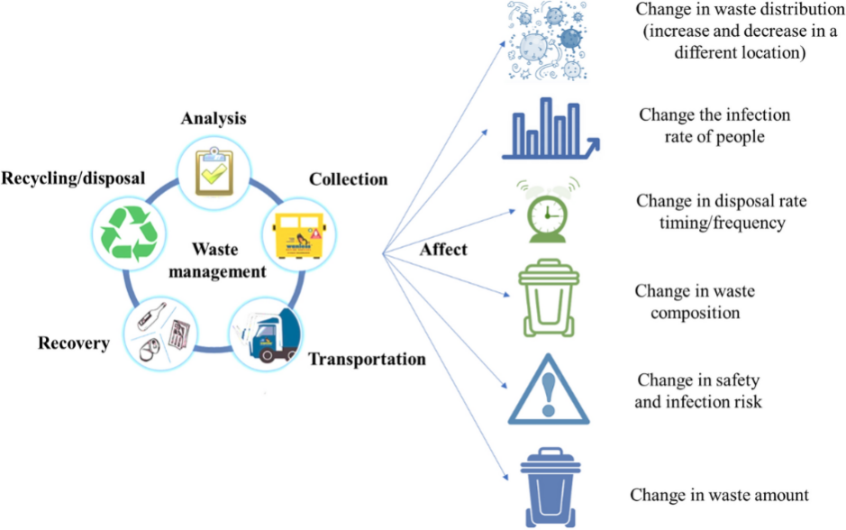
Figure 2: Optimising Waste Management through Data Analytics
Source: (Fang et al., 2023)
The data analytics can help cities to be more efficient in waste management by gathering and analysing information with the smart bins, waste trucks and recycling plants. Smart bins that have IoT can be used to track the level of fill and transmit real-time information to centralised platforms. Optimisation of waste collection routes is subsequently done by analytics tools, that minimise unnecessary visits and fuel usage. Such systems have been adopted in cities such as Singapore and Seoul to simplify collection schedules, reduce the cost of operations, and reduce the emission of greenhouse gases (Gulyamov, 2024). Predictive analytics can determine waste creation tendencies in the most popular tourist seasons to assist the authorities in allocating more resources to places of necessity.
Increasing the efficiency of Urban Transport with Mobility Data
The tourist cities usually have congestion and inefficiency in their transport systems because of the ever-changing flows of visitors. This can be overcome using Data analytics that compile and examine mobility data based on GPS positioning, public transport smart cards, and ride-sharing applications. Predictive models may determine the trends in travel, predict future congestion, and optimise the public transport routes dynamically. For example, Barcelona and Amsterdam apply analytics to increase or decrease bus service or encourage other forms of movement, such as cycling or walking (Gracias et al., 2023). Transport analytics can also guide long-term infrastructure investments to make transport networks resilient and sustainable in urban tourist destinations that are increasing in size.
Data-driven Energy-efficiency and Wise Resource management
Advanced data analytics can be used to streamline energy usage in hotels, attractions, and urban infrastructure. Smart grids and energy monitoring systems record the data concerning electricity and water consumption, and the authorities and businesses can diagnose inefficiency and change operations. Energy-saving systems can be automated with the help of analytics tools. Singapore has real-time energy dashboards to monitor the performance of districts to facilitate evidence-based sustainability policies (Baidal et al., 2021). This means that cities can use predictive analytics to determine the energy peaks, incorporate renewable sources better, and minimise wastage.

2.3 Case studies of Barcelona, Singapore, or Amsterdam
Barcelona
Barcelona is commonly known as one of the most popular smart tourism destinations in Europe that incorporates technology both to elevate the experience of visitors and make its tourism more sustainable. The city uses IoT sensors to track traffic, air quality and crowd density in real time using its Smart City Initiative. The systems allow the authorities to regulate the tourist traffic to avoid overcrowding in the most visited places, including La Rambla and Park Güell. Smart mobility solutions are also incorporated in the city, such as electric buses and sensor-driven parking systems, that lessen both emissions and traffic jams (Saker & Sayed, 2025). The open-data platform of Barcelona enables businesses and researchers to study tourism trends and create environmentally friendly services.
Singapore
Through sophisticated data analytics and intersectoral cooperation, Singapore has established itself as a top example of smart and sustainable tourism in the world. The Singapore Tourism Board (STB) applies AI and big data to comprehend the preferences of visitors to manage the capacity of the destinations. Smart systems are integrated transport systems, energy systems, and waste systems, that integrate the data to improve the efficiency of their operations. Sentosa Island in Singapore is another place that exists on uses digital dashboards to monitor real-time visitor numbers and environmental performance (Guernieri, 2023). These projects are consistent with the overall vision of the Smart Nation strategy of the city, demonstrating how the overall management of technology usage can help in enabling sustainable tourism without affecting the satisfaction of the visitor or the resilience of the city.
Amsterdam
The smart tourism plan of Amsterdam aims at reducing overtourism by way of making decisions that are driven by data and involving its community. The city applies real-time visitor tracking data and digital signage as an instrument to direct tourists to less crowded attractions. Sustainable transport management is another concept that AI analytics aids through encouraging cycling and using public transport in favour of personal transport. The City in Balance program in Amsterdam involves the integration of behavioural concepts and technology to ensure the growth of tourism in the country is of benefit to the communities (Nogueira et al., 2023). Digital twins are applied to estimate the effects of changes in tourism infrastructure to enhance long-term spatial planning.

2.4 Recommendations for developing cities with limited budgets
Prioritise Low-Cost, Scalable Technologies
The creation of cities with a small infrastructure should be oriented towards the adoption of affordable and scalable technologies with a high level of impact but a low level of investment. Cities do not need to spend billions on massive upgrades of infrastructure upgrades as they can start with pilot projects that make use of the IoT and inexpensive sensors to monitor traffic, waste, and energy levels. Proprietary systems can be substituted by open-source platforms and cloud-computing analytics tools through which municipalities can gather data and analyse it without having to invest in large hardware (Gracias et al., 2023). Implementing mobile-based visitor management applications and open data portals may improve communication, crowd management, and service delivery at a small fraction of the traditional prices.
Foster Public-Private Partnerships and Community Involvement
Jurisdictional governance is essential to cities that have limited funds. Local government, private company and academic partnerships can be used to pool resources and technical expertise. Indicatively, digital solutions, including crowd-tracking apps or environmentally friendly mobility services, can be co-created by tourism operators and tech startups. Engagement with the community is also a crucial factor, as the local businesses and residents are trained to be involved in the data collection or maintenance of the smart systems, ownership is increased, and the ultimate running expenses are minimised (Razmjoo et al., 2021). Including the private sector and civil society will help the cities develop inclusive ecosystems that not only divide the financial burden of developing sustainable tourism, but also the environmental burden.
Capitalise on Regional and International Support Programs
Emerging cities must not fail in seeking international financial aid and exchange of knowledge with organisations like the United Nations World Tourism Organisation (UNWTO), World Bank or regional development agencies. Numerous international programs offer grants, technical support and capacity building assistance on sustainable tourism and intelligent city planning. By taking part in such programs, cities can get access to the digital infrastructure support, staff training, and sustainability expertise (Baidal et al., 2021). The implementation of best practices of such successful cities as Barcelona or Singapore, due to knowledge exchange partnerships, can fast-track development at no significant expense.

2.5 Theoretical perspectives
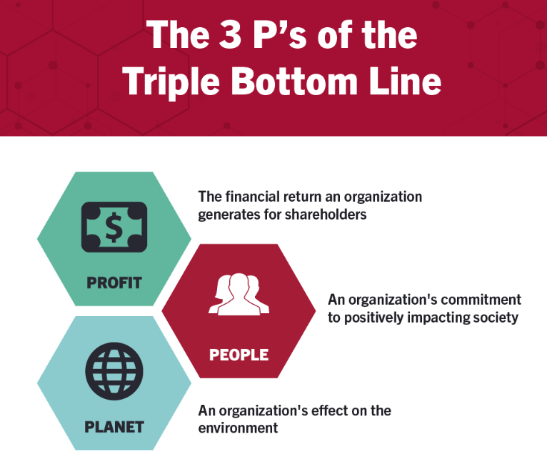
Figure 3: Triple Bottom Line (TBL) theory
Source: (Miller, 2020)
Environmental Sustainability
The environmental element of the Triple Bottom Line (TBL) concentrates on the need to lessen the environmental impacts of tourism development. Smart city technologies, if strategically incorporated, can radically help lessen the waste, emissions and resource use of urban destinations. IoT-enabled monitoring systems may help follow energy consumption, air quality, and waste production, so that cities can build data-driven sustainability initiatives. Digital twins enable planners to stage and consider the environmental effects of infrastructure on tourism before it is built, so that the ecosystem is preserved (Olena et al., 2025). Likewise, application of artificial intelligence driven by predictive models assists in creating optimised transport and energy structures, that lessen the carbon footprint.
Economic Viability
The economic dimension of TBL implies there must be economic sustainability in the environment alongside the environmental balance. Smart technology leads to operational efficiencies, that create economic opportunities within tourism, and also lessen costs. Technologies for data analytics allow businesses and city authorities to maximise the use of available resources, logistics, and have intelligence for forecasting market segments and levels, that leads to lessening unnecessary expenditure (Nogueira et al., 2023). For developing cities, the building of systems that allow substantial integration into a scalable, digital structure is the most economical way of creating continuing returns and is now recommended at many levels, particularly in the field of economic return for GDP and employment creation.
Social Well-Being
The social aspect of TBL advocates for equity and inclusiveness, as well as the well-being of local communities. Social sustainability is achieved through smart tourism strategies aimed at enhancing the quality of life, safety and accessibility. AI-enabled applications improve visitor experiences and contain overcrowding, reducing disruption to residents. Open data initiatives and participative governance frameworks empower communities to engage in tourism decision-making. Local communities benefit from digital education and skills programmes, that allow them to take advantage of smart tourism opportunities (Vujko et al., 2025).

3. Methodology

3.1 Data collection
The data utilized primarily for the research was secondary data. This was also the primary source of data which was analyzed in the merger of technology and sustainability in tourism destinations. An extensive range of reputable data sources have been used in this research (academic journals, industry reports, government documents, case study data) based in the well-developed smart tourism areas of Smart tourism destinations (cities of Barcelona, Singapore and Amsterdam) (Novera et al., 2022). The literature search for the correct literature was conducted in reputable online databases such as Science Direct, Google Scholar and the repository of the UN World Tourism Organisation (UNWTO).

3.2 Data analysis
The secondary data that was captured would be analysed from a systematic review and synthesis of this information. industry reports, journals, articles and case studies. The analysis of the gathered data from the various sources provided insight into the patterns and trends, the communicative interaction and best practices in relation to the use of the smart city technologies which would facilitate to a sustainable tourism provision. The results of the case studies were analysed to provide an insight into how effectively the Internet of Things (IoT), Artificial Intelligence (AI) and digital twins are performing their roles in the modern world and the successes, challenges and lessons learnt (Mazhar et al, 2021). The manner of analysis enabled the combined perception of how the solutions that are technology based can play a part in the sustainable tourism provision.

3.3 Research ethics
Although one may use secondary sources of data, research ethics remain important to support credibility, transparency, and intellectual property. All the information applied in this research, such as industry reports, scholarly journals, articles and case studies, was appropriately cited and referred to as per the scholarly requirements to prevent plagiarism (Razmjoo et al., 2021). To be accurate and reliable, only reputable and publicly available sources were chosen. The research did not use any confidential or proprietary information without authorisation under copyright and data ownership. The interpretation of data was performed in an objective manner, whereby biases were kept to a minimum, and the results were reported truthfully, even where the results have brought out the difficulties or limitations in smart tourism practices (Armond et al., 2021). Another ethical consideration was that of representing the case study cities so as not to misrepresent their policies or initiatives.

4. Findings
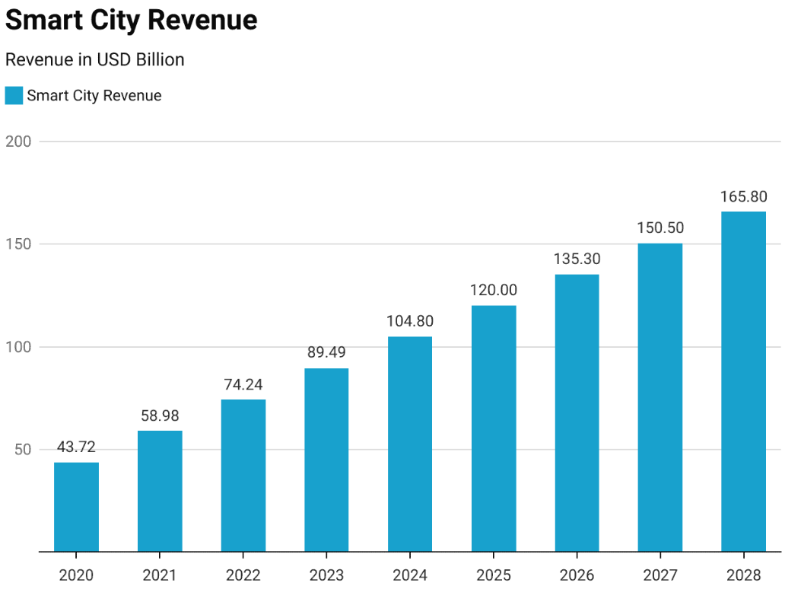
Figure 4: Smart city market revenue statistics
Source: (Pangarkar, 2024)
The graph of Smart City market revenue shows a strong and steady trend in this area between the years 2020 and 2028. In 2020, the global Smart City revenues stood at $43.72 billion and grew to $58.98 billion in 2021 due to the early adoption of digital solutions in cities (Mariani & Baggio, 2021). This growth accelerated in the following years, reaching a total of $74.24 billion for 2022 and an estimated $89.49 billion for 2023. This shows the trend of further growth, with revenues anticipated to exceed $120 billion by 2025, and to reach $135.3 billion by 2026. A forecast of $150.5 and $165.8 billion for the years 2027 and 2028, respectively, is expected in this area (Pangarkar, 2024). This trend reflects an increasing global investment in smart urban infrastructure systems, including IoT, AI and digital twin technologies that bring about sustainability in urban recreational and touristic spaces.
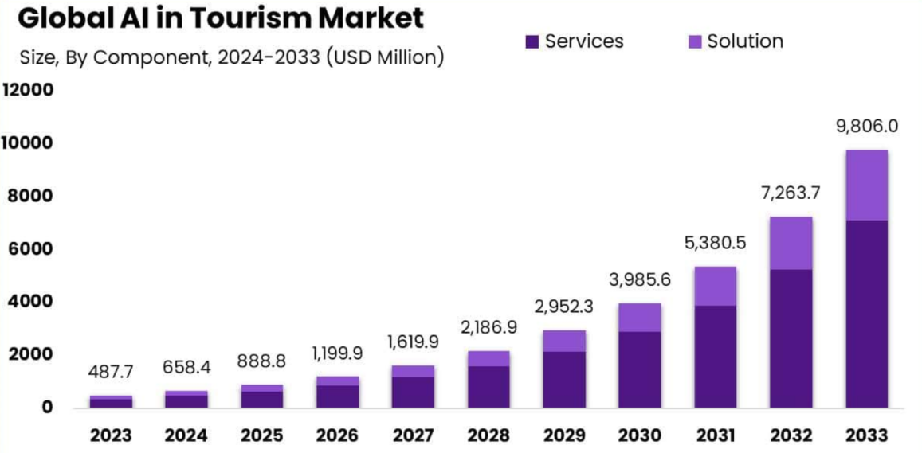
Figure 5: Global AI in tourism market
Source: (Market.us, 2024)
The growing acceptance of artificial intelligence technology in the tourism and travel space is reported in a rapidly growing Global AI in Tourism Market graph. The AI in Tourism Market was valued at USD 487.7 million in 2023, with North America having the largest regional share of 36% with approximately USD 175.57 million in revenue (Pachaury, 2024). The market is expected to grow at a CAGR of 35% during the forecast period 2024-2033, resulting in an expected USD 9,806.0 million size by 2033. Similarly, the AI in Travel Market is also growing swiftly, from USD 131.7 billion in 2023 to USD 2,903.7 billion in 2033, representing a CAGR of 36.25% (Market.us, 2024). From the above graph, it can be seen that AI-based solutions such as predictive analytics, chatbots, and personalised recommendations are increasingly important as they improve efficiency and help contribute to sustainable management of technology-based urban tourism through improving the visitor experience for destination management worldwide.
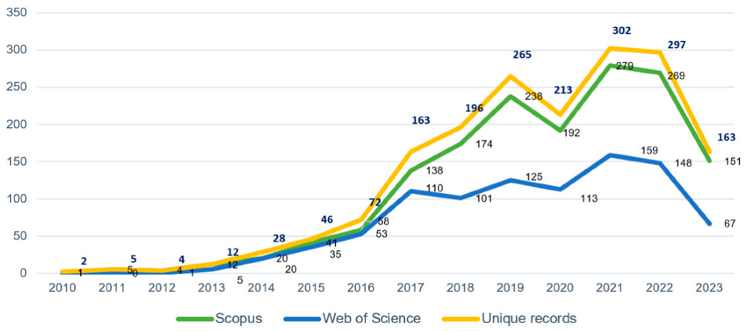
Figure 6: Waste management in smart cities
Source: (Szpilko et al., 2023)
The graph depicts waste management in smart cities and focuses on the effectiveness of technology-oriented solutions designed to improve the collection and disposal of refuse and other wastes. Because the smart bins created with IoT sensors integrated in them can monitor the fill levels of waste in real-time, a municipality, for example, will be able to schedule collection routes more efficiently and reduce undesired trips from collection points (Szpilko et al., 2023). This will mean less fuel consumption, lower operating costs and gas emissions, enhancing the environmental sustainability benefits of the equipment. With respect to the use of analytics with waste management systems, municipalities will be able to monitor certain trends, such as the amount of refuse produced in a tourist area at times of peak traffic and be able to arrange collection schedules with real-time analytics as such (Obersteiner et al., 2021). The systems of destinations such as Singapore and Barcelona have been produced, whereby it is found that such schemes are not only the tools of higher (improved) recycling results, but also lead to a cleaner urban environment.

5. Discussion

5.1 Impact of Smart Technologies on Urban Tourism Sustainability
Sustainability and Resource Conservation
The use of smart technologies has a great influence on environmental sustainability in tourism in the city. These IoT sensors, AI systems, and digital twins will help to monitor and manage real-time energy, water, and waste in the tourist regions. For example, smart grids and lighting efficiency in cities such as Singapore, that lead to minimised use of electricity, and predictive waste management by AI programs, that streamline collection paths and reduce landfills. As well, digital twins will enable planners to model the effects of the environment before introducing new attractions or infrastructure, preventing carbon footprint and conserving urban ecosystems (Jamalludin et al., 2025). These innovations make sure that the enhancement of tourism does not harm environmental health, as per the goal of sustainable development.
Improving Visitor Traffic and Experience
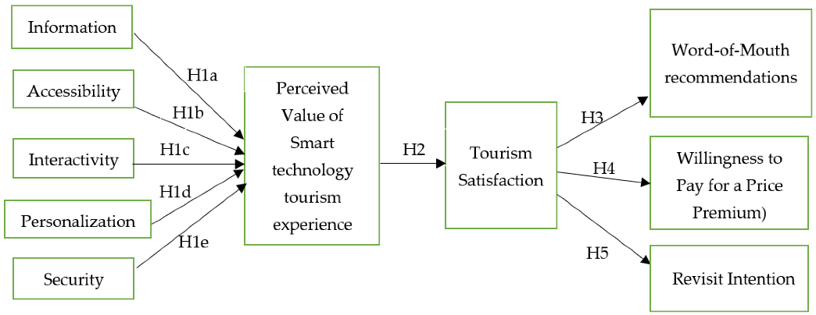
Figure 7: Improving Visitor Traffic and Experience
Source: (Zhang et al., 2022)
The visitor management is also enhanced by means of smart technologies, that directly affects the sustainability of urban tourism. Crowd monitoring with the assistance of AI and IoT will ensure the control of the number of people visiting attractions and decrease the risk of overcrowding and harmful social and ecological consequences of overtourism. Cities like Barcelona resort to real-time data to redirect visitors to less crowded locations to sustain both safety and satisfaction of the visitors (Day et al., 2021). Mobile apps and online platforms offer tourists customised schedules and eco-friendly travelling ideas, promoting the adoption of environmentally friendly practices and limiting the pressure on the city.
Economic and Social Advantages
Urban tourism has created economic and social value through smart technologies. Increased efficiency in operations will reduce the expenses incurred by municipalities and tourism operators, and the use of data in decision-making also contributes to investing in sustainable infrastructure. The community engagement sites enable the locals to be included in the planning of tourism activities, that will eliminate cases of social exclusion and reduce the conflicts between visitors and the local people. Cities can create local jobs in the high-tech tourism services, that boosts the economic sustainability and encourages fair economic development (Ionescu & Sârbu, 2024). Smart technologies ensure the creation of a comprehensive model in which the environmental, social, and economic aspects of the tourism sustainability of the urban environment are balanced.

5.2 Challenges in Implementing Smart Tourism Solutions
Financial and Resource Limitation
Another major issue with smart tourism solutions implementation is that they are expensive due to the need to adopt technology and infrastructure development. Cities with low-income or moderate levels of development, as well as many developing ones, have limited budgets, that limit investments in IoT sensors, AI platforms, and digital twins. Although there might be funds at the start, the constant expenses on maintenance, software upgrades and employee training can be an economic burden to municipal budgets. The lack of financial resources can lead to disjointed applications, with some organisations or attractions enjoying the benefits of intelligent systems (Pratama, 2024). The focus on cost-effective, scalable technologies is needed to ensure that the smart tourism projects can be sustainable and financially reasonable.
Data Control and Privacy Problems
The use of smart tourism depends greatly on data collection, processing, and analysis, and it presents the issue of data management and privacy to a great extent. IoT sensors and AI systems collect massive data regarding the movement of visitors, their behaviour and preferences. City-states can easily abuse sensitive data without strong data governance structures, and privacy will be invaded, or the rules may not be followed, including the GDPR (Jamalludin et al., 2025). Secure storage, responsible use, and ethical treatment of information make it important to ensure that the population has its trust and that smart tourism solutions are successful in the long term.
Technical and Operational Problems
There are also technical and operational challenges associated with the implementation of smart tourism solutions. The need to integrate several technologies into various urban infrastructure needs interoperability, standard protocols and consistency in connectivity. The effectiveness of the city may be constrained by the possibility that the city has outdated infrastructure that cannot serve highly advanced digital systems (Shen, 2024). Operational issues involve the coordination of different stakeholders, including the municipal authorities, tourism operators, and technology providers, so that there is coherent and efficient deployment.

5.3 Comparative Analysis of Global Smart Tourism Practices
Visitor Flow Management Smart Technologies
A high number of urban tourism sites around the world capitalise on smart technologies to track and control the flow of visitors to sites. IoT sensors, mobile apps and AI-based analytics can be used to monitor the real-time crowd density, get predictions on when the crowds will be at their highest and offer data-driven advice on how to redistribute the tourists on the attractions. This eliminates congestion, lessens environmental degradation and improves the general visitor experience (Ward et al., 2025). It has been observed that, compared to destinations that have not yet adopted integrated digital solutions, the reduced bottlenecks and more even distribution of tourists indicate the efficacy of the management of visitor flow in the field of sustainable tourism.
Data-Driven Resource Optimization
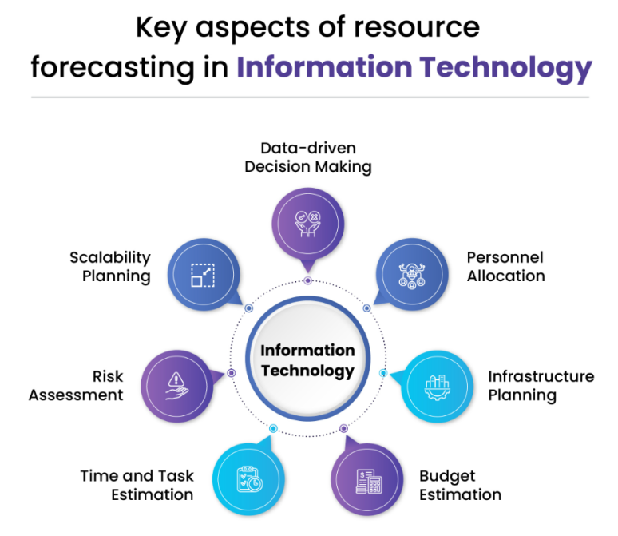
Figure 8: Data-Driven Resource Optimisation
Source: (Dallas, 2024)
It is becoming common in urban tourism destinations to make use of data analytics to optimise critical resources of the destination, including energy, water, and waste management systems. Smart grids, predictive waste management, and systems of energy monitoring enable the city to move resources most effectively, minimise the costs of operation, and diminish the impact on the environment. The destinations that realise these technologies have a better sustainability score and enhanced operations realisation than those that operate under the traditional resource management methodologies (Shen, 2024). This indicates the definite benefits of incorporating digital solutions into the urban sustainability strategies.
Improving social and economic sustainability
Social and economic sustainability also push practices of smart tourism because they promote community engagement, fair delivery of services, and the local economy. The use of technology-based platforms makes residents in the area feel that they are included in planning and participate through feedback, and have easier access to services, ensuring social inclusivity. Digitally, this allows for the elimination of inefficiencies in operation and the pinning down of opportunities for local businesses, building on data-driven analytics and innovative propositions of service (Pratama, 2024). The analysis of the comparative analysis suggests that such development and tourism strategies assist destinations in solving social and economic issues, resulting in improved long-term sustainability, whilst at the same time balancing the outcomes and requirements of the tourist and local communities.

6. Conclusion
A smart tourism space analysis explains how technology is transformational with regard to building sustainable urban destinations. With the implementation of smart city technology, including the Internet of Things (IoT), artificial intelligence (AI), and digital twins, cities will become more efficient in terms of the movement of visitors, excessive use of resources, and minimising environmental impact.
The sustainability of tourism can be promoted through smart technology, improving the community and economic stream of benefits. Engagement community platforms, participatory governance models can be used to increase the inclusivity level so that communities can play a significant part in tourism planning and decision-making. On the economic level, evidence-based plans will reduce operating expenses and encourage local entrepreneurship and launch investment in novel tourism solutions. Ecological, social, and economic factors are interconnected and interrelated in the Triple Bottom Line version of sustainability.
Although the use of smart tourism solutions has significant advantages, cost, technology restrictions, data privacy and the expense of highly skilled personnel are some of the challenges associated with its use. This is especially significant to the developing cities that should concentrate on the inexpensive and scalable technologies, develop successful partnerships between the governments and businesses, and use the support programmes that have bases in other countries to achieve success. Through the global best practices and application strategies in the local area, the emerging urban destinations would be able to embrace the new smart tourist solutions, which are both viable and sustainable.

References
Armond, A. C. V., Gordijn, B., Lewis, J., Hosseini, M., Bodnár, J. K., Holm, S., & Kakuk, P. (2021). A scoping review of the literature featuring research ethics and research integrity cases. BMC Medical Ethics, 22(1). https://link.springer.com/article/10.1186/s12910-021-00620-8
Baidal, J. A., Vera-Rebollo, J. F., Perles-Ribes, J., Femenia-Serra, F., & Celdrán-Bernabeu, M. A. (2021). Sustainable tourism indicators: what’s new within the smart city/destination approach? Journal of Sustainable Tourism, 31(7), 1–24. https://www.tandfonline.com/doi/abs/10.1080/09669582.2021.1876075
Dallas. (2024). Cogent | Blog | From Data to Decisions: How IT Projects Leverage Forecasting for Resource Allocation. Cogentinfo.com. https://www.cogentinfo.com/resources/from-data-to-decisions-how-it-projects-leverage-forecasting-for-resource-allocation
Day, J., Morrison, A. M., & Coca-Stefaniak, J. A. (2021). Sustainable tourism in urban destinations. International Journal of Tourism Cities, 7(4), 881–886. https://gala.gre.ac.uk/id/eprint/34530/
Fang, B., Yu, J., Chen, Z., Osman, A. I., Farghali, M., Ihara, I., Hamza, E. H., Rooney, D. W., & Yap, P.-S. (2023). Artificial intelligence for waste management in smart cities: a review. Environmental Chemistry Letters, 21(21). https://doi.org/10.1007/s10311-023-01604-3
Gracias, J. S., Parnell, G. S., Specking, E., Pohl, E. A., & Buchanan, R. (2023). Smart Cities—A Structured Literature Review. Smart Cities, 6(4), 1719–1743. mdpi. https://www.mdpi.com/2624-6511/6/4/80
Guernieri. (2023). An Economical, Sustainable and Technological Analysis of Impact of the Smart Cities - the Case Study of Barcelona and Singapore. Proquest.com. https://search.proquest.com/openview/1fc1ec30c06823bd9c202526d2c20826/1?pq-origsite=gscholar&cbl=2026366&diss=y
Gulyamov, S. (2024). Intelligent waste management using IoT, blockchain technology and data analytics. E3S Web of Conferences, 501, 01010. https://www.e3s-conferences.org/articles/e3sconf/abs/2024/31/e3sconf_iccsei2023_01010/e3sconf_iccsei2023_01010.html
Ionescu, A.-M., & Sârbu, F. A. (2024). Exploring the Impact of Smart Technologies on the Tourism Industry. Sustainability, 16(8), 3318. https://www.mdpi.com/2071-1050/16/8/3318
Ivars-Baidal, J., Casado-Díaz, A. B., Navarro-Ruiz, S., & Fuster-Uguet, M. (2023). Smart tourism city governance: exploring the impact on stakeholder networks. International Journal of Contemporary Hospitality Management. https://www.emerald.com/insight/content/doi/10.1108/ijchm-03-2022-0322/full/html
Jamalludin, Aziz, Ramli, Aziz, & Nasution. (2025). Tourism and Smart Cities: Business Strategies for Sustainable Urban Development. An International Journal, 17(1). https://www.gbmrjournal.com/pdf/v17n1/V17N1-10.pdf
Mariani, M., & Baggio, R. (2021). Big data and analytics in hospitality and tourism: A systematic literature review. International Journal of Contemporary Hospitality Management, 34(1). https://www.emerald.com/insight/content/doi/10.1108/ijchm-03-2021-0301/full/html
Market.us. (2024, October 15). AI in Tourism Market. Market.us. https://market.us/report/ai-in-tourism-market/
Mazhar, S. A., Anjum, R., Anwar, A. I., & Khan, A. A. (2021). Methods of Data Collection: a Fundamental Tool of Research. Journal of Integrated Community Health, 10(1), 6–10. researchgate. https://www.researchgate.net/profile/Syeda-Ayeman-Mazhar/publication/356269289_Methods_of_Data_Collection_A_Fundamental_Tool_of_Research/links/61fe7e23870587329e943cd1/Methods-of-Data-Collection-A-Fundamental-Tool-of-Research.pdf
Medina, P., Tur, A., & Casado, N. (2020). Tourism Business, Place Identity, Sustainable Development, and Urban Resilience: A Focus on the Sociocultural Dimension. International Regional Science Review, 44(1), 170–199. https://journals.sagepub.com/doi/abs/10.1177/0160017620925130
Miller, K. (2020). The Triple Bottom Line: What It Is & Why It’s Important. Harvard Business School. https://online.hbs.edu/blog/post/what-is-the-triple-bottom-line
Nogueira, E., Gomes, S., & Lopes, J. M. (2023). Triple Bottom Line, Sustainability, and Economic Development: What Binds Them Together? a Bibliometric Approach. Sustainability, 15(8), 6706. MDPI. https://www.mdpi.com/2071-1050/15/8/6706
Novera, C. N., Ahmed, Z., Kushol, R., Wanke, P., & Azad, Md. A. K. (2022). Internet of Things (IoT) in smart tourism: a literature review. Spanish Journal of Marketing - ESIC, 26(3). https://www.emerald.com/insight/content/doi/10.1108/sjme-03-2022-0035/full/html
Obersteiner, G., Gollnow, S., & Eriksson, M. (2021). Carbon footprint reduction potential of waste management strategies in tourism. Environmental Development, 39(39), 100617. https://www.sciencedirect.com/science/article/pii/S2211464521000075
Olena, U., None Pokolodna Mariia M, Pohasii Serhii, Vlashchenko Nataliia, & Andrenko Iryna. (2025). Digital and Ecological Solutions in Tourism Infrastructure Development: New Opportunities for Investors. IOP Conference Series Earth and Environmental Science, 1499(1), 012076–012076. https://iopscience.iop.org/article/10.1088/1755-1315/1499/1/012076/meta
Pachaury. (2024). Sustainable Tourism Infrastructure Development. Indian Scientific Journal of Research in Engineering and Management, 08(05), 1–5. https://www.academia.edu/download/117186109/Sustainable-Tourism-Infrastructure-Developmen.pdf
Pangarkar, T. (2024, May 15). Smart City Statistics 2024 By Urban Living, Technology, Lifestyle. Market Scoop. https://scoop.market.us/smart-city-statistics/
Pratama. (2024). Smart Tourism: Implementation and Challenges of IoT Technology in Popular Tourist Destinations. Journal of Management, 3(2), 418–432. https://myjournal.or.id/index.php/JOM/article/view/214
Razmjoo, A., Østergaard, P. A., Denaï, M., Nezhad, M. M., & Mirjalili, S. (2021). Effective policies to overcome barriers in the development of smart cities. Energy Research & Social Science, 79, 102175. https://www.sciencedirect.com/science/article/pii/S2214629621002681
Saker, A., & Sayed, M. (2025). The Impact of Tourism Development on Urban Spaces: A Comprehensive Approach to Sustainable Urban Development. International Journal of Engineering and Applied Sciences-October 6 University, 2(1), 126–135. https://journals.ekb.eg/article_406793.html
Shen, Y. (Sandy). (2024, January 9). Technological innovations and sustainable urban tourism. Www.elgaronline.com; Edward Elgar Publishing. https://www.elgaronline.com/edcollchap/book/9781803926742/book-part-9781803926742-21.xml
Suanpang, P., & Pothipassa, P. (2024). Integrating Generative AI and IoT for Sustainable Smart Tourism Destinations. Sustainability, 16(17), 7435–7435. https://www.mdpi.com/2071-1050/16/17/7435
Szpilko, D., de la Torre Gallegos, A., Jiménez Naharro, F., Rzepka, A., & Remiszewska, A. (2023). Waste Management in the Smart City: Current Practices and Future Directions. Resources, 12(10), 115–115. https://www.mdpi.com/2079-9276/12/10/115
Vujko, A., Knežević, M., & Arsić, M. (2025). The Future Is in Sustainable Urban Tourism: Technological Innovations, Emerging Mobility Systems and Their Role in Shaping Smart Cities. Urban Science, 9(5), 169–169. https://www.mdpi.com/2413-8851/9/5/169
Ward, K., Abbruzzese, T., Bunnell, T., Cardullo, P., Chang, I-Chun. C., Miller, B., Ribera-Fumaz, R., Shin, H., Spicer, Z., & Woods, O. (2025). A comparison of comparisons: Evidence from an international comparative study of “smart cities.” Environment and Planning C: Politics and Space. https://journals.sagepub.com/doi/abs/10.1177/23996544251320261
Zhang, Y., Sotiriadis, M., & Shen, S. (2022). Investigating the Impact of Smart Tourism Technologies on Tourists’ Experiences. Sustainability, 14(5), 3048. https://www.mdpi.com/2071-1050/14/5/3048

