Title: Gamified Talent Development for Gen Z in Tourism
Student Name: Gursewak Singh
Student No: DE240017

Table of Contents
1. Introduction 3
2. Understanding Gen Z and Gamification 4
3. Designing the Gamified Talent Development Framework 5
4. Mobile App UX and Communication Toolkit 6
5. AI Customization and Inclusivity Integration 7
6. Key Challenges and Mitigation Strategies 8
7. Conclusion 9
8. References 10

1. Introduction
Taking digital technology into account in educating talent across tourism sectors also helps to face the challenges linked to old teaching methods, especially for Generation Z, because their engagement in the job market is based on very different personal experiences and practices. This group, born from the mid-1990s onward, is technologically skilled and placed in a digital-native context so that using interactive systems and joining in on participatory design influences their professional involvement and ability learning (Williams et al., 2023). Because traditional development routes don’t fit with how Gen Z learns, gamified options have become necessary to supply them with the drive, skills and opportunities for competition using modular digital applications.
This work looks at constructing and describing a gamified talent development arrangement, designed for global tourism jobs, where stage-based lessons, virtual benefits for achievement and AI-aided customization play key roles. When you combine that model with inclusive features and an internally managed chat toolkit, the advantage is able to be inspired through various learning routes. Consequently, the report outlines a detailed design system supported by theories, mechanical models, infrastructure and policies for easy scaling and the benefit of all stakeholders.

2. Understanding Gen Z and Gamification
The formative manifestation of Generation Z, even interpreted from the standpoint of the decisive demographic mutations of global tourism workforce formations, has constrained a dimension of paradigm change of teaching and training logics in a sector where standard pedagogical mechanisms are now unable adapt to emergent references related to digital nativity. Born as this cohort in the arc post-mid 1990s, they show a heavy accommodation of algorithmic interactivity, feedback timing immediacy (Say 2014), and specifically adopt motivating stance of real-time experiential validation rather than delayed hierarchical appraisal systems (Seemiller & Grace, 2019). As a result, the inflexibility and linearization of traditional training modules have systemic frailties that compound the disaffection, performance plateau, and attrition rate of the Gen Z workforce in tourism firms (Kaifi et al., 2022).
To remedy the weaknesses evident in the traditional training paradigm, gamification emerges as an intervention approach with the potential to promote the advantage component, where participatory mechanics, iterative reward mechanisms, and milestone-based performance paths can be found in non-linear design structure. Badges, tokens, stage-based progress, and leaderboards can further be seen as designs that refashion work-related involvement to a continuous model guided by adaptive interactivity. In the wake of such realignment governed by the gamification design, task compliance is no longer the only outcome to increase, but also the shift of passive learners to active knowledge constructors with goal-directed autonomy.
Moreover, the scalability of such interventions, facilitated through mobile platform deployments, can also be considered as a framework response to the geographically dispersed and digitally oriented workforce prevalent in tourism service clusters. The comparative asymmetry in engagement outcomes—when gamified models are juxtaposed with traditional delivery approaches—provides empirical justification for a foundational realignment of developmental strategies to be undertaken. The following table, therefore, illustrates the differential frameworks of engagement and outcome regulation as observed in traditional versus gamified training systems.
Feature Category | Traditional Training | Gamified Training
Learning Structure | Linear, time-bound modules | Non-linear, stage-based progression
Feedback Mechanism | Periodic evaluations | Instantaneous, real-time feedback loops
Engagement Tools | Textbooks, lectures | Avatars, badges, points, challenges
Performance Visibility | Private assessments | Public leaderboards and collaborative ratings
Accessibility Format | In-person or static e-learning | Mobile-first, interactive platforms
Motivational Drivers | Compliance and obligation | Rewards, competition, peer recognition

3. Designing the Gamified Talent Development Framework
The necessity to formulate a gamified framework for talent development, particularly one that can be regulated within the vocational schema of Gen Z participation across tourism industry contexts, can be considered as a consequence of the systemic limitations inherent in non-interactive training modalities, which have failed to accommodate the behavioural and technological preferences demonstrated by this digitally native workforce. As such, the proposed framework is articulated through a sequential progression model that integrates digital modularity, performance recognition, and motivational scaffolding across five calibrated stages. Each of these stages, although structurally independent, is designed to sustain experiential continuity and engagement durability through gamified mechanics aligned with learning incentives and behavioural rewards (Domínguez et al., 2013).
The first stage, which can be identified as Onboarding, introduces the user to organisational identity, platform navigation, and introductory modules via interactive avatars, gamified quizzes, and micro-narratives. Upon completion, the _ "Welcome Badge" _ is awarded to push the advantage of early involvement for being acknowledged. The next phase named Skill Acquisition, offers material in the form of multimedia simulations, a series of presses, and culturally relevant communication modules, where the accrued XP is a quantitative measure of engagement effectiveness.
This is followed by comparing project simulation, the third phase, which can be used to justify the extent of application-based reinforcement in simulated tourism crises (and logistical decision maker modules). An increased mastery affirmation is made possible via the award of digital trophies that is given for a successful end of such simulation. The fourth stage, labelled Peer Evaluation, involves team quests and distribution of feedback and performance grades are crowd-sourced. High achievers in leaderboards are rewarded with increased repu- tational status and this dynamic creates competition and social comparison.
The final stage, Mastery, reinforces the learning from advanced modules including meta-cognitive challenges and leadership simulations. Upon completion of this level, digital certification is awarded that is structurally consistent with standard HRIS interfaces and can be easily integrated into promotion tracks and developmental records. The gamified approach, controlled within such a framework, therefore enables system-wide optimisation of training utilities, while keeping them easy to access and inclusive on mobile-centric digital platforms.
To this end, each phase of the developmental construct is underpinned by reinforcement systems that go beyond conventional training barriers, relocating the talent development ontology as a dynamically-evolving, digitally mediated progression environment.

4. Mobile App UX and Communication Toolkit
Mobile-first UX models can support gamified tourism training infrastructures when thinking of how digital technology supports people with various needs and perspectives. This concern becomes especially clear when observing Generation Z learners, given that they like using interactive interfaces, real-time visual lines of feedback and learning tracks designed just for them, all of which show the insufficiency of just linear digital platforms (Koivisto & Hamari, 2019). Therefore, the interface for mobile users is centred around easily accessing how much they have learned, their achievements and module navigation suggestions based on AI, so learners benefit from deep mental involvement.
The Level Tracker in the digital schema shows learner progress by drawing a bar colored and sized to match their level in the talent development system. Besides displaying how much progress is made, this function gives encouraging prompts (such as “You’re ready for the following assignment!”) to help students continue their lessons at the correct cadence for their learning speed. Besides, the Reward Badge Screen holds static records of success points like “Innovator,” “Mentor,” and “Expert,” which are also keys for opening gamified perks such as new skills areas and discussion groups.
The toolkit offers digital interactions using push notifications, regular updates in micro-forums and conversations handled by avatars. As these feature intentions are activated by hitting certain milestones or receiving endorsements from others, their design is in sync with behavioural nudge theory to ensure people are not flooded with too many updates. The system includes ways for participants to endorse calls, form temporary learning groups and share daily questions with each other during the training course:
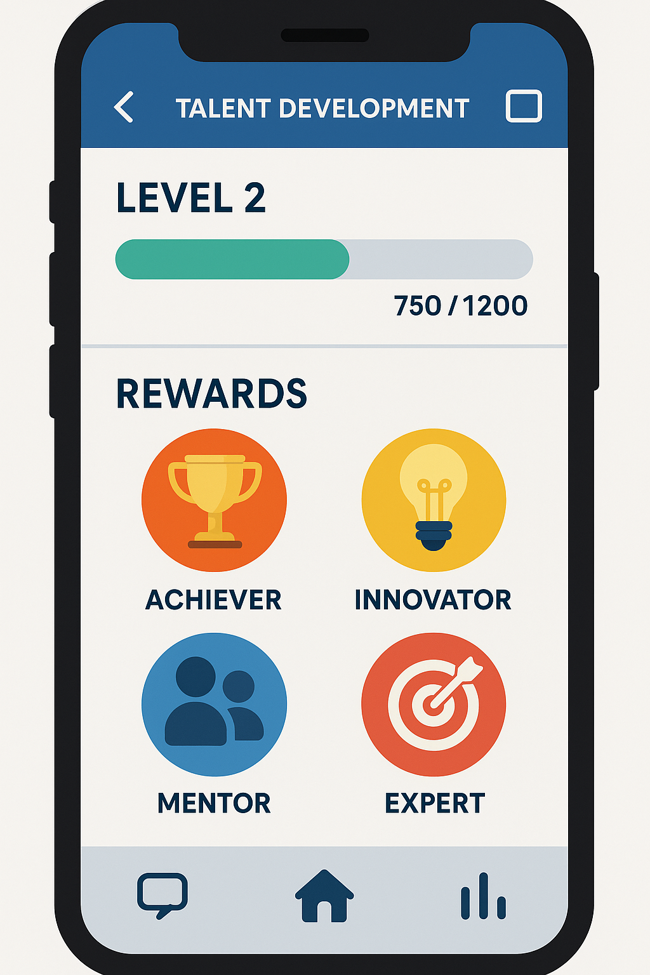
Sample mobile screen (see above)
As a result, the training is delivered while also rebuilding development by keeping navigation, learning and review all happening through a single digital path.

5. AI Customization and Inclusivity Integration
It can also be viewed as a regulatory feature, serving two key functions: optimising how the mobile system engages players and enforcing all users have equal access. With this system’s structure, AI is used to analyze user data and how they engage, the performance of various modules and changes in user skills to automatically adjust the learning content to fit the users at every stage. By doing so, the system can keep the task appropriate for each person which scientists say reduces motivation fatigue and maintains the pace of learning new things by showing more tasks or reminding students (Bravata et al., 2021).
The focus on inclusivity means that the AI system’s main function provides support for linguistic, cognitive and visual representation using multilingual NLP engines, screen-reading systems and modules for speech synthesis. Additionally, the platform adds interface mechanisms like neutral avatars, impartial badge expressions and unbiased communication styles which help promote and improve the psychosocial safety of its users. Moreover, asynchronous module functionality accommodates neurodivergent users, allowing progression variance without performance penalisation, thus enabling systemic parity across differentiated user groups (García-Holgado et al., 2020).
In parallel, demographic analytics regulated through the AI engine allows for the identification of emerging disparities in access, performance, or engagement across stratified user segments. These diagnostics are further directed into instructional design iterations, ensuring that systemic exclusion points are resolved in real time. Hence, the AI does not merely supplement training operations but acts as the epistemic core of the inclusive logic underpinning the gamified developmental ecosystem, supporting both excellence of outcome and equity of access in the context of Generation Z’s organisational integration.

6. Key Challenges and Mitigation Strategies
While the framework of gamified developmental infrastructures in tourism-based employment paradigms can be structured for strategic advantage, there remains a sequence of operational contingencies which can be identified as systemic limitations requiring mitigation to be encouraged under policy-aligned realignment. One of the most consistently encountered challenges is the emergence of digital fatigue, wherein prolonged interface interaction can be seen to precipitate reduced cognitive receptivity, diminished task compliance, and interface disengagement. As highlighted by Nouri (2021), this limitation can also be considered as regulatory for intervention, where micro-learning segmentation and asynchronous, offline-compatible modules provide scope for improvement to be allowed in mitigating saturation metrics across user segments.
In addition to fatigue, technological disparity across varying infrastructural contexts—especially in bandwidth-limited or hardware-constrained regions—functions as a prominent access barrier. This can be addressed through a dual-version deployment strategy, whereby low-data “lite” variants are concurrently introduced to ensure continuity of inclusion. Moreover, resistance to gamification among senior managerial cohorts, often regulated by legacy operational preferences, has also emerged as a structural inhibitor. As Werbach and Hunter (2012) explained, onboarding activities that prove meaningful and are rewarded according to performance incentives can help advantageous results flow from top managers to lower-level employees.
To deal with these kinds of problems, companies should use trusted consent screens, follow GDPR rules and design privacy features that rely on users’ choices. As a result, these obstacles, though found in the systems, can be changed when digital policies are developed systematically and with interface equity in mind.

7. Conclusion
Linking gamified approaches with programs to develop talent in travel-related jobs that focus on Generation Z workers, under strict digital innovation directives, is a valuable way to help them succeed. Mobile platforms that provide interface-led learning, leaderboards and varied rewards encourage different generations to build and keep their skills up (Deterding et al., 2011). The transformation includes changing both what happens and how it happens, with compliance-based study options changing into interactive ones suited to what digital natives find important.
Moreover, the embedding of AI-enabled personalisation features and inclusivity support protocols further promotes the scope of accessibility to be maintained in a structurally equitable format, allowing for adaptive progression to be facilitated irrespective of linguistic, cognitive, or infrastructural disparities. The internal communication toolkit and gamified UX construct also provide reinforcement loops for self-managed learning while encouraging cohort-based knowledge symbiosis. While systemic constraints such as digital fatigue and surveillance anxieties persist, they can be mitigated through regulatory recalibration and user-centric design logic. Hence, the gamified architecture can also be considered as a sustainable blueprint for repositioning organisational learning in alignment with future workforce trajectories and digital engagement norms.

8. References

- Bravata, D. M., Wattacheril, J., Ganguli, I., Wilkey, C., & Green, J. (2021). Digital health and equity: Is personalized technology the future of inclusive talent development? Journal of Medical Internet Research, 23(12), e30335. https://doi.org/10.2196/30335
- Deterding, S., Dixon, D., Khaled, R., & Nacke, L. (2011). From game design elements to gamefulness: Defining “gamification.” Proceedings of the 15th International Academic MindTrek Conference: Envisioning Future Media Environments, 9–15. https://doi.org/10.1145/2181037.2181040
- Domínguez, A., Saenz-de-Navarrete, J., de-Marcos, L., Fernández-Sanz, L., Pagés, C., & Martínez-Herráiz, J. J. (2013). Gamifying learning experiences: Practical implications and outcomes. Computers & Education, 63, 380–392. https://doi.org/10.1016/j.compedu.2012.12.020
- García-Holgado, A., Sánchez-Gómez, M. C., & García-Peñalvo, F. J. (2020). Addressing inclusivity in gamified learning: A framework for gender-neutral and accessible digital training platforms. Education and Information Technologies, 25, 1993–2013. https://doi.org/10.1007/s10639-019-10061-w
- Kaifi, B. A., Nafei, W. A., Khanfar, N. M., & Kaifi, M. M. (2022). Understanding Generation Z: Future workforce and strategic engagement approaches. International Journal of Business and Management, 17(3), 112–127. https://doi.org/10.5539/ijbm.v17n3p112
- Koivisto, J., & Hamari, J. (2019). The rise of motivational information systems: A review of gamification research. International Journal of Information Management, 45, 191–210. https://doi.org/10.1016/j.ijinfomgt.2018.10.013
- Nouri, J. (2021). The flipped classroom: For active, effective and increased learning – especially for Generation Z. International Journal of Educational Technology in Higher Education, 18(1), 1–15. https://doi.org/10.1186/s41239-021-00249-6
- Seemiller, C., & Grace, M. (2019). Generation Z: Educating and engaging the next generation of students. About Campus, 24(3), 21–26. https://doi.org/10.1177/1086482219855040
- Werbach, K., & Hunter, D. (2012). For the win: How game thinking can revolutionize your business. Wharton Digital Press.

