Strategic Marketing Management and Competitive Advantage
M03 Marketing Management Monthly Assignment
Option 1: Strategic Marketing Management and Competitive Advantage

Table of Contents
1. Abstract
2. Introduction
3. Literature Review
4. Methodology
5. Findings
6. Discussion
7. Conclusion
8. References
9. Appendices

Abstract
This report examines how strategic marketing management contributes to organizational success and competitive advantage in modern markets. It argues that marketing management is not simply the communication function of a firm, but a strategic capability that links market sensing, customer insight, segmentation, positioning, branding, value proposition design, channel coordination and relationship management to measurable business objectives. The report uses a qualitative secondary research methodology based on academic marketing theory, industry evidence and selected real world examples. The discussion draws on resource based theory, market orientation, customer based brand equity, service dominant logic, customer experience theory and contemporary evidence on marketing budgets and digital transformation. The findings show that strong marketing strategy improves business performance when 3 conditions are present. First, the organization uses research and analytics to define attractive segments and changing customer needs. Second, the brand offers a credible and differentiated value proposition that is visible in product design, pricing, service experience and communication. Third, the organization connects acquisition activity with retention, loyalty and profitability rather than treating growth as only a volume target. Examples from Apple, Nike, Starbucks and Netflix show that marketing strategy can strengthen market position, but also create risk when positioning, channel design and consumer expectations become misaligned. The conclusion recommends that organizations treat strategic marketing as a cross functional governance system that protects long term customer value, profitability and brand trust.

Introduction
Marketing management has become central to organizational success because customers now evaluate firms through a continuous stream of product experiences, digital interactions, peer reviews, service encounters and ethical signals. In this environment, marketing is no longer limited to advertising or sales support. It is a managerial process that identifies customer value, selects profitable opportunities, designs an attractive market position and coordinates the organization around promises that can be delivered consistently. Kotler, Keller and Chernev (2022) describe marketing management as the art and science of choosing target markets and building profitable customer relationships. This definition is important because it connects marketing directly to strategy, profit and value creation rather than to promotion alone.
The assignment brief requires critical examination of marketing management principles, strategies and practices, including market research, consumer behavior, segmentation, targeting, positioning, branding, pricing, distribution, promotion, customer relationship management, digital marketing and ethical decision making. This report addresses Option 1, which focuses on strategic marketing management and competitive advantage. The central argument is that marketing management contributes to organizational success when it converts customer and competitor understanding into focused strategic choices. The outcome is not only higher awareness, but stronger preference, willingness to pay, repeat purchase, customer advocacy and defensible differentiation.
Strategic marketing is especially important in mature and highly transparent markets. Many firms can copy product features, media channels and promotional messages quickly. Competitive advantage therefore depends less on isolated tactics and more on integrated marketing systems that are difficult to imitate. These systems include superior customer insight, brand meaning, data capability, channel control, community engagement and experience design. A firm with these capabilities can align customer needs with business objectives more effectively than rivals. This report critically evaluates those capabilities by combining theory with evidence from recent market practice.
The report is organized into 7 substantive sections. The literature review explains key theories that support strategic marketing management, including STP, brand equity, market orientation, resource based advantage and customer relationship management. The methodology explains how secondary evidence and case examples were selected. The findings then assess the role of marketing management, STP, branding, value proposition development, acquisition, retention, profitability and competitive advantage. The discussion evaluates tensions and limitations, including over segmentation, brand dilution, short term discounting, data dependency and ethical pressures. The conclusion summarizes the strategic contribution of marketing management and proposes practical recommendations for organizations that want to strengthen market position in a sustainable way.

Literature Review
Strategic marketing management begins with market orientation. Market orientation means that an organization systematically collects intelligence about customers and competitors, shares that intelligence across departments and responds through coordinated action. Narver and Slater (1990) argue that market orientation supports superior performance because it keeps the firm focused on customer value and competitor movement. Kohli and Jaworski (1990) similarly emphasize intelligence generation, intelligence dissemination and responsiveness. These ideas remain highly relevant because modern firms operate in markets where consumer preferences, media consumption and technology adoption change quickly. Without a disciplined market orientation, firms can confuse internal assumptions with actual customer value.
Segmentation, targeting and positioning are the core strategic choices that translate market orientation into action. Segmentation divides a heterogeneous market into meaningful groups with different needs, behaviors, resources and motivations. Targeting evaluates those groups and selects the segments that match the firm’s capabilities and profit objectives. Positioning defines the distinctive place the firm wants to occupy in the target customer’s mind. Wedel and Kamakura (2000) argue that segmentation supports resource allocation because it prevents firms from serving all customers in the same way. However, segmentation is only valuable when it leads to actionable decisions. A demographic segment that does not change product design, media choices, price architecture or service experience is only descriptive, not strategic.
Positioning is central to competitive advantage because it clarifies the reason a customer should choose one brand over another. Keller (1993) explains that customer based brand equity is created when consumers have strong, favorable and unique associations with a brand. This means that brand management is not only about logo recognition. It is about memory structures, trust, perceived quality, emotional relevance and differentiation. A strong brand lowers perceived risk, increases willingness to pay and gives firms greater resilience during market shocks. A weak or confused brand forces the organization to compete mainly on price or availability, which can reduce margin quality.
The resource based view strengthens this argument by explaining why some marketing capabilities are difficult to copy. Barney (1991) argues that resources generate sustained competitive advantage when they are valuable, rare, imperfectly imitable and supported by the organization. Strategic marketing resources can meet these conditions when they are embedded in brand heritage, data systems, customer communities, retail formats, product ecosystems and cross functional routines. For example, a competitor can imitate a discount, but it is harder to imitate Apple’s ecosystem based brand preference or Starbucks’ combination of product ritual, store environment, mobile ordering and loyalty membership. The advantage comes from the system, not a single campaign.
Porter (1985) provides another useful lens by linking competitive advantage to cost leadership, differentiation and focus. Marketing management contributes to all 3 routes, although it is often most visible in differentiation and focus. Differentiation requires the firm to understand which benefits customers value and whether those benefits justify a premium. Focus requires the firm to avoid spreading resources across segments that do not fit its capabilities. Cost leadership also needs marketing insight because a low cost model fails if it removes attributes that target customers consider essential. Therefore, marketing strategy supports competitive advantage by matching customer value with the firm’s economic logic.
Value proposition development connects STP with the marketing mix. Payne, Frow and Eggert (2017) define customer value propositions as strategic tools that articulate the benefits a firm offers and the proof that the firm can deliver those benefits. A value proposition is stronger when it expresses 3 things clearly: the customer problem, the benefit offered and the reason to believe. Vargo and Lusch (2004) also shift attention from goods to service and value co creation. Their service dominant logic suggests that value is not fully created by the company before exchange. It is experienced and interpreted by customers during use. This is important because marketing strategy must design experiences, communities and support systems, not only product attributes.
Customer relationship management and retention theory extend marketing management beyond acquisition. Kumar and Reinartz (2016) argue that profitable customer relationships depend on understanding lifetime value, customer heterogeneity and the cost of serving different segments. Retention can improve profitability because repeat customers may be less expensive to serve, more likely to buy additional products and more willing to recommend the brand. However, retention is not automatically profitable. A firm must understand which relationships create economic value and which are retained only through costly incentives. Strategic marketing management therefore requires a balance between acquisition volume and relationship quality.
Digital transformation has increased the strategic importance of analytics, but it has also increased complexity. Verhoef et al. (2021) argue that digital transformation changes customer interactions, business models and organizational capabilities. Marketing teams now use search data, social listening, customer relationship systems, ecommerce behavior, marketing automation and personalization tools. These tools can improve targeting and measurement, but they can also encourage short term optimization at the expense of brand equity. Binet and Field (2013) argue that effective marketing needs a balance between long term brand building and short term sales activation. This distinction is important because a firm can show strong campaign metrics while weakening pricing power or distinctiveness.
Ethical marketing also belongs in strategic marketing management because trust is part of competitive advantage. Misleading claims, hidden commercial influence, misuse of consumer data and greenwashing may produce short term sales, but they weaken credibility. Marketing ethics is therefore not separate from strategy. It defines the boundaries within which customer value can be created responsibly. In markets where consumers can publicly challenge brands, ethical failure can spread quickly through reviews, social platforms and media coverage. Strategic marketing management must therefore include governance over claims, data, partners, influencers and sustainability communication.

Methodology
This report uses a qualitative secondary research methodology. The purpose is not to test a statistical hypothesis, but to critically synthesize established marketing theory and real world evidence in order to explain how strategic marketing management contributes to organizational success. Secondary research is appropriate because the assignment asks for an analytical report on marketing principles, strategies and practices rather than a primary consumer survey. The evidence base includes academic marketing literature, annual reports, industry surveys and publicly available business reporting.
The academic literature was selected to cover the main theoretical foundations of strategic marketing management. These include market orientation, segmentation, targeting and positioning, brand equity, resource based advantage, competitive strategy, customer value propositions, service dominant logic, customer relationship management and digital transformation. The selected theories are relevant because they explain how firms move from customer insight to market choice, then from market choice to value creation and competitive advantage. Using several theories also prevents the report from treating marketing as a single promotional function.
The real world examples were selected because they represent different strategic marketing challenges. Apple is used as an example of ecosystem based differentiation and services growth. Nike is used to show the risk of channel and positioning imbalance when direct digital expansion weakens wholesale relationships and brand momentum. Starbucks is used to illustrate loyalty, customer experience and emotional engagement. Netflix is used to demonstrate value proposition redesign through pricing architecture, content positioning and advertising supported membership options. These examples are not treated as complete case studies. They are used as analytical illustrations of strategic marketing principles.
The analysis also uses selected quantitative evidence to support the interpretation. Apple’s 2025 Form 10 K provides category sales data for 2023, 2024 and 2025. The CMO Survey provides evidence on marketing budget intensity and expected spending changes across economic sectors. The Nike 2025 results provide evidence of the performance implications of channel mix and digital sales decline. Reuters reporting on Starbucks’ 2026 loyalty program update is used as an example of customer relationship strategy. These sources were chosen because they are recent, credible and directly relevant to the marketing management issues discussed.
The methodology has limitations. Secondary research cannot prove causality between a specific marketing strategy and a financial outcome because many factors influence performance, including product quality, operations, macroeconomic conditions, leadership decisions and competitive reactions. The examples are also selective. They support conceptual analysis rather than universal generalization. However, the method is suitable for a strategic report because it allows theory and practice to be connected in a structured way. The critical test used throughout the report is whether a marketing activity supports a defensible value proposition, improves customer outcomes and contributes to long term business objectives.

Findings
The first finding is that strategic marketing management helps organizations achieve business objectives by translating broad corporate goals into customer focused choices. Corporate goals such as revenue growth, market share, margin protection, new product adoption and international expansion are too general to guide day to day marketing activity. Marketing management makes these goals operational by identifying which customers matter most, what they value, how they choose, what barriers prevent purchase and what experience is needed after purchase. In this sense, marketing is a linking function between the external market and the internal organization.
Figure 1 summarizes this logic. Market sensing provides evidence about demand, competitors and customer behavior. STP decisions then turn that evidence into strategic focus. Value proposition development converts focus into a coherent promise, and the marketing mix delivers that promise through product, price, place, promotion and service. Customer outcomes such as acquisition, retention and advocacy then support business outcomes such as profitability, growth and competitive advantage. The model also implies that marketing failure can occur at any stage. A firm may collect data but choose the wrong segment, define a segment but position weakly, communicate strongly but deliver poorly, or acquire customers without retaining them.
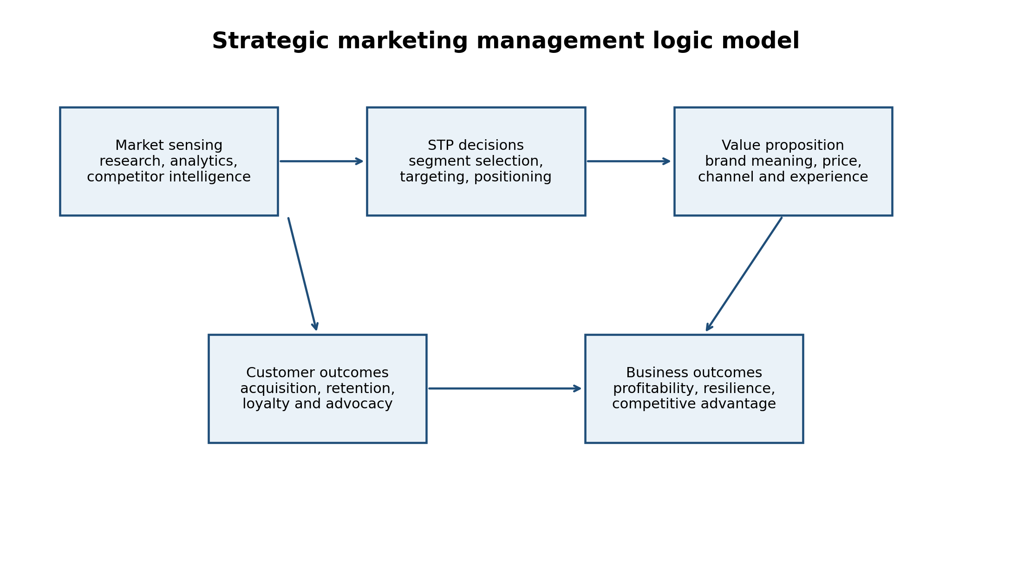
Figure 1. Strategic marketing management logic model.
Segmentation is especially important because customers differ in their willingness to pay, buying occasion, channel preference, risk perception and service expectations. A premium brand that targets every price sensitive customer will dilute its proposition, while a value brand that ignores service convenience may lose customers who are willing to pay a small premium for reliability. Effective segmentation therefore requires more than age, gender or income categories. It should combine behavioral, psychographic, needs based and value based evidence. For example, a streaming platform can segment customers by content preference, household structure, price sensitivity, advertising tolerance and churn risk. Each segment implies different packages, communication and retention triggers.
Targeting is the discipline that prevents marketing resources from being wasted. The CMO Survey shows that marketing expense intensity varies substantially across sectors, with B2C product companies reporting marketing expenses at 21.5 percent of overall budget and 15.5 percent of revenues, compared with lower levels in many B2B contexts. This does not mean that B2C product companies are automatically more strategic. It means that consumer facing markets often require heavier spending on visibility, retail activation, brand building and acquisition. The strategic issue is whether that spending is aligned with segment economics. High spending can be valuable when it builds preference and repeat purchase, but wasteful when it only buys short term attention.
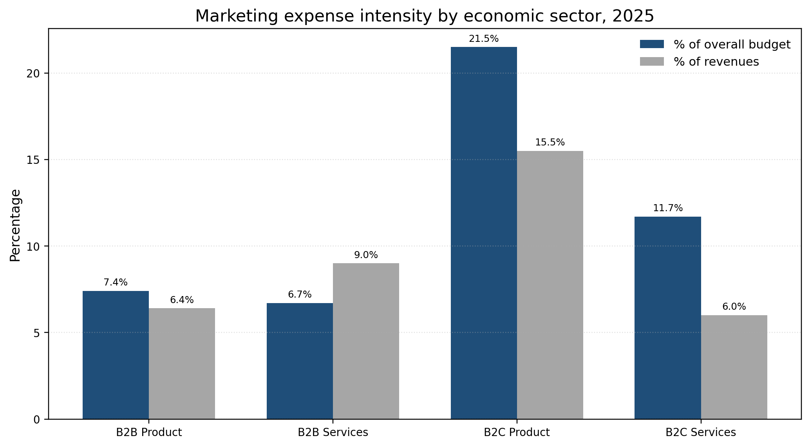
Figure 2. Marketing expense intensity by economic sector. Source data adapted from The CMO Survey 2025.
Positioning is the strategic bridge between targeting and branding. A brand position should define the frame of reference, the point of difference and the proof behind the claim. Apple illustrates this clearly. Apple’s market position is not based only on device specifications. It is based on a controlled ecosystem, perceived design quality, privacy cues, retail experience, services integration and social meaning. Apple’s 2025 Form 10 K shows that Services net sales increased from USD 85.2 billion in 2023 to USD 109.2 billion in 2025. This pattern supports the view that Apple’s marketing advantage is ecosystem based. Hardware creates the customer base, but services deepen the relationship and extend lifetime value.
The Apple example also shows how branding and value proposition development influence profitability. Services typically carry different margin characteristics from hardware, and a services ecosystem can reduce switching because customers store media, payments, subscriptions, applications and data inside the brand environment. This does not mean that marketing alone produced Apple’s financial performance. Product engineering, supply chain capability, developer relations and platform governance are also essential. However, strategic marketing management explains how the firm’s value proposition is perceived and why customers may accept premium pricing, repeated upgrades and service attachment.
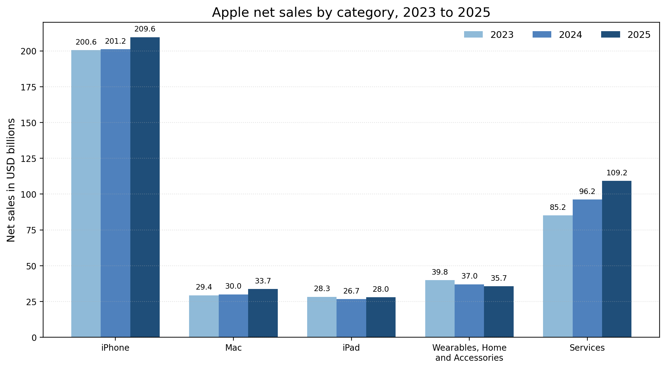
Figure 3. Apple net sales by category, 2023 to 2025. Source data adapted from Apple 2025 Form 10 K.
Nike provides a contrasting example. Nike built one of the world’s strongest sports brands through athlete endorsement, performance symbolism, emotional storytelling and cultural relevance. However, its fiscal 2025 results showed pressure in several areas. Nike reported revenue of USD 46.3 billion for fiscal 2025, down 10 percent on a reported basis, while Nike Direct revenue fell 13 percent due partly to a 20 percent decline in Nike Brand Digital. This evidence does not show that Nike’s brand has failed. It shows that marketing strategy can weaken when channel strategy, product freshness and brand demand creation are not aligned. A direct to consumer approach can improve data access and margin control, but over reliance on direct channels may reduce wholesale reach and marketplace energy if not managed carefully.
Branding also affects customer acquisition. Strong brands reduce the cost of acquiring customers because consumers already understand the promise and trust the brand. Weak brands must pay more for every click, lead or store visit because they lack memory availability and distinctiveness. Binet and Field’s distinction between brand building and activation is useful here. Acquisition campaigns can convert existing demand, but brand building increases the size and quality of future demand. Firms that focus only on performance metrics can over optimize for customers who were already likely to buy while under investing in the emotional and symbolic assets that create future growth.
Customer retention is the second major outcome of strategic marketing management. Starbucks shows how retention depends on experience, habit and emotional memory rather than discounts alone. Reuters reported that Starbucks planned to introduce a 3 tier loyalty structure in 2026 and that the company had 35.5 million active reward members. Its leadership emphasized engagement through experience rather than broad discounting. This illustrates a central strategic principle. Loyalty programs are not automatically strategic if they only train customers to wait for offers. They become strategic when they use data, service design and recognition to make the relationship easier, more personal and more valuable.
The relationship between retention and profitability is complex. Retention can increase customer lifetime value, but only when the retained customers generate adequate contribution after the cost of rewards, service and communication. Strategic marketing management therefore needs customer profitability analysis, not simply customer satisfaction scores. A business can have satisfied customers who are unprofitable because they buy only discounted products, return frequently or require costly support. It can also have highly profitable customers who are not emotionally loyal and may switch if competitors offer better convenience. The strongest marketing systems combine satisfaction, trust, habit and economic value.
Marketing strategies influence competitive advantage by shaping both differentiation and defensibility. Differentiation arises when customers perceive a meaningful difference. Defensibility arises when rivals cannot easily copy the source of that difference. Apple’s ecosystem, Nike’s cultural associations, Starbucks’ store ritual and Netflix’s data informed content and pricing architecture are all examples of complex marketing assets. Their value lies not only in messages but in systems of product, platform, community, data, distribution and experience. A slogan can be copied. A deeply embedded customer relationship system is much harder to copy.
Netflix demonstrates how strategic marketing management can reshape value propositions when market conditions change. Streaming markets became more crowded, content costs rose and password sharing reduced monetization. Netflix responded by changing pricing architecture, introducing advertising supported options and strengthening its content proposition. From a marketing strategy perspective, this is an example of value proposition redesign. The company did not only promote existing subscriptions more aggressively. It changed the offer to address different willingness to pay levels and different usage behaviors. This is strategically stronger than a simple price increase because it uses segmentation and product architecture to manage both growth and profitability.
The final finding is that strategic marketing requires organizational integration. Marketing promises are credible only when operations, product development, finance, sales, customer service and technology support them. A premium positioning fails if service quality is inconsistent. A low price positioning fails if supply chain costs make the model unsustainable. A sustainability positioning fails if procurement evidence does not support the claim. Therefore, marketing management must influence internal decision making, not only external communication. The most successful firms use marketing insight to guide innovation, channel investment, pricing decisions and service design.

Table 1. Strategic marketing contribution across selected organizations
Organization | Strategic marketing focus | Contribution to competitive advantage | Strategic caution
Apple | Ecosystem positioning, premium design and services attachment | Increases willingness to pay and strengthens switching barriers | Requires continuous innovation and trust in platform governance
Nike | Sports performance meaning, athlete storytelling and channel reach | Creates emotional differentiation and cultural relevance | Channel imbalance and product freshness can weaken demand
Starbucks | Experience based loyalty, mobile ordering and store ritual | Links habit, convenience and emotional memory | Discount led loyalty can reduce premium experience if overused
Netflix | Content positioning, pricing architecture and advertising supported options | Expands addressable segments and monetizes different willingness to pay levels | Advertising tolerance and content value must be managed carefully

Discussion
The findings indicate that strategic marketing management contributes to organizational success, but the relationship is not automatic. Marketing strategy creates value when it is selective, evidence based and aligned with organizational capability. It destroys value when it becomes a collection of disconnected campaigns, vanity metrics or generic brand statements. The most important implication is that managers should judge marketing by strategic coherence rather than activity volume. A firm can produce more content, run more advertisements and collect more data while still weakening its market position if these activities do not reinforce a differentiated value proposition.
One critical challenge is the tension between short term sales activation and long term brand equity. Performance marketing can be attractive because it produces visible metrics such as impressions, clicks, conversion rates and cost per acquisition. These metrics support accountability, but they can also narrow managerial attention. When firms rely too heavily on discounting, retargeting and direct response campaigns, they may train customers to buy only when price is reduced. This can damage brand quality perceptions and future margin. Strategic marketing therefore needs a portfolio approach in which acquisition, retention, brand building and customer experience receive appropriate investment.
A second challenge is over segmentation. Digital analytics allow firms to divide audiences into very small groups, but excessive segmentation can create operational complexity and inconsistent brand meaning. If each micro segment receives a different message, the brand may lose distinctive memory structures. Segmentation should therefore be guided by strategic importance, not only data availability. The question is not whether a data system can identify a segment, but whether the segment is large enough, reachable enough, profitable enough and different enough to require a distinct marketing response.
A third challenge concerns customer value and profitability. Customer centricity is often described positively, but not every customer expectation should be served. Some expectations are inconsistent with the firm’s economics, purpose or brand promise. For example, a premium brand should not chase every low price segment if that weakens exclusivity and service quality. A low cost brand should not add expensive personalization if its customers primarily value reliability and price. Strategic marketing management requires disciplined trade offs. The best marketers are not only creative communicators. They are decision makers who understand opportunity cost.
The examples also show that competitive advantage is fragile. Apple’s ecosystem advantage depends on continued trust, innovation and regulatory acceptance. Nike’s brand strength did not prevent revenue decline when product and channel issues weakened momentum. Starbucks’ loyalty base is valuable, but broad discounting could reduce perceived experience if the program becomes too transactional. Netflix’s pricing and advertising model may improve monetization, but it must manage consumer tolerance for advertising and content value. These examples demonstrate that marketing strategy must be continuously refreshed as customer expectations and competitive conditions change.
Ethical and social pressures also affect strategic marketing. Consumer data, personalization, influencer partnerships and sustainability claims can strengthen value propositions, but they can also create trust risks. A firm that positions itself as customer centered must be transparent about data use and honest about claims. Trust is increasingly part of brand equity. This means that strategic marketing management should include ethical review of targeting, persuasion, data collection and communications. The most defensible advantage is not aggressive persuasion, but trusted relevance.
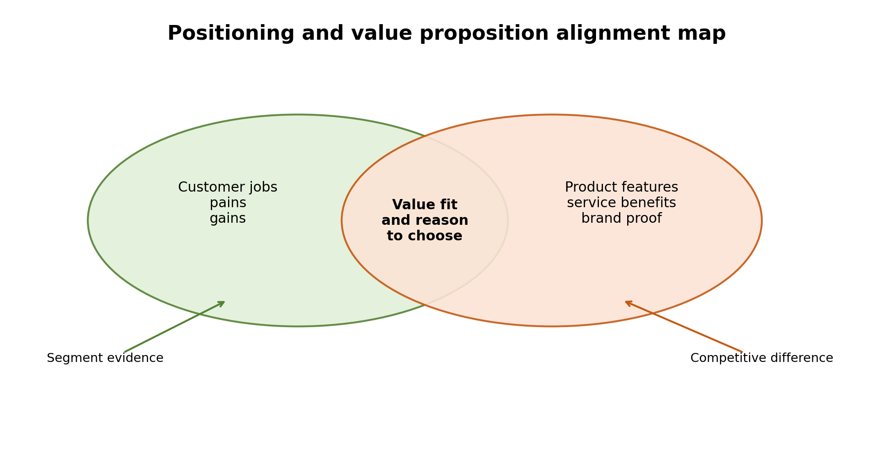
Figure 4. Value proposition and positioning alignment map.
Overall, strategic marketing management should be understood as a governance system for customer value. It aligns research, segmentation, targeting, positioning, brand equity, value proposition development, acquisition, retention and profitability. It also creates a feedback loop because customer behavior and market performance should inform future strategy. The strongest firms use marketing not only to sell what they already produce, but to decide what should be produced, how it should be priced, how it should be delivered and what relationship should be built with customers. This is why marketing management is a strategic contributor to organizational success rather than a tactical support activity.

Conclusion
Strategic marketing management contributes to organizational success by converting market understanding into focused choices about customers, value, brand meaning and relationships. The analysis shows that segmentation, targeting, positioning, branding and value proposition development are not isolated textbook tools. They are strategic mechanisms that shape acquisition, retention, profitability and competitive advantage. Apple, Nike, Starbucks and Netflix show that strong marketing can build market position, but also that advantage can weaken when channel design, product relevance or customer trust are mismanaged.
The central conclusion is that marketing management is most valuable when it is integrated with business strategy and operational delivery. A clear position must be supported by product quality, pricing logic, distribution access, customer experience and ethical communication. A strong brand can reduce perceived risk and increase preference, but it must be maintained through consistent value creation. Customer retention can improve profitability, but only when loyalty activity is linked to lifetime value rather than discounts alone.
Organizations should therefore treat strategic marketing as a long term capability. They should invest in market sensing, evidence based STP, distinctive brand assets, customer experience, retention analytics and governance over ethical claims. This approach allows marketing to contribute not only to sales growth, but also to trust, resilience and sustainable competitive advantage.

References
Apple Inc. (2025). Annual report on Form 10 K 2025. https://investor.apple.com/
Barney, J. (1991). Firm resources and sustained competitive advantage. Journal of Management, 17(1), 99 to 120.
Binet, L., & Field, P. (2013). The long and the short of it: Balancing short and long term marketing strategies. Institute of Practitioners in Advertising.
Deloitte, Duke University Fuqua School of Business, & American Marketing Association. (2025). The CMO Survey: Highlights and insights report 2025. https://cmosurvey.org/
Hunt, S. D., & Morgan, R. M. (1995). The comparative advantage theory of competition. Journal of Marketing, 59(2), 1 to 15.
Iyer, P., Davari, A., Zolfagharian, M., & Paswan, A. (2019). Market orientation, positioning strategy and brand performance. Industrial Marketing Management, 81, 16 to 29.
Keller, K. L. (1993). Conceptualizing, measuring, and managing customer based brand equity. Journal of Marketing, 57(1), 1 to 22.
Kohli, A. K., & Jaworski, B. J. (1990). Market orientation: The construct, research propositions, and managerial implications. Journal of Marketing, 54(2), 1 to 18.
Kotler, P., Keller, K. L., & Chernev, A. (2022). Marketing management (16th ed.). Pearson.
Kumar, V., & Reinartz, W. (2016). Creating enduring customer value. Journal of Marketing, 80(6), 36 to 68.
Lemon, K. N., & Verhoef, P. C. (2016). Understanding customer experience throughout the customer journey. Journal of Marketing, 80(6), 69 to 96.
Narver, J. C., & Slater, S. F. (1990). The effect of a market orientation on business profitability. Journal of Marketing, 54(4), 20 to 35.
Nike, Inc. (2025). Nike reports fiscal 2025 fourth quarter and full year results. https://investors.nike.com/
Payne, A., Frow, P., & Eggert, A. (2017). The customer value proposition: Evolution, development, and application in marketing. Journal of the Academy of Marketing Science, 45, 467 to 489.
Porter, M. E. (1985). Competitive advantage: Creating and sustaining superior performance. Free Press.
Reuters. (2026). Starbucks revamps U.S. loyalty program with three tiers. https://www.reuters.com/
Vargo, S. L., & Lusch, R. F. (2004). Evolving to a new dominant logic for marketing. Journal of Marketing, 68(1), 1 to 17.
Varadarajan, R. (2010). Strategic marketing and marketing strategy: Domain, definition, fundamental issues and foundational premises. Journal of the Academy of Marketing Science, 38, 119 to 140.
Verhoef, P. C., Broekhuizen, T., Bart, Y., Bhattacharya, A., Dong, J. Q., Fabian, N., & Haenlein, M. (2021). Digital transformation: A multidisciplinary reflection and research agenda. Journal of Business Research, 122, 889 to 901.
Wedel, M., & Kamakura, W. A. (2000). Market segmentation: Conceptual and methodological foundations (2nd ed.). Springer.

Appendices

Appendix A. Apple net sales by category used for Figure 3
Category | 2023 USD bn | 2024 USD bn | 2025 USD bn
iPhone | 200.583 | 201.183 | 209.586
Mac | 29.357 | 29.984 | 33.708
iPad | 28.300 | 26.694 | 28.023
Wearables, Home and Accessories | 39.845 | 37.005 | 35.686
Services | 85.200 | 96.169 | 109.158

Appendix B. Marketing expense intensity used for Figure 2
Economic sector | % of overall budget | % of revenues
B2B Product | 7.4 | 6.4
B2B Services | 6.7 | 9.0
B2C Product | 21.5 | 15.5
B2C Services | 11.7 | 6.0

