

Tourism and Culture: A Comparative Study of Berlin and Singapore

Student Name: Arvinder Singh
Student ID: DE240016

1st semester: Prof. Mr .Naresh Seetharam
Due Date: 28th February 2025

Abstract
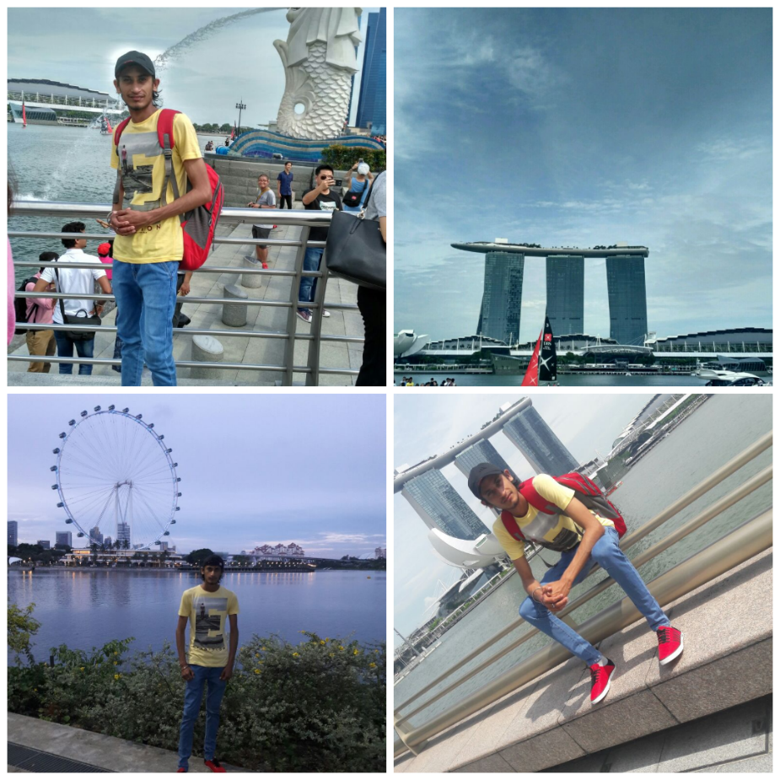
This report explores the multifarious interaction between tourism and culture in Berlin and Singapore, two cities representing a unique historical legacy and cultural identity. Berlin speaks of a scourge with the scars of the 20th-century conflicts. The city has successfully transformed its tortured and fragmented past into a haven for creativity, and counterculture, and a tourist hotspot with its historic sites and vibrant art and nightlife scene. Singapore, a developing multicultural city almost on the other side of the horizon of being a post-colonial nation, attempts to partition its traditions and cultural background with modernity in urban development, thus providing tourists with pre-planned heritage sites and contemporary attractions.
(Visited to Singapore 30th July, 2017)
The report looks at how both cities commodified their unique identities while dealing with issues related to over-tourism, cultural authenticity, and sustainability, presenting their tourism models, cultural assets, and social mechanics. One thing that this report establishes is that while Berlin flourishes upon inclusivity, historical introspection, and subcultural innovation, Singapore's quintessentially revolves around scripted multiculturalism, technological advancement and environmental sustainability; these will offer invaluable models for the other global cities that are grappling with the issues surrounding cultural tourism in the 21st century.
Contents
Introduction 4
Historical and Cultural Background 4
Berlin: A Tapestry of Turbulence and Transformation 4
Singapore: Multicultural nation looking younger than its age 5
Tourism Highlights in Berlin 6
Historical Monuments 6
Brandenburg Gate (1791): 6
Nightlife 9
Tourism Highlights in Singapore 9
Singapore: Showcasing Fusion of Tradition and Modernity 9
Traditional Arts- Preserving Cultural Heritage 11
Cultural Festivals: Celebrating Diversity 12
Natural Attractions: A Green Oasis 13
Cultural Comparison 14
Berlin: Fighting Authenticity and Subculture 14
Singapore: Engineering Harmony and Modernity 14
Common Ground 14
Tourism Strategies and Impact 15
Berlin 15
Key Strategies: 15
Impact: 15
Singapore 16
Key Strategies: 16
Effects: 16
SWOT Analysis of Berlin and Singapore 16
PESTLE analyses for Berlin and Singapore 17
Berlin Cultural Survey and Research Results 18
Section 2: Cultural Attractions and Experiences 20
Section 3: Local Culture and People 21
Brandenburg Tour 23
Recommendations 23
Conclusion 24
References: 25

Introduction

In an age of globalisation, tourism and culture are now inexorably bonded as cities all over the world strive to highlight their historical, artistic, and social heritage to boost tourists and grow the economy. Berlin and Singapore, while far apart and culturally differing, represent a case study on how cities have tapped into tourism potential through some exclusive cultural resources in their attempts to fashion their identities on the international stage.
Berlin, formerly a divided artifact of the Cold War, has blossomed as a vigorous centre of artistic expression, historic reflection, and countercultural movements. The city's capacity to don its gritty past on its sleeves retains the heritage and cannot turn its wounds of history into archetypes of resistance, freedom, and invention.
A young nation, with a sense of accord of various ethnicities and colonial influences: Singapore represents itself as a harmonious synthesis of tradition with futuristic vision, showcasing a tourist product characterized by an orderly urban landscape, cultured experiences, invention, and sustainability. This study aims to compare the cultural attractiveness of Berlin and Singapore in terms of their historical context, paramount attractions, strategies, and challenges. Through comparative assessment, the aim is for a general insight into culture as a definitional element to urban identities as they connect with the world and struggle through the most uncomfortable conditions of globalisation in their relations to the tourist industry.

Historical and Cultural Background

Berlin: A Tapestry of Turbulence and Transformation
Berlin is a microcosm of the 20th-century upheaval of Europe. Founded in the 13th century, it grew into a capital of Prussia in the 18th century, before assuming its role as the heartland of the German Empire in 1871. Nevertheless, it was at the time of the Cold War (1947–1991) that it defining modern narrative played out when the city was divided into physical and ideological halves by the Berlin Wall, erected overnight on August 13, 1961. Spanning 155 kilometres and fortifying everything with guard towers, minefields, and "death strips," the Wall became a visceral symbol of the Iron Curtain. Its fall on November 9, 1989, triggered by an outpouring of public protest and diplomatic shifts, marked an earthquake of history staking a claim for Germany's reunification in 1990 (Shafiezad, 2024).
Berlin turned, after the reunification, into a laboratory of cultural innovation. Neighbourhoods like Kreuzberg were once gritty enclaves straddling the west edge of the Wall and became a haven for counterculture and immigrant communities, particularly Turkish and Vietnamese groups, and avant-garde art collectives. Mitte, the historic core, unites Baroque splendour with Soviet-era architecture now converted into galleries and startups. An open-air monument to defiance, a 1.3 km stretch of the Wall known as the East Side Gallery boasts murals like Dmitri Vrubel's "My God, Help Me Survive This Deadly Love" (McCabe, 2019).
Berlin embodies cultural contrasts. The Pergamon Museum on Museum Island (a UNESCO site) contains monumental antiquities like the Ishtar Gate of Babylon, while the Hamburger Bahnhof exhibits contemporary works created by Cy Twombly and Joseph Beuys. The Berlin Philharmonic is conducted by such noteworthy names as Herbert von Karajan and Sir Simon Rattle and is an acclaimed institution whose concert hall designed by Hans Scharoun is acclaimed for its acoustically pristine harmony. Monumental memorials include Peter Eisenman's Holocaust Memorial (with 2,711 stelae meant to elicit disorientation and loss).
Berlin's creative pulse radiates from its underground techno clubs (Berghain, Tresor), LGBTQ+ festivals (Christopher Street Day), and culinary fusion (Doner kebab, re-invented by Turkish immigrants). Festival events like the Berlinale Film Festival and Festival of Lights raise its stature on the cultural map. Despite all the gentrification of the ongoing year, the city remains outcast and experimental, manifested in the temporary art squats of Tacheles and the sustainable urban project Prinzessinnengarten.

Singapore: Multicultural nation looking younger than its age
Colonial Heritage and Ethnic Diversification: In essence, therefore, it allowed it, given its history of a British trading port and colonial settlement, to be portrayed as multiracial and multicultural. Today, this City-State comprises a predominantly Chinese, Malay, Indian, and Eurasian population; they each have their festivals, customs, practices, languages, and modes of dressing. It is instead through the salting of these various ethnicities within one another that one can describe the bloodline coursing through Singapore's body social; hence, their assortment provides for that glimmer of cosmopolitan (Tung, 2022).
Nation-Building and Social Engineering: Singapore, since its separation from Malaysia in 1965, has undertaken a major nation-building exercise towards achieving the permanence of social cohesion, economic supremacy, and national identity. The authorities instituted programs and policies designed to foster multiculturalism, bimodal education, and a meritocratic society to mix with standards of austerity, diligence, and social harmony. This particular combination pushed forward the image of the local cultures, inscribing itself as yet another community of traditional yet reworked for modernity (Brito, 2019).
Economic Development and Urban Transformation: An extensive period of metamorphosis swept across the pristine nation of Singapore, after the magical overture in its economic progress. The city-state lavished much sought-after investments in infrastructure, technology and urban planning; meanwhile, it created a pleasant landscape, modern and efficient so the eyes behold. This innovation and urban development invariably account for Singapore's competitive advantages as a global business centre and as a highly-ranked tourist attraction.

Tourism Highlights in Berlin

Historical Monuments
Stunning monuments of considerable historical importance, attesting to its past afflictions and victories, dot the city of Berlin and have graced European soil.
Brandenburg Gate (1791): As a neoclassical monolithic structure, the Brandenburg Gate is considered an iconic symbol of the reunification of Germany. It has witnessed a strong and teeming history of Berlin, having initially been erected as a city gate in the 18th century. During the Cold War, it became an important icon since it was very much located near the Berlin Wall. Today, it is a visitable monument for every History Channel lover and tourist who is curious to know about Germany's past (ITB Berlin, 2003).
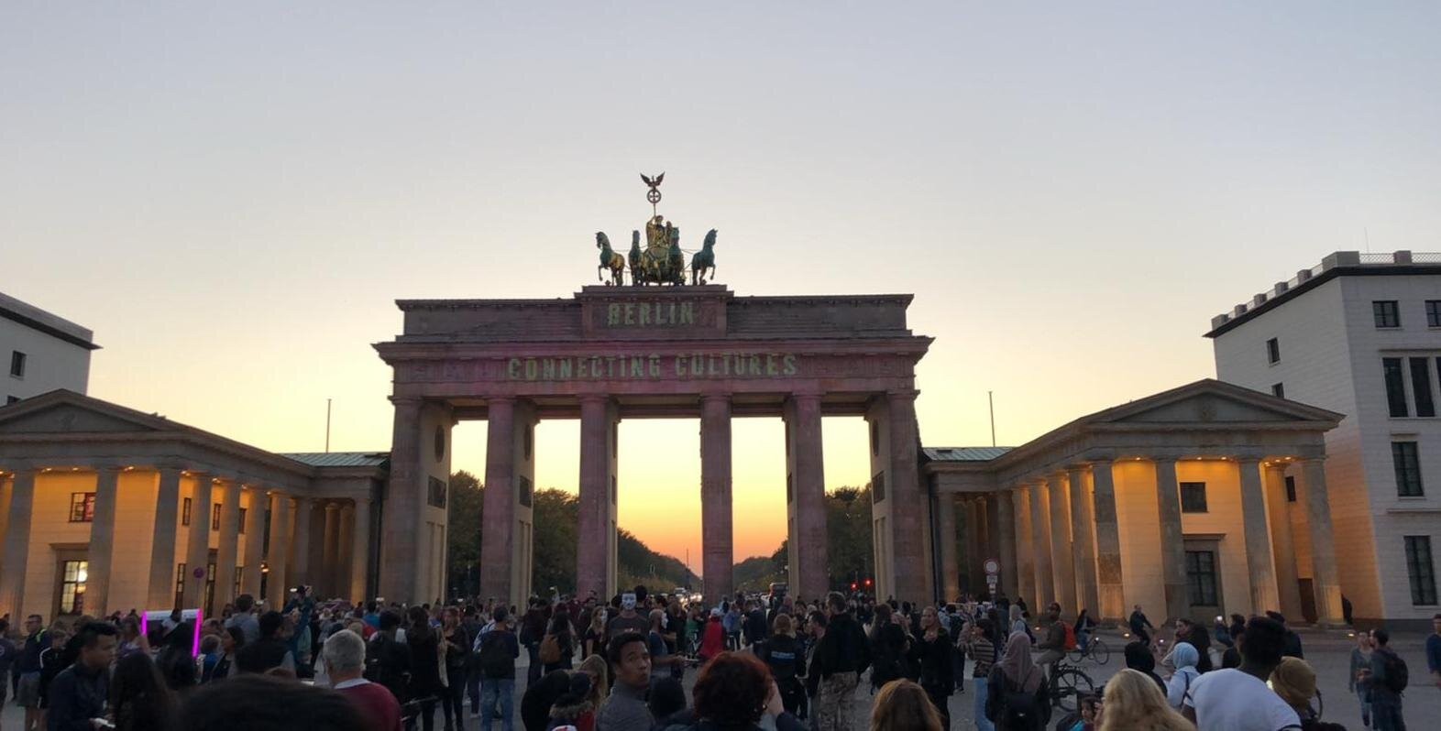
(Visited to Brandenburg Gate, 26th January, 2025)
Berlin Wall Memorial: The Berlin Wall, which segregated East from West Berlin, constitutes one of the most important tributes to the city in its history. The Berlin Wall Memorial preserves pieces of the wall and explains in detail the ramifications of the division. The open-air exhibitions include a documentation centre and a chapel to commemorate those who died attempting to escape.
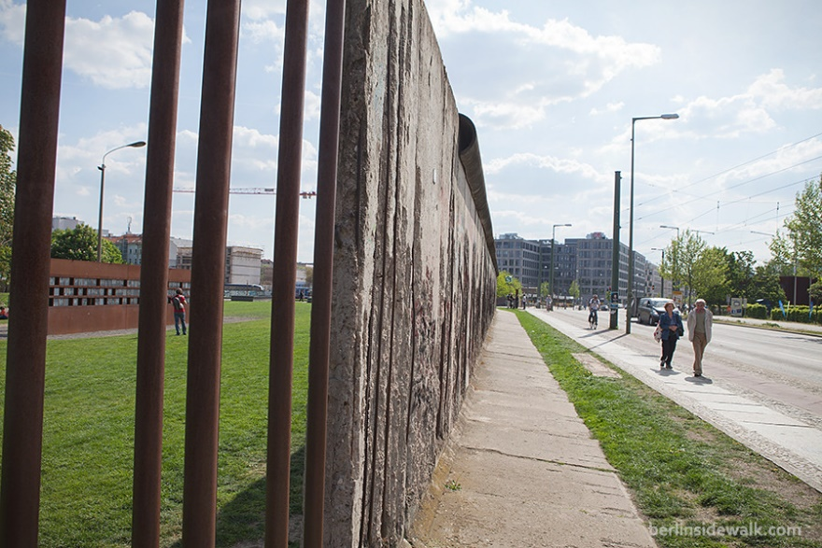
(Visited to Berlin Wall Memorial: 26th January, 2025)
Reichstag Building: Often deemed both an ecclesiastical and architectural marvel, the Reichstag provides the venue for the German parliament. Designed to epitomize governmental transparency, the building’s glass dome charted by Sir Norman Foster gives visitors a panoramic view of Berlin. Visitors are encouraged to explore its splendid architecture, with guided tours illustrating its political significance.
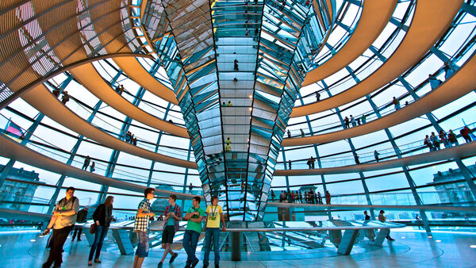
(Visited to Reichstag Building 27th January, 2025)

Cultural Events

The culture that exists in Berlin is one that is as colourful as many festivals and events are held there, attracting visitors from all over the world.

Berlin International Film Festival (Berlinale): Berlinale is considered one of the largest and most renowned international film festivals in the world. This is the arena for international film premieres, with thousands of viewings and the opportunity for networking in the industry.
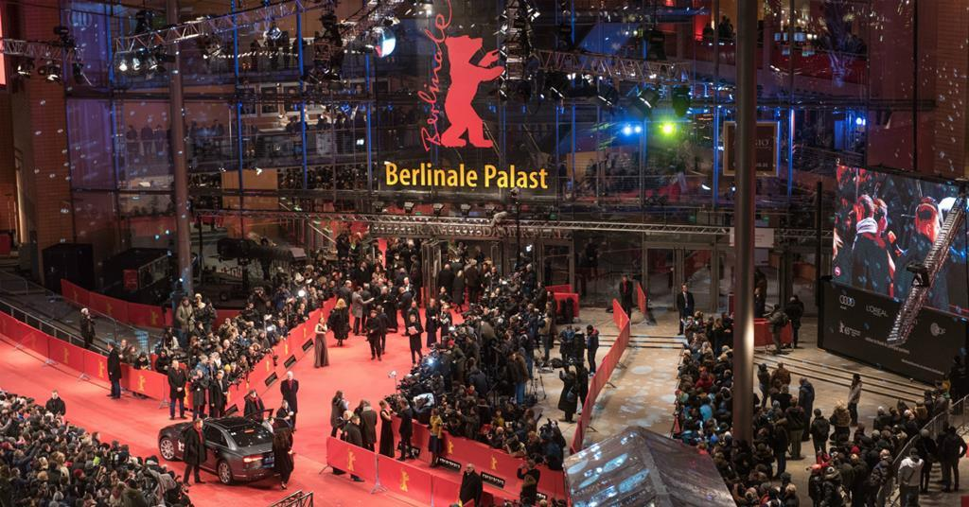
(Source-https://www.screendaily.com/news/screen-international-at-the-2024-berlin-film-festival/5190456.article)
If we can find the time and have some means to head to Berlin on Gallery Weekend, then we are ein for a treat. This event celebrates contemporary art and is the largest exhibition fair in Berlin throughout the year. This is where modern works from both established and upcoming artists are being shown, furthering Berlin's growth and reputation as one of the primary centres of contemporary art (McCabe, 2019).
A street festival celebrating Berlin's multiculturalism in music dance and food. It includes parade marching, performances, and food attractions assembled around the theme of its cultural influences(INTACT, 2022).

Nightlife

Berlin surely has its star-grade party pack with a wide variety of clubs, bars, and music venues. The city is most noted for its electronic. Clubs, such as Bergheim, have attracted musicologists from every part of the globe. To stick to the music genre, Berlin strenuously embarks upon its nightlife, including speakeasy venues, jazz bars, spaces that welcome tourists for all types of night time experiences.
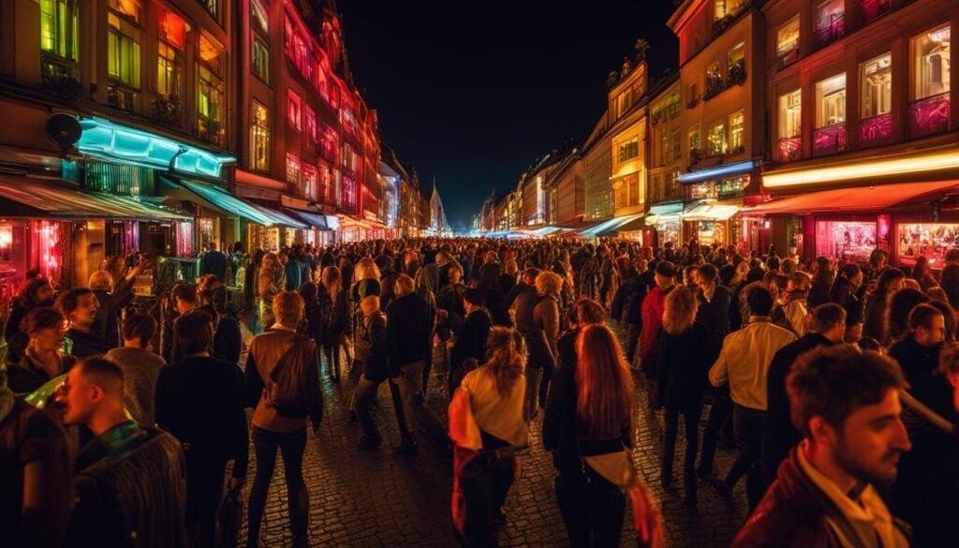
(Visited, 27th January, 2025)

Tourism Highlights in Singapore

Singapore: Showcasing Fusion of Tradition and Modernity
Historical and Religious Sites: Echoes of the Past
Chinatown: Vibrant and hustling, Singapore's Chinatown is a glimpse into the Chinese heritage of the city-state. The area has traditional shophouses, colourful markets, and religious sites such as the Buddha Tooth Relic Temple, a wonderful architectural wonder housing a holy Buddhist relic.
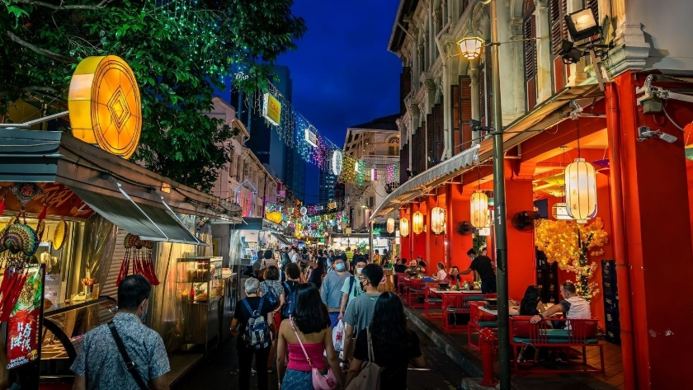
(Visited 27th August, 2017)
Kampong Glam: A historical area where one can marvel at Singapore's Malay and Arab heritage. It houses the exquisite Dome of the Sultan Mosque, one of Singapore's most spectacular landmarks, along with Arab Street, a lively thoroughfare fitted with textile shops, spice vendors, and Middle Eastern restaurants.
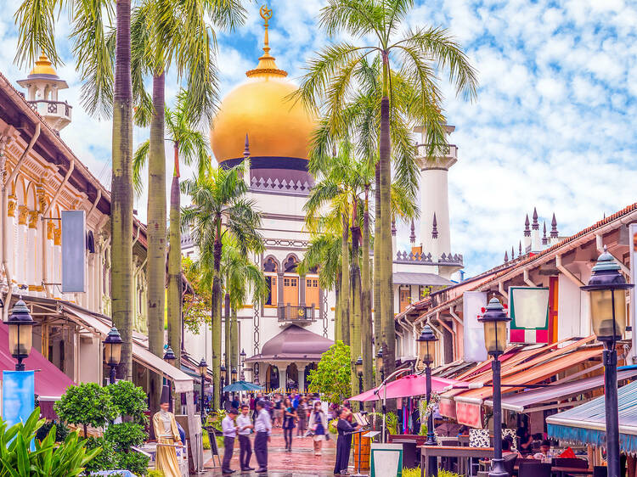
(Visited 27th August, 2017)
Little India: An aromatic neighbourhood in touch with the heritage of India in Singapore that is synonymous with colourful murals, spice shops that awaken one's sense of smell, and religious structures like Sri Veeramakaliamman Temple-a Hindu temple dedicated to the goddess Kali.
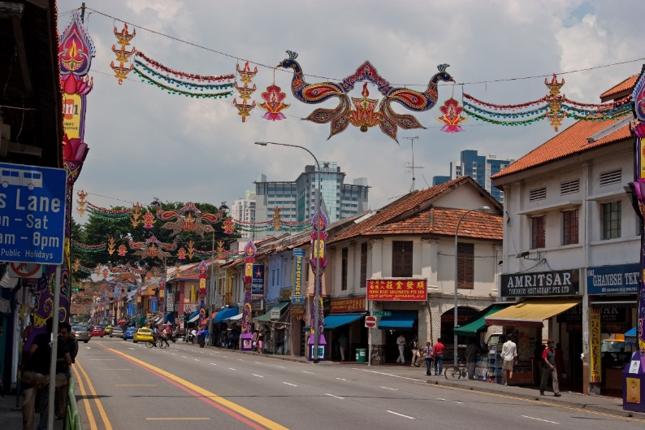
(Visited 27th August, 2017)

Traditional Arts- Preserving Cultural Heritage

Peranakan Culture: The Peranakan Museum gives an interesting perspective on the unique culture developed by the Peranakan people, descendants of Chinese immigrants who married local Malay women. The museum exhibits intricately embroidered kebayas, beaded slippers, and other artistic objects that represent the exquisite culture of the Peranakan.
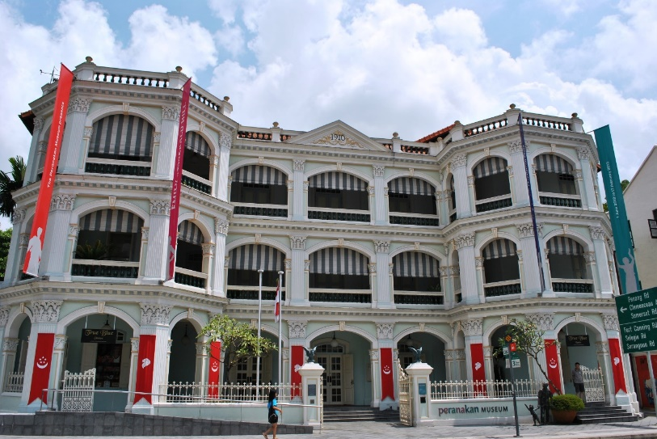
(Visited 28th August, 2017)
Hawker Centres: Singaporean hawker centres have grown to be a culinary institution that offers a smorgasbord of cheap, delicious food from every ethnic cuisine. Many hawker stalls have passed down generations while preserving that age-old culinary skill and recipes. Some hawker stalls even received Michelin stars, putting even more spotlight on the culinary talent found in our little red dot.
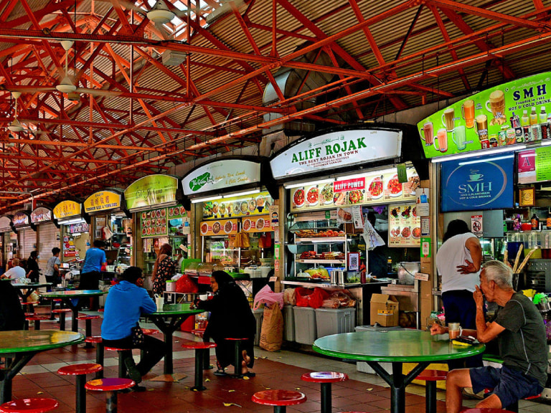
(Visited 28th August, 2017)

Cultural Festivals: Celebrating Diversity
Chinese New Year: The Chinese New Year is one of Singapore's grand cultural celebrations, festooned with celebrations, traditional performances, and family gatherings. The River Hongbao Festival, celebrated every year at the time of Chinese New Year, features magnificent lantern displays, cultural performances, and food stalls (Pramesti, 2024).
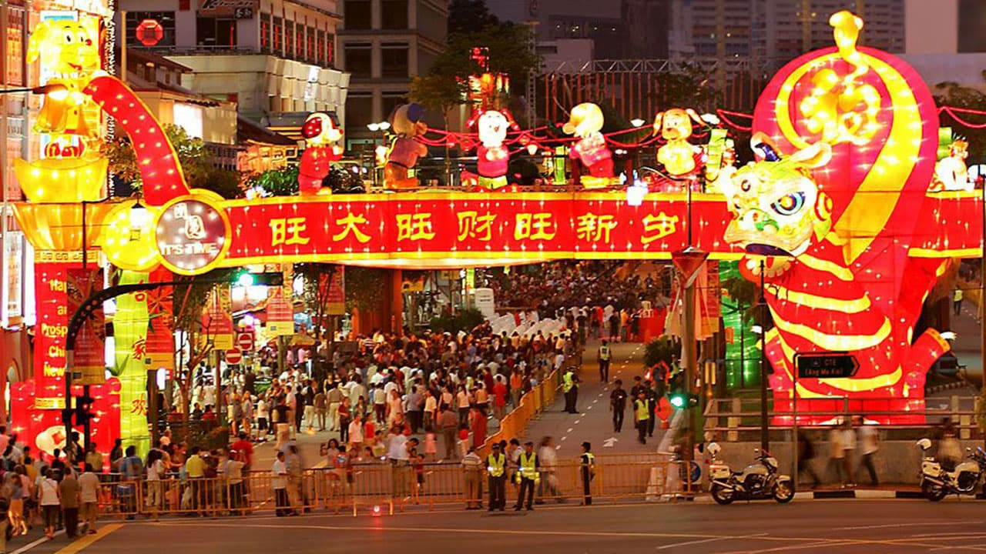
(https://time.astrosage.com/holidays/singapore/chinese-new-year-day?year=2025&language=en)
Thaipusam: Thaipusam is a Hindu festival celebrated by the Tamil community in Singapore. The festival includes a colourful procession in which devotees carry kavadis (ornate structures) and pierce their bodies with hooks and skewers as acts of devotion and penance.
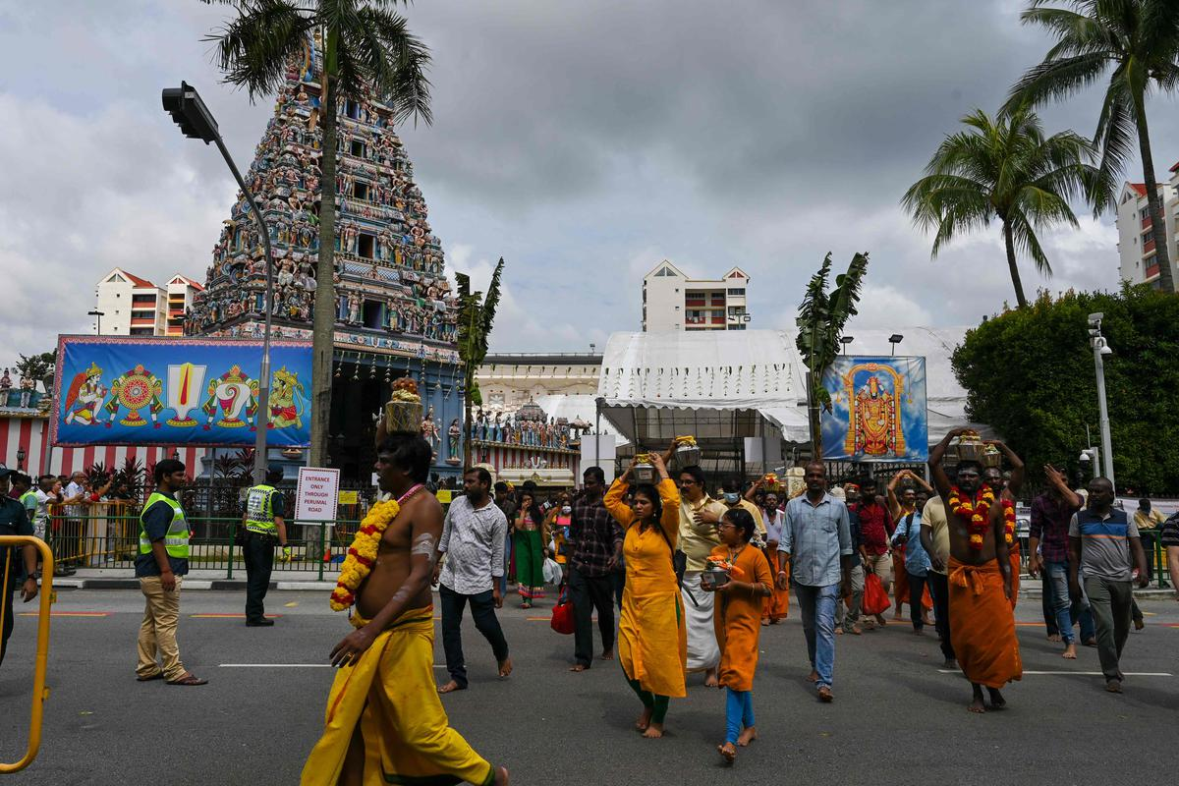
(https://travelforlifenow.com/thaipusam-singapore/)

Natural Attractions: A Green Oasis
Gardens by the Bay: Gardens by the Bay is a futuristic park that reflects the commitment of Singapore to sustainability and innovation. It has Super trees, erect vertical gardens that come alive at night, as well as biodomes that house Mediterranean and cloud forest flora.
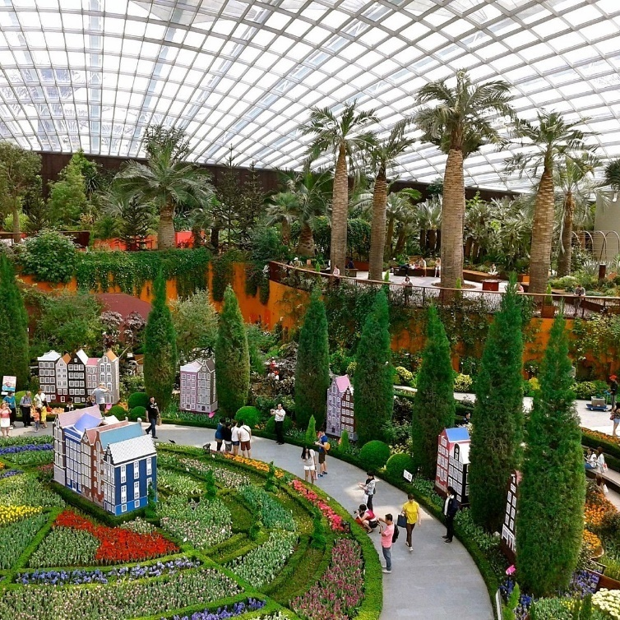
(https://www.visitsingapore.com/neighbourhood/featured-neighbourhood/marina-bay/gardens-by-the-bay/)
Singapore Botanic Gardens: The Singapore Botanic Gardens, which is a UNESCO World Heritage Site, is a green oasis in the heart of the city. The gardens encompass a diverse collection of plants, including the National Orchid Garden, which is a stunning display of orchids from around the world.
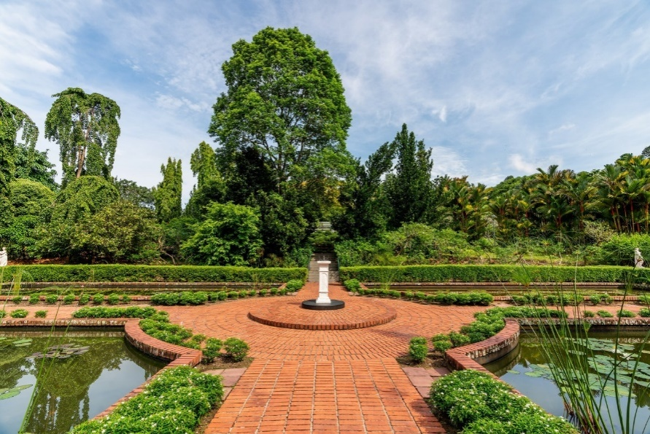
(Visited 28th August, 2017)
Cultural Comparison: Contrasting Approaches to Identity

Berlin: Fighting Authenticity and Subculture
Berlin's cultural identity goes back to its past, its artistic vigour and its outstretched hand extended to counter-culture movements. Monuments are erected, museums are designed, and an art scene burgeons on the wrecked past to account for a culture of memorial and critical thought. The vision of Berlin subcultures-from a techno scene to a street art community is forcefully from experimentation, inclusivity, and counter-hegemonic anti-mainstream principles (Brito, 2021).

Singapore: Engineering Harmony and Modernity
This well-crafted cultural identity positioned by the state bases itself on the model of multiculturalism, social harmony, and progress in Singapore. Again, through its ethnic enclaves, cultural occasions, and urban planning, the little city-state makes a declaration of tradition preservation against modernity. The new experiences offered by Marina Bay Sands and Gardens by the Bay illustrate the push for innovation in technology and sustainability in Singapore.
Common Ground: Heritage, Gentrification, and the Tourist Gaze
In many aspects, although Berlin and Singapore contrast with each other in their approaches, they share a common historical feature: They both use culture to lure cash into tourism. Both recognise heritage as a viable asset for tourism, with Berlin making use of its historic sites, such as Tempelhof Airport, and Singapore curating its ethnic precincts, which raises issues of gentrification concerning combining tourism needs with local communities. Recently, questions have also been raised about the moral implications further complicating the commodification of culture for tourism, thus assuring that authenticity is not bartered for the sake of profit (Khoi, 2022).

Tourism Strategies and Impact

Berlin
The tourism strategy for Berlin is built on sustainable, city-compatible, and socially equitable tourism. This recognizes the great place nature, the culture of the city, and the quality of life that residents subscribe to. The city aspires to unite sustainability and tourism while conserving the character of the districts and neighbourhoods.

Key Strategies:
- Qualitative Growth: A qualitative approach is to be adopted to deliver a greater sales impact and income in the tourism sector as it is no longer regarding a simple quantitative increase.
- Local Involvement: It gives local people the opportunity to serve as a source of information concerning the development of Berlin's tourism subsequently acting as an early warning system to avoid overwhelming tourist destinations.
- Sustainable Events: It will promote events where interaction takes place between residents and visitors, serving to inculcate a welcoming and hospitable attitude.
- Pandemic Safety: Making arrangements for the safety of those who visit and those who live in the city (Raihan, 2022).

Impact:
- Economic Contribution: Tourism has an immense contribution to the economy in Berlin by providing jobs and income.
- Quality of Life Improvement: By opting to promote sustainable and city-compatible tourism, Berlin will provide a stimulating environment to both beef up the living standard of its people and ultimately provide a unique experience to visitors as well.
- Cultural Preservation: The focus on preserving diverse neighbourhood cultures solidifies Berlin as a unique identity unto itself and hence very appealing.
- Flexible to Change: The dynamic nature of the tourism industry has compelled Berlin's strategies to adapt to a change in global and local outlook such as post-COVID independently.

Singapore
Singapore's tourism strategies, driven by the Singapore Tourism Board (STB), cover advertising directed towards various markets, the use of digital marketing, and collaboration with industry partners to advance the city-state tourism bid as a highly preferred destination. The STB also considers changes in tourism, namely holidaying at a single destination, an increased interest in eco-tourism, and adjusted changes.

Key Strategies:
- Targeting Diverse Markets: The STB has tailored its marketing initiatives in its search for specialty segments of the market such as families, luxury travellers, and Muslim travellers. AI and data analytics enhance digital marketing to bring personalized experiences to tourists.
- Leveraging Digital Marketing: The STB uses social media and online advertising and travel agencies to create awareness about Singapore1. We cater to our customers via chatbots, which provide an adequate quality of response 24 hours a day (Tung, 2022).
- Collaborating with Industry Partners: The STB collaborates with airlines, hotels, attractions, and event organizers in the crafting of irresistible packages and experiences.

Effects:
- Increase in Tourist Arrivals: Tourism marketing contributes tremendously to increasing visitor numbers to Singapore. The island nation's tourism body works with travel agencies, airlines, and other industry partners to develop attractive travel packages and promotions that pull visitors to make Singapore their travel destination.
- Economic Growth: This is one of the world's largest industries in the world and Singapore is no exception. The industry has anchored Singapore's international reputation and attractiveness as a viable business hub for study and living.

SWOT Analysis of Berlin and Singapore
This section provides a detailed SWOT assessment of Berlin and Singapore as viable tourism destinations.
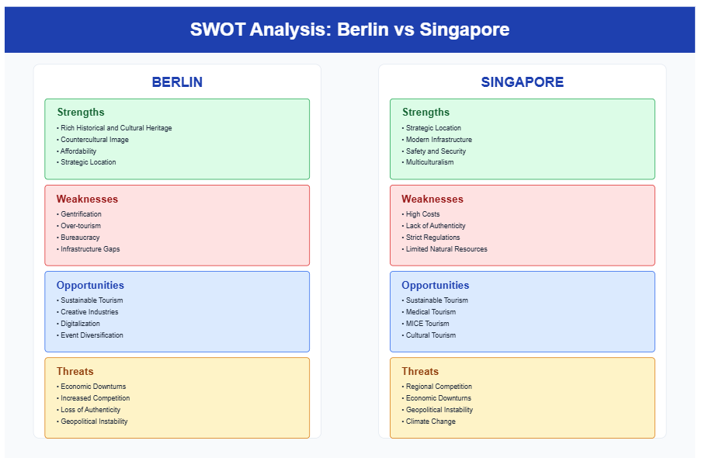
This SWOT analysis offers an elaborate examination of internal strengths and weaknesses vis-a-vis the external opportunities and threats of both Berlin and Singapore to tourism development so that it guides their tourism management policies and strategies in place today.

PESTLE analyses for Berlin and Singapore

Policy-related:
Berlin spares the focus of EU integration against Singapore focusing on ASEAN partnerships.
Differentiated security approaches and styles of governance.
Economic:
Berlin is more affordable, in contrast to the creative economy of the MICE industry strength of Singapore.
Social:
Berlin-Alternative cultures-nightlife, whereas Singapore-food tourism-multicultural heritage.
Technological:
Berlin: smart city services, while Singapore pursues a comprehensive approach under its Smart Nation initiative.
Environmental:
Berlin holds urban green spaces, while Singapore has integrated green architecture.
Legal aspect:
Berlin-Covers EU framework while Singapore-Operating under strict regulatory environment.

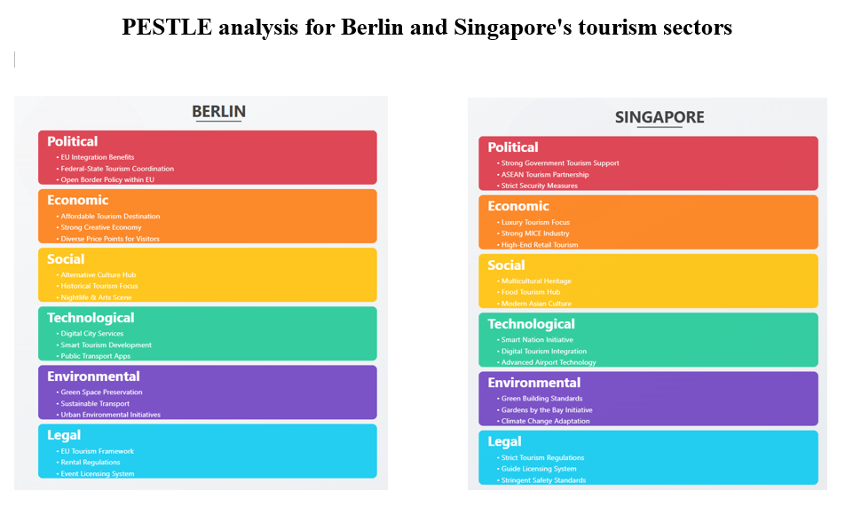

Berlin CulturalSurvey and Research Results

Master's Degree in Tourism and Recreation
Section 1: General Information

1. How long was your stay in Berlin?
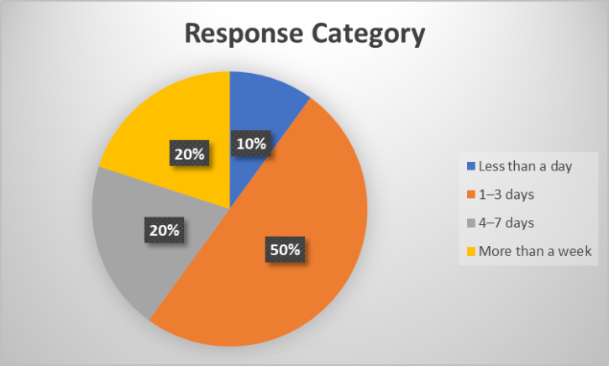
20% stayed over a week, 20% for 4-7 days, 50% for 1-3 days, and 10% for less than a day. The data skews towards longer visits to Berlin.
2.Where are you visiting from?
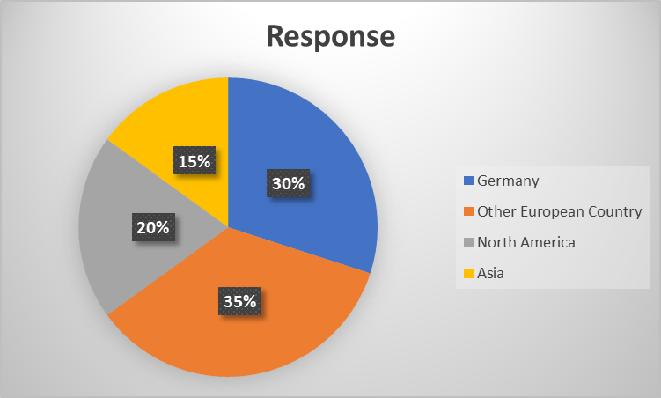
Most visitors are from other European countries (35%), followed by Germany (30%). North America and Asia each account for 15% and 20% of visitors, respectively.
3. How would you describe your interest in culture? (Please select all that apply)
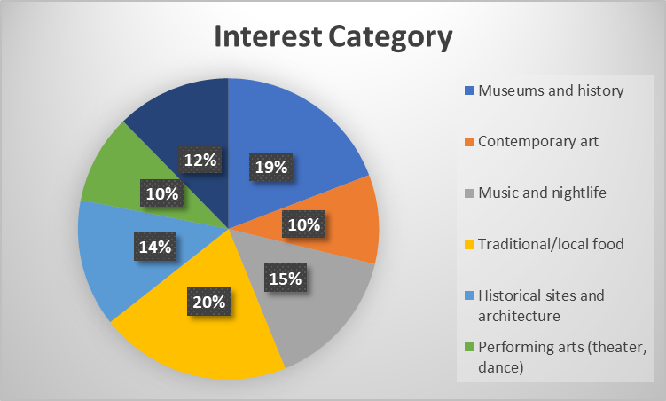
Visitors show strongest interest in historical sites and architecture (20%), followed by traditional food (19%) and museums/history (12%). Contemporary art and music/nightlife have moderate interest, while performing arts are less popular.

Section 2: Cultural Attractions and Experiences

4.Which cultural sites or attractions did you visit in Berlin? (Please select all that apply)
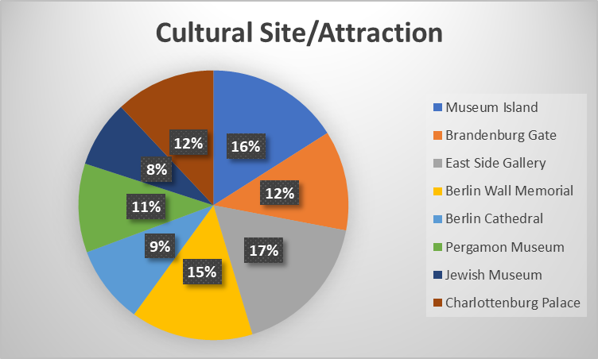
Museum Island (16%), East Side Gallery (17%), and Berlin Cathedral (12%). Other sites visited include the Brandenburg Gate (12%), Jewish Museum (11%), Pergamon Museum (9%), Berlin Wall Memorial (15%), and Charlottenburg Palace (8%).
5. How would you rate your experience with Berlin's cultural attractions overall?
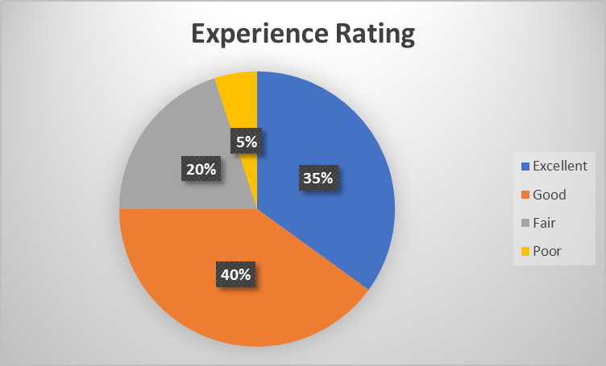
The majority rated their experience as "Good" (40%), followed by "Excellent" (35%). 20% found it "Fair," and only 5% rated it "Poor," indicating generally positive experiences with Berlin's cultural attractions.
6.What aspects of Berlin's cultural attractions did you enjoy the most? (You may select
more than one option)
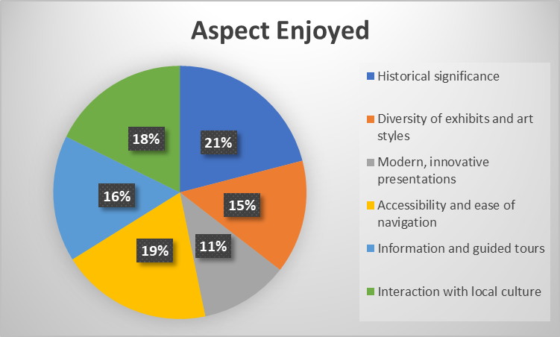
Visitors most enjoyed the diversity of exhibits and art styles (21%), followed by modern, innovative presentations (20%) and historical significance (18%). Accessibility and interaction with local culture were also appreciated.
7. Were there any cultural attractions or experiences you found disappointing?
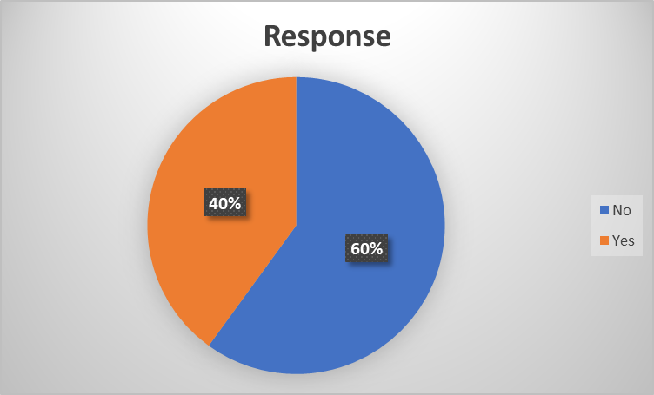
Yes, 60% of the responses indicated that there were cultural attractions or experiences found disappointing. This is shown in the chart as 40% of the responses are marked "Yes".

Section 3: Local Culture and People

8. How would you describe your interactions with locals in Berlin?
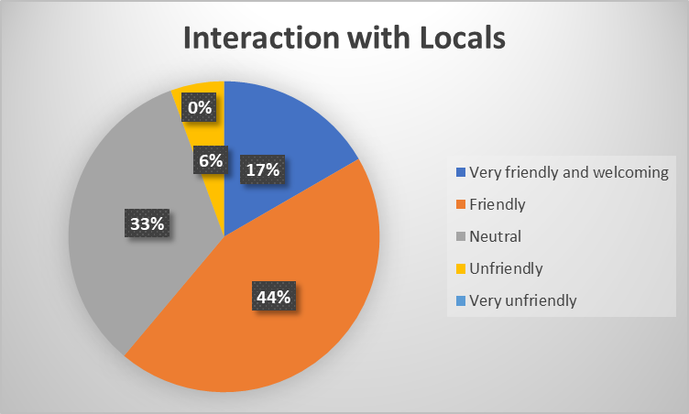
Most interactions were friendly (44%) or very friendly/welcoming (17%). 33% had neutral interactions, while a small portion (6%) found locals unfriendly. No one reported very unfriendly experiences.
9. Did you have the opportunity to attend any cultural events or festivals?
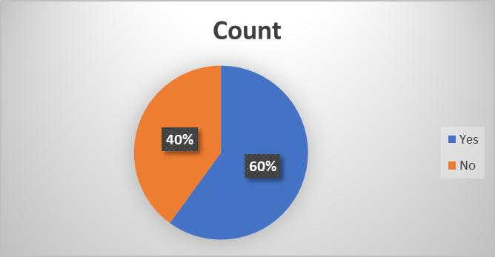
60% answered "yes," 40% answered "no"
10. How would you rate the authenticity of your experience with Berlin's local culture?
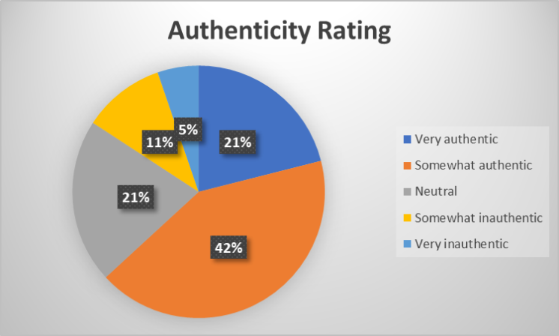
Most found Berlin's culture somewhat authentic (42%), while 21% found it very authentic. 21% were neutral, and 11% found it somewhat inauthentic. Only 5% felt it was very inauthentic, indicating a generally positive perception of cultural authenticity, though not overwhelmingly so.

(The survey sample size consists of 20 respondents, providing insights into visitors' cultural experiences, preferences, and suggestions regarding Berlin. While small, it offers a snapshot of diverse perspectives on the city's cultural appeal, 29th January, 2025)

Brandenburg Tour

I believe this was a one-of-a-kind highlight of my Berlin trip! Staring those shiny walls at the Gate that have borne witness to history, it is indeed stunning for its history beginning from the splendour of Prussia, the shadow of the Wall, and finally to the reunification time. The guide brought it all together, explaining the Quadriga and how the gate has undergone changes in function through the ages. This made me think a bit about the survey that we had gone through earlier-this one regarding authenticity. While at the Gate, I felt that profound connection to Berlin in its history; this was simply authentic! But the survey report shows that only 21% regarded their experience as "very authentic", while even more-a total of 42%-saw it as at least "somewhat authentic." This really begs one's mind to ponder what forges those perceptions. Perhaps the crowd or the commercial aspects prevent the authenticity for some. For me, though, the Brandenburg Gate was an experience of power and authenticity when faced with the past of Berlin.

Recommendations

Key to maintaining the appeal of Berlin as an innovative tourism destination is the city's engagement with gentrification to introduce low-cost housing legislation and enable self-supporting businesses in creative districts. The image of the city should be balanced with sustainable tourism practices. Investment in public transport and green infrastructure would reduce the threats of over tourism. Moreover, Berlin is well-positioned to utilize its digital development in ameliorating visitor experiences while circumscribing the uniqueness of its neighbourhoods and artists' communities.
Singapore should seek to enhance its tourism offerings other than its iconic landmarks by providing more verve to its cultural depth. Encouraging community-based tourism initiatives could be more authentic in appealing to local populations. In addressing travel affordability, the two key dimensions are those of making accommodation choices more affordable and caveat exploration of budget tastes. Enhancing environmental sustainability by investing in green initiatives to displace resource-based attractions will prove key to sustainability in a climate-sensitive world. Regional collaboration in tourism can also reduce dependency on each of the individual high-impact projects (Vovk, 2021).

Conclusion

Berlin and Singapore offer case studies of two cities that are effectively leveraging their cultural assets for the harnessing of tourism and rebranding their international identities. Berlin celebrates its history, creativity, and countercultural movements, creating a unique and authentic urban experience, whereas Singapore artfully curates its traditions, promotes social harmony, and flaunts its technological prowess to create a modern and innovative urban space.
Although successful at attracting tourists and boosting their economies, both cities are now threatened by over-tourism, gentrification, and commoditization of culture. This calls for balancing economic growth with local community needs, cultural authenticity preservation, and environmental protection to ensure long-term sustainability in tourism. By adapting this knowledge to each other and using best practices for sustainable tourism management, Berlin and Singapore will thus be able to continue thriving as a global centre for culture and tourism in the 21st century.

References:

Brito, M. M. (2021). Overtourism in coastal territories in the perspective of cruise tourism. Advances in Hospitality, Tourism, and the Services Industry, 350-370. https://doi.org/10.4018/978-1-7998-4318-4.ch017
Khoi, N. H., Le, N. H., & Ngoc, B. H. (2022). The effect of tourism development on the ecological footprint in Singapore: evidence from asymmetric ARDL method. Current Issues in Tourism, 25(15), 2500-2517.
McCabe, S. (2019). Advertising strategies for tourism and hospitality. Marketing Communications in Tourism and Hospitality, 207-236. https://doi.org/10.1016/b978-0-7506-8277-0.00008-2
Pramesti, D. Z. (2024). DiplomasiPublik Singapore Tourism Board (STB) MelaluiKampanye ‘SingapoReimagine'SebagaiUpayaMempertahankan Citra Pariwisata Singapura di Indonesia Tahun 2020-2022 (Doctoral dissertation, UPN" Veteran" Jawa Timur).
Raihan, A., Muhtasim, D. A., Farhana, S., Hasan, M. A. U., Paul, A., & Faruk, O. (2022). Toward environmental sustainability: Nexus between tourism, economic growth, energy use and carbon emissions in Singapore. Global Sustainability Research, 1(2), 53-65.
Shafiezad, O., &Mostofi, H. (2024). Sentiment analysis of Berlin tourists’ food quality perception through artificial intelligence. Tourism and Hospitality, 5(4), 1396-1417. https://doi.org/10.3390/tourhosp5040078
Statistics and similar facts. (2024). Statistics in the Law of Evidence, 107-147. https://doi.org/10.5040/9781509957361.ch-005
Tse, S., & Tung, V. W. S. (2022). Understanding residents’ attitudes towards tourists: Connecting stereotypes, emotions and behaviours. Tourism Management, 89, 104435.
Tourism recovery committee - ITB Berlin 2013 - Comité de Reactivación del turismo ITB de Berlin de 2003 (Version Espanola). (2013). https://doi.org/10.18111/9789284406555
Tourism recovery committee - ITB Berlin 2014 - Comité pour la relance du tourisme ITB Berlin 2003 (Version francaise). (2014). https://doi.org/10.18111/9789284406562
‘Case study 4: Berlin, Germany’. (2018). ‘Overtourism’? Understanding and Managing Urban Tourism Growth beyond Perceptions Volume 2: Case Studies, 25-26. https://doi.org/10.18111/9789284420629.4
Vovk, V., Beztelesna, L., &Pliashko, O. (2021). Identification of factors for the development of medical tourism in the world. International Journal of Environmental Research and Public Health, 18(21), 11205.

