M10 Applied Ethics and Bioethics
Bioethical Governance of Modern Biotechnology and Medical Research: Balancing Innovation, Human Dignity, Safety, Consent and Justice

Detailed Project Report
Option 2: Bioethical Issues in Modern Biotechnology and Medical Research

Submission Date: 24 May 2026

Table of Contents
Abstract 3
Introduction 4
Literature Review 6
Methodology 10
Findings 11
Discussion 17
Strategic Recommendations for Responsible Biotechnology 20
Conclusion 23
References 25
Appendices 28

Abstract
Modern biotechnology has moved from speculative laboratory science into clinical and commercial practice. Genetic testing is now used for diagnosis, risk prediction and reproductive planning; stem cell research is being translated into regenerative medicine; and gene editing has reached the point at which the United States Food and Drug Administration has approved a CRISPR based treatment for sickle cell disease. These advances create real health benefits, but they also place pressure on traditional bioethical safeguards because genomic information is familial, interventions may affect future persons, and global markets can commercialise hope before evidence is mature. This report examines major bioethical challenges in modern biotechnology and medical research, with a focus on genetic testing, somatic gene editing, heritable genome editing, cloning and stem cell research. It applies principlism, human dignity, human rights, care ethics and justice based reasoning to evaluate how consent, safety, privacy, professional responsibility and regulation should operate in practice. The report uses a desk based qualitative methodology, drawing on peer reviewed literature, international bioethics guidance and contemporary case examples. The findings show that biotechnology ethics cannot be reduced to approval forms or technical risk assessments. Responsible innovation requires scientific validity, robust informed consent, independent ethics review, proportional regulation, public engagement, long term monitoring and equitable access. The central argument is that biotechnology should be encouraged when it responds to serious health needs through transparent and independently reviewed evidence, but it should be restricted or delayed where it undermines human dignity, exposes participants to unreasonable uncertainty, enables discrimination, or widens global health inequity. The report concludes with practical guidelines for responsible biotechnology governance.

Introduction
Biotechnology and medical research now shape some of the most important moral choices in healthcare. Earlier debates about bioethics often centred on bedside decisions, such as whether a patient understood a treatment risk or whether confidentiality could be breached to protect others. Contemporary biotechnology expands these questions because decisions about genes, embryos, cells and data can affect families, future generations and wider society. A genetic test can reveal information about a person who never agreed to be tested. Stem cell research can promise treatment while also raising concern about embryo use, commercial exploitation and unproven clinics. Gene editing can be a therapy for severe disease, but it can also become a route to enhancement, unequal access and social pressure to produce particular kinds of children. These issues make applied ethics central to responsible innovation.
This report chooses Option 2 from the assignment brief and examines bioethical issues in modern biotechnology and medical research. The focus is strategic rather than purely descriptive. It asks how innovation can be supported without weakening human dignity, safety, consent and justice. The report argues that the key ethical question is not whether biotechnology is good or bad in itself. Biotechnology is ethically acceptable only when its purpose, evidence base, governance process and social effects can be justified. This position avoids 2 simplistic extremes. The first extreme is technological optimism, which treats any scientific advance as progress. The second is technological rejection, which blocks potentially beneficial research because of fear or moral discomfort. A stronger bioethical approach asks whether the innovation is scientifically valid, whether the affected persons have meaningful agency, whether harms are proportionate to expected benefits, whether oversight is independent, and whether access is fair.
The report is organised according to the required structure for a detailed project report. The literature review explains key theories and principles in applied ethics and bioethics. The methodology explains how a desk based normative and qualitative review was conducted. The findings analyse genetic testing, gene editing, cloning, stem cell research, ethics committees and legal frameworks. The discussion then develops a critical argument about consent, dignity, equity and professional responsibility. Tables and visuals are included to translate the ethical analysis into practical decision tools for researchers, healthcare organisations and regulators.
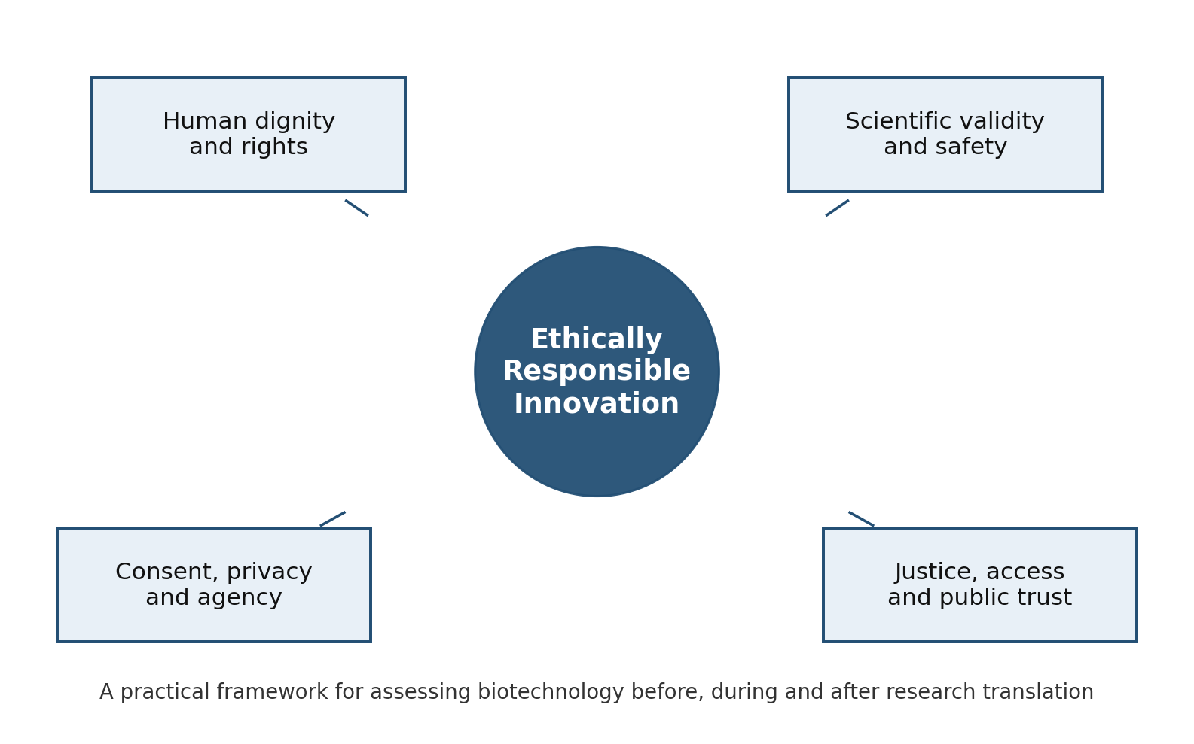
Figure 1. Bioethical governance framework for responsible biotechnology.
The importance of this topic has increased because some technologies are already in clinical use while others remain ethically disputed. For example, somatic gene editing can now be defended as a serious therapeutic tool when there is strong evidence, but heritable embryo editing remains ethically and legally problematic because it affects persons who cannot consent and may change genetic lines in unpredictable ways. The approval of a CRISPR based therapy for sickle cell disease shows that gene editing is no longer only a hypothetical concern. At the same time, the He Jiankui affair showed how weak governance, inadequate consent and individual ambition can damage public trust in science. Bioethics therefore operates as both a protection system and an enabling system. It protects participants and communities from misuse, but it also enables responsible research by creating transparent conditions under which society can trust medical innovation.

Literature Review
Bioethics developed as a response to the need for moral limits in medicine and research. The Belmont Report identified respect for persons, beneficence and justice as core principles for research involving human participants (Department of Health, Education, and Welfare, 1979). Beauchamp and Childress (2019) later developed the influential 4 principle approach of autonomy, beneficence, non maleficence and justice. These principles remain useful because they are practical and widely recognised. Autonomy requires respect for the person as a decision maker. Beneficence requires researchers and professionals to promote patient welfare. Non maleficence requires avoidance of unnecessary harm. Justice requires fair distribution of burdens and benefits. However, biotechnology shows that principlism alone is not enough. A person can sign a consent form without understanding genomic implications. A therapy can benefit a small number of wealthy patients while widening inequality. A study can satisfy local rules but still undermine global trust if it ignores future generations or public values.
Human dignity is therefore a central concept in bioethics. UNESCO's Universal Declaration on Bioethics and Human Rights connects bioethics with human rights and states that the dignity, rights and freedoms of human beings should be respected in science and medicine (UNESCO, 2005). In biotechnology, dignity has 2 meanings. The first is individual dignity, meaning that no person should be treated merely as experimental material or as a source of useful cells, embryos or data. The second is social dignity, meaning that science should not normalise discrimination, eugenic thinking or the idea that some lives are less worth living. This is especially relevant to genetic testing and embryo selection because genetic categories can be interpreted through prejudiced assumptions about disability, normality and worth.
Table 1. Ethical principles translated into biotechnology decision tests.
Ethical principle | Practical meaning in biotechnology | Key test for decision makers
Autonomy | Respect the capacity of patients, donors and participants to make informed choices about bodies, cells, genes and data. | Has consent been understandable, voluntary, specific enough and revisable where future data use is possible?
Beneficence | Promote health benefit and useful knowledge rather than novelty or commercial opportunity alone. | Is there a serious health or scientific need that justifies the intervention?
Non maleficence | Avoid unreasonable biological, psychological, informational and social harm. | Are uncertain, irreversible or inherited risks proportionate to expected benefit?
Justice | Distribute research burdens and benefits fairly across groups and countries. | Who bears risk, who receives benefit and who may be excluded from access?
Human dignity | Treat persons as ends in themselves rather than as tissue sources, data products or reproductive instruments. | Does the project respect the worth of every person, including disabled people and future persons?
Note. Adapted from core bioethics principles and human rights based bioethics guidance.
Informed consent is another major theme in the literature. Traditional consent assumes that a competent individual can receive information, weigh risks and voluntarily decide. The Declaration of Helsinki requires that participants are informed in plain language about aims, methods, benefits, risks, burdens, funding, conflicts of interest, privacy protections and other relevant aspects of research (World Medical Association, 2024). Biotechnology complicates this requirement because risks are often uncertain, data can be reused, and findings can have implications for relatives. Dynamic consent models have therefore been proposed for genomic research because they allow continuing communication, preference updates and more transparent data use (Kaye et al., 2015). However, dynamic consent is not a complete solution because it assumes digital access, health literacy and continuous engagement. It should be treated as one component of a broader governance structure rather than as a replacement for ethics review.
Scientific validity is a moral requirement, not only a technical requirement. Emanuel, Wendler and Grady (2000) argue that ethical research must have social or scientific value, valid methods, fair participant selection, favourable risk benefit ratio, independent review, informed consent and respect for participants. This framework is highly relevant to biotechnology because weak science can itself be unethical. A poorly designed stem cell trial may expose participants to risk without generating reliable knowledge. A commercial genetic test with low predictive value may create anxiety and unnecessary interventions. A gene editing study without adequate preclinical evidence may convert vulnerable patients into instruments for researcher ambition. In this sense, good science is part of good ethics.
Gene editing has become the most visible biotechnology debate. The National Academies report Human Genome Editing: Science, Ethics, and Governance distinguished between basic research, somatic editing and heritable editing, recommending strict oversight and caution especially where changes could be inherited (National Academies of Sciences, Engineering, and Medicine, 2017). The WHO later published recommendations and a governance framework for human genome editing, emphasising safety, effectiveness, ethics, transparency, registries, whistleblowing mechanisms and global coordination (World Health Organization, 2021a, 2021b). These documents show a shift from asking whether gene editing should exist to asking how different applications should be governed according to their risk, purpose and social implications.
Stem cell research raises overlapping but distinct concerns. The ISSCR guidelines describe ethical and practical standards for stem cell research and clinical translation, including specialised review, scientific justification, consent, avoidance of premature clinical use and transparency about unproven interventions (International Society for Stem Cell Research, 2021; Lovell Badge et al., 2021). Stem cell ethics is not limited to embryo status. It also includes donor consent, tissue ownership, exploitation of hope, conflicts of interest, trial design and access to approved therapies. A key problem is the growth of clinics offering unproven stem cell interventions directly to patients. These interventions often use persuasive marketing language but lack reliable evidence of safety and effectiveness. This shows why ethics committees and regulators must examine both formal research and the wider translation environment.
The literature on heritable genome editing and reproductive biotechnology highlights the importance of social justice. The Nuffield Council on Bioethics (2018) argued that heritable genome editing could be morally permissible only if intended to secure the welfare of the future person and if it would not increase disadvantage, discrimination or division in society. This conditional approach is useful because it recognises possible future benefits while refusing to treat parental preference or market demand as sufficient justification. It also makes public engagement essential. Biotechnology that changes reproduction, disability expectations or family identity cannot be governed only by technical experts.
Overall, the literature supports a layered model of bioethical governance. Individual consent matters, but it must be supported by scientific validity, independent review, regulatory oversight, public accountability and distributive justice. The strongest contemporary guidance therefore combines principles, human rights and responsible innovation. It recognises that biotechnology can reduce suffering, but only if research systems resist hype, commercial pressure, data misuse and unequal access.

Methodology
This report uses a qualitative desk based methodology. It does not collect primary data from patients, researchers or healthcare professionals. Instead, it analyses academic literature, international ethical guidance, regulatory examples and selected biotechnology case examples. This method is appropriate because the assignment requires ethical analysis rather than empirical measurement. The purpose is to develop a reasoned strategic paper that connects ethical theory with practical biomedical research issues.
The review was structured around 4 biotechnology areas: genetic testing and genomic data, gene editing, stem cell research and cloning or reproductive biotechnology. These areas were selected because they directly match the assignment task and because they create different types of ethical pressure. Genetic testing raises privacy, discrimination and family disclosure issues. Gene editing raises therapeutic promise, safety uncertainty and future generation concerns. Stem cell research raises questions about tissue sources, embryo status, clinical translation and unproven interventions. Cloning raises concerns about identity, welfare, commodification and social meaning.
The analysis used a principle and governance matrix. First, each technology was assessed against autonomy, beneficence, non maleficence and justice. Second, each technology was assessed against dignity, consent quality, safety evidence, regulatory maturity and social trust. Third, the role of ethics committees and legal frameworks was evaluated by asking whether oversight occurs at the correct stage, whether it is independent, whether public values are represented, and whether post approval monitoring is required. This approach allows ethical dilemmas to be compared without assuming that all technologies have the same risk level.
The method has limitations. It cannot measure public opinion or patient experience directly. It also relies on published guidance, which may lag behind emerging techniques. However, it is suitable for a project report because it provides transparent reasoning, uses recognised ethical frameworks and connects current examples to practical recommendations.

Findings
The first finding is that genetic testing creates benefits only when consent, counselling and data governance are strong. Genetic testing can diagnose rare diseases, guide treatment, identify inherited risk and support reproductive planning. It can also reduce uncertainty for families. However, the same information can create anxiety, stigma, insurance concerns and family conflict. A result may reveal risk for siblings, children or parents who did not request testing. This challenges a narrow individual model of confidentiality. Ethical practice should not simply disclose or conceal information by default. It should include pre test counselling, discussion of possible incidental findings, clear limits on confidentiality, and support for family communication. The most serious risk is that genomic information becomes a basis for discrimination or social sorting. For this reason, genetic testing should be connected to justice and dignity, not only to personal choice.
The second finding is that somatic gene editing is ethically more defensible than heritable genome editing, but it still requires strong evidence and long term monitoring. Somatic editing changes cells in an existing patient and is not intended to be inherited. It can be justified when the condition is serious, alternatives are limited, preclinical evidence is strong and risks are proportionate. The approval of Casgevy for sickle cell disease illustrates this therapeutic pathway. The approval is ethically significant because it shows how gene editing can move from experimental promise to regulated treatment. However, the therapy also raises justice questions because complex manufacturing, specialist infrastructure and high costs can restrict access. A therapy that exists only for wealthy systems or insured patients may deepen global health inequity even if it is scientifically impressive.
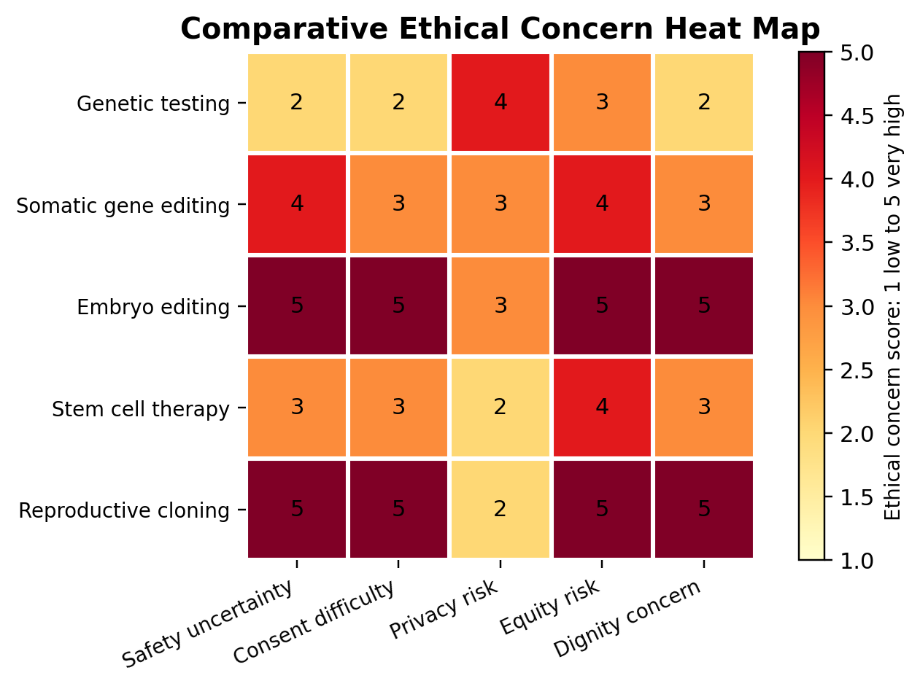
Figure 2. Comparative ethical concern heat map for selected biotechnology applications.
Table 2. Main benefits, ethical risks and minimum governance controls by technology area.
Technology area | Main benefit | Main ethical risk | Minimum governance control
Genetic testing | Diagnosis, risk prediction and targeted prevention. | Privacy breach, family disclosure conflict, discrimination and anxiety. | Pre test counselling, data protection, incidental finding policy and anti discrimination safeguards.
Somatic gene editing | Potential treatment for severe genetic disease without inherited change. | Off target effects, long term uncertainty, access inequity and therapeutic misconception. | Strong preclinical evidence, specialist review, registry and long term follow up.
Heritable genome editing | Possible prevention of serious inherited disease in future children. | No consent from future persons, irreversible lineage effects and enhancement pressure. | Current restriction unless medical necessity, safety, legality, public engagement and justice criteria are met.
Stem cell research | Disease modelling, drug testing and regenerative medicine. | Embryo controversy, donor exploitation and premature commercial claims. | ISSCR aligned review, donor consent, evidence thresholds and clinical translation controls.
Reproductive cloning | Genetic relatedness or replication claims. | Identity, welfare, commodification and major safety concerns. | Prohibition for reproductive use under current ethical and safety conditions.
Note. The table summarises the analysis developed in the findings section.
Heritable genome editing is different because it alters embryos or germline cells in a way that may affect future generations. The future person cannot consent, off target or unintended effects may not be fully known for decades, and social pressure could shift from disease prevention to enhancement. The He Jiankui case illustrates why individual consent forms cannot legitimise ethically premature research. The case involved embryo editing for HIV resistance, contested medical necessity, inadequate transparency and global condemnation (Greely, 2019). It demonstrated that public trust can be damaged when research governance is bypassed. The finding is not that all future heritable editing is impossible, but that current ethical thresholds should be much higher than for somatic therapy.
The third finding is that cloning remains ethically unacceptable for human reproduction under present conditions. Reproductive cloning raises serious concerns about safety, identity, family relationships, commodification and the welfare of the child. Even if technical risks were reduced, cloning would still need to justify why producing a genetically related copy serves the welfare of the future person rather than the preference of others. Therapeutic cloning or somatic cell nuclear transfer for research is ethically different because its purpose can be disease modelling or tissue generation, not producing a child. Nevertheless, it still requires strict oversight because it may involve embryos, eggs, donor burdens and social controversy.
The fourth finding is that stem cell research is ethically valuable but vulnerable to hype. Legitimate stem cell research can improve understanding of disease, support drug testing and contribute to regenerative medicine. Ethical problems arise when the source of cells is contested, when donors are not properly informed, when embryos are used without clear justification, or when commercial providers sell unproven interventions. Stem cell tourism is a serious example of beneficence being misused. Patients with incurable or chronic conditions may be willing to accept high risk when clinics promise improvement. Ethical governance must therefore require truthful communication, evidence thresholds and professional accountability. Hope is important in medicine, but hope becomes exploitation when it is sold without reliable evidence.
Table 3. Governance layers and limits in biotechnology oversight.
Governance layer | Primary role | Strength | Weakness if used alone
Research team | Design valid methods, disclose risk and protect participants. | Close knowledge of science and practical risks. | Conflicts of interest and optimism bias.
Research ethics committee | Independent review of risk, consent, recruitment and participant welfare. | Deliberative judgement and participant protection. | Limited capacity without specialist biotechnology expertise.
Regulator or law | Set enforceable limits, approvals, penalties and data duties. | Authority and consistency within a jurisdiction. | May be slower than scientific change and inconsistent across countries.
Professional bodies | Set standards for responsible clinical and research conduct. | Can shape behaviour through guidance and sanctions. | May lack direct enforcement over commercial actors.
Public engagement | Bring social values, lived experience and trust concerns into governance. | Improves legitimacy and detects hidden harms. | Can become symbolic if it does not influence decisions.
Note. Effective governance requires several layers because no single mechanism controls all ethical risks.
The fifth finding is that ethics committees and legal frameworks work best when they are treated as learning systems rather than one time approval mechanisms. Research ethics committees protect participants by reviewing risk benefit ratios, consent processes, privacy protections, recruitment fairness and conflict management. However, biotechnology needs review that continues across the innovation life cycle. Early stage review should examine scientific validity and social value. Trial stage review should monitor adverse events, consent and participant welfare. Translation stage review should examine access, marketing claims, follow up and data reuse. Legal frameworks provide enforceable boundaries, but they cannot anticipate every technical development. Ethics committees therefore add deliberative judgement, while law adds authority and sanctions.
The sixth finding is that responsible biotechnology requires public trust. Public trust is not achieved by public relations after decisions have already been made. It is built through transparency, meaningful engagement, disclosure of uncertainty and willingness to slow down when evidence is incomplete. In controversial areas such as embryo editing, public engagement should include disability advocates, patient groups, ethicists, clinicians, religious and cultural communities, and people from lower resource settings. Without this wider engagement, biotechnology governance risks becoming elitist and market driven.

Discussion
The findings show that the deepest bioethical issue in biotechnology is the relationship between power and vulnerability. Biotechnology gives researchers, companies and clinicians new power over cells, embryos, genomes and health data. Participants, patients, donors and future persons may be vulnerable because they need treatment, lack technical knowledge, trust professionals, or cannot speak for themselves. Ethical governance must therefore control not only physical harm but also informational, social and relational harm.
Autonomy is necessary but insufficient. Informed consent should never be treated as a signature that transfers moral responsibility from researchers to participants. For consent to be meaningful, information must be understandable, uncertainty must be honestly disclosed, alternatives must be described and withdrawal rights must be realistic. In genetic research, participants should be told whether data may be reused, shared internationally, linked with health records or used commercially. In stem cell research, donors should know whether donated cells may be transformed into cell lines or used in future projects. In gene editing trials, participants should understand that unknown long term risks may remain even after early safety testing. Consent should therefore be viewed as a continuing relationship rather than a single administrative event.
Beneficence and non maleficence also require careful interpretation. Biotechnology is often defended by reference to potential benefit. However, potential benefit is not the same as proven benefit. In early research, the main benefit may be knowledge rather than direct clinical improvement. This distinction must be communicated clearly to avoid therapeutic misconception. The principle of non maleficence requires particular caution where risks are irreversible, inherited or socially amplified. Embryo editing and reproductive cloning are ethically high risk not only because of biological uncertainty but also because they may change social expectations about what kinds of lives are considered acceptable.
Justice is the principle most likely to be neglected. A technology can satisfy safety and consent requirements while still being unjust. If expensive gene therapies are available only to wealthy patients, the benefits of publicly supported science may be captured by a narrow group. If genomic databases overrepresent European ancestry populations, predictive tools may be less accurate for underrepresented groups. If egg donors in stem cell research are recruited through financial pressure, scientific progress may rely on unequal burdens. Justice therefore requires attention to access, representation, benefit sharing and the global distribution of research burdens.
Human dignity provides a boundary against commodification. The body can be a source of information and material for research, but persons should never be reduced to data points, tissue sources or reproductive projects. This matters in cloning debates because the cloned child could be treated as an object created to satisfy another person's grief, identity project or genetic preference. It matters in genetic testing because disability should not be framed as a defect that removes the value of a life. It also matters in commercial genomic markets where consumers may be encouraged to treat identity, ancestry or risk as purchasable knowledge without adequate counselling.
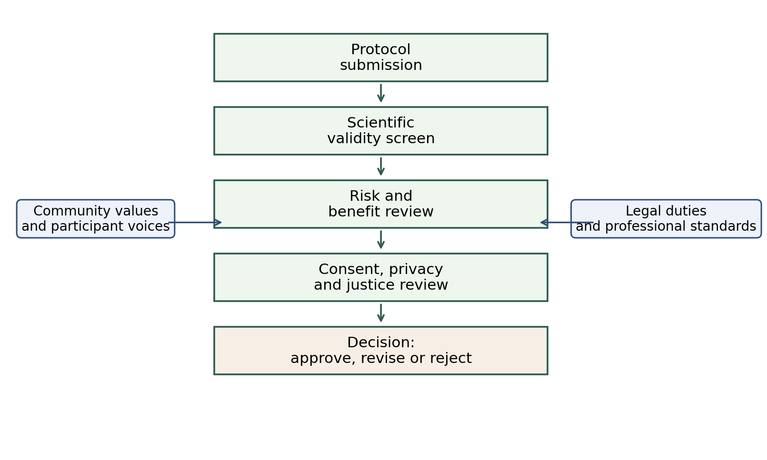
Figure 3. Ethics committee review model for high risk biotechnology research.
The role of ethics committees should be strengthened rather than weakened. Some researchers may view ethics review as bureaucracy, especially when innovation appears urgent. This view is mistaken. Independent ethics review protects research quality, public trust and professional legitimacy. However, committees must have the right expertise for advanced biotechnology. A standard medical ethics committee may not have sufficient genomics, data science, stem cell or reproductive ethics expertise. Committees should be able to request specialist review, community input and long term monitoring plans. They should also review conflicts of interest, especially where researchers have commercial stakes.
Legal frameworks are necessary but not sufficient. Law can prohibit dangerous practices, require approval, regulate data protection and penalise misconduct. Yet law is often slower than science. It can also vary across countries, creating opportunities for ethics shopping, where researchers or clinics move to jurisdictions with weaker regulation. International guidance from WHO, UNESCO, WMA and ISSCR helps reduce this problem by setting shared ethical expectations. Still, global guidance must be connected to national enforcement, institutional accountability and professional sanctions. Without enforcement, ethical declarations become symbolic.
A practical bioethical position should therefore be conditional and proportionate. Low risk genetic research may proceed with robust consent, privacy safeguards and fair recruitment. Somatic gene editing for serious disease may proceed where evidence is strong and long term follow up is required. Stem cell research may proceed under specialised oversight and transparent clinical translation standards. Heritable genome editing should not proceed for reproduction unless safety, medical necessity, societal consensus, legal approval and justice criteria are satisfied. Reproductive cloning should remain prohibited because the welfare, identity and commodification concerns are not resolved.

Strategic Recommendations for Responsible Biotechnology
Responsible biotechnology requires a governance model that is practical enough for institutions and strong enough to protect persons and communities. The following guidelines are recommended.
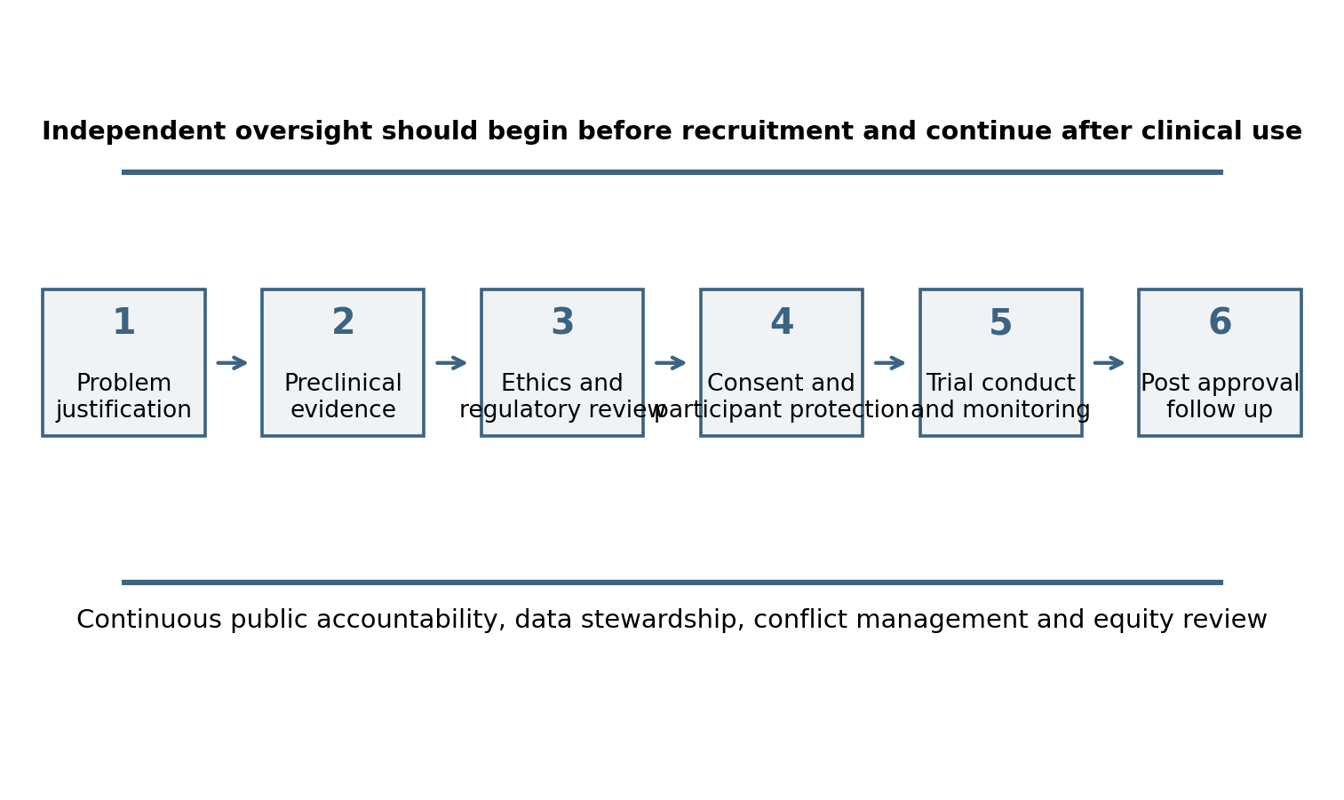
Figure 4. Responsible biotechnology pathway from problem justification to post approval follow up.
First, every biotechnology project should begin with a social value test. Researchers should explain the health problem being addressed, the population expected to benefit, and why the proposed method is necessary. This prevents novelty from being mistaken for value. Projects that use embryos, invasive cell collection or high risk gene editing should face a higher justification threshold.
Second, scientific validity should be reviewed as an ethical requirement. No ethics committee should approve a study that has poor design, weak preclinical evidence or unclear endpoints. In biotechnology, invalid research is harmful because it exposes participants to risk and may create misleading public expectations.
Third, informed consent should be layered. Participants should receive a clear summary, detailed technical information for those who want it, counselling where decisions are complex, and opportunities to revise preferences when data reuse or new findings arise. Consent materials should separate proven benefit from research uncertainty.
Fourth, genomic and cellular data should be governed through privacy by design. Data minimisation, secure storage, restricted access, transparent sharing policies and clear commercial use disclosures should be mandatory. Where familial findings are possible, protocols should explain how disclosure conflicts will be managed.
Fifth, ethics committees should include or consult specialist expertise. Biotechnology review should include expertise in genomics, stem cell science, data protection, law, clinical ethics, disability ethics and patient advocacy. Membership should be diverse enough to reduce professional blind spots.
Sixth, high risk applications should require public engagement before approval. Heritable editing, embryo research, reproductive technologies and large genomic databases affect social values. Public engagement should be early, documented and capable of changing the project design.
Seventh, clinical translation should require long term monitoring. Gene and cell therapies may have delayed harms. Approval should therefore include registries, adverse event reporting, patient follow up and transparent publication of results, including negative outcomes.
Eighth, justice should be built into funding and access decisions. Research sponsors and governments should consider how approved therapies will be made affordable, how underrepresented populations will be included in evidence generation, and how benefits will reach lower resource settings. Ethical innovation is incomplete if it produces therapies that are technically successful but socially unreachable.
Table 4. Strategic guidelines for responsible biotechnology and medical research.
Guideline | Action required | Ethical purpose
Social value threshold | Require clear explanation of the health need, target population and necessity of the method. | Prevents novelty without real benefit.
Evidence threshold | Do not approve high risk research without valid preclinical and methodological support. | Protects participants from invalid science.
Layered consent | Use plain language summaries, counselling, data use options and ongoing preference management. | Strengthens autonomy and reduces therapeutic misconception.
Privacy by design | Apply data minimisation, secure storage, access controls and transparent sharing policies. | Protects genomic identity and family interests.
Specialist ethics review | Add genomics, stem cell, disability, data protection, law and patient expertise. | Improves quality of independent oversight.
Equity plan | Require access, representation and affordability analysis before translation. | Prevents innovation from widening inequality.
Long term monitoring | Use registries, adverse event reporting and post approval follow up. | Detects delayed risks and protects public trust.
Note. The guidelines convert ethical principles into actions for researchers, ethics committees and regulators.

Conclusion
Modern biotechnology offers genuine possibilities for reducing suffering, diagnosing disease earlier and creating new forms of treatment. However, these benefits do not remove the need for ethical limits. Genetic testing, gene editing, cloning and stem cell research all show that biotechnology affects identity, privacy, family relationships, future persons and social justice. The central conclusion of this report is that bioethics should not be treated as an obstacle to innovation. It is the condition that allows innovation to become trustworthy.
A responsible approach must combine autonomy, beneficence, non maleficence, justice, human dignity and human rights. It must also recognise that consent forms and regulatory approvals are not enough by themselves. Biotechnology requires scientific validity, independent review, transparent risk communication, privacy protection, public engagement, long term monitoring and fair access. Somatic gene editing for serious disease can be ethically supported when these conditions are met. Stem cell research can be ethically valuable when it avoids exploitation and premature clinical claims. Genetic testing can empower patients when it includes counselling, confidentiality and discrimination safeguards. Heritable genome editing and reproductive cloning require much stronger restrictions because their risks reach beyond present participants.
The ethical goal is not to stop biotechnology. The goal is to make sure that scientific power remains accountable to human dignity, patient welfare and social justice. Innovation should proceed where it is evidence based, proportionate and fair. It should be slowed, revised or prohibited where it treats persons as means, hides uncertainty, exploits vulnerability or widens inequality.

References
Beauchamp, T. L., & Childress, J. F. (2019). Principles of biomedical ethics (8th ed.). Oxford University Press.
Council of Europe. (1997). Convention for the protection of human rights and dignity of the human being with regard to the application of biology and medicine: Convention on human rights and biomedicine. https://www.coe.int/en/web/conventions/full-list?module=treaty-detail&treatynum=164
Department of Health, Education, and Welfare. (1979). The Belmont Report: Ethical principles and guidelines for the protection of human subjects of research. https://www.hhs.gov/ohrp/regulations-and-policy/belmont-report/
Emanuel, E. J., Wendler, D., & Grady, C. (2000). What makes clinical research ethical? JAMA, 283(20), 2701-2711. https://doi.org/10.1001/jama.283.20.2701
European Commission. (2024). Artificial intelligence in healthcare. https://health.ec.europa.eu/ehealth-digital-health-and-care/artificial-intelligence-healthcare_en
Greely, H. T. (2019). CRISPR'd babies: Human germline genome editing in the He Jiankui affair. Journal of Law and the Biosciences, 6(1), 111-183. https://doi.org/10.1093/jlb/lsz010
International Society for Stem Cell Research. (2021). ISSCR guidelines for stem cell research and clinical translation. https://www.isscr.org/guidelines
Kaye, J., Whitley, E. A., Lund, D., Morrison, M., Teare, H., & Melham, K. (2015). Dynamic consent: A patient interface for twenty first century research networks. European Journal of Human Genetics, 23(2), 141-146. https://doi.org/10.1038/ejhg.2014.71
Lovell Badge, R., Anthony, E., Barker, R. A., Bubela, T., Brivanlou, A. H., Carpenter, M., Charo, R. A., Clark, A., Clayton, E., Cong, Y., Daley, G. Q., Fu, J., Fujita, M., Greenfield, A., Goldman, S. A., Hill, L., Hyun, I., Isasi, R., Kahn, J., ... Zandstra, P. W. (2021). ISSCR guidelines for stem cell research and clinical translation: The 2021 update. Stem Cell Reports, 16(6), 1398-1408. https://doi.org/10.1016/j.stemcr.2021.05.012
Marchant, G. E. (2021). Global governance of human genome editing: What are the rules? Annual Review of Genomics and Human Genetics, 22, 385-405. https://doi.org/10.1146/annurev-genom-111320-091930
National Academies of Sciences, Engineering, and Medicine. (2017). Human genome editing: Science, ethics, and governance. The National Academies Press. https://doi.org/10.17226/24623
National Academy of Medicine, National Academy of Sciences, and The Royal Society. (2020). Heritable human genome editing. The National Academies Press. https://doi.org/10.17226/25665
Nuffield Council on Bioethics. (2018). Genome editing and human reproduction: Social and ethical issues. https://www.nuffieldbioethics.org/publication/genome-editing-and-human-reproduction-social-and-ethical-issues/
Resnik, D. B. (2020). The ethics of research with human subjects: Protecting people, advancing science, promoting trust. Springer.
U.S. Food and Drug Administration. (2023, December 8). FDA approves first gene therapies to treat patients with sickle cell disease. https://www.fda.gov/news-events/press-announcements/fda-approves-first-gene-therapies-treat-patients-sickle-cell-disease
United Nations Educational, Scientific and Cultural Organization. (2005). Universal declaration on bioethics and human rights. https://www.unesco.org/en/legal-affairs/universal-declaration-bioethics-and-human-rights
World Health Organization. (2021a). Human genome editing: Recommendations. https://www.who.int/publications/i/item/9789240030381
World Health Organization. (2021b). Human genome editing: A framework for governance. https://www.who.int/publications/i/item/9789240030060
World Medical Association. (2024). WMA Declaration of Helsinki: Ethical principles for medical research involving human participants. https://www.wma.net/policies-post/wma-declaration-of-helsinki/
Zou, Y., Zhang, X., & Xu, L. (2025). Regulatory framework of human germline and heritable genome editing. Journal of Genetics and Genomics, 52(3), 231-240. https://doi.org/10.1016/j.jgg.2024.12.003

Appendices

Appendix A. Biotechnology Ethics Review Checklist
Appendix Table A1. Practical ethics review checklist.
Review question | Yes or No | Evidence required
Is the scientific purpose socially valuable? |  | Statement of health or knowledge benefit.
Are methods scientifically valid? |  | Protocol, preclinical evidence and statistical plan.
Are risks proportionate to expected benefit? |  | Risk benefit analysis and monitoring plan.
Is consent understandable and voluntary? |  | Participant information sheet and consent process.
Are privacy and data sharing controls adequate? |  | Data management plan and access rules.
Are vulnerable groups protected without unfair exclusion? |  | Recruitment plan and justification.
Is there a conflict of interest plan? |  | Disclosure and management process.
Is long term follow up required? |  | Registry or follow up schedule.
Note. This checklist can be used by a research team before formal submission to an ethics committee.

Appendix B. Indicative Consent Content for Genomic or Cell Based Research
• Purpose of the study and why the participant or donor has been invited.
• Procedures, samples, cell lines, genetic tests or data linkages involved.
• Expected benefits, if any, and a clear statement when direct benefit is unlikely.
• Known risks and uncertainties, including future data reuse and incidental findings.
• Confidentiality limits, data sharing arrangements and commercial use, if relevant.
• Options for withdrawal and the practical limits of withdrawal after de identification or publication.
• Contact details for questions, complaints and adverse event reporting.

Appendix C. Case Example Summary
The report uses the approval of Casgevy as an example of regulated somatic gene editing and the He Jiankui affair as an example of ethically premature heritable genome editing. The contrast is important. In the first case, a therapy moved through regulatory assessment for a serious disease. In the second case, reproductive embryo editing proceeded without adequate transparency, necessity or public legitimacy. Together, the examples show that the ethical status of biotechnology depends on purpose, evidence, oversight, consent quality and social consequences.

