
Planning and Management of Sustainable Tourism Spaces
Assignment 9
03.1.2025
Student Name: Jetender Singh
ID Number: DE240142

Table of Contents
Question 2 3
References 7

Question 2
The tourism industry is in a very sensitive environment in terms of commercial disruption like pandemics and recessions, natural calamities, political upheavals, and unexpected changes in regulations. The COVID-19 phenomenon reminded the travel industry of the rapid collapse of the industry under the conditions of travel bans and consumer insecurity. Resilient strategies targeting the need to adapt, manage costs, be innovative, and win customer trust are required to help tourism businesses survive and stay competitive in such disruptions. The following strategies are critical in ensuring that the tourism businesses survive the turbulent times and are ready to face any uncertainty in the future.
Business model diversification is one of the key strategies. Tourism businesses whose survival depends on a single source of income, like international tourists or seasonal visitors, will find it easier to survive during disruptions (Klamsaengsai et al., 2025). Some of the areas of diversification could include looking at the domestic markets, virtual tourism, merchandising, and provision of new services, including online culture workshops or destination gift products. As an example, hotels can provide coworking or long-stay options to remote workers, or travel agencies can switch to domestic slow-travel things. The diversification of the portfolio also results in businesses lessening their reliance on a particular group of customers and establishing sustainable sources of revenue.
The second important strategy is the transformation and integration of technologies. In the event of disruption, particularly pandemics, digital platforms are necessary in communicating with customers, service provision, and marketing. Virtual tours, online reservations, mobile apps, and chatbots are some of the tools that tourism companies can implement. The virtual or augmented reality experience enables customers to get to the destinations remotely, and this keeps the customer interaction alive even when physical travel is limited. Digital payments, touchless services, and smart check-ins are also ways to instill customer confidence in safety measures. Increasing profile, attracting new markets, and customer loyalty are achieved through social media and search engine optimization.
Cost restructuring and financial resilience are another strategy of significance. The financial pressure in times of disruption can rise considerably as a result of the low demand. Due to the unpredictable slowdowns, tourism firms should have flexible cost structures to survive (Matiku et al., 2021). This could involve resettling agreements, trimming down unnecessary costs, seeking government subsidies, and applying dynamic pricing theories. Creating emergency savings or resiliency funds will allow companies to meet operational expenses in times of low income. Recovery can also be supported by access to flexible financial mechanisms i.e., low-interest loans, credit lines, or crowdfunding.
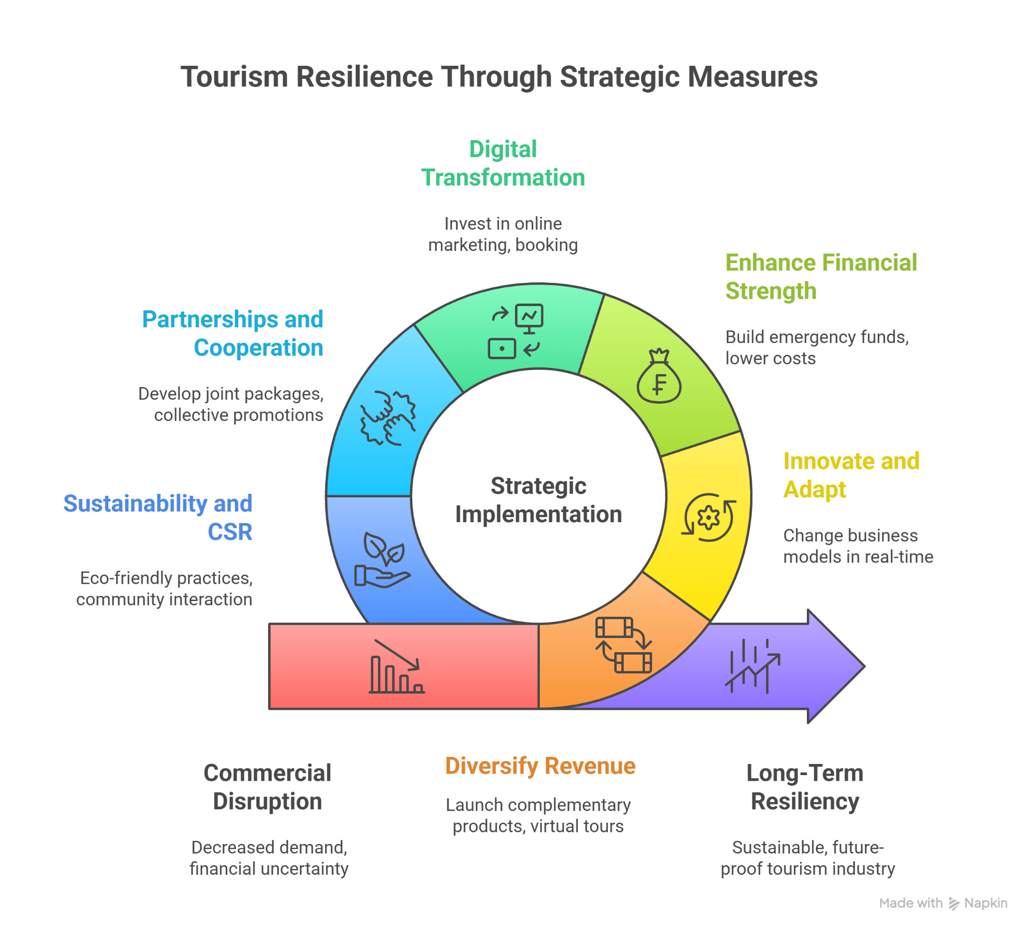
Figure 1: Tourism Resilience Through Strategic Measures
(Source: Self-Created)
Another way through which tourism businesses can be resilient is through strategic collaborations and partnerships. Through the networks of the industries, businesses have access to common marketing, collective bargaining, common resource pooling, and knowledge sharing. Indicatively, hotels, airlines, restaurants, and tour operators can partner to provide bundled packages, flexibility on cancellation, or loyalty programs. Long-term sustainability and the establishment of a better tourism ecosystem may be achieved with the help of partnerships with governmental agencies, technological enterprises, and local communities. Cross-sector deals also make innovation possible and open up new markets.
Rebuilding customer trust through safety and transparency is another strategy that is very important. In case of anomalies like pandemics, travelers are more sensitive to health risk, financial uncertainty, and travel prohibitions. Tourism companies should adopt transparent health and safety, hygiene protocols, and flexible cancellation rules in order to regain confidence. Openness with customers through websites, applications, and social media keeps the customer informed at all times. The possibility of taking out travel insurance and flexible reimbursement policies also makes it more likely that people will cease to be hesitant and make more bookings during unstable times.
Flexibility and workforce development of the human resources are essential for survival. Tourism enterprises usually depend on seasonal and service-based labor, and as such, they are susceptible during recessions or travel bans. Constant training, retraining employees to work with digital tools, and assisting employees in times of crisis improve loyalty and the quality of services. Making the most of possible remote work can enhance the flexibility of the personnel in the organization, when it comes to lowering the costs of labor as well as keeping the business operational. Employee support programs are also psychological and financial support programs that contribute to organizational morale and stability.
Product offering innovation is another important strategy. The tourism companies should be ready to redesign their services in accordance with the evolving customer demands. Wellness tourism, sustainable tourism, staycations, outdoor adventure experiences, ecotourism, and digital nomad packages are some of the trends that have gained prominence following the pandemic. It is more likely that businesses that are innovative and can change packages to match the needs of the current consumers will keep demand alive. Hotels can, e.g., create contactless spa services or personal tours, whereas transportation agencies can launch sanitized private shuttle services.
The strength of marketing and communication is also necessary. The brand presence in the disruption prevents the disengagement of the customers. Storytelling, emotional marketing, loyalty programs, and promotions that are targeted in nature can help the tourism business remind customers of the brand experience. The emphasis on value, flexibility, safety ,and uniqueness leads to customer retention. The marketing of the post-disruption should be based on the creation of trust, the promotion of new offers, and taking into account recovery-related experiences that appeal to reluctant travelers.
Lastly, there is a long-term plan for sustainability and resilience planning. The disruptions tend to reveal vulnerabilities in the operations of tourism. The integration of sustainability approaches, including local sourcing, use of renewable energy, and responsible tourism policies, provides efficiency, cost reduction, and reputation (Ijatuyi et al., 2025). Modern tourism planning is coming to a point of climate change, environmental protection, community involvement, and a focus on cultural preservation. The creation of risk management and continuity plans makes them prepared for any crisis in the future and improves the flexibility of the sector.
To sum up, the current surge of tourism enterprises should be flexible and resolute to overcome commercial shocks like pandemics and recessions. Tourism companies can overcome turbulence and emerge as stronger ones by means of diversification, digital innovation, financial planning, strategic partnerships, customer trust building, workforce flexibility, and sustainable development. Resilience is no longer optional but is a requirement to success in the long term in the tourism industry.

References
Ijatuyi, E.J., Yessoufou, K. and Patrick, H.O., 2025. Sustainable tourism and green space: exploring how green spaces and natural attractions contribute to local tourism economies and revenue generation in Gauteng province. Discover Sustainability, 6(1), p.236.
Klamsaengsai, S., Cheablam, O., Sasithornwetchakul, A., Churugsa, W. and Kaosiri, Y.N., 2025. Sustainable Tourism Assessment in Urban Green Spaces: The Case of Khung BangKachao, Thailand. Urban Science, 9(5), p.136.
Matiku, S.M., Zuwarimwe, J. and Tshipala, N., 2021. Sustainable tourism planning and management for sustainable livelihoods. Development Southern Africa, 38(4), pp.524-538.

