Customer Service in Tourism

Table of Contents
Slide 1: Introduction to Customer Service in Tourism 3
Slide 2: Role of Customer Service in Enhancing Visitor Experience 3
Slide 3: Economic Impact of Customer Service in Tourism 4
Slide 4: Challenges in Multicultural Tourism Settings 5
Slide 5: Verbal and Non-Verbal Communication in Tourism 6
Slide 6: Active Listening for Customer Service Staff 7
Slide 7: Using a Professional and Friendly Tone 9
Slide 8: Understanding Cultural Differences in Tourism 10
Slide 9: Adapting Communication Styles to Diverse Customers 10
Slide 10: Avoiding Stereotypes and Biases in Customer Service 12
Slide 11: Greeting and Welcoming Tourists Professionally 12
Slide 12: Providing Clear Information and Recommendations 13
Slide 13: Strategies for Handling Language Barriers 14
Slide 14: Resolving Customer Complaints Effectively 15
Slide 15: Maintaining Professionalism Under Pressure 16
References 18

Slide 1: Introduction to Customer Service in Tourism
- Customer service shapes visitor experiences and influences tourism businesses.
- Multicultural settings require enhanced communication skills for staff.
- Effective service improves guest satisfaction and destination reputation.
- This training covers communication, cultural sensitivity, and complaint management.
Speaker Note:
This module focuses on what the acronym CUSTERS for the promotion of customer services in the tourism field. This makes it possible for communication to help create a happy guest who in the long run will return to use the services. With increasing multiculturalism, the staff has to work in a different way. In this training, aspects related to the verbal communications, non-verbal communication, culture, and customer complaint handling skills will be improved. Good service delivery helps to create a better image, enhances credibility and increases the reputation of a business.

Slide 2: Role of Customer Service in Enhancing Visitor Experience
- High-quality service creates positive, lasting memories for tourists.
- Professional and friendly interactions improve customer satisfaction (Hosany, Sthapit & Björk, 2022).
- Clear communication reduces misunderstandings and enhances trust.
- Exceptional service encourages repeat visits and positive word-of-mouth.
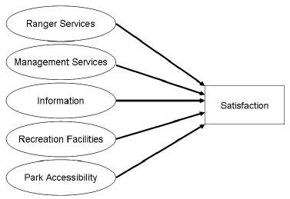
Speaker Note:
Lay customer cares down to ensure that every customer is appreciative of his or her visitation to the place. This perhaps can greatly aid in ensuring that visitors receive quality service provision since the staff are well communicating with one another. Courteous and official relations foster confidence, and satisfied guests would definitely recommend the hotels to others. When service is good also, the reputation of the destination attracts more tourists to the destination. Hence, good service delivery results in positive online reviews that can influence the potential visitors.

Slide 3: Economic Impact of Customer Service in Tourism
- Satisfied tourists spend more, boosting the local economy.
- Positive reviews attract more visitors and increase business revenue (Sthapit et al., 2023).
- Poor service can lead to negative online reviews and reduced bookings.
- Governments invest in training to enhance service quality and competitiveness.
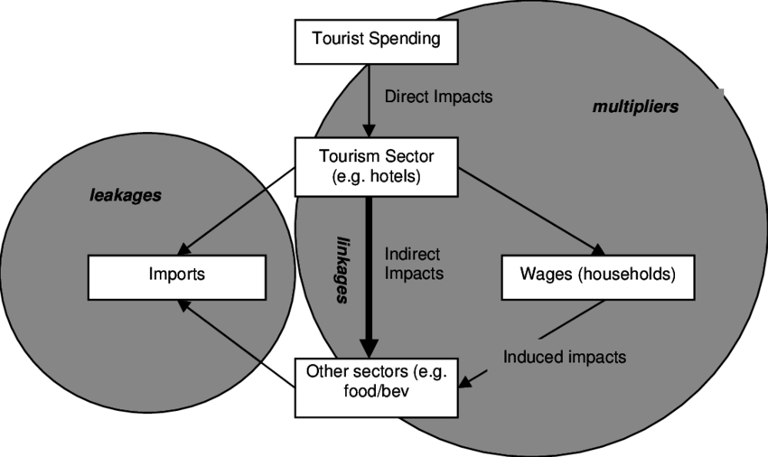
Speaker Note:
Customer service has a direct relationship to the economy of any destination. Tourism revenue is enhanced when the tourists are satisfied as they spend their money on accommodation, food, and attractions among other expenses. Thus, negative experiences lead to negative reviews and missing opportunities of receiving guests. This is true because most governments encourage training programs in a bid to ensure that high standards are observed in the provision of these services. Therefore, staff development improves guests’ experiences and provides a basis for higher levels of demand for tourism. Inefficient service delivery is likely to entice early departure of clients, thus affecting the retail market locally.

Slide 4: Challenges in Multicultural Tourism Settings
- Language barriers can cause miscommunication and frustration.
- Cultural differences affect greetings, gestures, and service expectations (Astuti et al., 2024).
- Varying dietary, religious, and accessibility needs require staff awareness.
- Staff must adapt their communication styles to diverse customers.
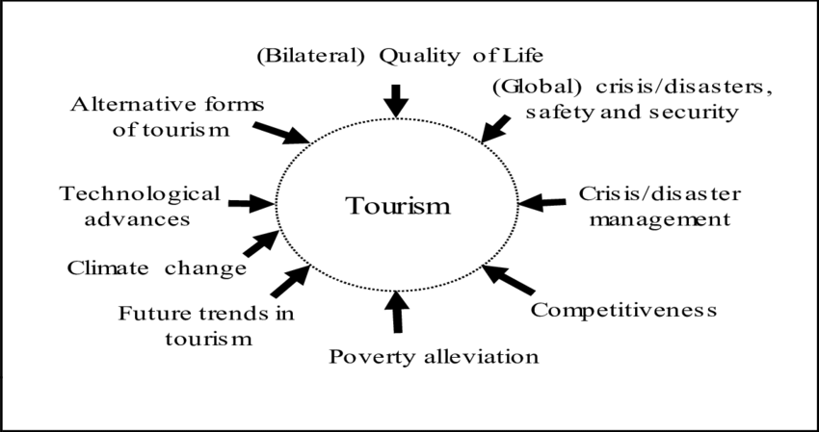
Speaker Note:
The issues of multicultural tourism include translation and interaction differences, among them language differences. The staff should be aware of various practices and resume that preference different clients by accommodating to clients’ individual difference. Thus, by being more adaptable and culturally sensitive in their delivery of services, it will be easier to accommodate more people with the service. It can be caused by a mistake of gesture or tone or a difference in etiquette which has to be paid special notice. It increases the probability that clients and co-workers will not be offended by an employee’s behavior. Acquiring knowledge of certain phrases in more than one language is advantageous in making an effective conversation with the guests.

Slide 5: Verbal and Non-Verbal Communication in Tourism
- Clear speech and polite language enhance understanding.
- Friendly body language, smiles, and eye contact build rapport (Pham Thi Phuong & Ahn, 2021).
- Avoid slang, idioms, and complex phrases with non-native speakers.
- Awareness of cultural differences in gestures prevents misinterpretation.
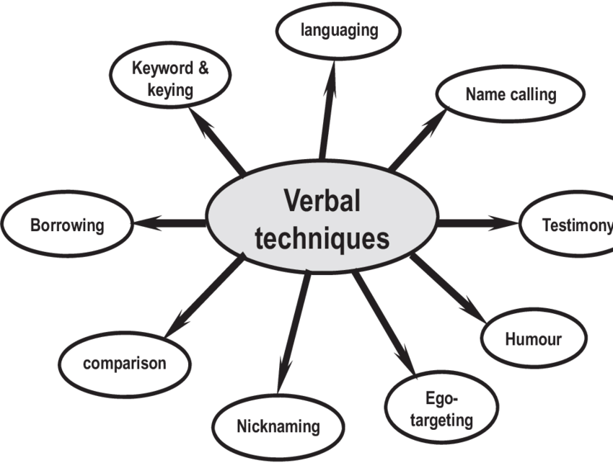
Speaker Note:
Customers often receive verbal and non-verbal communication service since it is a core aspect of boost up the business. Concise use of language helps pass information to guests effectively and appropriate staff posture makes a positive first impression on the guests. Not using slang is helpful for people, who do not know English idioms, and being careful with gestures may also cause offense in various nations.

Slide 6: Active Listening for Customer Service Staff
- Focus entirely on the customer without interruptions.
- Use nodding, paraphrasing, and affirmations to show understanding.
- Ask open-ended questions to clarify customer needs (Ma et al., 2022).
- Restate key points to ensure accurate communication.
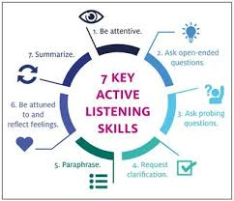
Speaker Note:
Listening is constructive in the course of providing customer service, and this may be referred to as active listening. Staff should avoid distractions and give an impression that they are interested in the customer and asking general questions to ensure that they capture all the details required from the customer. Repetition reinforces the idea presented and develops reliability of the information to the visitors. Continuing to look at the employee and expressing positive gestures strengthens appreciation of attention. Note taking is a good way of ensuring an individual does not forget some of the important aspects that they have just learned. Addressing concerns reflects the listener’s appreciation and helps them to have a clear understanding of their concerns.

Slide 7: Using a Professional and Friendly Tone
- Balance friendliness with professionalism in all interactions.
- Adjust tone based on the situation and customer needs.
- Use polite phrases like “How may I assist you?”
- Show enthusiasm in greetings but remain calm in complaints (Pu et al., 2023).
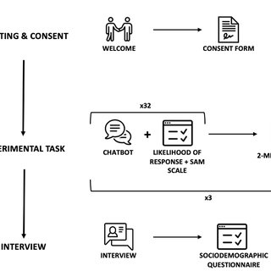
Speaker Note:
Developing a professional courteous tone towards the guests is important in enhancing good relations with the guests. Another point is that people are courteous when using language, and considering register in a certain situation contributes to obtaining pleasant outcomes. Guests can be welcomed excitedly, but when addressing the issue of their concern, manners must be calm.

Slide 8: Understanding Cultural Differences in Tourism
- Different cultures have unique communication norms and expectations.
- Greeting customs vary; some prefer handshakes, others bow (Hosany, Sthapit & Björk, 2022).
- Personal space preferences differ across cultures.
- Being culturally aware prevents misunderstandings and improves service.
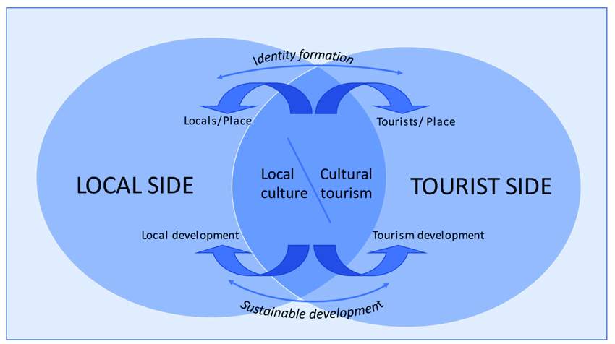
Speaker Note:
It is also important to point to the fact that culture plays a crucial role in interactions within tourism. Knowing the courtesies such as greetings, space, and ways of communication prevents creation of a serious offense to the clients by the different staff. Culture is important because it enhances and creates favorable impressions as well as reduces likelihood of cultural rapture.

Slide 9: Adapting Communication Styles to Diverse Customers
- Use simple, clear language with non-native speakers.
- Offer multilingual support through basic greetings or translation tools (Sthapit et al., 2023).
- Be flexible in tone and communication approach.
- Visual aids like maps and brochures enhance understanding.
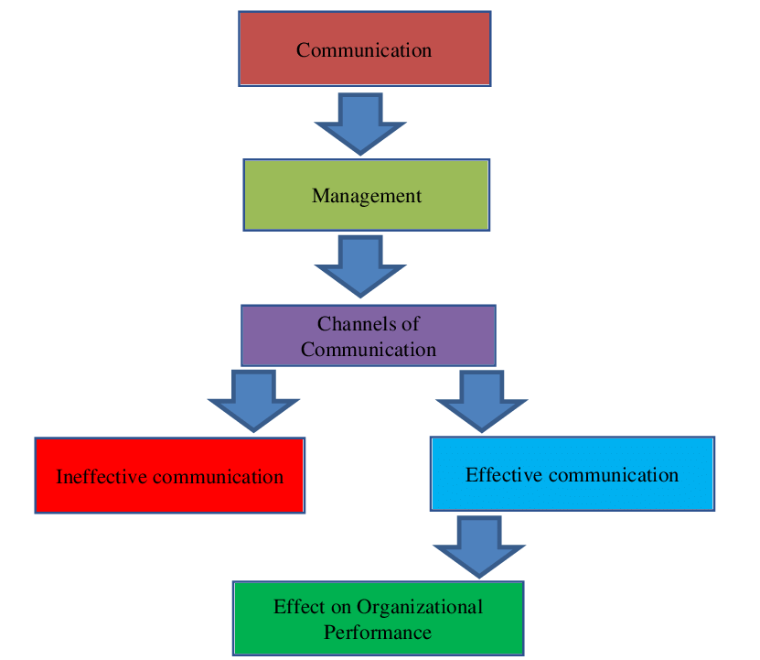
Speaker Note:
Adapting communication ensures inclusivity. That is why using simple to-comer language, the help of the translation instruments, and draws, too, is useful for non-native speakers to understand the text better. Imposing an extreme of a single working culture on others often proves uncomfortable to the members damaging the quality of the services offered Flexible attitude to working culture enables personnel to adopt their way of working knowing that therefore culture is quite different.

Slide 10: Avoiding Stereotypes and Biases in Customer Service
- Treat every guest as an individual, not based on assumptions.
- Avoid making generalizations about cultures or nationalities (Astuti et al., 2024).
- Show respect and curiosity when learning about customer preferences.
- Unconscious bias training helps staff deliver fair service.
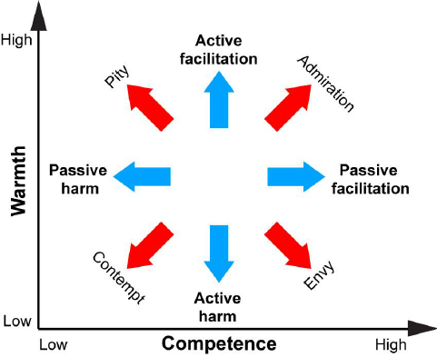
Speaker Note:
Stereotypes harm customer interactions. Employees have to work with every guest individually, they cannot make prejudices, and need to respect cultural differences. Prejudice recognition training eliminates cases of stereotype chiefly by focusing on offering equal services to all customers.

Slide 11: Greeting and Welcoming Tourists Professionally
- First impressions impact the overall customer experience.
- Use warm greetings and a respectful tone (Pham Thi Phuong & Ahn, 2021).
- Offer assistance proactively: “How may I help you today?”
- Adapt greetings based on cultural preferences.
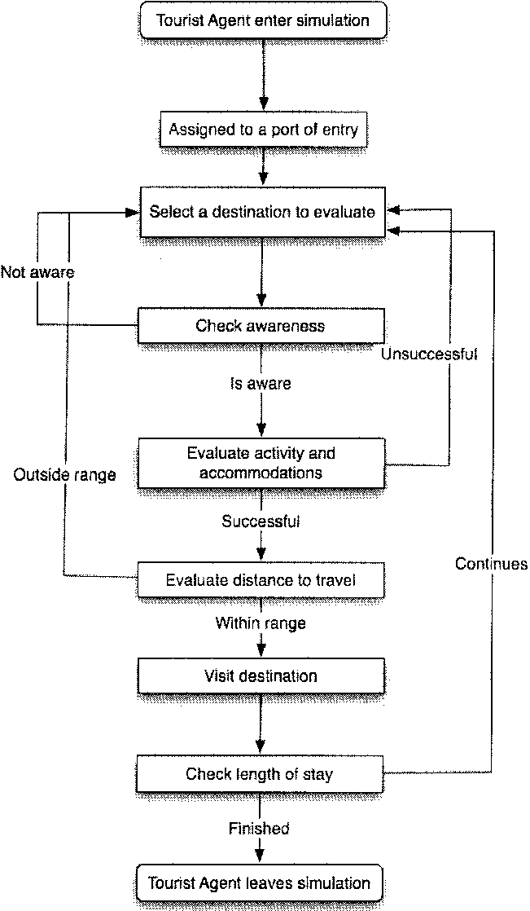
Speaker Note:
The first thing before anything can be achieved is to make the atmosphere warm and friendly to ensure the sessions run smoothly. The receptionist and proactive assistance of greetings increases the comfort and overall satisfaction of the guests while gains adaptation to any cultural systems.

Slide 12: Providing Clear Information and Recommendations
- Offer specific, relevant suggestions based on customer needs.
- Speak clearly and use simple language for clarity (Ma et al., 2022).
- Confirm understanding by asking, “Is this helpful?”
- Be enthusiastic when recommending local attractions.
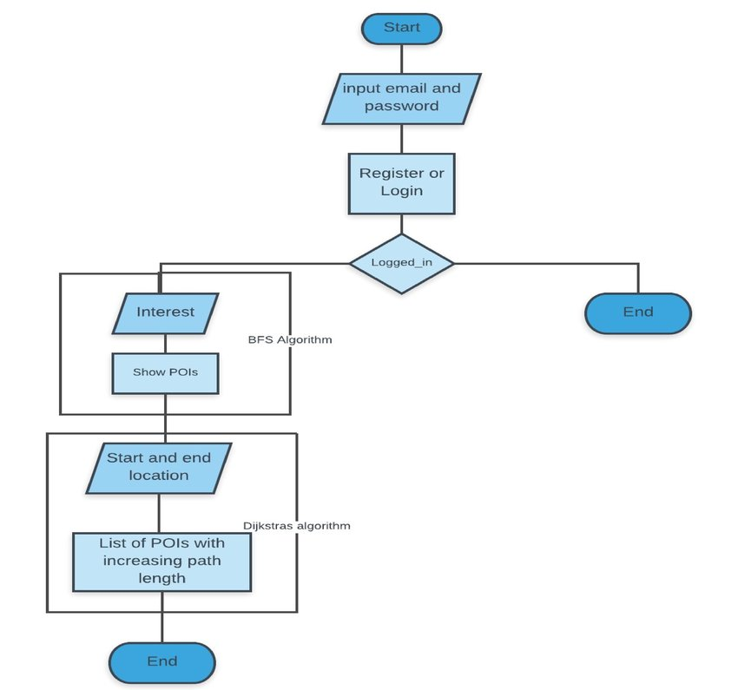
Speaker Note:
Due to it, tourists get proper direction information to help them in their tours. It is suggested that staff should address the visitors in simple language, make sure they understand what is said to them and demonstrate enthusiasm when suggesting or recommending a site of interest.

Slide 13: Strategies for Handling Language Barriers
- Speak slowly and clearly without raising voice (Astuti et al., 2024).
- Use gestures, maps, or translation apps to aid understanding (Pu et al., 2023).
- Learn basic phrases in common tourist languages.
- Stay patient and polite to reduce frustration.
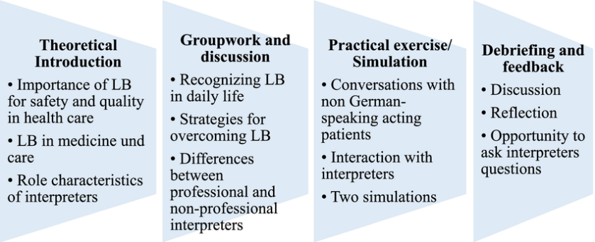
Speaker Note:
Conflicts of languages are closely associated with the concept of tourism. Having simple speech rate, using gestures and objects, and learning some basic words and phrases in various languages are the ways by which several communication barriers can be eliminated to ensure the guests are well communicated with.

Slide 14: Resolving Customer Complaints Effectively
- Listen actively without interrupting frustrated customers.
- Show empathy: “I understand how you feel.”
- Offer a solution promptly and professionally (Hosany, Sthapit & Björk, 2022).
- Follow up to ensure the customer is satisfied.
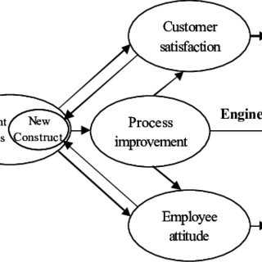
Speaker Note:
It is an indisputable fact that, how to handle complaints, one has to be patient and sympathetic. The best way of addressing customer complaints is to listen, admit the problem, presents the solutions, and then, to ensure that the customer is given feedback or inconclusive results.

Slide 15: Maintaining Professionalism Under Pressure
- Stay calm and composed, even with difficult customers.
- Use de-escalation techniques like lowering voice tone.
- Seek supervisor support if necessary (Sthapit et al., 2023).
- Focus on resolving issues rather than reacting emotionally.
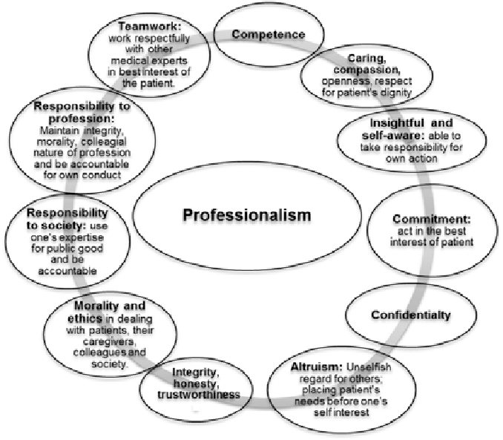
Speaker Note:
It is important in customer service that one should be professional so as to avoid portraying otherwise under pressure. For the staff, management should ensure that they do not develop aggressive behaviors, use aggressive words or gestures and should consider seeking assistance if attacked. By keeping her reactions to the work-related challenges rational rather than emotional, it is much possible to achieve the best solutions.

References
Hosany, S., Sthapit, E., & Björk, P. (2022). Memorable tourism experience: A review and research agenda. Psychology & Marketing, 39(8), 1467-1486. [Online]. Retrieved from: https://onlinelibrary.wiley.com/doi/abs/10.1002/mar.21665 [Retrieved on 29th March 2025].
Sthapit, E., Garrod, B., Stone, M. J., Björk, P., & Song, H. (2023). Value co-destruction in tourism and hospitality: a systematic literature review and future research agenda. Journal of Travel & Tourism Marketing, 40(5), 363-382. [Online]. Retrieved from: https://www.tandfonline.com/doi/abs/10.1080/10548408.2023.2255881 [Retrieved on 29th March 2025].
Astuti, E., Harsono, I., Uhai, S., Muthmainah, H. N., & Vandika, A. Y. (2024). Application of artificial intelligence technology in customer service in the hospitality industry in Indonesia: A literature review on improving efficiency and user experience. Sciences Du Nord Nature Science and Technology, 1(01), 28-36. [Online]. Retrieved from: https://north-press.com/index.php/snnst/article/view/15 [Retrieved on 29th March 2025].
Pham Thi Phuong, L., & Ahn, Y. J. (2021). Service climate and empowerment for customer service quality among Vietnamese employees at restaurants. Sustainability, 13(3), 1172. [Online]. Retrieved from: https://www.mdpi.com/2071-1050/13/3/1172 [Retrieved on 29th March 2025].
Ma, E., Wang, Y. C., Xu, S. T., & Wang, D. (2022). Clarifying the multi-order multidimensional structure of organizational citizenship behavior: A cross-cultural validation. Journal of Hospitality and Tourism Management, 50, 83-92. [Online]. Retrieved from: https://www.sciencedirect.com/science/article/pii/S1447677021002138 [Retrieved on 29th March 2025].
Pu, P., Cheng, L., Samarathunga, W. H. M. S., & Wall, G. (2023). Tour guides’ sustainable tourism practices in host-guest interactions: when Tibet meets the west. Tourism Review, 78(3), 808-833. [Online]. Retrieved from: https://www.emerald.com/insight/content/doi/10.1108/tr-04-2022-0182/full/html [Retrieved on 29th March 2025].

