ASSIGNMENT TITLE: TALENT MANAGEMENT

TOPIC: CRISIS-DRIVEN TALENT RETENTION PLAN IN TOURISM (REPORT)

STUDENT NAME: MANSI DHANJAL
STUDENT ID: DE240028

TABLE OF CONTENTS
Title | Page no.
Introduction
Background | 3
Objective | 3
Main Body
Crisis Communication Strategy | 4
Safeguard Reputation | 5
Reduce Harm | 6
Manage Public Opinion | 7
Maintain Trust | 8
Support Decision-Making | 9
Provide Timely and Accurate Information | 10
a. Sample Internal Memo | 11
b. FAQ for staff | 12
c. Staff Video Message Script | 13
Emotional Intelligence, Mental Well-Being & Remote Onboarding
Emotional Intelligence in Leadership | 14-16
Mental Well-Being Initiatives | 17-19
Remote Onboarding for New Hires | 20-21
Talent Analytics Post-Crisis
Talent Analytics Post-Crisis: Leveraging Data for Resilience and Growth | 22-23
Conclusion
Summary | 24
Key Finding | 24
Recommendations | 24
References | 25-26

- INTRODUCTION

  - Background
Crisis and Innovation:
The concept of crisis encompasses a variety of definitions that can be classified into macro and micro levels. While both types adversely affect organizational performance, macro-level crises arise from external factors beyond an organization's control, such as natural disasters or economic recessions, whereas micro-level crises are internally generated and avoidable, like service failures. This report focuses on the pandemic as a macro-level crisis that poses an immediate threat to both human life and business continuity.
Stakeholder Theory in Crisis Management:
A crisis is characterized as an unforeseen event that jeopardizes significant stakeholder expectations, potentially leading to severe repercussions for an organization's performance. This definition is consistent with stakeholder theory, which asserts that a firm's success relies on the individuals, groups, and institutions integral to its operations, while also acknowledging that a firm's actions can significantly influence the welfare of these stakeholders.

  - Objective

- Crises often drive innovation and transformation in hospitality. To survive and maintain customer trust, hospitality businesses have rethought and revamped:
- Operations
- Guest experiences
- Health and safety protocols
- There remains limited understanding of the innovative strategies adopted by international hotel chains in response to crises.
- During crises like pandemics or natural disasters, the tourism sector is heavily affected, often leading to:
- Furloughs
- Reduced working hours
- Layoffs
- MAIN BODY

  - CRISIS COMMUNICATION STRATEGY
An effective crisis communication strategy seeks to reduce harm, promote transparency, uphold trust, and facilitate informed decision-making. Its objectives include safeguarding reputation, alleviating adverse effects, shaping public perception, and delivering prompt information. The aim is to navigate the crisis adeptly, possibly transforming it into a favourable result by showcasing authenticity and openness.

Figure 1. Layout Of Crisis Communication Strategy

    - Safeguard Reputation
A key goal is to safeguard the organization's reputation and brand image during and after a crisis. To maintain an organization's reputation in such situations, it is essential to communicate quickly, clearly, and consistently. A designated spokesperson should deliver timely updates, demonstrating transparency and accountability. It is vital to recognize the issue, express empathy for those affected, and outline the immediate actions being taken. commitment to resolution. After the crisis, evaluate the response and address any long-term reputational concerns. By being proactive and honest, organizations can preserve trust and credibility even in challenging times.

Figure 2.

    - Reduce Harm
The strategy should focus on mitigating the effects of the crisis across various areas such as financial performance, operations, and stakeholder relations. To reduce harm during a crisis, organizations need to respond quickly and strategically to manage the situation. The initial step involves evaluating the extent and potential consequences, followed by implementing a pre-planned crisis response strategy. Early communication with key stakeholders is essential to avoid speculation and alleviate uncertainty. Providing accurate information, addressing any misunderstandings, and being available for follow-up questions is crucial. Internally, it is important to keep staff informed and unified in their messaging. Externally, collaborating with media and public channels is necessary to shape the narrative. A well-organized and transparent response greatly diminishes long-term operational and reputational risks.
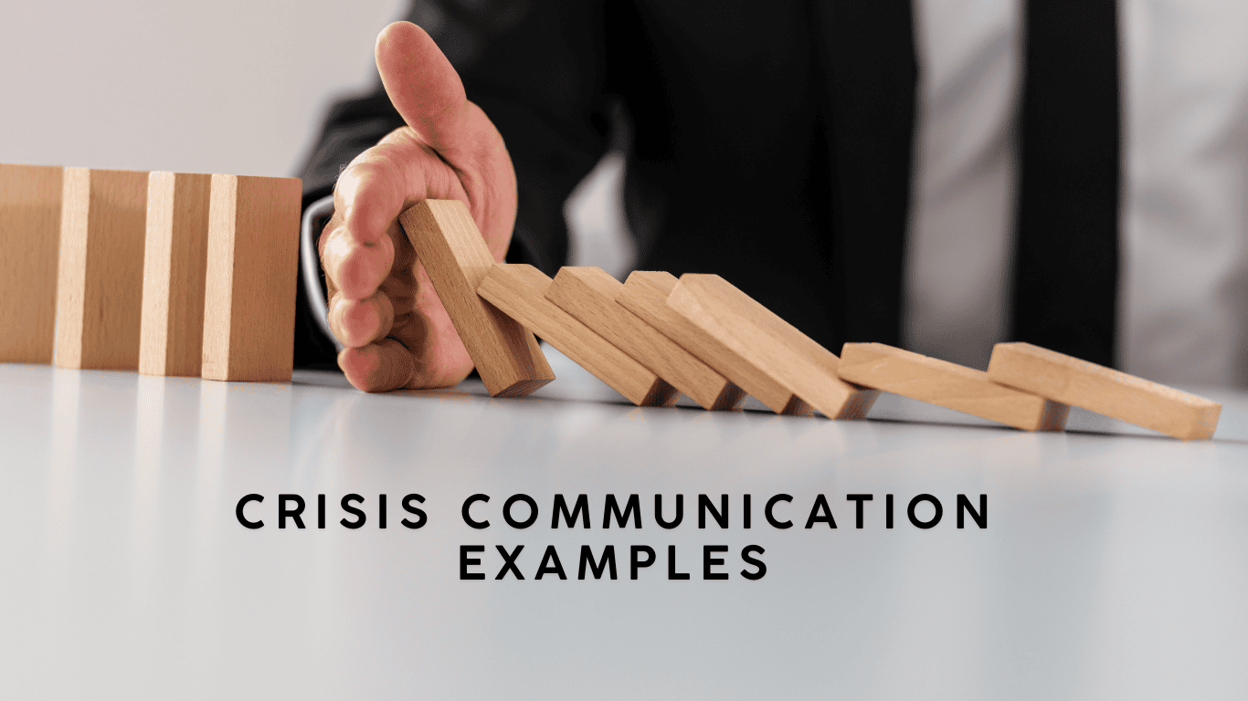
Figure 3.

    - Manage Public Opinion
Effective communication plays a crucial role in shaping the public's view of a crisis and the organization's response. To effectively manage public perception during such times, organizations should focus on transparency, empathy, and consistency in their communications. Public opinion is influenced not only by the facts presented but also by the manner in which they are conveyed. A well-defined narrative that recognizes the problem, takes responsibility when necessary, and details corrective measures can foster trust. Engaging with the public in a respectful manner, actively listening to their concerns, and providing timely responses is vital. By demonstrating accountability and sincere concern, organizations can steer public opinion towards a more positive perspective.
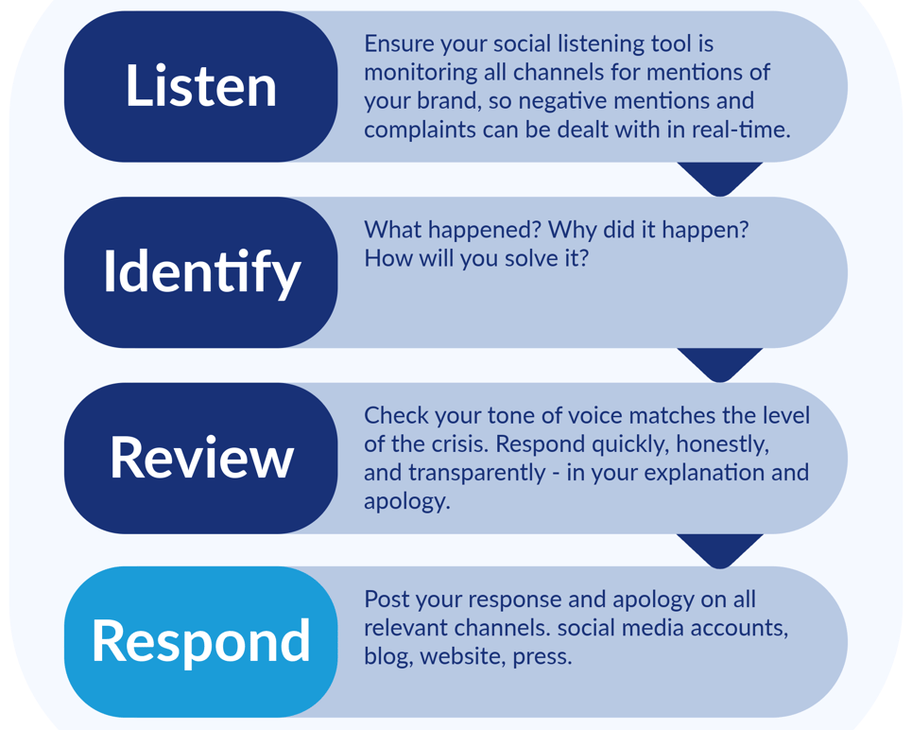
Figure 4. Crisis management - listen, identify, review, respond.

    - Maintain Trust
Upholding transparency, consistency, and responsible actions is essential for building or restoring trust with stakeholders. During a crisis, organizations need to be honest, responsive, and empathetic to maintain that trust. Clear communication that recognizes the problem and presents a definitive plan of action reflects integrity and strong leadership. It is important to avoid withholding vital information or minimizing the situation, as this can damage credibility. Demonstrating concern for those impacted and accepting responsibility, when necessary, highlights the organization’s dedication to ethical practices. Providing regular updates, even when new information is scarce, helps reassure stakeholders of ongoing efforts. By ensuring that actions consistently match words and values, organizations can maintain stakeholder confidence and navigate through the crisis while retaining their trust.

Figure 5. Role of Crisis Communication in Maintaining Trust

    - Support Decision-Making
The communication strategy should equip leadership with immediate insights and information to inform their decisions. Effective decision-making during a crisis relies on clear, precise, and prompt communication. Leaders need dependable information to evaluate risks and make well-informed decisions. An organized communication process guarantees that essential updates are delivered to decision-makers promptly and accurately. Open internal communication encourages teamwork and alignment among departments, minimizing confusion and facilitating rapid responses. On the external front, consistent messaging is crucial for managing stakeholder expectations and instilling confidence in leadership. Robust communication ultimately results in improved, quicker, and more strategic decision-making.

Figure 6. Importance of decision making in crisis management

    - Provide Timely and Accurate Information
It is crucial to provide stakeholders with timely and accurate updates to manage expectations and avoid misinformation. In crisis communication, delivering reliable information is vital to mitigate panic, uphold credibility, and prevent the spread of false information. Any delays or inaccuracies can worsen the situation and erode trust. Creating a central point of reference—like a dedicated webpage or a designated spokesperson—can help manage the narrative and reduce confusion. Frequent updates, even if they only serve to affirm ongoing actions, reflect transparency and a commitment to responsiveness. By proactively addressing rumours and keeping stakeholders informed, organizations can promote calm, build trust, and encourage collaboration during a crisis.

Figure 7. Practice to Provide Timely and Accurate Information

a. Sample Internal Memo
Subject: Update on Our Commitment to You During This Crisis
To: All Team Members
From: General Manager
Date: [Insert Date]
Dear Team,
In these uncertain times, our top priority remains your safety, job security, and well-being. Though we’re facing operational challenges, we are committed to keeping you informed and supported.
We are taking these immediate steps:
Reducing working hours rather than cutting jobs
Launching a Wellness Helpline and virtual counselling
Creating a flexible work and leave policy
Please stay connected with your department heads and HR for updates. We believe in the strength of our team and are confident we will overcome this together.
Warm regards,
[Manager’s Name]

b. FAQ for staff
- Will I lose my job?
We are doing everything possible to avoid layoffs. Other cost-cutting measures are being prioritized first.
- What support is available for my mental health?
Free virtual counselling sessions and an employee support line are now active.
- Will we still receive benefits during reduced hours?
Yes. Health benefits remain unchanged even if working hours are adjusted.
- How will we receive updates?
Regular updates via email, WhatsApp groups, and video messages every Friday.
- What is the purpose of this crisis communication strategy?
The strategy is designed to ensure consistent, timely, and accurate communication during a crisis to protect our organization’s reputation, support decision-making, and maintain trust among stakeholders.
- Who is authorized to speak on behalf of the company during a crisis?
Only designated spokespersons from the Communications or Executive team are authorized to speak publicly or to the media. Staff should direct all external inquiries to this team.
- What should I do if I’m contacted by the media?
Politely decline to comment and refer them to [Insert Contact Info] in our communications Department. Do not speculate or share any internal information.
- Where can I get the latest updates?
Official updates will be shared via company email, the intranet, and during team briefings. Always rely on these sources rather than rumours or unofficial channels.
- How should I communicate with clients or customers?
Use approved messaging provided by your manager or the Communications team. If unsure, check before responding to avoid misinformation.
- What if I see misinformation about the crisis?
Report it immediately to your manager or the Communications team. Do not attempt to correct it yourself unless you have explicit authorization.
c. Staff Video Message Script
[VIDEO SCRIPT – STAFF MESSAGE]
[Leader appears on screen, calm and composed, speaking directly to the camera]
(Tone: calm, empathetic, positive)
"Hi team. I want to take a moment to speak to you personally. This has been a challenging time for all of us. I know many of you are worried about the future, your jobs, and your families. I want you to know that we are with you.
We are not just a workplace—we’re a community. We are working to protect your jobs, support your mental health, and plan for recovery. Your hard work and loyalty mean everything to us. Thank you for standing strong. Together, we will get through this."
Please take care of yourselves and look out for each other.
[Ends with a brief nod or reassuring smile]

Figure 8. Crisis Management Workshops

- EMOTIONAL INTELLIGENCE, MENTAL WELL-BEING & REMOTE ONBOARDING

  - EMOTIONAL INTELLIGENCE IN LEADERSHIP

Emotional Intelligence (EI) is the ability to recognize, understand, manage, and influence emotions—both your own and those of others. In leadership, EI is a critical skill that often distinguishes exceptional leaders from average ones.
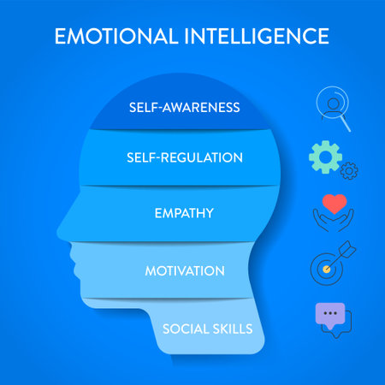
Figure 9. Key Components of Emotional Intelligence in Leadership

- Self-Awareness
  - Recognizing your own emotions and how they affect your thoughts and behaviour.
  - Leaders with self-awareness understand their strengths and limitations and are open to feedback.
- Self-Regulation
  - Controlling or redirecting disruptive emotions and impulses.
  - Emotionally intelligent leaders stay calm under pressure and make thoughtful decisions.
- Motivation
  - Being driven to achieve for the sake of achievement.
  - These leaders are passionate, optimistic, and committed to their goals.
- Empathy
  - Understanding the emotional makeup of others.
  - Empathetic leaders build strong relationships and make better decisions regarding team dynamics and morale.
- Social Skills
  - Managing relationships to move people in desired directions.
  - This includes effective communication, conflict resolution, and inspiring others.

Benefits of Emotional Intelligence in Leadership
- Understanding emotions helps leaders de-escalate tension.
- Leaders who connect emotionally with employees improve motivation and retention.
- EI-driven leadership supports a culture of respect, inclusion, and psychological safety.

Examples in Practice
- A leader calming an anxious team during a crisis by showing empathy and providing clear, reassuring communication.
- Giving constructive feedback that is honest but sensitive to how the person may receive it.

  - MENTAL WELL-BEING INITIATIVES
Mental well-being initiatives are programs, policies, or practices aimed at supporting psychological health in various settings—especially in workplaces, schools, and communities. These initiatives help reduce stress, improve productivity, and create healthier environments for individuals to thrive.
Common Types of Initiatives
    - Workplace Programs
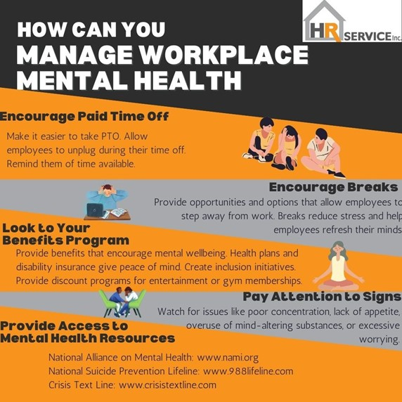
Figure 10. Managing Workplace Mental Health: A Step-by-Step Guide for Employers

- Employee Assistance Programs (EAPs): Free, confidential counselling services.
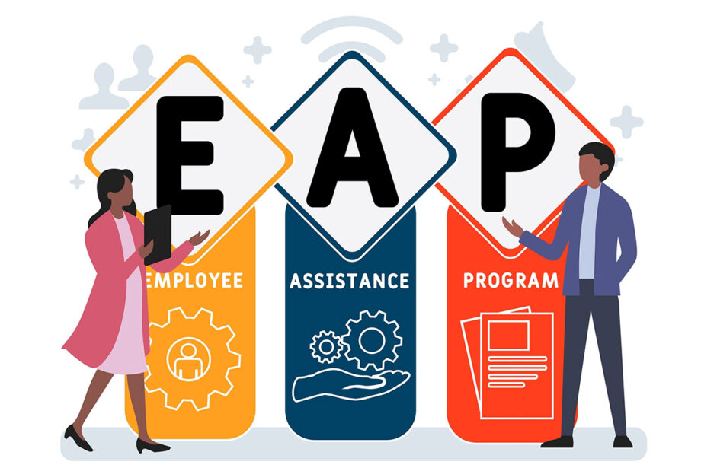
Figure 11. Employee Assistance Programs
- Flexible Work Arrangements: Remote work, compressed weeks, or flexible hours.
- Mental Health Days: Designated time off to recharge mentally.
- Mental Health Champions: Staff trained to promote mental health awareness and peer support.
    - Community-Based Initiatives
- Support Groups and Peer Counselling
- Public Awareness Campaigns
- Hotlines and Crisis Services
- Mental Health Screenings and Outreach Events
    - Best Practices for Effective Initiatives
- Leadership Buy-In: Mental well-being needs to be supported by top-level management or leadership.
- Cultural Sensitivity: Programs should reflect the diverse backgrounds of participants.
- Confidentiality and Trust: Ensure privacy in any mental health support offered.
- Regular Feedback and Evaluation: Assess impact and adapt initiatives as needed.
- Integration with Physical Health: Promote a holistic view of wellness.
Benefits of Mental Well-being Initiatives
Advantages of Mental Health Programs include decreased absenteeism and presenteeism, improved satisfaction among employees and students, boosted team morale and productivity, as well as enhanced coping strategies and resilience.

  - REMOTE ONBOARDING FOR NEW HIRES
Remote onboarding is the process of integrating new employees into an organization virtually, using digital tools and strategies. When done well, it helps new hires feel welcomed, supported, and productive—even without physical office interaction.

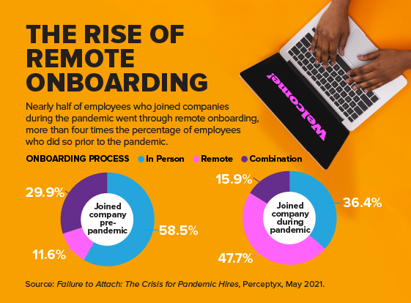

Figure 12. Rise Of Remote Onboarding

Key Objectives of Remote Onboarding
- Familiarize new hires with company culture, values, and policies
- Build relationships with team members and leadership
- Provide tools and training for job success

Essential Components of Remote Onboarding
1. Pre-boarding (Before Day One)
- Send welcome emails and a personalized onboarding schedule
- Ship necessary equipment (laptop, monitor, credentials, etc.)
- Share an onboarding portal or intranet with resources and documents
2. Day One Experience
- Virtual welcome session with HR and leadership
- Company overview, mission, and values presentation
3. First Week and Beyond
- Role-specific training and onboarding plans
- Scheduled check-ins with manager (daily or biweekly at first)
- Access to FAQs, organization charts, and key contacts
4. Ongoing Support
- 30/60/90-day check-ins to evaluate progress
- Regular feedback and open communication
Best Practices for Remote Onboarding
- Personalize the Experience: Tailor content to the new hire’s role and background
- Use Multiple Communication Channels: Email, video calls, instant messaging
- Foster Community: Encourage team interaction through virtual meetups or interest groups.

- TALENT ANALYTICS POST-CRISIS

  - Talent Analytics Post-Crisis: Leveraging Data for Resilience and Growth
In a post-crisis environment—such as after a pandemic, economic downturn, or organizational upheaval—talent analytics becomes a strategic tool for navigating uncertainty, rebuilding workforces, and driving sustainable performance.
Why Talent Analytics Is Critical Post-Crisis
- Reshape Workforce Strategies: Understand evolving workforce needs, skills gaps, and productivity levels.
- Support Agile Decision-Making: Enable data-backed decisions on hiring, retention, and redeployment.
- Monitor Employee Well-being: Track engagement, burnout risks, and mental health indicators.
  - Key Areas of Talent Analytics Post-Crisis
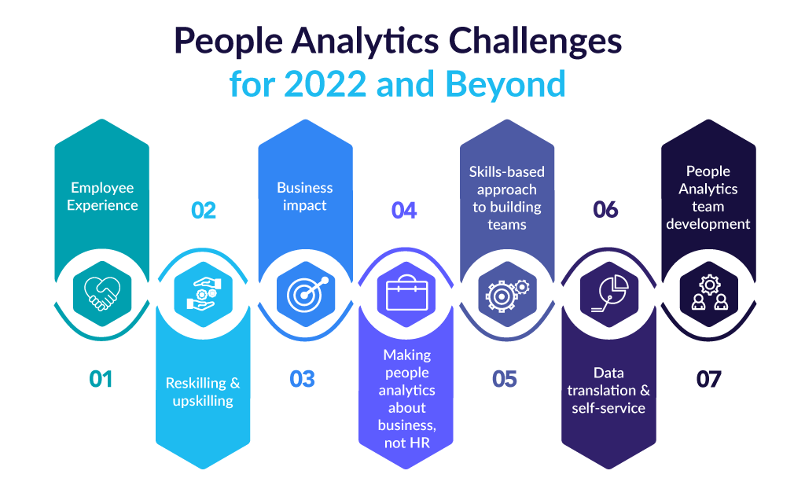
Figure 12. Rise Of Remote Onboarding
(Source: aihr.com)

  - Workforce Planning and Optimization:
- Forecast future talent requirements in alignment with business recovery strategies.
- Identify essential roles and vulnerable capabilities.
- Employ scenario modelling to prepare for transitions to hybrid or remote workforce arrangements.
  - Employee Engagement and Sentiment Analysis:
- Implement pulse surveys, sentiment analysis, and feedback mechanisms to assess employee morale.
- Detect indicators of burnout, disengagement, or potential turnover.
- Customize retention strategies to meet employee needs.
  - Skills Mapping and Reskilling:
- Evaluate the existing skill inventory against the demands of the post-crisis business environment.
- Identify high-potential employees for cross-training or upskilling opportunities.
- Facilitate internal mobility and career development using skill gap analysis.
  - Performance and Productivity Metrics:
- Analyse performance trends before and after the crisis.
- Utilize key performance indicators (KPIs) to evaluate the success of new work models, whether remote or hybrid.
- Ensure alignment of individual and team objectives with post-crisis priorities.
- Diversity, Equity, and Inclusion (DEI) and Representation Analysis:
- Review post-crisis diversity metrics to identify any regressions or advancements.
- Monitor promotion, hiring, and attrition rates across different demographics.
- Develop equitable hiring and retention strategies based on this analysis.
Tools and Technologies:
Utilize HRIS platforms such as SAP SuccessFactors and Workday, survey platforms like Qualtrics and Glint, and AI-driven dashboards for predictive insights.
Best Practices for Using Talent Analytics Post-Crisis
- Start with Strategic Questions: Tie analytics to business objectives.
- Ensure Data Integrity: Use clean, ethical, and well-governed data sources.
- Make it Actionable: Deliver insights that lead to specific, practical actions.
- CONCLUSION
Summary
An effective talent retention strategy during a crisis involves transparent communication, emotional awareness, support for well-being, and decisions based on data. The aim is to safeguard your most important asset—your workforce—ensuring a smoother and quicker recovery when normal operations resume.
In challenging times, keeping skilled talent is not merely a workforce concern; it is a crucial strategy for survival and recovery in the tourism industry.
Collaborating with industry partners and policymakers enhances the sector's capacity to endure disruptions and develop more resilient, adaptable workforces. Ultimately, investing in personnel guarantees that the tourism industry remains dynamic and ready for future challenges.
Key Finding
The most successful strategies for retaining talent during crises in the tourism industry are those that integrate flexibility, employee support, and proactive planning. Organizations that adopted adaptable workforce models, invested in reskilling initiatives, and focused on employee well-being were more effective in retaining essential staff, sustaining service quality, and expediting recovery. Furthermore, partnerships with government and industry organizations were vital in securing resources and influencing supportive policies.
Recommendations
1. Formulate Crisis-Ready HR Policies: Create flexible and scalable HR frameworks that can be swiftly implemented during emergencies.
2. Commit to Continuous Learning: Develop ongoing reskilling and upskilling programs to prepare the workforce for future challenges and enhance employee engagement.
3. Fortify Employee Support Systems: Introduce mental health programs, financial counselling, and employee assistance initiatives to promote staff well-being.
4. Improve Communication Practices: Ensure regular and transparent communication with employees to foster trust and alleviate uncertainty during crises.
5. Establish Strategic Partnerships: Work with government entities, tourism boards, and educational institutions to gain access to funding, resources, and policy assistance.
- References
Becken, S. and Hughey, K. F. D. (2013). Linking tourism into emergency management structures to enhance disaster risk reduction. Tourism Management (36), 77-85.
Birkholz, S., Muro, M., Jeffrey, P., and Smith, H. M. (2014). Rethinking the relationship between flood risk perception and flood management. Science of Total Environment, 478, 12-20. BMI (2022, March 29).
Braun, V. and Clarke, V. (2006). Using thematic analysis in psychology. Qualitative Research in Psychology, 3(2), 77-101.
Eldh, C. and Zillinger, M. (2022). Remote Effects of Terrorism on Tourists' Notions of Risk and Safety. In M. Valeri, Tourism risk: crisis and recovery management. Emerald Publishing Limited. Faulkner, B. (2001). Towards a framework for tourism disaster management. Tourism Management, 22, 135-147.
Faulkner, B. and Vikulov, S. (2001). Katherine, washed out one day, back on track the next: a post-mortem of a tourism disaster. Tourism Management (22), 331-344.
Fuchs, G. and Reichel, A. (2011). An exploratory inquiry into destination risk perceptions and risk reduction strategies of first time vs. repeat visitors to a highly volatile destination. Tourism Management, 32, 266-276.
Granot, H. (1997). Emergency inter-organisational relationships. Disaster Prevention and Management, 6(5), 305-310.
Grothman, T. and Reusswig, F. (2006). People at Risk of Flooding: Why Some Residents Take Precautionary Action While Others do not. Natural Hazards, 38, 101-120.
Jeuring, J. and Becken, S. (2013). Tourists and severe weather - An exploration of the role of 'Locus of Responsibility' in protective behaviour decisions. Tourism Management (37), 193-202. Karl, M. (2018). Risk and Uncertainty in Travel Decision-Making: Tourist and Destination Perspective. Journal of Travel Research, 57(1), 129-146.
Keim, M. E. (2008). Building Human Resilience: The Role of Public Health Preparedness and Response As an Adaptation to Climate Change. American Journal of Preventive Medicine, 35(5), 508-516.
Kreienkamp, F. et al. (2021, December 22). World Weather Attribution. Retrieved March 13, 2024, from www.worldweatherattribution.org
Kurleto, M. (2022). New Challenges in Tourism Management in the Face of Global Crisis Related to Climate Change. In M. Valeri, Tourism risk: crisis and recovery management. Emerald Publishing Limited.
Mair, J., Ritchie, B. W., and Walters, G. (2016). Towards a research agenda for post disaster and post-crisis recovery strategies for tourist destinations: a narrative review. Current Issues in Tourism, 19(1), 1-26.
McGee, T. K. (2011). Public engagement in neighbourhood level wildfire mitigation and preparedness: Case studies from Canada, the US and Australia. Journal of Environmental Management (92), 2524-2532.
Moreira, P. (2008). Stealth Risks and Catastrophic Risks: On Risk Perception and Crisis Recovery Strategies. Journal of Travel & Tourism Marketing, 23(2-4), 15-27.
Norris, F. H., Stevens, S. P., Pfefferbaum, B., Wyche, K. F., Pfefferbaum, R. L. (2008). Community Resilience as a Metaphor, Theory, Set of Capacities, and Strategy for Disasrer Readiness. American Journal of Community Psychology, 41, 127-150.
Nowell, L. S., Norris, J. M., White, D. E., and Moules, N. J. (2017). Thematic Analysis: Striving to Meet the Trustworthiness Criteria. International Journal of Qualitative Methods, 16, 1-13.
Poulaki, P., Stavrakis, I., Tarazonas, D., Vasilakis, N., and Valeri, M. (2022). Crisis Management in Tourism: COVID-19 Pandemic in Greece. In M. Valeri, Tourism risk: crisis and recovery management. Emerald Publishing Limited.
Ritchie, B. W. (2004). Chaos, crises, and disasters: a strategic approach to crisis management in the tourism industry. Tourism Management (25), 669-683.
Speakman, M. and Sharpley, R. (2012). A chaos theory perspective on destination crisis management: Evidence from Mexico. Journal of Destination Marketing & Management, 1, 67-77.
Tafel, M. and Szolnoki, G. (2020). Estimating the economic impact of tourism in German wine regions. International Journal of Tourism Research (22), 788-799.

