Operations Management in Hospitality

Assignment 17

Student Name: Kewal Kumar

Student ID: DE240138

Customers perceive deep discounts with stricter conditions as fair when the value exchange is clear and substantial
The customers are evaluating the exchange as fair when it comes to deep discounts in relation to harsher conditions because the exchange is transparent, voluntary and economically intelligible. A pre-paid restaurant seating, a non-refundable room reservation, or a pre-booked package, in hospitality revenue management, is considered a rate fence: the customer is offered a financial incentive, and the hotel is offered rate guarantee, preceding cash flow, and a reduced risk of cancellation. The trade-off implies that the fairness is enhanced since consumers can observe proportionality in what they forgo and on what they receive when the trade-off is explicit. Kim et al., (2023) suggests that travellers interpret the difference between the price of the non-refundable and free-cancellation offer as a kind of insurance premium, like the discounted price is accepted as a reward of taking more personal risk. Such a framing is relevant as it transforms the restriction into an option and not a punishment.
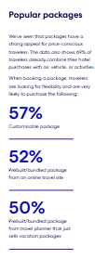
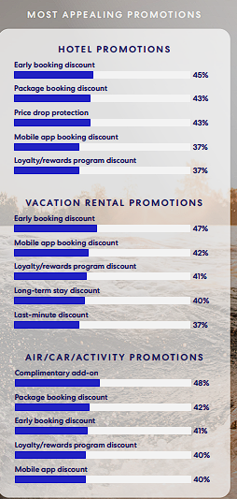

Figure 1: Popular packages and promotions
(Source: Expedia Group, 2025a)
Recent statistics about the industry reinforce this reasoning. According to Expedia Group (2025a) 47% of travellers would not buy non-refundable lodging in the country, and 57% will buy refundable lodging in an overseas trip: flexibility is a market value; thus, a hotel will have to provide a significant discount before lots of customers will willingly give it up. Recent market data also demonstrates the rationale behind flexibility bearing a clear consumer value: a survey conducted by McKinsey (2023) of over 5,000 travellers revealed that people are growing to value travel on their own terms, and the restrictive conditions of a booking will be accepted only once the price difference is significant enough to counterbalance the loss of flexibility. Such figures suggest that there is an opportunity cost of flexibility to suppliers. Hence, when a hotel rather makes a firm booking condition it is seen as fair only when the price concession is so big that it indicates the value of the forgone option.
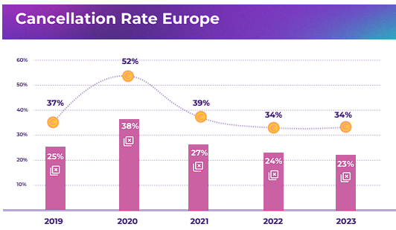
Figure 2: Cancellation rate for online booking
(Source: D-EDGE, 2024)
The context of the operations is important as well. According to D-EDGE (2024), hotel cancellation rates returned to normal in 2023 at 23% following an Apex in 2020 of 38% of revenue attached to online bookings but were cancelled in 2023. Similarly, SHR Group (2024) discovered that 23.1% of bookings were cancelled in 2023 and the direct-booking revenues lost to cancellations dropped to 15.4% in 2023 compared to 19.2% in 2022. Within that context, both a heavily discounted non-refundable price appears reasonable since the customers are free to conclude that the company has a legitimate managerial purpose: the company is not simply limiting them but trading off price with certainty of demand. Importantly, this is advocated by dual entitlement theory. When customers also obtain a plausible reward, customers take in companies safeguarding the profit. Therefore, deep discounts not only meet the requirements of economic reciprocity but also psychological fairness, and that is why they are commonly accepted in the hospitality markets.

Insignificant discounts combined with strict cancellation policies are unacceptable because they create an unfair and disproportionate burden on customers
Minor discounts and rigorous cancellation procedures are denied since the exchange is not fair in the proportionality test. Customers in hospitality do not mind restrictions as long as the restrictions seem to be under-compensated. When the discount is insignificant, then the guest forfeits flexibility, the right to refund and the right to react to travel arrangements but does not get much financial benefit in place of it. That imbalance triggers the sense of opportunism, as opposed to reciprocity. Kim et al., (2023) demonstrate that travellers can perceive cancellation flexibility as risk protection; so, when the price difference is insignificant, the flexibility-insurance premium is reasonable, and the restrictive alternative is exploitive instead of efficient. The discount is not as great as to justify the shifting of risk between hotel and the customer.
This conclusion is supported by recent evidence found in restaurants. Kim and Tang (2024) discovered that cancellation policies decrease restaurant ratings, although perceived fairness is better when strictness is lower and consumers are aware of the negative effects of no-shows on businesses. That is an acute fact in relation to hospitality operations: strict terms do not necessarily become unacceptable, but when the firms do not soften the rule, or both do not explain it convincingly, then they become unacceptable. Such reasoning is found in law and market. California has been asking hotels to provide no-cost cancellation within 24 hours of confirmation on bookings made at least 72 hours before arrival, that regulation, which started July 1, 2024, is indicative that lock-in is deemed unfair in the kind of transactions conducted with the public rate (CHLA, 2024). Regulation in this context is market norm and not technicality of law.
The existing market statistics explain the dangers of insignificant discounts. D-EDGE (2024) report that hotels have been able to tighten terms based on high demand once again, although a large percentage of travelers continue to seek post-pandemic flexibility that comes without a penalty, a persistent demand. The Global study of 11,000 respondents in 11 markets by Expedia Group (2025b) affirms that the priorities of the travelers have changed in the past five years. Simultaneously, Phocuswright (2024) estimates that online booking will represent two-thirds of travel bookings worldwide in 2026, implying that it will take a customer less time to become familiar with the rates and terms of online platforms. When the markets are so transparent with digital format, a small discount is added to a mean cancellation policy as it becomes revealed as bad value. Most importantly, it can undercut conversion, erode trust and drive business to other firms that have either superior flexibility, or a compensating reduction in price. That is why insignificant discounts and stringent policies should not be accepted as they do not comply with fairness and worsen the quality of perceptions and the quality of revenues overall.

Reference
Expedia Group (2025b) Traveller Value Index 2025. https://acotur.org.mx/wp-content/uploads/2025/08/Copia-de-expedia-group-traveler-value-index-report_en-us1.pdf
Kim, E. J., Kim, E. L., Kim, M., & Tanford, S. (2023). Post-Pandemic hotel cancellation policy: Situational cues as perceived risk triggers. Journal of Hospitality and Tourism Management, 55, 153–160. https://doi.org/10.1016/j.jhtm.2023.03.019
Expedia Group (2025a). Uncover the growing importance of travel, shifting traveler priorities, and emerging influences on booking. Retrieved from https://partner.expediagroup.com/content/dam/unified/partner/documents/reports/2025-reports/expedia-group-traveler-value-index-report_en-us.pdf
D-EDGE. (2024). Hotel Distribution Report 2024 Have Direct Bookings Reached a Peak? Retrieved from https://www.d-edge.com/wp-content/uploads/2024/04/Hotel-Distribution-Report-2024-EN.pdf
SHR Group (2024) Hotel Industry Trends Report 2024. https://www.traveldailynews.com/wp-content/uploads/securepdfs/2024/01/shr-group-hotel-industry-trends-report-2024.pdf
McKinsey. (2023, August). The state of tourism and hospitality 2024. Retrieved from McKinsey & Company website: https://www.mckinsey.com/industries/travel/our-insights/the-state-of-tourism-and-hospitality-2024
CHLA. (2024, June 10). Compliance Guide – 24-Hour Cancellation Requirements - California Hotel & Lodging Association. Retrieved April 14, 2026, from California Hotel & Lodging Association website: https://calodging.com/member_benefits/compliance-guide-24-hour-cancellation-requirements
Phocuswright. (2024, July 29). Global Travel Market Report 2024. Retrieved from Phocuswright.com website: https://www.phocuswright.com/Travel-Research/Market-Overview-Sizing/Global-Travel-Market-Report-2024

