

The Travel Tribe
A Comprehensive Business Plan for a Wellness Tourism Retreat

Course: Tourism and Recreation

Student Name: Arvinder Singh
Student ID: DE240016
Due Date: 1 April 2025

Executive Summary

The Travel Tribe is a ground-breaking wellness tourism retreat made specifically to extend transformative, health-centric getaways to its visitors. This era's fast-paced lifestyle not only leads more and more people to travel but also stimulates a search for paths to self-relaxation, not only to recover but also to regenerate mind, body, and spirit. Our resort caters to such needs using a broad spectrum of services such as yoga, meditation, nutritional counselling, and holistic wellness workshops. Located in a picturesque place, The Travel Tribe leverages cutting-edge wellness venues and sustainable practices, and the conjunction of these practices is carried out in an eco-friendly way, and the final result is the poise between oneself and the environment.
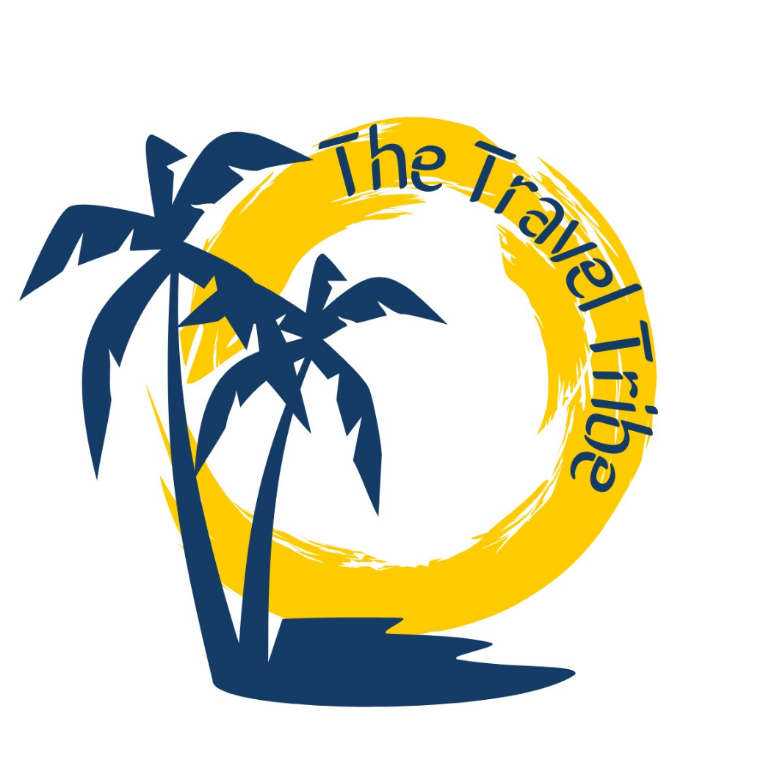
The Travel Tribe's initial and foremost idea is based on the conviction that well-being can be achieved only through the amalgamation of physical effort, psychic relaxation, and fuller nutrition. The venue's architecture and services are deliberately organized in a way that can attract a wide variety of customers, from hard-working professionals in search of a two-day retreat to individuals starting a longer path to self-improvement. Additionally, the business is based on the concept of sustainable tourism thus emphasizing the green movement and showing how health can be increased, as well as the environment and social aspects of a community can be protected(Abicht&Freikamp, 2005).
We conclude from our market analysis that wellness tourism is on the rise, as the increasing demand for retreats that combine health, leisure, and sustainability has been identified as a major trend. Considering that the main target is the middle to high-income sector, the ages of each individual in this group are from 30 to 65, the trend of a group for a well-being day, and the next in special programs of stress management, mental health. The information gained from the competitive analysis can be translated into a gap in the market for places that have a combination of the location, the environment, and wellness that is not only covered but also is a real thing, and a place. More about Residuals and Their Health Implications Article Writers You Can Rely On Competitive Analysis And Return On Investment, The Go-To Methods To Evaluate Success of Your Program, Work. The current market state is mainly represented by middle-aged and higher-income individuals and also points are valid for those individuals, families, or organizations that are searching for a place to stay and practice their wellness needs unblemished is rather insipid by such types of firms. Brief programs centred around the company's two main topics: reducing stress and promoting mental health(Boley&Sheth, 2018).
The focus of The Travel Tribe's business model is providing a unique value proposition through tailored wellness packages of high quality. Revenue sources will be from the direct booking of the retreat programs, the alliances with health and wellness product brands, the corporate wellness deals, and the sales of wellness products through both on-site and online channels. Operational strategies have been put in place, including a seamless booking system, modern facilities, and a group of highly skilled wellness professionals, to ensure the guest experience is at its best.
The business's financial forecasts show a clear increase in the profits micro and macro levels for the first five years, thanks to a strong marketing plan and tight-knit partnerships with customers. In-depth financial planning, starting from the cost of the setup, revenue projections, and the point of zero profit, is realized that the business model is viable and can bring long-term earnings coming from the retreat.
Risk management is an integral part of The Travel Tribe's strategy. Such potential risks as the fluctuations in tourism due to the season, a decrease in an economy, and unpredictable events (e.g., natural phenomena) are handled by the diversification of the revenue sources, insurance coverage of a wide range, and the operations of an adaptive cycle. Besides, the principle of the sustainable approach has been incorporated into all operations of the company, ranging from eco-friendly infrastructure and energy-efficient technologies to community activities that are supportive of the local environment(Bruyninckx et al., 2024).
Here's the gist. The Travel Tribe is a fashionably green, sustainable business concept that follows the new era of modern travellers looking for wellness and balance. With a well-researched and practical business plan that covers market analysis, operational strategy, and comprehensive financial planning, The Travel Tribe is perfectly positioned to be a top player in the wellness tourism sector, which is accelerating at an impressive rate.

Contents
Executive Summary 2
Market Analysis 6
Industry Overview 6
Target Market 6
Competitive Landscape 7
Market Trends and Opportunities 8
Business 9
Value Proposition 9
Revenue Streams 11
Pricing Strategy 12
Operational Plan 13
Location and Facilities 13
Staffing and Management 14
Technology and Systems 14
Day-To-Day Operations 15
Marketing Strategy 16
Customer Acquisition 16
Branding and Messaging 18
Sales Channels 18
Digital Marketing Initiatives 19
Financial Plan 20
Start-Up Costs 20
Revenue Projections 21
Profit & Loss Forecast 22
Risk Management 22
Identification of Hazards 22
Mitigation Strategies 23
Sustainability 24
Environmental Sustainability 24
Social Sustainability 24
Conclusion 25
References 26

Market Analysis

Industry Overview

The health tourism industry has experienced unprecedented development in the last ten years, driven by the rising consumer who is interested in health, sustainability, and holistic well-being. The data show that the world market for wellness tourism has been growing annually at a pace of 7-10%, and it appears that people are mostly seeking to experience relaxation and self-growth together. The market is not only operating in the luxury segment; a lower-income group also becomes aware of wellness issues and strives for affordable healthy lifestyle solutions even if the price is less of an issue(Connell, 2019).
The combination of progress in technology and growing knowledge of how a well-balanced lifestyle could benefit a person’s health has been part of the attractiveness of wellness destinations for people. Today’s consumers no longer travel for fun only, but they also want a personal development experience(Floyd & Choi, 2015). The changes in consumer behaviour together with the awareness of mental health problems have set up the scenario for the different wellness retreats offering specific programs for the physical and mental well-being that people need.

Target Market

The people who are fond of Travel Tribe's target market are numerous but specific enough and these are people who are willing to embrace wellness, sustainability, and change as part of their travelling experiences. The main ones are as follows:
- Affluent Professionals (Ages 30-65): Individuals seeking a break from high-stress careers, and interested in recharging their mental and physical health(Gössling et al., 2018).
- Corporate Clients: Companies that are in search of team-building and private wellness programs.
- Health-Conscious Families and Groups: Families and groups of friends looking for experience of closeness that boosts their overall well-being.
- International Tourists: People with eagerness to travel from affluent regions such as North America, Europe, and Asia to such an extent that they are more into hands-on experiences than those from other places are.
- Millennial and Gen Z Travelers: Young people who want to go out and see the world in a new and very real way, for example, by travelling to the wilderness and using energy-efficient gadgets, are the ones who are increasingly interested in authentic, immersive experiences, including wellness, and sustainability.

Competitive Landscape

The wellness tourism market is highly competitive as it includes an array of existing retreats and resorts that provide the same services. Yet, most of these options are only able to deliver such a limited number of services, such as inclusion of one or two eco-friendly practices without taking the sustainable management and authenticity of the local culture into account. Moreover, there is a big gap in the market for a retreat centre that provides wellness services and at the same time facilitates community-based projects and environmentally friendly operations(Hausmann, 2007).
Among the major opponents worth noting are the wellness resorts for the well-off, the small retreats for nature fans, and the travel offers inspired by the active lifestyles of the holidaymakers. A wellness ecosystem is a notion that stands for a great therapist, such as yoga and meditation, as well as nutritional counselling and lifestyle enhancement workshops. Moreover, based on serene natural surroundings, it is a good fit for the exploration of relaxation and recharging life a spirit(Kenny &Kronenberg, 2020).
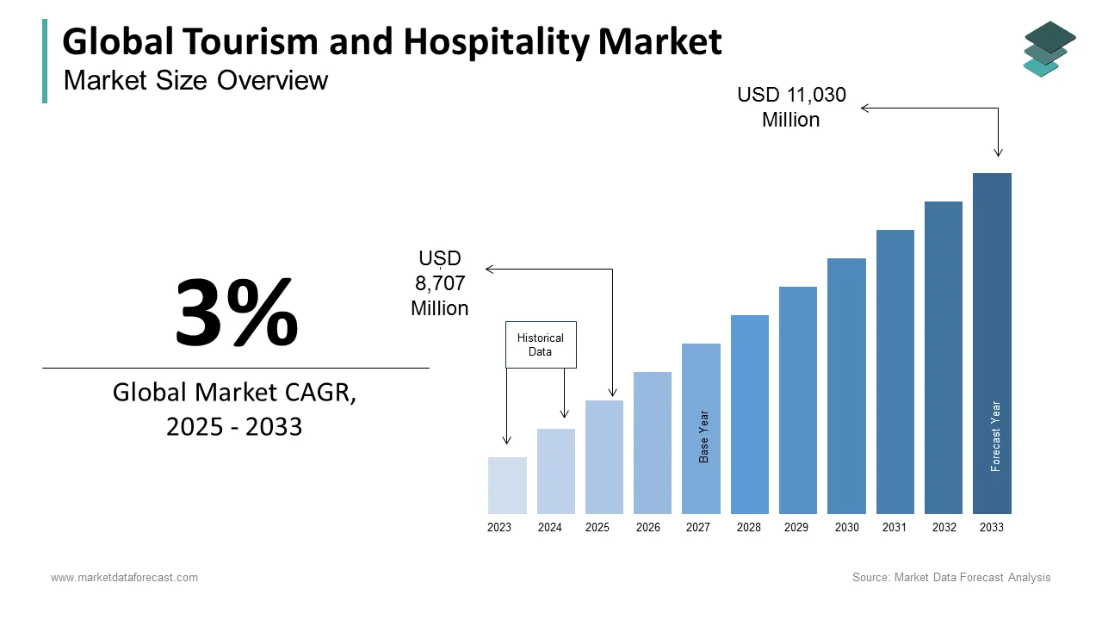
Source: https://www.marketdataforecast.com/market-reports/tourism-and-hospitality-market

Market Trends and Opportunities

Many wellness tourism trends are now in place that have metamorphosed the overall wellness tourism sector. These trends are:
- Technology Integration: Guests are more and more using apps and wearable devices to measure their health improvements, book classes, and get personalized health information.
- Comprehensive Health Approaches: More demand for holistic health retreats that not only refresh your body through exercise and workouts but also take care of your mental health through yoga and meditation and advise you about nutrition.
- Go Fresh! Go Green! Go Eco: The concerned public is now considered eco-friendly and thus the organizations involved in this industry are advised to follow this trend. Also, the initiatives that are community-friendly and the implementation of green practices are important considerations for the buyers.
- Customization and Personalization: Today, travellers are looking for packages that can be tailored to their exact health needs as well as preferences(Robinson & Lane, 2017).
- Post-Pandemic Recovery: The outbreak of COVID-19 has caused a related surge both in the consciousness of personal health, hygiene, and stress management requirements and in the interest in wellness retreats.
Opportunities for The Travel Tribe are partnerships with local health professionals, wellness brands, and community organizations to create an authentic, integrated service offering. Moreover, tapping into digital marketing channels to communicate with discrete segments is a relatively low-cost solution for brand awareness and customer acquisition(Lee et al., 2017).

Business

Value Proposition

The core of the business model of The Travel Tribe is a clearly defined value proposition that guarantees a wellness experience that is rich and transformative. Our retreat is uniquely designed to focus on the integration of the physical, mental, and nutritional well-being of an individual as a combined, harmonious, and one-piece package. The value proposition is made up of a few different elements including:
- Comprehensive Wellness Programs: We are able to provide our customers with a wide range of services such as yoga & meditation and nutrition counselling& wellness workshops, i.e. we make sure that every part of the customer's health is managed well.
- Customizable Retreat Packages: As we always realise that people are interested in taking a wellness journey, that fits only them, our services and packages are completely tailor-made.
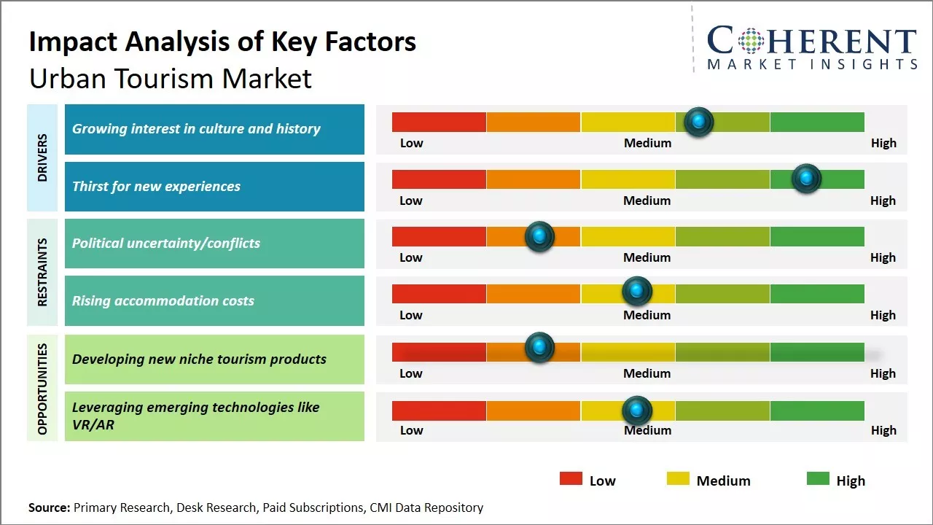
Source: https://www.coherentmarketinsights.com/industry-reports/urban-tourism-market
- Sustainable and Eco-Friendly Practices: The Travel Tribe is leading the way in the eco-friendly world. We have constructed our facilities using sustainable materials, energy-efficient systems, and waste-minimizing practices that show our intent to protect the ecology(Smith, 2019).
- Highly Qualified Team of Wellness Professionals: To carry out the mission of TTT, the team is comprised of well-qualified personnel who are experts in various fields such as yoga, meditation, nutrition, and wellness who can coach the customers accordingly. Through this, our guests will have professional help throughout the period of their stay.
Furthermore, the luxury of a non-pollution natural environment significantly contributes to relaxation and the restoration of health. The wild surroundings also serve as a visual representation of our sustainable mission(Stabler &Karg, 2016).

Revenue Streams

The key to financial stability and wider customer reach at The Travel Tribe Path lies in the diversification of revenue sources. The same revenue streams are:
- Direct Retreat Bookings: The major part of the money that will flow is purely when people will be making the wellness retreat bookings themselves. These are the services that can be ordered not just through the internet but traditional methods like travel agents as well(Boley&Sheth, 2018).
- Corporate Wellness Programs: Packages that are more oriented to the needs of companies will be created so that we can cater to them as well. This will include packages providing team-building workshops, counselling sessions, and employee wellness programs in general(Floyd & Choi, 2015).
- Ancillary Services and Product Sales: On-location sales of organic skincare products, health supplements, and branded clothes will also be an additional source of income. The main channel for this is not just the sale of the above through our physical space, but the online store will also be an extra sales point.
- Digital Wellness Platform: The delivery of virtual classes, wellness webinars, and the ability to individually track health, all through a monthly online subscription, will be a new revenue source, addressing also those segments that are beyond the grasp of physical guests(Hausmann, 2007).
- Partnerships and Sponsorships: Not only will the liaisons that we make with local suppliers, health professionals, and wellness brands elevate our service delivery, but they will also create room for the possibility of co-branding and sponsorship programs.

Pricing Strategy

Our pricing strategy indeed takes into account the quality and premium features of the services, the charges for which are highly competitive in the market. Some of the components that the pricing approach of our company is made of include:
- Offering buyers at least three different options for the same kind of product to meet everyone’s needs for which it is called tiered pricing (e.g., standard, premium, and luxury).
- Discounts can be a useful tool for companies to attract and seasonally adjust their customers’ life-cycle discounts during off-peak seasons by using seasonal discounts to control the volume. A flood of customers during fiscal year breaks can do a good job of earning profit by giving the best discounts on a seasonal basis as well as adjusting rates according to the situation.
- Attractive pricing is the tool used, besides quality services, to bring in and keep corporate groups and big reservations for events (gatherings, conferences, meetings). It encourages the corporate group to take the given services in the form of bulk contracts in which more profit would be reaped(Kenny &Kronenberg, 2020).
- By combining one such complimentary service as nutritional counselling sessions or private yoga classes with the main service, the total price charged becomes easier to explain. Also, this serves as another legitimization or a premium price of the main service itself(Robinson & Lane, 2017).
- Ours is to get the highest customer satisfaction, hence spreading the payment in parts and providing a discount for early booking is a better way of creating awareness and igniting the customer's early commitment(Stabler &Karg, 2016).

Operational Plan

Location and Facilities

The strategic position and infrastructure of The Travel Tribe are some of the key success factors for the business. The proposal has a calm and easily accessible location with a lot of available nature and not too far from cities. The suggested facility will be comprised of the following:
- Wellness Facilities: The idea for the wellness centres is a marriage of indoor and outdoor yoga studios, meditation gardens, and wellness halls that are all modern but warm, human-centric, and eco-friendly at the same time.
- Accommodation: There would be options for comfortable and environmentally friendly dwellings, that is, private villas or shared bungalows built with natural ventilation, solar panels, and eco-construction materials(Smith, 2019).
- Recreational Areas: The place is going to be surrounded by everything that will make the stay enjoyable, i.e. greens and flowers, cosy walking paths, and different water sources.
- On-Site Amenities: All that a retreat participant might need in terms of food and its source are catered by the variety of the healing, the heart disease healing, and the ~s that the local produce is used, a section for nutritional help, and spaces for cooking classes and wellness workshops are provided in the base of the retreat.
- Meeting and Event Spaces: The properties of workshops, conventions, or other types of friendly occasions, in addition to giving the guests pleasure, can be used for business purposes, such as conducting corporate and wellness seminars, events, etc.

Staffing and Management

The core team at The Travel Tribe is the key to our organizational success. The team we have in mind consists of the best of the best employees who have technical expertise and at the same time are motivated intrinsically. Our staffing structure features:
- Wellness Practitioners: The centre for yoga classes, meditation practices, fitness checks, and holistic care that our large number of certified members of the core team supports are our important existing programs. Though the change is not here yet, one should not forget it is still the focus.
- Nutritional Experts: Nutritionists and health advisors who have the professional qualifications to produce tailor-made dietary programs and conduct nutrition-related workshops(Kenny &Kronenberg, 2020).
- Management Team: The management team headed by experienced professionals capable of coming up with general strategies, managing the operations, and handling customer service and among them are the General Manager, Operations Manager, and Marketing Manager.
- Support and Administrative Staff: Customer service representatives, maintenance crews, housekeeping, and administration staff responsible for day-to-day operations running smoothly.
- Sales and Marketing Professionals: Executives leading digital marketing, brand partnerships, and corporate sales who are responsible for customer acquisition and brand awareness.

Technology and Systems

To give clients a trouble-free and sparkling experience, advanced technology solutions would be integrated into all the operations of The Travel Tribe:
- Booking and Reservation System: The system is a really good one where a person can easily make a reservation and pay for all and thus time their money is being processed and additionally, they can customize their own itinerary(Robinson & Lane, 2017).
- Customer Relationship Management (CRM): Software that is used for identifying a guest and their communication patterns allowing a hotel to communicate in a personal way and at the same time keep in their records the guest's service preferences.
- Wellness Tracking and Mobile Applications: A tie-up with wearable gadgets and mobile apps people can monitor their developments, make their orientation, and reach healthy living while they are away-from-home.
- Operational Software: Administrative tools relating to work schedule determination, management of stock, and control of financial details that also optimize the transparency aspect of the company.
- Digital Marketing Infrastructure: This includes the use of analytics, content management systems, and social media platforms that enable businesses to reach the desired customer base, therefore providing the most promising situation for companies to meet their goals and help them in the customer relationship lifecycle steps through various events technology and marketing automation that can be monitored by the company(Gössling et al., 2018).

Day-To-Day Operations

The daily operations at The Travel Tribe is a designed system that ensures that the best guest experience is provided from a guest's check-in to check-out. The most critical activities of the operational plan are as follows:
- Guest Reception: A smooth process of check-in/check-out stations through mobile apps and virtual kiosks, which deliver not only a personalized but an instant service.
- Program Scheduling: A daily program that has been created in such a way that it is balanced while meeting the requirements for health sessions, individual time, and optional partner programs at the same time, guests should indeed make themselves the same as this outline.
- Facility Maintenance: Regular cleaning, maintenance, and safety checks are included in the facility maintenance, and it ensures that all medical and hygiene standards are met.
- Food and Beverage Management: Organised and directed meals that were focused on local and organic produce and balance nutrition, cared for by the cooks and nutritionists.
- Customer Feedback and Service Recovery: The stage where all the customer's feedback is collected immediately, and the service recovery team is given immediate action that makes the ongoing quality of the service reliable.
- Emergency Protocols: Comprehensive safety steps and response plans for natural disasters, health crises, and other unexpected occurrences, together with staff training and exercises, are the cornerstone of safety procedures and emergency response(Boley&Sheth, 2018).

Marketing Strategy

Customer Acquisition

The Travel Tribe will develop a mixed customer acquisition strategy whose goal is to tap into as many market segments as possible. The primary tactics are as follows:
- Digital Marketing: Engaging SEO, PPC, and social media channels (Instagram, Facebook, LinkedIn) to communicate with people who are interested in healthy living and travel. The following are some of the content marketing projects: blogs, video testimonials, and wellness tips.
- Partnerships: Liaison travel agencies, corporate wellness providers, local health professionals, and lifestyle influencers in addition to contacting them to extend the market reach(Kenny &Kronenberg, 2020).
- Referral Programs: Setting up incentive-based referral programs that motivate past guests to bring in new clients, that is why it is organic word-of-mouth marketing.
- Public Relations: Getting promotions infamous for wellness, travel, and lifestyle media through press releases, interviews, and event sponsorships.
- Trade Shows and Expos: Running the wellness and travel expos to directly communicate with potential customers and industry partners(Robinson & Lane, 2017).
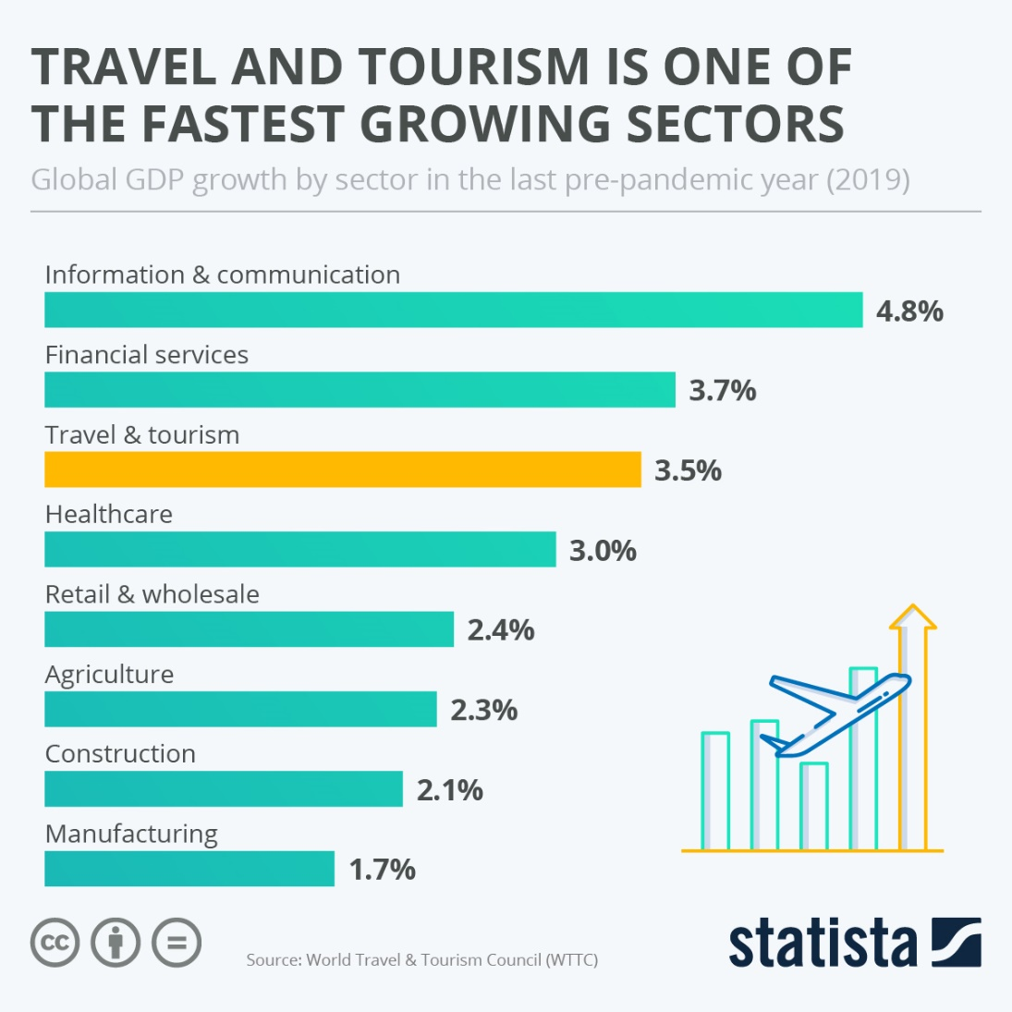
Source: https://www.statista.com/chart/29637/travel-and-tourism-gdp-growth/

Branding and Messaging

The strategy behind The Travel Tribe is all about genuineness, transformation, and sustainability. Our brand communication highlights:
- The aspect of Holistic Transformation: The presentation of the retreat as a trip that fuses physical, mental, and nutritional health.
- Community and Connection: The concept of The Travel Tribe is more than a retreatwhere participants make strong connections, and feel that they belong to an extended family.
- Sustainable Luxury: The demonstration of environmentally friendly measures and sustainable practices without sacrificing the quality and luxury of the retreat.
- Authenticity: Bringing to light real testimonials, behind-the-scenes content, and true stories of transformation that the target customers can resonate with(Smith, 2019).
Our visual branding will have a consistent application of a unique logo, a nature-inspired colour palette that is soothing, and stylish types every time there is a contact point like the website, social media pages, printed materials, and on-site signages.

Sales Channels

The Travel Tribe will apply more than one sales channel, which will be beneficial in the invasion of the primary and secondary target markets while the same will be a convenience to all customers which will ultimately lead to a wider clientele base:
- Direct Online Sales: A portal that is very easy to navigate and covers all the information fully how the customers can go and what they can enjoy the best services of becoming a part of the retreat to the wellness of the customers, especially with the use of eco-friendly products.
- Corporate Sales: A sales team will be put in place to run around looking for corporate clients who need the services for retreats, team-building, events, and wellness workshops.
- Travel Agencies and Third-Party Platforms: Collaborations with travel agencies having past practice with wellness tourism or internet travel agencies of the same nature will have potential guests be brought in to cover the same ground as existing channels/ locations thus reaching a new but the fitting audience of ideal customers.
- On-Site Sales: Business opportunities that include the retail sector, comprising the sale of wellness products and merchandise that go well with the guest experience(Smith, 2019).

Digital Marketing Initiatives

In the marketing set up, digital marketing is the main strategy we are using to build brand awareness and also to engage with potential customers(Abicht&Freikamp, 2005).
- Social Media Campaigns: Consistent, creative visuals and stories on Instagram, Facebook, and LinkedIn that feature guest experiences, retreat activities, and off-stage events(Stabler &Karg, 2016).
- Email Marketing: Advertised, timely email campaigns targeted at former guests, potential clients, and corporate accounts with newsletters, promotions, and tailor-made health tips.
- Search Engine Optimization (SEO): Regularly produced content-related and website optimization things that boost the rankings for the keywords of wellness retreats, sustainable travel, and holistic health are in trend.
- Content Marketing: Creation of high-quality articles, e-books, and video content that shows public wellness trends, environmental sustainability, and life-changing stories of personal transformation.
- Influencer Partnerships: Working together with wellness influencers and travel bloggers to not only increase our presence but also to drive trust in the brand(Hausmann, 2007).

Financial Plan

Start-Up Costs

Opening a wellness hotel for The Travel Tribe company will mean that the start-up costs are going to contain the following main:
- Property Acquisition/Lease: Get hold of a place in a smart location that also has natural beauty, is easily reachable and is big enough to make the entire project possible of a full-scale wellness retreat(Kenny &Kronenberg, 2020).
- Facility Development and Construction: The costs that will come from building and remodelling the hotels, wellness centres, entertainment places, and eateries. The point is to use sustainable and eco-friendly building materials and energy-efficient technologies.
- Equipment and Furnishings: Purchase of inventory for the yoga and fitness programs, meditation equipment, kitchen machinery, office supplies, and ecological furniture.
- Technology Infrastructure: The planning and execution of online booking systems, CRM platforms, wellness tracking integrations, and digital marketing tools.
- Marketing and Launch Expenses: New branding, the first versions of the website, initial promotional events, PR activities, and hiring a digital marketing consultant will be the initial stage of the marketing effort.
- Working Capital: Funds for the daily expenses of the company will be enough for its smooth operation within the first months of the business before the revenue generating part of the business is stable.
The estimates of the expenses will be adjusted according to the offers of the suppliers, the conditions of the local market, and the exact scale of the construction and new facility installations(Hausmann, 2007).

Revenue Projections

'The Travel Tribe' revenue forecasts are moderately taken into account.
Conservative estimates of income-
- Retreat Packages: here are direct reservations for those who are interested in health managing events. Companies offer various durations (weekend, week-long, and extended retreats) obtaining the benefit of customization.
- Corporate Wellness Programs: The company gets income from the services of the corporate wellness retreats and wellness workshops(Floyd & Choi, 2015).
- Ancillary Services: is the term used to denote the addition of on-site wellness products, organic food and beverage services, and branded merchandise to the hotel's main services.
- Digital Platform Subscriptions: Sign-ins and fees from subscribers who access wellness information, and wellness seminars through our website regularly.
- Partnerships and Sponsorships: extra income earned through co-branded initiatives and sponsorships from the local community(Lee et al., 2017).
A five-year financial forecast, intending to produce quite a high consumption rate, reveals that revenue will go up as more customers will be made aware and the company will strengthen its position in the market. Occupancy assumptions, the average spending per guest, and the growth of each revenue stream will be covered in the detailed models.

Profit & Loss Forecast

The profit and loss forecast for The Travel Tribe aims to set forth credible and likely revenue growth, cost savings, and operational improvement in the most effective manner. The statement of income refers to the elements as follows:
- Gross Revenue: Collected from the employment of the retreat, the releasement of the occurred costs, and the subscription.
- Cost of Goods Sold (COGS): These are the costs that need to be paid to make wellness services and they usually are, for example, the compensation of the instructors, the nutritional supplies, and the facility maintenance.
- Operating Expenses: They comprise items that are the backbones of the expenses such as staffing, marketing, utilities, insurance, and administrative costs.
- Net Profit: Geared towards achieving the end of year two with the first step being the new position added and increased new customers as the business picks up. The goal of the company's profits is continuous throughout measurement(Gössling et al., 2018).

Risk Management

Identification of Hazards

The exertion of wellness tourism business is fraught with a variety of challenges that necessitate one to see over the risks proactively, and thus, the concerns are the following:
- Seasonal Fluctuations: The demand can be influenced by the changes in the market that are associated with the season of the year.
- Economic Downturns: Shifts in economic conditions have a direct ray effect on the amount of money consumers.
- Natural Disasters: Because the venue is in the outside environment, the resort may face risks like being struck by severe weather or natural disasters.
- Regulatory Changes: Safety, health, and the environment are the areas where the new regulations can be found and these can easily and quite drastically affect the operations of tour and travel businesses.
Health and Safety Incidents: Among prospective eventualities are those cases, which are connected with grid accidents or unexpected diseases of the guests present in the resort.

Mitigation Strategies

The Travel Tribe, as a problem-solving measure, is going to be the implementer of the following set of mitigation strategies:
- Income Diversification: A multi-channel strategy, such as corporate deals, optional services, and digital content, spreads efforts over many areas, reducing the reliance on a single source of income.
- Solid Insurance Coverage: A range of insurance covers will protect assets, reduce risks, and support the business during crises—property, liability, and business interruption.
- Emergency Preparedness Plans: Aids for natural disasters, health emergencies, and operational disruptions are a must-having, hence detailed protocols have to be settled and renewed regularly.
- Regulatory Compliance: There is a need for constant checking of the regulations and standards in that industry and the training of staff regularly contribute to the total compliance of the company and eventually reduce ti-in lawsuit threats.
- Seasonal Offers: A Marketing strategy that is flexible with price structures and promotion tactics designed to increase off-peak hotel booking and, in the end, lessen the income stream volatility(Gössling et al., 2018).

Sustainability

Environmental Sustainability

The Travel Tribe is determined to make sustainable practice a part of their day-to-day operations. They have developed the following major efforts:
- Eco-Friendly Construction: The green construction materials need to be taken advantage of, the lighting that saves energy has to be installed and renewable energy sources like solar panels must be fully used.
- Waste Management: There is a need to continue with the implementation of recycling programs and waste of single-use plastics to be lessened in every facility that belongs to the company.
- Water Conservation: Using water-saving technologies and practices for the hotel and restaurant businesses.
- Sustainable Landscaping: Planning gardens and open spaces using plants that naturally grow in the area and at the same time require less irrigation and no chemical fertilizers.
- Carbon Footprint Reduction: Balancing the release of greenhouse gases by investing in local projects and making guests always use transportation means that do not deplete natural resources(Bruyninckx et al., 2024).

Social Sustainability

Social sustainability represents The Travel Tribe's business philosophy. The steps that will be made are:
- Community Engagement: Involving local people including artists, farmers, and wellness providers to build the local economy.
- Fair Employment Practices: Keeping a fair wage policy, continuously training workers, and further implementing the labour safety standards.
- Cultural Sensitivity: Showing respect for and involving local cultural customs and traditions in the wellness retreat experience.
- Guest Well-Being: Introducing hygiene safety measures that adhere to stringent standards, delivering well-established wellness programs and even better customer service to the guests' queries(Bruyninckx et al., 2024).

Conclusion

The Travel Tribe does not just introduce a new idea into wellness tourism but it is combining the health-based approach with business standards in a way that is ecologically friendly and unprecedented in the industry. This business plan clearly describes how the think strategically about the entry into a market and finding the ways to be a winner are achieved through respect for the wholeness of the personality, operational efficiency, and ecological friendliness. Through deep market immersion, creative service generation, and good financial management, The Travel Tribe stands out as a place that can go top in the energy source for those who come for a revolution and balance in a world where mental well-being is increasingly the measure of happiness(Bruyninckx et al., 2024).
The Travel Tribe is not only able to satisfy the market's needs by going digital, creating sustainable local partnerships, and staying loyal to the principles of environmental sustainability, but it is also becoming a foundation for long-term market growth and profitability. The holistic approach that this plan introduces makes sure that every functional area, from the sales department to the manufacturing, works for the accomplishment of the shared goal of individual well-being and eco-friendly behaviour at the same time.
The financial models, risk averting tactics, and various green policies make up a well-balanced and sturdy overall structure of the business. With the health tourism sector's continuous growth, The Travel Tribe is assured of making most of the new developments in the field and offering its clients a truly unique and life-changing experience(Connell, 2019).
To deliver a positive and sustainable way of life and where downtime is equally or more anticipated than the final goal, that is The Travel Tribe. To be more specific, we can say that the Travel Tribe is not only a business venture, but it is also a move to healthier and more sustainable living, in which the path to wellness is the desired goal as much as getting there.

References
Abicht, L., &Freikamp, H. (2005). Tourism in Germany: trends, facts and figures. Trends and skill needs in tourism.
Boley, B., &Sheth, J. (2018). Wellness tourism: A global trend in travel and health. Journal of Tourism and Hospitality, 7(3), 195–205.
Bruyninckx, H. H. D., Hellweg, S., Schandl, S., Vidal, H., Razian, B., &Nohl, H. (2024). Global Resources Outlook 2024: Bend the trend-Pathways to a liveable planet as resource use spikes. United Nations Environment Programme.
Connell, J. (2019). Medical tourism and wellness: Global strategies for the new consumer market.
Floyd, M., & Choi, Y. (2015). The rise of wellness tourism: Trends, opportunities, and challenges. International Journal of Hospitality Management, 45, 1–10.
Global wellness tourism economy: Trends and outlook. (2020). Global Wellness Institute.
Gössling, S., Scott, D., & Hall, C. M. (2018). Global trends in tourism and environmental sustainability. Tourism Management, 68, 1–3.
Hausmann, A. (2007). Cultural tourism: Marketing challenges and opportunities for German cultural heritage. International Journal of Heritage Studies, 13(2), 170–184. https://doi.org/10.1080/13527250601121351
Kenny, J., &Kronenberg, J. (2020). The evolution of wellness tourism: Examining consumer trends and business strategies. Tourism Analysis, 25(4), 435–447.
Lee, D., Lee, Y., & Lee, C. (2017). Impact of wellness tourism on regional development. Journal of Destination Marketing & Management, 6(3), 183–193.
Mental health and well-being in tourism: Policy guidelines for sustainable development. (2021). World Health Organization.
Robinson, P., & Lane, B. (2017). Sustainable tourism and wellness: Strategies for the future. Journal of Sustainable Tourism, 25(2), 148–163.
Smith, J. (2019). Wellness tourism: Trends, challenges, and opportunities. Journal of Sustainable Tourism, 27(5), 679–695.
Stabler, M. J., &Karg, A. (2016). Wellness tourism: Industry, consumer behavior, and health outcomes. Annals of Tourism Research, 58, 92–104.

