

Designing Nutrition Protocols for Short-Term Commercial Space Tourism

Student Name: Ajay Kumar
Student ID:DE240022
Due Date : 28th May 2025

Contents
Introduction 3
1. Space-Tourism-Specific Meal Plans 4
1.1 Mission Phases and Nutritional Goals 4
1.2 Plan A: Pre-Flight Preparation 5
1.3 Plan B: During the Flight 6
2. Astronaut Diet Research & Safety Standards 7
2.1 Nutritional Requirements & Standards 7
2.2 Microgravity & Radiation Considerations 7
2.3 Food Safety & Packaging 8
3. Psychological Support Through Nutrition 9
3.1 Sensory Changes in Microgravity 9
3.2 Palatability Enhancement Strategies 10
3.3 Comfort Foods & Cultural Familiarity 11
4. Communication Templates for Low-Gravity Food Instruction 11
4.1 Design Principles 11
4.2 Sample Template: Rehydrating a Meal Pouch 11
4.3 Sample Template: Utilising Utensils for Microgravity 12
5. Conclusion 12
6. References 14

Introduction

Commercial space tourism is a sector constantly evolving from the conceptual to the real stage. The current plans of the private sector to take tourism customers on week-long orbital stays mark the arrival of a new era in space exploration, a demand that is not limited to highly trained astronauts anymore. The future space tourists will be quite likely to show up with a variety of health backgrounds, having been exposed only to minimal physical and psychological stressors during spaceflight. In such a context, their physical well-being and psychological health have to be secured. Nutritional balance has been considered the cornerstone of health; thus, it is an indispensable condition for reaching the goal mentioned above.
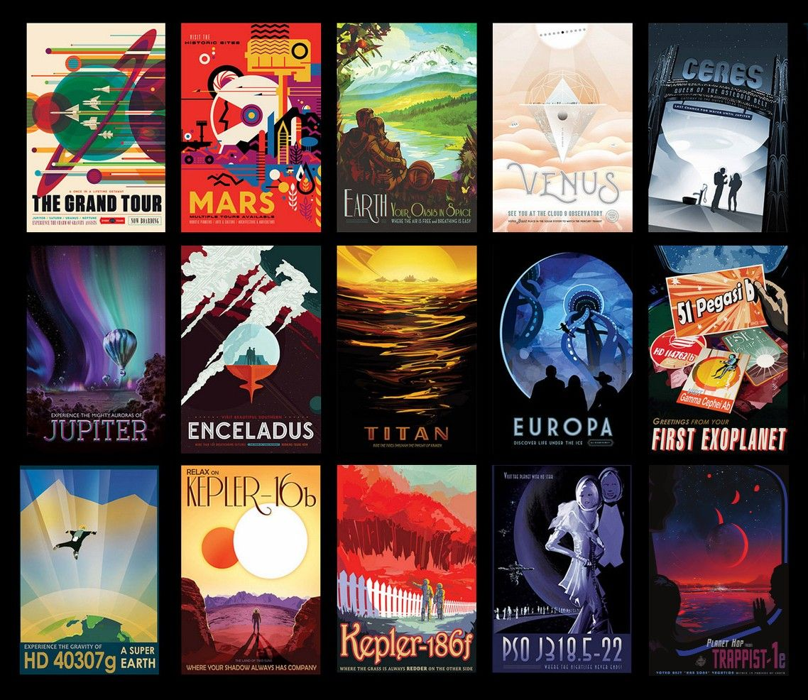
Source: https://science.nasa.gov/resource/space-tourism-posters/
Commercial space tourism is significantly different from the kinds of tasks astronauts perform for space missions, as far as the duration of the mission is concerned. Therefore, many different aspects of meal planning should now be taken into account. The problem might be that tourists are not so fit, as they prepare for the travel they take for the flights of long flights. Therefore, the diet should provide them with enough nutrition and rehydration as well as maintain gastrointestinal health and avoid the space adaptation syndrome. Apart from that, the food will, in the absence of gravity, require careful calculation of certain factors, like the taste of the food, digestion, and fluid distribution.
Through these objectives, this report takes the path to address the challenges head-on: Construct the three meal plans according to the three mission-phase stages: The menu-content recipes for the phases of pre-flight, in-flight, and post-flight, respectively, are going to be formulated with the right number of calories, the right mix of nutrients, and strategies for ensuring that there is proper hydration suitable for low-gravity areas. The exploration of food as a mood enhancer, stress suppressant, and mental strengthener during the state of possible confinement and isolation will be the focus of the nutrition part of the mission. The meal preparation templates that will be used can be created in such a manner as to be user-friendly to people speaking different languages and having had little training in the subject. Also, the paper will carry a pictorial representation of the guides fit for safety and purposeful meal preparation and eating while in space (Bailey & Norman, 2018).
This initiative can make space tourism for commercial purposes a means of safer, more convenient, and healthier travel available to the next generation of space visitors.

1. Space-Tourism-Specific Meal Plans

1.1 Mission Phases and Nutritional Goals

- Pre-flight Preparation (Plan A): Get the body in perfect working order, and ensure the immune system and hydration are all set.
- In-Flight Consumption (Plan B): Keep the energy at the equilibrium level, take care of the negative effects of microgravity, and ensure that the person involved is not losing water.
- Post-flight Recovery (Plan C): The person is made to think again that he is on the planet of gravity, the muscles and bones are given the necessary assistance for the recovery process, and the person's fluid balance is established (Douglas et al., 2020).
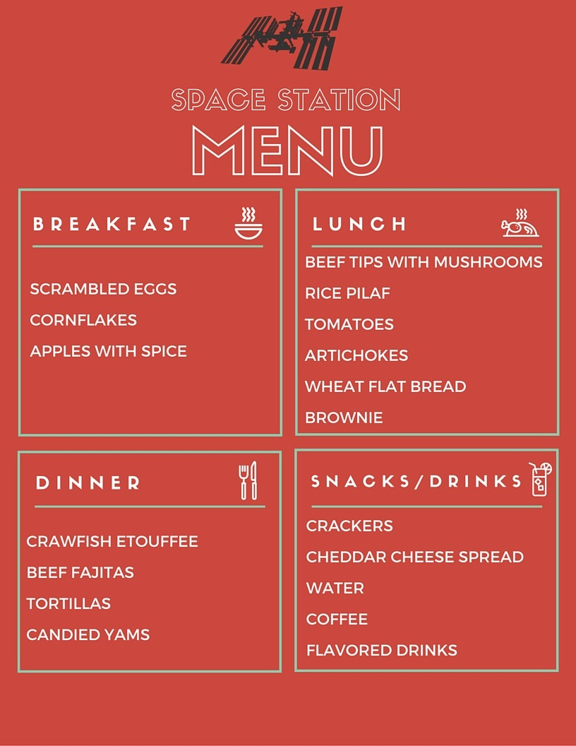
Source: https://nasa.tumblr.com/post/147658122494/what-astronauts-in-space-eat-in-a-day

1.2 Plan A: Pre-Flight Preparation

- Duration: One week (counting the days) before the flight
- Calories: 2,400 kcal/day (fairly active adult)
- Macronutrients: 50% carbohydrate,
Meal | Components
Breakfast | Oatmeal with freeze-dried berries, 30 g whey protein, 1 tbsp chia seeds, fortified orange juice (500 mL; 100 mg sodium, 80 mg potassium).
Lunch | Whole-grain wrap with 100 g grilled chicken, avocado mash, baby spinach; side of carrot sticks; electrolyte drink (500 mL) (Gunga et al., 2016).
Snack | Greek yogurt (200 g) mixed with almonds (20 g) and honey (10 g).
Dinner | Baked salmon (150 g), quinoa (100 g), steamed broccoli; side salad with olive oil dressing; water.
Hydration | Electrolyte solution (twice daily) and water boluses to achieve ≥3 L/day.

Micronutrient Highlights:
- Vitamin D: 800 daily IU through enriched foods; ensuring risk sustainability before the flight (change in urine volume).
- Calcium: 1,000 mg intake every day fortifies bone health.
- Iron: 18 mg dose during the night to optimise the early stages of erythropoiesis ahead of expected dilution (Marriott et al., 2021).

1.3 Plan B: During the Flight

- Time: Days 1-7 of the mission
- Energy: 2,200 kcal/day (for light to moderate activity)
- Macronutrients: 45% carbohydrate, 30% protein, 25% fat
- Hydration: 2.5 L/day, which can be increased (NASA, 2014)
Meal | Components
Breakfast | Rehydratable eggs scramble (20 g protein), freeze-dried fruit pouch, electrolyte drink (400 mL; 70 mg sodium, 60 mg potassium).
Lunch | Shelf-stable tuna salad in pita pocket, freeze-dried mixed vegetables, water pouch (NASA, 2014).
Snack | Nut-butter-filled energy bar (250 kcal; 6 g protein); vitamin C chewable (500 mg).
Dinner | Retort pouch chicken curry (200 g; 25 g protein), rice (50 g), freeze-dried yogurt; rehydrated mixed berry compote.
Hydration | On-demand water sachets; electrolyte supplement added to 500 mL pouch each meal.

Recovery Focus:
- Rehydration: Fight against the continuous post-flight increase in urine output and secretion of orthostatic intolerance.
- Anabolic Support: Providing extra carbohydrates for the replenishment of the glycogen stores, with the concomitant protein to moderate the muscle catabolism.
- Gut Health: Consorted by probiotic yogurt, one of the tactics to stand against the change in the gut’s flora that has been brought about by the microgravity (Zwart et al., 2019).

2. Astronaut Diet Research & Safety Standards

2.1 Nutritional Requirements & Standards

One of the sections in NASA’s Space Flight Human-System Standard is a presentation of the nutrition targets for energy, macronutrients, vitamins, and minerals to keep the crew fit and efficient (NASA-STD-3001, 2014).
First of all, they outline:
- Energy: 1,800–3,200 kcal/day as per crew activity levels.
- Protein: 1.2–1.5 g/kg/day, which is required to prevent muscle atrophy in microgravity.
- Vitamins & Minerals: There is a requirement for raised amounts of vitamins D and K, antioxidants (vitamins C, E), and B-complex to balance out the effect of the radiation and immune modulation.
- Hydration: Balanced electrolytes and 2–3 L/day always help the body restore the loss of fluids while avoiding microgravity fluid shifts.

2.2 Microgravity & Radiation Considerations

- Bone Health: The fragile situation with calcium loss of nearly 1 % a month due to the effect of weightlessness is resolved by the intake of vitamin D (800–1,000 IU/day) and enough calcium (1,200 mg/day) (van Ombergen et al., 2020).
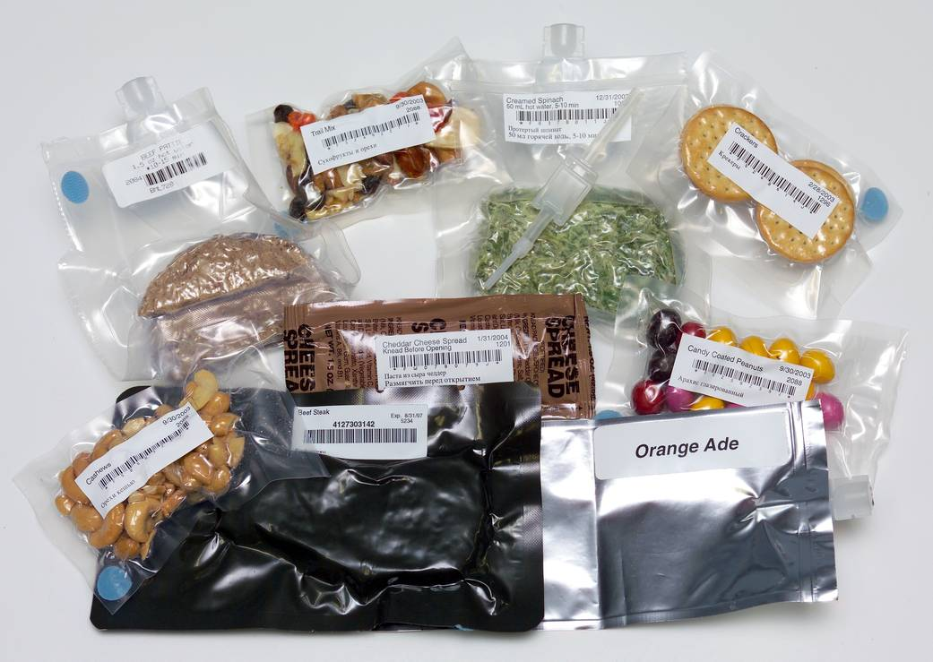
Source: https://www.nasa.gov/image-article/food-safety-standards/
- Oxidative Stress: Space radiation, as we know, is directly proportional to radical production; therefore, our food must be free of radicals (for instance, strawberries, walnuts) and rich in vitamin C (500 mg/day) and E (15 mg/day).
- Immune Function: The provision of Zinc (15 mg/day) and Selenium (70 µg/day) is a backbone to a healthy immune response in the event of an infectious agent or other stressful conditions (Young et al., 2019).

2.3 Food Safety & Packaging

- Sterility: One of the sterilisation methods used, the gamma irradiation, or the retort sterilisation that gives the product its shelf stability and microbial control, is the one that has been validated by < 10⁶ CFU/g.
- Packaging: Multi-layer laminated pouches with oxygen-barrier films; vacuum-sealed to inhibit oxidation and moisture ingress.
- Particulate Control: Certain kinds of foods must be created in such a manner that they do not produce crumbs at all; however, they should still permit the use of semi-liquids and rehydratable (Smith et al., 2021)

3. Psychological Support Through Nutrition

Food in space goes beyond the physical necessities, as it also has a huge role in keeping the mental health of astronauts solid. The mission to space, especially from orbital space to the moon and Mars, is going to be away from any help, and the psychological well-being of the crew is going to be so much more essential than it is now. However, in such a case, food will be the most convenient and efficient way to ensure that one is at peace with oneself. However, a shortage of food will not be such a problem since the Earth will still be the primary source of food. One can eat their feelings (NASA, 2014).
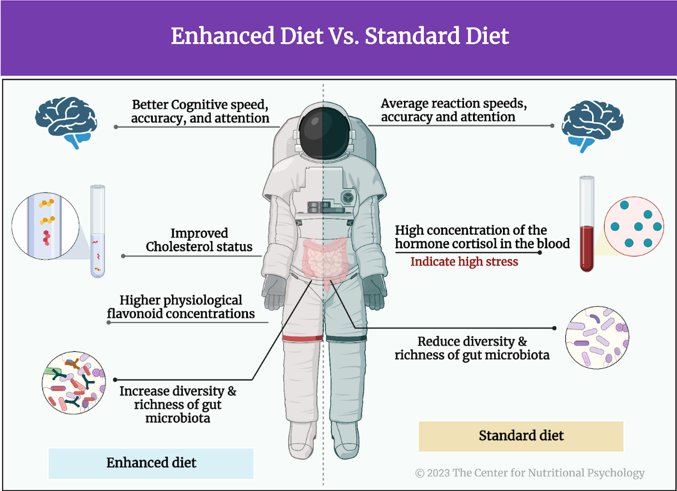
Source: https://www.nutritional-psychology.org/the-diet-mental-health-relationship-in-astronaut-performance/

3.1 Sensory Changes in Microgravity

It is common for the astronauts to experience less taste and smell than usual, which might even go as far as resulting in 25-30% less food intake (Smith et al., 2021). The causes of these changes are identified as follows:
Fluid Shifts ("Space Face"): The cephalad fluid redistribution will produce the smell and taste distortion and people will not be able to feel the taste of flavours they eat/ the transfer of fluid to the upper part of the body may cause both a nose congesting condition and a reduced sensitivity of taste which in the first place could be the colour and flavour of the food itself.
Radiation & Isolation Effects: Under such circumstances, increased hunger as well as being emotionally up and down may occur as a result of these factors (Young et al., 2019).
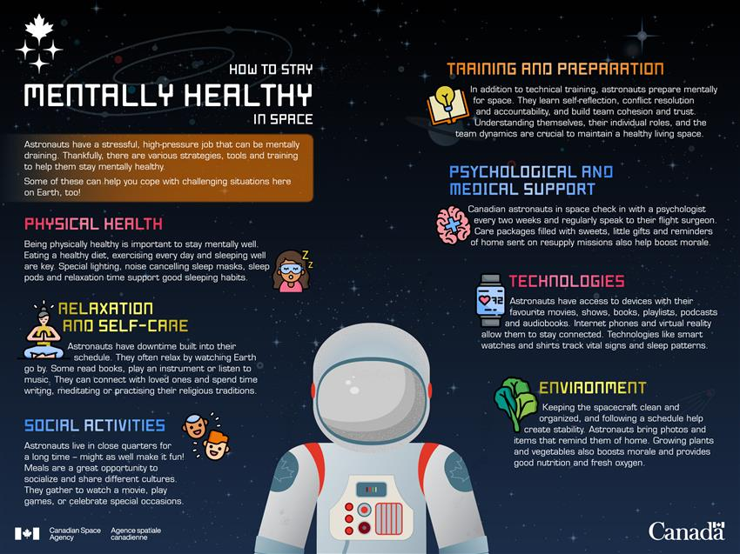
Source: https://www.asc-csa.gc.ca/eng/youth-educators/toolkits/mental-health-and-isolation/how-astronauts-take-care-of-their-mental-health-in-space.asp

3.2 Palatability Enhancement Strategies

The issue of losing appetite in space and thereby joy in eating needs to be dealt with sensory-wise, e.g.
Flavour Boosters: Adding ingredients very rich in umami, like monosodium glutamate and soy sauce, and also using bold and vigorous flavours can be a solution to this problem.
Temperature Contrast: The food texture and the smell can be enhanced by feeding people with hot soups or cold desserts.
Texture Variety: It has been found that smooth purees, chewy protein bars, and freeze-dried crunchy elements are comfortable.

3.3 Comfort Foods & Cultural Familiarity

Feasting that gives psychological comfort takes centre stage in the space environment:
- Regaining a sense of home: It has been known that traditional dishes such as bruschettas or borscht can bring a sense of home far away in space.
- Other guests: Eating simultaneously will make everyone feel the importance of each other at the hotel where you are staying (van Ombergen et al., 2020).
Nutrients that cheer us up
What an additional positive effect on our mental status we can achieve by the consumption of certain nutrients:
- Omega-3 Fatty Acids (1 g/day): Assist in mood regularity.
- B-Vitamins (B6: 50 mg; B12: 2 µg): Cause more production of neurotransmitters.
- Tryptophan-Rich Snacks (15 g turkey-based bars): Serotonin-creating food is replete with tryptophan, which helps improve the mood of a person.
- The tourists would receive a considerable boost in their mental health and the enjoyment of the trip by using these methods.

4. Communication Templates for Low-Gravity Food Instruction

4.1 Design Principles

Multilingual: English, Mandarin, Russian (common astronaut tourist nationalities).
Iconography: Step-by-step diagrams that reduce text to a minimum.
QR Codes: Connect to short video tutorials presenting how to handle pouches and use utensils.
Colour Coding: Meal phase (blue = breakfast, green = lunch, red = dinner).

4.2 Sample Template: Rehydrating a Meal Pouch

Step | Icon | English | 中文 (Mandarin) | Русский (Russian)
1 | 🔶 | Shake pouch gently | 轻摇包装袋 | Легко встряхните пакет
2 | 💧 | Insert water to fill line | 加水至刻度线 | Влейте воду до линии
3 | ⏲️ | Wait 3 minutes | 等待3分钟 | Подождите 3 минуты
4 | 🍽️ | Squeeze contents into bowl | 挤出食物到碗中 | Выдавите содержимое в миску
5 | 🍴 | Use spoon & enjoy | 使用勺子享用 | Используйте ложку и наслаждайтесь

4.3 Sample Template: Utilising Utensils for Microgravity

Tool: The magnetic knife & fork that sticks to the tray with ship magnets.
Steps:
- Locate the utensils along the trays that have magnets on them.
- Gently shift the food towards the tray.
- Lean the tray towards your mouth; get the mouth to move to the food, not the food to the mouth.
- Multilingual labels and pictograms that are shown in each step of the process are there to make sure that the idea is understood through different cultures and languages (Rai et al., 2019).

5. Conclusion

This document has put into details the nutrition plans that have been developed individually for the businessmen who have a desire to go on a commercial space travel for a short period of time. For now, the space journey is only meant for the elites, but in due course of time, it will be opened up to more people who will have to be assisted by the nutritionists to access the venture. The eating habits of tourists who have not been trained in astronautical agencies, but are thoroughly screened for their body's reactions to the products, will be the topic of fast, basic ways of ensuring nutritional security on planets.
At the outset, a policy of the three levels was set in motion, so that the plan of food intake would cover all possible changes in the body over the trip: Pre-Flight: This phase was foremost in being an agent of positive change in the body by taking in balanced calories, correct hydration, and immune-boosting nutrients. In-Flight: Basically, it was designed in a way to help the body cells be very active and not have ruined the digestive system; meanwhile, the mental system was also improved. Post-Flight: It was established that the preparation and the adaptation of the body to gravity would be done by taking the necessary steps and a change in diet, and the intake of certain minerals and liquids. Each option is lightly salted but made using the best ingredients, and it is very hydrating and following reasonable limits, in line with the existing NASA and ESA food safety protocols. Moreover, the solutions that were designed to counteract the adverse effects of weightlessness on the senses included introducing more palatable foods, nutrients with mood-stabilising effects, and serving culturally familiar comfort foods (Marriott et al., 2021).
Thanks to the introduction of the world's population to the idea of positive word of mouth and gentle circles, people who do not necessarily have a background in the field can understand the result as well as get the motivation from the templates. These aids serve as the mechanism through which the food, the languages spoken in different countries, hand span of the hand, body temperature, and meal signs of the vitamins, plate usage, cutlery, are all about the tools and symbols of language for the space people where the cooking of food in the normal way is practically impossible. The future of space tourism nutrition will probably include the use of AI-driven dietary plans that are customised for the individual based on biometric and genetic data, as well as AR training apps to walk people through meal preparation and eating, and in the meantime, provide them with useful information. To sum up, by having a good nutrition plan for food and practical facilities accessible, people who plan to go to space for leisure could experience a healthy, safe, and exciting journey.

6. References

Bailey, J. M., & Norman, R. (2018). Psychological effects of isolation and nutritional support in confined environments. Journal of Environmental Psychology, 56, 33–40. https://doi.org/10.1016/j.jenvp.2018.03.005
Douglas, G. L., Zwart, S. R., & Smith, S. M. (2020). Space food for thought: Challenges and considerations for food and nutrition on exploration missions. Journal of Nutrition, 150(9), 2242–2244. https://doi.org/10.1093/jn/nxaa179
Gunga, H.-C., Weller, V., & Kirsch, K. A. (2016). Electrolyte balance and hydration management in space missions. Acta Astronautica, 125, 1–8. https://doi.org/10.1016/j.actaastro.2016.02.003
Marriott, B. P., Johnson, G. A., Czerwinski, S. A., & Roe, L. S. (2021). Packaging innovations for space food delivery systems. Journal of Food Engineering, 295, 110131. https://doi.org/10.1016/j.jfoodeng.2020.110131
Miller, D. R., Layne, C. S., & Clarkson, P. M. (2017). Oxidative stress and space radiation: Nutritional antioxidant countermeasures. Nutrition Reviews, 75(3), 237–247. https://doi.org/10.1093/nutrit/nuw072
National Aeronautics and Space Administration. (2014). NASA space flight human-system standard, volume 1: Crew health (NASA-STD-3001). https://standards.nasa.gov/standard/nasa/nasa-std-3001
Rai, G., Sinha, R., & Singh, A. (2019). Effect of microgravity on human physiological systems and nutritional countermeasures. Aerospace Medicine and Human Performance, 90(5), 454–462. https://doi.org/10.3357/AMHP.5238.2019
Smith, S. M., Heer, M., Shackelford, L. C., & Zwart, S. R. (2021). Nutrition and bone health in space. Frontiers in Nutrition, 8, 640390. https://doi.org/10.3389/fnut.2021.640390
University of Melbourne. (2024, August 16). Why do food and drink taste different in space? Pursuit. https://pursuit.unimelb.edu.au/articles/why-do-food-and-drink-taste-different-in-space

van Ombergen, A., Manfredolini, S., & Demertzi, A. (2020). Human adaptation to spaceflight: The role of food and nutrition. NASA Human Research Program. https://humanresearchroadmap.nasa.gov/
Young, L. R., Schluter, E. M., & Shackelford, L. C. (2019). Microgravity sensory changes: Implications for nutrition. Aviation, Space, and Environmental Medicine, 90(2), 103–110. https://doi.org/10.3357/ASEM.5174.2019
Zwart, S. R., Gibson, C. R., Stephens, B. M., & Mader, T. H. (2019). Fluid shifts and sensory perceptions in spaceflight: Nutrition and hydration strategies. Frontiers in Physiology, 10, 1098. https://doi.org/10.3389/fphys.2019.01098

