Planning and Management of Sustainable Tourism Spaces
Assignment 7


Title:
Sustainable Conservation and Heritage Analysis of Aachen Cathedral as a UNESCO World Heritage Site

Student Name:
Harpreet Singh

Student ID:
DE240148

Table of Contents
1. Introduction 3
2. Outstanding Universal Value (OUV) 3
3. Criteria for Inscription 4
3.1 Criterion (i): Masterpiece of human creative genius 4
3.2 Criterion (ii): Significant interchange of human values. 4
3.3 Criterion (iv): Outstanding example of a significant stage in human history. 5
3.4 Criterion (vi): Association with important historical events. 5
4. The Authenticity and Integrity of the Site 5
5. Conservation Strategy 6
5.1 Main Threats and Risks 6
5.2 Risk Factor Matrix 6
5.3 Mitigation Actions 6
6. Conclusion 6
References 8

1. Introduction
Aachen Cathedral, located in Aachen, North Rhine-Westphalia, Germany, is one of Europe’s most important medieval monuments. The Carolingian Empire began in the eighth century when Charlemagne built a church there. Later, this church became the coronation site of German kings. The Cathedral was designated UNESCO World Heritage Site in 1978 becoming the first site in Germany to receive this designation. Its value is attributed to the architectural value, historical importance as well as the integration into European cultural identity by UNESCO. UNESCO inscription must meet stringent cultural criteria demonstrating outstanding universal value and integrity (Mahmoodi et al., 2024). This report aims to analyse the cathedral of Aachen in terms of its Outstanding Universal Value (OUV), the UNESCO criteria which this monument fulfils, its authenticity and integrity, and key conservation issues that it faces. The report also considers current threats and appropriate mitigation strategies for the site’s long-term preservation.

2. Outstanding Universal Value (OUV)
Aachen Cathedral has extraordinary worldwide value because it is among the most important creations of early medieval Europe. The cathedral was built in the late 8th and early 9th century under Charlemagne. It became the spiritual and political centre of the Carolingian Empire. The unparalleled design, scale, and artistic aspirations of the dome and high altar of St. Peter’s Basilica marked the beginning of the resurgence of classical culture and Christian authority in Western Europe. The site also shaped European identity, being the coronation church of German kings for many centuries, thus linking it to the identity of the region (Duval, 2023).
Cultural attributes of cathedral of Aachen help to support its universal value. One of the finest features is a gem of Carolingian architecture, the Palatine Chapel. The creative and influential qualities of the Great Mosque at Samarra are evident in the dome of the octagonal structure. This style inspired the design of churches throughout medieval Europe. The beautiful decoration of the interior—mosaics, bronze doors, and marble columns—shows how classical and Byzantine and northern European influences combined. The cathedral is important worldwide because it is a shrine of great importance for pilgrims, which includes many relics and artistic treasures (Santa-Cruz & López-Guzmán, 2017).

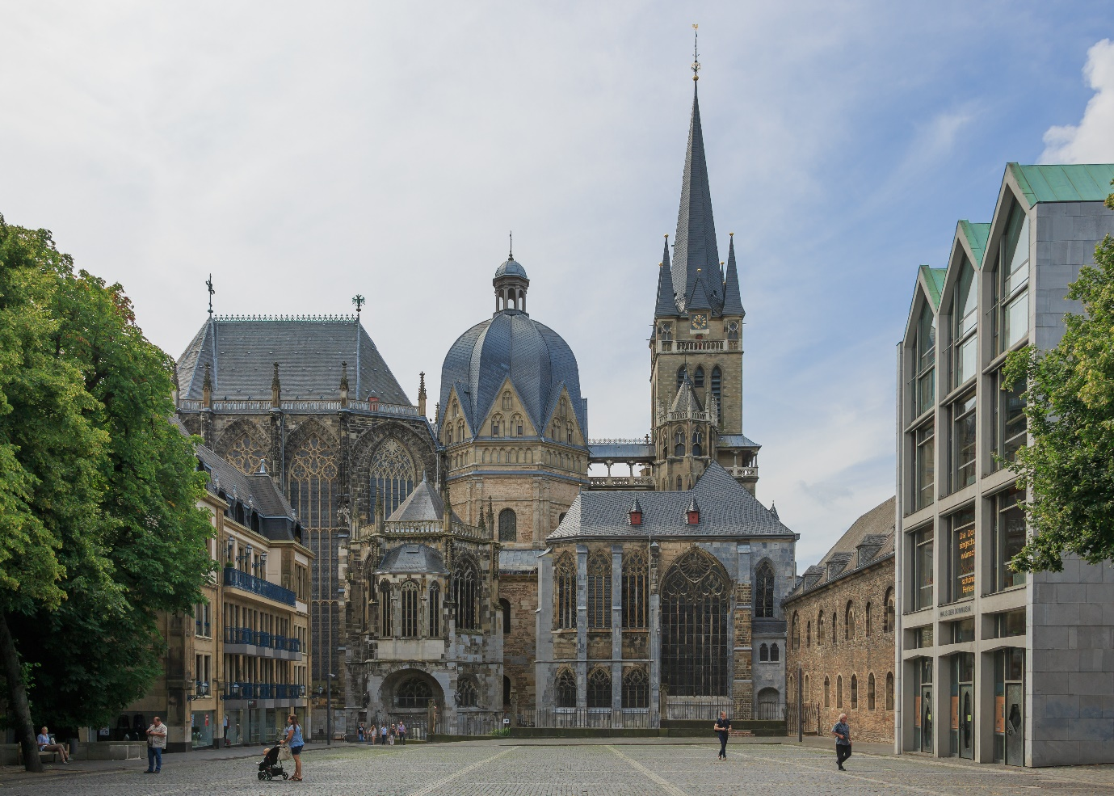
Figure 1: Aachen Cathedral
The Aachen cathedral image shows the octagonal Palatine Chapel with the Westwerk at the famous Cathedral Aachen. The architectural features assist in the OUV by visually showcasing how the cathedral’s unique design, huge scale, and technological innovations became a key symbol of the early European Middle Ages.

3. Criteria for Inscription
The UNESCO World Heritage List nominates the Aachen Cathedral based on various cultural criteria and is of global importance. The primary standards are Criterion (i), Criterion (ii), Criterion (iv), and Criterion (vi). The universal value of the cathedral in four areas are architecture, culture, and European history.

3.1 Criterion (i): Masterpiece of human creative genius
The palatine chapel and especially the whole complex signify an early medieval architectural masterpiece. Thus, this criterion applies. The innovative octagonal design, intricate vaulting and superior decorative elements show master builders' achievement. Recent digital documentation projects demonstrate the design sophistication of the building and its long-lasting effect (Pritchard et al, 2023). A wonderful combination of classical, Byzantine, and northern European design elements was included in this object. In addition, it shows a very creative for its period.

3.2 Criterion (ii): Significant interchange of human values.
Aachen Cathedral reflects cultural exchange across regions. The building was influenced by Roman and Byzantine architecture, while the shape and style of Aachen inspired later medieval buildings across Europe (Duval, 2023). The flow of ideas in the site shows its significance in bridging cultural artistic origins, hence universal value.

3.3 Criterion (iv): Outstanding example of a significant stage in human history.
The cathedral is the defining monument of the Carolingian Renaissance. The structure is a significant turning point in European cultural growth and one of the best-preserved editions of Carolingian building (Pritchard et al., 2023)

3.4 Criterion (vi): Association with important historical events.
Aachen Cathedral has been home to the coronation of German kings for 600 years. The historical association of the site adds great significant value. As per Khalaf (2020), UNESCO states that joint evaluations help ensure integrity and continuity.
Together, these criteria support the cathedral’s outstanding universal value, linking clearly with the architectural and cultural importance described in the OUV section.

4. The Authenticity and Integrity of the Site
- Authenticity of Aachen Cathedral: The authenticity of the Aachen Cathedral is strongly preserved through the use of original materials, designs and workmanship. The Palatine Chapel, the most important part with its key geometric layout, marble columns, bronze doors and mosaics were all a hangover from Charlemagne. Authentic if the original form, workmanship & meaning of a heritage site are intact and visible (Gullino & Larcher, 2013). It is true for Aachen. The religious and ceremonial use of the cathedral shall continue, ensuring the authentic enduring cultural purpose and spiritual value. The contemporary documenta­tion, which deals with the repair work, restoration work and the conservational work, shall respect and keep intact the historic materials which are already present there and all the conservational works shall look different from the original and not disturbing the originality (Muthuswamy & Esakki, 2024)
- Integrity of the Cathedral and Its Surroundings: The integrity of the site is high because the main architectural elements are intact and well protected. These include the octagon, choir, chapels and historic precinct. Integrity simply means whether the site has all essential features that help to express its value. (Gullino and Larcher, 2013). The loss of any major structural components and the buffer zone ensures that one will not affect the other visually or physically. Urban planning controls in Aachen helps to protect its historic enclave. Even after centuries of the cathedral faces many environmental and structural challenges, conservation strategies seek to protect the physical fabric as well as the cultural meaning (Muthuswamy & Esakki, 2024).
The current level of authenticity and integrity at Aachen Cathedral is considered strong. Restoration and monitoring activities are controlled to avoid damage and also conform to UNESCO standards. Because of this, it continues to express its Outstanding Universal Value in a clear manner and is a well-preserved example of Carolingian architecture.

5. Conservation Strategy

5.1 Main Threats and Risks
- Environmental Decay and Climate Change: Rising temperatures, increased rainfall, and humidity weaken stone surfaces, mosaics, and historic materials. Climate change is a growing global risk for heritage sites (Lafrenz Samuels & Platts, 2022).
- Air Pollution and Material Erosion: Pollution from urban activity accelerates stone decay and damages exterior surfaces, reducing long-term stability.
- Structural Weakness and Age-Related Damage: The building, as one of the oldest cathedrals in Europe, is suffering from many natural works.
- Tourism Pressure: Large numbers of visitors cause damage, crowding and stress interiors in architecture (Crowley et al., 2022).
- Fire Risk: Heritage buildings containing historic timber elements usually face serious consequences, even with modern systems.

5.2 Risk Factor Matrix
Threat | Likelihood | Impact / Significance
Climate-related deterioration | High | High
Air pollution & stone decay | High | High
Structural age-related issues | Medium | High
Over-tourism | Medium | Medium
Fire risk | Low/Medium | High

This risk matrix illustrates all major threats to Aachen Cathedral indicating their probability and impact with color coding. Air pollution and climate-related degradation present the biggest, most serious risks, as rated very high in likelihood and impact. The chances of structural ageing and tourism pressures are moderate. Fire risk is low probability and high consequence.

5.3 Mitigation Actions
- Technical Measures: Install climate and pollution monitoring systems and apply protective treatments to vulnerable materials to reduce climate-related deterioration (Lafrenz Samuels & Platts, 2022).
- Managerial Measures: Strengthen visitor management, improve buffer-zone controls, and regulate nearby development to support long-term preservation (Mahmoodi et al., 2024).
- Community & Stakeholder Involvement: Engage local authorities, conservation experts, and community groups in awareness programs and collaborative protection efforts (Crowley et al., 2022).
- Monitoring & Review Mechanisms: Conduct regular risk assessments and update conservation plans to adapt to emerging climate and structural challenges (Masini, 2024).

6. Conclusion
Aachen Cathedral is unique site; one that provides insight into the architectural innovation, cultural exchange, and political history and realities of early medieval Europe. The association of the OUV with Charlemagne, characterized by its unique Carolingian architecture, and its long use as the coronation church of German kings. The region was the meeting place for different civilizations and cultures between the mountains. It was also a bastion of the Medes, the Parthians and the Sasanians. This cathedral’s state and level of authenticity are remarkably high. Take a close look at the preserved original materials and careful restorations. You might see a pattern of strong protective plans here. Nonetheless, it remains under threat from climate-based decay and air pollution among other factors. To preserve the site and provide efficient protection from erosional processes, it requires impactful and comprehensive conservation efforts which will include technical monitoring, visitor management, community involvement and risk assessments. By this commitment, the exceptional universal value of the Cathedral of Aachen will be preserved for future generations.

References
Crowley, K., Jackson, R., O’Connell, S., Karunarthna, D., Anantasari, E., Retnowati, A., & Niemand, D. (2022). Cultural heritage and risk assessments: Gaps, challenges, and future research directions for the inclusion of heritage within climate change adaptation and disaster management. Climate Resilience and Sustainability, 1(3). https://doi.org/10.1002/cli2.45
Duval, E. (2023). European heritage on the global stage. Aachen Cathedral, West German cultural diplomacy and UNESCO world heritage. http://openscience.ub.uni-mainz.de/bitstreams/303bf4b1-d0c1-4019-b6d5-ef3fe7bb6c39/download
Gullino, P., & Larcher, F. (2013). Integrity in UNESCO World Heritage Sites. A comparative study for rural landscapes. Journal of Cultural Heritage, 14(5), 389–395. https://doi.org/10.1016/j.culher.2012.10.005
Khalaf, R. W. (2020). The Implementation of the UNESCO World Heritage Convention: Continuity and Compatibility as Qualifying Conditions of Integrity. Heritage, 3(2), 384–401. https://doi.org/10.3390/heritage3020023
Lafrenz Samuels, K., & Platts, E. J. (2022). Global Climate Change and UNESCO World Heritage. International Journal of Cultural Property, 29(4), 409–432. https://doi.org/10.1017/s0940739122000261
Mahmoodi, M., Talebian, M. H., & Vatandoost, R. (2024). Analysis and Explanation of the Effective Components in the Selection of Sites for Inscription on the World Heritage List. pazhoheshha-ye Bastan shenasi Iran, 13(39), 379-406. https://www.sid.ir/fileserver/je/1156-282209-x-1159443.pdf
Masini, N., & Soldovieri, F. (2017). Cultural heritage sites and sustainable management strategies. In Sensing the past: From artifact to historical site (pp. 1-19). Cham: Springer International Publishing. https://link.springer.com/chapter/10.1007/978-3-319-50518-3_1
Muthuswamy, V. V., & Esakki, S. (2024). Exploring Sustainable Cultural Preservation: Strategies, Challenges, and Community Engagement in Heritage Conservation Efforts. Rita Revista Indexada de Textos Academicos, (21). https://redfundamentos.com/menu-script/index.php/rita/article/view/412
Pritchard, D., Griffo, M., Attenni, M., Barni, R., Bianchini, C., Inglese, C., & Ley, Y. (2023). Evolution of Recording Methods: The Aachen Cathedral World Heritage Site Documentation Project. The International Archives of the Photogrammetry, Remote Sensing and Spatial Information Sciences, 48, 1241-1249. https://isprs-archives.copernicus.org/articles/XLVIII-M-2-2023/1241/2023/
Santa-Cruz, F. G., & López-Guzmán, T. (2017). Culture, tourism and world heritage sites. Tourism Management Perspectives, 24, 111-116. https://www.sciencedirect.com/science/article/pii/S2211973617300867

