

Research Title : The Motivations for Travel

Student Name : Vivek Vivek
Student ID Number : DE240014
1st semester : Prof. Mr. Mahmoud Abdou
Due Date : 28th of February 2025

Table of Contents
Introduction 3
Theoretical Frameworks in Travel Motivation 3
Travel Inspiration 4
Psychological Motivations 5
Social and Cultural Influences 5
Demographic Variations 5
Impact of Digital Marketing and Influencers 6
Discussion 7
Sustainability and Ethical Tourism 7
Conclusion 7
References 8

Introduction
Individual, social, and social factors all play a perspective in the complex and many reasons that individuals travel. For the tourism sector to provide experiences that are suited to a variety of demands, it is crucial to comprehend why individuals choose to travel (Nguyen & Tong, 2022). Motivations can be anything from social engagement and social exploration to relaxation and adventure. A few theoretical systems, such as Maslow's chain of command of needs and the push-pull theory, which separate between internal wants and outside attractions, have been used by researchers to study the reasons for travel (Bert van Wee & Cao, 2022). Creativity, diversity, novelty, shortage, and the integrity of tourism sites are all factors that some individuals accept can influence the attention of visitors. The presence of a traveller attraction empowers it to have the capacity to lower the degree of tourist immersion. Static tourism places are typically dull. By looking at psychological, social, and social factors, this study explores the main reasons individuals travel. It also looks at how these motivating forces differ depending on components like age, gender, and financial foundation.

Theoretical Frameworks in Travel Motivation
Travel is a unique situation for consumption. In the traveller and neighbourliness division, the primary offering is the involvement itself. Experiential consumption involves pursuing "fantasies, feelings, and fun" as restricted to utilitarian and coherent problem-solving tasks. In tourism, eudaimonia meaning, development, and self-realization is becoming more broadly recognized, both outside hedonic values and via the prism of positive psychology (Gössling & Dolnicar, 2022).
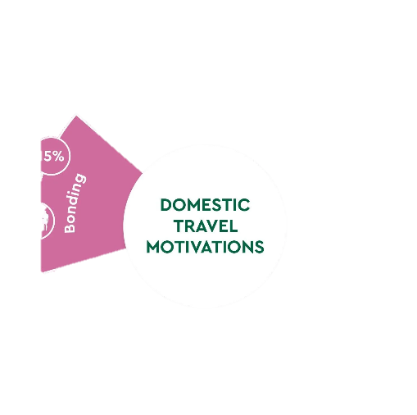
Figure 1 Travel Motivations Framework (Isu, 2015)
Because of the increased worldwide connectedness and perceivability of goals due to innovative improvements, tourism has advanced into an extractive economy that offers experiences. It was inspected how the primary inspirations, supplementary inspirations, practices, and sociodemographic research sample components changed and interacted. Religion and tourism are the primary drivers of these different and multifaceted practices, but they are also linked to social legacy tourism, leisure, social and familial life, and other reasons. A major component in drawing individuals to a region and making it a "must-visit destination" is the fight for packages and internet visibility. Since of this, the individuals who live there have no control over the way their home is depicted (Schiopu et al., 2022). The cost of travel was the primary calculate in respondents' choice to select the area, followed by less congested and off-the-beaten-path areas. To learn more about the motivation for travel, think about how tourism marketing strategies significantly impact these reasons.

Travel Inspiration
Understanding traveler motivation involves elucidating the motivations for travel. The manager should be aware of the traveller segment that's assigned based on how important the initial goal was thought to be. Improving strategies to attract tourists can be facilitated by gaining a deeper comprehension of their motivations. Hence, one of the key components that motivates sightseers to re-visit a tourist goal is the plan to adapt to their rationale. Those who begin to create it are followed by others. While a few early adopters in a put resist and separate themselves from the tourism division, others diversify and launch tourism businesses.
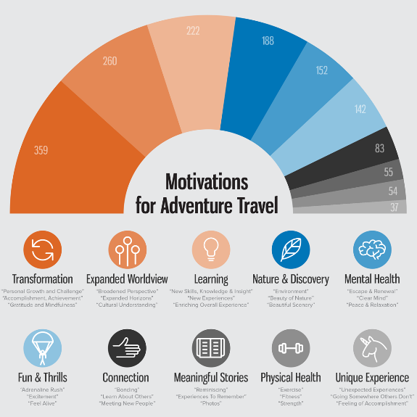
Figure 2 Travelers Motivated (Beckmann, 2017)

Psychological Motivations
A deeper comprehension of the reasons behind tourists' travels may help within the creation of plans and boost tourism. An individual's choice to travel is affected by internal variables known as psychological motivations. These include the need to unwind, get away from the routine, have fun, and develop personally. Interest in a follow-up visit will be based on the starting visit's experience. The attraction will offer chances for more intense visits if all of its components can be improved. One of the variables that decides the diversity of identical offerings is the attractiveness of the advertise offer. According to research, a part of tourists looks for exercises that would make them feel emotionally and mentally revived. Researchers have looked at the many aspects and components of motivation, which is vital to understanding the behaviour of young individuals. In the areas of tourism and hospitality, motivation to travel is a commonly investigated subject (Zheng et al., 2021). People are motivated to travel for a variety of reasons, including individual preferences, sociocultural impacts, and the desire to try new things.

Social and Cultural Influences
Social and social reasons like the need for social contact, social discovery, and status advancement are common drivers of travel. Individuals travel to outside areas to way better their social standing, find unused cultures, or remain in touch with adored ones. Moreover, social media is important because it impacts travel choices by advancing appealing experiences and locations. The study serious to offer insights into traveller conduct by assessing these factors, empowering travel agencies to improve client happiness and develop more fruitful marketing plans (Lewis et al., 2021). The degree to which consumers accept that close friends and family individuals think they should use a certain innovation is known as social impact. Despite being skilled at motivating and interesting, they regularly fail to advocate for maintainable travel and responsible tourism. Their material frequently places more emphasis on thrill-seeking and beauty than on ethical quality.

Demographic Variations
Travel motivations vary among different demographic groupings. Cultural background, wage level, age, and gender all have a big impact on travel preferences. Younger visitors, for instance, frequently look for adventure and social intelligent, though senior travellers might put more value on comfort and cultural disclosure (Yang, 2020). Travel motivating forces are provided to increase tourism under normal circumstances, but they can also operate as both trend boosters and trend inhibitors amid post-pandemic periods when individuals are exhausted and slanted to take revenge trips. Managements of tourism must boost visitor numbers to sustain development. According to these studies, the crave to travel is a complex phenomenon that's affected by a number of inner and outside impacts. For example, the importance of comprehending what group individuals to partake in different tourism exercises. For example, adventure searchers are driven by energy and thrills, while others may look for calm and tranquilly as a stress-relieving strategy.
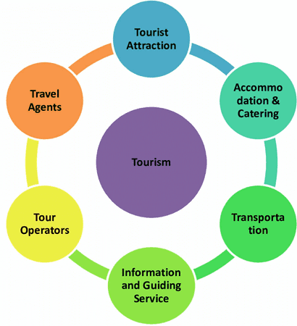
Figure 3 Composition of Tourism (rajvuniversity, 2024)

Impact of Digital Marketing and Influencers
The more individuals who visit, the more money will be made. The administration hence becomes interested in travellers who are interested in visiting, particularly those who are interested in coming back. Within the travel and tourism sector, the desire to return is vital (Teeroovengadum et al., 2021). The larger part of administrators of tourism destinations depends on visitors' want to return. In the case of tourism and travel agencies, TIs can work as boosters by improving and inducing revenge travel in tourists, while in the case of employees, they can act as inhibitors by replacing revenge travel for those who are depleted by the widespread. to create focused marketing strategies, it is fundamental to comprehend these statistic distinctions. It is empowering to think that these effective voices might shift their stories to one that's more responsible, raising awareness of the value of securing places, regarding local traditions, and reducing natural impact to make a more environmentally friendly travel segment (Moura et al., 2022). The term "social influence" describes how much a person's social systems, companions, family, coworkers, and opinionated leaders think that certain travel and tourism-related technologies like driverless cars, driverless sightseeing instructors, and driverless taxis are relevant and steady with their group standards. Good marketing can draw consideration to certain experiences or attractions that fit with popular travel subjects like relaxation or adventure.

Discussion
Travel inspirations are ever-changing and affected by a complex web of social, social, and psychological components. This study emphasises how pivotal it is to comprehend these motivations to improve consumer happiness and customise marketing strategies. For example, experience tourism offers to thrill-seekers, while wellness tourism targets individuals who need to unwind. Conditions, occasions, and patterns in the tourism industry, as well as the capacity to make a range of tourism that draws visitors, affect how tourism creates in a given place.

Sustainability and Ethical Tourism
The overseers of tourist destinations must understand why individuals come. The deeper circumstances that enable individuals to intentionally develop, involvement life to the fullest, and develop have been recognised by positive psychology. To development the tourism industry in the setting of awareness, has and destinations must carefully change and make critical choices. Travel choices are affected by social media, which emphasises the significance of advanced promoting strategies that interface with the target demographic. Also, understanding demographic varieties helps travel organizations to effectively divide their clientele and offer individualised experiences that cater to a range of demands.

Conclusion
Travel reasons vary and are impacted by social, social, and mental components. According to this study, individuals travel for a variety of reasons, such as social contact, experience, relaxation, and social interest. Also, it appears notable demographic varieties in the reasons individuals travel, which are affected by components like age, gender, and financial status. Influencers also help spread the word about already unknown travel locations. Through their social media profiles, empower others to visit an area for young individuals. The most elevated cruel score is for young motivation.

References
Beckmann, C. (2017, February). Research Reveals Adventure Travelers Primarily Motivated by Transformation. AdventureTravelNews. https://www.adventuretravelnews.com/research-reveals-adventure-travelers-primarily-motivated-by-transformation

Bert van Wee, & Cao, J. (2022). Residential self-selection in the relationship between the built environment and travel behavior: A literature review and research agenda. Advances in Transport Policy and Planning, 75–94. https://doi.org/10.1016/bs.atpp.2020.08.004

Gössling, S., & Dolnicar, S. (2022). A review of air travel behavior and climate change. WIREs Climate Change, 14(1). https://doi.org/10.1002/wcc.802
Isu. (2025). Isu.pub. https://assets.isu.pub/document-structure/230217113942-dd4872b9669ebfade8fa2247ce35e17c/v1/492a62b755ea3c20f76c7e5ace68e2f5.jpeg

Lewis, H., Schrier, T., & Xu, S. (2021). Dark tourism: Motivations and Visit Intentions of Tourists. International Hospitality Review, 36(1), 107–123. EMERALD. https://doi.org/10.1108/ihr-01-2021-0004

Moura, A., Eusébio, C., & Devile, E. (2022). The “why” and “what for” of participation in tourism activities: travel motivations of people with disabilities. Current Issues in Tourism, 1–17. https://doi.org/10.1080/13683500.2022.2044292

Nguyen, T. T. T., & Tong, S. (2022). The impact of user-generated content on intention to select a travel destination. Journal of Marketing Analytics, 11, 443–457. https://doi.org/10.1057/s41270-022-00174-7

rajvuniversity. (2024, June 15). Composition of Tourism industry - Vrindawan University. Vrindawan University - Sikhega India Toh Badhega India. https://vuniversity.in/composition-of-tourism-industry/

Schiopu, A. F., Hornoiu, R. I., Padurean, A. M., & Nica, A.-M. (2022). Constrained and virtually traveling? Exploring the effect of travel constraints on intention to use virtual reality in tourism. Technology in Society, 71, 102091. https://doi.org/10.1016/j.techsoc.2022.102091

Teeroovengadum, V., Seetanah, B., Bindah, E., Pooloo, A., & Veerasawmy, I. (2021). Minimising perceived travel risk in the aftermath of the COVID-19 pandemic to boost travel and tourism. Tourism Review, ahead-of-print(ahead-of-print). https://doi.org/10.1108/tr-05-2020-0195

Yang, E. C. L. (2020). What motivates and hinders people from travelling alone? A study of solo and non-solo travellers. Current Issues in Tourism, 24(17), 1–14. https://doi.org/10.1080/13683500.2020.1839025

Zheng, D., Luo, Q., & Ritchie, B. W. (2021). The Role of Trust in Mitigating Perceived Threat, Fear, and Travel Avoidance after a Pandemic Outbreak: A Multigroup Analysis. Journal of Travel Research, 004728752199556. https://doi.org/10.1177/0047287521995562

