Sustainable Tourism, Local Development and Social Impact: Managing Growth, Quality of Life and Local Resources
Option 3: Sustainable Tourism, Local Development, and Social Impact
M20 - Tourism and Local Development Cooperation

Table of Contents
1. Abstract
2. Introduction
3. Literature Review
4. Methodology
5. Findings
6. Discussion
7. Conclusion
8. References
9. Appendices

Abstract
This report analyses the role of sustainable tourism in promoting balanced local development and social impact. It explores the relationship between sustainable tourism, poverty reduction, quality of life, environmental protection, cultural identity and long term community resilience. The report argues that tourism can improve local development when visitor expenditure supports livelihoods, public services, cultural continuity and resource conservation, but it can also harm communities when growth is unmanaged. The analysis uses a qualitative secondary research method and applies sustainable tourism concepts to real world issues such as overtourism, leakage, resident quality of life, cultural commodification, environmental pressure and inclusive enterprise development. Current policy sources emphasise that tourism needs to address economic, social and environmental impacts while meeting the needs of visitors, the industry, host communities and the environment (United Nations Department of Economic and Social Affairs, n.d.; UN Tourism, n.d.). The findings show that sustainable tourism contributes to poverty reduction mainly through employment, local supply chains and community enterprise, but those benefits depend on ownership, fair work, local sourcing and governance. The report recommends visitor management, local procurement, community benefit funds, environmental standards, heritage protection, accessible tourism, carrying capacity tools and transparent indicators. The conclusion is that sustainable tourism should not be treated as a marketing label. It is a local development strategy that manages growth within social and ecological limits while protecting the identity and quality of life of host communities.

Introduction
Sustainable tourism has become a central concept in local development because destinations increasingly recognise that tourism growth can create both opportunity and harm. Tourism can bring income, jobs, infrastructure, entrepreneurship and cultural visibility. It can also create waste, congestion, environmental degradation, housing pressure, cultural distortion and social inequality. The local development question is therefore not only how to attract visitors, but how to manage tourism so that it improves quality of life without damaging the resources and communities on which tourism depends.
The United Nations sustainable tourism definition is widely used because it requires tourism to consider current and future economic, social and environmental impacts while addressing the needs of visitors, industry, the environment and host communities (United Nations Department of Economic and Social Affairs, n.d.). This definition is useful because it places host communities beside visitors and businesses. It rejects the idea that tourism success can be measured only by arrivals, occupancy or spending. A destination can receive many tourists and still fail as a local development model if residents experience poor wages, exclusion, cultural loss or environmental pressure.
This report focuses on Option 3 and analyses sustainable tourism, local development and social impact. It explores the relationship between sustainable tourism, poverty reduction and quality of life. It discusses environmental, cultural and social impacts on local communities. It assesses strategies for managing growth while protecting local resources and identity. It then recommends sustainable tourism practices that support long term local development. The report is written from a critical perspective because sustainable tourism is often used as a promotional term without sufficient attention to power, distribution and limits.
The argument developed here is that sustainable tourism supports balanced local development only when 3 conditions are present. First, economic benefits must reach local households and small enterprises rather than leaking mainly to external owners. Second, tourism growth must be managed within environmental and social carrying capacities. Third, communities must participate in decisions about cultural representation, resource use and benefit sharing. Without these conditions, tourism may increase short term revenue while weakening long term development. With these conditions, tourism can become a tool for poverty reduction, conservation, cultural pride and improvement in quality of life.
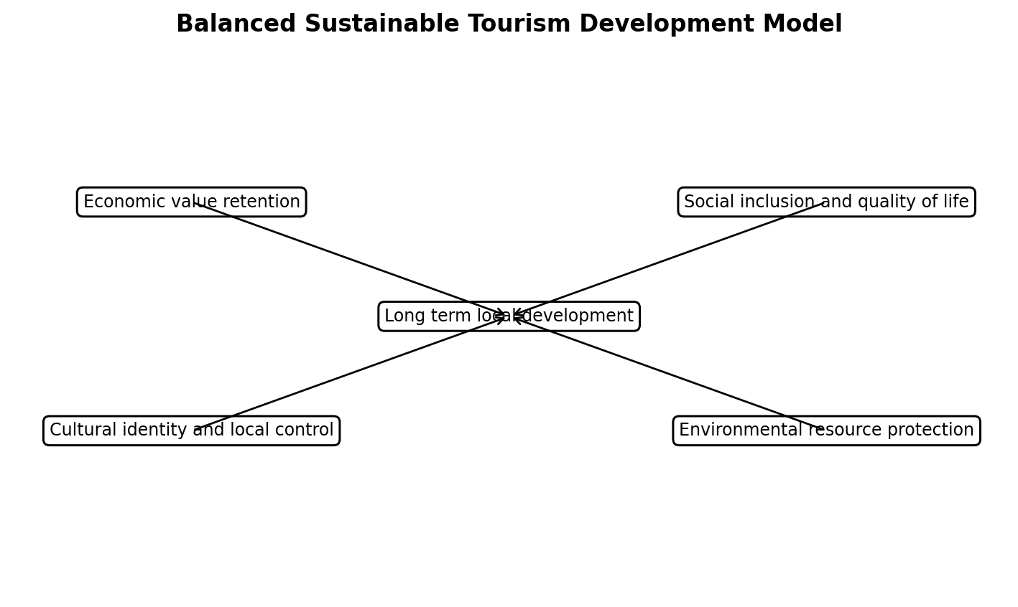
Figure 1. Balanced sustainable tourism development model.

Literature Review
Sustainable tourism emerged as a response to the limitations of mass tourism and narrow economic growth models. Traditional tourism planning often prioritised arrivals, investment and foreign exchange. Sustainable tourism adds questions about who benefits, what resources are consumed, which cultural practices are affected and whether tourism is compatible with long term community wellbeing. UN Tourism states that sustainable development in tourism should support biodiversity conservation, social welfare and economic security (UN Tourism, n.d.). This balance is important because tourism depends on environmental and cultural assets that can be damaged by unmanaged use.
The relationship between tourism and poverty reduction is complex. Tourism can reduce poverty by creating jobs, supporting small businesses, expanding markets for agriculture and crafts, generating tax revenue and funding community projects. It can also provide income in rural and remote areas where alternatives are limited. Community based tourism is often promoted because it places communities closer to ownership and control. Research on community based tourism suggests that it can support sustainable development when participation, economic viability and environmental stewardship are integrated (Jackson, 2025; Quang et al., 2023). However, poverty reduction should not be assumed. If local people receive only casual labour while outside investors control assets, poverty impacts remain weak.
Quality of life is a useful lens because residents experience tourism in ways that are broader than income. Tourism may improve quality of life by creating jobs, improving roads, expanding public transport, supporting restaurants and cultural events, improving safety and increasing pride in place. It may reduce quality of life by raising rents, crowding public spaces, increasing noise, creating seasonal work stress, changing neighbourhood identity or putting pressure on water and waste systems. Recent tourism wellbeing research emphasises that tourism's effects on residents can be positive and negative, so destination management must understand the nature of these effects rather than assuming general community support (Godovykh, 2025).
Environmental impacts are central to sustainable tourism. Tourism can support conservation when park fees, eco lodges, guide services and community revenue create incentives to protect biodiversity and landscapes. It can also damage resources through water use, waste, carbon emissions, habitat disturbance, coastal erosion, traffic, construction and wildlife pressure. The environmental issue is not only the number of visitors, but the management system. A smaller number of poorly managed visitors can cause severe damage, while a larger number managed through rules, infrastructure and education may be less harmful. Sustainable tourism therefore requires standards, monitoring and enforcement.
Cultural impacts are equally important. Tourism can strengthen cultural preservation by creating markets for crafts, festivals, food, music, storytelling, heritage buildings and local interpretation. It can also commodify culture by changing practices to meet tourist expectations or allowing outsiders to control cultural narratives. The difference often depends on community control. When residents decide how culture is shared and how revenue supports cultural continuity, tourism can increase pride and intergenerational transmission. When culture is packaged without consent, tourism can create resentment and identity loss.
Social impacts include inclusion, exclusion, conflict, gender relations, power distribution and resident attitudes. Tourism may create social mobility and entrepreneurial opportunities, but it can also produce inequality between those with assets and those without. Landowners, hotel investors and tour operators may benefit more than renters, informal workers and low income households. Overtourism cases show that residents may protest not because they reject all visitors, but because the tourism model no longer appears compatible with everyday life. In the Canary Islands, large protests criticised an unsustainable tourism model linked to affordability and environmental concerns (Burgen, 2024). This demonstrates that social acceptance is a core sustainability indicator.
Managing tourism growth requires moving from destination promotion to destination governance. Growth management includes zoning, visitor dispersal, caps at sensitive sites, booking systems, pricing tools, short term rental regulation, infrastructure investment, environmental fees and resident monitoring. The OECD argues that tourism policy must be coordinated and forward looking to build resilience, sustainability and inclusion (OECD, 2024). This is important because sustainable tourism is not achieved by individual eco friendly businesses alone. It requires public policy, private sector responsibility and community participation across the whole destination system.
The literature also highlights the importance of linkages. Sustainable tourism is stronger when it connects with local agriculture, fisheries, crafts, transport, construction, creative industries and education. Linkages increase local value retention and reduce leakage. They also create development spillovers beyond tourism firms. For example, local food procurement can support farmers, reduce imports, strengthen food identity and improve visitor experience. Linkages therefore connect sustainability with economic development. They show that environmental and social objectives can reinforce local competitiveness when managed strategically.
Table 1. Sustainable tourism impacts on local communities
Impact area | Potential benefit | Potential harm | Management response
Economic | Jobs, enterprise income, tax revenue and supplier markets. | Leakage, low wages, dependency and unequal benefits. | Local sourcing, fair work, enterprise finance and ownership models.
Environmental | Conservation funding and incentives to protect landscapes. | Waste, water stress, emissions, habitat disturbance and construction pressure. | Carrying capacity, visitor rules, fees, infrastructure and monitoring.
Cultural | Heritage funding, pride, craft markets and storytelling. | Commodification, loss of meaning and external control of narratives. | Community interpretation, cultural protocols and fair payment.
Social | Public infrastructure, events, safety and local pride. | Crowding, housing pressure, noise and resident resentment. | Resident satisfaction surveys, housing policy and public space protection.

Methodology
This report uses a qualitative secondary research methodology. It analyses sustainable tourism and local development through policy sources, academic literature and real world examples. Primary research was not conducted because the task requires a broad strategic analysis of sustainable tourism's social, cultural, economic and environmental impacts. The method is suitable because the topic involves complex destination systems and comparative lessons rather than a single measurable variable.
The analysis follows 4 steps. First, sustainable tourism is defined using current international development framing. Second, the report identifies how sustainable tourism can contribute to poverty reduction and resident quality of life. Third, it evaluates environmental, cultural and social impacts that may undermine development if tourism growth is unmanaged. Fourth, it develops recommendations for sustainable practices that protect local resources and identity while supporting long term local development.
The report uses examples selectively to illustrate mechanisms rather than to claim that one model fits all destinations. Community based tourism initiatives in Thailand, India and Türkiye are used to show inclusion and capacity building, while overtourism pressures in the Canary Islands are used to show the risks of unmanaged growth. The limitation of the method is that secondary sources may simplify complex local realities. To reduce this limitation, the report discusses both positive and negative impacts and places emphasis on governance, distribution and resident voice.

Findings
The first finding is that sustainable tourism can support poverty reduction when it creates accessible income for low income residents. Tourism generates demand for accommodation, food, transport, guiding, crafts, entertainment, maintenance and local experiences. These activities can be labour intensive and place based, making them accessible to households that may not have industrial employment opportunities. However, poverty reduction is strongest when residents own or co own businesses, receive fair wages, access training and participate in value chains. If tourism only creates casual low paid jobs, poverty reduction remains limited.
The second finding is that sustainable tourism can improve quality of life through shared infrastructure. Tourism can justify investment in roads, public transport, lighting, signage, sanitation, waste management, broadband, parks, heritage restoration and safety systems. These improvements can benefit residents as well as visitors. The risk is that infrastructure investment may prioritise tourist zones while ordinary neighbourhoods remain underserved. Sustainable local development requires infrastructure planning to pass a resident benefit test. Public investment should improve everyday life, not only the visitor journey.
The third finding is that tourism improves quality of life when it strengthens local pride and cultural identity. Cultural tourism can create appreciation for food, music, architecture, language, festivals, crafts and heritage. It can support artisans and encourage younger generations to value local traditions. UNDP India describes community based tourism in Ladakh as a way of protecting nature and conserving traditions through local involvement (UNDP India, 2021). This type of tourism can support cultural continuity because the community is not only performing for visitors but also using tourism to sustain valued practices.
The fourth finding is that environmental impacts can undermine local development if not managed. Tourism can increase water use, waste generation, energy demand, traffic, coastal pressure, wildlife disturbance and construction impacts. These costs are often experienced locally, even when profits leave the destination. Sustainable tourism must therefore internalise environmental costs through regulation, fees, standards, conservation reinvestment and visitor education. Environmental protection should not be presented as separate from development. For many destinations, clean water, biodiversity, beaches, forests and landscapes are the foundation of both resident wellbeing and tourism competitiveness.
The fifth finding is that cultural impacts are mixed. Tourism can fund heritage conservation and create markets for cultural products, but it can also commodify identity. Cultural commodification occurs when practices are changed, simplified or staged mainly to meet visitor expectations. This can weaken meaning and create conflict between economic opportunity and cultural dignity. The strongest sustainable tourism practice is community controlled interpretation. Communities should decide which traditions are shared, how stories are told, who is paid and which practices remain private. Cultural protocols are therefore a practical management tool, not a symbolic gesture.
The sixth finding is that social impacts often appear through housing, public space and resident attitudes. Tourism can increase short term rental demand and raise rents in popular areas. It can also crowd streets, transport, beaches and heritage sites. Residents may become frustrated when the local economy appears to serve visitors more than local needs. The Canary Islands protests show how residents may challenge a tourism model when affordability and environmental pressure become too high (Burgen, 2024). Sustainable tourism therefore requires resident satisfaction monitoring and policies that protect housing, access and public goods.
The seventh finding is that visitor management is essential for protecting local resources and identity. Strategies include booking systems for fragile sites, limits on cruise ship arrivals, timed entry, differential pricing, tourist taxes, codes of conduct, zoning, low impact transport and dispersal to less crowded areas. However, dispersal should not simply move pressure from one community to another. It should be planned with receiving communities and accompanied by infrastructure and benefit sharing. Visitor management is most effective when it combines regulation with education and local participation.
The eighth finding is that local procurement links sustainability with economic development. Sustainable tourism should reduce leakage by encouraging hotels and restaurants to buy local food, crafts, services and experiences. Local sourcing supports farmers, artisans and small businesses while also creating authentic visitor experiences. It can reduce transport emissions and strengthen destination identity. However, local suppliers may need support to meet quality, quantity and reliability standards. Destination management organisations should therefore act as brokers between tourism businesses and local producers.
The ninth finding is that sustainable tourism requires data and accountability. Destinations often measure arrivals, occupancy and spending, but these indicators do not show sustainability. A balanced monitoring system should include local employment quality, wage levels, local procurement, business ownership, resident satisfaction, water use, waste volumes, biodiversity indicators, cultural site condition, housing affordability and distribution of benefits. Transparent reporting helps residents understand whether tourism is improving local development or simply increasing pressure.
The final finding is that sustainable tourism depends on cooperation. Communities, governments, NGOs, private firms and visitors all influence outcomes. Government can regulate and invest, but businesses control many operational decisions. Communities hold local knowledge and legitimacy, but they need capacity and market access. NGOs and development partners can help with training and inclusion. Visitors influence demand through behaviour and spending choices. Sustainable tourism therefore requires a shared governance system rather than isolated actions by individual stakeholders.
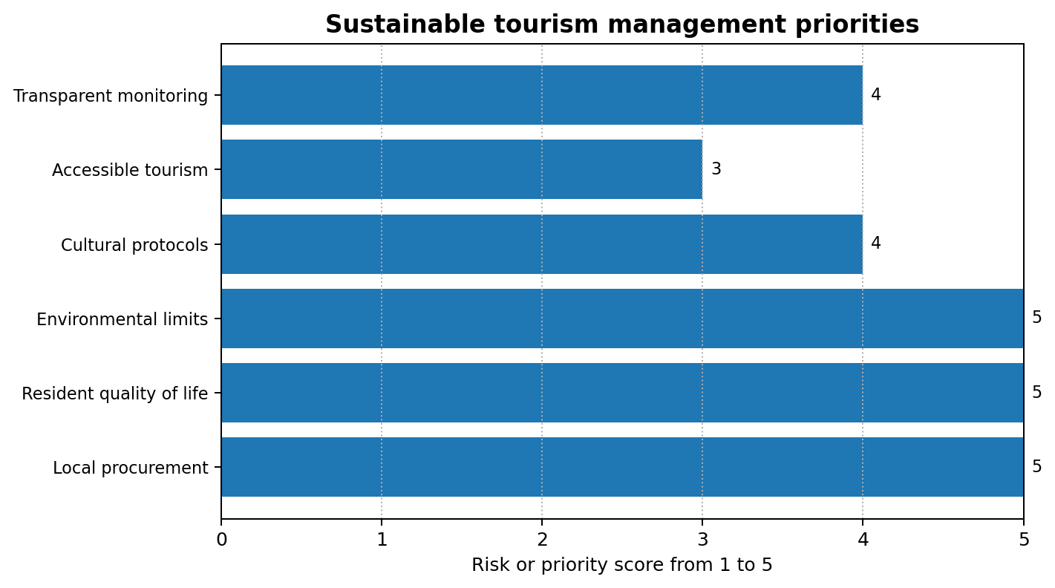
Figure 2. Sustainable tourism management priorities.

Table 2. Sustainable tourism practice recommendations
Practice | Local development contribution | Indicator
Local procurement programme | Retains value through farmers, artisans and service providers. | Percentage of tourism purchasing from local suppliers.
Visitor management at sensitive sites | Protects resources and resident quality of life. | Peak visitor numbers, site condition and complaints.
Community benefit fund | Turns tourism revenue into shared local goods. | Amount reinvested in public priorities and published accounts.
Cultural governance protocol | Protects identity and controls interpretation. | Number of community approved cultural products and protocol breaches.
Accessible tourism design | Improves inclusion for visitors and residents. | Accessibility audits completed and improvements delivered.

Discussion
The findings show that sustainable tourism is a development strategy only when it manages trade offs openly. Tourism creates income, but it also consumes resources. It can preserve culture, but it can also commodify it. It can fund infrastructure, but it can also redirect public investment towards visitors. It can improve quality of life for some residents while reducing it for others. These trade offs mean that sustainable tourism cannot be measured through a single indicator. It requires balanced decision making that considers distribution, limits and long term effects.
Poverty reduction is the most frequently claimed benefit of tourism, but the claim should be tested carefully. Tourism reduces poverty when low income residents have access to good jobs, enterprise ownership, market connections and skill development. It is less effective when external businesses capture profits and local workers remain in insecure service roles. A sustainable tourism strategy should therefore include local hiring standards, living wage principles, apprenticeships, micro finance, community enterprise support and supplier inclusion. Poverty reduction is not a by product of arrivals. It is an outcome of deliberate inclusion.
Quality of life should be treated as a central destination performance measure. Residents evaluate tourism through everyday experience: whether streets are crowded, whether wages are fair, whether housing is affordable, whether public spaces remain accessible and whether cultural identity is respected. A destination that ignores resident quality of life risks losing social licence. Social licence means community acceptance of tourism activity. Once social licence is damaged, tourism becomes politically unstable even if visitor demand remains strong. Resident surveys, participatory forums and public reporting can help maintain trust.
Environmental sustainability requires more than encouraging tourists to behave responsibly. Visitor behaviour matters, but structural systems matter more. Waste collection, water pricing, building regulations, transport options, energy systems and protected area management shape environmental outcomes. A destination that invites more visitors without upgrading waste and water systems is effectively transferring environmental costs to residents. Sustainable tourism should therefore include environmental carrying capacity, polluter pays principles and reinvestment of tourism revenue into conservation and infrastructure.
Cultural sustainability requires local control over representation. Tourists often seek authenticity, but authenticity can become commercial pressure when external businesses decide what local culture should look like. Community led interpretation is a stronger model because it allows residents to define meaning and boundaries. This can be supported through cultural councils, heritage trusts, intellectual property protection, fair payment for performers and limits on access to sacred or sensitive sites. The purpose is not to freeze culture, but to ensure that cultural change is not dictated mainly by tourist demand.
Managing growth is politically difficult because tourism businesses often benefit from more visitors, while residents may experience the costs. Destination authorities therefore need clear criteria for when growth should slow, where it should be redirected and what conditions must be met before expansion. These criteria could include water capacity, waste capacity, resident satisfaction, housing affordability, ecological indicators and public transport capacity. Growth should be conditional on community wellbeing and resource protection, not treated as an automatic objective.
Sustainable tourism also requires market repositioning. Some destinations pursue high volume, low spending tourism that puts pressure on infrastructure without generating enough local value. Others can shift towards longer stays, local experiences, off season travel, low impact mobility and higher local spending. However, higher spending tourism can also become exclusive or displace residents if not governed carefully. The goal is not simply to attract wealthier tourists. It is to attract forms of tourism that match local capacity, respect community identity and generate fair value.
The strongest practical model is a local sustainability compact. This compact would define the responsibilities of government, communities, businesses and visitors. Government would provide regulation, infrastructure and monitoring. Businesses would commit to local hiring, procurement, waste reduction and fair partnerships. Communities would participate in planning and cultural governance. Visitors would follow codes of conduct and support local enterprises. Revenue tools such as visitor levies or conservation fees could fund shared priorities. Such a compact turns sustainable tourism from a slogan into a set of obligations.
A further concern is climate change. Many destinations depend on climate sensitive assets such as beaches, reefs, snow, forests, wildlife and historic urban areas. Sustainable tourism strategies should include climate adaptation, disaster preparedness and diversification of visitor products. Climate risk is not separate from local development because storms, heat, water scarcity and biodiversity loss directly affect residents and tourism businesses.
Accessibility should also be included in sustainable tourism. Inclusive design for disabled visitors, older visitors and families with children can improve the visitor experience while also improving local public spaces. Accessibility is a social impact issue because it determines who can participate in tourism as a visitor, worker or entrepreneur. It also links sustainability with dignity and equal opportunity.
Finally, sustainable tourism should include education for visitors. Codes of conduct, interpretation, signage and guide training can shape behaviour around waste, photography, dress, wildlife, sacred sites and local purchasing. Visitor education cannot replace regulation, but it helps align tourist behaviour with community expectations and environmental limits.
A further concern is climate change. Many destinations depend on climate sensitive assets such as beaches, reefs, snow, forests, wildlife and historic urban areas. Sustainable tourism strategies should include climate adaptation, disaster preparedness and diversification of visitor products. Climate risk is not separate from local development because storms, heat, water scarcity and biodiversity loss directly affect residents and tourism businesses.
Accessibility should also be included in sustainable tourism. Inclusive design for disabled visitors, older visitors and families with children can improve the visitor experience while also improving local public spaces. Accessibility is a social impact issue because it determines who can participate in tourism as a visitor, worker or entrepreneur. It also links sustainability with dignity and equal opportunity.
Finally, sustainable tourism should include education for visitors. Codes of conduct, interpretation, signage and guide training can shape behaviour around waste, photography, dress, wildlife, sacred sites and local purchasing. Visitor education cannot replace regulation, but it helps align tourist behaviour with community expectations and environmental limits.
A further concern is climate change. Many destinations depend on climate sensitive assets such as beaches, reefs, snow, forests, wildlife and historic urban areas. Sustainable tourism strategies should include climate adaptation, disaster preparedness and diversification of visitor products. Climate risk is not separate from local development because storms, heat, water scarcity and biodiversity loss directly affect residents and tourism businesses.
Accessibility should also be included in sustainable tourism. Inclusive design for disabled visitors, older visitors and families with children can improve the visitor experience while also improving local public spaces. Accessibility is a social impact issue because it determines who can participate in tourism as a visitor, worker or entrepreneur. It also links sustainability with dignity and equal opportunity.
Finally, sustainable tourism should include education for visitors. Codes of conduct, interpretation, signage and guide training can shape behaviour around waste, photography, dress, wildlife, sacred sites and local purchasing. Visitor education cannot replace regulation, but it helps align tourist behaviour with community expectations and environmental limits.
A further concern is climate change. Many destinations depend on climate sensitive assets such as beaches, reefs, snow, forests, wildlife and historic urban areas. Sustainable tourism strategies should include climate adaptation, disaster preparedness and diversification of visitor products. Climate risk is not separate from local development because storms, heat, water scarcity and biodiversity loss directly affect residents and tourism businesses.
Accessibility should also be included in sustainable tourism. Inclusive design for disabled visitors, older visitors and families with children can improve the visitor experience while also improving local public spaces. Accessibility is a social impact issue because it determines who can participate in tourism as a visitor, worker or entrepreneur. It also links sustainability with dignity and equal opportunity.
Finally, sustainable tourism should include education for visitors. Codes of conduct, interpretation, signage and guide training can shape behaviour around waste, photography, dress, wildlife, sacred sites and local purchasing. Visitor education cannot replace regulation, but it helps align tourist behaviour with community expectations and environmental limits.
A further concern is climate change. Many destinations depend on climate sensitive assets such as beaches, reefs, snow, forests, wildlife and historic urban areas. Sustainable tourism strategies should include climate adaptation, disaster preparedness and diversification of visitor products. Climate risk is not separate from local development because storms, heat, water scarcity and biodiversity loss directly affect residents and tourism businesses.
Accessibility should also be included in sustainable tourism. Inclusive design for disabled visitors, older visitors and families with children can improve the visitor experience while also improving local public spaces. Accessibility is a social impact issue because it determines who can participate in tourism as a visitor, worker or entrepreneur. It also links sustainability with dignity and equal opportunity.
Finally, sustainable tourism should include education for visitors. Codes of conduct, interpretation, signage and guide training can shape behaviour around waste, photography, dress, wildlife, sacred sites and local purchasing. Visitor education cannot replace regulation, but it helps align tourist behaviour with community expectations and environmental limits.
A further concern is climate change. Many destinations depend on climate sensitive assets such as beaches, reefs, snow, forests, wildlife and historic urban areas. Sustainable tourism strategies should include climate adaptation, disaster preparedness and diversification of visitor products. Climate risk is not separate from local development because storms, heat, water scarcity and biodiversity loss directly affect residents and tourism businesses.
Accessibility should also be included in sustainable tourism. Inclusive design for disabled visitors, older visitors and families with children can improve the visitor experience while also improving local public spaces. Accessibility is a social impact issue because it determines who can participate in tourism as a visitor, worker or entrepreneur. It also links sustainability with dignity and equal opportunity.

Conclusion
Sustainable tourism can promote balanced local development by supporting jobs, small enterprises, infrastructure, cultural preservation, environmental protection and resident quality of life. However, these benefits are not automatic. Tourism can also create dependency, leakage, inequality, environmental pressure, cultural commodification, housing stress and resident opposition. The main conclusion is that sustainable tourism must be governed through local development cooperation, not merely marketed as responsible travel.
The report recommends a model based on local procurement, fair employment, community participation, cultural protocols, environmental standards, visitor management, resident quality of life monitoring and transparent benefit sharing. Destinations should measure success through local value retention, resident satisfaction, resource protection and cultural continuity as well as visitor spending. Sustainable tourism is most credible when it protects the people and places that make tourism possible. Long term local development depends on managing tourism within social and ecological limits while ensuring that communities have ownership, voice and visible benefits.

References
Ashley, C., Roe, D., & Goodwin, H. (2001). Pro-poor tourism strategies: Making tourism work for the poor. Overseas Development Institute.
Bramwell, B., & Lane, B. (2011). Critical research on the governance of tourism and sustainability. Journal of Sustainable Tourism, 19(4-5), 411-421.
Burgen, S. (2024, April 20). Tens of thousands protest against Canary Islands' unsustainable tourism model. The Guardian. https://www.theguardian.com/world/2024/apr/20/thousands-protest-canary-islands-unsustainable-tourism
Goodwin, H. (2011). Taking responsibility for tourism. Goodfellow Publishers.
Jackson, L. A. (2025). Community-based tourism: A catalyst for achieving the Sustainable Development Goals. Tourism and Hospitality, 6(1), 29. https://www.mdpi.com/2673-5768/6/1/29
Lacher, R. G., & Nepal, S. K. (2010). From leakages to linkages: Local-level strategies for capturing tourism revenue in Northern Thailand. Tourism Geographies, 12(1), 77-99. https://doi.org/10.1080/14616680903493654
Mitchell, J., & Ashley, C. (2010). Tourism and poverty reduction: Pathways to prosperity. Earthscan.
Organisation for Economic Co-operation and Development. (2024). OECD tourism trends and policies 2024. OECD Publishing. https://www.oecd.org/en/publications/2024/07/oecd-tourism-trends-and-policies-2024_17ff33a3.html
Quang, T. D., et al. (2023). Toward sustainable community-based tourism development. Humanities and Social Sciences Communications, 10, 676. https://pmc.ncbi.nlm.nih.gov/articles/PMC10617687/
Scheyvens, R. (1999). Ecotourism and the empowerment of local communities. Tourism Management, 20(2), 245-249.
Tosun, C. (2000). Limits to community participation in the tourism development process in developing countries. Tourism Management, 21(6), 613-633.
United Nations Department of Economic and Social Affairs. (n.d.). Sustainable tourism. https://sdgs.un.org/topics/sustainable-tourism
United Nations Development Programme India. (2021, October 23). Community-based tourism: Protecting nature, conserving traditions. https://www.undp.org/india/blog/community-based-tourism-protecting-nature-conserving-traditions
United Nations Development Programme Thailand. (2023). Community-Based Tourism for All: Co-creation Journey. https://www.undp.org/thailand/publications/community-based-tourism-all-co-creation-journey
United Nations Development Programme Turkiye. (n.d.). Capacity development for sustainable community based tourism. https://www.undp.org/turkiye/projects/capacity-development-sustainable-community-based-tourism
UN Tourism. (n.d.). Sustainable development. https://www.untourism.int/sustainable-development
World Bank. (n.d.). Tourism. https://www.worldbank.org/ext/en/topic/tourism
World Economic Forum. (2024, February 15). Turning tourism into development. https://www.weforum.org/stories/2024/02/turning-tourism-into-development/

Appendices
Appendix A provides a sustainable tourism monitoring checklist. It includes water use, waste generation, resident satisfaction, local procurement, local ownership, cultural site condition, housing affordability and conservation reinvestment.
The checklist should be reported publicly because sustainability claims need visible evidence. Transparent reporting helps residents, businesses and government agencies see whether tourism is moving towards long term development or simply increasing pressure.

