M09 Digital Transformation and Innovation MBA
Digital Leadership, Change Management and Ethical Technology Use
Selected assignment option: Option 3
Report type: Detailed project report
Student Name: __________________________
Student ID: __________________________

Table of Contents
Section | Page
Title Page | 1
Table of Contents | 2
Abstract | 3
1. Introduction | 3
2. Literature Review | 5
3. Methodology | 9
4. Findings | 10
5. Discussion | 14
6. Conclusion | 20
References | 22
Appendices | 25

Abstract
Successful digital transformation depends on leadership, change management and ethical technology governance as much as it depends on software, data and infrastructure. This report analyses the role of digital leaders in guiding transformation, building digital culture, managing employee adoption and ensuring responsible use of technologies such as artificial intelligence, analytics, automation and employee monitoring tools. It uses qualitative secondary research and framework synthesis to examine academic theory, current regulatory guidance and practical governance standards. The findings show that digital leaders must create strategic direction, build psychological safety, align cross functional teams, translate technology into business value and protect stakeholders from avoidable harms. Ethical risks include data privacy breaches, cybersecurity failures, algorithmic bias, excessive surveillance, shadow artificial intelligence and loss of employee trust. Change management practices support adoption by clarifying purpose, involving users, developing skills, redesigning work and using feedback loops. The report recommends a responsible transformation framework combining leadership accountability, structured change management, data governance, artificial intelligence risk management, human oversight and continuous assurance. The overall conclusion is that ethical digital transformation is not a constraint on innovation. It is a condition for sustainable competitiveness because organisations cannot scale digital systems without trust, legitimacy and employee commitment.

1. Introduction
Digital transformation is often presented as a technology challenge, yet many transformation failures are rooted in leadership, culture, change adoption and ethical governance. Organisations can invest in cloud platforms, artificial intelligence, automation and analytics, but these investments do not automatically produce value. Employees must understand the purpose of change, managers must redesign processes, customers must trust digital services and leaders must ensure that technologies are used responsibly. The rise of generative artificial intelligence has intensified this issue because the same tools that improve productivity can also create privacy, bias, misinformation, cyber and accountability risks. The managerial challenge is therefore to lead transformation in a way that is both innovative and legitimate.
This report addresses Option 3 by analysing digital leadership, change management and ethical technology use. It explores how digital leaders guide transformation, build digital culture and manage organisational change. It discusses ethical issues including data privacy, cybersecurity, algorithmic bias, employee surveillance and responsible artificial intelligence. It also evaluates how change management practices support employee adoption of new technologies. The report finally recommends practical frameworks for responsible, ethical and sustainable digital transformation.
The central argument is that ethical leadership and change management are not soft additions to digital strategy. They are core transformation capabilities. A firm that ignores employee adoption will struggle to scale digital tools. A firm that violates privacy or deploys biased algorithms may lose customer trust, face regulatory penalties and damage its reputation. A firm that allows uncontrolled artificial intelligence experimentation may expose confidential data or create unreliable outputs. Conversely, a firm that combines strategic vision, employee participation, accountable governance and responsible innovation can create a digital culture that supports both performance and trust. This report therefore treats digital transformation as a socio technical process in which people, technology and ethics must be aligned.
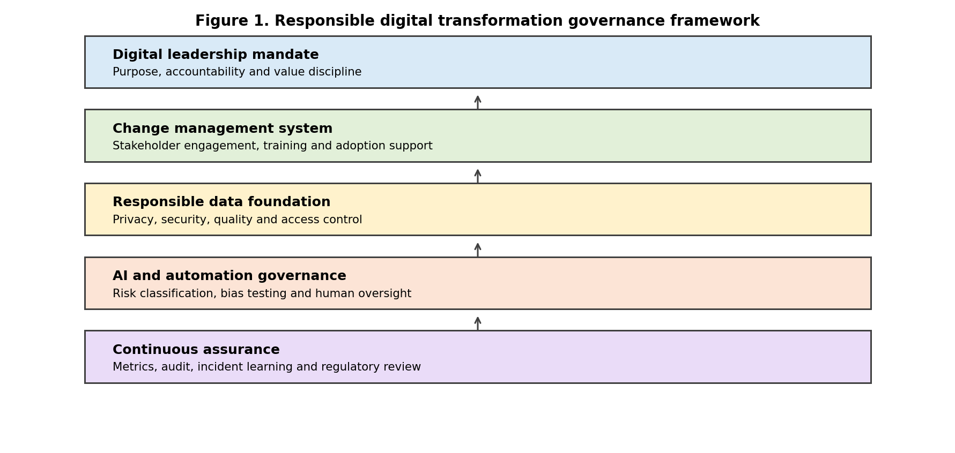
Source: Author synthesis based on NIST (2023), ISO (2023), Kotter (1995) and Westerman et al. (2014).

2. Literature Review

2.1 Digital leadership and digital culture
Digital leadership refers to the ability to mobilise people, processes and technologies towards strategic transformation in a digital environment. It is different from traditional information technology sponsorship because digital leaders must connect technology choices with customer value, business model change, data governance and workforce capability. Westerman et al. (2014) argue that digital masters combine digital capability with leadership capability. This distinction is useful because some firms are technologically active but strategically weak, while others have senior commitment but lack technological execution. Effective digital leadership requires both dimensions.
The literature on digital transformation supports this view. Vial (2019) presents transformation as a process where digital technologies trigger strategic responses that create changes in value creation, organisational structure and barriers. Verhoef et al. (2021) also show that transformation moves beyond digitisation and digitalisation because it changes the firm more deeply. These definitions imply that leadership must manage strategic renewal rather than technology installation. Leaders must decide which capabilities matter, which legacy routines must change, which risks are acceptable and how benefits will be measured. They must also create a narrative that makes transformation meaningful to employees.
Digital culture is a related leadership challenge. A digital culture does not mean that every employee becomes a software specialist. It means that the organisation values experimentation, data informed decisions, cross functional collaboration, customer centricity and learning. Kane et al. (2015) argue that strategy, not technology, drives digital transformation. This point is important because culture shapes how employees use technology. If the culture punishes failure, employees will not experiment. If departments protect data, analytics will remain fragmented. If managers use dashboards to blame rather than learn, employees may manipulate metrics or avoid transparency. Digital leaders must therefore build psychological safety, shared goals and clear accountability.
Change management theory explains why transformation requires structured adoption practices. Lewin (1947) framed change as unfreezing current behaviour, moving to a new state and refreezing new routines. Although this model is simple, it highlights the need to disrupt old habits and stabilise new behaviours. Kotter (1995) emphasised urgency, coalition building, vision, communication, empowerment, short term wins and institutionalisation. These principles remain relevant because digital transformation can create uncertainty about roles, skills, status and job security. Employees are more likely to adopt new technologies when they understand the reason for change, see credible leadership commitment and receive practical support.

2.2 Ethical technology risks
Ethical technology use has become a central component of digital transformation because technologies can affect rights, opportunities and trust. Data privacy is the starting point because digital systems collect, combine and analyse large volumes of personal and operational data. Privacy risk increases when data is collected without clear purpose, retained too long, shared across systems without governance or used for secondary purposes that stakeholders did not expect. The General Data Protection Regulation in Europe established strong principles around lawful processing, transparency, minimisation and rights, and its influence has shaped global privacy expectations. Even outside Europe, organisations face increasing pressure to demonstrate responsible data stewardship.
Cybersecurity is another ethical and strategic issue. Digital transformation expands attack surfaces through cloud services, connected devices, APIs, remote work tools and third party integrations. IBM (2025) reported a global average data breach cost of USD 4.4 million and highlighted an artificial intelligence oversight gap in which adoption outpaces governance. This shows that security is not merely a technical control. It is a leadership responsibility because cyber failures can harm customers, employees, suppliers and shareholders. Digital leaders must therefore integrate security into transformation design rather than add it after deployment.
Algorithmic bias and responsible artificial intelligence create further challenges. Artificial intelligence systems can reproduce biased data, optimise for narrow objectives or make decisions that are difficult to explain. Mittelstadt et al. (2016) argue that algorithms raise concerns about evidence, opacity, unfair outcomes and accountability. Floridi et al. (2018) also emphasise principles such as beneficence, non maleficence, autonomy, justice and explicability. These ethical principles matter because artificial intelligence increasingly influences recruitment, credit, pricing, healthcare, customer service and workplace monitoring. Organisations need governance structures that assess not only model accuracy but also fairness, context, explainability and human consequences.
Employee surveillance is an especially sensitive issue in digital transformation. Digital work platforms can track keystrokes, location, productivity indicators, communications and task completion. Monitoring may support safety, coordination and compliance, but excessive surveillance can undermine autonomy and trust. Zuboff (2019) warns that data extraction can become a form of power when individuals have limited control over how behavioural data is collected and used. In the workplace, the ethical challenge is to balance legitimate business interests with dignity, proportionality and transparency. Digital leaders should avoid treating employees as data points only. They must ensure that monitoring supports improvement rather than fear.
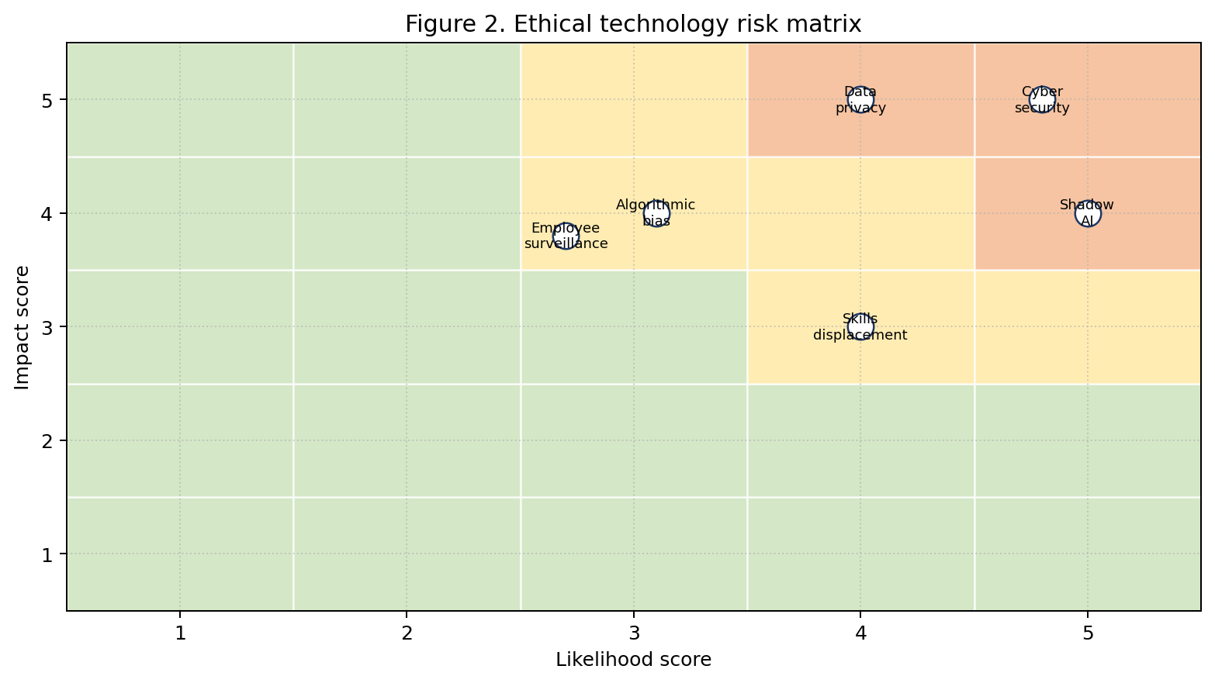
Source: Author risk assessment based on the reviewed literature and current governance guidance.

2.3 Responsible transformation guidance and standards
Regulatory and standards based guidance increasingly supports responsible transformation. The NIST Artificial Intelligence Risk Management Framework provides a structure for mapping, measuring, managing and governing artificial intelligence risk (NIST, 2023). ISO/IEC 42001:2023 provides requirements for an artificial intelligence management system and is presented by ISO as a structured way to manage risks and opportunities associated with artificial intelligence. The European Commission (2024) states that the European Union Artificial Intelligence Act entered into force on 1 August 2024 and will become fully applicable on 2 August 2026 with some exceptions. These frameworks show that responsible technology use is becoming a practical compliance and governance requirement rather than an optional value statement.
Table 1. Frameworks used to analyse leadership, change and ethics
Framework or theory | Core contribution | Use in this report
Digital leadership | Combines digital capability with leadership capability. | Explains why transformation requires strategic direction and cultural change.
Kotter change model | Emphasises urgency, coalition, vision, communication and institutionalisation. | Supports employee adoption analysis.
NIST AI RMF | Governs, maps, measures and manages AI risk. | Supports responsible AI governance recommendations.
ISO/IEC 42001 | Provides an AI management system approach. | Supports continuous assurance and lifecycle management.
EU AI Act | Introduces risk based regulatory governance for AI systems. | Shows that AI responsibility is now a compliance concern as well as an ethical concern.

3. Methodology
This report uses qualitative secondary research and framework synthesis. The method is suitable because the topic requires integration of leadership theory, change management theory, ethics literature, responsible artificial intelligence guidance and current regulatory developments. Peer reviewed academic sources are used to explain digital leadership, organisational change and algorithmic ethics. Authoritative institutional sources are used to interpret responsible artificial intelligence, data protection and artificial intelligence governance. Recent industry evidence is used where it provides relevant context on adoption and risk.
The analysis is organised around 4 questions. First, what do digital leaders do during transformation? Second, how do change management practices support employee adoption? Third, what ethical risks arise from data intensive and artificial intelligence enabled transformation? Fourth, what practical governance framework can help organisations transform responsibly? These questions are linked to the assignment task and provide a logical basis for the findings and discussion.
A risk matrix is used to structure ethical issues by likelihood and impact. The scoring is an author synthesis based on the literature rather than a statistical risk calculation. This is appropriate because the report is conceptual and strategic, not a primary empirical study. The framework presented in the discussion is similarly designed as a practical management model. The limitation is that risks vary by industry, technology and legal jurisdiction. A bank, hospital, retailer and manufacturer will not face identical data risks. The report therefore avoids universal claims and focuses on principles that can be adapted to organisational context.

4. Findings

4.1 Leadership direction and cross functional alignment
The 1st finding is that digital leaders create strategic direction and reduce ambiguity. Digital transformation often fails when employees receive mixed signals about whether technology is a cost cutting tool, a customer experience strategy, a compliance requirement or a broader business model shift. Leaders must clarify the purpose of transformation and connect it to measurable outcomes. For example, a transformation strategy might aim to reduce customer response time, improve demand forecasting, automate repetitive finance tasks or increase cyber resilience. Without this clarity, projects compete for attention and employees may experience change fatigue. Digital leadership therefore begins with strategic framing.
The 2nd finding is that digital leaders build cross functional alignment. Digital technologies cut across departmental boundaries. An artificial intelligence customer service tool may require data from marketing, customer operations, legal, cybersecurity and information technology. A cloud migration may affect finance, procurement, risk management and operations. An employee analytics platform may affect human resources, compliance and line managers. Leaders must create governance forums where these interests are coordinated. This does not mean that every decision should become bureaucratic. It means that digital transformation requires clear decision rights, escalation paths, risk ownership and benefit accountability.

4.2 Change adoption and employee support
The 3rd finding is that change management practices improve adoption by translating strategy into employee behaviour. Training is necessary but not sufficient. Employees also need involvement in design, clear process documentation, peer support, manager coaching and feedback mechanisms. Early involvement is especially important because frontline employees often know where digital tools will create friction. If technology is imposed without consultation, employees may create workarounds or use the system only superficially. Kotter's (1995) emphasis on communication and short term wins remains useful because employees need visible proof that change is practical and beneficial. A digital transformation programme should therefore include adoption metrics such as usage quality, process compliance, employee confidence and customer impact, not only system deployment dates.

4.3 Ethical technology risks and controls
The 4th finding is that data privacy and cybersecurity are foundational trust conditions. Customers and employees are more likely to accept digital services when they believe data is collected for legitimate purposes, protected effectively and used transparently. Privacy by design requires organisations to minimise data collection, define retention periods, control access and explain uses in clear language. Cybersecurity by design requires threat modelling, identity controls, encryption, monitoring, incident response and third party risk management. These controls support competitiveness because trust reduces friction in digital adoption. A firm that loses trust may face customer churn, regulatory scrutiny and internal resistance even if its technology is sophisticated.
The 5th finding is that algorithmic bias requires governance across the artificial intelligence lifecycle. Bias can enter during problem definition, data collection, labelling, model training, deployment and feedback. A model used for recruitment may disadvantage some groups if historical hiring data reflects unequal opportunity. A credit model may reproduce structural patterns if it uses variables correlated with protected characteristics. A customer service model may provide lower quality responses to language groups that are underrepresented in training data. Bias control therefore requires documented use cases, representative data checks, model testing, human review, monitoring and appeal mechanisms. Responsible artificial intelligence cannot be delegated fully to technical teams because it involves social and legal judgement.
The 6th finding is that employee surveillance should be governed through proportionality and transparency. Digital leaders should ask whether monitoring is necessary, whether less intrusive alternatives exist, who can access the data, how long it is retained and whether employees understand the purpose. Monitoring that supports safety or fair workload allocation may be defensible. Monitoring that creates constant pressure without meaningful employee benefit may damage trust and psychological safety. Ethical surveillance governance should include consultation, clear policy, data minimisation, separation between operational coaching and disciplinary use, and regular review.

4.4 Governance obligations and responsible transformation
The 7th finding is that responsible transformation is becoming a formal governance obligation. NIST (2023), ISO (2023), OECD guidance and the European Union Artificial Intelligence Act all point towards more structured accountability for artificial intelligence and digital risk. Organisations therefore need repeatable processes rather than informal ethical intention. A responsible transformation model should include risk classification, impact assessment, documented controls, model monitoring, human oversight and incident learning. This is especially important for generative artificial intelligence because employees may use external tools to process confidential data or generate outputs that appear credible but are inaccurate. Shadow artificial intelligence is a management problem because it develops when official tools are too slow, unclear or unavailable.
Table 2. Ethical risks and minimum governance responses
Risk | Why it matters | Minimum control response
Data privacy | Personal data misuse damages trust and can create regulatory exposure. | Purpose limitation, minimisation, retention rules and access control.
Cybersecurity | Digital transformation expands the attack surface. | Secure architecture, identity controls, monitoring and incident response.
Algorithmic bias | AI systems can reproduce unfair patterns or opaque decisions. | Impact assessment, representative data checks, bias testing and human review.
Employee surveillance | Monitoring can undermine autonomy and psychological safety. | Transparency, proportionality, consultation and limited access.
Shadow AI | Unapproved tools can expose confidential data and produce unreliable outputs. | Approved tools, clear rules, training and reporting channels.

5. Discussion

5.1 Leadership as capability building
The findings show that digital leadership operates at the intersection of strategy, culture, change and governance. Leaders must sponsor technology investment, but their deeper role is to create conditions under which people can adopt technology responsibly. This requires a shift from project management to capability building. A project mindset asks whether the system has gone live. A capability mindset asks whether the organisation can use the system to improve decisions, serve customers, protect stakeholders and adapt over time. This distinction is essential because many digital tools appear successful at launch but fail to change daily work.
A practical digital leadership framework should begin with purpose. Leaders should define what the transformation is for and what it is not for. For example, artificial intelligence adoption should not be framed vaguely as becoming an artificial intelligence organisation. It should be connected to specific outcomes such as reducing routine service handling time, improving forecasting accuracy or supporting employee knowledge retrieval. This purpose should then be translated into a portfolio of use cases with clear owners, value metrics and risk levels. High risk use cases, such as automated decisions affecting employment or customers, should receive stronger governance than low risk productivity tools.

5.2 Culture, adoption and responsible experimentation
The 2nd part of the framework is culture. Digital culture must combine experimentation with responsibility. Some organisations overemphasise risk control and become slow. Others overemphasise experimentation and create uncontrolled technology use. A mature culture encourages experimentation within guardrails. Employees should know which data can be used, which tools are approved, when human review is required and how to report problems. Leaders should reward learning and transparency rather than only speed. This matters because employees may hide failures if they believe mistakes will be punished. Hidden failures are dangerous in digital systems because small errors can scale quickly.
The 3rd part is change management. Leaders should treat adoption as a designed process. Before deployment, they should identify affected roles, expected behaviour changes, skill gaps and likely sources of resistance. During deployment, they should provide training, peer champions, help desk support and practical examples. After deployment, they should measure usage quality and business impact. The adoption curve in Figure 3 shows that employees move from awareness to understanding, trial, embedding and continuous improvement. Leadership attention is required at each stage because enthusiasm at launch often declines when employees face real workflow complexity.

5.3 Risk based governance and continuous assurance
The 4th part is ethical technology governance. Figure 2 shows that privacy, cybersecurity, algorithmic bias, surveillance, shadow artificial intelligence and skills displacement can all become significant risks. These risks are not identical, but they share a common feature. They arise when technology changes power, information access or decision processes. Ethical governance should therefore include impact assessment before deployment, data protection review, cyber review, bias testing where artificial intelligence is used, human oversight for consequential decisions and transparent communication with stakeholders. For high risk uses, organisations should also provide appeal and correction mechanisms.
The 5th part is continuous assurance. Digital transformation is not completed when a platform is deployed because models drift, threats change, regulations evolve and user behaviour adapts. Organisations need ongoing monitoring of performance, fairness, security incidents, user satisfaction, customer complaints and unintended consequences. ISO/IEC 42001 is useful because it frames artificial intelligence governance as a management system rather than a one off checklist. Similarly, the NIST framework encourages organisations to govern, map, measure and manage artificial intelligence risks across the lifecycle. These approaches support sustainability because they institutionalise learning.
The report also shows that ethical technology use can be a source of competitive advantage. Trustworthy digital systems reduce adoption resistance, support brand reputation and protect organisations from costly failures. Customers are more likely to share data with firms that communicate clearly and protect information. Employees are more likely to use digital tools when they believe the tools support their work rather than monitor them unfairly. Regulators are more likely to view firms favourably when governance is documented and proactive. Ethical transformation therefore supports long term growth by reducing legitimacy risk.

5.4 Fair transition and employee capability
There is also a tension between speed and responsibility. Digital markets reward fast experimentation, yet ethical and regulatory obligations require care. The solution is not to slow all innovation. It is to classify risks and match governance intensity to risk level. Low risk internal productivity tools can move quickly with basic data controls and training. Medium risk customer interaction tools may require testing, monitoring and escalation paths. High risk automated decision systems require formal impact assessment, bias review, human oversight and legal involvement. This differentiated approach allows organisations to innovate without treating all technologies as equally risky.
A final issue is employee capability. Digital transformation can create anxiety about automation and job displacement. Leaders should not dismiss these concerns with vague reassurance. They should provide reskilling pathways, role redesign, career support and honest communication about how work will change. Responsible transformation does not promise that no jobs will change. It promises that change will be managed fairly, transparently and with support. This is ethically important and strategically necessary because employees are the people who translate digital tools into customer value. A workforce that feels excluded from transformation is unlikely to sustain it.
A responsible transformation framework should also include role based digital literacy. Senior executives need enough literacy to challenge technology proposals, understand risk trade offs and avoid both hype and excessive fear. Middle managers need skills in process redesign, data interpretation and coaching because they translate strategic priorities into daily routines. Frontline employees need practical training on how tools affect their tasks, how to report errors and how to use data responsibly. Technical specialists need communication skills so that risk and performance issues can be understood by non technical stakeholders. Without this layered capability, digital transformation becomes dependent on a small expert group and cannot scale across the organisation.
Measurement is equally important. Leaders should not rely only on implementation milestones such as the number of systems deployed or training sessions completed. They should use adoption and trust indicators. Relevant measures include employee confidence in using the tool, perceived usefulness, customer complaints, error rates, escalation rates, privacy incidents, bias test results, cybersecurity control maturity and benefits realised against baseline. These measures should be reviewed regularly by a transformation steering group that includes business, technology, risk, legal, human resources and employee representation where appropriate. This creates shared accountability and prevents ethical concerns from being treated as late stage obstacles.
Communication should be continuous rather than episodic. Employees often hear about digital transformation during launch events but receive limited explanation when problems appear. Responsible leaders should communicate what is changing, why it is changing, what support is available, which decisions remain human and how concerns can be raised. They should also acknowledge uncertainty. Overconfident promises can damage trust when systems fail or benefits take longer than expected. Credible communication is specific, honest and linked to action. For example, leaders can explain that an artificial intelligence assistant will support drafting and retrieval but will not replace managerial judgement, performance evaluation or confidential decision making without review.
The practical recommendation is to establish a digital ethics and change board for material transformation programmes. This board should not operate as a symbolic committee. It should review high risk use cases before deployment, approve data use, monitor adoption, examine complaints and require corrective action when harms are identified. It should also maintain a register of artificial intelligence tools, automation systems, data sources and third party dependencies. Such a board creates organisational memory and prevents each project team from reinventing ethical governance. It also helps leaders show regulators, employees and customers that responsible transformation is embedded in management practice.
Leaders should also integrate responsible procurement into digital transformation. Many risks originate outside the organisation because cloud providers, analytics vendors, automation suppliers and artificial intelligence platforms influence data flows and system behaviour. Procurement should therefore assess security certifications, data processing terms, audit rights, model transparency, incident reporting, subcontracting and exit arrangements. This is important because an organisation remains accountable to customers and employees even when a technology function is outsourced. Responsible procurement also reduces lock in by requiring portability plans, clear service levels and documentation of how vendor systems can be replaced or integrated with alternatives.
Finally, responsible transformation should be linked to sustainability and social value. Digital tools consume energy through data centres, devices and model training, and they can also change labour demand across occupations. Leaders should therefore consider environmental and social consequences when selecting technologies. This does not mean rejecting digital innovation. It means choosing efficient architectures, reducing unnecessary data retention, designing automation to improve work quality where possible and using reskilling to share benefits more fairly. A transformation that improves profit but damages trust, workforce dignity or sustainability is strategically fragile. Ethical digital leadership therefore requires a broader view of value creation than short term productivity alone.
This broader view should be made visible in board reporting. Digital transformation dashboards should include not only delivery status and financial benefits, but also adoption quality, employee sentiment, risk events, data incidents, model performance and unresolved ethical issues. When these indicators are reported together, leaders can see whether digital progress is balanced or whether value is being achieved by transferring hidden risk to customers, employees or society. Such transparency improves governance and supports more credible strategic decision making.
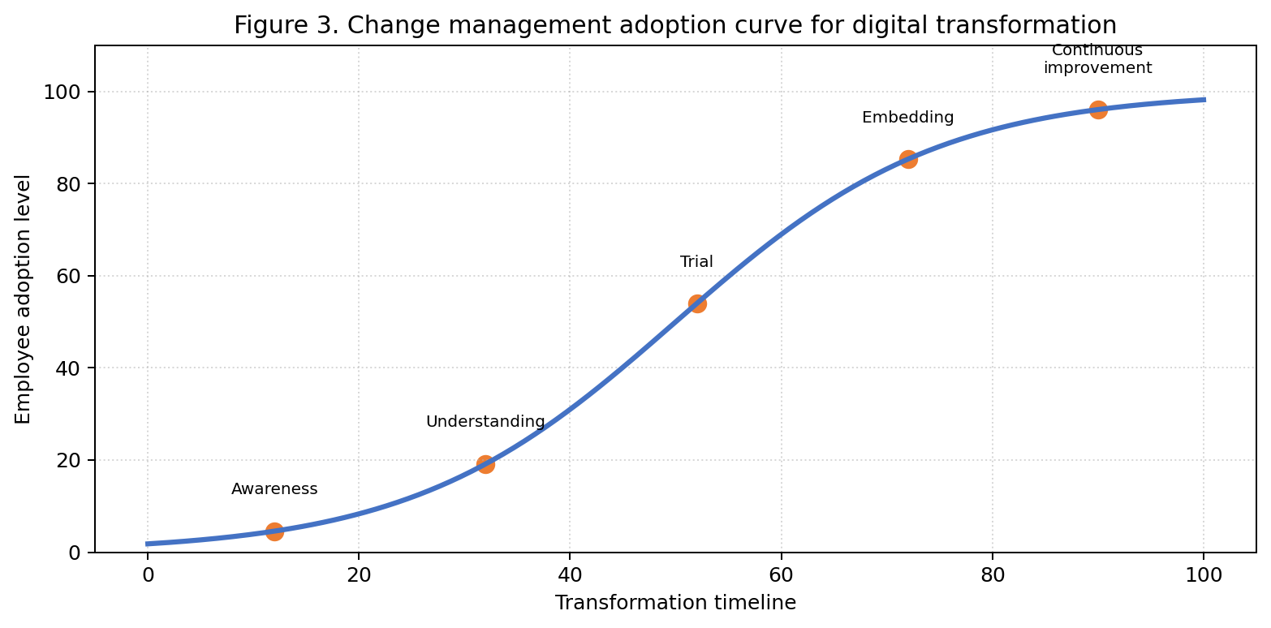
Source: Author synthesis based on change management theory.

6. Conclusion
Digital transformation succeeds when leadership, change management and ethical governance are integrated into the transformation model. Digital leaders must set direction, build culture, coordinate cross functional decisions and protect stakeholder trust. Change management practices support adoption by helping employees understand, test, use and improve new technologies. Ethical governance is necessary because digital systems create risks around privacy, cybersecurity, bias, surveillance and accountability. The report has argued that responsible transformation is not a barrier to innovation. It is the basis for sustainable innovation because trust allows digital systems to scale. Organisations should therefore use practical frameworks that combine purpose, adoption support, data governance, artificial intelligence risk management, human oversight and continuous assurance. This approach enables organisations to gain digital benefits while maintaining legitimacy, employee commitment and long term competitiveness.

References
Armenakis, A. A., & Bedeian, A. G. (1999). Organizational change: A review of theory and research in the 1990s. Journal of Management, 25(3), 293-315. https://doi.org/10.1177/014920639902500303
European Commission. (2024). AI Act. https://digital-strategy.ec.europa.eu/en/policies/regulatory-framework-ai
Floridi, L., Cowls, J., Beltrametti, M., Chatila, R., Chazerand, P., Dignum, V., Luetge, C., Madelin, R., Pagallo, U., Rossi, F., Schafer, B., Valcke, P., & Vayena, E. (2018). AI4People: An ethical framework for a good AI society. Minds and Machines, 28, 689-707. https://doi.org/10.1007/s11023-018-9482-5
IBM. (2025). Cost of a Data Breach Report 2025. https://www.ibm.com/reports/data-breach
International Organization for Standardization. (2023). ISO/IEC 42001:2023 Artificial intelligence management system. https://www.iso.org/standard/42001
Kane, G. C., Palmer, D., Phillips, A. N., Kiron, D., & Buckley, N. (2015). Strategy, not technology, drives digital transformation. MIT Sloan Management Review and Deloitte University Press.
Kotter, J. P. (1995). Leading change: Why transformation efforts fail. Harvard Business Review, 73(2), 59-67.
Lewin, K. (1947). Frontiers in group dynamics: Concept, method and reality in social science. Human Relations, 1(1), 5-41. https://doi.org/10.1177/001872674700100103
McKinsey & Company. (2025). The state of AI: How organizations are rewiring to capture value. https://www.mckinsey.com/capabilities/quantumblack/our-insights/the-state-of-ai-how-organizations-are-rewiring-to-capture-value
Microsoft. (2025). Annual report 2025. https://www.microsoft.com/investor/reports/ar25/index.html
Mittelstadt, B. D., Allo, P., Taddeo, M., Wachter, S., & Floridi, L. (2016). The ethics of algorithms: Mapping the debate. Big Data & Society, 3(2), 1-21. https://doi.org/10.1177/2053951716679679
National Institute of Standards and Technology. (2023). Artificial Intelligence Risk Management Framework (AI RMF 1.0). https://nvlpubs.nist.gov/nistpubs/ai/nist.ai.100-1.pdf
Organisation for Economic Co operation and Development. (2024). OECD AI principles overview. https://oecd.ai/en/ai-principles
Vial, G. (2019). Understanding digital transformation: A review and a research agenda. The Journal of Strategic Information Systems, 28(2), 118-144. https://doi.org/10.1016/j.jsis.2019.01.003
Verhoef, P. C., Broekhuizen, T., Bart, Y., Bhattacharya, A., Dong, J. Q., Fabian, N., & Haenlein, M. (2021). Digital transformation: A multidisciplinary reflection and research agenda. Journal of Business Research, 122, 889-901. https://doi.org/10.1016/j.jbusres.2019.09.022
Westerman, G., Bonnet, D., & McAfee, A. (2014). Leading digital: Turning technology into business transformation. Harvard Business Review Press.
Zuboff, S. (2019). The age of surveillance capitalism. PublicAffairs.

Appendices

Appendix A. Responsible digital transformation checklist
Question | Responsible answer expected before scaling
Purpose | The use case has a clear business and stakeholder purpose.
Data | The data is lawful, relevant, minimised and quality checked.
Risk | Privacy, security, bias, surveillance and operational risks are assessed.
People | Affected users are trained, consulted and supported.
Oversight | Decision rights, human review and escalation routes are defined.
Assurance | Performance, fairness, security and adoption are monitored after deployment.

Appendix B. Adoption indicators for a digital transformation programme
Indicator | Example metric
Awareness | Percentage of affected employees who understand the purpose of the technology.
Capability | Percentage completing role relevant training and assessment.
Usage quality | Frequency of correct workflow use rather than login count only.
Employee trust | Survey score on perceived fairness, usefulness and support.
Business impact | Customer response time, error reduction, cost improvement or risk reduction.

