Talent Development Strategy for Post-COVID Tourism Startups

Contents
Table of Figures 3
1. Introduction 4
2. Main Body 5
2.1 Talent Rebuilding Strategy 5
2.1.1 Overview of the Startup Hotel Chain’s Current Staffing Challenges 5
2.1.2 Gig Workforce Integration 5
2.1.3 Hybrid Roles & Remote Opportunities 6
2.1.4 Digital Onboarding & AI Tools 8
2.2 Recommendations for Long-Term Resilience and Wellness Integration 8
2.2.1 Workplace Wellness Programs 8
2.2.2 Retention and Loyalty Programs 9
2.2.3 Leadership & Culture 9
2.2.4 Technology & Innovation in HR 10
3. Conclusion 11
Reference 12

Table of Figures
Figure 1: Sample Social Media Job Post (Instagram/LinkedIn) 6
Figure 2: AI Performance Dashboard Sample 7

1. Introduction
The COVID-19 crisis hit the tourism and hospitality industry in South America very hard, causing mass layoffs, the closure of businesses, and a dramatic drop in consumer confidence in traveling. With the industry starting to bounce back, the start-up hotel chains are faced with the daunting task of recreating a strong workforce which is able to adjust to the new realities of operation. Human Resources (HR) leadership is, in that regard, vital to recovery of the workforce, loyalty of the staff, and engraving the future flexibility into the company culture. The focus of the given report is to outline a progressive HR approach that will utilize gig workers, hybrid staffing models, and digital onboarding tools to address the changing business requirements. With the incorporation of new forms of communication, AI-based performance systems, and remodeled Employee Value Propositions (EVPs), HR leaders will be able to restructure staff engagement helping to achieve sustainable growth. This report entails the construction of a thorough talent rebuilding plan, specimen digital communication resources, and practical recommendations of long-term resilience and employee wellness integration.

2. Main Body

2.1 Talent Rebuilding Strategy

2.1.1 Overview of the Startup Hotel Chain’s Current Staffing Challenges
The post-pandemic reality has severely altered the functioning dynamics of hotel startups in the whole of South America and poses a perplex mix of issues concerning the human resource. The prevalence of layoffs in the midst of the COVID-19 crisis has created severe understaffing in the industry, with a considerable number of hotels unable to satisfy the service demand as tourism slowly starts to pick up. Adding to this dilemma is a change in the expectations of the workforce as employees are now more likely to focus on work-life balance, job security and health safety. Budgetary constraints in startups also limit their capability to re-engage full-time employees or conduct extensive hires, making it challenging to reconstitute teams (Kaliannan et al., 2022). Moreover, the economic uncertainty of the wider region generates a feeling of insecurity that discourages talented workers to rejoin a not-so-stable sector. The swift introduction of digital tools and technologies like contactless check-ins, mobile reservations, automated services contributed to an emerging skills gap since not all the once hospitality workers are skilled technically as needed now. Furthermore, the pandemic has led to a shift towards gig work, which has dented the traditional form of staff loyalty, as many employees are embracing a freelance work model in other sectors. In such cases, hotel startups will need to focus on agile, technology-enabled HR practices that can attract contemporary talent and promote resilience, engagement, and long-term workforce stability (Kravariti et al., 2023).

2.1.2 Gig Workforce Integration
Gig workers can serve as an effective solution to the hotel operations in the post-COVID period, being expandable, cost-efficient, and flexible. These workers are mostly freelancers or contract-based professionals allowing hotel startups to scale their workforce in real-time reflecting seasonal variations and occupancy requirements without having to manage full-time salaries and benefits in the long term. Gig workers are particularly relevant in situations where repeatability in skills is essential, but temporary in use like housekeeping, organizing events, front desk services, and digital marketing. The robust rates of digital familiarity and readiness among them correlate with the hospitality industry moving in the direction of contactless services and tech-based guest experiences (Shah et al., 2023). Hotel chains need to provide clear, open short-term engagements with competitive pay, at-will working hours, and skill building to draw and retain talented gig professionals. Gig workers can be highly motivated and engaged with incentives like digital wellness resources, performance bonuses, and loyalty rewards programs. Creating a culture of inclusion, respect and clarity in the workplace is also important. The ease of integration is also guaranteed by providing technological tools in scheduling, collaboration, and feedback and the turnover is less. Hotels can achieve both agility and high services standards by appreciating the values of gig workers as partners (Mahato et al., 2021).
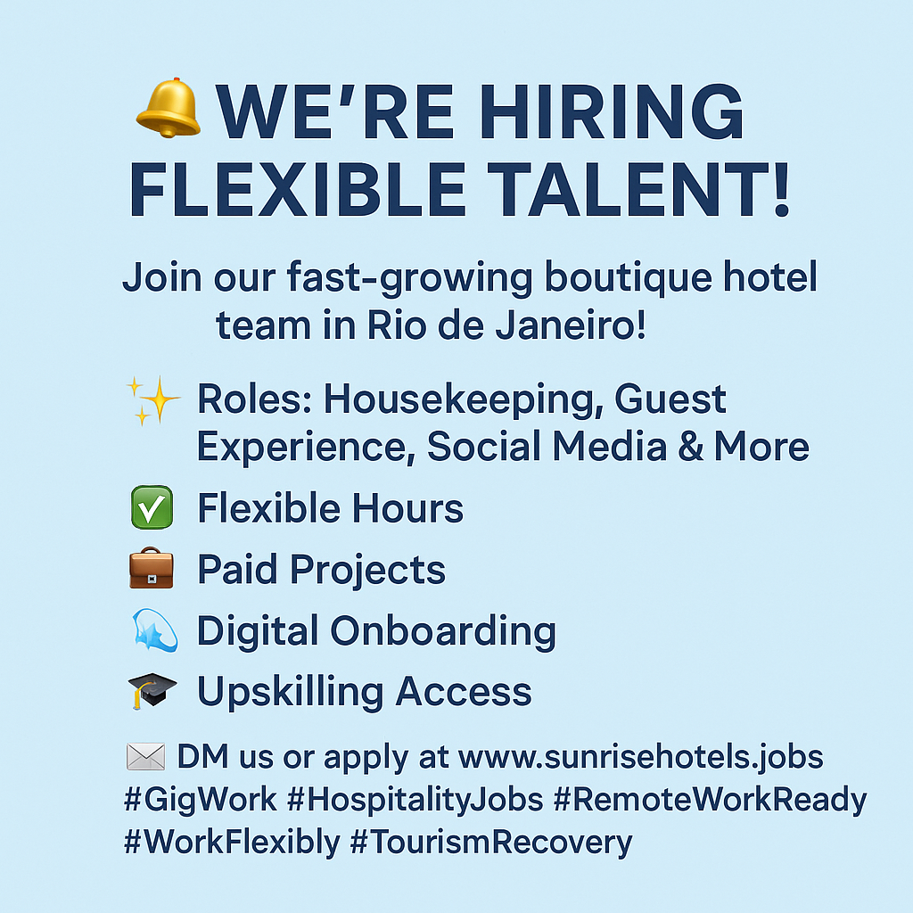
Figure 1: Sample Social Media Job Post (Instagram/LinkedIn)
(Source: Created by Author)

2.1.3 Hybrid Roles & Remote Opportunities
In the evolving hospitality environment, hybrid work has emerged as a sustainable staffing model. While core functions like front desk operations and housekeeping remain in-person, many administrative and guest support roles can be transitioned to hybrid formats. For example, positions in reservations, digital marketing, customer service, and revenue management can be successfully performed remotely or on a part-time office basis. This flexibility not only reduces overhead costs but also enhances employee satisfaction and work-life balance. To support hybrid roles, HR departments must implement clear guidelines and policies regarding work schedules, availability expectations, and communication protocols (Sigala et al., 2024). Providing hotel-issued equipment (laptops, secure Wi-Fi, access credentials), regular virtual check-ins, and remote training ensures that hybrid employees remain connected and productive. Rebranded Employee Value Proposition (EVP) - "At Sunrise Hotels, we believe flexibility fuels performance. Our hybrid roles empower you to work where you thrive—whether that’s from home or in-house. With continuous learning, digital support, and flexible hours, you’re free to grow your career in a way that fits your life. Because when you succeed, so do we." This EVP emphasizes autonomy, personal growth, and digital inclusivity—three essential pillars to attract and retain modern hospitality talent.
Digital Onboarding & AI Tools:
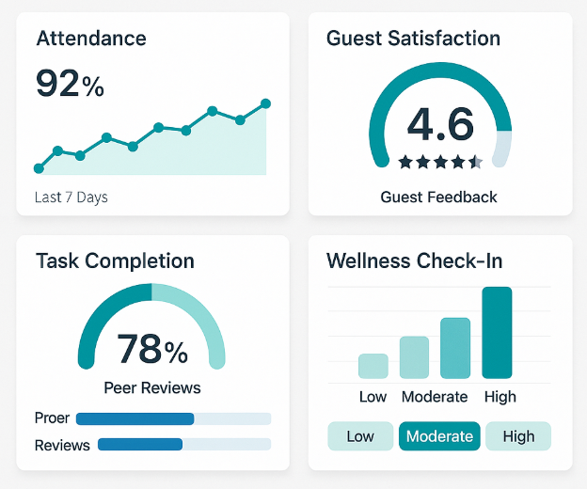
Figure 2: AI Performance Dashboard Sample
(Source: Created by Author)

2.1.4 Digital Onboarding & AI Tools
The hospitality industry will require a digital onboarding system that will integrate gig and hybrid workers in an efficient, scalable, and interesting way. Onboarding normally commences with an individual welcome message email with access information to a central onboarding portal. New recruits are then taken through a programmed, interactive learning system that provides modules specific to the roles assigned to them. Such modules can consist of virtual tours through the hotel, company brand information, guest service guidelines, safety and hygiene guidelines, and introductions to key digital tools in the hotel operation. The onboarding plan is typically developed to work with a 3 to 5-day time addition, contingent upon the intricacy of the job (Ahmadi Lari & Soare, 2025). Google Workspace and Trello help in smooth communication and task tracking, and hospitality-specific tools such as Mews or Hotelogix can be utilized during property management system training. The modules also include interactive components like quizzes, video walkthroughs, real scenarios, and task simulation to ensure the knowledge stays in memory. The resulting tech-driven onboarding process is faster than before in terms of employee readiness and confidence because it guarantees uniform training at numerous locations, and contributes to remote and suitable work patterns in a post-pandemic workforce (Arora et al., 2024).

2.2 Recommendations for Long-Term Resilience and Wellness Integration

2.2.1 Workplace Wellness Programs
Implementing comprehensive workplace wellness programs is vital for fostering long-term employee resilience, especially in a post-pandemic hospitality environment where burnout and stress are widespread. Mental health support should be a cornerstone of these programs, including confidential counseling services, partnerships with mental health professionals, and regular webinars on emotional well-being. Wellness days—paid leave specifically dedicated to rest and recovery—help prevent burnout and demonstrate employer empathy. Stress management workshops, yoga sessions, and mindfulness activities can be offered monthly, both virtually and in-person, to accommodate hybrid work arrangements (Clerici et al., 2023). These initiatives should be integrated into regular HR operations, not treated as one-off campaigns, ensuring employees know wellness is a continuous priority. Hybrid wellness programs are especially important for gig and remote workers, who may lack access to on-site resources. Offering digital wellness apps, virtual fitness classes, and online community forums helps maintain engagement and support regardless of location. When wellness is embedded into the company culture, staff feel more valued, supported, and emotionally prepared to manage job-related challenges, leading to improved retention and overall performance (Tenhunen, 2023).

2.2.2 Retention and Loyalty Programs
To foster long-term commitment and reduce staff turnover, hotel startups must implement structured retention and loyalty programs that go beyond traditional compensation. Personalized rewards systems that recognize individual achievements, such as “Employee of the Month” or project-based bonuses, can significantly boost morale. Upskilling opportunities through internal training, certifications, or sponsored online courses help employees feel invested in and more inclined to grow with the company. These programs should be open to all employment types—gig, hybrid, and full-time—to ensure inclusivity and fairness (Andreea Orîndaru et al., 2021). Team-building retreats or social events, whether virtual or physical, strengthen interpersonal relationships and reinforce team cohesion, particularly after the isolating effects of COVID-19. Additionally, the integration of AI can make retention strategies smarter and more personalized. AI tools can monitor engagement metrics such as log-in frequency, task completion rates, and feedback responses to identify early signs of disengagement. Based on these trends, HR can proactively offer tailored incentives—like flexible shifts, career coaching, or wellness credits—to keep staff motivated and loyal. This data-driven, empathetic approach makes employees feel understood and cared for (Kraus et al., 2024).

2.2.3 Leadership & Culture
A resilient hospitality workforce cannot thrive without supportive, adaptive leadership and a culture grounded in transparency and inclusivity. Leaders must shift from traditional top-down models to empathetic, people-centered management styles that encourage open dialogue and shared decision-making. Training programs for managers should emphasize emotional intelligence, active listening, and conflict resolution to equip them with the tools to lead compassionately. Leadership visibility and authenticity—through regular staff updates, open office hours, or anonymous suggestion platforms—build trust and psychological safety among employees. Furthermore, resilience should be embedded as a core organizational value and introduced from day one during onboarding (Dietsch, 2021). Orientation programs should include resilience-building exercises and case studies that demonstrate the company's commitment to adaptability, innovation, and personal growth. Ongoing development sessions should reinforce this value through storytelling, peer mentorship, and crisis simulations. Promoting an inclusive leadership culture that embraces diverse perspectives ensures every employee feels seen and respected, which strengthens loyalty and morale. In a post-COVID environment, cultural resilience is just as critical as operational agility in driving sustainable success (Fernández-Bedoya et al., 2025).

2.2.4 Technology & Innovation in HR
Technological advances are the principal way to maintain the lasting HR value, particularly in dynamic and decentralized hotel workforces. HR department needs to analyze its digital infrastructure and improve it regularly to provide efficiency, transparency, and engagement of any type of employee. This involves the integration of cloud-based performance management, digital feedback, and AI-backed learning systems. Personalization tools powered by AI enable HR to fine-tune learning progress based on personal learning style, career plans, and performance data. As an example, an agent with a potential leadership quality can have automatic updates regarding supervisor training opportunities or mentoring sessions (Oana Bărbulescu et al., 2021). Chatbots can answer HR-related queries 24/7, increasing accessibility and reducing administrative workload. Gamified learning portals and mobile-accessible dashboards help make engagement and skill-building fun, frequent, and measurable. Additionally, integrated HRIS (Human Resource Information Systems) streamline payroll, attendance, and performance data in one ecosystem, enabling faster and smarter decision-making. Investing in cutting-edge HR tech reflects a forward-thinking company culture, improves employee satisfaction, and enables the flexibility needed in the modern hospitality workforce—ultimately leading to higher retention and a more agile, empowered team (Lee & Bang, 2021).

3. Conclusion
In conclusion, the implementation of modern HR strategies is essential for the successful post-COVID recovery of startup hotel chains in South America. By embracing agile talent management models that incorporate gig workers and hybrid roles, hotels can adapt to fluctuating demand while reducing operational overhead and increasing flexibility for employees. The integration of AI and digital tools further enhances efficiency by streamlining onboarding, tracking performance, and personalizing development pathways. These technologies not only support scalable HR operations but also foster data-driven decision-making and continuous improvement. Equally important is the commitment to wellness integration, which builds workforce resilience, reduces burnout, and strengthens employee loyalty in a highly competitive labor market. Strategic HR management that values inclusivity, well-being, and technological innovation is no longer optional—it is vital for organizational survival and growth. Moving forward, HR leaders must remain committed to innovation, agility, and employee empowerment to create a sustainable, future-ready workforce that can thrive in the evolving hospitality landscape.

Reference
Ahmadi Lari, H., & Soare, A.-R. (2025). Strategic Planning for AI in Tourism Businesses. The Role of Artificial Intelligence in the Tourism and Hospitality Sector, 273–301. https://doi.org/10.4324/9781003545125-18
Andreea Orîndaru, Popescu, M.-F., Alexoaei, A. P., Ștefan-Claudiu Căescu, Florescu, M. S., & Anca-Olguța Orzan. (2021). Tourism in a Post-COVID-19 Era: Sustainable Strategies for Industry’s Recovery. Sustainability, 13(12), 6781–6781. https://doi.org/10.3390/su13126781
Arora, M., Ahmad, V., Arora, T., & Kumar, R. (2024). Digital Transformation and Talent Management. CRC Press EBooks, 50–70. https://doi.org/10.1201/9781032638188-4
Clerici, A. P., Murphy, C., & Almeida, N. M. C. (2023). The future of wellness tourism after COVID-19. European Spatial Research and Policy, 30(1), 103-122.
Dietsch, S. (2021). Reimagining leadership post COVID-19. Journal of Character and Leadership Development, 8(2).
Fernández-Bedoya, V. H., Ruiz-Palacios, M. A., Meneses-La-Riva, M. E., & Suyo-Vega, J. A. (2025). Tourism Entrepreneurship in Latin America: A Systematic Review of Challenges, Strategies, and Post-COVID-19 Perspectives. Sustainability, 17(3), 989.
Kaliannan, M., Darmalinggam, D., Dorasamy, M., & Lew, T.-Y. (2022). Rethinking Talent Management Strategies in Malaysia’s Tourism Sector Post COVID-19. ASM Science Journal, 17, 1–7. https://doi.org/10.32802/asmscj.2022.878
Kraus, S., Caputo, A., Palacios-Marqués, D. & Danvila-del-Valle, I. (2024), "Guest editorial: Talent attraction and retention strategies in the post-COVID era: an introduction", Management Decision, Vol. 62 No. 10, pp. 2961-2968. https://doi.org/10.1108/MD-10-2024-246
Kravariti, F., Jooss, S. & Scullion, H. (2023), "Talent management and COVID-19: lessons and opportunities: Guest editorial", International Journal of Contemporary Hospitality Management, Vol. 35 No. 8, pp. 2685-2690. https://doi.org/10.1108/IJCHM-08-2023-093
‌Lee, G.-W., & Bang, M.-Y. (2021). A study on Innovation Methods for the Content Industry in the post-COVID-19 Era. The International Journal of Advanced Culture Technology, 9(3), 142–151. https://doi.org/10.17703/ijact.2021.9.3.142
Mahato, M., Kumar, N. & Jena, L.K. (2021), "Re-thinking gig economy in conventional workforce post-COVID-19: a blended approach for upholding fair balance", Journal of Work-Applied Management, Vol. 13 No. 2, pp. 261-276. https://doi.org/10.1108/JWAM-05-2021-0037
Oana Bărbulescu, Tecău, A. S., Munteanu, D., & Constantin, C. P. (2021). Innovation of Startups, the Key to Unlocking Post-Crisis Sustainable Growth in Romanian Entrepreneurial Ecosystem. Sustainability, 13(2), 671–671. https://doi.org/10.3390/su13020671
Shah, S., Sindakis, D. S., & Kaur, D. J. (2023, October 13). Reimagining Global Talent Management for Talented Migrants in a Post-Covid-19 World. Social Science Research Network. https://doi.org/10.2139/ssrn.4600110
Sigala, M., Albrecht, J. N., Vorobjovas-Pinta, O., Fang, M., & Yeark, A. (2024). Introduction: Case-Based Research in Tourism, Travel, and Hospitality: Rethinking Theory and Practice. 1–12. https://doi.org/10.1007/978-981-97-1891-7_1
Tenhunen, P. (2023). The New Normal Era in Human Resource Management. Implementations, solutions and emerged new trends after Covid 19 in Tourism Industry (Master's thesis, Itä-Suomen yliopisto).
‌

