Student ID: DE240142

BALANCING TOURISM GROWTH AND ENVIRONMENTAL CONSERVATION IN COASTAL ECOSYSTEMS
Abstract
This study will address the critical balance of growth in tourism and conservation of the environment in the coastal ecosystem and define challenges and opportunities of the achievement of sustainable spatial planning in tourism. Due to the increasing number of tourists visiting such coastal regions due to the beauty that they are endowed with and the recreational potentials that are offered, the pressure has been increasing in the vulnerable marine and terrestrial ecosystems. The paper gets deeply into how sustainable management practices, policy framework and development of new planning tools relate in enabling the co-existence of tourism development and the protection of the ecosystem. As the paper demonstrates, integrated coastal zone management, community-based conservation, and green infrastructure planning are some of the key approaches that can be named with the help of a critical literature review and analysis of the practices conducted in the world, since all the mentioned approaches could be employed to preserve the ecological integrity and increase economic viability. The findings bring forth the significance of participatory governance, stakeholder relationships and adaptive policy guides that react to the long-term sustainability goals. Lastly, the study provides insight on how coastal tourism could be transformed into resilient, inclusive, and environmentally responsible tourist destinations that can conserve biodiversity, enhance the livelihood and guarantee the future attractiveness of the coastal environment to future generations.
Keywords: Coastal tourism, sustainable planning, environmental conservation, spatial management, community well-being

Table of Contents
1. Introduction 4
1.1 Background and Context 4
1.2 Research Aim and Significance 5
2. Literature Review 6
2.1 Introduction to Sustainable Tourism and Coastal Ecosystems 6
2.2 Theoretical Foundations of Sustainable Spatial Planning in Tourism 7
2.3 Global Sustainability Frameworks and Policy Approaches 8
2.4 Case Studies of Sustainable Coastal Tourism Practices 10
2.5 Debates and Challenges in Balancing Tourism and Conservation 11
2.6 Summary of Literature Gaps 12
3. Methodology 12
3.1 Research Design 12
3.2 Data Sources 13
3.3 Data Collection and Analysis 13
3.4 Justification and Limitations 14
4. Findings 14
4.1 Introduction 14
4.2 Findings and Analysis 15
4.3 Summary 19
5. Discussion 19
6. Conclusion 21
References 23
Appendices 28

1. Introduction

1.1 Background and Context
The coastal territories have been considered to be one of the most active and ecologically rich areas on earth and serve as an important meeting place in the marine and terrestrial worlds (Williams et al. 2024). The areas hold a large part of the biodiversity within the world, and serve a very important role in promoting the economic and social establishment, by offering tourism, fisheries and cultural heritage. Rising global mobility and the growing demand for seaside recreation have led to the development of coastal tourism that has provided massive economic momentum, such as job creation and development of infrastructure development (Zanko and S, 2024). Nonetheless, this growth has also led to massive destruction of the environment, such as the destruction of habitats, contamination and erosion of coastal regions. The result of these unsustainable activities is dire effects on the vulnerable ecosystems like the coral reefs, mangroves and wetlands that defend the shorelines and sustain the marine life (Ahmed et al. 2025). The key issue is to find the balance between economic development based on the tourism sector and natural resource protection. To ensure an intertwining of the ecological protection and the economic and social goals and to make sure that the development is not limited to the environmental boundaries, but on the contrary, the community seems to be resiliency-driven in the long-term and that the ecological ecosystem stays in good health, sustainable spatial planning and management are needed.

1.2 Research Aim and Significance
Research Aim
The aim of the study is to critically analyse how strong spatial planning and management can be effectively utilised to balance tourism development with conservation of environmental factors in coastal ecosystems.
Research Significance
The study is relevant because it involves a comprehensive and cross-disciplinary research project, as it embraces environmental management, tourism planning, and socio-economic sustainability (Mason et al. 2023). The paper contributes to the advancements of the existing body of knowledge on how integrated coastal zones management and ecosystem-based solutions can be achieved to support co-existence between anthropogenic development and natural conservation through the analysis of the world's case studies and theoretical perspectives (Hafiz Hanafiah and M, 2022). It proposes the participatory nature that lays emphasis on collaboration among the policy formulation teams, locals, and the tourism stakeholders to achieve shared sustainability objectives. In this discussion, communities in coastal regions are recognised to have their culture and livelihood highly dependent on the environmental conditions (Buhalis et al. 2023). Besides this, the paper also explains the increasing urgency of the adaptive planning systems in consideration of climate change, overexploitation and the rising sea levels.

2. Literature Review

2.1 Introduction to Sustainable Tourism and Coastal Ecosystems
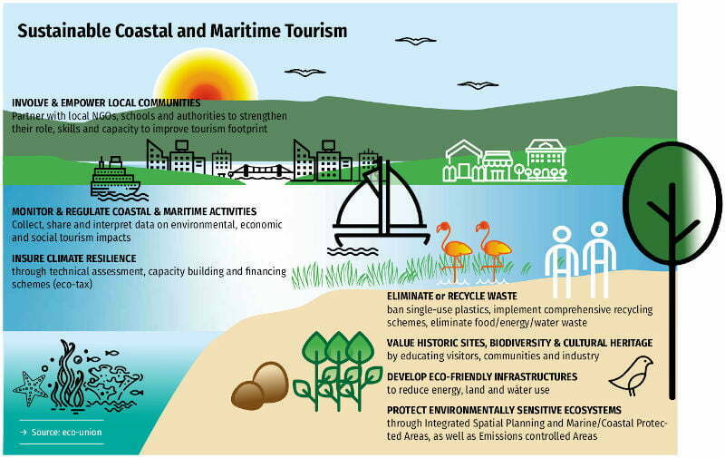
Figure 2.1: Sustainable Tourism and Coastal Ecosystems
(Source: resortsupportfiji.com, 2019)
Sustainable tourism has become an extremely essential aspect of the world tourism planning, especially in fragile coastal ecosystems, which have become not only ecologically but also economically important (Lukoseviciute et al. 2021). According to the United Nations World Tourism Organisation (UNWTO), sustainable tourism can be described as the kind of development that not only fulfils the needs of the visitors but also the industry as well as the host communities but also preserving environmental and cultural integrity for future generations (Canton and H, 2021). The coastal ecosystems, including coral reefs, mangroves, beaches and estuaries, are vital sources of key ecosystem services, such as stabilisation of shorelines, carbon storage and sustenance of livelihoods by millions of people (Puig-Cabrera et al. 2023). Nevertheless, the high rise in coastal tourism has increased the pressure on the environment due to uncontrolled construction, pollution, and destruction of habitats. Mass tourism facilities such as resorts and ports usually substitute natural habitats, which leads to the loss of biodiversity and a fragile ecosystem. As a result, sustainable spatial planning and management are the only way of balancing tourism development and environmental conservation.

2.2 Theoretical Foundations of Sustainable Spatial Planning in Tourism
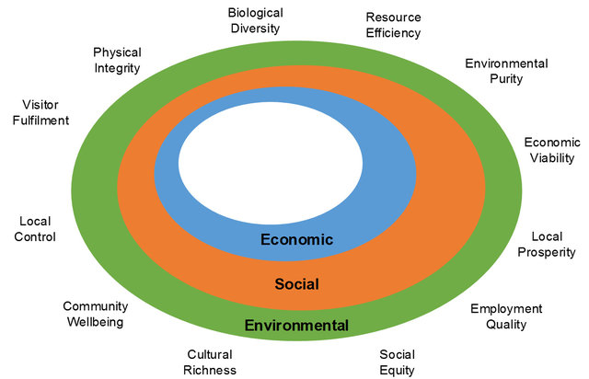
Figure 2.2: Theoretical Foundations of Sustainable Spatial Planning in Tourism
(Source: researchgate.net, 2013)
The concepts of interdisciplinary environmental stewardship, economic viability, and social equity form the basis of sustainable spatial planning in tourism (Hariram et al. 2023). One of the key frameworks is the Triple Bottom Line (TBL), whose intention is to ensure that people, planet, and profit are balanced. Within the framework of coastal tourism, TBL promotes the policies that can preserve the environmental resources and support local societies, as well as create sustainable economic development (Pisarović et al. 2025). The Carrying Capacity Theory also helps in planning as it helps in ascertaining the maximum that a destination can support in the form of tourism without subjecting the environment and the surroundings to irreversible ecological or social impact. This is especially important along the coastlines, where delicate ecosystems like the coral reefs, mangroves and dunes are at risk of overuse. This can be achieved by regulating the number of visitors and the types of infrastructure development within these limits so as to sustain the ecological stability and well-being of the community (Canton and H, 2021). To enhance these methods, complementary to them, Ecosystem-Based Management (EBM) is a trend towards a holistic view wherein the relations between terrestrial and marine systems are also considered, and ecological, social, and economic goals are made consistent.

2.3 Global Sustainability Frameworks and Policy Approaches
Framework / Approach | Focus / Objectives | Examples / Implementation
UN Sustainable Development Goals (SDGs) | Promote economic growth, climate action, and marine conservation | Goals 8, 13, 14; applied globally in tourism planning
Integrated Coastal Zone Management (ICZM) | Coordinated management across tourism, fisheries, urban planning, and conservation | Implemented in Europe and Asia; promotes participatory governance
Blue Economy | Sustainable use of ocean resources; eco-friendly infrastructure and recreational activities | Adopted in island nations and coastal destinations; includes ecosystem restoration
Environmental Certification Schemes | Encourage responsible tourism and high environmental standards | Examples: Green Globe, Blue Flag; recognized internationally
Table 2.1: Global Sustainability Frameworks and Policy Approaches
(Source: Self-Created)
There are various global frameworks and approaches to policies that are used to direct sustainable coastal tourism that combines environmental, economic, and social goals. The global plan on the implementation of sustainability in tourism planning is in the form of the United Nations Sustainable Development Goals (SDGs), Goal 8 (Decent Work and Economic Growth), Goal 13 (Climate Action), and Goal 14 (Life Below Water) (da Silva et al. 2024). Coastal tourism advances these goals since it helps in the economic development as well as preserving the marine and coastal environment. The use of an approach termed as Integrated Coastal Zone Management (ICZM) is a well-known model that advocates inter-sectoral tourism, fisheries, urban management and conservation (da Silva et al. 2024). ICZM has reduced conflicts and ensured the ecosystem functions, which have effectively been put into practice in a few European and Asian settings, established as an example of participatory governance. The Blue Economy model also focuses on the use of sustainable use of ocean resources, promoting environmentally friendly development of infrastructure, low-impact recreational activities, and the restoration of the ecosystem in tourism. Environmental certification schemes like Green Globe and Blue Flag assert responsible tourism by increasing the standards of a destination that are of good environmental standards.

2.4 Case Studies of Sustainable Coastal Tourism Practices
Case Study 1: Costa Rica’s Guanacaste Coast
Costa Rica is popularly known as a pioneer in sustainable tourism in the world, especially in the Guanacaste coast. Eco-lodges, marine protected areas and certification, including the Certification for Sustainable Tourism (CST) that assesses businesses on three environmental, social and economic sustainability parameters, have been implemented in the country. Guanacaste has not adapted large resort development and has focused on smaller resorts with an eco theme that ensures inclusion of renewable energy sources, waste management programmes and water conservation programmes (Sariego-Kluge et al. 2025). The communities living along the coasts are actively involved in conservation projects, such as restoring mangroves, and practising sustainable practices in fishing. These projects have conserved essential habitats of marine turtles, mangroves and coral reefs and have also helped in drawing eco-tourists. Consequently, tourism has been playing a key role in the local economic growth without affecting the biodiversity, showing how regulatory systems, community participation, and environmental accolades can be used effectively to balance between growth and conservation.
Case Study 2: Australia’s Great Barrier Reef
The Great Barrier Reef is the largest coral reef system in the world which is experiencing enormous demands due to tourism, climate change, and coastal development in Australia. The Reef 2050 Plan is currently a long-term sustainability policy that combines tourism management, environmental conservation, and scientific investigation (Walpole et al. 2022). The important interventions are zoning to regulate the tourism activities, high restrictions to visitors visiting the vulnerable sites, reef restoration initiatives and continuous monitoring of the ecology. The plan also involves the involvement of local interests to ensure that the economic benefits are shared without prejudice and the preservation of the health of the ecosystem. The Reef 2050 Plan has softened some of the ills of mass tourism, safeguarded endangered species and improved coral resilience and is evidence of the significance of integrated planning and adaptive management to support high-value coastal ecosystems (Barnes et al. 2022).

2.5 Debates and Challenges in Balancing Tourism and Conservation
Although major progress has been made in sustainable coastal tourism, many controversies and dilemmas have been raised in relation to balancing economic growth in conservation of the environment. A lot of areas on the coast rely mostly on the earnings of tourism and tend to emphasize socio-economic benefits rather than ecological sustainability. This dependency leaves governments and other stakeholders reluctant to limit activities through a regulatory tool like visitor numbers, zoning, and infrastructure increase limits because of the risk of loss due to reduced revenues. Involvement of communities and equity have been the main issues since in most cases the local populations will not be in the decision-making process and hence the social justice will be compromised, since conflicts may arise among the residents, the authorities and tourism developers. Unplanned development, poor waste management, and marine pollution continue to exist as those factors lead to the environmental degradation of the coastal ecosystem. These pressures are triple-folded by climate change, which expresses itself through rising sea levels, eroding coastal areas, and extreme chronic weather, all of which undermine the ability of tourism infrastructure to sustain itself.

2.6 Summary of Literature Gaps
Although the existing literature provides valuable pieces of information regarding the design of sustainable tourism models and practices that are employed in other nations, several essential gaps can be identified. The former weakness is the high proportion of individual cases that, in most cases do not produce sector models that can be implemented in other fields of coast. Additionally, the soundness of the interface between ecological science and policy in tourism is wanting, leading to a lack of a myriad of fragmented management policies that are ill-equipped to handle the complex environmental and socio-economic nexus. Social factors of sustainability that are hardly sought are equity, community participation in a project, and equitable sharing of gains, which limit the effective implementation of planning interventions. Besides the above, the sustainability certifications, governments, and planning strategies have rarely been assessed in a systematic manner, and that creates unpredictability as to their efficacy in the long-term. The futuristic research needs to take into consideration the dynamics of adaptive spatial planning models that will be responsive to the dynamic conditions of the environment, tourism demand and socio-economic influences.

3. Methodology

3.1 Research Design
The analysis applied in this study is the qualitative research design in a bid to critically analyse the balance of tourism development and environmental conservation on the coastal ecosystem. The understanding of the complex relations of the ecological, economic and social aspects is the object of study with the aid of a qualitative approach, and the key elements of sustainable spatial planning (Mason et al. 2023). The study employs the exploratory and descriptive approaches to conduct research on the structures of planning, policies and good practices applicable in real-life coastal destinations. The article dwells on a case study approach, based on the successful example of the sustainable vacation coastal tourist programmes across the globe. The design permits the thorough research on the processes besides the outcomes of sustainable planning in order to generate various critical requirements that ultimately lead to ecological adequacy, economically viable planning and community health.

3.2 Data Sources
In the research, only secondary sources of data will be used to obtain comprehensive information about sustainable coastal tourism practices. The peer-reviewed journal articles, academic books, governmental reports, policy documents, and publications of international organisations, including the UNESCO and the World Bank, are the main sources of evidence. The best information on the contextual information of worldwide best practices is found in reputable online databases and case study documentation (Hafiz Hanafiah and M, 2022). By applying secondary data, the study will examine existing frameworks, determine policy efficacy, and find common problems and solutions in the management of coastal tourism. This method entails a general, comparative vision of the strategies making a balance between tourism development and ecological and social sustainability.

3.3 Data Collection and Analysis
The data collection is carried out in the form of a systematic literature review carried out to identify the relationship that exists between tourism development and environmental conservation in the coastal ecosystem. The review is based on the major themes such as sustainable spatial planning, ecosystem-centred management, stakeholder interaction, policy framework, and environmental certifications (Williams et al. 2022). There are well-known case studies, especially the Costa Rica and the Great Barrier Reef, that are examined to draw up the efficient strategies and the learnt lessons. Thematic coding is used to analyse the data to divide repetitive patterns, issues, and best practices. It allows combining theoretical and practical knowledge and concentrating on the critical aspects that can facilitate eco-friendly tourism by reducing the level of ecological deterioration and enhancing social justice in the coastal areas.

3.4 Justification and Limitations
The qualitative methodology adopted is quite appropriate since it offers a comprehensive view of sustainable coastal tourism based on the synthesis of different sources and real-life examples. It is a way of defining intricate relationships between the environmental, economic and social processes that could be missed by other quantitative methods. Nevertheless, an analysis of secondary data is associated with the possibility of bias in data accuracy, the point of view when publications are published, and the variability of detail (Buhalis et al. 2023). The lack of the main fieldwork also restricts the understanding of the ideas of localised experiences between stakeholders and real-time ecological conditions. The limitations do not render the approach ineffective in the assessment of best practices and the effectiveness of policies and planning frameworks, and thus present useful advice on the management of sustainable coastal tourism.

4. Findings

4.1 Introduction
This chapter outlines the results of research conducted using secondary data sources to discuss sustainable planning of coastal tourism spaces. The section is designed on economic, environmental, and social aspects that can affect tourism growth and ecosystem preservation. It focuses on the assessment of environmental risks, policy instruments, and community involvement, establishing important trends that enable the maintenance of a balanced relationship between tourism development and environmental sustainability.

4.2 Findings and Analysis
Economic Significance and Vulnerability of Coastal Tourism
According to the World Travel and Tourism Council (2024), in 2023 the coastal and marine tourism direct contribution to the global economy was US$1.5 trillion and the industry offered jobs to approximately 52 million individuals. It was also the largest contributor to total tourist spending in the world with a direct US tax revenue of about US$820 billion. The WTTC states that mitigation and adaptation efforts will demand US$65 billion per year to shield coastal tourism against climate change and environmental degradation (Gössling & Scott, 2025).
An example is in the Kingdom of Morocco where the World Bank estimates that between 32 and 35% of the coastal tourism employment might have disappeared by 2035 unless the climate change-related alterations in tourist flows are mitigated. Coastal tourism maintains livelihoods and growth, but at the same time, it is a high-risk due to environmental stressors, and strategic planning is needed to guarantee its sustainability.
Environmental Risks in Coastal Ecosystems
According to the UNESCO World Heritage Centre (2025), approximately one-third of the total coral reefs are already severely damaged and 70% of all coral reefs are under a threat of being eliminated by 2030 unless the current trends are reversed.
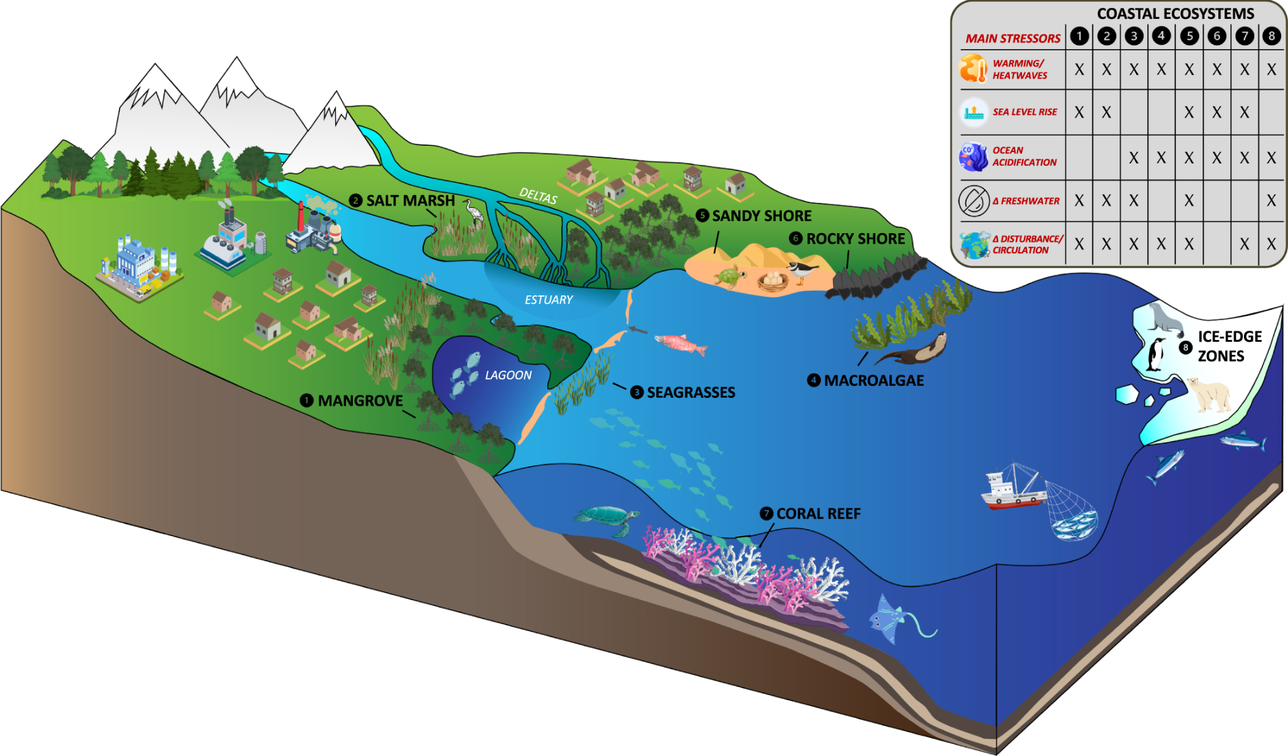
Figure 4.1: Environmental Risks in Coastal Ecosystems
(Source: Guild et al. 2025)
Sandy beach erosion, both as a scenic resource and a natural protective buffer is another environmental hazard. According to the World Bank Group (2025b), 24% of all sandy beaches in the world are eroding, especially in Africa, Southeast Asia and the Pacific Islands. In Thailand, approximately 30% of the coastline has been eroded in the last 30 years, equivalent to an estimated value of land worth US$1.3 billion.
In coastal economies like Morocco the erosion, heat waves, and decreasing tourist numbers are estimated to shrink employment in hotels and restaurants by 14-32% based on the situation (Sampath, 2025). These results affirm that the sustainability of tourism in coastal ecosystems is under threat by environmental degradation that involves loss of corals, erosion of beaches, and the effects of climate change.
Effectiveness of Planning Tools: Marine Protected Areas & Certification Schemes
The policy instruments review shows that instruments like Marine Protected Areas (MPAs) and environmental certification schemes have both positive and negative effects. More recent research indicates that approximately 33.1 million marine-based scuba dives occur each year across the world, with 70% of this number taking place in MPAs (Cabral et al. 2025). Among the MPA-related diving locations, only 15% are of the highly or fully protective types. The research also indicates that by turning a representative of unguarded dive locations into well-guarded MPAs, an extra US$2 billion a year of direct tourism income could be produced.
In the example of the Gili Matra Islands (Indonesia) within an MPA, a study found that, although the stakeholders acknowledge that the MPA promotes both ecosystem services and tourism, many local (non-influential) stakeholders believed the management was failing to achieve social and economic benefits. The Mnazi Bay Marine Park (Tanzania) established that MPAs were capable of reducing ecosystem agents of change, including overfishing and degradation of habitats, but governance and community participation and monitoring made the difference (Katikiro et al. 2021).
Case Study Evidence of Balanced Approaches
A review of destinations where sustainable planning has been more effective enables important lessons to be noted. Small-scale eco-resorts, community participation and ecosystem restoration have made the Guanacaste Seashores in Costa Rica focus on promoting tourism without significant biodiversity loss. The Great Barrier Reef in Australia is under intense pressure due to mass tourism, coral bleaching due to climate change and needs to be planned in a more adaptive manner (Barnes et al. 2022). As a consequence of recent bleaching events, there have been 25-33% declines in coral cover in certain reef areas.
According to the World Bank Group’s (2025b) report “When the Beach Disappears”, beach tourism generates about 5.2% of world GDP, where sandy beaches are disappearing at a rate of 24% worldwide.
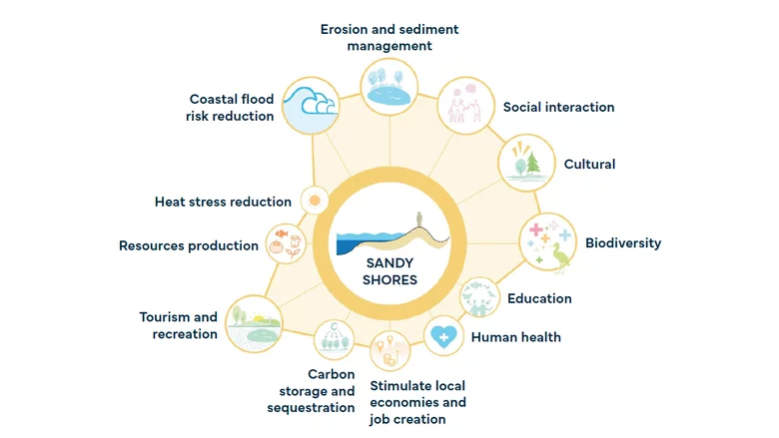
Figure 4.2: Benefits of Sustainable Sandy Shores
(Source: World Bank Group, 2025b)
These examples demonstrate that destinations can be successful when they:
- Restrict expansion on a resort scale and encourage low-impact infrastructure.
- Engage local communities in decision-making and the sharing of benefits.
- Incorporate ecosystem protection (mangroves, coral reefs, dunes) into tourism spatial planning.
Tourist places that focus on high growth rates without much control tend to experience ecosystem degradation, displacement of tourists, and financial instability.
Social and Community Well-being Outcomes
The results further highlight that the process of balancing tourism and conservation should incorporate social equity and community welfare. Nature-based tourism statistics indicate that local incomes may grow substantially in the Nosy Be region of Madagascar, as every tourist dollar yields approximately US$2.48 of local income. Uganda has an average of US$2.03 per tourist dollar (World Bank Group, 2025a).
Other research warns that social outcomes are based on stakeholder governance. Non-influential stakeholders in the Gili Matra Islands reported that the MPA management failed to maximise their benefits (Rosadi et al. 2022). The Moroccan coastal tourism report also cautions that any job loss due to climate effects will have a disproportionate impact on small businesses and the female labour force. The findings indicate that sustainable spatial planning should not be limited to ecological and economic aspects but should entrench social equity, empowerment of local communities, benefit-sharing mechanisms and inclusive governance.

4.3 Summary
The results reveal that sustainable coastal tourism needs to have integrated spatial planning to balance ecological conservation with economic growth and social well-being. It is proven that unregulated growth and fragile administration enhance environmental hazards and social disparities. Marine Protected Areas, certification schemes, and community-based eco-resorts are effective when managed inclusively, guaranteeing long-term environmental sustainability and robust tourism economies.

5. Discussion
The results indicated that interdependence between economic well-being, ecological well-being and social well-being in the coastal tourism systems has been a very complex one. Coastal and marine tourism was established to be a significant economic contributor to global GDP and workforce which suggested the pivotal role of tourism in the global economy (Karani & Failler, 2020). Nevertheless, the economic reliance was discovered to put the coastal destinations at risk of environmental degradation and climate-related risks. The increasing risk throughout the ecological and economic spheres were identified as the rising sea levels, coral bleaching, and shoreline erosion that deteriorates the tourism infrastructure, workforce, and the livelihoods of the community. Therefore, there was stress and the necessity of sustainable spatial planning in order to balance between tourism growth and long-term ecological sustainability.
The tools of planning like Marine Protected Areas (MPAs) and environmental certification schemes were noted to offer both ecological and economic positive effects, but their effectiveness was seen to largely rely on the proper governance approach, involvement of communities and enforcement related to these instruments. It was mentioned that MPA improved the services of the ecosystem and biodiversity protection, but the social legitimacy of the management was low when the local actors were not represented in the management processes (Hunitie & Mohammad, 2024). As illustrated with the Gili Matra and Mnazi Bay Marine parks, participation in governance process and capacity building was required to achieve sustainable development results in a balanced manner.
Based on examples like the ones in the Guanacaste Coast of Costa Rica helped to demonstrate how community based eco-tourism, small-scale development and conservation-based planning can bring about economic gains without causing a major deterioration of the biodiversity. Conversely, it was found, based on the Great Barrier Reef, that mass tourism and the lack of adequate adaptation policy has enhanced ecological destruction against regulatory frameworks. The difference in these results implied that adaptive planning and integrated coastal management need to be constantly implemented in order to react to environmental feedback and occurrences.
Another important component that was determined to be very critical is the social aspect of sustainability. It was determined that coastal tourism planning should encompass equitable sharing of benefits, diversification of livelihood as well as inclusion of gender in lieu of profit. The results of Madagascar and Uganda showed that nature-based tourism can pay greater attention to communities as long as they are turned into stakeholders. Thus it was decided that sustainable coastal tourism is only realisable when proper systems of integrated frameworks, which need to incorporate economic sustainability, ecological stability, and social justice are in place under adaptive and participatory systems of spatial planning.

6. Conclusion
Based on the research it can be stated that coastal and marine tourism is very important in the world economy as it brings a lot of employment, earnings as well as community building. This growth has however been determined to be placing mounting pressure on delicate coastal systems like coral reefs, mangroves, wetlands and sandy beaches. These ecosystems are the habitats that sustain marine biodiversity as well as offer the natural barrier against erosion and other climatic hazards along the coastline. Results of the studies verified that the development of tourism without control, poor management and lack of effective environmental policies tend to speed up the process of habitat loss and endanger sustainability. As a result, it is concluded that a focal part of the tourism development in the coastal areas should be sustainable spatial planning and sustainable spatial management.

It was also established that the incorporation of economic, environmental, and social aspects is crucial to realising sustainable tourism in the coastal areas. The United Nations Sustainable Development Goals (SDGs), the Integrated Coastal Zone Management (ICZM) and the Blue Economy are all useful frameworks to base in balancing tourism with both conservation and community well-being. But their success will be achieved through proper implementation at local level, involvement of stakeholders and constant monitoring. Eco-friendly tourism, community integration, as well as adaptive management have proven to be a balanced growth in case studies like the Guanacaste Coast in Costa Rica. As an example, the Great Barrier Reef, which has experienced poor adaptation and exploitation amidst disastrous consequences, has demonstrated that a decline in an ecosystem is irreversible. Thus, a system has been put in place that adaptive, participatory, and ecology-based spatial planning is necessary in the creation of resilience and long-term ecological and economic stability.
Limitations
The main limitation of the study has been its use of secondary sources of data. As per Tien et al. (2021), the lack of primary field data did not allow for capturing the real-time perception of stakeholders and the ecological conditions of the site. The difference in reliability and scope of secondary sources could also have been the source of bias in the interpretation of findings. In addition, the applied qualitative method, although useful in delivering in-depth analysis ability, restricted quantification of the associations between tourism pressure, change in the ecosystem, and socio-economic consequences. This research has also been limited by the heterogeneity of global coastal settings since generalisation of the research findings to all regions makes it difficult. As per Jotaworn & Nitivattananon (2023), further studies that will advance to mixed methods, field notes and longitudinal measurements may give more accurate estimates of the effects of policy and adaptive management measures.
Recommendations
It is based on the findings that a number of recommendations have been forwarded. To begin with, governments are advised to implement integrated coastal management models that integrate both the spatial planning and ecosystem-based management in order to avoid excessive development in the area and loss of habitat. The enforcement of Marine Protected Areas (MPAs) and environmental certification schemes needs to be done in a stronger manner in order to bring the compliance and accountability (Lin et al. 2022). Secondly, Pelmin (2025) recommended that participatory governance structures be institutionalised so as to engage the local communities, tourism stakeholders and policymakers in the process of making joint decisions. Such a strategy would improve transparency, fairness and empowerment of the community.
Thirdly, it should design adaptive mechanisms of planning to address emerging issues like the upsurge of the sea level, changes in climatic conditions, and pollution. Zoning and tourism capacity limits should be informed by constant ecological monitoring which should be informed by scientific data (Job et al. 2020). Finally, the aspect of education, training, and awareness campaigns should also be given priority to uphold sustainable tourism practices among the tourists and the operators (Sreenivasan & Singh, 2024). Through the incorporation of sustainability in governance, business, and community structures, the coastal destinations would be in a position to preserve their ecological stability to be socio-economically stable and viable in the long term.

References
Ahmed, R., & Tamim, M. T. R. (2025). Marine and Coastal Environments: Challenges, Impacts, and Strategies for a Sustainable Future. International Journal of Science Education and Science, 2(1), https://doi.org/53-60.10.56566/ijses.v2i1.325
Barnes, M. L., Datta, A., Morris, S., & Zethoven, I. (2022). Navigating climate crises in the Great Barrier Reef. Global Environmental Change, 74, 102494.https://doi.org/10.1016/j.gloenvcha.2022.102494
Buhalis, D., Leung, X. Y., Fan, D., Darcy, S., Chen, G., Xu, F., ... & Farmaki, A. (2023). Tourism 2030 and the contribution to the sustainable development goals: the tourism review viewpoint. Tourism review, 78(2), 293-313. https://doi.org/10.1108/TR-04-2023-620
Cabral, R. B., Millage, K. D., Mayorga, J., Kordell, T., Kelkar, M., Caughman, A. M., ... & Bradley, D. (2025). Marine protected areas for dive tourism. Scientific Reports, 15(1), 1923. https://www.nature.com/articles/s41598-024-83664-1
Canton, H. (2021). World tourism organization—UNWTO. In The Europa directory of international organizations 2021 (pp. 393-397). Routledge.https://doi.org/10.4324/9781003179900
da Silva, L., Gardolinski, S. A., & Medaglia, J. (2024). Tourism and the United Nations Sustainable Development Goals: a scientific perspective. Applied Tourism, 9(2), https://doi.org/10.14210/at.v9i2.1890
Gössling, S., & Scott, D. (2025). Tourist demand and destination development under climate change: complexities and perspectives. Journal of Sustainable Tourism, 1-32. https://www.tandfonline.com/doi/abs/10.1080/09669582.2025.2543953
Guild, R., Wang, X., & Quijón, P. A. (2025). Climate change impacts on coastal ecosystems. Environmental Research: Climate, 3(4), 042006. https://iopscience.iop.org/article/10.1088/2752-5295/ad9f90/meta
Hafiz Hanafiah, M. (2022). Framing the future agenda of blue tourism in sustainable coastal tourism destinations. Tourism and hospitality management, 28(2), 465-470.https://doi.org/10.20867/thm.28.2.6
Hariram, N. P., Mekha, K. B., Suganthan, V., & Sudhakar, K. (2023). Sustainalism: An integrated socio-economic-environmental model to address sustainable development and sustainability. Sustainability, 15(13), 10682.https://doi.org/10.3390/su151310682
Hunitie, M. F. A., & Mohammad, S. I. S. (2024). Sustainable marine and coastal tourism: A catalyst for blue economic expansion in Sri Lanka. Journal of Ecohumanism, 3(6), 1214-1228. https://www.researchgate.net/profile/Khaleel-Al-Daoud/publication/392706399_Sustainable_Marine_and_Coastal_Tourism_A_Catalyst_for_Blue_Economic_Expansion_in_Sri_Lanka/links/684e9621df3fa4286a40cf78/Sustainable-Marine-and-Coastal-Tourism-A-Catalyst-for-Blue-Economic-Expansion-in-Sri-Lanka.pdf
Job, H., Becken, S., & Lane, B. (2020). Protected Areas in a neoliberal world and the role of tourism in supporting conservation and sustainable development: an assessment of strategic planning, zoning, impact monitoring, and tourism management at natural World Heritage Sites. In Protected areas, sustainable tourism and neo-liberal governance policies (pp. 1-22). Routledge. https://www.researchgate.net/profile/Susanne-Becken/publication/320967907_Protected_Areas_in_a_neoliberal_world_and_the_role_of_tourism_in_supporting_conservation_and_sustainable_development_an_assessment_of_strategic_planning_zoning_impact_monitoring_and_tourism_management/links/5c5d8d02299bf1d14cb47a65/Protected-Areas-in-a-neoliberal-world-and-the-role-of-tourism-in-supporting-conservation-and-sustainable-development-an-assessment-of-strategic-planning-zoning-impact-monitoring-and-tourism-managem.pdf
Jotaworn, S., & Nitivattananon, V. (2023). Multi-stakeholder synergies for enhancing environmental management of beach recreation in the eastern coast, Thailand. Current Research in Environmental Sustainability, 5, 100204. https://www.sciencedirect.com/science/article/pii/S2666049022000822
Karani, P., & Failler, P. (2020). Comparative coastal and marine tourism, climate change, and the blue economy in African Large Marine Ecosystems. Environmental Development, 36, 100572. https://researchportal.port.ac.uk/files/22689881/FAILLER_2020_cright_Comparative_Coastal_and_Marine_Tourism_Climate_Change_and_Blue_Economy.pdf
Katikiro, R. E., Kweka, O. L., Minja, R., Namkesa, F., & Ponte, S. (2021). Stakeholder engagement and conservation outcomes in marine protected areas: Lessons from the Mnazi Bay-Ruvuma Estuary Marine Park (MBREMP) in Tanzania. Ocean & coastal management, 202, 105502. https://www.sciencedirect.com/science/article/pii/S0964569120304099
Lin, Y., Huang, F., Zhang, Y., Wang, Q., Huang, J., Chen, Q., & Xue, X. (2022). An improved framework of marine major function-oriented zoning in advancing ecosystem-based management. Journal of Marine Science and Engineering, 10(5), 684. https://www.mdpi.com/2077-1312/10/5/684
Lukoseviciute, G., & Panagopoulos, T. (2021). Management priorities from tourists’ perspectives and beach quality assessment as tools to support sustainable coastal tourism. Ocean & Coastal Management, 208, 105646.https://doi.org/10.1016/j.ocecoaman.2021.105646
Mason, P., Augustyn, M., & Seakhoa-King, A. (2023). Tourism destination quality and the UN Sustainable Development Goals: tourism Agenda 2030. Tourism Review, 78(2), 443-460. https://doi.org/10.1108/TR-05-2022-0259
Pelmin, M. (2025). Shared governance in community-oriented tourist destinations: An exploratory case study. Journal of Interdisciplinary Perspectives, 3(5), 91-101. https://www.jippublication.com/index.php/jip/article/download/237/183
Pisarović, A., Janković, M., & Tišma, S. (2025). Sustainable Tourism for Blue Growth. Athens journal of tourism, 12(2), 169-188..https://doi.org/10.30958/ajt.12-2-4
Puig-Cabrera, M., Martínez-del Vas, G., Beltrán-Bueno, M. Á., & Nuevo-López, A. (2023). Tourism towards the well-being of small island developing states: Tourism agenda 2030. Tourism Review, 78(2), 614-629.https://doi.org/10.1108/TR-02-2022-0100
Rosadi, A., Dargusch, P., & Taryono, T. (2022). Understanding how marine protected areas influence local prosperity—a case study of Gili Matra, Indonesia. International Journal of Environmental Research and Public Health, 19(20), 13508. https://www.mdpi.com/1660-4601/19/20/13508
Sampath, D. (2025). Coastal Tourism, Climate Change, and Sustainability. Educohack Press. https://books.google.com/books?hl=en&lr=&id=ZZdIEQAAQBAJ&oi=fnd&pg=PA1962&dq=In+coastal+economies+like+Morocco+the+erosion,+heat+waves,+and+decreasing+tourist+numbers+are+estimated+to+shrink+employment+in+hotels+and+restaurants+by+14-32%25+based+on+the+situation.+&ots=V998du3bsJ&sig=ytnVJdCNXssH1sZtafHeHoGKxuk
Sariego-Kluge, L., & Morales, D. (2025). Tourism and sustainability transitions: A scalar analysis of agency in Costa Rica.https://doi.org/10.1007/978-3-031-69918-4
Sreenivasan, G. K., & Singh, M. (2024). THE ROLE OF TOURISM EDUCATION AND AWARENESS IN TOURISM PROMOTION: A CRITICAL REVIEW OF THE STRATEGIES OF THE GOVERNMENT OF INDIA. In International journal for research publication and seminar (Vol. 15, No. 1, pp. 26-35). https://www.researchgate.net/profile/Sreenivasan-G-K/publication/383330903_THE_ROLE_OF_TOURISM_EDUCATION_AND_AWARENESS_IN_TOURISM_PROMOTION_A_CRITICAL_REVIEW_OF_THE_STRATEGIES_OF_THE_GOVERNMENT_OF_INDIA/links/66c8a94dc2eaa5002312f046/THE-ROLE-OF-TOURISM-EDUCATION-AND-AWARENESS-IN-TOURISM-PROMOTION-A-CRITICAL-REVIEW-OF-THE-STRATEGIES-OF-THE-GOVERNMENT-OF-INDIA.pdf
Tien, N. H., Viet, P. Q., Duc, N. M., & Tam, V. T. (2021). Sustainability of tourism development in Vietnam's coastal provinces. World Review of Entrepreneurship, Management and Sustainable Development, 17(5), 579-598. https://www.researchgate.net/profile/Tony-Ng-29/publication/353595938_Sustainability_of_tourism_development_in_Vietnam%27s_coastal_provinces/links/6784d4df8210a977a1869502/Sustainability-of-tourism-development-in-Vietnams-coastal-provinces.pdf
UNESCO World Heritage Centre. (2025). Assessment: World Heritage coral reefs likely to disappear by 2100 unless CO2 emissions drastically reduce. https://whc.unesco.org/en/news/1676
Walpole, L. C., & Hadwen, W. L. (2022). Extreme events, loss, and grief—An evaluation of the evolving management of climate change threats on the Great Barrier Reef. Ecology and Society, 27(1), 37.https://doi.org/10.5751/es-12964-270137
Williams, B. A., Watson, J. E., Beyer, H. L., Klein, C. J., Montgomery, J., Runting, R. K., ... & Wenger, A. (2022). Global rarity of intact coastal regions. Conservation biology, 36(4), e13874.https://doi.org/10.1111/cobi.13874
World Bank Group. (2025a). Nature-Based tourism. In World Bank. https://www.worldbank.org/en/topic/environment/brief/nature-based-tourism?
World Bank Group. (2025b). When the Beach Disappears: How Tourism Can Work with Nature to Fight Erosion. In World Bank. https://www.worldbank.org/en/topic/disasterriskmanagement/publication/when-the-beach-disappears-how-tourism-can-work-with-nature-to-fight-erosion?
World Travel & Tourism Council. (2024, November 21). US$65 Billion Needed Annually to Shield Coastal and Marine Tourism from Climate Crisis. WTTC. https://wttc.org/news/usd-65-billion-needed-annually-to-shield-coastal-and-marine-tourism-from-climate-crisis?
Zanko, S. (2024). Unraveling the Architectural Evolution of Tourism in the History of Seaside Resorts: A Case Study of the Croatian Coastline. Journal of Tourism & Leisure Studies, 9(1).https://doi.org/10.18848/2470-9336/CGP/v09i01/31-56

Appendices
Appendix A: Global Coastal Tourism Overview
Indicator | Value / Statistic | Key Insight
Global revenue from coastal and marine tourism (2023) | US$1.5 trillion | Major contributor to the global tourism economy
Employment supported by coastal tourism | ~52 million jobs | Significant global employment driver
Share of global tourist spending | 50% | Half of the total global spending
Annual adaptation investment required | US$65 billion | Needed to mitigate climate impacts
Potential job loss in Morocco by 2035 | Up to 32% | High vulnerability to climate change
Appendix B: UNESCO’s World Heritage List


