

Visitor Management at Big Sur, California: A Case Study in Sustainable Tourism Stewardship
ASSIGNMENT 4

Student number:
student ID:
Table of Contents
Introduction 2
Reason for developing and implementing the visitor‑management plan 2
Key challenges the site faced 3
Strategies and measures used to manage these challenges 4
Outcomes and success of the visitor‑management plan 4
Conclusion 5
References 6

Introduction
The management of visitors is a very important issue when it comes to the sustainability of tourist attraction sites especially those that are under strain in terms of nature and infrastructure. This report discusses visitor management plan in place at Big Sur, California which is an internationally recognized natural site facing the problem of over-tourism (PTG, 2020). The case study covers the motives underpinning the formulation of the plan, the difficulties that were faced, and the ideas that were used in dealing with them. It also reviews the performance of the plan and its success in general with regard to advocating sustainable tourism practices.

Reason for developing and implementing the visitor‑management plan
Big adopted Big Sur region is a very scenic as well as rough region of the coastline that receives huge amounts of visitors through the State Raceroute1 and other access routes. Pressures, which had been rising over the past several years, involved the number of visitors, the crusting of popular sites (like the Bixby Bridge), traffic congestion, the uncontrolled behaviour of the visitors (including wilderness/back -country trails, illegal fires, litter), and adverse impacts on both the local population and the natural resources (Bigsurkate, 2024).
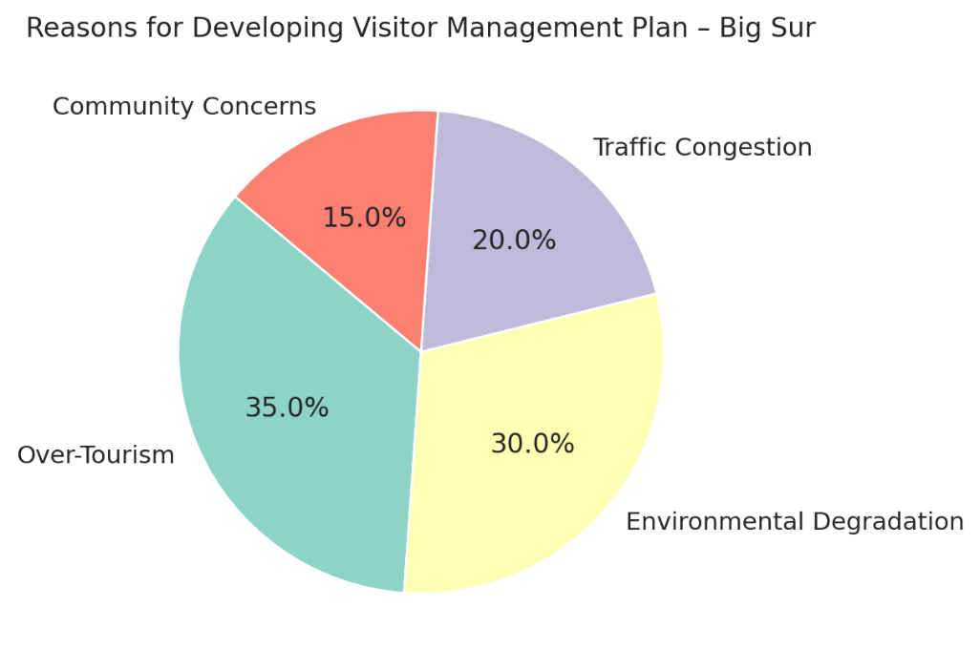
Figure 1: Reasons for Developing visitor Management Plan - Big Sur
Stakeholders were motivated by these problems to prepare a stewardship/ visitor -management plan to guarantee that the subsequent visitation is controlled in a manner that safeguards the natural and cultural heritage of Big Sur, enhances the standards of living of the residents and also maintains the economic advantages of tourism i.e. to transform unmanaged mass- visitation to sustainable management of destination stewardship.

Key challenges the site faced
Some of the principal challenges identified in the Big Sur DSP included:
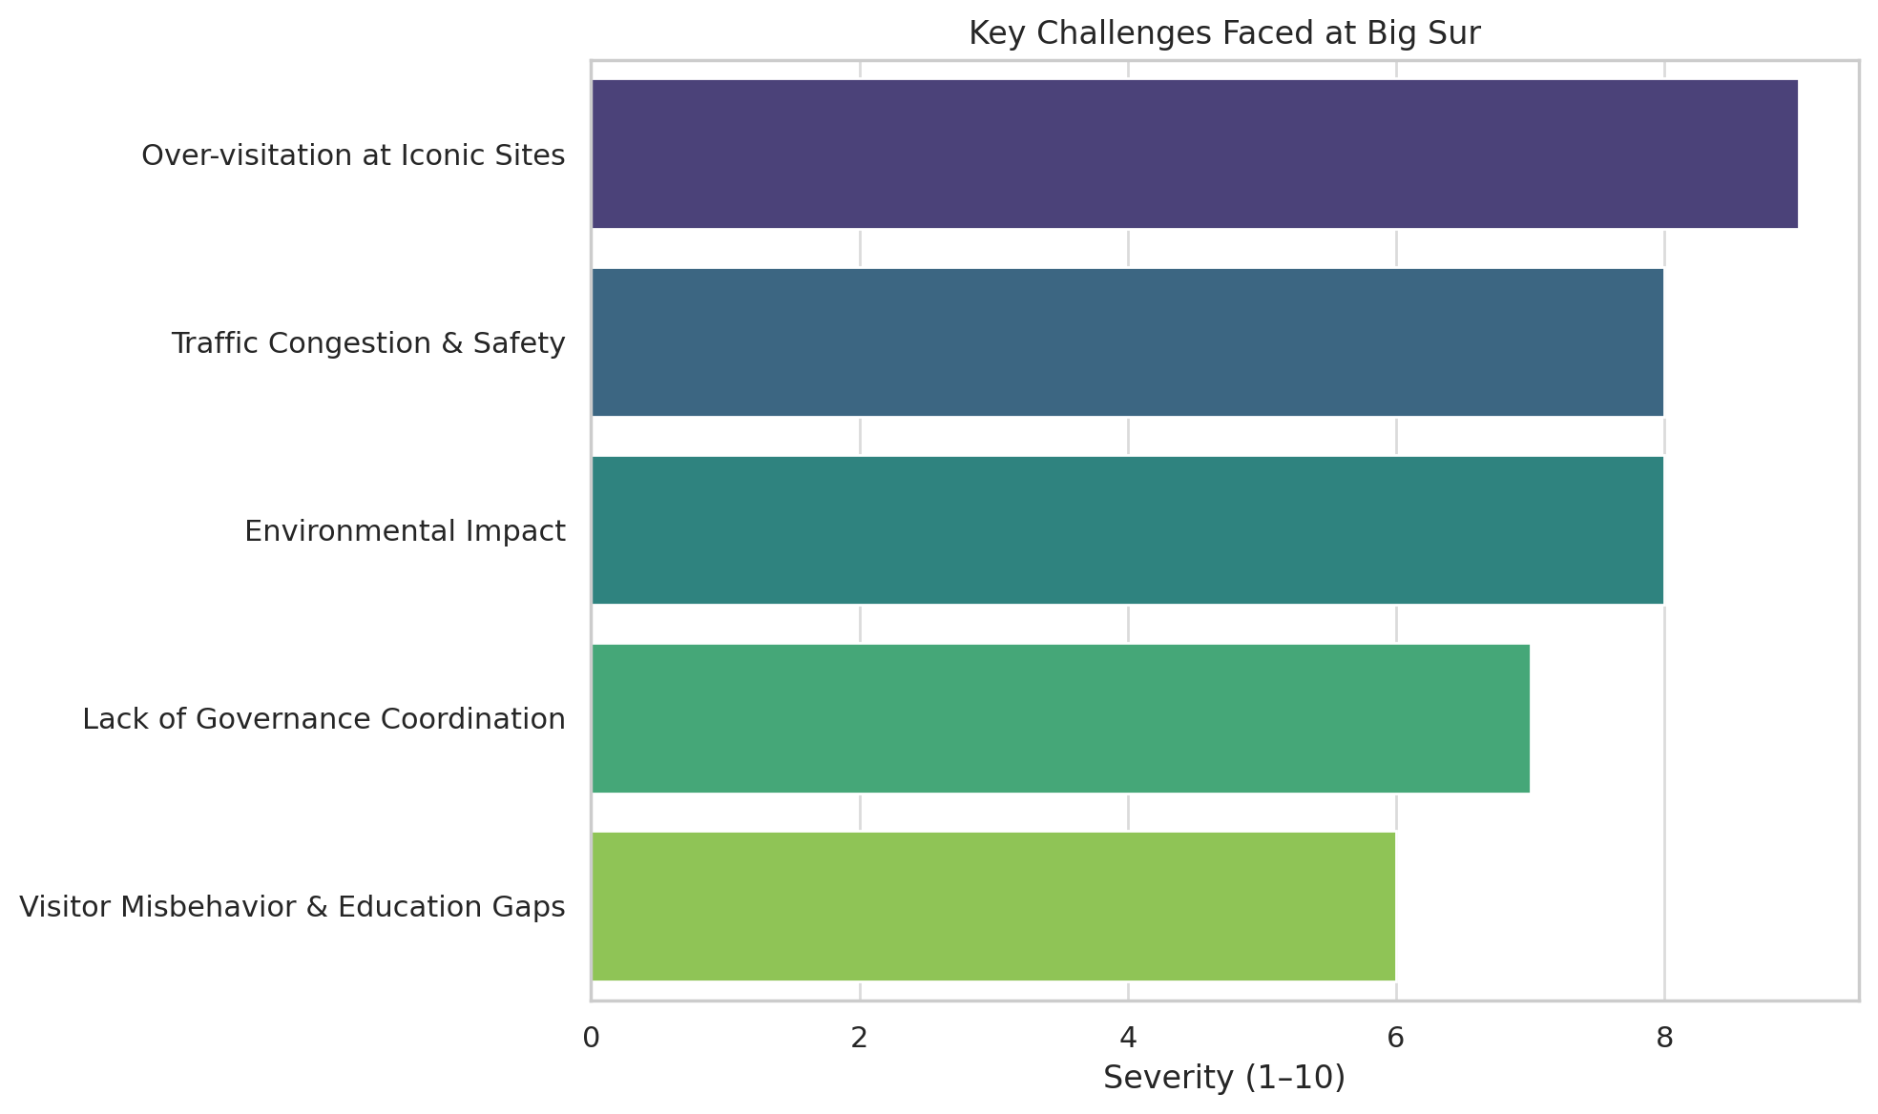
Figure 2: Key Challenges faced at Big Sur
There were multiple serious problems that Big Sur was encountering because there were more tourists being attracted to the region. Excessive visitation of iconic sites and back-country trails caused environmental degradation in areas through ramification of illegal campfires and erosion. The highway 1 was very congested with people walking and parking in unsafe areas along the highway and near popular areas such as Bixby Bridge. The natural and cultural resources in the area were abused through unauthorized utilization, littering and overcapacity camping. The ability to manage was also hampered as a result of fragmented administration among a number of the agencies as well as inadequate funding available to sustain interventions. On top of this, a significant proportion of the visitors were uninformed of the need to be environmentally responsible and therefore it was imperative that specific educational efforts were made and the need to adopt a culture of stewardship in order to conserve the destination (Cabigsur, 2020).

Strategies and measures used to manage these challenges
The Big Sur Destination Stewardship Plan (DSP) offered a set of short-term and long-term plan of actions to solve the identified issues and enhance sustainable tourism (Russell, 2020).
- Funding Mechanism (Go Green Visitor Day Pass/Sustainability Fund): A visitor day pass was proposed which would be paid to create a sustainable fund to be used on the environmental conservation and local community development to reduce the ecological footprint of the tourism.
- Visitor Management Framework Back Country and Wilderness Areas: It was suggested that an all-encompassing framework be in place to control access to the trails and public land, govern fire safety regulations, provide visitor records and pilot traffic diversion programmes. These were to safeguard the natural habitats and the control of carrying capacity.
- Traffic and Access Management Pilot in Important Places: A 12-month pilot was introduced to the Bixby Bridge to control traffic and enhance pedestrian safety and test scalability solutions to future visitor hotspots.
- Community Corps and Volunteer Engagement: a local volunteer organization was established to work directly with the tourists encouraging responsible behaviour and environmental mindfulness.
- Stakeholder Engagement and Governance Co-ordination: Raising the DSP was done through strict engagement of the residents, land owners, agencies and businesses to have a joint and locally supported strategy.
- Monitoring, Data Collection and Adaptive Management: Data-driven solutions were highlighted to follow visitor trends, environmental health as well as traffic patterns to facilitate decision-making continual and adaptive strategies.

Outcomes and success of the visitor‑management plan
Big Sur Destination Stewardship Plan has borne good fruits. It was officially adopted in 2020 by the Monterey County Board of Supervisors but resulted in the adoption by the U.S. Forest Service of a management structure of the back-country in 2021. The day-pass system and Sustainability Fund has developed a sustainable model of funding known as Go Green. It has improved community involvement by volunteer corps, which enhanced visitor education and stewardship. Traffic management at Bixby Bridge such as pilot projects has been good to give useful data in improvement. On the whole, the plan is making a great stride in harmonizing tourism and managing environmental conservation and community welfare by managing visitors with a series arrangement of activities.

Conclusion
Big Sur Destination Stewardship Plan is a very thoughtful visitor-management program that addresses obvious over-visitation, environmental and community issues within the high-value natural destination. The plan offers a viable approach to the management of sustainable tourism by the use of a combination of funding, coordinated stakeholder governance, visitor education, pilot access management, and data-based monitoring schemes. There is encouraging early performance. It is a desirable model of other destinations that would want to graduate beyond uncontrolled tourism development and management in terms of stewardship of the visitors, the community and place.

References
Bigsurkate (2024). Visitor Use Management Plan lays foundation for sustainable recreation access on Monterey Ranger District in Big Sur – BigSurKate. [online] BigSurKate. Available at: https://bigsurkate.blog/2024/06/06/visitor-use-management-plan-lays-foundation-for-sustainable-recreation-access-on-monterey-ranger-district-in-big-sur/ [Accessed 23 Oct. 2025].
Cabigsur (2020). Big Sur Destination Stewardship Project (DSP). [online] Community Association of Big Sur. Available at: https://www.cabigsur.org/big-sur-destination-project/ [Accessed 23 Oct. 2025].
PTG (2020). Destination Stewardship Plan Safeguards Big Sur. [online] Ptgconsulting.com. Available at: https://ptgconsulting.com/case-study/beyond-green-big-sur [Accessed 23 Oct. 2025].
Russell, S. (2020). Big Sur Destination Stewardship Management Plan Survey. [online] Big Sur California. Available at: https://blogbigsur.wordpress.com/2020/02/19/big-sur-destination-stewardship-management-plan-survey/ [Accessed 23 Oct. 2025].

