

Bachelor's in Tourism and Recreation
Planning and Management of Sustainable Tourism Spaces
Submitted by : Sumit Kumar
Title: Developing Sustainable Tourism Spaces: Strategies for Balancing Environmental, Economic, and Social Factors
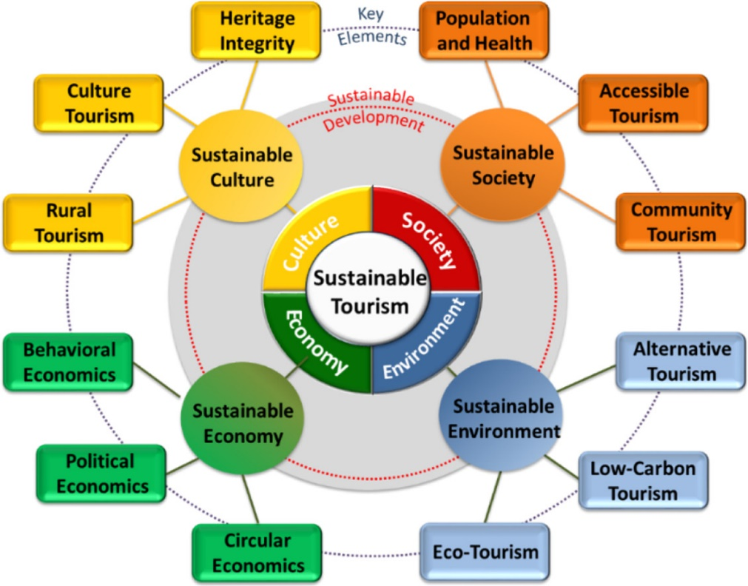

1.Abstract
Because climate change, mass tourism, loss of biodiversity, and social inequality are putting more and more stress on tourist spots, planning for sustainable tourism has become very important. This report talks about how tourist areas can make money, protect the environment, and make the community healthier at the same time. The report uses theories about how people behave as consumers, frameworks for sustainable tourism, and international case studies to carefully look at how places can best deal with the effects of tourism while also building long-term resilience.
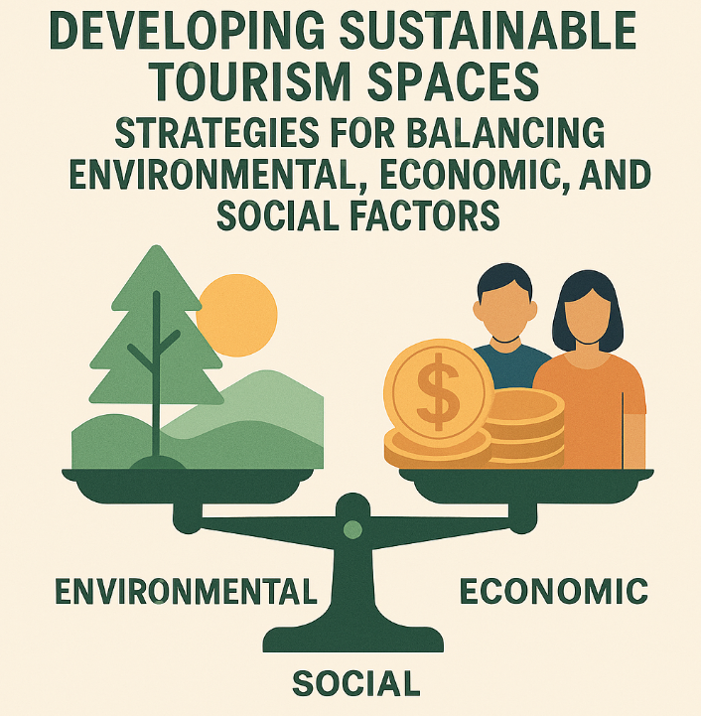
The study investigates three essential dimensions of sustainability: environmental, economic, and social—utilizing a qualitative analysis of academic literature, global policy reports, and secondary case study data. The results show that strategic planning needs to include conservation practices, circular economy methods, community involvement, and strategies for managing visitors in a way that is good for the environment. Successful models like Costa Rica's ecotourism program, Bhutan's High-Value Low-Volume strategy, Germany's Black Forest sustainable management, and New Zealand's Māori-led tourism show that things can go well.
The report talks about big changes in how people act, like more people who care about the environment, a desire for real local experiences, and a shift toward tourism that helps the environment. It also talks about issues like too many tourists, not enough money, not enough rules being followed, and fights between tourists and residents. Some ideas are to use smart technologies to keep an eye on carrying capacity, strengthen community co-management systems, offer a wider range of tourism products, and plan for green infrastructure.
The study shows that long-term plans for sustainable tourism spaces must include protecting the environment, growing the economy, and promoting social justice. Governments, local communities, and tourism businesses must all work together well for tourism destinations to be strong and good for the environment.

Contents
1.Abstract 2
2.Introduction 5
3. Literature Review 8
4. Methodology 16
5. Finding 19
6. Discussion 27
7. Recommendation 29
Reference List 34

2.Introduction
Tourism is one of the fastest-growing sectors of the global economy. It creates a lot of jobs, builds infrastructure, and adds a lot to the world's GDP. But this rapid growth has also made things like environmental damage, cultural loss, loss of biodiversity, and social and economic inequality worse (UNWTO, 2023). As traditional mass tourism models become unsustainable, making places for sustainable tourism has become an important way to balance social, economic, and environmental goals. Sustainable tourism emphasizes the enduring resilience of destinations, responsible resource utilization, community empowerment, and the preservation of natural and cultural assets (Bramwell & Lane, 2022).
The idea is based on the Triple Bottom Line (TBL) framework, which says that the economy, society, and environment are all connected and need to work together for long-term sustainability (Elkington, 1998). This framework for planning tourism makes sure that growth is good for the economy, the environment, and local communities. The way modern tourists act also has an effect on how places plan sustainable experiences. More and more, people who travel want things that are good for the environment, real interactions with locals, and experiences that don't hurt the environment too much (Mihalič & Kuščer, 2021).
Theories of consumer behaviour elucidate these changes more effectively. The Theory of Planned Behaviour (Ajzen, 1991) explains how tourists' attitudes toward the environment and social norms affect their sustainable behaviours. The Value–Belief–Norm (VBN) theory, on the other hand, says that travellers who care about protecting the environment are more likely to choose eco-friendly tourism experiences (Stern, 2000). These theories support sustainable tourism planning that aligns with visitor motivations and behavioural expectations.
This report talks about how to plan and manage destinations so that they can find a balance between the three main parts of sustainability. It looks at ways to help the environment, like cutting down on waste, protecting biodiversity, building systems that are good for the environment, and running operations that don't add to carbon emissions. It also looks into economic strategies like starting businesses in the area, managing capacity, diversifying tourism products, and creating sustainable value chains. We look at social strategies like getting people involved, preserving culture, and sharing benefits fairly to see how tourism can make life better in a community.
The report includes case studies from around the world to give a complete picture. Costa Rica's ecotourism model shows that you can protect the environment and grow the economy at the same time. Bhutan's High-Value, Low-Volume tourism policy is an example of how controlling the number of tourists can help preserve the culture. The Black Forest area of Germany is an example of a new way to plan tourism that puts conservation first. On the other hand, Māori-led tourism in New Zealand focuses on community ownership and bringing back Māori culture. Iceland's carbon-neutral tourism programs show how tourism systems that use renewable energy could work.
The goal of this report is to:
- Look into ways to plan and manage sustainable tourism.
- Look at how consumer behaviour is changing to make tourism spaces more sustainable.
- Look at the best ways to develop sustainable tourism around the world.
- Give new, useful suggestions for making tourism more sustainable.
This report provides strategic insights for creating tourism spaces that are resilient, inclusive, and environmentally responsible by looking at scholarly works, policy frameworks, and real-world case studies.

3. Literature Review
The advancement and oversight of sustainable tourism areas have emerged as a critical focus of scholarly inquiry, as global destinations face escalating environmental challenges, socio-cultural conflicts, and economic instability. This literature review brings together theoretical frameworks, behavioural trends, sustainability models, and empirical research that are all important for finding a balance between environmental, economic, and social factors in tourism planning. It also uses examples from around the world to show how to develop sustainable destinations.
3.1 Defining Sustainable Tourism
Sustainable tourism arose as a reaction to the detrimental effects of conventional mass tourism, notably the deterioration of ecosystems, cultural erosion, and disproportionate economic advantages (Sharpley, 2020). The United Nations World Tourism Organization (UNWTO, 2023) says that sustainable tourism is tourism that meets the needs of both current visitors and host communities while also protecting and improving opportunities for the future. Some of its basic ideas are respect for the environment, respect for different cultures, economic viability, and fair distribution of benefits.
The Triple Bottom Line (TBL) framework (Elkington, 1998) is commonly utilized in tourism research because it comprehensively incorporates social, environmental, and economic dimensions. The TBL promotes long-term planning in tourism that balances protecting the environment, helping the local community, and making the destination more competitive. Mihalič (2016) contends that TBL facilitates the alignment of growth-oriented tourism economies with conservation objectives, rendering it an essential planning instrument.
Modern tourism planning is also affected by other frameworks, like the UN Sustainable Development Goals (SDGs). SDG 8 (Decent Work and Economic Growth), SDG 12 (Responsible Consumption and Production), and SDG 13 (Climate Action) are all very important for making tourism more sustainable (UNDP, 2021). These frameworks stress development that is regenerative and focused on the community. They push policymakers to come up with new ideas that go beyond traditional models of sustainability.
3.2 Theories of Consumer Behaviour and Sustainable Tourism Choices
To manage sustainable tourism spaces, you need to know how travellers act. Theories of consumer behaviour help us understand how tourists adopt environmentally friendly habits and respond to efforts to make things more sustainable.
3.2.1 Theory of Planned Behaviour (TPB)
Ajzen's (1991) Theory of Planned Behaviour posits that attitudes, subjective norms, and perceived behavioural control affect intentions to perform particular behaviours. In tourism, the Theory of Planned Behaviour elucidates the rationale behind eco-conscious travellers opting for sustainable accommodations, reducing waste, or engaging in conservation initiatives. Lam and Hsu (2006) discovered that perceived behavioural control significantly influences tourists' readiness to participate in environmentally sustainable practices while travelling.
3.2.2 Theory of Value–Belief–Norm (VBN)
Stern's (2000) VBN theory posits that individuals with robust biospheric values demonstrate increased motivation to engage in sustainable behaviours. Chiu, Lee, and Chen's (2014) research demonstrates that tourists possessing robust pro-environmental beliefs are more inclined to endorse conservation fees, choose eco-lodges, and engage in low-impact activities.
3.2.3 Theory of Push–Pull Tourist Motivation
Dann's (1977) motivation model elucidates the reasons tourists pursue sustainable experiences. Push motivations encompass environmental concerns and the aspiration for genuine cultural engagement, whereas pull motivations involve attractions such as natural landscapes, wildlife conservation areas, and culturally immersive tourism offerings.
3.2.4 Behavioural Economics and Sustainable Decisions
Nudging strategies, including green labelling, carbon footprint displays, or default green options, can affect how tourists act without taking away their freedom to choose (Thaler & Sunstein, 2008). Research indicates that tourists are more inclined to make sustainable choices when presented as socially desirable or ethically responsible (Reynisdottir & Song, 2018).
These theories collectively underscore the necessity of crafting sustainable tourism experiences that correspond with tourist motivations and behavioural anticipations.
3.3 Planning for tourism that is good for the environment
The heart of sustainable tourism is protecting the environment. Places have problems like losing habitats, making waste, not having enough water, and releasing carbon into the air. Literature underscores various environmental strategies:

3.3.1 Protected Areas and Biodiversity Conservation
Protected areas like national parks and wildlife reserves are important for tourism that focuses on conservation. Eagles et al. (2002) contend that effectively managed parks can produce income while preserving biodiversity. Costa Rica's conservation model, which protects more than 25% of its land, shows how ecotourism can help with reforestation, protecting wildlife, and storing carbon.
3.3.2 Eco-Infrastructure and Green Building
Low-impact tourism spaces are supported by green building standards, water systems that are good for the environment, and the use of renewable energy. Gössling (2019) talks about how solar technology, rainwater harvesting, and eco-friendly architecture can help tourism accommodations cut down on emissions.
3.3.3 Managing visitors and making transportation more sustainable
It is very important to cut down on emissions from transportation. Innovations like bike-sharing networks, electric shuttle systems, and pedestrian zones make the environment better (Hall, 2020). Germany's Black Forest area has a successful model in the form of a public transportation pass for tourists that cuts down on the use of private cars.

3.3.4 Adapting to Climate Change
More and more places are using climate-resilient planning, such as protecting the coast, managing forests, and using geothermal heating. The geothermal tourism infrastructure in Iceland shows how renewable energy can help visitors have carbon-neutral experiences (Jóhannesson et al., 2019).
3.4 Economic sustainability and local wealth
Sustainable tourism must promote economic resilience and equitable prosperity.
3.4.1 Different kinds of tourism products
Ecotourism, cultural tourism, agritourism, adventure tourism, and wellness tourism are all ways that destinations can become more diverse. Diversification makes businesses more competitive and less reliant on mass tourism (Bhat, 2021).
3.4.2 Local Value Chains and the Growth of Small and Medium-Sized Businesses
Ashley and Roe (2002) contend that local procurement, community-owned enterprises, and microbusiness development are vital for equitable tourism economies. The Māori tourism industry in New Zealand shows how small businesses owned by indigenous people can help preserve culture while also making money.

3.4.3 Economic Leakages and the Sharing of Benefits
When foreigners own a lot of tourism businesses, local economies get less benefit (Torres & Momsen, 2011). To cut down on leakages, sustainable tourism promotes buying from local businesses, hiring locals, and sharing profits.
3.4.4 Rules for carrying capacity and making money
By charging entrance fees, using quota systems, or changing prices based on demand, you can control the number of visitors to fragile areas while still making money. Bhutan's "High Value, Low Volume" policy uses high tourist taxes to protect the environment and keep its culture alive (Dorji, 2020).
3.5 Community Well-Being and Social Sustainability
Social sustainability makes sure that tourism improves the quality of life in the area and brings people together through culture.
3.5.1 Community-Based Tourism (CBT)
CBT gives residents the power to plan and run tourism activities. Scheyvens (1999) contends that CBT fosters community pride, capacity development, and equitable distribution of benefits. Thailand's Mae Kampong Village and Kenya's Maasai ecotourism projects are two examples of how this can work.
3.5.2 Keeping Cultural Heritage Safe
Sustainable tourism safeguards traditional arts, rituals, languages, and heritage structures. Timothy and Boyd (2003) say that cultural tourism helps people keep their identities while also bringing money into communities.
3.5.3 Interaction between residents and tourists and the social carrying capacity
Overtourism can cause residents to be angry, move, and have social problems (Koens, Postma, and Papp, 2018). Collaborative planning and stakeholder dialogue reduce conflicts and increase community support.
3.6 Regenerative Tourism: A New Path
Recent literature posits regenerative tourism as a transformative paradigm that transcends mere harm reduction to actively restore ecosystems and communities. Pollock (2019) says that regenerative tourism is growth that makes places better than they were before. Coral restoration tourism in Australia and rewilding tourism in Scotland are two examples.
Regenerative practices put a lot of focus on:
- restoration of ecosystems
- Models of the circular economy
- cultural renaissance
- a strong partnership with the communit
- This new model is a sign of the next step in the development of sustainable tourism spaces
3.7 A summary of what the literature says
The literature emphasizes that sustainable tourism necessitates cohesive planning across environmental, economic, and social frameworks. Theories about how people behave as consumers show what drives people to choose sustainable travel, and best practices from around the world show that balanced development is possible. But there are still problems because of bad governance, too many tourists, climate change, and market-driven pressures.
These insights form a basis for examining practical strategies in the Findings section.

4. Methodology
This study employs a qualitative research methodology exclusively utilizing secondary data, in alignment with academic standards for a theoretical and analytical project report. The qualitative approach facilitates a comprehensive examination of sustainable tourism planning strategies, behavioural trends, and global best practices, which are essential for comprehending the multifaceted characteristics of sustainable tourism environments (Creswell, 2014).
4.1 Research Design
The study employs an exploratory and descriptive framework, appropriate for investigating nascent concepts such as regenerative tourism, sustainable visitor management, and eco-innovation. Exploratory research facilitates the examination of under-researched areas, such as the behavioural economics of sustainable travel, whereas descriptive analysis allows for a systematic evaluation of established frameworks, including the Triple Bottom Line and the UN Sustainable Development Goals (Saunders et al., 2019).
4.2 Sources of Data
Credible academic and professional sources provided secondary data, such as
Peer-reviewed journals, such as the Journal of Sustainable Tourism and the Annals of Tourism Research
Reports from international organizations, like the World Bank, UNEP, and UNWTO
Documents from the government about tourism strategy
Books, papers from conferences, and rules for making policies
Publications of case studies from Costa Rica, Bhutan, Germany, Iceland, New Zealand, and other places that are known for doing things well
Using more than one data source helps you understand sustainability practices better and makes it easier to compare different insights.
4.3 Gathering and Looking at Data
We collected data by doing a structured review of the literature using keywords like "sustainable tourism spaces," "destination management," "consumer behaviour in tourism," "ecotourism," "regenerative tourism," and "community-based tourism." Sources were evaluated according to scholarly credibility, pertinence, and publication timeliness.
The analysis utilized thematic coding to identify and synthesize recurring themes, including environmental strategies, economic diversification, cultural preservation, behavioural trends, and governance challenges. This approach is frequently employed to analyze secondary tourism research and is proficient in establishing linkages within intricate sustainability frameworks (Nowell et al., 2017).
4.4 Validity, Reliability, and Limitations
To improve validity, only sources that were peer-reviewed and from experts were used. Cross-checking several case studies and comparing academic findings with policy reports made the results more reliable.
But there are some limits. Secondary data may not completely capture recent transformations in rapidly evolving tourism landscapes, especially in post-pandemic scenarios. Case studies may be limited in their applicability due to their context-specific nature. However, the qualitative nature of the research guarantees substantial analytical depth and significance for conceptual comprehension.

5. Finding
The results of this study show that the only way to create sustainable tourism spaces is to use a multidimensional approach that includes environmental protection, economic stability, and social inclusion. Looking at data from around the world and case studies shows that successful tourist spots use coordinated planning, community involvement, and new ways to be environmentally friendly.
5.1 Plans for Environmental Sustainability
Environmental strategies are an important part of sustainable tourism. Their goals are to protect natural ecosystems, lower carbon emissions, and deal with the stress that visitors put on them. The results show that there are four main strategies:
5.1.1 Management of Protected Areas and Conservation
More and more places are setting aside conservation zones to protect biodiversity, limit development, and control the effects of tourism. National parks help protect the environment by controlling who can visit, creating buffer zones, and charging conservation fees. Protected areas in Costa Rica can bring back deforested land, help wildlife grow back, and make money through ecotourism.

5.1.2 Infrastructure that is green and facilities that have little impact
Tourism facilities that use green buildings, accommodations powered by renewable energy, and eco-certification make sure they have the least impact on the environment possible. Solar-powered heating, greywater recycling, and rainwater harvesting are some technologies that help ease the strain on resources. The Black Forest region of Germany shows how adding eco-design to hotels can cut down on emissions and energy use.

5.1.3 Managing waste, water, and energy
Tourism areas have a lot of problems with not having enough water and making too much waste. Sustainable places have strict rules about separating trash, composting, reducing plastic use, and using trash in a circular way. Iceland is a great example of how to use geothermal energy in an advanced way. It uses renewable heating and electricity in tourist facilities while lowering carbon intensity.
5.1.4 Adapting to Climate Change and Using Nature-Based Solutions
The results show that places that are at risk from climate change, like coastal erosion or melting glaciers, put climate adaptation first. Nature-based solutions, such as restoring wetlands, mangroves, and forests, make the climate more resilient and create opportunities for ecotourism.When environmental strategies are used across a whole region and are backed up by strict rules, they work best.

5.2 Strategies for Economic Sustainability
Sustainable tourism must also make sure that the economy stays strong in the long term, that it benefits the local community, and that it doesn't rely too much on unstable international markets. Three main strategies were found:

5.2.1 Diversification of Tourism Products
Ecotourism, cultural tourism, adventure tourism, agro-tourism, and wellness are all ways that places can become more diverse. Diversification makes the economy less vulnerable and less seasonal. For instance, New Zealand encourages Māori cultural tourism along with adventure tourism. This brings in more money and strengthens cultural identity.
5.2.2 Making Local Value Chains Stronger
Keeping tourism money in the area is important for economic sustainability. The findings show how important it is to:
- getting farm goods from nearby sources
- helping businesses owned by the community
- helping craft markets grow
- teaching people in the area how to be business owners
- Studies show that tourism businesses that are based in the community cut down on economic leakage and raise household income.
5.2.3 Managing visitors and controlling revenue
When destinations control how many visitors they get and make steady money, they are more likely to be economically sustainable. Bhutan's "High Value, Low Volume" model uses high tariffs to control the flow of tourists and make sure that the money made goes toward conservation and community development.

Destinations create more resilient tourism systems by combining economic goals with social and environmental goals.

5.3 Strategies for Social Sustainability
Social sustainability makes sure that tourism helps, not hurts, local communities. Results suggest new priorities:
5.3.1 Community Involvement and Shared Management
People are more likely to support tourism when they are involved in planning, making decisions, and running the community. Participatory planning makes things more open and lessens the conflict between residents and tourists. Māori iwi (tribes) in New Zealand share management of tourism assets to make sure that visitors have experiences that are shaped by cultural norms and social values.
5.3.2 Protecting and Understanding Culture
Sustainable tourism helps to preserve cultural heritage, traditional knowledge, and living cultural expressions. Destinations that include storytelling, rituals, traditional crafts, and indigenous knowledge in their tourism offerings help keep cultures alive and make visitors more appreciative.

5.3.3 Fairness and Inclusive Development
If not carefully managed, tourism can make social inequality worse. The findings show that there is a need for:
- policies for hiring in the area
- entrepreneurship programs that include people of all genders
- fair sharing of tourism income
- These strategies help people accept each other and make things last for a long time.

5.4 GLOBAL CASE STUDIES
The following case studies show how places find a balance between environmental, economic, and social sustainability.
Case Study 1: Costa Rica – A Model for National Ecotourism
Costa Rica is known around the world as a leader in eco-friendly tourism. Its policies focus on protecting biodiversity, regenerating forests, and developing low-impact tourism because more than 25% of its land is set aside as protected areas. Ecotourism is a big part of GDP and helps pay for conservation. Community-based lodges, wildlife rehabilitation centres, and national parks are examples of how protecting the environment and growing the economy can work together. Carbon-neutral tourism projects make the destination even more environmentally friendly.

Achieved Balance:
Environmental: protected areas and restoring forests
Economically: ecotourism brings in money and creates jobs
Social: ecolodges owned by the community, education, and getting involved
Case Study 2: Bhutan—Tourism with a High Value and Low Volume
The idea behind Bhutan's tourism policy is Gross National Happiness (GNH). To keep the number of visitors down and protect the environment, the country charges international tourists a daily fee. The money goes to conservation projects, cultural preservation, and social welfare programs. The controlled tourism model has helped protect Himalayan ecosystems, keep Bhutanese culture alive, and make sure that everyone gets their fair share of the benefits
Balance Reached:
Environmental: Controlled visitor flows keep overtourism from happening
Economics: A high tariff brings in steady money
Social: Keeping traditions alive and helping the community
Case Study 3: Germany—Sustainable Management of the Black Forest
The Black Forest region in Germany is a great example of advanced environmental planning. It has green accommodations, conservation areas, and ways to get around that are good for the environment. Tourists can use the KONUS Card system to get around for free on public transportation in the area. This cuts down on the use of private cars and the pollution they cause. The area supports organic farming, protecting forests, and making crafts.

Balance Reached:
Environmental: forests that are safe and sustainable mobility
Economic: Markets for local crafts and organic goods
Social: Keeping rural jobs alive

Case Study 4: Māori-Led Tourism in New Zealand
New Zealand uses traditional Māori knowledge to plan tourism. Māori groups work together to manage natural attractions, run cultural tours, and run conservation programs. This strengthens cultural heritage while making sure that Māori values like kaitiakitanga (guardianship) are respected in the environment.
Balance Reached:
Community-led conservation for the environment
Economic: businesses owned by Indigenous people and job creation
Social: Cultural renewal and empowerment of identity

Case Study 5: Iceland—Carbon -Travel that doesn't harm the environment
Iceland's tourism is mostly powered by renewable energy sources, like geothermal and hydroelectric power. Some of the strategies are low-emission transportation, green accommodation standards, and carbon-offsetting programs. Iceland also has strict rules for visitors in fragile volcanic and glacial areas.
Achieved Balance:
Environmental: Renewable energy has a smaller carbon footprint
Economic: Money made from tourism goes back into conservation.
Social: A lot of people in the area want to protect the environment

6. Discussion
The results show that creating sustainable tourism spaces needs a comprehensive and coordinated approach that takes into account environmental, economic, and social needs. This discussion critically assesses the implications of the analyzed strategies and case studies concerning established theories, behavioural patterns, and practical obstacles.
A major point is that long-term tourism viability depends on environmental sustainability. Places like Costa Rica and Iceland show that good conservation, using renewable energy, and nature-based solutions can make tourism much less harmful to the environment. These practices are in line with the ideas behind the Triple Bottom Line framework, which says that ecological systems and economic success are linked (Elkington, 1998). But the problem is putting these steps into action consistently, especially in developing countries where money and government are tight (Mowforth & Munt, 2016). High-cost interventions like geothermal energy systems may not be possible in these situations without help from other countries.
Strategies for economic sustainability stress the need to diversify tourism products, strengthen local value chains, and control the flow of visitors. Bhutan's High Value, Low Volume policy shows how controlled tourism can keep income steady while also protecting cultural and environmental resources. However, critics contend that these models might hinder accessibility for low-income travellers, prompting concerns regarding inclusivity (Dorji, 2020). In the same way, local value chain development helps people become more economically independent, but it needs a lot of capacity-building to make sure that local business owners can compete with outside investors in tourism (Torres & Momsen, 2011). Additionally, global economic shocks, like the COVID-19 pandemic, have shown weaknesses in economies that depend on tourism. This means that long-term tourism planning must also include strong crisis-management plans (UNWTO, 2021).
Social sustainability, especially community involvement, is very important for the long-term resilience of a destination. The success of Māori-led tourism in New Zealand shows that when communities have a say in tourism stories and decisions, cultural authenticity is enhanced and social equity is improved. This is in line with Scheyvens' (1999) framework for empowerment, which says that communities get the most out of tourism when they have control over it. However, engaging with the community can be hard and take a lot of time, and participatory processes can be slowed down by power imbalances, political influence, or not enough representation of marginalized groups (Cole, 2007). Tourism development can make social tensions worse and break up communities if it isn't handled carefully.
Consumer behaviour is also very important for making tourism spaces that are good for the environment. The increase in eco-conscious travellers corresponds with behavioural theories like the Theory of Planned Behaviour and the Value–Belief–Norm Model, which stress the significance of attitudes, values, and perceived behavioural control (Ajzen, 1991; Stern, 2000). Places that are open about their commitment to sustainability and offer clear eco-friendly options are more likely to get tourists to act in a positive way. Sustainable choices, on the other hand, often depend on how much they cost, how easy they are to make, and what is normal in the culture. This shows that behavioural nudges and policy changes are still needed to change the behaviour of most tourists (Thaler & Sunstein, 2008).
The problem of overtourism is a big problem that has been talked about in a lot of research and case studies. Even places with well-developed policies for sustainable tourism, like Iceland, have had a lot of tourists during peak seasons. This shows that there is a difference between what tourism policy makers want and what actually happens in the market. Dynamic visitor quotas, smart technology, and assessments of carrying capacity can help ease these pressures, but they need strong governance and political will to work.
The discussion shows that sustainable tourism strategies can work very well, but only if they are planned for the long term, have enough money, are well-managed, involve the community, and are followed by everyone. The next section uses these ideas to make clear, useful suggestions.

7. Recommendation
Based on the results and critical analysis, several strategic suggestions are made to improve the planning and management of sustainable tourism areas. These suggestions are meant to help places improve their environmental protection, economic resilience, and social inclusion while also keeping up with global trends in sustainability.
7.1 Make environmental management better by using green innovation
Destinations should use new ways to protect the environment, like using renewable energy, staying in eco-certified hotels, and following green building standards. Governments can encourage people to adopt by giving them tax breaks, grants, and technical help. Adding electric mobility systems, nature-based solutions for climate resilience, and circular waste management systems will make visitors happier and put less strain on the environment.
7.2 Use smart visitor management and carrying capacity tools
To fight overtourism, places should use smart technologies that keep track of how many people are visiting in real time, how stressed the environment is, and how busy the roads are. Digital visitor permits, online reservation systems, and geo-fencing are some of the tools that can help keep the number of tourists at a manageable level. Regularly updating carrying capacity assessments is necessary for zoning rules, building new infrastructure, and running marketing campaigns. Dynamic pricing and seasonal dispersion strategies can help spread tourists out even more.
7.3 Offer a wider range of tourism products and improve local value chains
Destinations should offer more than just regular tourist activities by adding ecotourism, agritourism, cultural tourism, and wellness tourism experiences. Workshops to build skills, microfinance programs, and policies that give preference to buying from local businesses can all help local entrepreneurs and boost community incomes. Building stronger connections between tourism businesses and local providers of food, crafts, and services will help everyone grow.
7.4 Improve Community Co-Management and Participation
To make sure that society stays stable, local communities need to be involved in a real way. Governments and tourism organizations should help with planning workshops, co-management agreements, and community-led tourism projects. You can also set up community development funds that are paid for by tourism money. Incorporating indigenous knowledge and cultural practices into tourism experiences can help visitors feel more connected to the place while also preserving their identity.
7.5 Teach people how to be responsible tourists and encourage them to do so.
Destinations should use behavioural interventions to encourage tourists to act in ways that are good for the environment. This includes clear signs, eco-friendly options by default (like stations for reusable bottles and low-impact transportation), and campaigns to raise awareness of cultural and environmental responsibilities. Working with tour companies, airlines, and hotels can help spread the message of sustainability throughout the visitor's journey.
7.6 Create Policy Frameworks for Long-Term Resilience
Governments need to make the legal systems stronger for long-term tourism growth. This includes rules for the environment, policies for local ownership, standards for sustainable infrastructure, and plans for disaster resilience. Governments, NGOs, businesses, communities, and policymakers should all work together on multi-stakeholder governance platforms.
These suggestions can help places create a balanced and resilient model of sustainable tourism that helps ecosystems, communities, and economies at the same time.
8. Conclusion
Online reviews and recommendations from friends have completely changed how people behave when they travel. They are now the most important factors in how people look for information, compare options, and make final booking decisions. This report shows that they have an effect on every step of the consumer journey, from awareness and consideration to experience and feedback after the purchase. Digitalization has made travellers more likely to rely on the experiences of others to lower risk, feel safe, and set expectations.
The results show that trust and the feeling of authenticity are very important in how travellers react to online reviews. People think platforms that have verified reviews, clear policies, and lots of user-generated content are more trustworthy, which makes them more likely to buy something. Peer recommendations, particularly those disseminated via social media and personal networks, possess enhanced persuasive efficacy owing to emotional credibility and social influence.
But problems like fake reviews, too much information, and bias from influencers can hurt consumer trust and the quality of their decisions. Because of this, tourism companies need to use strategic methods for managing their reputation, making sure their information is real, and communicating digitally.
Overall, online reviews and recommendations from friends are powerful tools that not only help travellers make smart choices, but also change how the tourism industry works. In a market that is becoming more digital, businesses that use these digital insights well, are open about their operations, and encourage honest guest feedback will be better able to build trust, improve the customer experience, and achieve long-term growth.

Reference List
Ajzen, I. (1991) ‘The theory of planned behavior’, Organizational Behavior and Human Decision Processes, 50(2), pp. 179–211.
Ashley, C. and Roe, D. (2002) Making tourism work for the poor: Strategies and challenges in southern Africa. London: Overseas Development Institute.
Bhat, S. (2021) ‘Tourism diversification and regional economic resilience’, Tourism Management Perspectives, 40, pp. 1–10.
Bramwell, B. and Lane, B. (2022) ‘Sustainable tourism: An evolving global approach’, Journal of Sustainable Tourism, 30(2), pp. 381–399.
Chiu, Y-H., Lee, W-I. and Chen, T-H. (2014) ‘Environmentally responsible behavior in ecotourism’, Journal of Travel & Tourism Marketing, 31(8), pp. 950–965.
Cole, S. (2007) Tourism, culture and development: Hopes, dreams and realities in East Indonesia. Clevedon: Channel View Publications.
Creswell, J.W. (2014) Research design: Qualitative, quantitative, and mixed methods approaches. 4th edn. Thousand Oaks: Sage.
Cvelbar, L.K. and Mihalič, T. (2021) ‘Determinants of tourist environmentally responsible behaviour’, Tourism Economics, 27(3), pp. 540–559.
Dann, G.M.S. (1977) ‘Anomie, ego-enhancement and tourism’, Annals of Tourism Research, 4(4), pp. 184–194.
Dorji, R. (2020) ‘Bhutan’s high value, low volume tourism policy’, Sustainability, 12(6), pp. 1–14.
Eagles, P.F.J., McCool, S.F. and Haynes, C.D. (2002) Sustainable tourism in protected areas: Guidelines for planning and management. Gland: IUCN.
Elkington, J. (1998) Cannibals with forks: The triple bottom line of 21st century business. Oxford: Capstone.
Gössling, S. (2019) ‘Environmental impacts of tourism’, Journal of Sustainable Tourism, 27(7), pp. 1024–1043.
Hall, C.M. (2020) ‘Sustainable mobility for tourism’, Journal of Transport Geography, 86, pp. 1–10.
Jóhannesson, G.T., Huijbens, E. and Sharpley, R. (2019) ‘Icelandic tourism and the quest for sustainability’, Tourism Geographies, 21(5), pp. 929–948.
Koens, K., Postma, A. and Papp, B. (2018) ‘Is overtourism overused?’, Sustainability, 10(12), pp. 1–15.
Lam, T. and Hsu, C.H.C. (2006) ‘Predicting behavioral intention of choosing a travel destination’, Tourism Management, 27(4), pp. 589–599.
Mihalič, T. (2016) ‘Sustainable-responsible tourism discourse’, Journal of Cleaner Production, 111, pp. 461–470.
Mihalič, T. and Kuščer, K. (2021) ‘Drivers of pro-environmental tourist behaviour’, Tourism Review, 76(4), pp. 984–998.
Mowforth, M. and Munt, I. (2016) Tourism and sustainability: Development, globalisation and new tourism in the third world. 4th edn. London: Routledge.
Nowell, L.S., Norris, J.M., White, D.E. and Moules, N.J. (2017) ‘Thematic analysis: Striving to meet trustworthiness criteria’, International Journal of Qualitative Methods, 16, pp. 1–13.
Pollock, A. (2019) Overtourism and regenerative tourism: Rethinking sustainable travel. London: Earthscan.
Reynisdottir, M. and Song, H. (2018) ‘The impact of behavioural nudges on environmentally responsible tourist behaviour’, Tourism Management, 69, pp. 202–213.
Saunders, M., Lewis, P. and Thornhill, A. (2019) Research methods for business students. 8th edn. Harlow: Pearson.
Scheyvens, R. (1999) ‘Ecotourism and the empowerment of local communities’, Tourism Management, 20(2), pp. 245–249.
Sharpley, R. (2020) Tourism, sustainable development and the theoretical divide, Journal of Sustainable Tourism, 28(12), pp. 1932–1949.
Stern, P.C. (2000) ‘Toward a coherent theory of environmentally significant behaviour’, Journal of Social Issues, 56(3), pp. 407–424.
Thaler, R.H. and Sunstein, C.R. (2008) Nudge: Improving decisions about health, wealth, and happiness. New Haven: Yale University Press.
Timothy, D.J. and Boyd, S.W. (2003) Heritage tourism. Harlow: Prentice Hall.
Torres, R. and Momsen, J. (2011) ‘Tourism and local development in Cuba’, Development Policy Review, 29(1), pp. 59–78.
UNDP (2021) Sustainable Development Goals Report. New York: United Nations Development Programme.
UNWTO (2021) Tourism and COVID-19 Recovery Report. Madrid: World Tourism Organization.
UNWTO (2023) International Tourism Highlights. Madrid: World Tourism Organization.

