Digital Marketing, Branding, and Ethical Marketing Practice
M03 Marketing Management Monthly Assignment
Option 3: Digital Marketing, Branding, and Ethical Marketing Practice

Table of Contents
1. Abstract
2. Introduction
3. Literature Review
4. Methodology
5. Findings
6. Discussion
7. Conclusion
8. References
9. Appendices

Abstract
This report analyzes the role of digital marketing, branding and ethical practice in modern marketing management. It argues that digital tools such as social media marketing, search engine marketing, content marketing, influencer marketing, email marketing and marketing automation have become central to brand awareness, engagement and sales performance. However, the same tools also create ethical risks involving privacy, misleading advertising, greenwashing, undisclosed influencer relationships and manipulation of consumer behavior. The report uses qualitative secondary research supported by academic literature, industry data and regulatory guidance. The findings show that digital branding works best when it combines reach, relevance, trust and measurable customer value. Search remains a major advertising format, digital video has grown strongly, social and creator based marketing are increasingly important, and programmatic buying has become a dominant mechanism for automated media placement. Yet these developments can weaken trust if marketers prioritize aggressive targeting and conversion metrics over transparency and responsibility. The report therefore recommends responsible digital marketing practices based on 5 principles: truthful claims, consent based data use, clear disclosure of commercial influence, fair automation and governance over sustainability messages. The conclusion states that ethical practice is not a constraint on brand performance. It is a strategic condition for sustainable customer trust and long term brand equity.

Introduction
Digital marketing has changed marketing management by making communication more interactive, measurable and personalized. Brands can now reach customers through search engines, social media platforms, ecommerce marketplaces, email, websites, mobile applications, video platforms, creators and automated advertising exchanges. This creates major opportunities for awareness, targeting, engagement and sales conversion. It also creates a more demanding environment because consumers can ignore, block, review, compare and publicly challenge brands more easily than before. Marketing management must therefore combine digital growth with brand trust and ethical responsibility.
This report addresses Option 3, which focuses on digital marketing, branding and ethical marketing practice. The report explores the main digital marketing tools used by modern organizations, discusses how digital branding and customer engagement influence brand awareness, trust and sales performance, assesses ethical issues such as misleading advertising, data privacy, greenwashing, influencer transparency and manipulation of consumer behavior, and recommends responsible marketing practices for sustainable trust and brand equity. The report takes the position that digital marketing is not simply a media channel. It is a strategic system that shapes how customers discover, evaluate, purchase, use and discuss brands.
The importance of the topic is clear from current market evidence. DataReportal reports that global internet users reached 6.12 billion in April 2026 and that social media user identities reached 5.79 billion. IAB and PwC report that U.S. internet advertising revenue reached USD 294.6 billion in 2025, with search, display, digital video, audio and other formats becoming increasingly integrated into automated and data rich advertising systems. These figures show that digital communication is now a primary arena of competition. However, scale also increases responsibility. When brands use personal data, automated targeting and persuasive content, they must respect consumer autonomy and avoid deception.
The report is structured as follows. The literature review explains digital marketing, brand equity, customer engagement, digital customer experience, marketing automation and ethical marketing. The methodology then explains the secondary research approach. The findings analyze digital tools, digital branding, advertising format trends, programmatic buying and key ethical risks. The discussion evaluates the strategic tension between personalization and privacy, performance metrics and brand trust, influencer authenticity and commercial transparency, and sustainability communication and greenwashing. The conclusion proposes a responsible digital marketing model that organizations can use to build sustainable customer trust and brand equity.

Literature Review
Digital marketing refers to marketing activities that use digital technologies to create, communicate and deliver value to customers. Chaffey and Ellis Chadwick (2022) argue that digital marketing includes online communications, customer data management, digital platforms and customer experience design. This definition is useful because it moves beyond the idea that digital marketing is only online advertising. Digital marketing is a broad managerial capability involving content, data, technology, customer journeys and performance measurement. It includes paid, owned and earned media, as well as ecommerce and customer relationship systems.
Search engine marketing is one of the most mature digital tools. It captures consumer intent because users often search when they are already seeking information, comparison or purchase options. Search can support awareness, lead generation and conversion, but its cost increases when competition for keywords is high. Search engine optimization can create longer term visibility through content quality, technical website performance and relevance, while paid search can generate immediate traffic. From a strategic perspective, search works best when it is linked to a clear value proposition and a relevant landing experience. Paying for traffic is inefficient if the brand promise, price, product information or checkout process is weak.
Social media marketing is valuable because it allows brands to participate in culture, communities and peer sharing. Dwivedi et al. (2021) show that digital and social media marketing affect consumer behavior, brand communication and marketing strategy. Social media can increase awareness and engagement, but it also exposes brands to public criticism and rapid comparison. This means that social media marketing requires authenticity, responsiveness and consistency. A brand cannot rely on polished content alone if customer service, product quality or ethical behavior contradict the message.
Content marketing is the strategic creation and distribution of useful or entertaining content to attract and retain customers. It differs from traditional advertising because it often aims to help, educate or involve customers rather than directly interrupt them. Content marketing can strengthen brand expertise, improve search visibility and support customer engagement. However, content quality matters. Generic content created only for search ranking can damage credibility if it lacks insight. Effective content should reflect customer questions, decision barriers, product use problems and emotional motivations. It should also support the brand’s positioning.
Influencer marketing has become important because creators often appear more relatable than traditional celebrities or brand advertisements. Influencers can provide social proof, niche community access and contextual storytelling. However, influencer marketing depends heavily on perceived authenticity. If commercial relationships are hidden or if creators promote products that do not fit their audience, trust can weaken. The FTC’s Endorsement Guides emphasize the need to disclose material connections between advertisers and endorsers. This regulatory focus shows that influencer marketing is not only a creative tactic. It is also an ethical and compliance issue.
Email marketing and customer relationship management remain important because they use owned or permission based relationships. Email can support onboarding, cross selling, retention, service updates and loyalty. Marketing automation can improve timing and relevance by triggering messages based on customer behavior. For example, abandoned basket emails, renewal reminders and personalized product recommendations can improve conversion and retention. However, automation becomes problematic when it overwhelms consumers, uses unclear consent or exploits vulnerability. Responsible automation should be relevant, limited and easy to control.
Digital branding links digital interactions to brand equity. Keller (1993) argues that customer based brand equity depends on strong, favorable and unique associations. In digital settings, these associations are formed through websites, app design, social content, reviews, creator partnerships, search visibility, service responsiveness and post purchase communication. Brand awareness is no longer created only by mass media reach. It is also created through repeated micro encounters across digital touchpoints. Lemon and Verhoef (2016) emphasize the full customer journey, which is helpful because customers often move across channels before making a decision.
Customer engagement theory explains why digital marketing can create value beyond immediate sales. Brodie et al. (2011) define customer engagement as a psychological state that arises from interactive customer experiences with a brand. Engagement can include liking, commenting, reviewing, sharing, community participation and co creation. High engagement can strengthen brand salience and advocacy, but engagement alone is not always valuable. Negative comments can also be engagement. Therefore, marketers must interpret engagement quality, not only engagement quantity. A campaign with many clicks but low trust or high complaints may damage brand equity.
Ethical marketing is increasingly central to digital marketing because digital tools amplify both influence and risk. Martin and Murphy (2017) discuss the privacy implications of data driven marketing and argue that consumer data use affects trust. Privacy, transparency and fairness are central because personalization often depends on tracking and profiling. The GDPR principles of lawfulness, fairness, transparency, purpose limitation and data minimization provide a useful benchmark for responsible data use. Ethical digital marketing therefore requires marketers to ask not only whether data can be used, but whether its use is justified, understandable and respectful.
Greenwashing is another major ethical issue. The European Commission states that credible and trustworthy environmental labels and claims help consumers make better informed decisions and support fair competition. This matters for digital marketing because sustainability claims can spread quickly through websites, social platforms, influencers and paid ads. Vague claims such as environmentally friendly or climate positive can mislead consumers if they are not supported by evidence. Ethical digital branding requires substantiation, specificity and lifecycle awareness. Otherwise, sustainability communication can become a reputational risk rather than a source of brand equity.

Methodology
This report uses a qualitative secondary research methodology. The objective is to analyze digital marketing, branding and ethical practice through a synthesis of academic theory, industry data, regulatory guidance and real world examples. Secondary research is suitable because the assignment asks for a strategic paper rather than primary market research. The method allows the report to connect digital marketing concepts with recent evidence about digital advertising, customer engagement, privacy expectations and regulatory standards.
The academic sources were selected to provide theoretical foundations for digital marketing and brand management. These sources cover digital marketing strategy, customer based brand equity, customer engagement, customer experience, digital transformation, relationship marketing, privacy and ethical marketing. The industry sources were selected because they provide recent data on digital advertising revenue, digital platform usage, social media adoption, creator economy spending and consumer expectations around personalization and data. Regulatory sources were selected to assess ethical practice in influencer disclosure, data protection and environmental claims.
The report uses IAB and PwC data to visualize the growth of internet advertising formats and programmatic advertising. These data are relevant because they show where marketing budgets are moving and why digital channels are now central to brand competition. DataReportal is used to contextualize the scale of internet and social media usage. PwC’s Customer Experience Survey is used to support the discussion of personalization and trust. FTC, GDPR and European Commission sources are used to identify compliance and ethical expectations for influencer, data and green claims.
The analysis is interpretive rather than statistical. It examines how digital tools create marketing value and how ethical risks can weaken that value. This approach is appropriate because the key question is not simply whether digital marketing is growing. The strategic question is how digital marketing should be managed so that brand awareness, trust and sales performance improve together. The report therefore evaluates each tool against 4 criteria: customer relevance, brand equity contribution, sales linkage and ethical risk.
The limitations of the methodology should be acknowledged. Industry reports often focus on broad market trends and may not apply equally to all sectors. Academic sources may lag behind rapidly changing platforms and technologies. Regulatory guidance also differs across jurisdictions. Therefore, the recommendations are presented as general principles that organizations should adapt to their market, legal environment and customer expectations. Despite these limitations, the approach is appropriate for a marketing management report because it uses multiple forms of credible evidence to build a critical and practical analysis.

Findings
The first finding is that digital marketing tools now perform different but connected roles in the customer journey. Search engine marketing captures active intent. Social media marketing builds awareness, cultural relevance and engagement. Content marketing educates customers and supports trust. Influencer marketing provides social proof and community access. Email marketing and CRM support retention and repeat purchase. Marketing automation coordinates timing, personalization and measurement across channels. These tools are most effective when they are integrated around a consistent brand position rather than managed as separate tactical silos.
Figure 1 presents digital branding as an ecosystem. Search, social, content, influencers, email, CRM and marketing automation all feed into brand trust and customer value. The governance layer is important because every channel can create ethical risk. Search advertising can mislead if claims are exaggerated. Social media can manipulate if content hides sponsorship. Influencer marketing can deceive if commercial relationships are not disclosed. Email and automation can irritate or exploit if consent is unclear. The finding is therefore that digital marketing capability must include both technical execution and ethical governance.
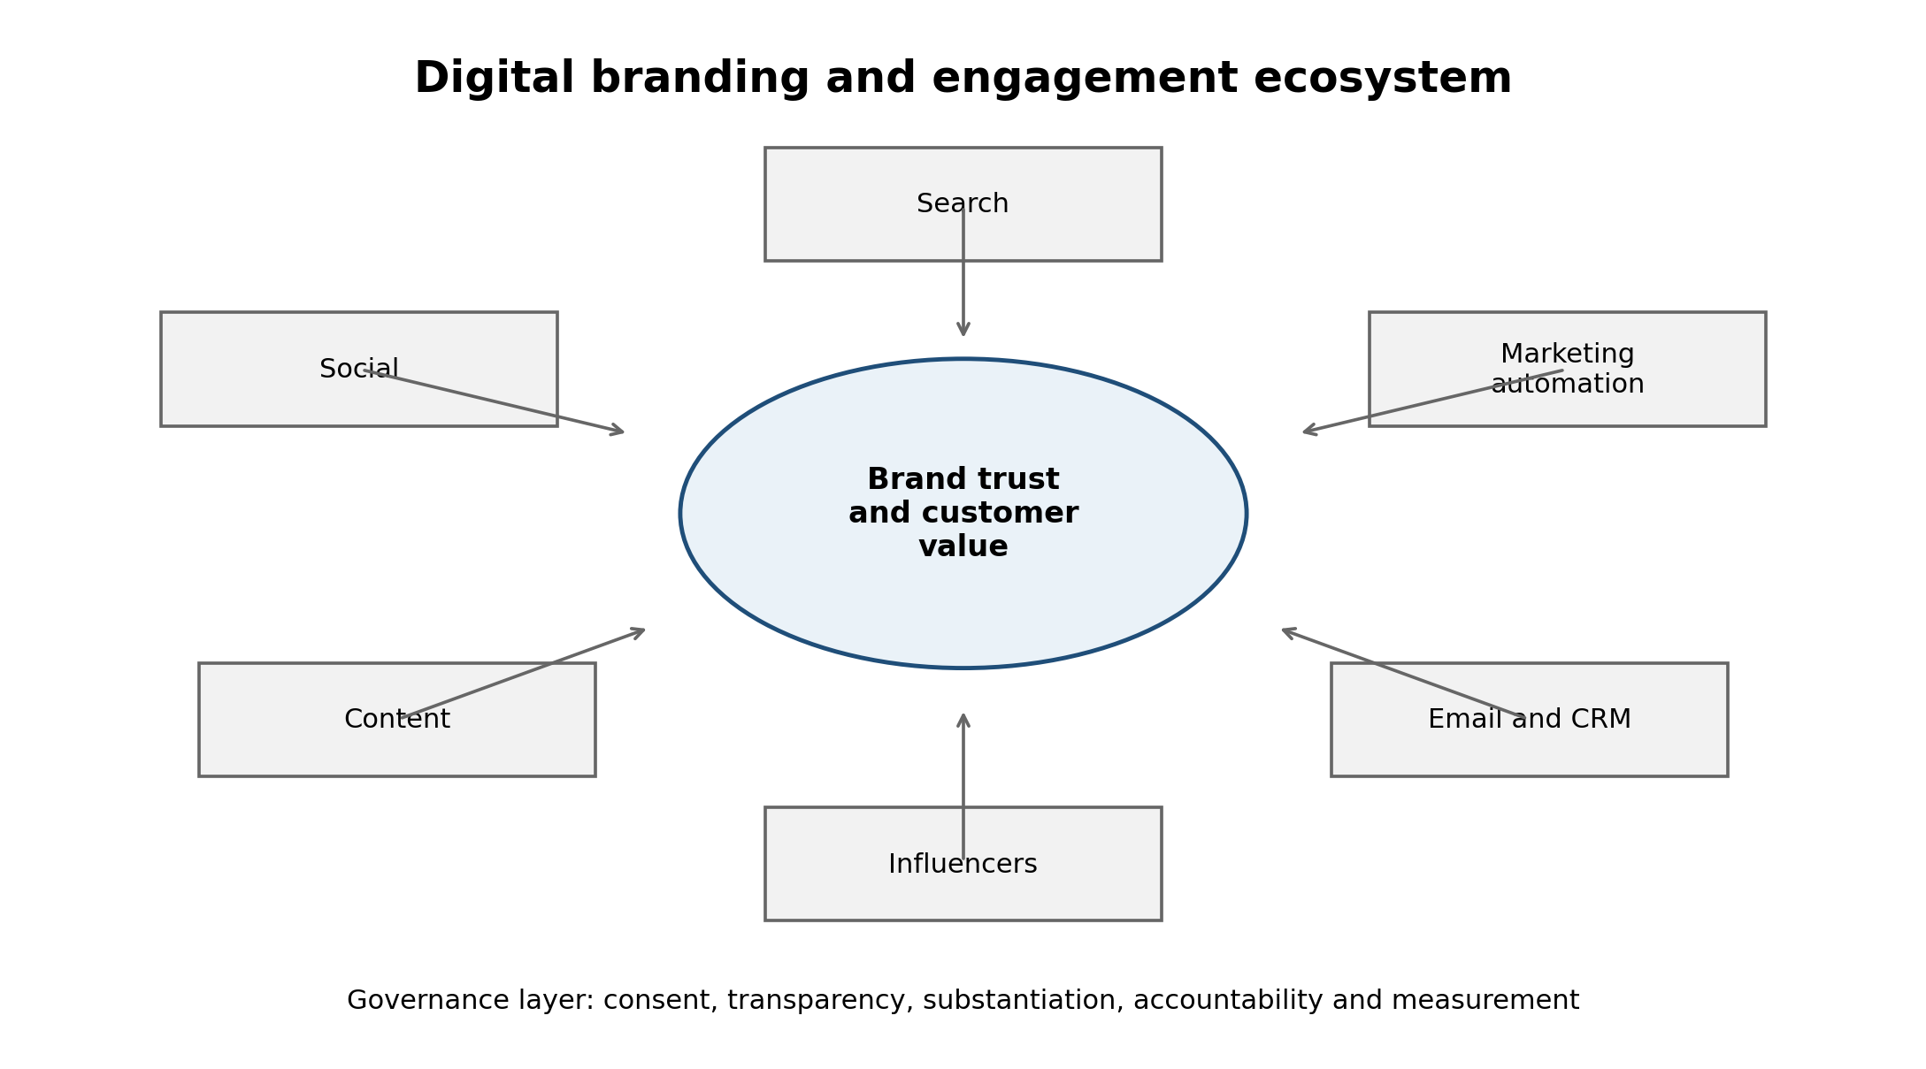
Figure 1. Digital branding and engagement ecosystem.
Search remains strategically important because it links demand discovery with purchase intent. IAB and PwC report that search revenue reached USD 114.2 billion in 2025 and represented the largest share of U.S. internet advertising revenue. This shows that despite the growth of social and video formats, search continues to be a major commercial gateway. However, the rise of AI driven search may change how consumers discover brands. If customers increasingly receive summarized answers rather than lists of links, brands will need to build stronger authority, structured content and distinctive associations so that they remain visible in AI mediated discovery.
Digital video is one of the strongest growth areas. IAB and PwC report that digital video revenue increased from USD 62.1 billion in 2024 to USD 78.0 billion in 2025, representing strong year on year growth. Video is strategically attractive because it can combine emotion, demonstration, storytelling and direct response. It allows brands to show product use, lifestyle fit and social identity. However, video also increases creative demands. Poorly targeted or repetitive video can create irritation, while highly polished content may underperform if it does not feel authentic to the platform. Managers therefore need platform specific creative strategy.
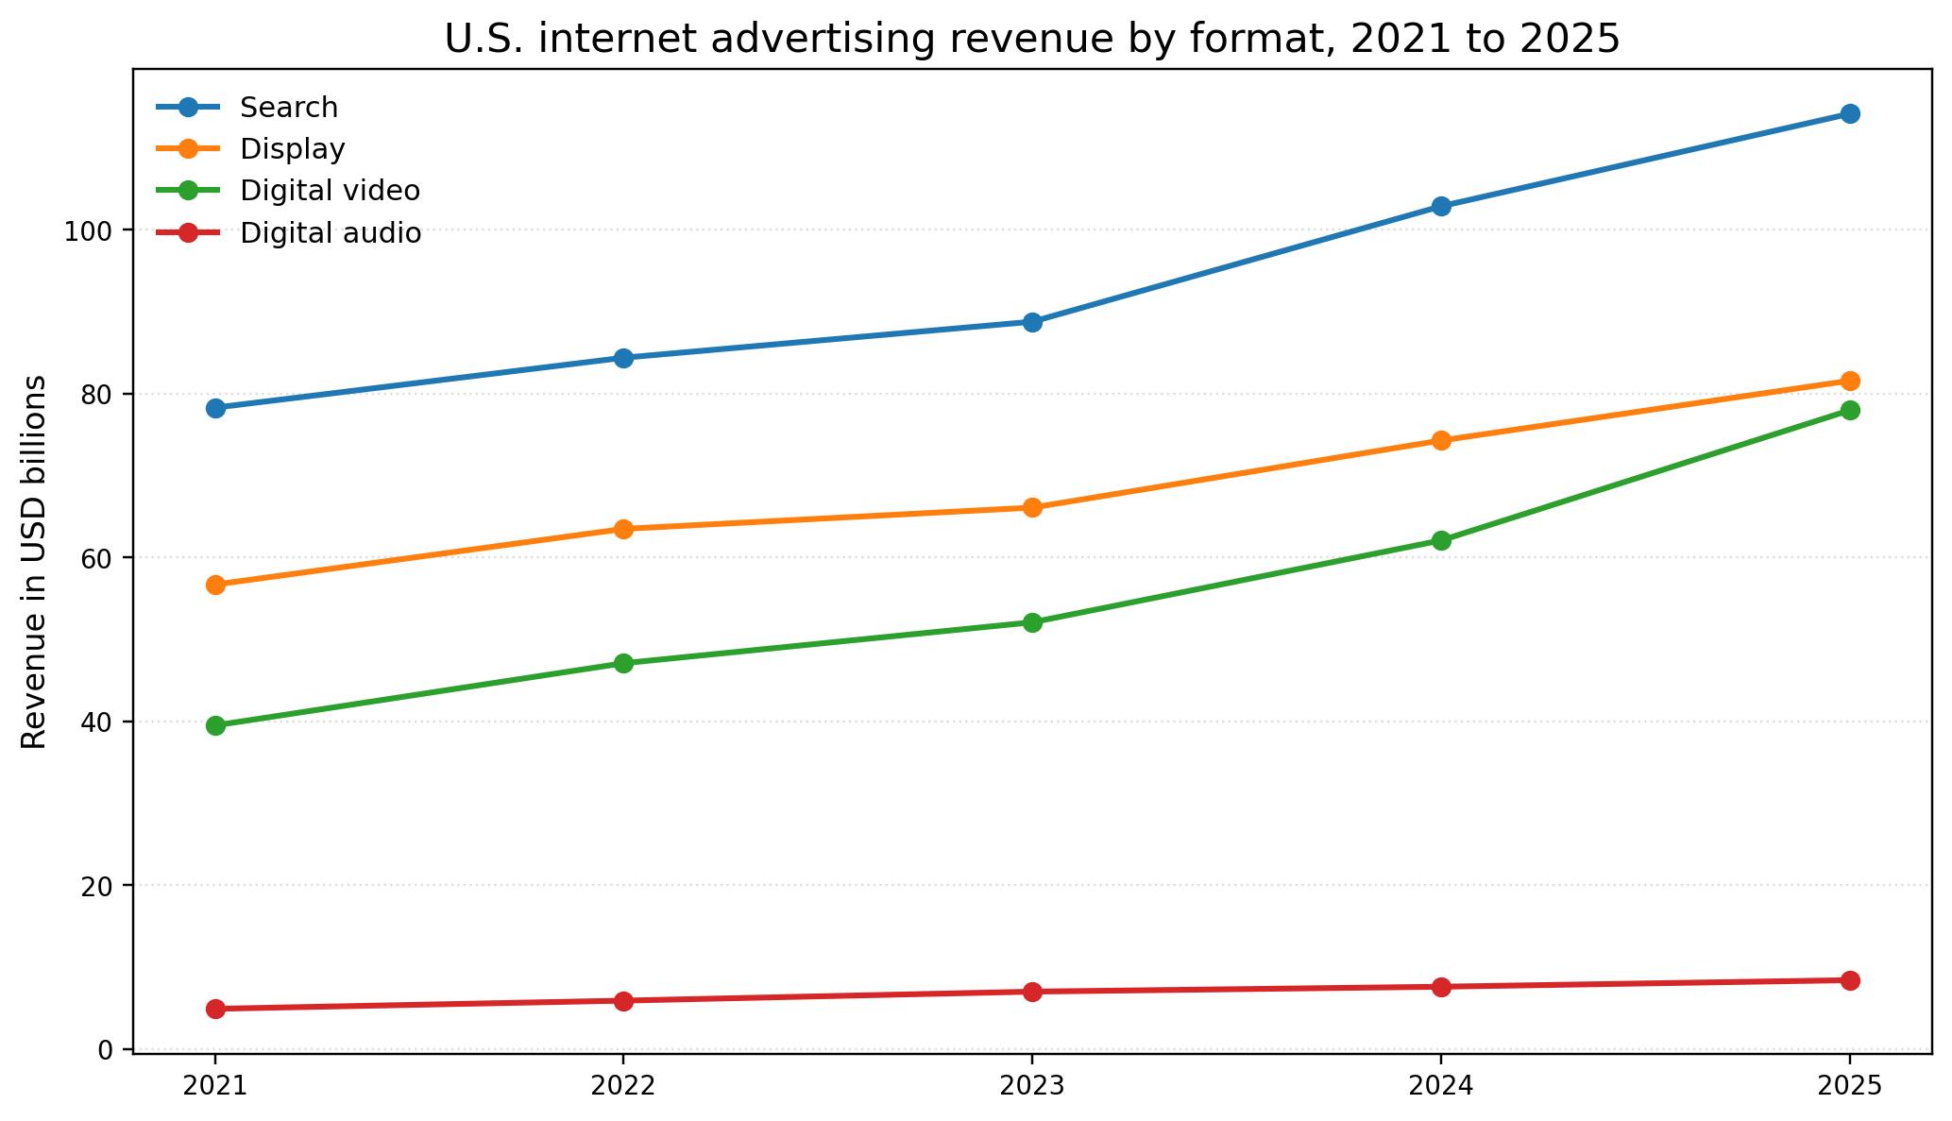
Figure 2. U.S. internet advertising revenue by format, 2021 to 2025. Source data adapted from IAB and PwC 2026.
Social media and creator marketing are increasingly important for awareness and trust. IAB reporting indicates that U.S. creator economy ad spend increased from USD 13.9 billion in 2021 to USD 29.5 billion in 2024 and was projected to reach USD 37 billion in 2025. This growth reflects the shift from brand controlled messages to creator mediated influence. The strategic advantage of creators is their audience relationship. The strategic risk is that this relationship can be damaged if creators are selected only for reach and not for fit, credibility and values alignment. Effective influencer strategy therefore requires audience fit, disclosure, content quality and measurement beyond vanity engagement.
Programmatic advertising has become a dominant mechanism for automated media buying. IAB and PwC report that programmatic advertising revenues, excluding search, reached USD 162.4 billion in 2025, while non programmatic placements excluding search declined to USD 18.0 billion. This shows that automated buying is now a core infrastructure of digital marketing. Programmatic advertising can improve scale, targeting and optimization, but it can also create brand safety, fraud, privacy and transparency risks. Brands need controls over where ads appear, what data is used, how frequency is managed and how outcomes are measured.
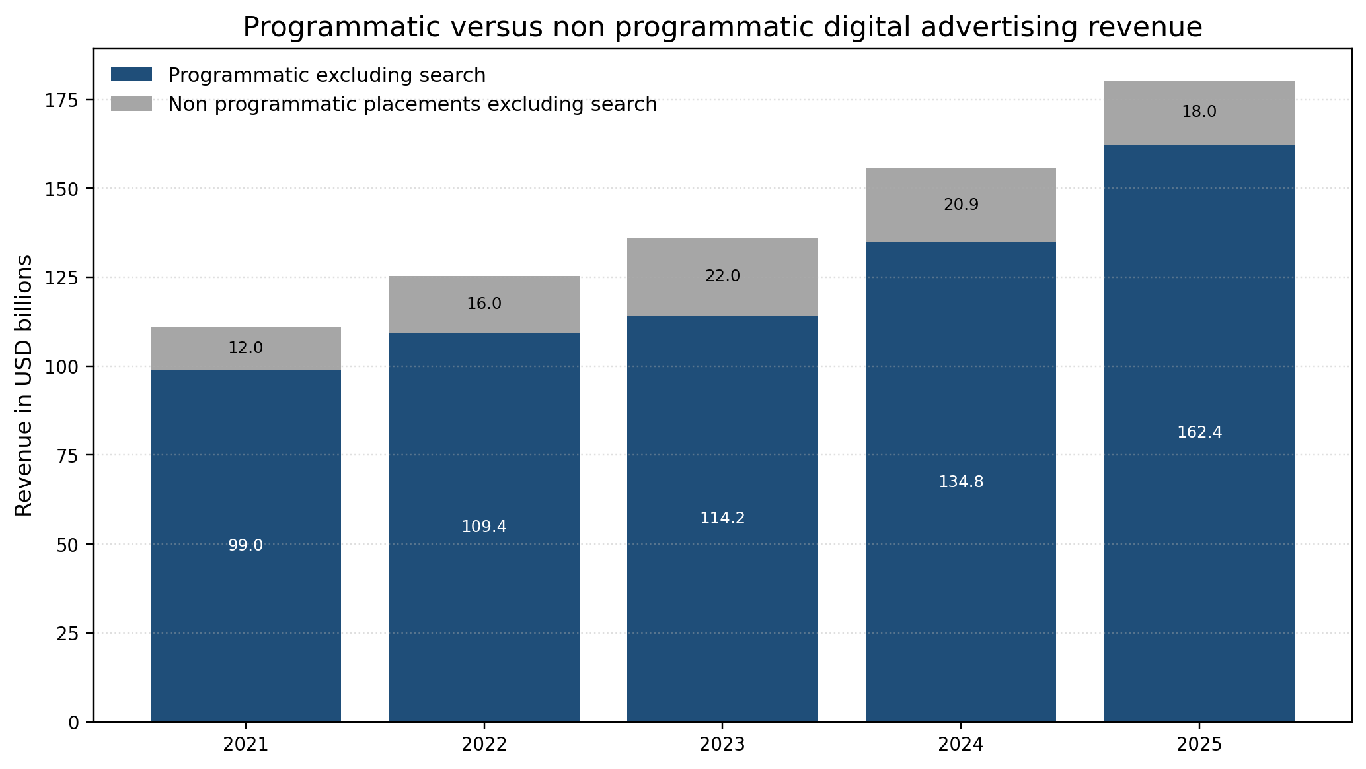
Figure 3. Programmatic versus non programmatic digital advertising revenue. Source data adapted from IAB and PwC 2026.
Digital branding influences brand awareness by increasing reach and memory availability across multiple touchpoints. A consumer might first see a brand through search, then encounter a creator review, then read website content, then receive an email or retargeted advertisement. Each interaction either strengthens or weakens brand associations. Consistency is therefore important. If the brand’s website promises expertise but social content appears careless, or if advertising promises sustainability without evidence, the brand experience becomes fragmented. Digital brand management must coordinate tone, design, claims, service response and customer data practices.
Digital engagement influences trust when it gives customers meaningful interaction rather than simple exposure. Useful responses to comments, transparent handling of complaints, educational content, clear product information and community participation can create trust. However, engagement can also become manipulative when marketers use dark patterns, false scarcity, hidden subscription terms or emotional pressure. The ethical boundary lies in whether the interaction helps customers make informed choices or pushes them toward decisions they would not make under transparent conditions.
Sales performance is affected by digital marketing through both direct and indirect mechanisms. Direct mechanisms include paid search conversion, social commerce, affiliate links, email offers and marketing automation triggers. Indirect mechanisms include brand salience, trust, reviews, advocacy and customer experience. A narrow measurement system may overvalue direct clicks and undervalue brand building because the final click is easier to measure than the earlier interactions that created preference. Managers should therefore use balanced metrics such as awareness, consideration, conversion, retention, customer lifetime value, sentiment and complaint rates.
Data privacy is a major ethical issue because personalization depends on information about individuals. PwC reports that 9 out of 10 consumers are willing to share some type of personal data for personalized service, but willingness depends on what is collected, how it is used and whether the benefit is clear. This shows that consumers do not reject personalization entirely. They reject personalization that feels unfair, hidden or intrusive. Responsible marketers should therefore use clear consent, understandable explanations, preference centers, limited data collection and visible customer benefits.
Misleading advertising remains a risk in digital environments because claims can be produced quickly, tested aggressively and distributed widely. Misleading claims may involve exaggerated product benefits, fake urgency, manipulated reviews or unclear pricing. Digital marketers may be tempted to optimize for conversion even when the claim is borderline. This is strategically dangerous because deception can weaken brand trust and trigger regulatory action. Ethical advertising should be accurate, specific and supported by evidence.
Influencer transparency is a connected issue. The FTC’s revised Endorsement Guides emphasize disclosure of material connections between advertisers and endorsers. In practice, this means that consumers should be able to identify when content is sponsored, gifted or otherwise commercially connected. Hidden sponsorship can make advertising look like independent opinion, which distorts consumer judgement. Responsible influencer marketing should therefore require clear disclosure, creator fit, honest product experience and contract terms that do not force misleading statements.
Greenwashing is another major issue because sustainability has become a brand differentiator. Digital channels make it easy to spread broad environmental claims, but those claims can be misleading if they are vague or unsupported. The European Commission’s green claims work emphasizes credible and trustworthy environmental labels and claims. For marketers, this means that sustainability communication must be evidence based. Claims should state the specific product attribute, lifecycle boundary, measurement basis and independent verification where relevant. General claims should be avoided if they cannot be substantiated.
The overall finding is that digital marketing strengthens brand equity when it is relevant, useful, transparent and consistent. It weakens brand equity when it becomes intrusive, deceptive, inconsistent or overly automated. Digital marketing management should therefore treat trust as a performance asset. Trust improves the likelihood that consumers will share data, accept recommendations, buy again, forgive mistakes and advocate for the brand. Without trust, digital reach becomes more expensive and less effective.

Table 1. Digital marketing tools, value contribution and ethical controls
Tool | Primary value contribution | Main ethical risk | Responsible control
Search marketing | Captures active demand and purchase intent | Misleading claims or unclear landing page information | Evidence based claims and transparent pricing
Social media marketing | Builds awareness, engagement and cultural relevance | Manipulative engagement or poor complaint handling | Clear community standards and responsive service
Content marketing | Educates customers and builds expertise | Generic or disguised advertising content | Useful content with clear authorship and evidence
Influencer marketing | Adds social proof and audience trust | Hidden sponsorship and poor brand fit | Clear disclosure and creator fit review
Email and automation | Supports retention and timely communication | Intrusive frequency or unclear consent | Preference centers and data minimisation

Discussion
The findings show that digital marketing creates major strategic opportunities, but it also changes the ethical burden of marketing management. Traditional marketing often relied on broad messages delivered through controlled media. Digital marketing operates through platforms, algorithms, creators, user data and automated decision systems. This creates a more complex accountability problem. A brand may not fully control where an advertisement appears, how an influencer frames a product, how an algorithm targets a consumer or how third party data has been collected. Nevertheless, customers and regulators still hold the brand responsible. Marketing managers must therefore govern the whole digital system.
The first strategic tension is personalization versus privacy. Personalization can improve customer value by reducing irrelevant messages, simplifying choices and recommending useful products. However, personalization can also feel intrusive when it uses sensitive data, follows customers across contexts or makes inferences that customers did not expect. The solution is not to abandon personalization. The solution is to make personalization transparent, limited and beneficial. Customers should understand why they are receiving messages and should be able to control preferences. Data minimization should be treated as a design principle, not only a legal requirement.
The second tension is performance marketing versus brand building. Digital marketing has made conversion measurement easier, but this can lead managers to overvalue short term metrics. Click through rates, cost per acquisition and return on ad spend are important, but they do not capture the full value of brand trust, mental availability and customer experience. Over optimized campaigns may target the same customers repeatedly, increase ad fatigue and reduce brand distinctiveness. A responsible digital strategy should allocate budget across both immediate conversion and long term brand equity. It should also measure customer satisfaction, retention and sentiment.
The third tension is influencer authenticity versus commercial control. Brands use influencers because their audiences trust them, but that trust depends on independence, fit and honest voice. If brands over script creators, the content becomes less authentic. If brands fail to control claims and disclosure, the content becomes risky. The best practice is to select creators whose audience and values fit the brand, brief them on required claims and disclosures, and allow enough creative freedom for authenticity. Influencer marketing should not be treated as a shortcut to hidden persuasion. It should be treated as a transparent partnership.
The fourth tension is sustainability branding versus greenwashing. Consumers increasingly expect brands to address environmental and social issues, but this creates incentives to overstate progress. Digital campaigns often compress complex sustainability evidence into simple phrases, badges and hashtags. That simplicity can become misleading if the claim is too broad. Responsible practice requires marketers to work with sustainability, procurement and legal teams before making claims. A claim should be specific, measurable and relevant to the product. If evidence is partial, the communication should make the boundary clear.
The fifth tension is automation versus human judgement. Marketing automation can improve efficiency and relevance, but it can also scale errors. A misleading claim, biased targeting rule or irritating frequency setting can affect thousands or millions of customers quickly. Human oversight is therefore essential. Brands should audit automated journeys, test whether messages are understandable, monitor complaints and create escalation routes for ethical concerns. Automation should support customer value rather than replace responsibility.
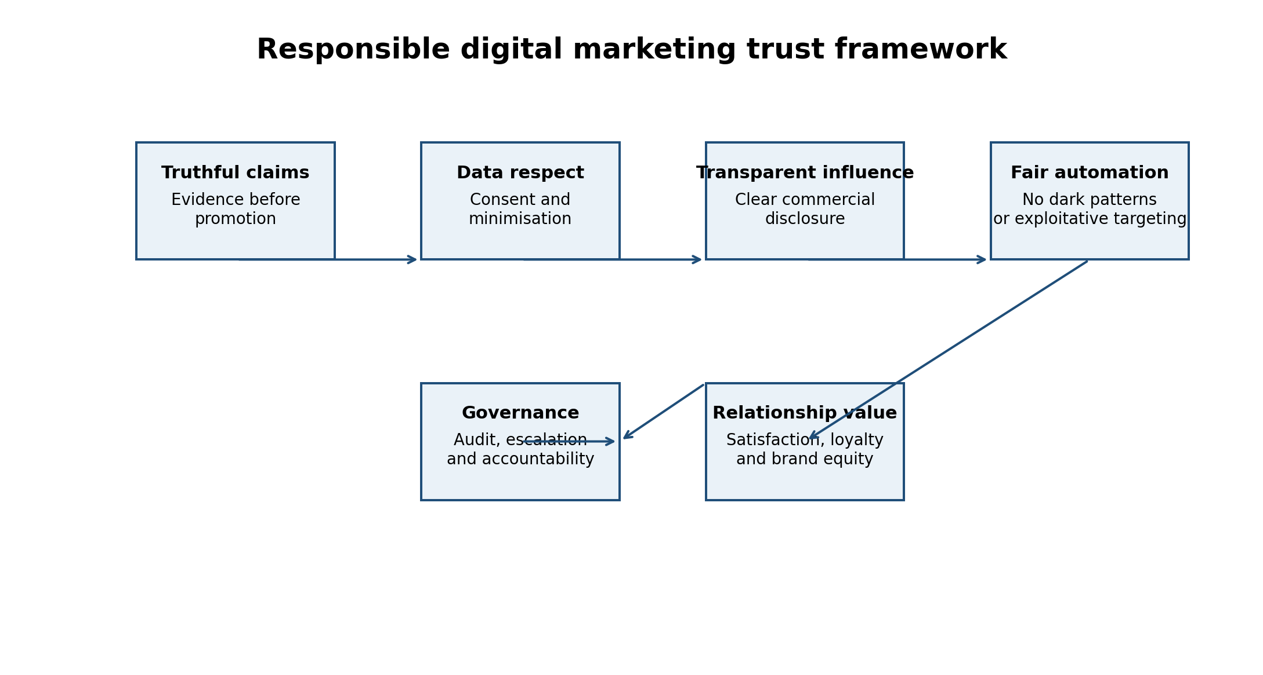
Figure 4. Responsible digital marketing trust framework.
The responsible digital marketing framework in Figure 4 addresses these tensions. Truthful claims protect consumers from deception. Data respect protects privacy and autonomy. Transparent influence protects the credibility of influencer and creator content. Fair automation protects consumers from manipulative design and excessive targeting. Governance connects these principles to accountability through review, measurement and improvement. Relationship value is the outcome because ethical practice should strengthen satisfaction, loyalty and brand equity.
This approach has practical implications for managers. First, digital marketing plans should include an ethics review alongside budget, audience and creative plans. Second, campaign dashboards should include trust indicators, not only sales indicators. These may include opt out rates, complaint rates, review sentiment, customer service issues and disclosure compliance. Third, brands should maintain claim libraries with approved evidence for product, performance and sustainability statements. Fourth, influencer contracts should require disclosure and allow creators to express honest experience. Fifth, data use should be explained in plain language with clear customer controls.
Ethical practice is sometimes treated as a constraint on marketing creativity, but the analysis suggests the opposite. In crowded digital markets, trust is a scarce asset. Consumers who trust a brand are more likely to share data, accept personalized communication, engage with content, buy repeatedly and recommend the brand. Therefore, ethical practice can improve marketing effectiveness over the long term. The key is to define ethics not as defensive compliance, but as part of customer value creation.

Conclusion
Digital marketing, branding and ethical practice are now inseparable parts of marketing management. Search, social media, content marketing, influencer partnerships, email, CRM and automation give organizations powerful tools for awareness, engagement and sales growth. Industry evidence shows that digital advertising formats, programmatic buying, video and creator marketing are now central to competitive marketing strategy. However, these tools also increase risks involving privacy, deception, hidden influence, greenwashing and manipulative design.
The main conclusion is that digital marketing creates sustainable brand equity only when it is trusted. Awareness without trust produces fragile attention. Personalization without consent produces resistance. Influencer reach without disclosure produces ethical risk. Sustainability claims without evidence produce reputational damage. Therefore, responsible marketing is not separate from performance. It is a condition for long term performance.
Organizations should adopt responsible digital marketing practices based on truthful claims, consent based data use, transparent influence, fair automation and evidence based sustainability communication. They should also measure customer trust, satisfaction and retention alongside conversion metrics. This balanced approach allows digital marketing to build not only immediate sales, but durable customer relationships and sustainable brand equity.

References
Binet, L., & Field, P. (2013). The long and the short of it: Balancing short and long term marketing strategies. Institute of Practitioners in Advertising.
Brodie, R. J., Hollebeek, L. D., Juric, B., & Ilic, A. (2011). Customer engagement: Conceptual domain, fundamental propositions, and implications for research. Journal of Service Research, 14(3), 252 to 271.
Chaffey, D., & Ellis Chadwick, F. (2022). Digital marketing: Strategy, implementation and practice (8th ed.). Pearson.
DataReportal. (2026). Digital 2026 mid year global update report. https://datareportal.com/
Dwivedi, Y. K., Ismagilova, E., Hughes, D. L., Carlson, J., Filieri, R., Jacobson, J., Jain, V., Karjaluoto, H., Kefi, H., Krishen, A. S., Kumar, V., Rahman, M. M., Raman, R., Rauschnabel, P. A., Rowley, J., Salo, J., Tran, G. A., & Wang, Y. (2021). Setting the future of digital and social media marketing research. International Journal of Information Management, 59, 102168.
European Commission. (2026). Green claims. https://environment.ec.europa.eu/topics/circular-economy-topics/green-claims_en
Federal Trade Commission. (2023). Guides concerning the use of endorsements and testimonials in advertising, 16 CFR Part 255. https://www.ecfr.gov/current/title-16/chapter-I/subchapter-B/part-255
GDPR Info. (2026). Article 5 GDPR: Principles relating to processing of personal data. https://gdpr-info.eu/art-5-gdpr/
IAB & PwC. (2026). Internet advertising revenue report: Full year 2025. Interactive Advertising Bureau and PwC. https://www.iab.com/
Keller, K. L. (1993). Conceptualizing, measuring, and managing customer based brand equity. Journal of Marketing, 57(1), 1 to 22.
Kotler, P., Keller, K. L., & Chernev, A. (2022). Marketing management (16th ed.). Pearson.
Kumar, V., & Reinartz, W. (2016). Creating enduring customer value. Journal of Marketing, 80(6), 36 to 68.
Lemon, K. N., & Verhoef, P. C. (2016). Understanding customer experience throughout the customer journey. Journal of Marketing, 80(6), 69 to 96.
Martin, K. D., & Murphy, P. E. (2017). The role of data privacy in marketing. Journal of the Academy of Marketing Science, 45, 135 to 155.
PwC. (2025). The loyalty illusion: 2025 customer experience survey. https://www.pwc.com/
TV Tech. (2025). IAB: Creator economy ad spend now dwarfs ad spend for total media industry. https://www.tvtechnology.com/
Vargo, S. L., & Lusch, R. F. (2004). Evolving to a new dominant logic for marketing. Journal of Marketing, 68(1), 1 to 17.
Verhoef, P. C., Broekhuizen, T., Bart, Y., Bhattacharya, A., Dong, J. Q., Fabian, N., & Haenlein, M. (2021). Digital transformation: A multidisciplinary reflection and research agenda. Journal of Business Research, 122, 889 to 901.
Wedel, M., & Kannan, P. K. (2016). Marketing analytics for data rich environments. Journal of Marketing, 80(6), 97 to 121.
Wirtz, J., & Lovelock, C. (2022). Services marketing: People, technology, strategy (9th ed.). World Scientific.

Appendices

Appendix A. U.S. internet advertising revenue by format used for Figure 2
Year | Search | Display | Digital video | Digital audio
2021 | 78.3 | 56.7 | 39.5 | 4.9
2022 | 84.4 | 63.5 | 47.1 | 5.9
2023 | 88.8 | 66.1 | 52.1 | 7.0
2024 | 102.9 | 74.3 | 62.1 | 7.6
2025 | 114.2 | 81.6 | 78.0 | 8.4

Appendix B. Programmatic advertising data used for Figure 3
Year | Programmatic excluding search | Non programmatic placements excluding search
2021 | 99.0 | 12.0
2022 | 109.4 | 16.0
2023 | 114.2 | 22.0
2024 | 134.8 | 20.9
2025 | 162.4 | 18.0

