ASSIGNMENT TITLE: ADVANCED BUSINESS ENGLISH FOR TOURISM AND RECREATION (REPORT)

TOPIC: TOURISM MARKETING CAMPAIGN

STUDENT NAME: MANSI
STUDENT ID: DE240028

Table of Contents
Slide 1: Title Slide 3
Slide 2: Introduction 3
Slide 3: Destination Overview 4
Slide 4: Marketing Mix – 4Ps 5
Slide 5: Key Marketing Strategies 6
Slide 6: Brand Positioning & Messaging 7
Slide 7: Press Release Overview 8
Slide 8: Email Marketing Strategy 9
Slide 9: Advertising & Print Media Strategy 10
Slide 10: Conclusion 11
Slide 11: Reference 12
Slide 12: Thank You!! 13

Slide 1: Title Slide
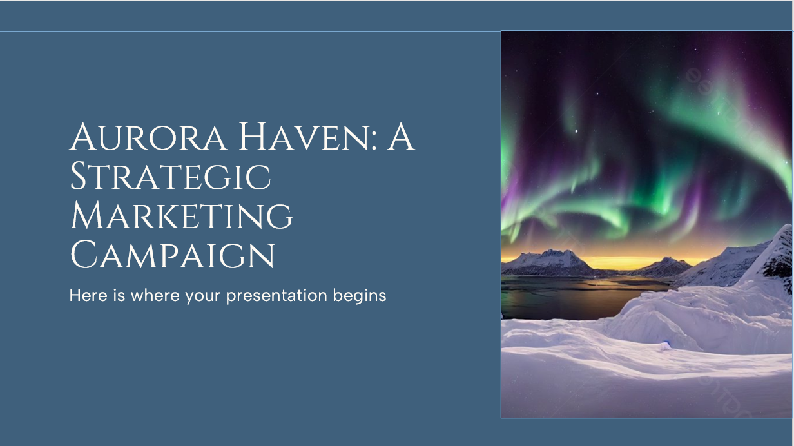
Title: Aurora Haven: A Strategic Marketing Campaign

Slide 2: Introduction
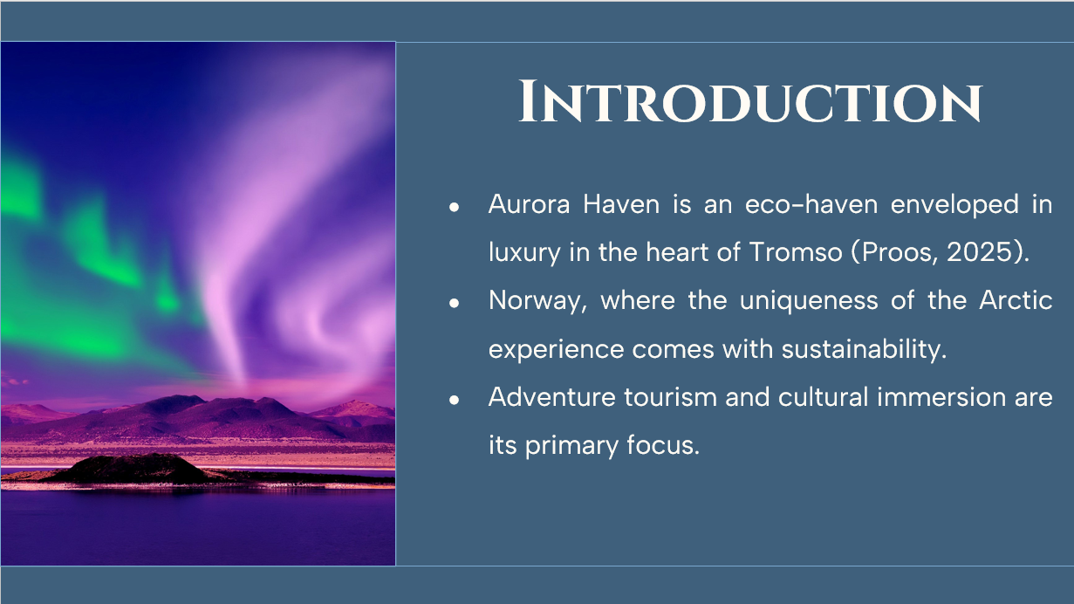
- Aurora Haven is an eco-haven enveloped in luxury in the heart of Tromso (Proos, 2025).
- Norway, where the uniqueness of the Arctic experience comes with sustainability.
- Adventure tourism and cultural immersion are its primary focus.
SN
Aurora Haven's marketing strategy also includes press releases, promotional websites, and targeted advertising to attract clientele that include global luxury travelers, adventure seekers, and eco-tourists (Proos, 2025).

Slide 3: Destination Overview
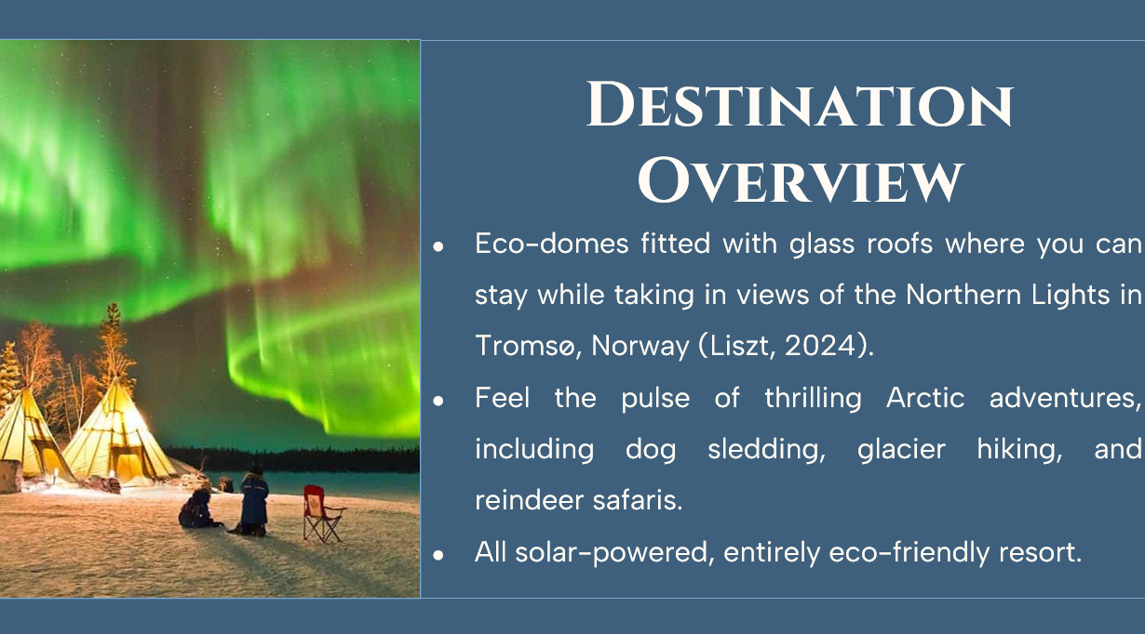
- Eco-domes fitted with glass roofs where you can stay while taking in views of the Northern Lights in Tromsø, Norway (Liszt, 2024).
- Feel the pulse of thrilling Arctic adventures, including dog sledding, glacier hiking, and reindeer safaris.
- All solar-powered, entirely eco-friendly resort.
SN
Aurora Haven uniquely offers upscale visitors a chance to cherish luxury, adventure, and sustainability fostered by the environment. These elements ultimately form blissful memories for guests above and beyond compare (Liszt, 2024).

Slide 4: Marketing Mix – 4Ps
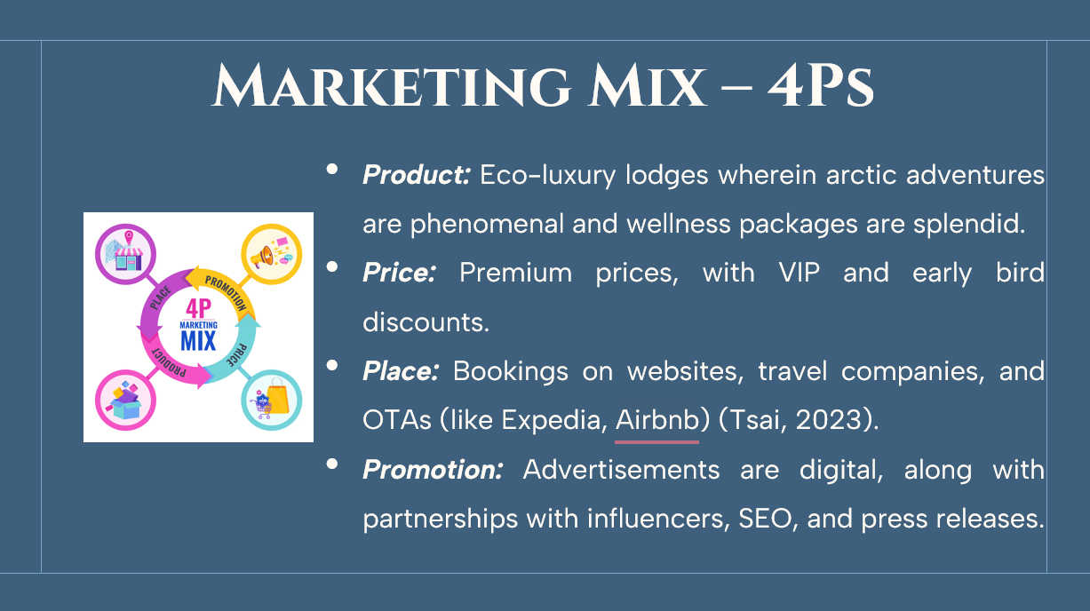
- Product: Eco-luxury lodges wherein arctic adventures are phenomenal and wellness packages are splendid.
- Price: Premium prices, with VIP and early bird discounts.
- Place: Bookings on websites, travel companies, and OTAs (like Expedia, Airbnb) (Tsai, 2023).
- Promotion: Advertisements are digital, along with partnerships with influencers, SEO, and press releases.
SN
The multi-channel marketing strategy considers social media interaction, online travel portals, and experiential marketing to promote visibility and direct bookings (Tsai, 2023). Targeted promotions, influencer partnerships, and digital advertising help the company gain worldwide reach.

Slide 5: Key Marketing Strategies
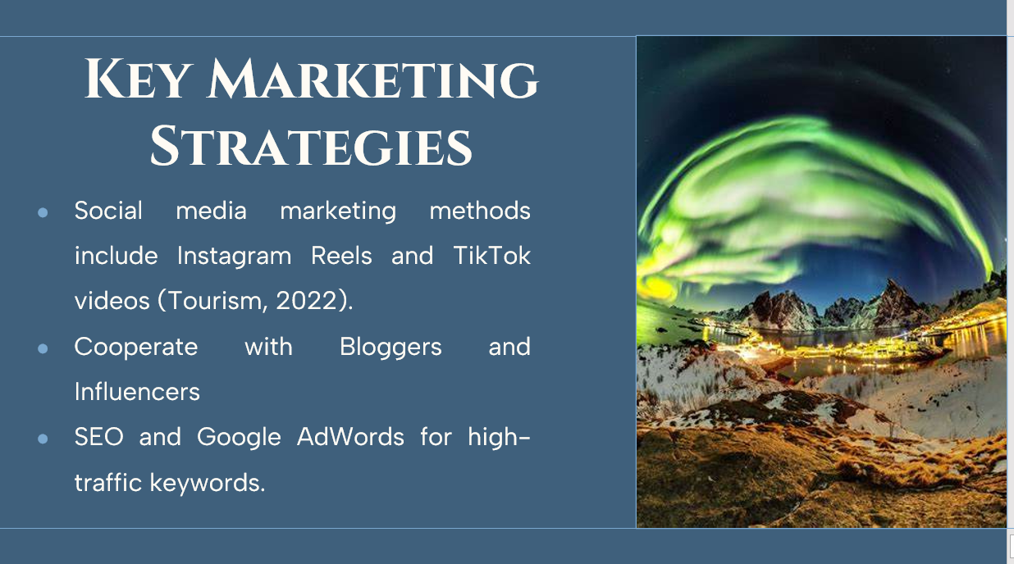
- Social media marketing methods include Instagram Reels and TikTok videos (Tourism, 2022).
- Cooperate with Bloggers and Influencers
- SEO and Google AdWords for high-traffic keywords.
SN
Aurora Haven develops its market presence and customer engagement through digital marketing, influencer engagements, and targeted promotions to establish itself as the leading luxury Arctic destination (Tourism, 2022).

Slide 6: Brand Positioning & Messaging
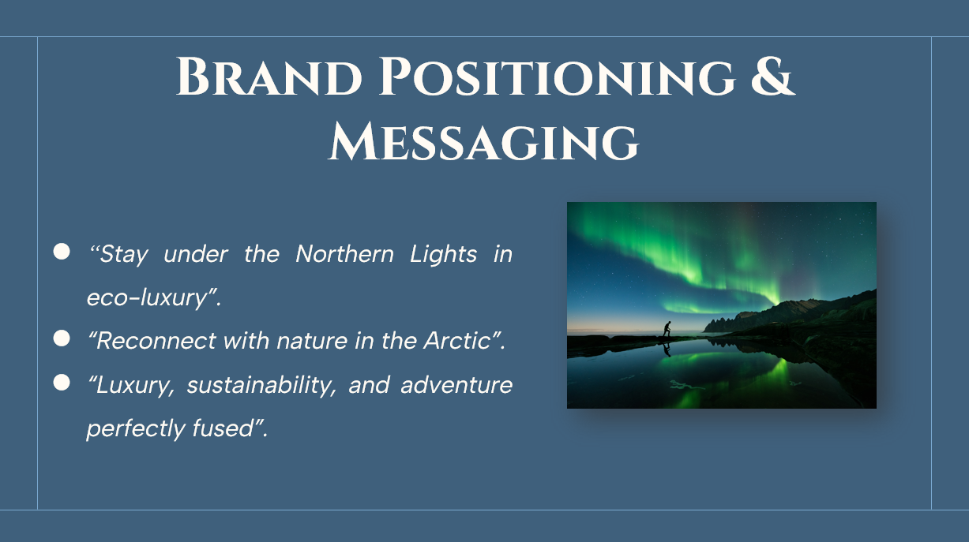
- “Stay under the Northern Lights in eco-luxury”.
- “Reconnect with nature in the Arctic”.
- “Luxury, sustainability, and adventure perfectly fused”.
SN
The campaign's marketing messages are powerful and emotional, establishing Aurora Haven as an experience of a lifetime (Keage, 2024). Its exclusivity, environmental awareness, and adventure give it more of an international appeal.

Slide 7: Press Release Overview
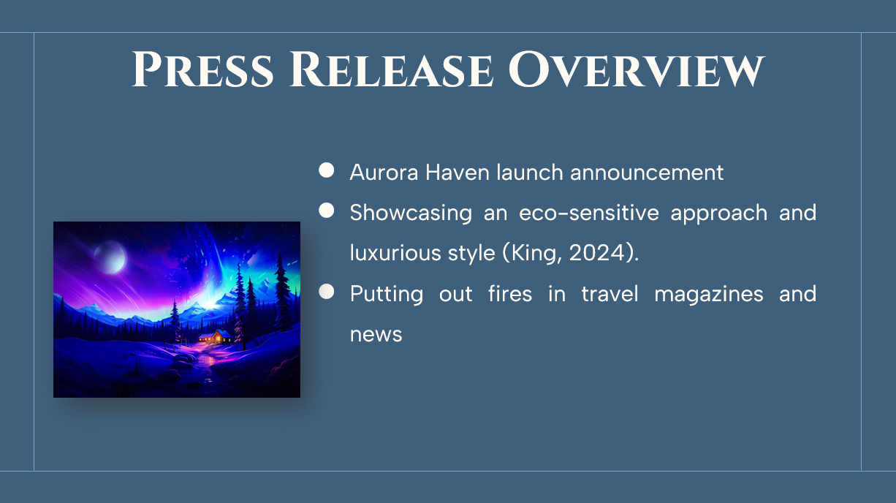
- Aurora Haven launch announcement
- Showcasing an eco-sensitive approach and luxurious style (King, 2024).
- Putting out fires in travel magazines and news
SN
A good press release increases the brand's credibility and awareness among travel journalists and influencers, helping to enhance visibility and praise in global media (King, 2024).

Slide 8: Email Marketing Strategy
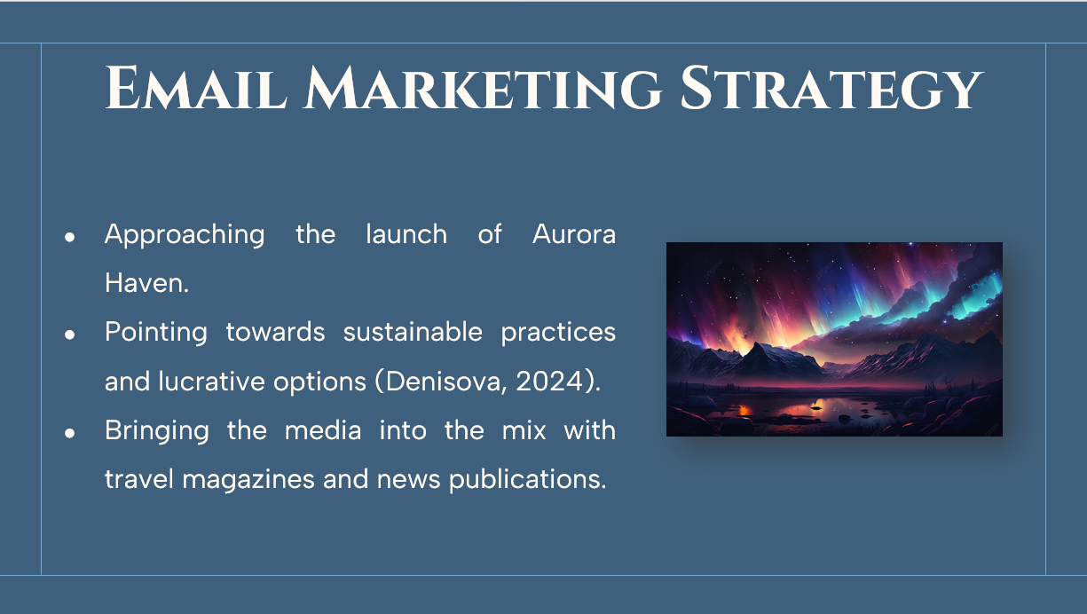
- Approaching the launch of Aurora Haven.
- Pointing towards sustainable practices and lucrative options (Denisova, 2024).
- Bringing the media into the mix with travel magazines and news publications.
SN
The meticulously written press release will amplify the brand's credibility and draw the attention of travel journalists, influencers, and major media outlets, leading to increased coverage and visibility (Denisova, 2024).

Slide 9: Advertising & Print Media Strategy
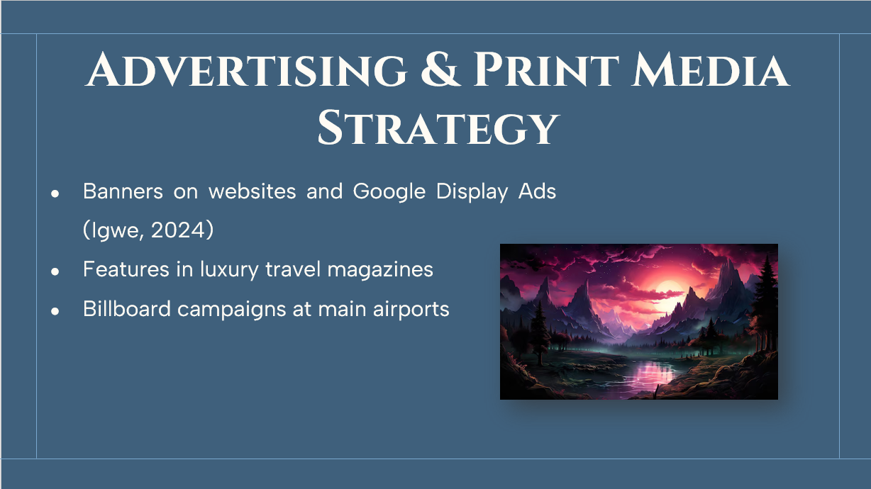
- Banners on websites and Google Display Ads (Igwe, 2024)
- Features in luxury travel magazines
- Billboard campaigns at main airports
SN
Digital- and print-based advertising synergism ensures a global approach to entice high-net-worth individuals and cosmopolitan travelers for optimum visibility and engagement (Igwe, 2024).

Slide 10: Conclusion
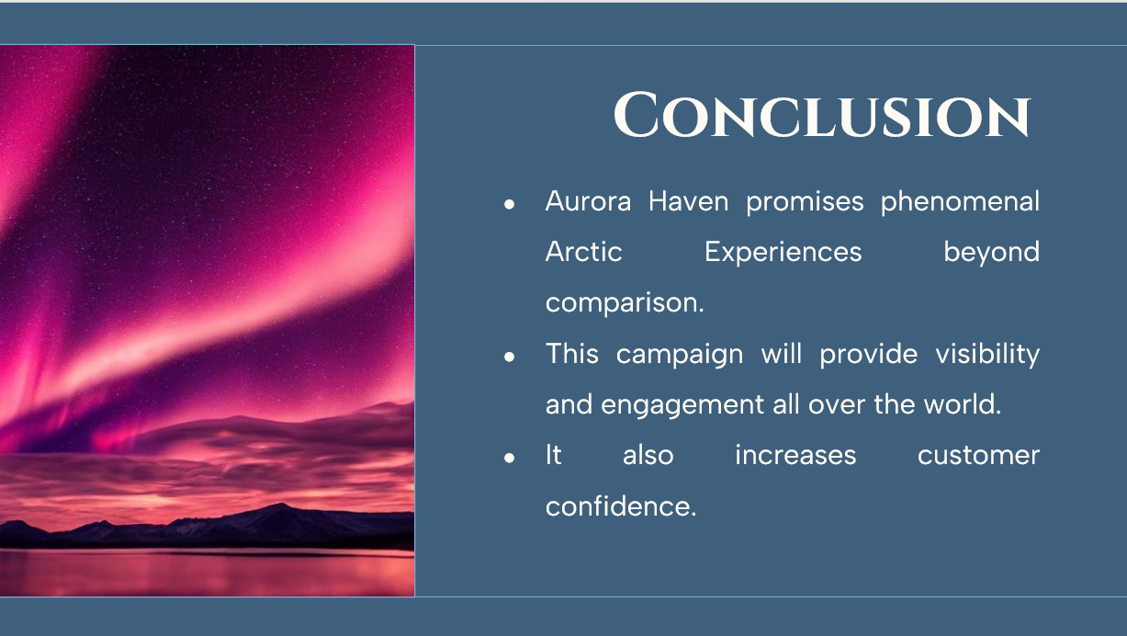
- Aurora Haven promises phenomenal Arctic Experiences beyond comparison.
- This campaign will provide visibility and engagement all over the world.
- It also increases customer confidence.
SN
With great social marketing, online engagement, and a sustainable brand, Aurora Haven is emerging as a world-class luxury destination for the Arctic. These strategies boost bookings and revenues.

Slide 11: Reference
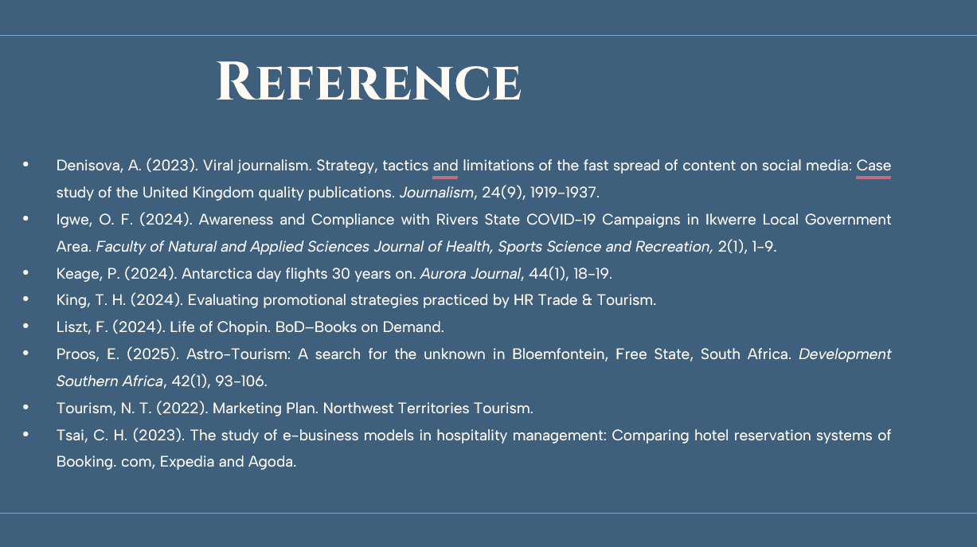
Denisova, A. (2023). Viral journalism. Strategy, tactics and limitations of the fast spread of content on social media: Case study of the United Kingdom quality publications. Journalism, 24(9), 1919-1937.
Igwe, O. F. (2024). Awareness and Compliance with Rivers State COVID-19 Campaigns in Ikwerre Local Government Area. Faculty of Natural and Applied Sciences Journal of Health, Sports Science and Recreation, 2(1), 1-9.
Keage, P. (2024). Antarctica day flights 30 years on. Aurora Journal, 44(1), 18-19.
King, T. H. (2024). Evaluating promotional strategies practiced by HR Trade & Tourism.
Liszt, F. (2024). Life of Chopin. BoD–Books on Demand.
Proos, E. (2025). Astro-Tourism: A search for the unknown in Bloemfontein, Free State, South Africa. Development Southern Africa, 42(1), 93-106.
Tourism, N. T. (2022). Marketing Plan. Northwest Territories Tourism.
Tsai, C. H. (2023). The study of e-business models in hospitality management: Comparing hotel reservation systems of Booking. com, Expedia and Agoda.

Slide 12: Thank You!!


