DIGITAL TRANSFORMATION AS A DRIVER OF BUSINESS COMPETITIVENESS

Student Name: Gagandeep
Abstract
This report aims to provide an in-depth and critical examination of the potential of digital transformation to create greater competitiveness of the organisation by creating digital capabilities, innovation capacity and strategic adaptability. Organisations operating in such highly competitive surroundings like increasing technological changes, changing customer expectations and the dependency on data-driven decision-making has come a greater significance of Digital transformation. The report does not just cover technology adoption, rather it looks to how organisations develop the competitive advantage through embedding digital technologies, organisational capabilities and strategic change.
Dynamic Capabilities Theory has been selected as main analysis lens highlighting the power of organisations to sense opportunities and embrace technological opportunities and convert resources to meet market conditions effectively. The digital transformation journeys at Netflix, Starbucks, Siemens, Amazon and Microsoft all exhibit a different type of digital transformation pathway and are analysed using a multiple-case-study approach.
The results suggest that the investment in valuable digital capabilities, such as data analytics, artificial intelligence, cloud computing, automation and customer intelligence is the enabler to a successful digital transformation. These capabilities enable innovation, operational efficiency, engage in customers and adjust to business model, improve competitiveness of organizations. It is also found that, to achieve the sustainable competitive advantages, technology alone cannot be helpful but the capability to co-relate the technological investment with the organisational capability and strategy is essential for achieving the competitive success.
The report presents key managerial implications, indicating that companies need to focus on capability development, creating an environment for innovation, making informed decisions with data and changing their business model in order to make the most of the digital transformation and remain competitive.

Table of Contents
1. Introduction 5
1.1 Background to Digital Transformation and Business Competitiveness 5
1.2 Research Problem 5
1.3 Research Aim 5
1.4 Research Objectives 5
1.5 Structure of the Report 6
2. Literature Review 6
2.1 Defining Digital Transformation 6
2.2 Dynamic Capabilities Theory as the Foundation of Digital Transformation 7
2.3 Digital Capabilities as Strategic Resources 8
2.4 Digital Innovation and Competitive Advantage 9
2.5 Business Model Transformation and Organisational Performance 9
3. Methodology 10
3.1 Research Philosophy 10
3.2 Research Approach 10
3.3 Research Design 10
3.4 Case Selection Criteria 11
3.5 Data Sources 11
4. Findings and Analysis 11
4.1 Netflix: Data Analytics, AI and Platform Competitiveness 11
4.2 Starbucks: Digital Customer Experience Transformation Through Deep Brew AI 12
4.3 Siemens: Industrial IoT and Digital Twin Transformation 12
4.4 Amazon: Intelligent Automation and Operational Excellence 13
4.5 Microsoft: Business Model Reinvention Through Azure Cloud Ecosystems 13
5. Discussion 14
5.1 Digital Capabilities as the Foundation of Competitiveness 14
5.2 Innovation Capability as a Mediator of Performance 14
5.3 Operational Efficiency and Business Performance 15
5.4 Challenges of Digital Transformation 15
6. Conclusion 16
6.1 Summary of Findings 16
6.2 Theoretical Contribution 17
6.3 Practical Implications 17
6.4 Final Conclusion 17
References 18
Appendices 21
Appendix A: Digital Transformation Framework 21
Appendix B: Comparative Case Analysis Matrix 22
Appendix C: Digital Capabilities and Competitive Outcomes Mapping Table 22

1. Introduction

1.1 Background to Digital Transformation and Business Competitiveness
Digital transformation is one of the organisations must to compete in the digital economy. Rapid developments in the fields of Industry 4.0 technologies like artificial intelligence (AI), big data analytics and the Internet of Things (IoT) have changed the way enterprises generate value and gain customer connections and optimise operations. Digital platforms and data-based business models are more and more becoming the base for competition and can efficiently improve innovation and operational performance (Kraus et al., 2021). As a result, it is crucial for organisations to build robust digital capabilities to remain competitive and do continuous innovations to deal with the changes in the market (Vărzaru et al., 2024; Zhang and Wang, 2024).

1.2 Research Problem
Having now made large investments in digital technologies, there are a lot of organisations that don't achieve their expected performance or competitive benefits. Nevertheless, it has been suggested that not every technology has the potential to create transformations on its own, but it is needed to develop the capabilities of adapting, innovating and reallocating resources (Ellström et al., 2022). Transformation efforts often fail due to difficulties with organisational resistance, shortage of competent workforce, lack of leadership support, poor change management and so on (Al-Moaid et al., 2024). Thus, the inclusion of digital capabilities and their role in achieving competitive advantages is a study subject of high importance (Dukhaykh, 2026).

1.3 Research Aim
This report aims to review critically the role of digital transformation in improving the competitiveness of the organisations by increasing their digital capabilities, innovation capacity and strategic adaptability.

1.4 Research Objectives
- To present and explore recent theories of the digital transformation.
- To assess the importance of digital capability in organisations.
- To study some organisational digital transformation programs.
- To make an assessment on the competitiveness impact of digital transformation.
- To determine the key components to success and implementation hurdles.

1.5 Structure of the Report
This report is divided into six major sections to give a thorough examination of digital transformation as a catalyst for business competitiveness. The literature review then provides the theoretical frame of reference; important concepts of the digital transformation, the dynamic capabilities, the digital capabilities, the innovation and the business model transformation have been analysed. The research methodology is explained in this section, which includes the research philosophy, approach, design and data sources to be used for the study. The findings and analysis section includes a detailed evaluation of the digital transformation initiatives carried out by Netflix, Starbucks, Siemens, Amazon and Microsoft, discussing the technologies adopted, capabilities created and outcomes enjoyed. The discussion section describes how the insights provided in the case studies can be combined and what implications they have for the competitiveness of organisations. Finally, the major findings are summarised, the theoretical, practical implications are discussed and recommendations are given on the role of digital transformations for sustainable competitive advantage and long-term organisational success.

2. Literature Review

2.1 Defining Digital Transformation
Digital transformation is the strategic use of digital technology within their business and processes to enhance business, innovation and competitiveness. It is important to discern between digitisation, digitalisation and digital transformation as these are different levels of technological development. The process of converting analogue information into data that is used by computers is known as digitisation. Digitalisation is the application of digital technologies to optimize the processes in an organization and its operations. But digital transformation is strategic change that has organisation-wide impact in the context of business models, customer relationships and value creation processes (Kraus et al., 2021). Digital transformation has become a fact of life for modern organisations, in this competitive world, organisations are increasingly using digital transformation to make them more flexible, and increase their Innovation capability. According to Egodawele et al (2022) the process of digital transformation should come with organisational restructuring and adaptation. Also, Zhang and Wang (2024) highlight digital transformation involves the intertwined technological, managerial and operational changes, which in turn may build sustainable competitive advantage.

2.2 Dynamic Capabilities Theory as the Foundation of Digital Transformation
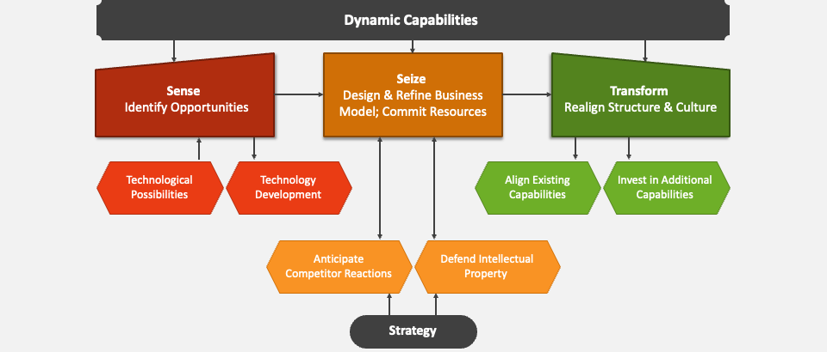
Figure 1: Dynamic Capabilities Theory
(Source: Ellström et al., 2022)
Dynamic Capabilities Theory was used as a theoretical background for the understanding of digital transformation as it explains adaptation of the organisations with changes in the environment. The theory will be that organisations need to be able to sense opportunities and apply strategic investments to seize those opportunities, while at the same time creating capabilities that transforms the internal resources so they are ready for the competition (Ellström et al., 2022). Sensing capability is an organisation's ability to identify technological opportunities, changing customer behaviour and market disruptions. Netflix exemplifies sensing in its strategy to recognise how people have stopped watching TVs and instead turned to online streaming. Seizing opportunity involves investing in technology and the organisational resources to take advantage of opportunities that are identified. Azure's cloud infrastructure investment by Microsoft provides an example of how companies can proactively capitalise on digital opportunities to bolster their market stance (Qiu, Zhang and Li, 2025). Transforming capability, the ability to change organizational structures and business model to accommodate innovation and strategic change. The improvements in customer experience within Starbucks were as a result of their redesigned interactions with customers, including mobile ordering and AI-driven personalisation (de la Torre et al., 2025). Recent studies have given strong emphasis to the role of dynamic capabilities, which plays a crucial role in shaping the competitiveness of organisations and their innovation performance in the context of digital transformation initiatives (Alrub, Alzghoul and Alzubi, 2025). To achieve successful transformation and sustainability, leadership and culture of innovation play a pivotal role (Dukhaykh, 2026).

2.3 Digital Capabilities as Strategic Resources
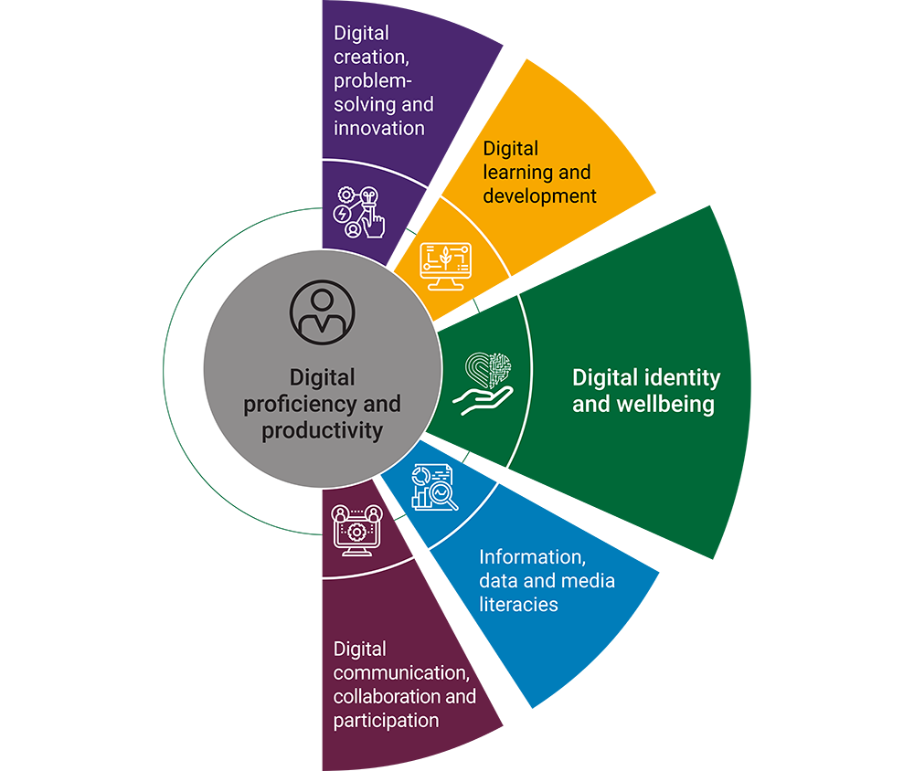

Figure 2: Digital Capabilities
(Source: Candraningrat, Hidayat and Sutrisno, 2025)
Digital capabilities can be described as strategic organisational resources which can be used to make effective use of technologies and to eliminate the negative consequences of technologies on the business's performance. They are the data analytics capability, AI capability, cloud computing capability and digital innovation capability, and customer intelligence capability. Having higher-level digital skills can help organisations to make better decisions, be more efficient and have more personalised customer experiences. Such capabilities can then be turned into valuable strategic assets, as per the Resource-Based View, that contribute to sustainable competitive advantage. Candraningrat, Hidayat and Sutrisno (2025) believe that the abilities in the digital era will build up the organisational adaptability and innovation capability. Likewise, Valdez-Juárez and Castillo-Vergara (2024) determined that the capabilities of digital technologies have a favourable impact on innovation and economic performance of SMEs. Zhou, Liu and Zhang (2025) also underline that more digitally capable organizations are more agile and competitive. Huang, Li and Wang (2025) conclude that the combined effect of management features and digital competencies on competitiveness in business organizations.

2.4 Digital Innovation and Competitive Advantage
Digital transformation helps companies sustain competitive advantage by advancing its innovation capability and optimising organisational performance. Digital capabilities facilitate organisations creating new products, services and ways of operating that allow them to perform better in the market and obtain greater customer satisfaction. The innovation capability is a middle-ground variable between DT and competitive outcomes. Having the capability to innovate digitally means that organisations can better adapt to the technology disruption and evolving consumer demands. Valdez-Juárez and Castillo-Vergara (2024) state that the digital transformation improves the innovation performance and was demonstrated, highlighting knowledge integration and technological flexibility. The results reveal that digital transformation has a positive impact because it enhances dynamic capabilities and collaborative knowledge sharing, thus benefiting open innovation performance. However, De la Torre et al. (2025) highlight the importance of responsible digital innovation to sustainable competitive advantage. Likewise, Vărzaru et al. (2024) find that digital technologies positively contribute to increasing productivity, performance in innovation and strategic competitiveness in different sectors.

2.5 Business Model Transformation and Organisational Performance
Digital transformation adds value to the organisation through change in business models, operation and systems for engaging customers. Digital technologies are now increasingly being adopted to re-imagine and reinvent revenue models, enhance service delivery and optimise operations. Traditional value creation processes have changed dramatically as has the model with the platforms of subscription-based systems and decision-making based on data. The acceptance of Cheng et al. (2026) is that the significant efficacy of digital transformation is the high operational flexibility, innovation and strategic responsiveness that it offers to firms. Wahyudi, Santoso and Prasetyo (2026) also noted that implementation of digital innovation framework gives benefits to the operational efficiency and productivity of the organisation. The study conducted by Vazaru et al. (2024) reported that a positive effect is given by digital technologies on financial performance, innovation outcomes and customer satisfaction. Additionally, Asa, Bello and Yusuf (2026) reveal that there is a link between digital transformation and increased competitiveness of SMEs through their contributions to agility and innovation capability within the organisation.

3. Methodology

3.1 Research Philosophy
The research philosophy used in this study is interpretivist in which the aim is to try to understand organisational phenomena within their “real world” context. The interpretivist approach is suitable because digital transformation is not a mere process of discovering new parameters or objectives for IT investments but is a complex strategic process formed and shaped by organisational culture, leadership decisions, the technological capabilities as well as market conditions. The study will not measure the variables quantitatively, but aims at understanding an organization's use of digital technologies to improve competitiveness and reach its strategic objectives.

3.2 Research Approach
In terms of methodology, the qualitative approach of research is followed, allowing an in-depth study of the practices of digital transformation and its impact on the competitiveness of organisations. Qualitative research helps to explore elements of strategic decision-making, organisational capability and of contextual factors that are essential for successful transformation initiatives. This can be helpful for understanding complex business phenomena that cannot be checked, comprehended or clarified just by numbers.

3.3 Research Design
The research approach is “multiple-case-study” to examine the issue of digital transformation from various contexts of organisations. Using a case-study approach can be helpful to effectively analyse the experiences with transformation in practice and to compare both transformation strategies, technologies and outcomes between organisations. By examining multiple cases, findings and themes can be enhanced in terms of identifying common themes and patterns related to successful Digital Transformation.

3.4 Case Selection Criteria
Five organisations were identified as it too exemplifies the different approaches to digital transformation. Data-driven transformation of the platform by means of Analytic and Personalisation, as shown by Netflix. Starbucks is an example of how business-to-consumer interactions are evolving, with customers interacting with a brand digitally and services made possible by AI. Siemens is a vision of industrial digital transformation, IoT and Digital Twin. Intelligent operations transformation is exemplified by Amazon, which takes place through automation and predictive analytics; the business model transformation is happening at Microsoft, via cloud and platform-based services.

3.5 Data Sources
The sources of data included peer-reviewed journal articles, company annual reports, digital strategy publications and industry reports. These secondary sources are reliable and detailed sources of information concerning organisational transformation efforts, technology implementation and number of competitive results. Data triangulation provides validity and reliability of the analysis by using multiple sources of data.

4. Findings and Analysis

4.1 Netflix: Data Analytics, AI and Platform Competitiveness
Integrating digital data to become a viable consumer streaming service was a big leap for Netflix as people started to prefer getting on-demand movies over DVDs. In response, the company started to invest in cloud computing and AI powered recommendation systems and big data analytics. It's all thanks to these technologies that Netflix was able to study watching habits and make personalized content suggestions to viewers. The organisation built the machine learning and data analysis along with content intelligence which enhanced customer engagement and strategic decision-making. Cloud infrastructure also helped with its ability to be scalable and reliable across the globe. Dynamic Capabilities Theory states that in order to be competitive, organisations need to be able to reshape their resources and capabilities to accommodate the environment they operate in (Ellström et al., 2022). Netflix was able to detect the evolving consumer habits and adapt its business model to remain competitive in the digital era, through embracing digital innovation (Alrub, Alzghoul and Alzubi, 2025).

4.2 Starbucks: Digital Customer Experience Transformation Through Deep Brew AI
Starbucks is undertaking digital transformation to enhance customer engagement, and to better stand out against a saturated and competitive retail market. It has launched its ‘Digital Flywheel Strategy’ which includes mobile ordering, loyalty programmes, customised marketing and AI-led product suggestions via its Deep Brew platform. These technologies helped Starbucks increase their abilities to gather and examine consumer information, which in turn, has helped the company to increase its marketing performance levels and purchase experiences. Thus, the organisation gained the capability of customer Analytics, Personalisation and Mobile Commerce. The transformation led to greater customer loyalty, increased purchase frequency and enhanced customer engagement via customer experience and digital convenience. Digital capabilities appear to have a positive impact by enhancing organisational performance and innovation, for instance, through building customer intelligence and strategic adaptability (Valdez-Juárez and Castillo-Vergara, 2024). Likewise, in a dynamic business landscape, advanced digital capabilities can help drive sustainable competitive advantage (Candraningrat, Hidayat and Sutrisno, 2025).

4.3 Siemens: Industrial IoT and Digital Twin Transformation
A Siemens customer was reported to be suffering from manufacturing plant-quality issues and was incurring losses from equipment downtime due to inefficiencies in the plants' operating cycles. In order to conquer these challenges, the organization adopted Industrial Internet of Things (IoT) technology, digital twins and predictive maintenance systems. Virtual models such as a digital twin were developed for the physical assets and IoT was used to constantly track operational data from machinery and production systems. Predictive analytics allowed for the identification of potential equipment failures prior to them occurring, allowing for potentially proactive maintenance. These programs allowed Siemens to develop the ability for predictive maintenance, digital manufacturing and real-time operational analytics. The retooled gains increased productivity, significantly decreased down time and drove greater operational efficiency. The studies reveal that the implementation of digital technologies contributes to the improvement of the organisational performance from the point of view of technological integration as well as efficiency gains (Vărzaru et al., 2024). Moreover, digital innovation frameworks can aid in the optimisation of efforts and increase productivity in industrial applications (Wahyudi, Santoso and Prasetyo, 2026).

4.4 Amazon: Intelligent Automation and Operational Excellence
Amazon had to deal with some of the difficulties of running a complicated global fulfilment system and the rising of customer demands for quicker delivery. It integrated predictive analytics, AWS cloud-based infrastructure and machine learning algorithms into its supply chain network, warehouse robotics and so on, to enhance the effectiveness. These technologies created automation of fulfilment processes, better inventory forecast, and better logistics optimisation. Because of this, Amazon was able to build automation and logistics intelligence/predictive analyses that advanced the performance of its operations. It allowed to reduce operational costs, increase scalability and provide faster fulfilment services. AWS came up with other sources of income other than retail, too. Research shows that digital capacities contribute to enhancing competitive ability in organisations, both in terms of strategic responsiveness and operational agility (Zhou, Liu and Zhang, (2025). The use of digital resources and capabilities to manage their business in an effective way further boosts long-term business performance (Huang, Li and Wang, 2025).

4.5 Microsoft: Business Model Reinvention Through Azure Cloud Ecosystems
Microsoft is changing its software licensing approach by turning everything into a cloud service, allowing for subscription-based licensing and emphasizing AI technologies, all essential for its "cloud-first" strategy, focused on Azure cloud services. This plan freed the company to move to a recurring subscription revenue model and enterprise cloud-based business model. Microsoft built cloud integration features, AI innovation and platform ecosystems, which helped to enhance organisational agility and competitiveness. The change gained enhanced enterprise footprint, leaped technology innovation and enhanced financial stability on continuous revenue growth. Based on research, digital transformation enhances the innovation performance by fostering dynamic capabilities and organisational flexibility (Qiu, Zhang and Li, 2025). Capability development and creating strategic value (de la Torre et al., 2025) are also channels of delivering sustainable CAs related to digital innovation, which is responsible.

5. Discussion

5.1 Digital Capabilities as the Foundation of Competitiveness
The results indicate that one of the key pillars of organisational competitiveness in the digital economy is the digital capability. Netflix, Amazon and Microsoft are companies of different types, but all three have created their capabilities to use data, artificial intelligence, cloud technology and computer platforms successfully to gain the benefits of a competitive advantage. By implementing data analytics and machine learning algorithms, Netflix has been able to tailor content recommendations and boost customer retention. Amazon builds logistics intelligence and automation relevant to the fulfilment capacity and efficiency. Microsoft's competitiveness was boosted by adding cloud ecosystem capabilities and Azure innovation driven by artificial intelligence.
All of these organisations have a common characteristic, which is that technology on its own was not value creating. Rather, it was in the capacity to integrate technological resources with the knowledge and decision making processes in the organisation. An explanation for this is Dynamic Capabilities Theory – this indicates that organisations need to constantly sense market opportunities, seize the possible technological opportunities and reconfigure internal resources to stay competitive. Thus, digital capabilities must not only be treated as a technology investment but also an asset for the organisation (as explained in Alrub, Alzghoul and Alzubi, 2025). Along the same lines, Dukhaykh (2026) states that continuous process of renewing and developing organisational capability is essential to attain sustainable competitive advantage in a digital transformation era.

5.2 Innovation Capability as a Mediator of Performance
The results of the analysis also reveal that innovation capability is a critical mechanism for a link between digital transformation and organisational performance. Organisations gain value from digital technologies thanks to factors such as: access to data, automation and analysis tools; but only when these are turned into new products, services and business models. For instance, Netflix used user data to make content decisions and to personalise users' services. Starbucks uses AI-driven analytics for personalised marketing strategies and customer engagement as part of their Digital Flywheel Strategy. Microsoft has placed cloud computing and AI at the heart of their shipping new, subscription-based services, which have reshaped their business paradigm.
These examples indicate that digital transformation will enhance the performance indirectly through increasing organisational innovation capability. The companies with better innovation capabilities are more able to meet: customer needs, take advantage of new opportunities and achieve differentiation. This is justified by research which has shown that digital transformation positively affects innovation performance from the perspectives of knowledge integration and development of dynamic capabilities (Qiu, Zhang and Li, 2025). Likewise, Valdez-Juárez and Castillo-Vergara (2024) determined that digital skills are beneficial for innovation outcomes that consequently lead to better organisational and financial performance.

5.3 Operational Efficiency and Business Performance
An Amazon-Siemens comparison shows how digital transformation actually supports the operational efficiency and business performance. The technologies adopted by both organisations to optimise complex operational processes for improving productivity were advanced digital technologies. Weak tees included a partnering with warehouse robotics, machine learning and predictive analytics for smart fulfilment operations to cut delivery times and boost inventory management. To reduce equipment downtime and increase manufacturing efficiencies, Siemens applied Industrial IoT technologies – in this case, digital twins and predictive maintenance – to the manufacturing process.
While the various technologies varied, both organizations saw similar results, with improvements in productivity, resource utilization and costs of operation. This suggests, that digital transformation can create tremendous performance gains with investments aligned with the operations objectives. Studies have shown that the use of digital innovations contributes to the efficiency of the organisation by reducing its dependence on manual processes and optimising responsiveness (Wahyudi, Santoso and Prasetyo, 2026). In addition, Cheng, Zhao and Huang (2026) highlight that the impact of transformation is likely to be positive due to the increased flexibility, productivity, and strategic responsiveness of firms.

5.4 Challenges of Digital Transformation
Though beneficial, digital transformation is fraught with challenges in terms of implementation. Often resistance from the organisation occurs when technological change is seen as threatening to work practice. Resistance impede and hinder implementation and its impact on transformation efforts. Digital skills gaps also pose a significant challenge in the sense that in order to achieve a successful transformation, staff members that can effectively handle advanced technologies and data-driven processes are needed. Furthermore, as organisations rely more and more on interconnected digital systems and the cloud, so do cybersecurity concerns.
Legacy systems also pose challenges in the transformation process, as they might not be easily integrated with new technologies and may require additional time and expense to implement. Leading, engaging and continuously developing the capabilities of employees is therefore critical in order to tackle such challenges. Al-Moaid et al. (2024) suggest that the ability to evolve and the readiness of an organisation matters when it comes to embarking on successful digital transformation. In a similar vein, Kahveci (2025) mentions capability development and ongoing improvement as key enablers to being successful in digital transformation. Technology, organisational and human factors need to be concurred together to be able to attain a sustainable competitive advantage as a result of digital transformation, as put forward by Shehadeh, Alshurideh and Kurdi (2023).

6. Conclusion

6.1 Summary of Findings
The research in this report focused on the support of digital transformation for organisations to become competitive by building their digital capabilities, innovation capacity and strategic adaptability. Netflix, Starbucks, Siemens, Amazon and Microsoft are just a few examples of the companies that can attest to the fact that digital transformation isn't just about the individual technologies. While every organisation took a different path on their transformation journey all were able to realise competitive benefits through the combination of digital technologies and their organisation, strategic goals, or capability development. Netflix retained customers with data and machine learning, Starbucks used AI based personalisation to engage customers, Siemens improved its industries' operational efficiencies with Industrial IoT and Digital Twins, Amazon used intelligent automation and achieved operational excellence, and Microsoft permanently changed its business with cloud based services. All these cases are evidence of the fact that organisations need capabilities in order to render their use of digital technologies competitive; that sustainable competitiveness is not to be reached by a mere application of technologies.

6.2 Theoretical Contribution
Dynamic Capabilities Theory is identified as the most suitable theory to describe a successful digital transformation. This theory highlights how sensing opportunities, capturing technological advances, and converting organisational resources in relation to the changes in the environment are important (Ellström et al., 2022). These capabilities are at the heart of the ability to innovate, adapt strategically, and gain competitive edge as is demonstrated by the experiences of the 5 organisations. Recent research also suggests that dynamic capabilities play a crucial role in successful digital transformation and how they help organisations to continuously renew their resources and adapt to technological disruptions (Alrub, Alzghoul and Alzubi, 2025). Moreover, it is recognized that achieving sustainable competitive advantage in an increasingly digital market is also a consequence of the persistent need to develop and reconfigure capabilities of organizations (Dukhaykh, 2026).

6.3 Practical Implications
From the results, some inferences can be drawn by the managers or organizational leaders. Investments should not only be focused on acquiring "tech", but also on putting weight into digital capabilities and learning in the organisation. Second, organisations need to foster a culture that is geared towards innovation, where experimentation, collaboration and always doing it better are encouraged. Third, decision making using data should permeate the organisation to facilitate its strategic planning and effectiveness in operations. Last, and far from least, digital transformation is not just an IT project; it is one of Line of Business renewal.

6.4 Final Conclusion
Finally, it is clear that digital transformation can be considered as a potential levers of organisational competitiveness if it is supported by substantial technological investments, digital capabilities, innovation processes and organisational strategic transformation. What matters is not technology per se but rather how digital resources are applied within an organization and with the knowledge, leadership and adaptability of its staff. Thus, continuous capability development and renewal within these organisations can positively position them to contemplate long-term growth and remain competitive in a continuously digitalisation business context.

References
Al-Moaid, N.A.A., Alnsour, M., Al-Qeed, M. and Alshurideh, M., 2024. Developing dynamic capabilities for successful digital transformation. Journal of Innovation and Entrepreneurship, 13. Available at: https://link.springer.com/article/10.1186/s13731-024-00446-9
Alrub, Y.A., Alzghoul, A. and Alzubi, M., 2025. Dynamic capabilities and digital transformation: Toward sustainable competitive advantage. Administrative Sciences, 15(1), Article 21. Available at: https://www.mdpi.com/2076-3387/15/1/21
Asa, A.R., Bello, M. and Yusuf, A., 2026. The transformative impact of digital technology on SME performance. Cogent Business & Management. Available at: https://www.tandfonline.com/doi/full/10.1080/23311975.2026.2643949
Candraningrat, C., Hidayat, A. and Sutrisno, B., 2025. The dynamics of digital capabilities. TEM Journal, 14(3), pp.2599-2610. Available at: https://www.temjournal.com/content/143/TEMJournalAugust2025_2599_2610.pdf
Cheng, L., Zhao, W. and Huang, J., 2026. How digital transformation enhances firm performance. Finance Research Letters. Available at: https://www.sciencedirect.com/science/article/pii/S2444569X26000168
de la Torre, A., López, T., Salazar, J. and Molina, P., 2025. Dynamic capabilities and digital innovation: Pathways to competitive advantage through responsible innovation. Journal of Responsible Innovation. Available at: https://www.tandfonline.com/doi/full/10.1080/23299460.2025.2500154
Dukhaykh, S., 2026. Dynamic capabilities and sustainable competitive advantage under digital transformation. Sustainability, 18(3), p.1320. Available at: https://www.mdpi.com/2071-1050/18/3/1320
Egodawele, M., Sedera, D. and Bui, V., 2022. A systematic review of digital transformation literature (2013-2021) and development of an overarching model. arXiv. Available at: https://arxiv.org/abs/2212.03867
Ellström, D., Holtström, J., Berg, E. and Josefsson, C., 2022. Dynamic capabilities for digital transformation. Journal of Strategy and Management, 15(2), pp.272-286. Available at: https://www.emerald.com/insight/content/doi/10.1108/JSMA-04-2021-0089/full/html
Huang, X., Li, Y. and Wang, J., 2025. Digital transformation, management characteristics and business competitiveness. Research in International Business and Finance. Available at: https://www.sciencedirect.com/science/article/pii/S1544612325013510
Kahveci, E., 2025. Digital transformation in SMEs: Enablers, interconnections and continuous improvement. Administrative Sciences, 15(3), p.107. Available at: https://www.mdpi.com/2076-3387/15/3/107
Kraus, S., Durst, S., Ferreira, J.J., Veiga, P., Kailer, N. and Weinmann, A., 2021. Digital transformation: An overview of the current state of the art of research. SAGE Open, 11(3). Available at: https://journals.sagepub.com/doi/10.1177/21582440211047576
Qiu, P., Zhang, X. and Li, H., 2025. The impact of digital transformation on open innovation performance: Evidence from dynamic capability theory. Heliyon. Available at: https://pmc.ncbi.nlm.nih.gov/articles/PMC11892873/
Shehadeh, M., Alshurideh, M. and Kurdi, B., 2023. Digital transformation and competitive advantage in the service sector: A moderated mediation model. Sustainability, 15(3), p.2077. Available at: https://www.mdpi.com/2071-1050/15/3/2077
Stoumpos, A.I., Kitsios, F. and Talias, M.A., 2023. Digital transformation in healthcare: Technology acceptance and strategic implications. International Journal of Environmental Research and Public Health, 20(4), p.3407. Available at: https://www.mdpi.com/1660-4601/20/4/3407
Valdez-Juárez, L.E. and Castillo-Vergara, M., 2024. Digital transformation and innovation, dynamic capabilities and financial performance in SMEs. Cogent Business & Management, 11(1). Available at: https://www.tandfonline.com/doi/full/10.1080/23311975.2024.2318635
Vărzaru, A.A., Bocean, C.G., Rotea, C.C. and Budică, I., 2024. Digital transformation and innovation: The influence of digital technologies on business performance. Systems, 12(9), p.359. Available at: https://www.mdpi.com/2079-8954/12/9/359
Wahyudi, I., Santoso, B. and Prasetyo, D., 2026. A framework for digital innovation and operational efficiency. Data and Metadata. Available at: https://www.sciencedirect.com/science/article/pii/S3051051126000027
Zhang, P. and Wang, Y., 2024. Digital transformation: A systematic review and bibliometric analysis from the corporate finance perspective. arXiv. Available at: https://arxiv.org/abs/2412.19817
Zhou, J., Liu, Y. and Zhang, X., 2025. Digital transformation, dynamic capabilities and strategic aggressiveness. Journal of Retailing and Consumer Services, 86. Available at: https://www.sciencedirect.com/science/article/pii/S105905602500766X

Appendices

Appendix A: Digital Transformation Framework
Dynamic Capability | Digital Transformation Activity | Organisational Outcome | Competitive Outcome
Sensing | Identifying technological opportunities and market changes | Improved strategic awareness | Early market adaptation
Seizing | Investing in AI, cloud computing, analytics and digital platforms | Enhanced innovation capability | Competitive differentiation
Transforming | Reconfiguring business models, processes and organisational resources | Organisational agility | Sustainable competitive advantage
Application to Case Organisations
Organisation | Sensing | Seizing | Transforming
Netflix | Recognised streaming demand | Invested in cloud computing and AI | Shifted from DVD rental to digital platform
Starbucks | Identified demand for personalised experiences | Implemented Deep Brew AI and mobile commerce | Created Digital Flywheel ecosystem
Siemens | Identified manufacturing inefficiencies | Invested in IoT and digital twins | Developed smart manufacturing systems
Amazon | Recognised fulfilment complexity | Adopted robotics and predictive analytics | Automated global operations
Microsoft | Recognised cloud market growth | Invested in Azure ecosystem | Transitioned to subscription-based services
Source: Adapted from Ellström et al., (2022), Alrub, Alzghoul and Alzubi (2025), and Dukhaykh (2026).

Appendix B: Comparative Case Analysis Matrix
Organisation | Digital Transformation Initiative | Key Technologies | Digital Capabilities Developed | Competitive Outcomes
Netflix | Streaming platform transformation | AI, cloud computing, big data analytics | Machine learning, content intelligence, analytics capability | Personalisation, customer retention, global scalability
Starbucks | Digital Flywheel Strategy | Deep Brew AI, mobile applications, analytics | Customer analytics, personalisation, mobile commerce | Loyalty growth, customer engagement, repeat purchases
Siemens | Smart manufacturing transformation | Industrial IoT, digital twins, predictive analytics | Predictive maintenance, digital manufacturing, operational analytics | Reduced downtime, productivity gains
Amazon | Intelligent automation strategy | Robotics, AI forecasting, machine learning, AWS | Logistics intelligence, predictive analytics, automation capability | Faster fulfilment, lower operating costs, scalability
Microsoft | Cloud-first transformation | Azure, SaaS, AI services | Platform integration, cloud ecosystem capability, AI innovation | Recurring revenue growth, market expansion

Appendix C: Digital Capabilities and Competitive Outcomes Mapping Table
Digital Capability | Organisational Example | Competitive Outcome
Big Data Analytics Capability | Netflix | Personalised recommendations and content investment decisions
Machine Learning Capability | Netflix | Improved customer retention
Customer Analytics Capability | Starbucks | Enhanced customer engagement
Mobile Commerce Capability | Starbucks | Increased purchase frequency
Predictive Maintenance Capability | Siemens | Reduced equipment downtime
Digital Manufacturing Capability | Siemens | Improved operational efficiency
Automation Capability | Amazon | Lower fulfilment costs
Logistics Intelligence Capability | Amazon | Faster delivery performance
Cloud Ecosystem Capability | Microsoft | Expanded enterprise customer base
AI Innovation Capability | Microsoft | Accelerated product and service innovation

