Evaluation of the nature and attributes of a consumer based on their psychological, attitude, and buying behavior.

Name- Karan Rana
Id no - Q1006286

Table of Contents
1. Introduction 3
2. What is learning and memory from a marketing perspective? How do firms use it to their advantage? 4
2.1. Consumer Learning 4
2.2. Consumer Memory 4
2.3. Firms use the concept to their advantage. 4
2.4. Behavioral learning theories 5
2.5. Cognitive learning theories 6
2.6. Pepsi adopted the modeling strategy to improve its brand sales 7
2.7. Apple.inc uses the individual effect to target cognitions of consumers 8
3. What is the difference between a need, want, and desire for a customer? What strategies do companies implement to influence the customers for purchasing? 9
3.1. Consumer Need 9
3.2. Consumer Wants 11
3.3. Consumer desire 12
4. Three assumptions on an Apparel company that sells products both online and offline. 13
4.1. F&F clothing 13
4.2. Use of discount coupons to reinforce consumer purchase 13
4.3. Mindful sustainability practices 14
4.4. Product preferences 15
5. Conclusion 17
6. References 18

Introduction
The following report will be analysing the aspects of operation management from a psychological perspective. It will demonstrate the knowledge underlying the concepts that are associated with consumer behavior about buying goods and experiences. It will pursue different approaches that will be able to solve problems with the presentation and analysis of qualitative and quantitative data.

2. What is learning and memory from a marketing perspective? How do firms use it to their advantage?
According to Shaw and Bagozzi (2018), two factors that determine customer behavior in marketing involve:

2.1. Consumer Learning
From a marketing perspective, according to De (2019) learning is a process that is associated with how knowledge regarding purchase and consumption is acquired. It is through the learning process do the customers acquire knowledge regarding a product or organization in the market. The current customers' knowledge of a specific product is what determines their purchase behavior.

2.2. Consumer Memory
Consumer memory is a cognitive function that determines the purchase behavior and begins with their interpretation of the products being offered.

Memory process of consumer
Source: Author
The following are the processes that are associated with the memory of a customer.
- Encoding: it is the first stage where information is interpreted by being placed in the memory store.
- Storage: Involves retaining information in the memory
- Retrieval: Retrieval is a process in which a stored memory is located.

2.3. Firms use the concept to their advantage.
Several marketing firms can adapt the learning and memory principle to seek improved sales revenue and effectively attract customers. Customers use the existing knowledge based on which the purchase of a product is determined.
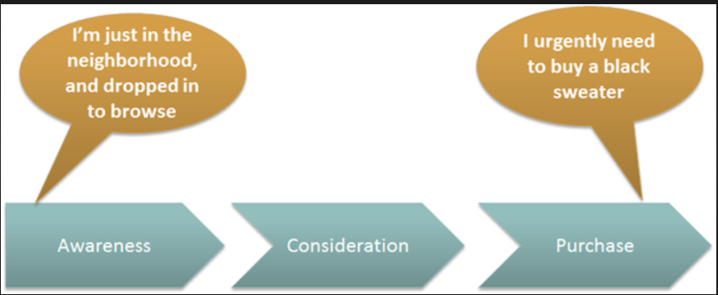
Customer purchase behavior cycle
Source: (forentrepreneurs.com, 2022)

Marketers find it to be important for as to the manner customers acquire knowledge about their products and the form in which the information is interpreted. This is where the marketers would like to offer information on the products or services that it is seeking to offer to their customers. The way products are being used or maintained is being demonstrated. The strategies that marketers use often depend on learning theories being proposed as below:

2.4. Behavioral learning theories
The customers are being exposed to the information through the means of marketing, where marketers adopt the model of classical conditioning behavioral theory. It is thought this model where the advertisers and marketers repeatedly demonstrate information on the products on a repeated basis that stimulates the customers to attain curiosity towards the products displayed.
A report by Jain and Weiten, (2020) suggests that a consumer can be persuaded to adopt a product that they were not previously willing to try out by the means of classical conditioning. They could be convinced to seek new behaviors and bring alternations to the existing thought patterns, with the means of habituation. The repetition of information through advertising campaigns reinforces associative learning and the customer begins to grow familiar with the product (Kuman et al., 2018). Classical conditioning is adopted through the second form i.e. stimulus generalization where advertisers use a brand name to create and sell its product diversity. The customer can generalize the products under one name and make interpret the quality of the product and use it accordingly. For instance, a researcher suggests that if a customer is accustomed to drinking a specific green tea product in the market, he or she can be encouraged to switch to coffee through the means of repeated exposure to the information regarding coffee (Molinillo et al., 2020). This analogy is being utilized by several marketers to improve their sales revenue.
Marketers also largely rely on the operant conditioning theory to turn consumers’ low level of involvement towards the products into a high level of involvement through the process of structuring and delivering product information in a manner that would be aligned accordingly. The marketers take advantage of the rewards system to seek the desired behavior from the customers. The probability that a specific behavior will be demonstrated, is often reliant on the kind of reinforcement that the marketers adopt. This may involve positive reinforcement where specific behavior is being encouraged and negative reinforcement where the probability of specific behavior is discouraged.
The use of rewards is being encouraged to drive customer satisfaction. For instance, the customers are being given a smaller product to try out, which makes it rewarding enough for them to encourage buying an actual product or an entire subscription of services. Some of the rewards used by marketers involve the use of sales or discounts (Kim et al., 2020).

2.5. Cognitive learning theories
Marketers often target the customer's cognitions to encourage them to purchase the specific product demonstrated. The cognitive theory allows the marketers to address the core needs and preferences of the target customers and accordingly strategize the display of product advertisements to connect with the customer (Alvarez et al., 2018).
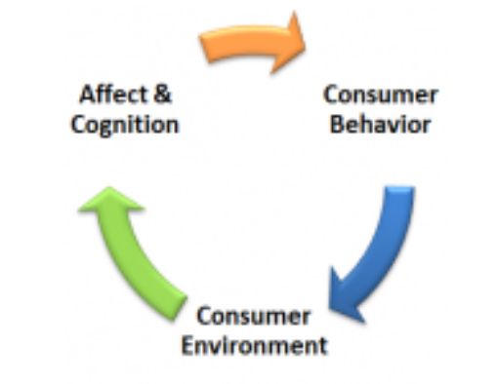
Wheel of customer analysis
Source: (stephenzoeller.com, 2022)

Observational learning: Marketers target customers’ cognitions through demonstrating specific behavior which would induce observation of target customers which would further bring about influence customers’ attitudes, preferences, and decision making. Marketers make use of social models or modeling to meet their goals. This induces the process of learning amongst customers and encourages motivation to buy or seek a brand's services.

2.6. Pepsi adopted the modeling strategy to improve its brand sales
According to a report by Ramesh et al., (2019), the modeling theory is being utilized that allowed the brand to communicate with the potential customers effectively. While during a certain period, the brand had been undergoing competition with a similar cola brand named as ‘Coca Cola’, it was facing difficulties associated with seeking a customer base in the market.
Hence, the brand adopted the modeling strategy that boosted its sales in the United States immediately. The target customers of the brand involved reaching out to the youth and younger generation of the country while depicting the message of a dominant American culture that values freedom. Hence, its advertising and commercial introduced Michael Jackson along with his pop songs that encouraged its target customers to imitate and seek the brand products effectively.

2.7. Apple.inc, use the individual effect to target cognitions of consumers
Mostafa and Kasamani (2020), stated that Apple as a brand takes advantage of the customer cognitions and decision making by targeting customers in most of the sense associated. This involves customers’ feelings, emotions, evaluations, and even thoughts that influence the cognitive system of an individual.
Apple’s advertising often involves neutral colors such as black or white, offering its customers a message of creativity and innovation. moreover, the display of product details in the advertising allows the customer to seek the idea of product convenience that the customer can get.
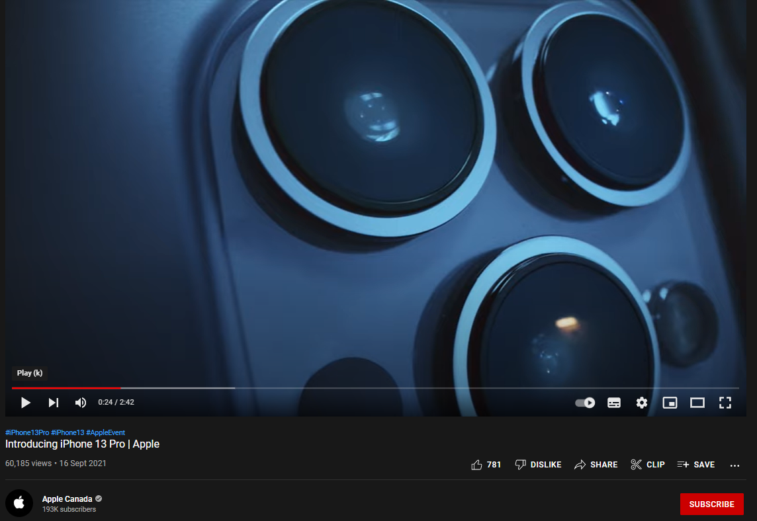
Apple.inc advertising its product specifications that target consumer cognitions
Source: (youtube.com, 2022)

3. What is the difference between a need, want, and desire for a customer? What strategies do companies implement to influence the customers for purchasing?
There is an interrelationship between customer needs, wants, and desires that determine that allows the marketers to be able to align their products accordingly and generate positive customer behavior.

Customer decision-making is influenced by needs, desires, and wants.
Source: (Panwar et al., 2019)

3.1. Consumer Need
A customer need is a base from where the marketing begins. The purchase behavior that a consumer depicts has its connection with the rise in the customers’ need for the specific product (Gurgu et al., 2020). Marketers targets the following needs of the customers that lead to purchase behavior:
- Physiological needs: these are the most common needs that marketers emphasize. The physiological needs involve those that primarily drive the customers for the aim of survival. These needs incorporate an individual’s housing, food, or nourishment respectively.
- Safety needs: There are those individual needs that emphasize the physical safety of the consumer.
- Personal needs: Personal needs of the consumers have they're associated with freedom, rights, or autonomy towards self-expression in society.
- Social needs: Social needs of an individual incorporates the quality of living that consumers may prefer to hold.
- Ego needs: the ego needs to incorporate the personal ego of an individual that allows them to feel better and help enhance the consumer’s self-image.
McDonald’s targets consumer needs.

Mcdonald's brand targets consumer needs through the "I'm Lovin' It Campaign"
Source: (Creativecommons.org, 2022)
McDonald’s fast-food campaign is being marketed as “I’m Lovin’ It” which communicates to its customers that fast food is something to be loved and enjoyed. With an advertising strategy, it has managed to evoke a sense of dissatisfaction and physiological need that can only be met when the consumers seek McDonald’s food products (Royle and Rueckert, 2022).

Apple targets consumers’ social and ego needs.

Apple.inc satisfies consumer needs by targeting their lifestyle
Source: (Pereira, 2019)

Apple as a brand emphasizes structuring its marketing strategy in a manner that satisfies consumers' social and ego needs. Apple communicates with its consumers by depicting a lifestyle of comfort and enhancing self-image (Pereira, 2019).

3.2. Consumer Wants
The consumer wants to involve the factor that ensures that individual needs are being satisfied. It helps develop pathways to satisfy the consumers’ needs. Consumer wants are often subconscious. Needs may involve for instance the hunger that the individual may experience, whereas getting some food involves the individual seeking satisfaction through meeting hunger which incorporates the wants of an individual. The core emphasis in the marketing aspect is the 'wants' that the brands approach. The customers are given the pathways in which they could meet their needs. Moreover, advertising can also direct the customers toward restructuring a customer’s needs. This allows them to align consumer needs with wants.

3.3. Consumer desire
Consumer desire is an emotion associated with a specific product. It is closest to the needs of the consumer, based on which the consumer can meet personal, ego, or social needs. Consumer desires are often created and structured by marketers and makes it to be “desire-by-product” communication (Duralia, 2018). This form of communication is structured by the means of product marketing strategy.
- The brand attempts to understand the needs of the customers through the mode of surveys and group discussions.
- Market research is being performed to identify the gap between customers' needs and the products offered in the market
- Segmentation on target customer needs is being performed.
- Promotion of specific products is advertised accordingly.

4. Three assumptions on an Apparel company that sells products both online and offline.

4.1. F&F clothing

F&F clothing brand
Source: (creativecommons.org, 2022)
F&F clothing is an apparel and accessories retail store that is a branch and extension of Tesco, located in the UK. It offers sustainable fashion clothes for men, women, and kids that are being presented perfectly. The brand quality is comfortable, unique, and stylish which makes it to be one of the number one fashion brands (fandfclothing.com, 2022).

4.2. Use of discount coupons to reinforce consumer purchase

Discount coupons provide a rewarding experience to customers
Source: (fandfclothing.com, 2022)

F&F clothing offers its consumer's club cards that come with a monthly subscription. This card offers its customers a monthly subscription plan to get a 10% discount on groceries. To further seek 10% off on the fashion products, it also allows double data for the consumers to stay connected. These discount coupons further come with a one-month free trial that is a rewarding experience for consumers to seek.

Source: (tesco.com, 2022)

4.3. Mindful sustainability practices
According to Kim et al., (2020), consumers are more likely to buy products from brands that enable sustainable practices and implement the value for the environment and society. F&F clothing can demonstrate the use of sustainability in the products that it is to offer.
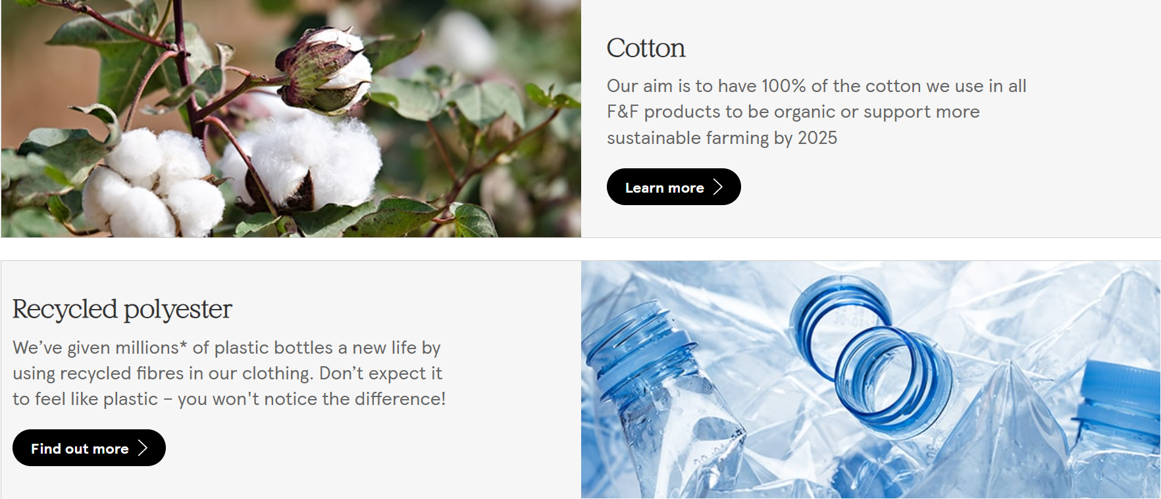
Sustainability practices at F&F Clothing
Source: (tesco.com, 2022)
Each specific clothing product is being developed with 100% use of cotton that reflects the organic manner of functioning, intending to support farming by the year 2025. Recycled polyester for clothing is another strategy to eliminate plastic in the environment and improve environmental wellbeing.

4.4. Product preferences
F&F clothing brand ensures to offer its products with a flexible product catalog that aligns with the needs of its local customers. for instance, the brand offers its customers special and updated clothing apparel for its local customers to enjoy the summer season. The clothing variety is well reflected by the brand along with the differences in the colors and sizes made available.
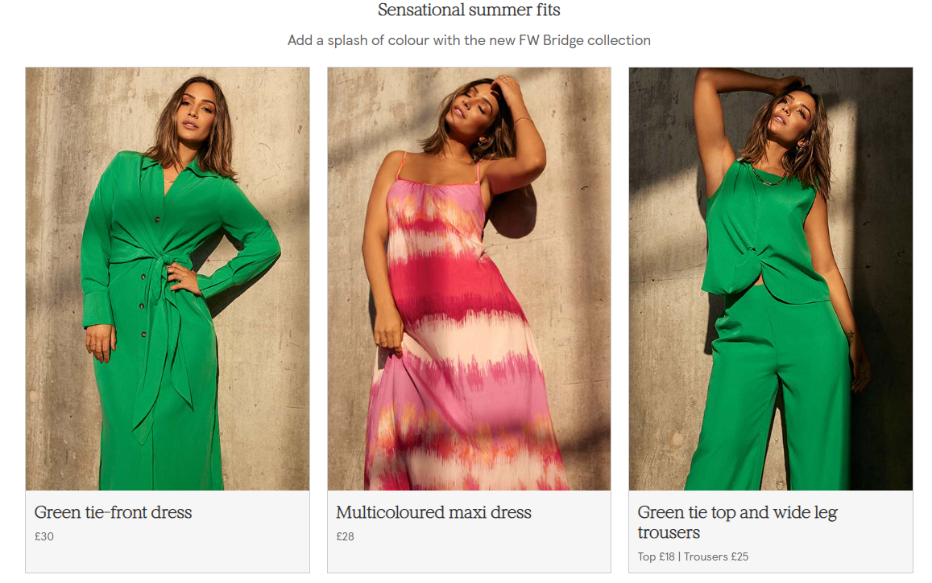
Wide range of product preferences at F&F Clothing
Source: (tesco.com, 2022)
With the variety in its products being made available, the brand can promote itself and position itself accordingly within the market. This targets the consumer's needs and desires, while also ensuring that the consumer may be able to seek the utmost information on the products being made available in the market. This is an effective strategy for generating the overall revenue from its potential consumers.

5. Conclusion
Several marketing firms can adapt the learning and memory principle to seek improved sales revenue and effectively attract customers. Customers use the existing knowledge based on which the purchase of a product is determined.
The report analyzed the aspects of operation management from a psychological perspective. It demonstrated the knowledge underlying the concepts that are associated with consumer behavior about buying goods and experiences. It had further pursued different approaches that will be able to solve problems with the presentation and analysis of qualitative and quantitative data.

6. References
Alvarez-Milán, A., Felix, R., Rauschnabel, P.A. and Hinsch, C., 2018. Strategic customer engagement marketing: A decision-making framework. Journal of Business Research, 92, pp.61-70.
De Mooij, M., 2019. Consumer behavior and culture: Consequences for global marketing and advertising. Sage.
Duralia, O., 2018. Integrated Marketing Communication and Its Impact on Consumer Behavior. Studies in Business & Economics, 13(2).
fandfclothing.com, 2022 [online] Available at: <https://fandfclothing.com/> [Accessed 04 June 2022]
forentrepreneurs.com, 2022 [online] Available at: <https://www.forentrepreneurs.com/buying-cycle-and-triggers/> [Accessed 04 June 2022]
Gurgu, E., Gurgu, I.A. and Tonis, R.B.M., 2020. Neuromarketing for a better understanding of consumer needs and emotions. Independent Journal of Management & Production, 11(1), pp.208-235.
Kim, J., Kang, S. and Lee, K.H., 2020. How social capital impacts the purchase intention of sustainable fashion products. Journal of Business Research, 117, pp.596-603.
Kim, W., Kim, H. and Hwang, J., 2020. Sustainable growth for the self-employed in the retail industry is based on customer equity, customer satisfaction, and loyalty. Journal of Retailing and Consumer Services, 53, p.101963.
Kumar, R.S., Dash, S., and Malhotra, N.K., 2018. The impact of marketing activities on service brand equity: The mediating role of evoked experience. European Journal of Marketing.
Molinillo, S., Mercadé-Melé, P. and De Noronha, T., 2020. Cause-related marketing influence on consumer loyalty in a medium-sized city. Sustainability, 12(9), p.3632.
Mostafa, R.B. and Kasamani, T., 2020. Brand experience and brand loyalty: is it a matter of emotions?. Asia Pacific Journal of Marketing and Logistics.
Panwar, D., Anand, S., Ali, F. and Singal, K., 2019. Consumer decision-making process models and their applications to market strategy. International Management Review, 15(1), pp.36-44.
Pereira, A.C.F.D., 2019. Apple ID: building a model of consumer brand identification.
Ramesh, K., Saha, R., Goswami, S., and Dahiya, R., 2019. Consumer's response to CSR activities: Mediating role of brand image and brand attitude. Corporate Social Responsibility and Environmental Management, 26(2), pp.377-387.
Royle, T. and Rueckert, Y., 2022. McStrike! Framing,(political) opportunity and the development of a collective identity: McDonald’s and the UK Fast-Food Rights Campaign. Work, Employment and Society, 36(3), pp.407-426.
Shaw, S.D. and Bagozzi, R.P., 2018. The neuropsychology of consumer behavior and marketing. Consumer Psychology Review, 1(1), pp.22-40.
stephenzoeller.com, 2022 [online] Available at: <https://www.stephenzoeller.com/apple-consumer-behavior-marketing/> [Accessed 04 June 2022]
tesco.com, 2022 [online] Available at: <https://www.tesco.com/clubcard/clubcard-plus?icid=icid=ff_hub_clubcard> [Accessed 04 June 2022]
tesco.com, 2022 [online] Available at: <https://www.tesco.com/zones/clothing> [Accessed 04 June 2022]
youtube.com, 2022 [online] Available at: <https://www.youtube.com/watch?v=SwU16hQeFm8> [Accessed 04 June 2022]

