M16 – COMMERCIAL AND MARKETING MANAGEMENT

TOPIC : COMMERCIAL STRATEGY AND MARKETING PERFORMANCE IN MODERN ORGANISATIONS

DETAILED PROJECT REPORT
STUDENT NAME: TANISH MASHAL
STUDENT ID: HBT26001

Abstract
In the evolving business landscape commercial and marketing management has become the main pillar to set a strong presence in the market. This study aims at exploring the significance of commercial strategy and marketing strategy to attain sustained business growth. In order to find broader aspects of the chosen study context, secondary qualitative research methods have been considered. Constructing four themes allowed disclosing distinct phenomena on evolving marketing management of modern businesses. The findings identify that commercial and marketing strategies have a very significant role in improving the performance of the organisations in terms of growth, customer acquisition, sales and profitability. Segmentation, pricing, targeting and market positioning are essential key factors for success, and competition, with challenges like digitalisation and changing consumer behaviours. Overall discussions indicate high consistency between objectives and themes, with clear marketing effectiveness. Thus, the study concludes that a customer-centric approach, data-driven and digitally enabled marketing are vital to sustainable competitive advantage, long-term growth, and better organisational performance in a modern and dynamic market.

Table of Contents
Introduction 5
Literature Review 8
Methodology 13
Findings 16
Discussion 20
Conclusion 23
References 26

Table of Figures
Figure 1: Benefits of marketing strategies in competitive markets 6
Figure 2: Business development with marketing management 9
Figure 3: Marketing challenges faced by global organisations 11
Figure 4: “Tesla: Innovation Over Advertising?” 19

Introduction
Introduction
This chapter introduces fundamental aspects of commercial and marketing strategies that have a large influence to improve sales performance and attain long-term sustained business growth. It has been shown that different elements of commercial and marketing strategies play a crucial role in market positioning in supporting real-world examples.
Background
In the era of digitalisation marketing and commercial strategies have been focused by organisations which have become a preferred tool to enhance organisational performance and enhance customers’ loyalty. The figure 1 demonstrates a clear insight that digital form of marketing strategies used by worldwide marketers helped to increase organisational efficiency and lead generation. Figure 1 also portrays that global social media marketing and its advertising expenses would exceed 345 billion dollars by the end of 2029 (Statista, 2025). The commercial strategies and marketing approaches including pricing, product standardisation, and promotion strategies have a significant influence on overall companies’ sales, customer and financial performance of organisations. In consideration with all these factors this study targets to highlight broader aspects of commercial and marketing strategies of organisations that contribute to uplift organisational positioning and competitive edge within evolving business dynamics.
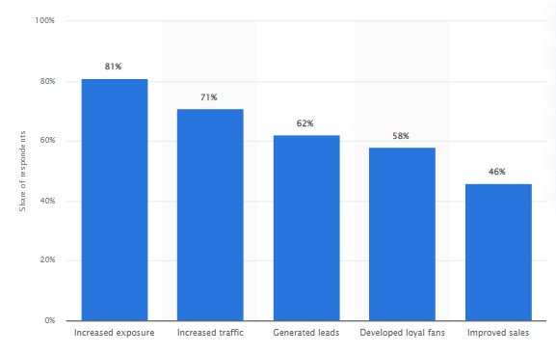
Figure 1: Benefits of marketing strategies in competitive markets
(Source: Statista, 2025)
Problem statement
In today’s rapidly evolving business dynamics robust marketing initiatives and other commercial strategies have become more crucial than ever. A dramatic shift in consumer preferences, conventional marketing approaches have been observed to maintain competitive edge and improve brand visibility before targeted customers (Forbes, 2024). In the ever-expanding digital landscape organisations employ immersive experiential marketing approach also with commercial strategies in order to captivate wide customer bases and leave a long-lasting impression before diverse audiences worldwide. The report reveals that the global marketing automation industry generated revenue of over 8 billion U.S dollars in 2024. It has been expected to reach 21.7 billion dollars by the end of 2032 (Statista, 2026). Therefore, embracing robust commercial and marketing strategies can play a pivotal role to improve sales performance and profitability.
Aim and objectives
Aim:
The study aims at exploring the contribution of commercial and marketing strategies towards boosting organisational performance, customer acquisition and profitability.
Objectives:
- To explore the significance of commercial and marketing management on business growth.
- To critically evaluate challenges to implement commercial and marketing decisions to enhance organisational performance.
- To analyse factors influences commercial and marketing strategies within the evolving business landscape.
- To identify broader strategies to improve commercial and marketing strategies for improving sales performance, customer acquisition and profitability.
Research questions
The most vital question of this study is given below:
- What is the significance of commercial and marketing management on business growth?
- What are the challenges faced by organisations to implement commercial and marketing decisions to enhance organisational performance?
- How the major factors that influence commercial and marketing strategies within the evolving business landscape?
- What are the effective ways to commercial and marketing strategies for improving sales performance, customer acquisition and profitability?
Summary
In conclusion, this chapter has outlined the main research context that has been critically discussed in other chapters. It has been observed that a robust marketing approach can offer unparalleled opportunities for businesses. Furthermore, commercial and marketing strategies contribute towards developing brand awareness by promoting actionable advertising.

Literature Review
Introduction
This chapter has broadly discussed the significant influence of marketing and commercial strategies in alignment with theoretical aspects to find actionable insights on the research phenomena.
Themes
Significance of relationship between commercial management, marketing management, and business growth
In the dynamic market landscape marketing and commercial strategies are crucial to survive and flourish in a competitive market. In view of Kalogiannidis et al. (2022), in the pursuit of consistent business growth a major role is played by effective commercial and marketing strategies. The author stated that the robust marketing strategies assists businesses operating in various industries to navigate business complexities in an ever-evolving business landscape. As per study of Rolando, & Mulyono, (2025) the prowess of robust commercial management strategies has emerged as the cornerstone to attain long-term sustained growth. This in turn enhance profitability as well as strengthen competitiveness.
There is a positive relationship between commercial strategies and marketing strategies that links with unravelling and innovative approaches which ultimately fuel the engine of business expansion. According to Hokmabadi et al. (2024) marketing management is not only a task to sell products but it strategically focuses on enhancing customer satisfaction along with achieving organisational goals. In marketing strategies various factors are prioritised such as market segmentation, pricing, targeting and positioning that mainly sculpt profitable outcomes in terms of sustained business growth and revenue generation. In view of Farida, & Setiawan, (2022) marketing management is quite different from marketing strategies as it adds various factors such as planning, executing, and overseeing in alignment with business objectives. The author stated that combining commercial and marketing management has a large influence to attract new customers, market segmentation, and improve brand loyalty before the target audience. As per the study of Rosário, & Dias, (2023), marketing management enhances brand visibility that ultimately helps in developing competitive edge in an evolving market. Therefore, marketing and commercial strategies contribute to showcase unique selling points and encourage customer retention.
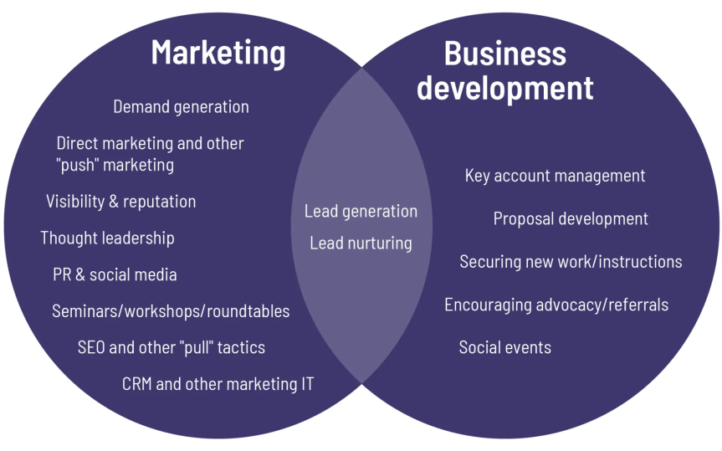
Figure 2: Business development with marketing management
(Source: Inspired by Rosário, & Dias, 2023)
Challenges faced by organisations to implement commercial and marketing decisions to targeting, positioning, and revenue generation
Marketing management has become the backbone of modern businesses operating in competitive dynamics of various sectors. According to Nordin, & Ravald, (2023), the dramatic shift in the marketing landscape has developed huge challenges for leading organisations where budget constraints, complex landscape of technology are the major issues. The successful commercial and marketing management requires integration of new technologies, technical knowledge, financial support and robust stakeholder engagement. In view of De Ruyter et al. (2022) organisations often struggle to foster cross-functional collaboration with stakeholders that negatively impact overall marketing performance. Many organisations struggle to adapt new technologies to their streamline marketing approaches that have a negative influence on targeting, positioning, and revenue generation. In accordance with Rosário, & Dias, (2023), budgetary constraints often develop huge challenges for organisations to leverage advanced marketing technologies that ultimately hamper operational efficiency. Therefore, organisations which are accustomed with traditional methods often slowdown in adapting flexible and robust marketing management.
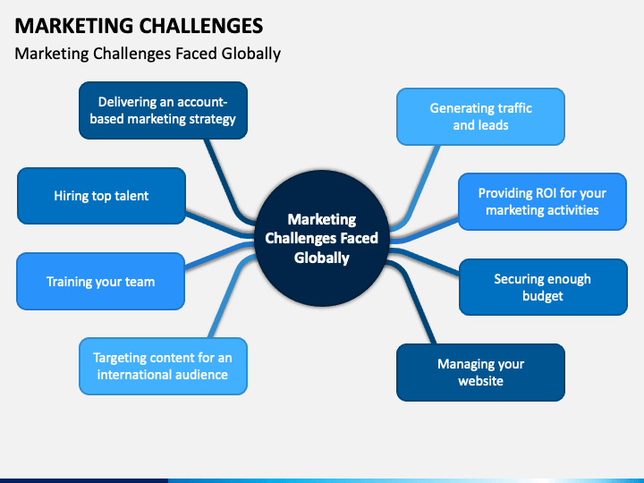
Figure 3: Marketing challenges faced by global organisations
(Source: Inspired by De Ruyter et al. 2022)
Major factors that influence commercial and marketing strategies within the evolving business landscape for pricing, market segmentation, targeting, positioning, and revenue generation strategies
Blending commercial and marketing management helps organisations to find data-driven insights regarding the market scenario and plan accordingly to attain long-term sustained growth. In view of Handoyo et al. (2023), the rapid technological progress and altering consumer preferences has become the main concern before markets to implement multifaceted strategies. Promoting marketing management requires technical innovation and ethical consideration. Felix, & Rembulan, (2023) argued that a biggest change has been observed in consumer behaviour in the era of globalisation where substitute products are available to customers. Therefore, a dramatic shift in consumer expectation has significantly shaped marketing initiatives of organisations. In the opinion of Ngo et al. (2023), changes in regulatory framework related to data privacy and regulation have made marketing and commercial strategies more complex. Therefore, marketing strategies need to be transparent that share core organisational value and help to build trust among customers.
Effective ways to commercial and marketing strategies for improving sales performance, customer acquisition and profitability
The marketing landscape is evolving gradually due to shifts in consumer preferences and market structure. In view of Sudirjo, (2023) strengthening marketing and commercial strategies required to increase robust digital asset management that can help to expand and streamline tasks of marketing. Relying on a cohesive tech ecosystem can be helpful to enhance organisational productivity by increasing sales margins. As per the view of Purnomo, (2023), leveraging data analytical tools works to evaluate key performance indicators (KPIs) that contribute to optimise marketing and commercial management of organisations. Furthermore, lack of communication between departments results in inconsistent messaging and missed marketing opportunities. As of Farida, & Setiawan, (2022) stakeholder engagement plays a predominant role to track progress of marketing strategies, review the process and reduce delays in customer acquisition. Therefore, commercial and marketing strategies require flexible change management within organisational settings to ensure comprehensive training to adapt digital marketing technologies.
Theoretical framework
In the modern changing business landscape organisations started adapting robust marketing management approaches to improve business performance, sales performance towards developing competitive edge in the market. The resource-based view (RBV) model shows that an organisation needs to deliver excellent services to develop a competitive edge with its unique, rare and valuable resources. Additionally, the market-based view (MBV) model stresses on a company's initiatives to strengthen its promotional strategies to experience comparative advancements in an evolving market. Therefore, competitive strategies contribute to developing organisational positioning.
Literature Gap
Evaluating the research finding of pre-existing research shows theoretical underpinning on marketing management does not suit the modern marketing scenarios within the evolving business landscape. In the evolving business landscape, a new change has been observed in terms of implementing commercial and marketing strategies for organisational growth. The modern marketing approaches of organisations have introduced emerging cutting-edge technologies for customer acquisition and boost business performance. Therefore, all these new aspects need to be addressed to identify practical and broader implementation in modern marketing techniques.
Summary
In conclusion, it has been observed that effective marketing and commercial management play a predominant role for sustained organisational growth, customer acquisition, and brand visibility.

Methodology
Introduction
This chapter reflects the methods that have been applied to collect data and data analysis to develop insightful research conclusions. This chapter will portrait justification of each chosen research method.
Research philosophy
In this study interpretivism research philosophy has been considered to gather subjective knowledge on the research context. In view of Junjie, & Yingxin, (2022), interpretivism research philosophy allows one to find subjective meaning and the socially constructed nature of the research context in alignment with reality. Considering interpretive research philosophy helped to evaluate the structural framework of marking management of modern businesses.
Research approach
In order to shed light on the chosen research phenomena, a deductive research approach has been taken into consideration. According to Hall et al. (2023), deductive research in a theory-driven approach helps to evaluate the existing framework in a context. Therefore, deductive research approaches contributed to explore existing marketing frameworks linking with organisational growth.
Research design
In this qualitative research descriptive research design has been prioritised to explore marketing and commercial strategic trends in modern businesses. As per the study of Ansari et al. (2023) descriptive research design enables researchers to observe and measure relevant variables to explore correlation between variables. Considering descriptive research design helped to evaluate interconnectedness between commercial and marketing strategies.
Research strategy
The qualitative research method was considered as the flexible method to receive subjective insights on the research context. According to Pullen Sansfaçon et al. (2024) qualitative research method helps to evaluate complexities of phenomena and explore new insights. Employing qualitative research methods helped emphasise the social context of modern marketing management which is applied for enhancing competitiveness.
Data Collection
In terms of gathering foundational knowledge on the chosen subject matter, a secondary qualitative data collection approach was employed. In view of Ajayi, (2023) secondary data collection method allows researchers to synthesise existing data to support broader aspects of a particular context. The secondary qualitative method included collecting relevant secondary data from authentic data sources to enhance reliability of research findings.
Data analysis
In order to interpret the pattern of variables thematic data analysis was considered. According to Rosairo, (2023) thematic data analysis is applied to recognise patterns and themes linking with the chosen data sets. In this thematic data analysis process four themes were constructed to develop meaningful research outcomes.
Ethical consideration
In this secondary qualitative study safe handling of data sets were highly prioritised to maintain research integrity. In this process ethical guiding principles of the university were considered and Data Protection Act 2018 was fully adhered to keep transparency in data interpretation. According to Taquette et al. (2022), ethical consideration in secondary data helps to avoid sampling biases and safeguard data to extract valuable data from data sources. In order to maintain ethical aspects proper citation has been added and attribution of creators has also been considered.
Summary
In conclusion, the research methodology chapter has revealed the vital procedures that have been filled in this study for data collection and data evaluation to find insightful research conclusions.

Findings
Introduction
The findings indicate the role of commercial and marketing strategies for better performance of the organisation. Thus, the results offer an opportunity to understand issues and strategies for sustainable growth.
Findings
Theme 1: Commercial and marketing strategies' impact on organisational performance, regarding business growth, customer acquisition, sales performance and profitability
Business growth, customer acquisition, sales and profitability are all significantly enhanced by commercial and marketing strategies, with a significant impact on the performance of the business. Homburg & Wielgos (2022) discovered that digital marketing skills provide high value to companies promoting customer engagement, market responsiveness and data-driven decision-making. All capabilities assisted organisations to enhance customer acquisition and retention, and ultimately led to improved sales performance and sustainability. On the contrary, marketing strategies are a strategic enabler which also helps the business to gain a sustainable competitive advantage. According to Gao et al. (2023), a positive correlation exists between marketing strategy and business strategy, with positive impacts on financial performance. Better market positioning, customer-centric strategies and coordinated business decisions enhanced the generation of revenue, market share and operational efficiency. For example, Netflix is utilising positioning and subscription models to target services, increasing retention and long-term sustainability (Netflix, 2025). In contrast, a firm that established connections between pricing and marketing and business goals had satisfied business relationships and better results. Therefore, well-integrated commercial and marketing strategies are key players to organisational success and long-term financial sustainability.
Theme 2: Key factors for successful commercial and marketing strategies, such as pricing, market segmentation, targeting and positioning strategies, and approaches towards generating revenues
The importance of revenue-based decision-making, effective positioning, targeting and segmentation, and pricing in successful commercial and marketing strategies is highly important. As per Mahfuza et al. (2022), market segmentation is one of the determinants that help in revenue generation since the organisations categorise customers based on purchasing behaviour and pricing. By better supporting the loyal and price-sensitive customers, businesses could apply targeted pricing and discount adjustments to increase market penetration, customer retention and profitability. On the contrary, Mergner, Brüggemann & Olbrich (2026) highlighted that targeting and positioning strategies also have a pivotal role in determining competitive advantage and sales outcomes. Segmented marketing mix strategies would better align with the desires of consumers regarding the product, promotion and price segmentation. For example, dynamic pricing, personalisation and segmentation of Amazon manage digital competition, customer acquisition, sales growth and profitability (IJLMH, 2025). Thus, positioning and targeting the customers generate a positive impact towards profitability, strategic decisions and sustainable success in the competitive environment.
Theme 3: Key challenges that organisations encounter in implementing commercial and marketing strategies, including market competition, consumer preference, digital transformation and pricing issues
Multiple challenges in the process of implementation of commercial and marketing strategies in the organisations are competition, changing consumer needs, digital transformation, and pricing strategies. According to Gerpott & Berends (2022), the key challenges in digital markets and online markets are intense market competition and pricing complexity. Complex challenges for the firms are the price competitiveness and profitability, especially with a consumer who can easily switch to alternatives. Quach et al. (2026), noted that one of the significant strategic challenges in the market is digital transformation and changing consumer trends. Companies that embrace new digital technologies frequently deal with issues of data privacy, technology adaptation costs and struggles with customer expectations. For instance, Tesla focuses on innovation-driven marketing and high prices to reinforce its competitive advantage and its per car sold on R&D amounted to 2,984 USD (Armstrong, 2022). Identified challenges can undermine customer confidence and the effectiveness of marketing campaigns. Thus, innovation, competitive price, customer expectation and digital transformation are important factors to consider for a successful implementation of commercial and marketing strategies.
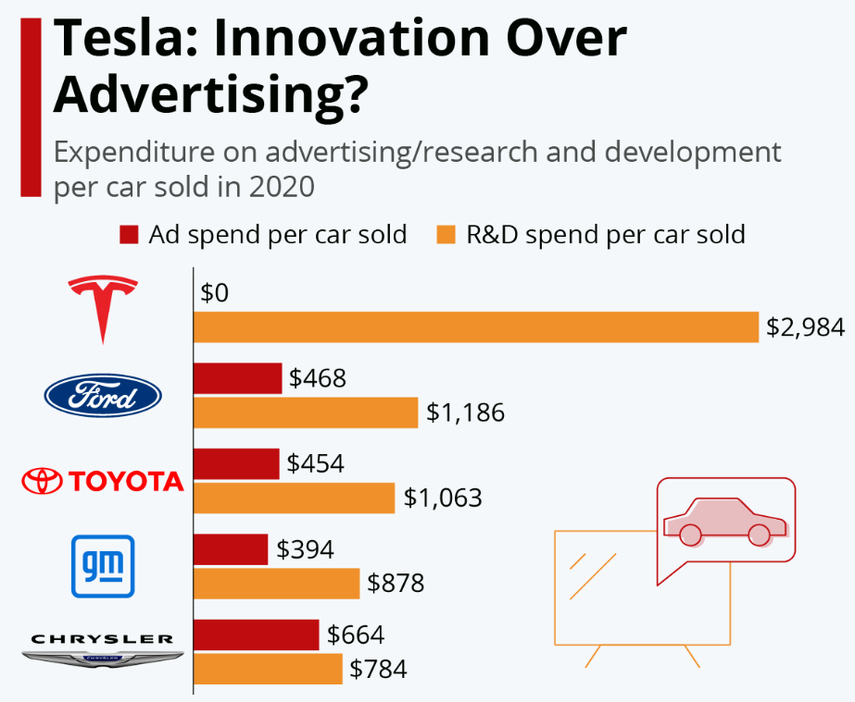
Figure 4: “Tesla: Innovation Over Advertising?”
(Source: Armstrong, 2022)
Theme 4: Recommendations for commercial and marketing performance in the modern organisation to enhance customer retention, competitive advantage, revenue growth and long-term sustainability
Connecting commercial and marketing with customer-centred innovation and value creation strategies may help improve the performance of organisations. Windarsari (2025) addressed that the combination of relationship marketing, personalisation and data-driven customer engagement can smooth the path towards customer retention and long-term sustainability. Companies that focus on customer experience, customer loyalty and targeted communications also experience higher rates of retention, repeat sales, and revenue growth. On the contrary, the significance of customer trust and value creation may improve competitiveness and profitability. Sastra, Sallatu & Sanusi (2025), emphasised the importance of digital transformation and market-oriented abilities for sustainable competitive advantage. In contrast, organisations can become more efficient, responsive, and profitable in the market by using digital tools, innovation, and adaptive marketing. Thus, the use of customer-centric marketing, technological innovation, and strategic adaptability is essential for modern organisations to increase profitability and continue growth.
Conclusion
The results indicate that effective commercial and marketing strategies can have a positive impact on growth, profitability and customer retention. Therefore, a customer-oriented and adaptive approach is crucial for the long-term success of an organisation.

Discussion
Introduction
The discussion highlights the major challenges, ideas and points of view concerning the issue being studied. Comparative analysis critically evaluates key factors, through practical learning, to improve marketing understanding.
Discussions
Modern organisations have a strong alignment between the importance of commercial and marketing management to achieving growth and performance of the business. Kalogiannidis et al. (2022) highlighted the importance of strategic marketing management in e-commerce promotions to achieve better customer engagement outcomes and better visibility. In contrast, in the modern market, digital marketing capabilities mainly strengthen customer acquisition and sales performance for better revenue. Rolando & Mulyono (2025) revealed that e-commerce marketing strategies serve as enablers for the development of the digital economy to generate revenue. On the contrary, marketing is the process of developing plans with accurate, precise and well-planned marketing activities to enhance the generation of revenues and market expansion. Similarly, the findings of Gao et al. (2023) highlight that marketing-business strategy alignment can have a positive impact on financial performance, market share and operational efficiency. Moreover, the significance of digital transformation and marketing skills works better for the resilience and continued growth of businesses, contributing to the understanding of digital marketing. Digital transformation also presents as a source of sustainable competitive advantage as highlighted by Homburg & Wielgos (2022). Thus, the findings show that an integrated approach towards commercial and marketing strategies can greatly improve business growth, customer retention, profitability and sustainability of the modern organisation.
Successful commercial and marketing strategies are based on segmentation, pricing, targeting and positioning as a complex factor regarding implementation. According to Nordin and Ravald (2023), marketing decision-making is becoming more challenging in an uncertain business environment with dynamic competition and a necessity for fast strategic adaptation. On the other hand, pricing and market segmentation are essential for generating revenues and retaining customers, ensuring their loyalty. De Ruyter et al. (2022) argued that the changes in the marketing strategy need to manage the broader economic and competitive challenges to improve business performance. On the contrary, targeting and positioning have a significant impact on a competitive advantage and sales performance of an organisation in the modern business environment. Mergner, Brüggemann & Olbrich (2026) stated that positioning opportunities come with data-driven marketing, and challenges arise in the context of the implementation of technologies and available data analytics. Thus, the need to balance innovation, market responsiveness and customer-focused commercial planning may meet the demands of effective strategic decisions for sustainable business performance.
A changing environment, commercial and marketing strategies are highly dependent on internal business considerations and external market threats. As per Handoyo et al. (2023), business strategy, operational efficiency, market uncertainty and competitive intensity play a major role in the business performance and innovation. The initiative is in line with the competitive and complex market environment of the present time to ensure profitability and strategic flexibility. In contrast, Felix & Rembulan (2023) argue that consumer preference shift and consumer expectation are linked to customer experience, engagement, and loyalty, playing important roles in successful marketing campaigns. Moreover, digital content, trust, and technological interaction also have a significant role in the purchasing decisions of modern consumers for better engagement. As per Quach et al. (2026) digital transformation and changing consumer trends in the modern business scenario resulted in significant challenges. Thus, organisations need to adjust to competition, technological innovation, changing customer behaviour, and increasing operational efficiencies, ensuring effective commercial and marketing strategies for sustained performance.
Overall strategies aimed at improving the long-term commercial and marketing performance by means of innovation, digitalisation and competitive positioning at modern business environment. Sudirjo (2023) states that the effective approach to marketing can be achieved through strategic focus on product differentiation, value creation, and constant innovation to improve competitiveness in global markets. The findings validate the notion that in dynamic markets, organisations need to constantly innovate their marketing strategies to stay competitive and ensure the continuity of growth. On the contrary, Purnomo (2023) noted the role of digital marketing strategies that have a significant impact on sales conversion rates through improved customer targeting and engagement in e-commerce platforms. Digital marketing strategies align with the emphasis on the way customer-centric innovation, personalisation and data-driven engagement boost customer retention and revenue growth. Moreover, Sastra, Sallatu & Sanusi (2025) state that the use of digital transformation and adaptive marketing capabilities may enhance the responsiveness and profitability of organisations. Therefore, incorporation of innovation, digital marketing and customer-oriented strategies is a key factor to ensure sustainable growth and competitive advantage in the long-term.
Conclusion
The discussion concluded by summarising the main issues, perspectives and inputs that came up with regard to more depth marketing performance analysis and evaluation. Thus, the results highlight the need for effective strategies and continuous improvement to deliver desired outcomes for modern businesses.

Conclusion
In conclusion, the study finds that commercial and marketing strategies have a great role in improving the performance of any organisation. Identified strategies promote the growth of businesses, acquisition of customers, the performance of the sales department and future profitability. Using segmentation, targeting, pricing and digital transformation effectively helps to build up competitive advantage and customer retention in the modern business environment. Thus, businesses need to overcome market competition, consumer change and technological challenges to sustain long-term growth and strategic success.
Objective 1 connects with Theme 1 as the findings validate that commercial and marketing strategies support business development, customers, sales and profit objectives. Objective 2 also relates to Theme 2 as both reference the areas of segmentation, pricing, targeting, and positioning as areas of success. Moreover, Objective 3 is aligned with Theme 3, indicating market competition, consumer behaviour, digital transformation and pricing challenges impacting implementation. Theme 4 helps to meet Objective 4, which stresses the importance of innovation, digital marketing and customer-oriented thinking in sustainable organisations for long-term competitive advantage.
Recommendation 1: Improving digital transformation and data-driven marketing initiatives
Organisations need to prioritise investing in advanced digital tools like AI analytics, CRM systems and automation to better target customers and make decisions. As per Halim, Kesuma & Siregar (2023), digital transformation may enhance customer targeting efficiency and lead to improved sales conversion rates and a greater profit margin. Thus, the strategy can lead to higher customer acquisition, better customer engagement and performance in sales as a long-term competitive advantage.
Recommendation 2: Enhancing customer-centric and value-based strategies for better customer engagement
Businesses need to prioritise fostering customer relationships by providing personalised services, loyalty programs, and consistent value. According to Rosário & Casaca (2023), customer-centred marketing enhances customer retention, brand trust, and repeat buying for further business growth. Thus, value-based pricing, combined with targeted communication, optimises the profitability and market positioning of companies, safeguarding a sustainable source of revenue and long-term success.
One of the limitations is that the use of secondary literature to show the industry's practices may not accurately reflect the current commercial or marketing practices or region-specific differences. Moreover, the emphasis on selected studies poorly allows for greater generalisation to all sectors to understand revenue growth, customer engagement and satisfaction rate. Future studies are needed to use primary data such as surveys, interviews and case studies to support empirical observation of business strategies. Other research areas may include the use of new technologies such as AI marketing, predictive analytics, and blockchain marketing. Thus, the study could be extended to other fields and other regions to make findings more robust in commercial and marketing performance outcomes in the long term.

References
Ajayi, V. O. (2023). A review on primary sources of data and secondary sources of data. Available at SSRN 5378785. https://papers.ssrn.com/sol3/Delivery.cfm?abstractid=5378785
Ansari, M. R., Rahim, K., Bhoje, R., & Bhosale, S. (2022). A study on research design and its types. International Research Journal of Engineering and Technology (IRJET), 9(7), 1132-1135. https://www.academia.edu/download/92557672/IRJET_V9I7216.pdf
Armstrong, M. (2022). Tesla: Innovation Over Advertising? https://www.statista.com/chart/27080/ad-and-r-d-spend-per-car-sales-tesla/?srsltid=AfmBOoqM4XBzho-vX2E15kJwYfy7Wfy_cMhfBdv6h2mzQExld3huW5rX
De Ruyter, K., Keeling, D. I., Plangger, K., Montecchi, M., Scott, M. L., & Dahl, D. W. (2022). Reimagining marketing strategy: driving the debate on grand challenges. Journal of the Academy of Marketing Science, 50(1), 13-21. https://link.springer.com/content/pdf/10.1007/s11747-021-00806-x.pdf
Farida, I., & Setiawan, D. (2022). Business strategies and competitive advantage: the role of performance and innovation. Journal of open innovation: Technology, market, and complexity, 8(3), 163. https://www.sciencedirect.com/science/article/pii/S2199853122007648
Felix, A., & Rembulan, G. D. (2023). Analysis of key factors for improved customer experience, engagement, and loyalty in the e-commerce industry in Indonesia. Aptisi Transactions on Technopreneurship (ATT), 5(2sp), 196-208. https://att.aptisi.or.id/index.php/att/article/download/350/228
Forbes, (2024). Mastering Modern Marketing: Strategies For Today's Business Landscape. https://www.forbes.com/councils/forbesbusinesscouncil/2024/04/17/mastering-modern-marketing-strategies-for-todays-business-landscape/
Gao, J., Siddik, A. B., Khawar Abbas, S., Hamayun, M., Masukujjaman, M., & Alam, S. S. (2023). Impact of E-commerce and digital marketing adoption on the financial and sustainability performance of MSMEs during the COVID-19 pandemic: An empirical study. Sustainability, 15(2), 1594.https://doi.org/10.3390/su15021594
Gerpott, T. J., & Berends, J. (2022). Competitive pricing on online markets: a literature review. Journal of Revenue and Pricing Management, 21(6), 596.https://doi.org/10.1057/s41272-022-00390-x
Halim, H., Kesuma, T. M., & Siregar, M. R. (2023). Digital transformation strategy to optimize company performance. Jurnal Manajemen Bisnis, Akuntansi Dan Keuangan, 2(2), 189-200. : https://doi.org/10.55927/jambak.v2i2.7022
Hall, J. R., Savas-Hall, S., & Shaw, E. H. (2023). A deductive approach to a systematic review of entrepreneurship literature. Management Review Quarterly, 73(3), 987-1016. https://www.researchgate.net/profile/Selen-Savas-Hall/publication/360260172_A_deductive_approach_to_a_systematic_review_of_entrepreneurship_literature/links/627d85a4107cae2919a1267b/A-deductive-approach-to-a-systematic-review-of-entrepreneurship-literature.pdf
Handoyo, S., Suharman, H., Ghani, E. K., & Soedarsono, S. (2023). A business strategy, operational efficiency, ownership structure, and manufacturing performance: The moderating role of market uncertainty and competition intensity and its implication on open innovation. Journal of Open Innovation: Technology, Market, and Complexity, 9(2), 100039. https://www.sciencedirect.com/science/article/pii/S2199853123001415
Hokmabadi, H., Rezvani, S.M. & De Matos, C.A., (2024). Business resilience for small and medium enterprises and startups by digital transformation and the role of marketing capabilities—A systematic review. Systems, 12(6), p.220. https://www.mdpi.com/2079-8954/12/6/220
Homburg, C., & Wielgos, D. M. (2022). The value relevance of digital marketing capabilities to firm performance. Journal of the Academy of Marketing Science, 50(4), 666-688.https://doi.org/10.1007/s11747-022-00858-7
IJLMH (2025). Amazon's Dynamic Pricing Strategy. https://ijlmh.com/wp-content/uploads/Amazons-Dynamic-Pricing-Strategy.pdf
Junjie, M., & Yingxin, M. (2022). The Discussions of Positivism and Interpretivism. Online Submission, 4(1), 10-14. https://files.eric.ed.gov/fulltext/ED619359.pdf
Kalogiannidis, S., Kagioglou, F. A., & Papaevangelou, O. (2022). Strategic marketing management influence on making e-commerce promotions. International Journal of Scientific Research and Management, 10(1), 2949-2955. https://www.researchgate.net/profile/Stavros-Kalogiannidis/publication/357913267_Strategic_Marketing_Management_Influence_on_Making_E-_Commerce_Promotions/links/61e714339a753545e2dd6da6/Strategic-Marketing-Management-Influence-on-Making-E-Commerce-Promotions.pdf
Mahfuza, R., Islam, N., Toyeb, M., Emon, M. A. F., Chowdhury, S. A., & Alam, M. G. R. (2022). LRFMV: An efficient customer segmentation model for superstores. Plos one, 17(12), e0279262.https://doi.org/10.1371/journal.pone.0279262
Mergner, N., Brüggemann, P., & Olbrich, R. (2026). Mastering the marketing mix: An empirical approach to strategically orchestrate the marketing mix across segments and competitors. Journal of Marketing Analytics, 1-20.https://doi.org/10.1057/s41270-026-00463-5
Netflix (2025). How Netflix's Recommendations System Works. https://help.netflix.com/en/node/100639
Ngo, T. T. A., Quach, P., Nguyen, T. V., Nguyen, A. D., & Nguyen, T. M. N. (2023). Short video marketing factors influencing the purchase intention of Generation Z in Vietnam. Innovative marketing, 19(3), 34. https://www.researchgate.net/profile/Duy-Nguyen-180/publication/372923112_Short_video_marketing_factors_influencing_the_purchase_intention_of_Generation_Z_in_Vietnam/links/6630cfba7091b94e93e73d12/Short-video-marketing-factors-influencing-the-purchase-intention-of-Generation-Z-in-Vietnam.pdf
Nordin, F., & Ravald, A. (2023). The making of marketing decisions in modern marketing environments. Journal of Business Research, 162, 113872. https://www.sciencedirect.com/science/article/pii/S0148296323002308
Pullen Sansfaçon, A., Gravel, E., & Gelly, M. A. (2024). Dealing with scam in online qualitative research: Strategies and ethical considerations. International Journal of Qualitative Methods, 23, 16094069231224 https://journals.sagepub.com/doi/pdf/10.1177/16094069231224610
Purnomo, Y. J. (2023). Digital marketing strategy to increase sales conversion on e-commerce platforms. Journal of Contemporary Administration and Management (ADMAN), 1(2), 54-62. https://journal.literasisainsnusantara.com/index.php/adman/article/download/23/38
Quach, K., Nguyen, T. T., Quach, S., Pham, H. T., Weaven, S., Nguyen, Q. V. H., ... & Thaichon, P. (2026). Digital twins: Enhancing personalized experience through multiple and dynamic persona across customer phygital journey. Australasian Marketing Journal, 34(1), 86-102.https://doi.org/10.1177/14413582251358859
Rolando, B., & Mulyono, H. (2025). E-commerce as a catalyst for digital economy development: a study of marketing strategies and their impact. Journal of Distribution Science, 23(4), 61-79. https://accesson.kr/jds/assets/pdf/55482/journal-23-4-61.pdf
Rosairo, H. S. R. (2023). Thematic analysis in qualitative research. Journal of Agricultural Sciences–Sri Lanka, 18(3). https://jas.sljol.info/articles/10526/files/64f33f9912a52.pdf
Rosário, A. T., & Dias, J. C. (2023). How has data-driven marketing evolved: Challenges and opportunities with emerging technologies. International Journal of Information Management Data Insights, 3(2), 100203. https://www.sciencedirect.com/science/article/pii/S2667096823000496
Rosário, A., & Casaca, J. A. (2023). Relationship marketing and customer retention-a systematic literature review. Studies in Business and Economics, 18(3), 44-66.https://sciendo.com/pdf/10.2478/sbe-2023-0044
Sastra, E., Sallatu, M. A., & Sanusi, A. (2025). The impact of digital transformation and innovation capability on competitive advantage: The mediating role of market orientation in emerging markets. Hasanuddin Economics and Business Review, 75-85.https://doi.org/10.26487/hebr.v9i1.6485
Statista, (2025). Leading benefits of social media marketing according to marketers worldwide as of January 2025. https://www.statista.com/statistics/188447/influence-of-global-social-media-marketing-usage-on-businesses/?srsltid=AfmBOooZ-bTuQX4tYS5jiNVnv61g-MluHyfUTC3_XANsn42XxgRqq90L
Statista, (2026). Marketing automation – statistics & facts. https://www.statista.com/topics/10768/marketing-automation/?srsltid=AfmBOoreUEePc2lxKBrWbaH1XIL0ixfBuhuHiaP3mlvaMtIU2DCo-kRK
Sudirjo, F. (2023). Marketing strategy in improving product competitiveness in the global market. Journal of Contemporary Administration and Management (ADMAN), 1(2), 63-69. https://journal.literasisainsnusantara.com/index.php/adman/article/download/24/39
Taquette, S. R., & Borges da Matta Souza, L. M. (2022). Ethical dilemmas in qualitative research: A critical literature review. International Journal of Qualitative Methods, 21, 16094069221078731. https://journals.sagepub.com/doi/pdf/10.1177/16094069221078731
Windarsari, W. R. (2025). Digital Customer Relationship Management: Building Long-Term Loyalty through Data-Driven Engagement. Jurnal Manajemen dan Kewirausahaan (JUMAWA), 3(1), 271-278.https://doi.org/10.59971/jumawa.v3i1.389

