

A Comparative Analysis of Tourism Promotion Strategies in Berlin and London

Ajay Kumar
Student ID NO: DE240022

1st semester: Prof. Mr .Naresh Seetharam
Due Date: 28th February

Abstract
This report is a detailed comparative analysis of tourism promotion activities in the important urban tourism destinations of Berlin and London. An investigation is made into each site about its historical and cultural backgrounds, outstanding tourism features, and marketing strategies directed to foreign visitors. Sources of data consisted of quality, official tourism board reports, and secondary literary works. The study applied SWOT analysis together with comparative frameworks for locating strengths, weaknesses, opportunities, and threats for both cities in tourism.
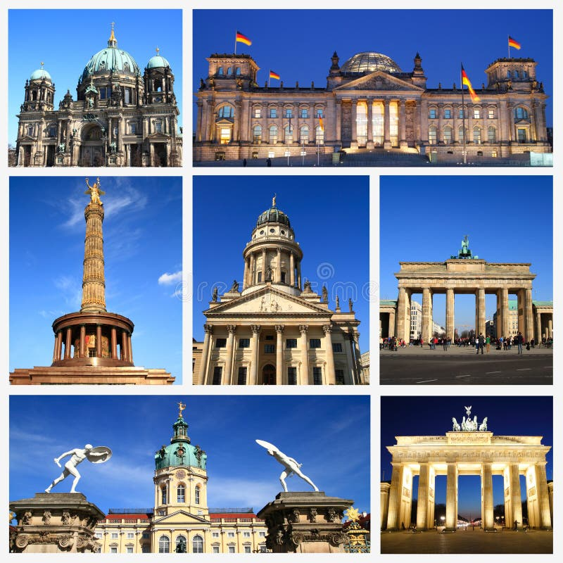
(Source – Client, June, 2024)
The findings of the study indicate that Berlin's marketing message revolves around its unique historical heritage and creative culture, while London's marketing approach concentrates on its ageless universal landmarks and worldly experience. The challenges that both cities encounter, including the management of sustainable tourism and enhanced competition, are common to each. Key recommendations specify expanding Berlin's promotional outreach to non-European markets and investment in niche tourism sectors, while London is advised to diversify its promotion and develop some budget travel package

Contents
Introduction 5
Historical and Cultural Background 5
Berlin: A Tapestry of Turbulence and Transformation 5
London: Layers of Legacies and Global Influence 7
Tourism Highlights in Berlin 8
Historical Monuments 8
Brandenburg Gate (1791): 9
Berlin Wall Memorial: 9
Reichstag Building: 10
Cultural Events 10
Nightlife 11
Restaurants in Berlin 12
Tourism Highlights in London 12
Historical and Religious Sites 12
Traditional Arts 14
Cultural Festivals 15
Natural Attractions 16
Cultural Comparison 17
Berlin: One of its Kind 17
London: A Timeless Heritage 17
General Site 18
Tourism Strategies and Impact 18
Berlin 18
London 19
Tools of Analysis 19
SWOT analysis: 19
PESTLE analyses for Berlin and London 20
Framework of Comparative Analysis: 21
Quantitative tools: 21
Justification: 21
Berlin Cultural Survey and Research Results 22
Section 1: General Information 22
Section 2: Cultural Attractions and Experiences 23
Section 3: Local Culture and People 25
Brandenburg Tour 27
Recommendations 28
Conclusion 28
References: 30

Introduction

Tourism is important because, among others, it provides an economic base by generating home and local revenue, creating employment, and allowing for cultural exchange. The paper, therefore, does a comparative analysis of tourism promotional strategies dependent on Berlin and London, which are two world-famous cities known for flourishing tourism.
The strategic aim of the study is to analyse and compare how tourism is promoted in Berlin and London, discussing best practices and shortcomings therein.
Why Berlin and London: Berlin, being the real cultural capital of Germany, attracts millions of tourists due to its historical significance and bohemian character. London is a cosmopolitan city that lacks no historical monuments or cultural institutions trying to affirm their relevance against modern tourist attractions. Hence, a comparison between the two cities may shed light on the difference in the approaches adopted toward the promotion of tourism.
Significance of Tourism Promotion: In any city, proper working of the promotion mechanism for tourism is imperative to attract international travellers, sustain local businesses, and enhance the national economic pool. Both Berlin and London, therefore, allocate great costs toward ensuring innovation in the campaigns they run to ensure they remain competitive in the global tourism market.
Overview of Methodology and Scope: This study follows a comparative framework by performing a SWOT analysis and data collection from primary and secondary sources. The analysis looks at such elements as promotional strategies adopted by the cities, collaboration with stakeholders, and the success of campaigns used to attract tourists.

Historical and Cultural Background

Berlin: A Tapestry of Turbulence and Transformation

Berlin is a microcosm of the 20th-century upheaval of Europe.
- Founded in the 13th century, it grew into a capital of Prussia in the 18th century, before assuming its role as the heartland of the German Empire in 1871. Nevertheless, it was at the time of the Cold War (1947–1991) that it defining modern narrative played out when the city was divided into physical and ideological halves by the Berlin Wall, erected overnight on August 13, 1961. Spanning 155 kilometres and fortifying everything with guard towers, minefields, and "death strips," the Wall became a visceral symbol of the Iron Curtain. Its fall on November 9, 1989, triggered by an outpouring of public protest and diplomatic shifts, marked an earthquake of history staking a claim for Germany's reunification in 1990 (Dedeke, 2017).
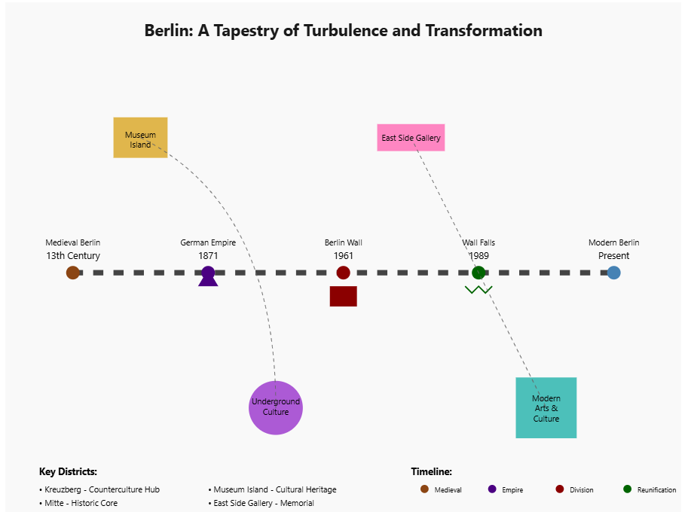
Berlin turned, after the reunification, into a laboratory of cultural innovation.
- Neighbourhoods like Kreuzberg were once gritty enclaves straddling the west edge of the Wall and became a haven for counterculture and immigrant communities, particularly Turkish and Vietnamese groups, and avant-garde art collectives. Mitte, the historic core, unites Baroque splendour with Soviet-era architecture now converted into galleries and stratus. An open-air monument to defiance, a 1.3 km stretch of the Wall known as the East Side Gallery boasts murals like Dmitri Vrubel's "My God, Help Me Survive This Deadly Love" (McCabe, 2019).
Berlin embodies cultural contrasts.
- The Pergamon Museum on Museum Island (a UNESCO site) contains monumental antiquities like the Ishtar Gate of Babylon, while the Hamburger Bahnhof exhibits contemporary works created by Cy Twombly and Joseph Beuys. The Berlin Philharmonic is conducted by such noteworthy names as Herbert von Karajan and Sir Simon Rattle and is an acclaimed institution whose concert hall designed by Hans Scharoun is acclaimed for its acoustically pristine harmony. Monumental memorials include Peter Eisenman's Holocaust Memorial (with 2,711 stelae meant to elicit disorientation and loss).
Berlin's creative pulse radiates from its underground techno clubs (Berghain, Tresor), LGBTQ+ festivals (Christopher Street Day), and culinary fusion (Doner kebab, re-invented by Turkish immigrants). Festival events like the Berlinale Film Festival and Festival of Lights raise its stature on the cultural map. Despite all the gentrification of the ongoing year, the city remains outcast and experimental, manifested in the temporary art squats of Tacheles and the sustainable urban project Prinzessinnengarten.

London: Layers of Legacies and Global Influence

Starting as Londinium,
- A Roman trading port on the Thames, London was at its formative stages in AD 43. After numerous upheavals, including Boudicca's revolt (60 AD) which almost finished the city, London was abandoned until its renaissance in the Anglo-Saxon and Norman times. By the 16th century, it was the epicentre of Tudor power, as seen in Henry VIII’s Hampton Court Palace. The Great Fire of 1666, which destroyed medieval London, made way for Christopher Wren's Baroque monuments, most notably St. Paul's Cathedral. The city's imperial zenith occurred in the 19th century when the Houses of Parliament (with its neo-Gothic clock tower, Big Ben) and Tower Bridge were constructed, reflecting towering influences of Britain's industrial and colonial might.
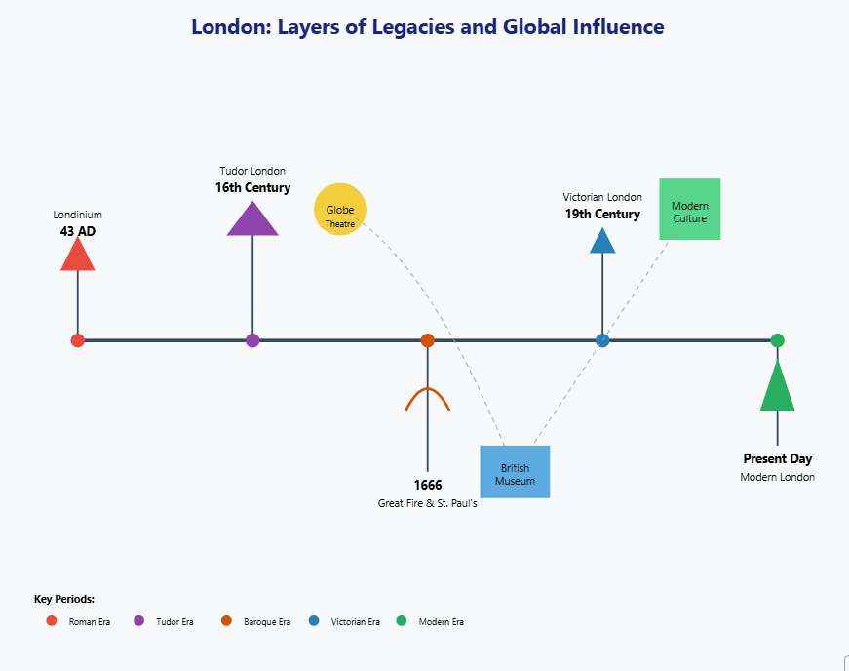
Culturally, London is a mosaic of influences from around the globe.
- More than 300 languages are spoken here, with places such as Brick Lane (Bengali curry houses), Brixton (Caribbean carnivals), and Chinatown lying testament to every wave of migration. Founded in 1753, the British Museum houses 8 million objects, including the Rosetta Stone and the Parthenon Marbles, although questions surrounding their provenance are ongoing. Though less antique, the Victoria and Albert Museum takes you through design history via its 2.3 million objects, from Renaissance tapestries to Alexander McQueen gowns.
- London's theatrical lineage began with Shakespeare's Globe Theatre, to be reconstructed near its site built in 1599, and runs up to the neon-laden West End, where eternal classics like The Phantom of the Opera coexist alongside avant-garde pieces in the National Theatre, attracting millions. From Chaucer and Dickens to Woolf and Zadie Smith, literary giants have left their imprint on the city’s alleys and drawing rooms (Widiyastuti, 2022).
Contemporary London is caught in this dance between tradition and new forms.
- Tate Modern, within a refurbished power station, is home to Warhol and Hockney, sitting side by side with the installations of Ai Weiwei. Sky Garden and The Shard offer views of a skyline merged with Wren's spires and Renzo Piano's glass shards. With its origins going back to 1863, this transport incumbent, the Underground, a titan in its own right, possesses a graphic information system worthy of any designer's envy.
- The annual Trooping the Colour, a royal military parade, and the Notting Hill Carnival, Europe's largest street festival, highlight the dual aspects of the protector of monarchy and affirmer of multiculturalism. Amid the wave of Brexit talks and economic shifts, London still plays home to finance (the city), academic opportunities (Imperial College), and creativity embodied in all its forms, forever rewriting the directions its trajectory may take while retaining layers of its storied past.

Tourism Highlights in Berlin

Historical Monuments

Stunning monuments of considerable historical importance, attesting to its past afflictions and victories, dot the city of Berlin and have graced European soil.
Brandenburg Gate (1791): As a neoclassical monolithic structure, the Brandenburg Gate is considered an iconic symbol of the reunification of Germany. It has witnessed a strong and teeming history of Berlin, having initially been erected as a city gate in the 18th century. During the Cold War, it became an important icon since it was very much located near the Berlin Wall. Today, it is a visitable monument for every History Channel lover and tourist who is curious to know about Germany's past (Colvin, 2017).
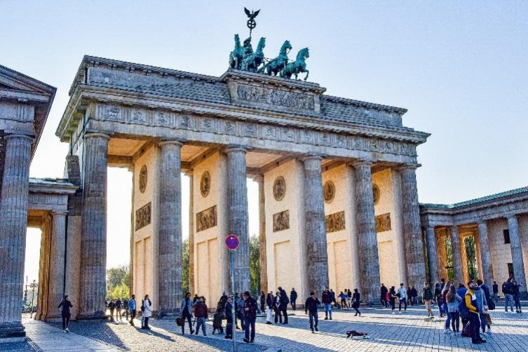
(Visited to Brandenburg Gate, 25th January, 2025)
(https://www.youtube.com/watch?v=j3kWJwWANH4)
Berlin Wall Memorial: The Berlin Wall, which segregated East from West Berlin, constitutes one of the most important tributes to the city in its history. The Berlin Wall Memorial preserves pieces of the wall and explains in detail the ramifications of the division. The open-air exhibitions include a documentation centre and a chapel to commemorate those who died attempting to escape (Flego, 2017).
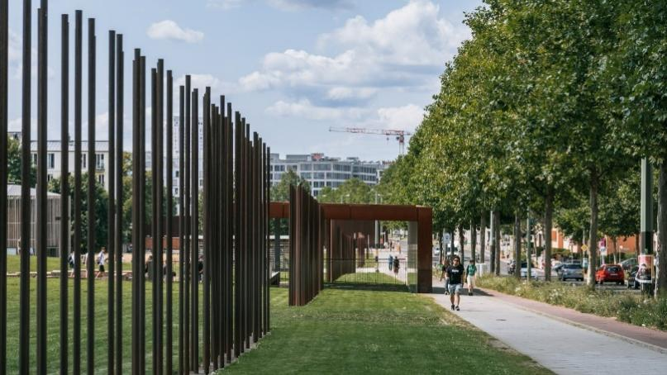
(Visited to Berlin Wall Memorial: 25th January, 2025)
(https://www.youtube.com/watch?v=DJ-GEP6_VrQ)
Reichstag Building: Often deemed both an ecclesiastical and architectural marvel, the Reichstag provides the venue for the German parliament. Designed to epitomize governmental transparency, the building’s glass dome charted by Sir Norman Foster gives visitors a panoramic view of Berlin. Visitors are encouraged to explore its splendid architecture, with guided tours illustrating its political significance.
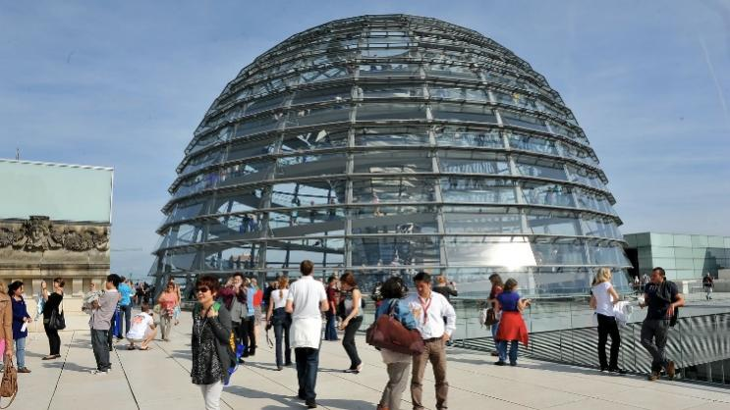
(Visited to Reichstag Building 27th January, 2025)
(https://www.youtube.com/watch?v=1Bnj23jzDcg)

Cultural Events

The culture that exists in Berlin is one that is as colourful as many festivals and events are held there, attracting visitors from all over the world.

Berlin International Film Festival (Berlinale): Berlinale is considered one of the largest and most renowned international film festivals in the world. This is the arena for international film premieres, with thousands of viewings and the opportunity for networking in the industry.
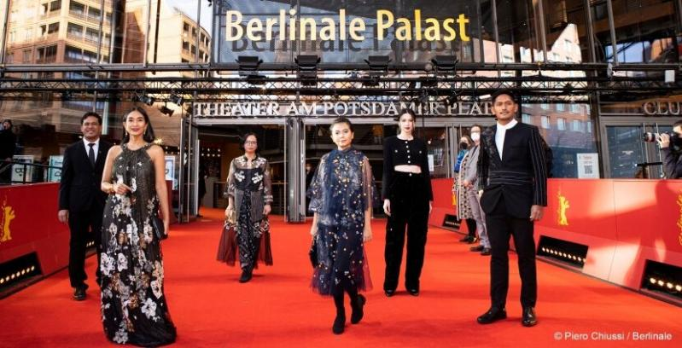
(Source-https://beaumondetraveler.com/content/berlin-international-film-festival-guide-review/)
(https://www.youtube.com/berlinale)
If we can find the time and have some means to head to Berlin on Gallery Weekend, then we are ein for a treat. This event celebrates contemporary art and is the largest exhibition fair in Berlin throughout the year. This is where modern works from both established and upcoming artists are being shown, furthering Berlin's growth and reputation as one of the primary centres of contemporary art.
A street festival celebrating Berlin's multiculturalism in music dance and food. It includes parade marching, performances, and food attractions assembled around the theme of its cultural influences (INTACT, 2022).

Nightlife

Berlin surely has its star-grade party pack with a wide variety of clubs, bars, and music venues. The city is most noted for its electronic. Clubs, such as Bergheim, have attracted musicologists from every part of the globe. To stick to the music genre, Berlin strenuously embarks upon its nightlife, including speakeasy venues, jazz bars, spaces that welcome tourists for all types of night time experiences.
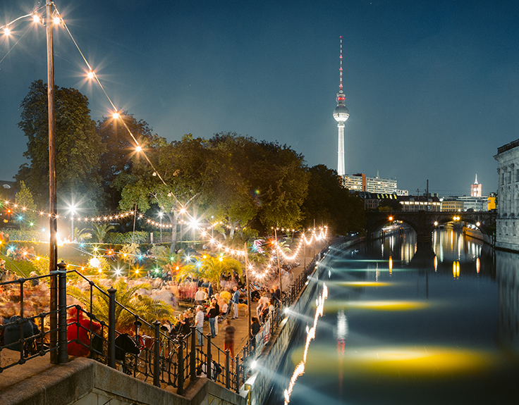
(Visited, 28th January, 2025)
(https://www.youtube.com/playlist?list=PL_BgoOcyI7Dv4t4v-L8uM8Yz7idM-ZEr3)

Restaurants in Berlin
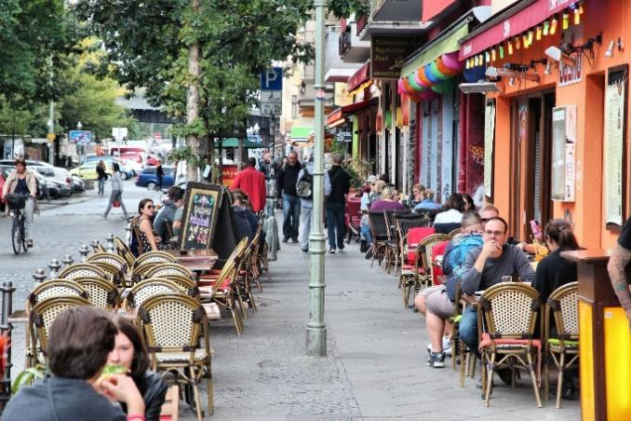
(Visited, 28th January, 2025)
(https://www.youtube.com/watch?v=pPFqtCA2bD0)
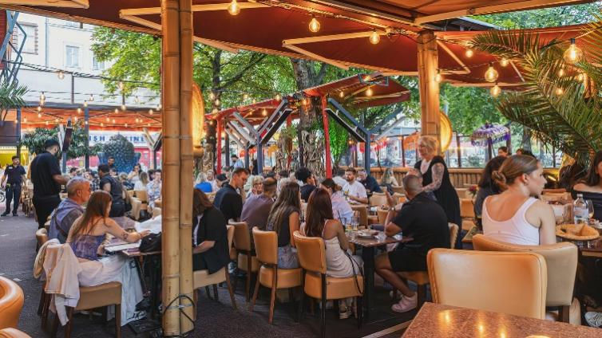
https://www.youtube.com/watch?v=C8s-XmnJIps

Tourism Highlights in London

Historical and Religious Sites

London, with such a long history spanning centuries, contains a multitude of historic and religious establishments and key attractions for tourists.
London Bridge is a historical structure that crosses the River Thames into central London. The bridge has been reconstructed many times over the centuries, starting with the Roman version. The most well-known medieval stone bridge was built in 1209, which has shops and houses along its span, forming a busy metropolis.

The existing spur was completed in 1973 after it was built as a streamlined concrete and steel structure intended to address the heavy traffic demand of the city of London. Ironically, the prior 1831 bridge was sold and moved to Lake Havasu City, Arizona. London Bridge is part of the rich history and culture of London, confused many times with the more ornately decorated close-by Tower Bridge.
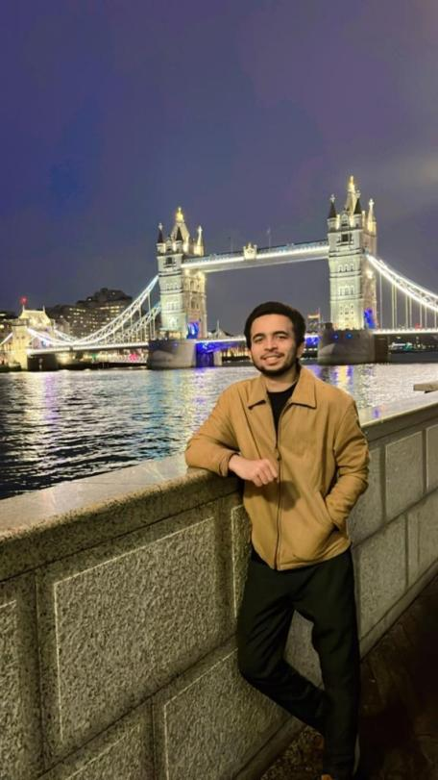
(Visited to London Bridge 30th June, 2024)
(https://www.youtube.com/watch?v=JbK3-hEP0DA)
Tower of London: It is an ancient castle and former royal residential fortress which now houses the Crown Jewels. The cases vary from a royal residence, treasury, prison, and fortress, and more. People visit and see medieval architecture; horrendous and fascinating tales blur out. One finds the Yeoman Warders more popularly known as Beefeaters giving these tales.
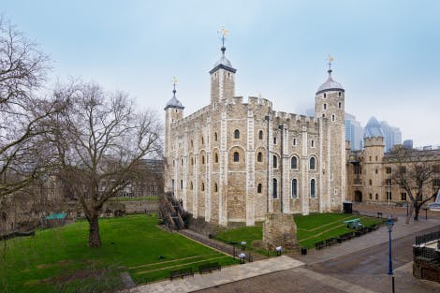
(Visited to Tower of London 30th June, 2024)
Westminster Abbey is a UNESCO World Heritage Site with significant historical and religious importance. London has been the venue for countless royal ceremonies, including coronations and weddings. Additionally, it serves as the final resting place of numerous British monarchs and distinguished individuals, which makes it an essential visit for anyone interested in history and architecture.
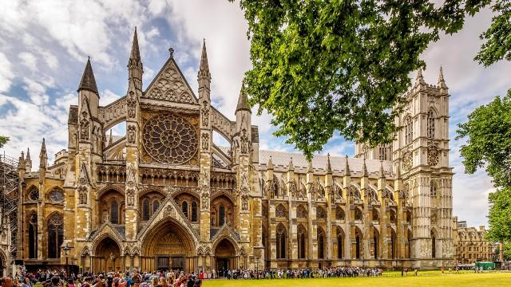
(Visited to Westminster Abbey 29th June, 2024)
(https://www.youtube.com/channel/UCNySjNq1BUNEu7azGutrDEw)

Traditional Arts

The city demonstrates a steadfast dedication to preserving and honouring traditional arts through its renowned theatres and museums.
- West End: Known for its vibrant theatrical scene, the West End offers a diverse array of plays and musicals that range from classic productions to contemporary works.
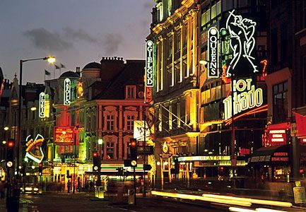
(Visited to West End 2nd July 2024)
(https://www.youtube.com/channel/UCgrA524q825FtGsF3mYyw1g)

- British Museum: Artifacts from the Ancient Egyptian, Greek and Roman cultures populate the British Museum, taking visitors on a cultural odyssey. Also, the visitor is educated in history and archaeology along the way (Flego, 2024).
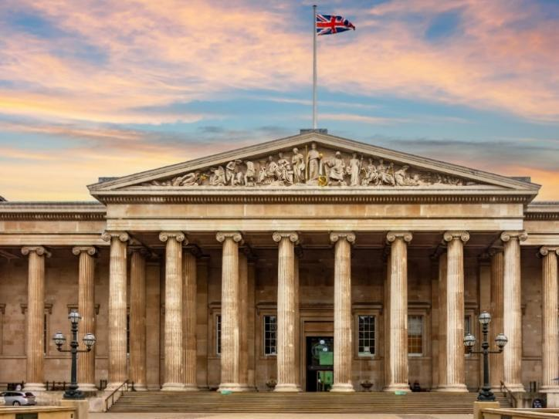
(Visited to British Museum 2nd July 2024)
(https://www.youtube.com/user/britishmuseum)

Cultural Festivals
Many cultural festivals show off the cultural diversity adding an artistic edge to the city of London.
- Notting Hill Carnival: The spirit of Caribbean culture, fun, and vitality are passion incarnated into one of the largest European street celebrations, which draws millions every year. Mixes include music, food, and arts.
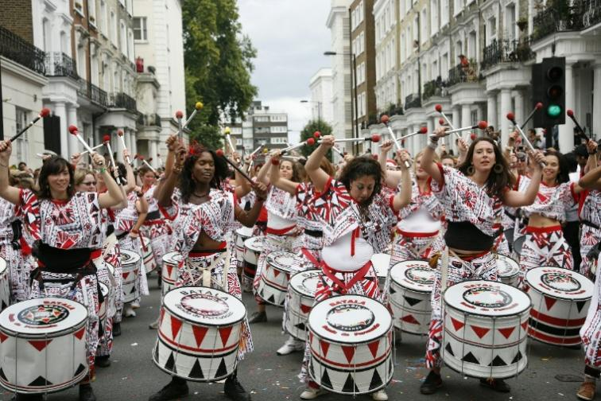
(https://www.lonelyplanet.com/news/notting-hill-carnival-first-timers)
(https://www.youtube.com/channel/UCh_NOS6MTjH323XDRSBqtsA)
- London Film Festival: This is a great event for the film lover as it exhibits films from around the world. It provides a launching pad for newbie filmmakers and highlights some cinematic achievements that are ground-breaking.
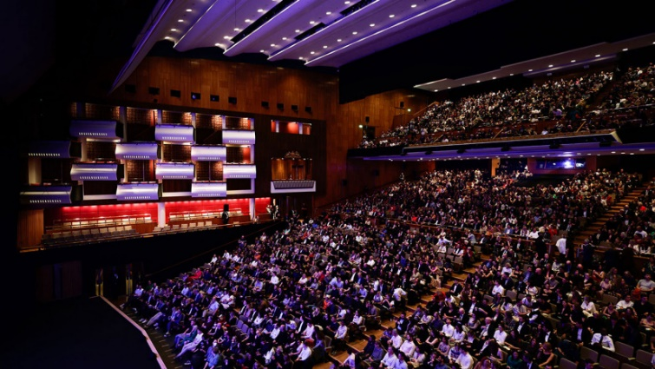
(Source - https://images.occasiongenius.com/picture.php?/84660)
(https://www.youtube.com/playlist?list=PLXvkgGofjDzjENtaAMqw64Jhhm5-o0NcC)

Natural Attractions

Perhaps more than any immense hub with all the noise of the city anyway are trees and other green stuff, attractions that provide an excellent escape from the rough life of the city.
- Hyde Park: One of the largest and most popular parks in London- a huge one that greets the city with some peace. Row on the Serpentine, attend concerts, picnic, or just dwell within those peaceful surroundings.
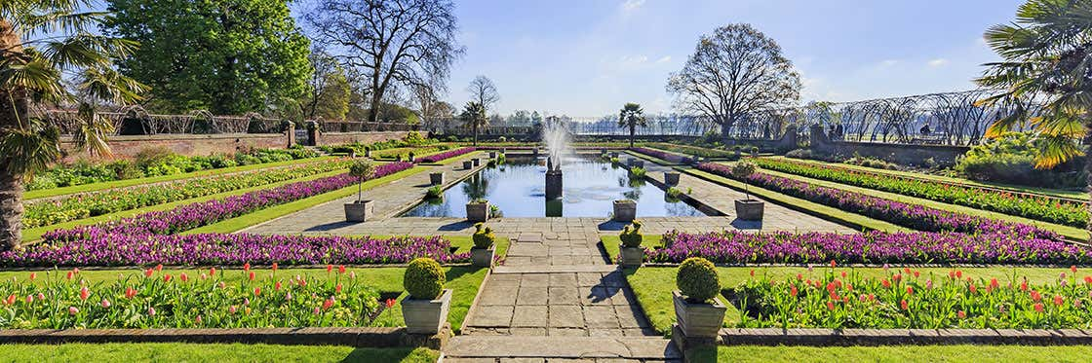
(Source - https://www.londoncitybreak.com/hyde-park)
- Kew Gardens: One of the UNESCO esteemed world heritage sites, they consist of unique plant collections and magnificent scenery. The gardens seem to be a little heaven for nature lovers and botanists as they have rare plant species and breathtaking glasshouses.
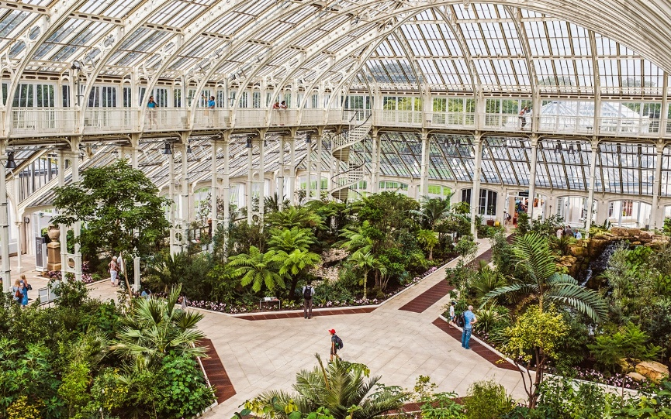
(Visited to Kew Gardens ^{4th} July 2024)
(https://www.youtube.com/watch?v=ioG_Vfh0Kxw)

Cultural Comparison

Berlin: One of its Kind
Berlin is a vibrant and artistic true melting pot of cultures that end up defining diversity and invention; a womb for artists, entrepreneurs, and lovers of culture. Its divided history gives the city a backdrop of resilience and reinvention, which is reflected in its flourishing arts scenes and modern architectural developments.

London: A Timeless Heritage

London is unique for its historic appeal blended with modern polish. Age-old traditions are nestled next to an outlook toward the future. The city appreciates its past while being hip to qualify itself as a world cultural leader (Bİnbasİoglu, 2019).

General Site
Both cities are culturally savvy while being conscious of the many distinctive backgrounds regarding preservation vis-a-vis innovation. After extensive investments have been made to put in place some platforms for the promotion of cultural products and organise events drawing a global audience, Berlin and London are focused towards sustainable tourism and inclusivity.

Tourism Strategies and Impact

Berlin
- Digital Marketing: Berlin has been actively engaging tourists via its social media campaigns and interactive websites. By announcing real-time updates on local events, must-see attractions, and travel tips, such digital tools have enhanced the overall visitor experience.
- Stakeholder Collaborations: The collaboration between local businesses, cultural institutions, and government bodies provides a concrete basis for Berlin's tourism sector to flourish in the present and the coming years. Partnerships may give visitors the chance to engage deeply in experiences, ranging from private guided tours to cultural events run by local communities.
- Sustainability: Berlin supports green tourism initiatives, such as bicycle renting and a sustainable hotel network, and responsible tourism initiatives. The city encourages its visitors to discover the sights by bike, by electric public transport, or by foot to lessen environmental impacts.
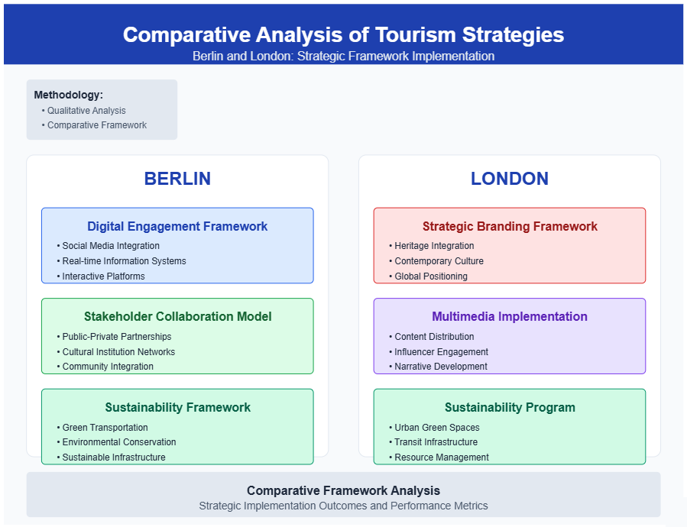

London
- Branding: London is branded to reinvent itself as a destination filled with cultural and financial importance that blends history with modern-day attractions, giving rest to places such as Buckingham Palace, the British Museum, and the Shard, thus making them the wise choice space for innumerable travel junkies around the world.
- Multimedia Campaigns: High-quality video content, celebrity endorsements, and immersive storytelling projects all help keep London's glow on the world stage. Strategic digital marketing efforts showcasing London's arts and culture, luxury shopping, and nightlife attract an extremely broad audience.
- Sustainable Tourism: In this regard, London is introducing urban initiatives to enhance sustainability such as the establishment of new green spaces, support for green hotels, and the promotion of public transport use.
- By adopting novel marketing strategies, creating partnerships across various sectors, and shaping sustainability environments, Berlin and London keep opening their gates to millions of visitors (Suntikul, 2023).

Tools of Analysis

SWOT analysis:

The SWOT analysis tool views tourist promotion in Berlin and London in terms of strengths, weaknesses, opportunities, and threats.
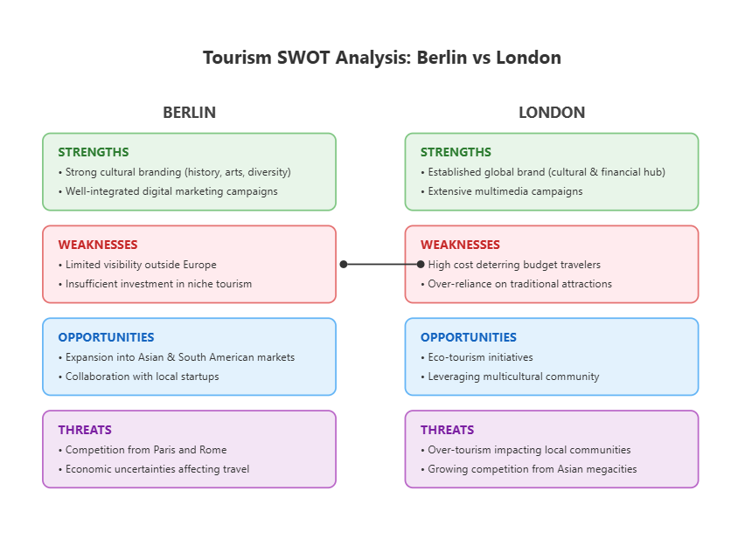

PESTLE analyses for Berlin and London

The important distinctions noted refer to:

- Berlin, as a union state, integrates itself with the EU, while London adjusts to living outside it after leaving
- Budget Berlin versus posh London
- The alternative Berlin against the royal heritage of London
- Smart City versus Contactless in tech focus
- Environmental emphasis
- Framework of legal running (the EU under one, and the UK under another)
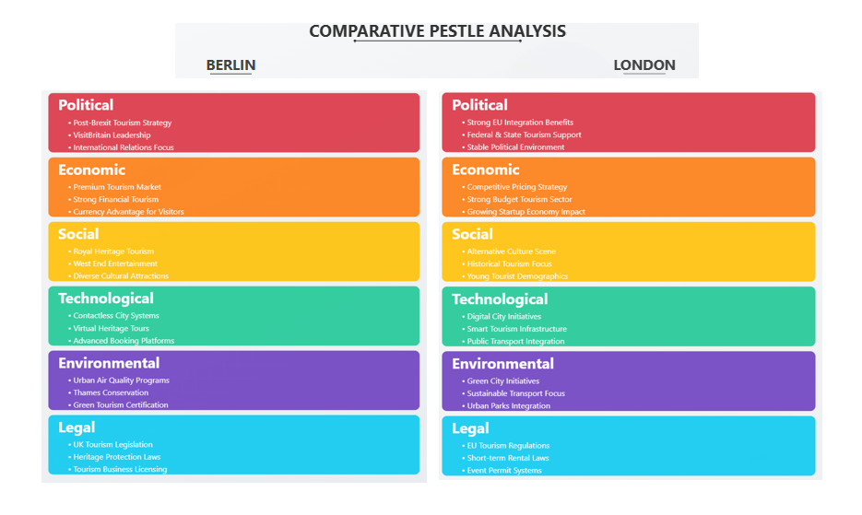

Framework of Comparative Analysis:
This is structured to contrast taken on the similarities and differences between branding approaches, campaign execution, and stakeholder involvement.

Quantitative tools:

- Statistical analysis of visitor numbers and revenue data.
- Graphical representation of findings to facilitate better interpretation through charts and graphs.
Justification: The use of these analytic tools ensures a systematic and evidence-driven analysis, which allows for clear comparisons and informative conclusions.

Berlin Cultural Survey and Research Results

Master's Degree in Tourism and Recreation

Section 1: General Information

1. How long was your stay in Berlin?
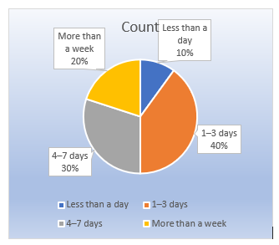
Berlin visitor stays vary: 40% are 1-3 days, 30% last 4-7 days, 20% exceed a week, and 10% are less than a day, based on this chart's data.
2.Where are you visiting from?
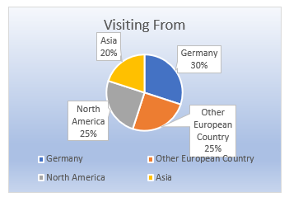
It shows visitors primarily come from Germany (30%), North America (25%), and other European countries (25%), with a smaller portion from Asia (20%). It indicates the origin of tourists, highlighting Germany as the top source.
3. How would you describe your interest in culture? (Please select all that apply)
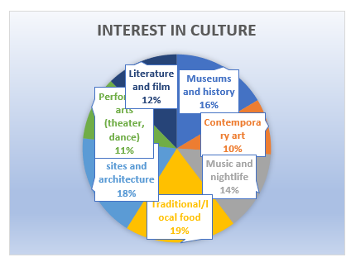
Survey reveals a strong interest in traditional/local food (19%) and historical sites/architecture (18%), followed by museums/history (16%) and music/nightlife (14%).

Section 2: Cultural Attractions and Experiences

4.Which cultural sites or attractions did you visit in Berlin? (Please select all that apply)
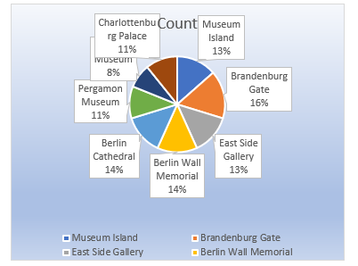
According to the survay visited the Brandenburg Gate (16%), Berlin Cathedral (14%), and the Berlin Wall Memorial (14%). Museum Island and the East Side Gallery were also visited (13% each), along with the Pergamon Museum and Charlottenburg Palace (11% each).
5. How would you rate your experience with Berlin's cultural attractions overall?
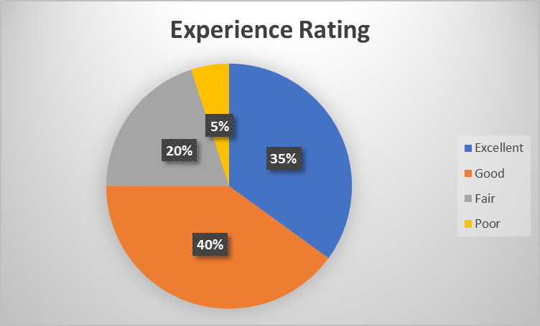
The majority of visitors rated their experience as "Good" (40%), followed closely by "Excellent" (35%). "Fair" experiences accounted for 20%, while only 5% reported a "Poor" experience.

6.What aspects of Berlin's cultural attractions did you enjoy the most? (You may select
more than one option)
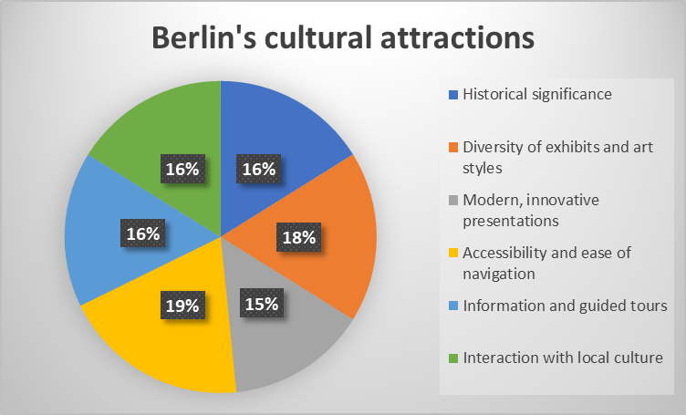
Berlin's cultural attractions impressed visitors most with their accessible navigation (19%) and modern presentations (18%). Historical significance and exhibit diversity were also appreciated (16% each), along with local culture interaction and guided tours.

7. Were there any cultural attractions or experiences you found disappointing?
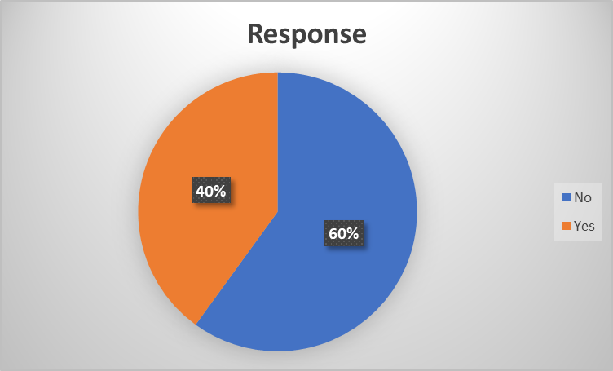
Yes, 40% of responses indicated disappointment with some attractions.

Section 3: Local Culture and People

8. How would you describe your interactions with locals in Berlin?
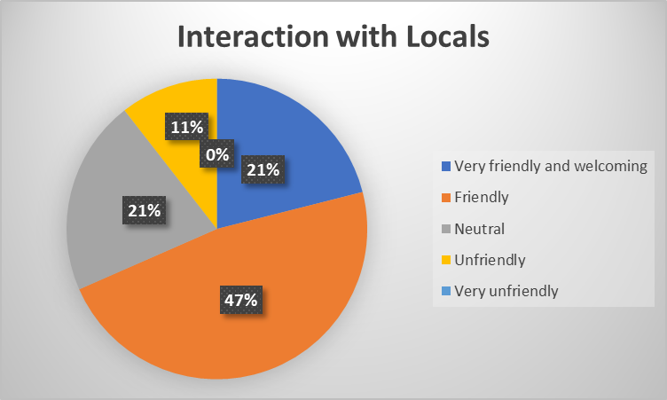
The majority of interactions with Berlin locals were positive: 47% found them friendly and 21% very friendly/welcoming. 21% had neutral interactions, while 11% reported unfriendly experiences. No one reported very unfriendly interactions, suggesting generally positive or neutral experiences overall.

9. Did you have the opportunity to attend any cultural events or festivals?
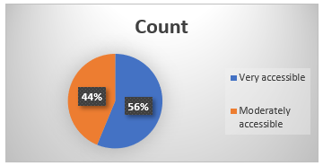
It shows accessibility ratings, with 56% rating Berlin as "very accessible" and 44% "moderately accessible.

10. How would you rate the authenticity of your experience with Berlin's local culture?
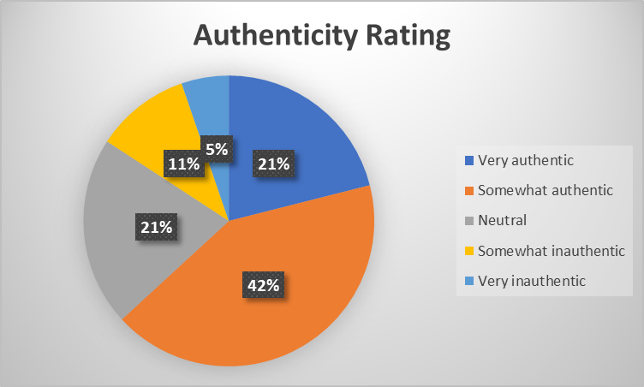
Most found Berlin's culture somewhat authentic (42%), while 21% found it very authentic. 21% were neutral, and 11% found it somewhat inauthentic. Only 5% felt it was very inauthentic, indicating a generally positive perception of cultural authenticity, though not overwhelmingly so.
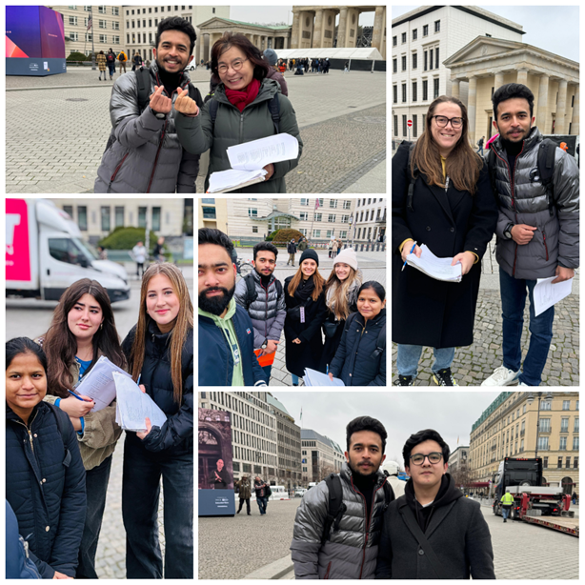

(The survey sample size consists of 20 respondents, providing insights into visitors' cultural experiences, preferences, and suggestions regarding Berlin. While small, it offers a snapshot of diverse perspectives on the city's cultural appeal, 8th November, 2024)

Brandenburg Tour

I believe this was a one-of-a-kind highlight of my Berlin trip! Staring those shiny walls at the Gate that have borne witness to history, it is indeed stunning for its history beginning from the splendour of Prussia, the shadow of the Wall, and finally to the reunification time. The guide brought it all together, explaining the Quadriga and how the gate has undergone changes in function through the ages. This made me think a bit about the survey that we had gone through earlier-this one regarding authenticity. While at the Gate, I felt that profound connection to Berlin in its history; this was simply authentic! But the survey report shows that only 21% regarded their experience as "very authentic", while even more-a total of 42%-saw it as at least "somewhat authentic." This really begs one's mind to ponder what forges those perceptions. Perhaps the crowd or the commercial aspects prevent the authenticity for some. For me, though, the Brandenburg Gate was an experience of power and authenticity when faced with the past of Berlin.

Recommendations

Following this, the strategy of the tourist office in Berlin must refocus on dealing with a wider pool of target countries beyond Europe, such as those in Asia, America, and Africa, using either global tour operators or participation in world tourism expos to gain greater visibility. As a highlight, niche areas ranging from gastronomy, featuring an emphasis on local through global cuisines, to eco-tourism, capped off with cycling tours and green accommodation, are other areas that could help attract specialised travellers.
Collaborations with globally recognised art institutions and cultural celebrations (Dedeke, 2017) would further boost Berlin's attractiveness for culturally curious audiences, akin to London, which would consider advertising not just its famous landmarks, but also more hidden gems like neighbourhood markets and historical sites when introducing a whole new slant. Establishing affordable packages targeting budget-conscious tourists in cooperation with airlines and hotels while encouraging greening through electric transport, cycle paths, and eco-friendly hotels (Albrecht, 2017) can help draw eco-aware markets. Engaging with young tech-savvy individuals would require updating London for tourism. This would balance tradition with the innovative way of presenting London tourism-orchestrated events within the ambient kinetics of the industry.

Conclusion

Both Berlin and London live in unique cultural and economic settings that sell tourism. Berlin is acquiring its cutting-edge image as an urban cultural centre of worldwide and historical significance which may captivate the interest of art devotees, historians, and elite tourists. Whereas, London is leveraging its ever-present recognition, historical mainstreaming, and up-to-date coming into mode to thrive upon an audience of all genders across the world.
The cities strengthened and managed to keep themselves steadfast competitors in the international tourism market through the strategies they surfaced to draw culture to their advantage. Nevertheless, the cities face serious challenges in the form of competition from other global metropolises and the requirement to conform to culturally sensitive sustainable tourism. These difficulties aside, Berlin and London enjoy promising potential via the upsurge of other trends and marketing niches within the tourism environmental context.

References:

Albrecht, J. N. (2017). Introduction to visitor management in tourism destinations. Visitor management in tourism destinations, 3-8. https://doi.org/10.1079/9781780647357.0003
Bİnbasİoglu, H. (2019). World heritage sites and their impact in the context of destination marketing. Sustainable destination branding and marketing: strategies for tourism development, 106-116. https://doi.org/10.1079/9781786394286.0106
Colvin, Andrew James, (born 28 April 1947), comptroller and city solicitor, City of London Corporation (formerly Corporation of London), 1989–2012. (2017). Who's Who. https://doi.org/10.1093/ww/9780199540884.013.11600
Dedeke, A. (. (2017). Creating sustainable tourism ventures in protected areas: An actor-network theory analysis. Tourism Management, 61, 161-172. https://doi.org/10.1016/j.tourman.2017.02.006
Duwadi, P. (2024). Heritage tourism and its impact on livelihood: A study on heritage site. Rural Development Journal, 4(1), 85-107. https://doi.org/10.3126/rdj.v4i1.64028
Flego, C., & Tei, A. (2024). Creative and cultural hub sustainability: From theory to practice. International Journal of Cultural Policy, 1-16. https://doi.org/10.1080/10286632.2024.2372332
Lei, W. S., Suntikul, W., & Chen, Z. (2023). Tourism development induced social change. Annals of Tourism Research Empirical Insights, 4(1), 100088. https://doi.org/10.1016/j.annale.2023.100088
McCabe, S. (2019). Advertising strategies for tourism and hospitality. Marketing Communications in Tourism and Hospitality, 207-236. https://doi.org/10.1016/b978-0-7506-8277-0.00008-2
Museum island, historical centre of Berlin. (2024). Berlin — A Postcolonial Metropolis, 28-35. https://doi.org/10.5771/9783748946779-28
Selling Berlin in the twentieth century: Historical perspectives urban modernity and the birth of contemporary place selling practices. (2013). Staging the New Berlin, 49-80. https://doi.org/10.4324/9780203137543-7
Tourism recovery committee - ITB Berlin 2003 - Comité pour la relance du tourisme ITB Berlin 2003 (Version francaise). (2004). https://doi.org/10.18111/9789284406562
Widiyastuti, D., & Wardhani, I. K. (2022). Travel intention of people susceptible to COVID-19: Social issues. Proceedings of the International Academic Conference on Tourism (INTACT) "Post Pandemic Tourism: Trends and Future Directions" (INTACT 2022), 50-65. https://doi.org/10.2991/978-2-494069-73-2_5

