European Institute of Innovation, Entrepreneurship and Technology
Project Report Name: Designing the Extended Marketing Mix (7 Ps) for Sustainable Hospitality

Name-Satwinder kaur
Student ID- satwinder6015

Executive Summary
The report has evaluated how an integrated strategy of Extended Marketing Mix (7Ps) can be designed to tackle marketing development sustainability within the hospitality market in the case of TUI BLUE. The paper has focused on the emerging significance of sustainable tourism and evolving customer demands of responsible tourist experiences. The environmental responsibility, authentic experiences and quality services have been found to be more important to the travellers in the process of choosing a hotel. The STP analysis has also established the following target market segments of TUI BLUE like eco-conscious travellers, experience-seeking customers and international leisure travellers. The report has determined the contribution of experience marketing and service design towards enhancing customer satisfaction and brand loyalty. The analysis of 7ps has been done with the way Product, Price, Place, Promotion, People, Process and Physical Evidence have helped in the creation of sustainable values. Distribution channel trade-offs between direct booking and Online Travel Agencies have also been put into consideration in the analysis. An implementation plan, including a 12-month implementation plan, budget and KPI framework have been created to facilitate real-life application. The purpose for which the suggested strategy has been proposed is to enhance sustainable positioning of TUI BLUE as well as enhance customer relationships and competitive edge in the hotel industry.

Table of Contents
1. Introduction 3
2. Market & Consumer Behaviour Analysis 4
2.1 Sustainable Tourism Market Trends 4
2.2 Consumer Behaviour in Sustainable Hospitality 5
2.3 Experience Marketing and Service Design 7
3. Segmentation, Targeting, and Positioning (STP) 9
3.1 Market Segmentation 9
3.2 Targeting Strategy 10
3.3 Positioning Strategy 12
4. Extended Tourism Marketing Mix (7 Ps) 12
4.1 Sustainable Hospitality Best Practice Analysis 12
4.2 Extended 7Ps of marketing mix 13
4.3 Integrated 7Ps Matrix for TUI BLUE Market Development 17
5. Implementation, Budgeting & KPIs 19
5.1 Implementation Plan 19
5.2 Budget Allocation 21
5.3 KPIs and Measurement 22
Conclusion & Recommendations 23
Conclusion 23
Recommendations 23
References 25

1. Introduction
As new trends in customer demands and more concerns about environmental awareness have emerged, sustainable hospitality has become a top priority in the tourism industry. However, travellers do not focus on basic kinds of accommodation but require hotels to offer them huge experiences through environmental and social effects. Thus, hospitality organisations need to have good marketing strategies, which build customer value and sustainable development.
Long-term marketing mix (7Ps) offers a simple platform on which to examine the ways the ideas of hospitality brands can evolve and convey their sustainable experiences. This model entails Product, Price, Place, Promotion, People, Process and Physical Evidence, which are influencing the customer perceptions, satisfaction and loyalty. These dimensions have to work together in a sustainable hospitality sector as clients not only think about the values and practices that underlie the brand but also about the service that they receive.
The report will be targeted at TUI BLUE that is a hospitality brand of TUI Group and how a strategy of integrating 7Ps would contribute towards sustainable development of the market. The analysis of the market trends and consumer behaviour, is then followed by brand segmentation, targeting and positioning. It then explores the effects of experience marketing, service design, channel of distribution and sustainable service practices. Finally, an implementation plan along with budget plans, and key performance indicator (KPI) are developed to improve the sustainable hospitality marketing strategy of TUI BLUE.

2. Market & Consumer Behaviour Analysis

2.1 Sustainable Tourism Market Trends
With the increasing concern travellers are attributing to the effects of tourism on the environment and on social issues, sustainable tourism is on the rise in the world tourism market. Current customers require hotels to be waste-minimising, to be good in their resources and to contribute back to the communities they operate in and at the same time providing a comfortable stay (Mishra & Kumar, 2024). In 2030, the sustainable tourism market in the world is estimated to be $7369.37bn (Figure 1). Such a huge projected market size is a growth opportunity to TUI BLUE. However, the brand should be highly alert to make sure that sustainability is not an elusive aspect of the hotel experience but should be used as a marketing tool. Increasing customer interest also translates to increasing competition, since more green products and services are developed by hospitality brands (Pilelienė et al., 2024). TUI BLUE will thus have to work on the areas of combining its sustainability initiatives with quality services and experiences alongside the local experiences and customer values. This would help the brand to stay up to date with the changing traveller experiences and in addition, better position the brand in the sustainable hospitality environmental scenery.
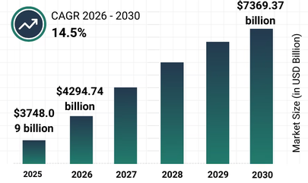
Figure 1: Sustainable tourism market size
(The Business Research Company, 2025)

2.2 Consumer Behaviour in Sustainable Hospitality
Environmental awareness, and the personal values as well as the price and anticipated hospitality experience are all part of the consumer behaviour of sustainable hospitality. Eco- tourists can also choose to be hosted at a hotel that minimises waste, conserves energy and development of the community (Shang et al., 2023). The reason for rising eco-tourism is increasing surface heat, like Figure 2 shows the temperature data of 1910-2021 for Asia, Africa, Europe and North America.
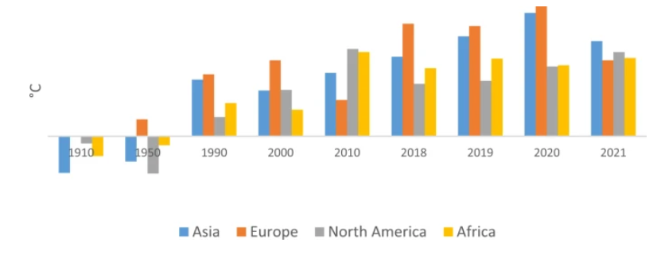
Figure 2: Surface temperature
(Shang et al., 2023)
Nonetheless, sustainability might not be critical in the final decision of the book. The other factors that are important to the customers include the price, location, comfort, reviews and service quality. This presents a challenge to TUI BLUE because the green practices must create a tangible value to customers instead of making their life more complicated by making things more costly and less convenient without an apparent value on which to be based. Relevancy is also applicable to trust of the customers (Palacios-Florencio et al., 2021). The brand image can be harmed due to ambiguous or exaggerated claims of sustainability. TUI BLUE hence needs to streamline its environmental processes to be understood by customers to be user-friendly when making a reservation and in their stay at the hotel. A compromise between responsible behaviour and comforting, quality and local experience would resemble a more suitable approach to meet customer expectations and help to establish closer relationships with the environmentally conscious travellers.

2.3 Experience Marketing and Service Design
Experience marketing is concerned with establishing meaningful emotional relationships among customers and a brand as opposed to delivering a mere service. As the trend towards green tourism takes center stage, customers have begun to focus more on comfort-based, environmentally friendly and experiences that involve local experience in its purest form (Demir et al., 2021). In TUI BLUE, customer satisfaction can be improved by providing sustainable experiences such as local cultural experiences, wellness services and responsible hotel practices, through making holidays more memorable and more valuable (Tui-blue.com, 2022). Figure 3 shows its current hotels with sustainable certifications.
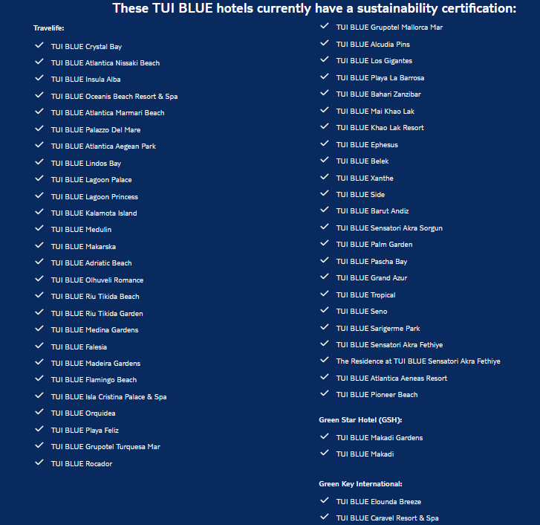
Figure 3: TUI BLUE hotels with sustainability certificates
(Tui-blue.com, 2022)
Service design makes a significant contribution as well as the hospitality services are designed with the help of various types of communication with customers such as booking, arrival, accommodation and communication after staying. Effort of customers can be minimized by creating effective service process design that may assist in enhancing overall holiday experience. In response, TUI BLUE can also educate its customers on sustainability activities in the customer journey by providing transparent customer information about environmental activities, digital and personalised suggestions (TUI BLUE, 2024). There is a close correlation between brand loyalty and customer satisfaction since customers are able to make repeat visits after they are satisfied and report favourably. By having sustainability activities evident and linked to high-quality service, customers will tend to have loyalty in a sustainable hospitality. However, it may not be the right fit to only focus on environmental activities as customers need to be able to have convenience, reliability and value for money (Happonen et al., 2022). Thus, TUI BLUE must be able to strike a balance between the sustainability and quality and service delivery. By incorporating experience marketing and good service design, the brand can develop improved customer relationships as well as increase its competitive advantage in the green tourism market.

3. Segmentation, Targeting, and Positioning (STP)

3.1 Market Segmentation
TUI BLUE can segment its sustainable hospitality market according to the different customer characteristics:
- Demographic: TUI BLUE may target the youth (25-34 years), the middle-aged (35-54 years) and older people (55 years or older) as they have the means to spend on good experiences in holidays. Such categories can include the possibilities of comfort and wellness, sustainability and customized travelling services (Seyfi & Hall, 2024). Other segments are families and couples, who would like to have comfortable and responsibility travel products.
- Geographic segmentation: The international travellers are aware of sustainable tourism and TUI BLUE can address them. Depending on local weather and taste the interests of local travel can be promoted to various destinations.
- Psychographic segmentation: Single travellers who are environmentally friendly, health-conscious, and also customers who appreciate the importance of local culture are key segments. Such customers desire to remain in a hotel which coincides on environmental and life values (Schönherr & Pikkemaat, 2024).
- Behavioural segmentation: The brand can target the repeat customers those who make decisions more sustainably and those who are interested in responsible accommodation. Such societies would be readily willing to embrace the idea of establishing a long-term relationship between them and the sustainable hotel brands (Popșa, 2023).

3.2 Targeting Strategy
The targeting strategy TUI BLUE uses should be segmentation of consumers who appreciate experience-based and sustainable holidays.
- Eco-conscious customers: There is an opportunity that the brand can attract customers who care a lot about this aspect when staying in a hotel, as environmental responsibility, and want to resort to the hotels with eco-sustainable practices. It is because eco-tourism market is rising rapidly and it will reach $838.50bn by 2032 (Figure 4).
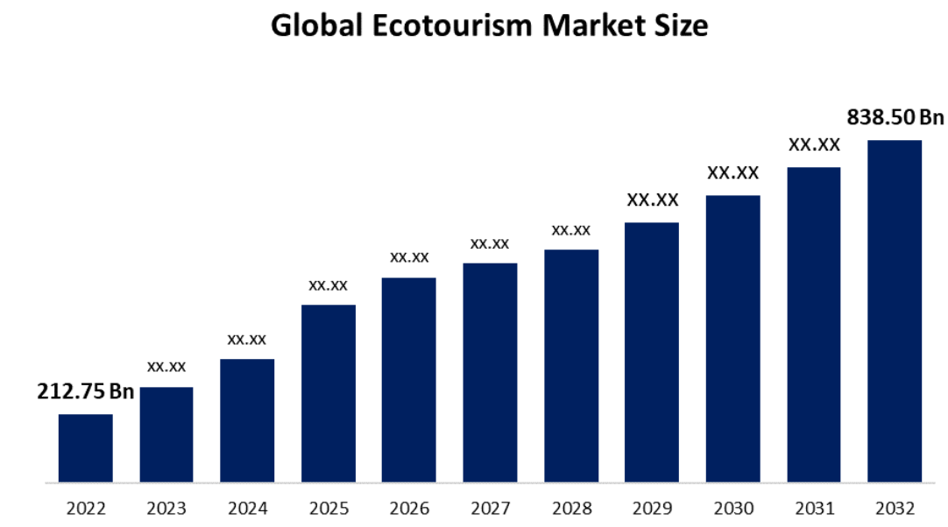
Figure 4: Global eco-tourism market rise
(Spherical Insights, 2024)
- Experience-seeking travellers: Wellness-oriented, local culture-oriented, personalised holiday experience are a perfect type of customers to target. Accommodation is not as important to them as other types of jobs.
- International leisure tourism: TUI BLUE can seek to target European and international tourists who seek to get believable service, comfort and responsible tourism (Salleh et al., 2022).
- Repeat customers: Customers who tend to visit the hotel frequently should be retained by a hotel by involving them in personalised communication with the clients and building brand loyalty since customers who visit the hotel frequently may promote long term growth.

3.3 Positioning Strategy
TUI BLUE will position itself as a sustainable lifestyle hotel brand which incorporates responsible tourism with quality of holiday experiences. The brand can differentiate in the form of providing green accommodation, wellness and experiences of the locals and services provided to the visitors that are personal. Compared to the normal hotel industry, where accommodation is the primary concern of the hotel, TUI BLUE can invest into the value of real experiences that resonate with the destinations of the customers and also alleviate environmental degradation (Kreye, 2026). The positioning should be centred around sustainable holidays without jeopardising comfort and quality. This will help in attracting the responsible travellers who do not wish responsible decisions to come at the expense of convenience, relaxation and good reliable service. When communicated properly, the sustainability practices can be effectively utilized to earn customer trust and competitiveness of TUI BLUE in the green tourism industry.

4. Extended Tourism Marketing Mix (7 Ps)

4.1 Sustainable Hospitality Best Practice Analysis
The sustainable hospitality programs can be well-known examples of how to blend environmental responsibility and value to the customer in tourism brands. Combining the concept of sustainability with the notions of wellness and safeguarding the strong local culture and environment, Six Senses focuses on luxury experiences in their resorts (Pakpahan et al., 2022). However, the company's model of its gifts brings a sustainable correlation between sustainability and customer feeling. The luxurious stance can limit access to priceless traveller. TUI BLUE will be able to embrace its emphasis on meaningful experiences and it will continue to have a broader market strategy.
The responsible tourism model followed by Intrepid Travel encourages small group tourism, interacting with the local community and environmentalism least harm (Cheer et al., 2021). This will enable increased authenticity and will enable customers to explore destinations in a more sustainable manner. However, this model can be principally applied in respect to travel experiences as opposed to hotel-based services, where it may prove hard to directly apply the model to the TUI BLUE hospitality services and activities.
These are but a few that could be learned by TUI BLUE when it is formulating its 7Ps strategy. The brand will be poised to have a mix of the experience-oriented sustainability solution implemented by Six Senses and that implemented by Intrepid Travel local connection and responsible tourism (Farhadi Uonaki et al., 2022). The hotel will have to foresee the market by fitting the sustainability of Product, Price, Place, Promotion, People, Process and Physical Evidence rather than requiring physical evidence to be an isolated activity. This will help the brand to create congruent customer experiences, build trust and expand its existence in the sustainable hospitality sector.

4.2 Extended 7Ps of marketing mix
Products
Sustainable and experience-based hospitality should be the focus of the product strategy of TUI BLUE. The brand would be able to provide us with a comfortable stay and wellness experiences, local culture and responsible tourism (TUI Group, 2026). The aspects of sustainability, such as energy-efficient buildings, reduced waste creation and minimised local services, could be used to add customer value. But quality and convenience must be coupled with sustainability because as much as customers need environmentally friendly options, they need a nice holiday as well. This strategy can assist TUI BLUE to establish more differentiation in its competitive hospitality world.
Price
TUI BLUE should base its pricing on value-based ideas of sustainable experiences. Direct booking channels will assist the brand in keeping better customer relations, less reliance on third-party commissions, and gathering customer information. Whereas OTA (Online Travel Agency) like Booking.com and Expedia possess a greater number of customers and are available to new customers (Tsai, 2023). The trade-off is that OTAs raise visibility and might decrease profitability. As such, TUI BLUE will have to strike a balance by providing direct booking incentives and reflective OTA relationships.
Place
Place defines how the customers will get and consume hospitality services of TUI BLUE. A multi-channel distribution strategy should be used as it is necessary to target various customer bases in the foreign markets. The official site can enhance customer relationships, generate personalised offers and offer more control over the customer experience by direct booking on the official site (Business TUI BLUE, 2024). That said, the Online Travel Agencies (OTAs), such as Booking.com and Expedia, have the abilities to spread brand awareness and grab unaware households. It is also more costly in the distribution costs in terms of commission rates given by these avenues. So, TUI BLUE needs to adopt a middle ground between enhancing the advantages of direct booking and taking advantage of OTAs to increase the market coverage and the number of customers.
Promotion
Promotion needs to play a key role in instilling the sanity of sustainability to TUI BLUE and gaining customer confidence. The digital marketing channels where the brand should share the sustainable hotel practices, local experiences and responsible tourism activities include social media, online marketing and email marketing (Paulo et al., 2022). Information and customer reviews created by users and testimonials can be used to make the message of sustainability closer to the truth and encourage more active customer participation. However, the sustainability communication must be clear and adequate as ambiguous statements may be the cause of greenwashing suspicion. TUI BLUE needs to concentrate on clear promotional messages that communicate its environmental activities, even as it relates to sustainability and comfort, quality and unforgettable holiday experiences. The plan will be in a position to enhance brand loyalty and foster relationships with sustainability-conscious travellers.
People
A large part of the hospitality marketing consideration is represented by people since all the employees are face-to-face contacts of the customer. TUI BLUE employees strive to improve their service quality through communicating, problem-solving and their ability to implement sustainable practices in their interaction with the guests. By developing strong customer trust and highlighting the renewed efforts of sustainability, with the awareness of the brand's environmental values of the brand previously instilled within themselves, leaders are in a better place to communicate (Jovanovic, 2026). Not only should there be increased training on how to behave responsibly in their operations, but also on how to relate to their customers. But the sustainability goals would be complicated in a situation where we have employees of varying service levels or those who fail to impart the brand values.
Process
The process is applicable to customer perception in the sense that there are series of service touchpoints with the guests in a hotel. TUI BLUE should ensure the booking, arrival, stay and departure are convenient, quick and user-friendly. The online solutions would also make it more convenient such as online check-in and customer-focused communication and help with sustainable operations due to the reduced use of paper (tui-blue.com, 2023). Other ethical practices should also be adopted by the brand in day-to-day activities which should involve minimisation of waste and good management of resources. Nevertheless, sustainable processes and service delivery should not bother the guests or reduce the service delivery. This hotel will have to do the balancing of the sustainability of operations with convenient and reliable service delivery to customers in attaining the positive experience of hospitality.
Physical Evidence
Physical evidence would aid customers to draw a line between quality and life of an intangible hospitality service. As there is no opportunity to test an option, as the customers have not experienced it, the perceptions will rely on the obvious aspects like hotel design, the hotel facilities inside the rooms, the restaurants and the sustainability certification. Physical features should be exploited to prove how TUI BLUE is environmentally responsible, by operating energy-saving mechanisms, recycling and consuming less single-use plastic (tui-blue.com, 2026). These visible actions will be able to make sustainability a bit more familiar to customers, and create brand equity..

4.3 Integrated 7Ps Matrix for TUI BLUE Market Development
A 7Ps marketing framework can be integrated to enable TUI BLUE to relate sustainability with customer value and development of the market in the long run. Sustainability should not be a process but a standalone activity, but the brand is expected to take it into account in its entire marketing decisions.
7Ps Element | Current Focus | Market Development Strategy
Product | TUI BLUE provides wellness, accommodation and activities locally in its provision of holidays. | Customise more towards sustainable experiences such as local culture experiences, wellness and meaningful travel experiences.
Price | The hotel must be able to deliver value instead of making an emphasis on the low pricing. | Adopt sustainable pricing strategies that include delightful bonuses on making bookings online as an encouragement in brand loyalty.
Place | Direct booking channels and external distribution platforms can be utilised by TUI BLUE. | Use Online Travel Agencies (OTAs) to book directly and offer tailored products, as bookings would be more internationalised and reach new people.
Promotion | The concept of sustainability communication assists in brand awareness and communication with customers. | Take part in clear digital marketing, testimonials and social media content to communicate sustainability efforts and avoid the ambiguity of green statements within customers.
People | The quality of service and customer experience are determined by the employees. | Provide sustainability training to the employees to ensure that they can provide usual service and stir the message about an environmentally sustainable brand to their customers.
Process | The processes of the service are essential to the convenience and satisfaction of the customers. | Encourage online booking, Customer relationship and smooth operations without going into the execution of effective service delivery.
Physical Evidence | The perceptions of customers are based on the hotel properties and the apparentness of sustainability. | Visualise the elements of sustainability environmentally friendly facilities, well-planned and well-informed environmental practices.
Table 1: Extended 7Ps of marketing mix for TUI BLUE
(Self-developed)
The integrated matrix demonstrates the correspondence between customer experience and the operational practices with marketing communication is the foundation of sustainable market development of TUI BLUE (Table 1). Taking a sustainable product as an example, environmentally conscious travellers would be keen on buying sustainable products, but with visual effects that they can observe (Laheri et al., 2024). Similarly, effective processes and involvement of the employees ensure that the guarantee of sustainability can be translated in the guest experience. Therefore, it can create a stable sustainable brand image and promote customer satisfaction and competitive advantage in a hospitality industry with the help of the 7Ps approach.

5. Implementation, Budgeting & KPIs

5.1 Implementation Plan
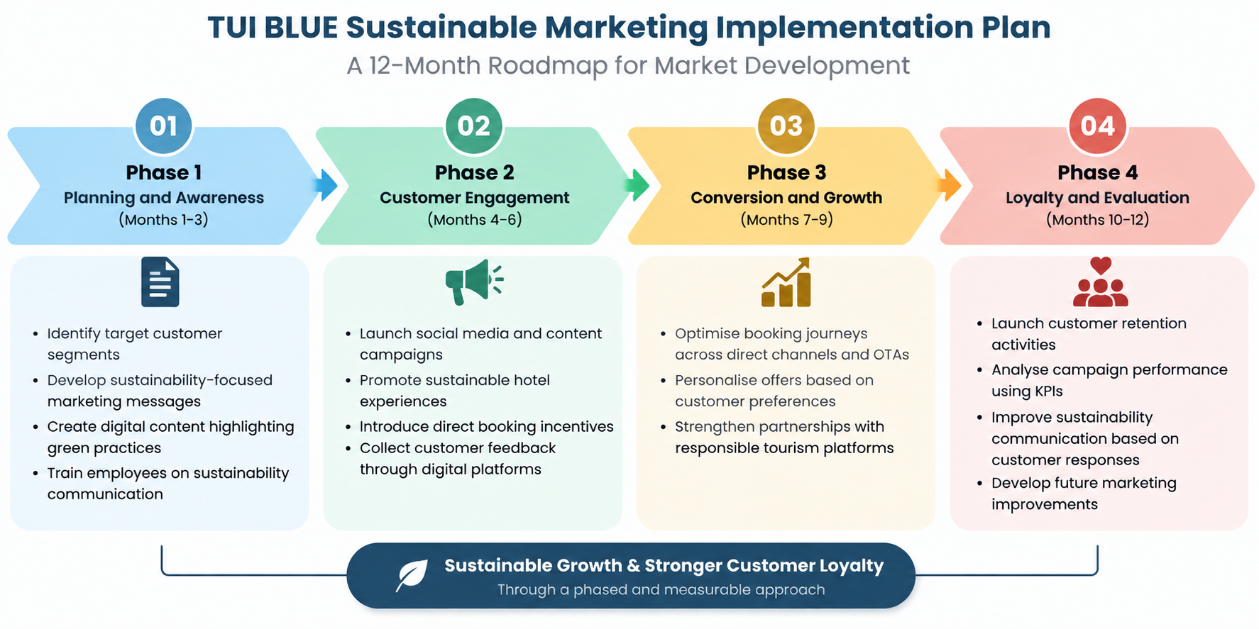
Figure 5: Implementation plan for TUI BLUE sustainable marketing
(Self-developed)
To implement sustainable marketing strategy, TUI BLUE has a 12-month plan to do so that consists of four key phases (Figure 5):
Phase 1: Planning and awareness (Months 1-3)
- Identify target customer segments
- Develop better sustainability marketing communications.
- Create internet resources which show green activities.
- Provide training on sustainability communication to the employees.
Phase 2: Customer Interaction (Months 4-6)
- Present content and social media campaign.
- Enhance environmentally friendly hotel experiences.
- Provide firstcome best offers.
- Gather feedback data about customers over the Internet.
Phase 3- Conversion and Growth (Months 7-9)
- Maximise direct channel and OTA trips.
- Customise transactions on basis of customer preferences.
- Enhance collaborations with responsible tourism sites.
Phase 4: Loyalty and assessment (Months 10-12)
- Begin retention program and business.
- Measure the performance of campaigns with the help of KPIs.
- Increase sustainability communication in response to customers.
- Carry out improvements in future marketing.
This gradual strategy will make certain that TUI BLUE instills sustainable marketing techniques progressively since it equally monitors the response of the customers and the business performance.

5.2 Budget Allocation
Budget Area | Estimated Budget (€) | Percentage
Digital Marketing & Online Advertising | €150,000 | 27.3%
Website & Direct Booking Development | €80,000 | 14.5%
Sustainability Communication & Content | €60,000 | 10.9%
Social Media & Influencer Marketing | €50,000 | 9.1%
Employee Training & Development | €40,000 | 7.3%
Sustainable Customer Experience Development | €70,000 | 12.7%
CRM & Customer Loyalty Activities | €35,000 | 6.4%
Market Research & Customer Feedback | €25,000 | 4.5%
KPI Monitoring & Evaluation | €15,000 | 2.7%
Contingency Fund | €25,000 | 4.5%
Total Estimated Budget | €550,000 | 100%
Table 2: Estimated budget of sustainable marketing plan for TUI BLUE
(Self-developed)
The proposed budget of €550,000 will be spent on major areas where they will need to adopt the TUI BLUE sustainable marketing strategy (Table 2). They will put the majority of investments in online promotion and the development of contact and conversion of customers directly. To ensure the implementation and long-term markets development are successful, sustainability communication, the customer experience, employee training and the performance monitoring of the employees are also financed.

5.3 KPIs and Measurement
TUI BLUE should be in a position to have some Key Performance Indicators (KPIs) which they can use to reach the level of success of sustainable marketing approach. These measures can be applied in customer response measurement, performance of marketing and business outcome.
- Direct Booking Rate: This is a common rate of how many of the customers book via the TUI BLUE channels and it is a rate that determines the effectiveness of de-platforming OTAs (Boermans et al., 2024).
- Conversion Rate: It is a figure of the number of visitors to the site who subsequently make a reservation with the help of the marketing activity.
- Customer Acquisition Cost (CAC): This is a measure of the cost that is needed to acquire one customer and it is used to measure marketing efficiency (Remy et al., 2023).
- Customer Satisfaction Score (CSAT): This is an indicator of customer satisfaction with the services provided by hotels, sustainability and experience.
- Repeat Booking Rate: Evaluate the loyalty of the customers in terms of repeat customers (Solomenko & Charalabides, 2024).
- Social Media Engagement Rate: Use of the likes/shares/ comments to measure customer engagement with the sustainability content (Saini et al, 2023).
- Website Traffic Growth: Measures the increase or decrease of exposure and customer attraction on the internet.
- Sustainability Engagement Rate: Measures rate of customer engagement and experience of sustainability.

Conclusion & Recommendations

Conclusion
The report has discussed the application of extended 7Ps marketing mix to the sustainable development of hospitality and the market by TUI BLUE. The analysis has established responsible tourism interest amongst the customers and other aspects such as comfort, price and quality service have remained significant factors in decision making to book. The TUI BLUE has been forced to find some middle-ground between customer value and the environment. Eco-conscious and experience-seeking and international leisure travellers have as well been discovered by the STP analysis as key customer groups. The 7Ps analysis has already presented the need to have sustainability included in product, price and in distribution, promotion, employees, service process and physical buildings. The direct and the OTA channel booking has come out with contrasting advantages and disadvantages that have predetermined the fair attitude to distribution. The implementation plan they have proposed has described a 12 months plan, which is supported by a proposed budget and quantifiable measures of KPIs. These initiatives have created a feasible way of customer satisfaction, customer loyalty and sustainable positioning of TUI BLUE to the market.

Recommendations
Boosting sustainable experiences: TUI BLUE should also develop a more intimate sustainable experience with the combination of the local culture, wellness and responsible tourism. This can be successful in enhancing customer value and brand loyalty.
Expanding direct booking incentive: The brand needs to increase the incentive of direct booking by providing personalised deals and customer loyalty benefits to enjoy improved customer relations and reduce dependency on OTA.
Employee training: TUI BLUE will need to offer frequent sustainability and services training to employees to make sure sustainability and service delivery is regular.
Transparent promotion: This will need to place their sustainability at centre of stage in the Internet site where the buyer would be more assured and this issue of greenwashing would be reduced or done away with.

References
Boermans, D. D., Jagoda, A., Lemiski, D., Wegener, J., & Krzywonos, M. (2024). Environmental awareness and sustainable behavior of respondents in Germany, the Netherlands and Poland: A qualitative focus group study. Journal of Environmental Management, 370, 122515. https://doi.org/10.1016/j.jenvman.2024.122515
Business TUI BLUE (2024). Digital Hotel platform. [online] Available at: https://business.tui-blue.com/digital-hotel-platform/ [Accessed 18 Sept. 2026].
Cheer, J. M., Ting, H., & Leong, C. M. (2021). Responsible tourism: A new era of responsibility. Journal of Responsible Tourism Management, 1(1), 1-17. https://doi.org/10.47263/JRTM.01-01-01
Demir, M., Rjoub, H., & Yesiltas, M. (2021). Environmental awareness and guests’ intention to visit green hotels: The mediation role of consumption values. Plos one, 16(5), e0248815. https://doi.org/10.1371/journal.pone.0248815
Farhadi Uonaki, M., Jahanian, M., Pourtaheri, M., & Eftekhari, A. R. (2022). Providing an experience-oriented tourism model in creative cultural attractions Case study: Tehran city. urban tourism, 9(2), 13-26. https://doi.org/10.22059/jut.2022.339631.1018
Happonen, A., Nolte, A., Bystriakova, N., Santti, U., & Kärhä, K. (2022). Study on hackathons for new innovation seed and business model development needs in digitalization driven sustainability, circularity and environmentally friendly solutions demanding digitalizing societies. New Innovations in Economics, Business and Management, 4, 1-29. DOI: 10.9734/bpi/niebm/v4/14443D
Jovanovic, S. (2026). What tui (xtra:Tui1)’s new TUI blue leadership means for shareholders. [online] Simply Wall St. Available at: https://simplywall.st/stocks/de/consumer-services/etr-tui1/tui-shares/news/what-tui-xtratui1s-new-tui-blue-leadership-means-for-shareho [Accessed 18 Sept. 2026].
Kreye, N. (2026). TUI Blue brings its leisure hotel experience to Europe’s cities. [online] TUI Group. Available at: https://www.tuigroup.com/en/newsroom/news/tui-blue-brings-its-leisure-hotel-experience-to-europes-cities [Accessed 18 Sept. 2026].
Laheri, V. K., Lim, W. M., Arya, P. K., & Kumar, S. (2024). A multidimensional lens of environmental consciousness: towards an environmentally conscious theory of planned behavior. Journal of Consumer Marketing, 41(3), 281-297. https://doi.org/10.1108/JCM-03-2023-5875
Mishra, L. K., & Kumar, N. (2024). Sustainable travel and the rise of eco-tourism: Trends, challenges, and opportunities. Journal of Tourism & Hospitality, 13(2), 56-66. https://dbrau.ac.in/wp-content/uploads/2024/10/JTH-July-2024.pdf#page=69
Pakpahan, A., Komala, I. G. A. M. K., Ernawati, N. M., Nyoman, N., Triyuni, N. W. W. A., & Suja, I. K. (2022). Best Practices of Sustainable Development to Make Six Senses Uluwatu a Green Hotel. Jurnal Bali Membangun Bali, 3(1). DOI 10.51172/jbmb http://ejournal.baliprov.go.id/index.php/jbmb
Palacios-Florencio, B., Santos-Roldán, L., Berbel-Pineda, J. M., & Castillo-Canalejo, A. M. (2021). Sustainable tourism as a driving force of the tourism industry in a post-COVID-19 scenario. Social indicators research, 158(3), 991-1011. https://doi.org/10.1007/s11205-021-02735-2
Paulo, M., Miguéis, V. L., & Pereira, I. (2022). Leveraging email marketing: Using the subject line to anticipate the open rate. Expert systems with applications, 207, 117974. https://doi.org/10.1016/j.eswa.2022.117974
Pilelienė, L., Grigaliūnaitė, V., & Bogoyavlenska, Y. (2024). A bibliometric review of innovations in sustainable tourism research: Current trends and future research agenda. Sustainability, 16(16), 7124. https://www.mdpi.com/2071-1050/16/16/7124
Popșa, R. E. (2023). Importance of sustainability in the hotel industry. Expert Journal of Business and Management, 11(2), 183-188. https://business.expertjournals.com/ark:/16759/EJBM_1116popsa183-188.pdf
Remy, D., Boo, H. C., & Tee, S. (2023). From traditional to new hotel revenue management metrics: An exploratory study on the potential of NRevPAR and RevPAC. Tourism and hospitality management, 29(2), 221-233. https://doi.org/10.20867/thm.29.2.6
Saini, H., Kumar, P., & Oberoi, S. (2023). Welcome to the destination! Social media influencers as cogent determinant of travel decision: A systematic literature review and conceptual framework. Cogent Social Sciences, 9(1), 2240055. https://doi.org/10.1080/23311886.2023.2240055
Salleh, L., Delibasic, M., & Abrham, J. (2022). Destination environmental branding and sustainable eco-conscious consumer1. Transformations in Business & Economics, 21(2), 56. https://www.researchgate.net/profile/Rizwan-Ahmed-7/publication/361085021_Destination_Environmental_Branding_and_Sustainable_Eco-Conscious_Consumer/links/62aae85be1193368baa02af2/Destination-Environmental-Branding-and-Sustainable-Eco-Conscious-Consumer.pdf?origin=journalDetail&_tp=eyJwYWdlIjoiam91cm5hbERldGFpbCJ9
Schönherr, S., & Pikkemaat, B. (2024). Young peoples’ environmentally sustainable tourism attitude and responsible behavioral intention. Tourism Review, 79(4), 939-952. https://doi.org/10.1108/TR-01-2023-0022
Seyfi, S., & Hall, C. M. (2024). Is gen Z a pro-SDG generation? A critical review and reflection. The Elgar companion to tourism and the sustainable development goals, 246-258. https://doi.org/10.4337/9781802203219.00025
Shang, Y., Bi, C., Wei, X., Jiang, D., Taghizadeh-Hesary, F., & Rasoulinezhad, E. (2023). Eco-tourism, climate change, and environmental policies: empirical evidence from developing economies. Humanities and Social Sciences Communications, 10(1), 275. https://www.nature.com/articles/s41599-023-01777-w
Solomenko, D., & Charalabides, S. (2024). Aspect extraction for hotel reviews: A hybrid approach. ResearchGate, Aug. https://www.researchgate.net/profile/Darya-Solomenko/publication/384729222_Aspect_Extraction_for_Hotel_Reviews_A_Hybrid_Approach/links/670540167d49be5c483e4e67/Aspect-Extraction-for-Hotel-Reviews-A-Hybrid-Approach.pdf
Spherical Insights (2024). Ecotourism Market Size, Share and Forecast to 2032. [online] Available at: https://www.sphericalinsights.com/reports/ecotourism-market [Accessed 18 Sept. 2026].
The Business Research Company (2025). Sustainable tourism global market report 2025. [online] Available at: https://www.thebusinessresearchcompany.com/report/sustainable-tourism-global-market-report [Accessed 18 Sept. 2026].
Tsai, C. H. (2023). The study of E-Business models in hospitality management: comparing hotel reservation systems of Booking. com, expedia and Agoda. https://aisel.aisnet.org/iceb2023/64/
TUI BLUE (2024). Sustainability - business TUI blue. [online] Available at: https://business.tui-blue.com/sustainability/ [Accessed 18 Sept. 2026].
TUI Group (2026). TUI Blue turns 10: Driving growth and shaping the leisure hotel experience of tomorrow. [online] Available at: https://www.tuigroup.com/en/newsroom/news/tui-blue-turns-10-driving-growth-and-shaping-the-leisure-hotel-experience-of-tomorrow [Accessed 18 Sept. 2026].
Tui-blue.com (2022). Sustainability. [online] Available at: https://www.tui-blue.com/en/en/about-us/sustainability/ [Accessed 18 Sept. 2026].
tui-blue.com (2023). Tui blue concept overview | hotels designed for you. [online] Available at: https://www.tui-blue.com/en/en/concept/ [Accessed 18 Sept. 2026].
tui-blue.com (2026). Style hotels | unique & exceptional resorts at TUI Blue. [online] Available at: https://www.tui-blue.com/en/en/concept/style/ [Accessed 18 Sept. 2026].

