

RESEARCH TITLE: THE HISTORICAL BACKGROUND AND EVOLUTION OF TOURISM
Student name:Sachin kumar
Date: February -25-2025
Student ID number:DE24004

Table of Contents
Introduction 3
Main body 3
Discussion 6
Conclusion 7
References 9

Introduction
Tourism is a term considered to be one of the largest industries, which has evolved significantly over time. Tourism is comprehensively shaped by considering economic development and the impacts of technological progress. In the early ancient times, travelling was considered to be an act of the resulting trade, exploration and the fact of obtaining religious pilgrimages. Tourism gained its potential foundation in the Renaissance by considering grand tours (Mustafa, 2021). The overall report will schematically determine the historical background and the step-by-step evolution of tourism. The socio-economic impacts on tourism will be examined. The severe effect of the pandemic on tourism will also be discussed along with the identification of possible future tourism. The report will help in evaluating all these historical incidents and approaches of people in terms of travelling. The present and upcoming trends of tourism will also be determined in this report.

Main body
Ancient tourism
The early travellers were mostly diplomats and merchants, who used to look for wealth and knowledge. Considering the Mesopotamian and Egyptian travel, the Sumerians were focused on travelling for trade. The Egyptians were focused on building temples and tombs alongside the river Nile (Mustafa, 2021). On the contrary, Greeks were focused on introducing leisure tourism, as they used to travel to the Olympic Games and several healing centres. They were more focused on making travel more systematic, as they made extensive road networks.
Medieval tourism
The medieval period is the timeline from the 5th to the 15th century and travelling was limited to this timeline. During this time, the concept of leisure travel was erased (Frost & Frost, 2021). This is because of the political instability and poor infrastructure, which significantly impacted tourism. In this particular time, several religious sites were discovered. Such as Mecca, Santiago de Compostela and many other religious destinations attracted thousands of people across the world. In Europe, the most visited religious cities were Rome and Canterbury.
Renaissance and grand tour
This period started in the 15th century and ended in the 17th century. In this particular time, travel and tourism got new interests in art, travel, and culture. The majority of the people started to praise fine arts and sculptures and destinations full of cultural heritage (Wilde, 2018). Most of the people travelled to gather necessary information for their education, such as travelling to cities like Paris, Venice, as well as Rome. The people during this time were focused on documenting the historical travel destinations across the globe. This phase of travelling can be defined as the approach to discovering historical and architectural destinations across the world.
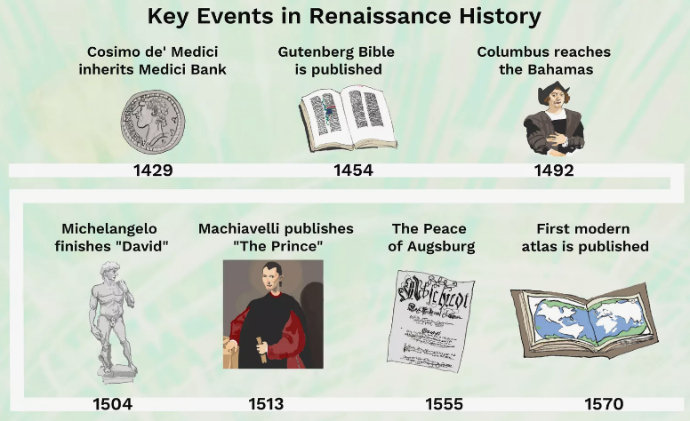
Figure 1: Key events in Renaissance history
(Source: Wilde, 2018)
Industrial revolution and the rise of modern tourism
The transformation in tourism first came in the early 19th century. The fastest and the most affordable travel was the mode of railway travel. This is because of the expansion of railways in different countries like Britain, Europe, and other countries. The concept was launched during that period when the use of steamships revolutionised and opened the scope of international travelling (Fullana et al., 2021). For example, Thomas Cook is a company that focused on offering affordable packages to the people and also started offering organised tour plans. Several coastal areas were developed and these areas became popular among the people for their relaxation.
20th-century mass tourism
In the 20th century, tourism has experienced a significant growth. The global economy has experienced growth and a better infrastructure ensured tourism growth in the international market (Scott, 2021). In the mid-20th century, there were several airlines that started to offer affordable travelling. For example, British Airways made it easier for people to travel internationally within a budgetary cost. After 1950, the world has seen significant growth such as discovering destinations such as Las Vegas, and Mediterranean resorts in Europe.
21st-century tourism
The digital age came within tourism and in this time, several considerations have been implemented. People started to use technologies in terms of booking and purchasing exclusive packages from tourism companies (Remoaldo et al., 2024). The people started to have more assistance as the tourism companies used mobile applications and websites to provide services. At this time, the majority of the companies are focused on promoting eco-friendly tourism and having a target of the net zero emissions.

Discussion
Socio-economic impacts of tourism
Tourism has been able to contribute towards the enhancement of the economy. Considering all the growth, there are some significant challenges. The concept of tourism also contributed highly to the economy of a country (Thommandru et al., 2023). For example, Dubai and Maldives are some of the destinations, which completely rely on the revenue that comes from tourism. Along with this significance, there is a negative approach as well. Mass tourism sometimes creates chaotic situations and it may lead to the loss of cultural authenticity in the destinations.
Environmental and ethical concerns
Considering environmental and ethical concerns, overcrowded tourist destinations may lead towards a shortage of local resources and may result in pollution. Air travel companies are more focused on limiting carbon gas emissions to maintain their sustainability in the market (Dias et al., 2021). Ethical tourism campaigns may be disrupted due to the issues of wildlife exploitation and local community exploitation. It is currently the goal for every travel organisation to maintain its sustainability by considering all the environmental measures to meet net zero emissions soon.
Impact of covid-19 on tourism
This is the severe impact of the pandemic on global tourism. All the services have been disrupted due to the impact of COVID-19. Several economic downturns have been faced by different countries and as a result of this, several travel restrictions have been imposed by the countries (Škare, Soriano & Porada-Rochoń, 2021). All the travel companies have faced a huge loss at this time. After this period, the companies started to adopt different health protocols and started initiating contactless services. In the time of the COVID-19 pandemic, many travel companies started to launch virtual travelling options so that they could maintain their sustainability in those difficult situations.
Future of tourism
The future of tourism aligns with the use of technologies in businesses. Many organisations must introduce chatbots and AI to provide required assistance to people. Majority of the tourism companies must stop using plastic materials and must use materials that can be easily decomposed. Eco-friendly travelling is one of the best approaches that will be the primary measures of tourism companies to secure their future sustainability (Scott, 2021). An introduction to space travel will be exciting for people. For example, Blue Origin is a company that started offering this service to the people. This significant approach will not only strengthen the landscape of tourism but also will open a wide range of exploration for a broader context.

Conclusion
The report has determined the historical development by considering the tourism business landscape. A schematic structural development has been discussed in this report to evaluate the historical landscape of tourism. All relevant examples have been provided to support the comprehensive historical development of tourism. Along with determining those areas, the new trends and cultures related to tourism have also been examined. This ensured the findings of the step-by-step growth of tourism over the years. The report has also determined some potential challenges so that the possible ways of mitigation can be derived. The impacts of the pandemic have also been discussed, as this pandemic disrupted the overall revenues of the tourism industry due to regional restrictions. Along with deriving all the components, the possible goal for the future of tourism has also been provided to understand the next possible moves of the companies to maintain their sustainability and contributions towards maintaining environmental standards.

References
Dias, Á., Aldana, I., Pereira, L., da Costa, R. L., & Antonio, N. (2021). A measure of tourist responsibility. Sustainability, 13(6), 3351. https://www.mdpi.com/2071-1050/13/6/3351/pdf
Frost, J., & Frost, W. (2021). Medieval imaginaries in tourism, heritage and the media. Routledge. https://books.google.com/books?hl=en&lr=&id=CC40EAAAQBAJ&oi=fnd&pg=PT9&dq=Medieval+tourism+period&ots=6zDKkV3Q3f&sig=HGHva5UZ1xUqlATgLVrktKA9MH4
Fullana, O., Tello, E., Murray, I., Jover i Avellà, G., & Marull, J. (2021). Socio-ecological transition in a Mediterranean agroecosystem: What energy flows tell us about agricultural landscapes ruled by landlords, peasants and tourism (Mallorca, 1860-1956-2012). Ecological Economics, 2021, vol. 190, num. 107206, p. 01-12. https://diposit.ub.edu/dspace/bitstream/2445/180423/1/713926.pdf
Mustafa, M. H. (2021). Cultural heritage: A tourism product of Egypt under risk. Journal of Environmental Management and Tourism (JEMT), 12(01 (49)), 243-257. https://journals.aserspublishing.eu/jemt/article/download/5899/3060
Remoaldo, P., Lopes, H., Ribeiro, V., & Alves, J. (2024). Tourism and Climate Change in the 21st Century: Challenges and Solutions. https://riull.ull.es/xmlui/bitstream/handle/915/39633/Climate_Change_and_Tourism_in_Spain._The_Case_of_the_Canary_Islands_and_the_Costa_Blanca__Alicante_.pdf?sequence=1
Scott, D. (2021). Sustainable tourism and the grand challenge of climate change. Sustainability, 13(4), 1966. https://www.mdpi.com/2071-1050/13/4/1966/pdf
Škare, M., Soriano, D. R., & Porada-Rochoń, M. (2021). Impact of COVID-19 on the travel and tourism industry. Technological forecasting and social change, 163, 120469. https://www.ncbi.nlm.nih.gov/pmc/articles/PMC9189715/
Thommandru, A., Espinoza-Maguiña, M., Ramirez-Asis, E., Ray, S., Naved, M., & Guzman-Avalos, M. (2023). Role of tourism and hospitality business in economic development. Materials Today: Proceedings, 80, 2901-2904. https://www.researchgate.net/profile/Mohd-Naved/publication/353229404_Role_of_tourism_and_hospitality_business_in_economic_development/links/61279a5f0360302a005f1f75/Role-of-tourism-and-hospitality-business-in-economic-development.pdf
Wilde, R. (2018). Key Renaissance Events in Art, Philosophy, Politics, Religion, and Science. ThoughtCo. Retrieved from https://www.thoughtco.com/renaissance-timeline-4158077 [Retrieved on: February 04, 2025].

