FINANCIAL MANAGEMENT IN THE HOSPITALITY INDUSTRY

Student ID: DE240138

Student Name: Kewal Kumar

Abstract
This paper analyses the importance of financial management in hospitality industry with special references to financial accounting, cost control, and financial forecasting. The study seeks to examine the role of such tools in promoting profitability, liquidity and long-term sustainability. The study assesses the significance of financial statements in decision making, functionality of cost management strategies and the relevance of break-even analysis in evaluating financial feasibility using secondary data and a case study of Marriott International. The results demonstrate the fact that performance evaluation is supported by financial accounting, operational efficiency and profitability are strengthened by cost control. Moreover, break-even analysis and forecasting aids in strategic planning and risk management. There are, however, limitations based on market uncertainty and variation in the demand. This research finds that a trans-disciplinary approach to financial management is necessary to enhance decision-making and secure sustainable development in the hospitality industry.

TABLE OF CONTENTS
Abstract 2
1. Introduction 6
1.1 Background 6
1.2 Problem Statement 7
1.3 Objectives 7
1.4 Scope and Limitation 8
2. Literature Review 8
2.1 Theoretical Framework of Hospitality Accounting 8
2.2 Concepts of Profitability and Liquidity 9
2.3 Cost Management Theories 9
2.4 The Strategic Role of Financial Forecasting 11
3. Methodology 12
3.1 Research Design 12
3.2 Data Collection 13
3.3 Data Analysis 14
4. Findings 14
4.1 Financial Accounting and Reporting in Hospitality 14
4.1.1 Managing Profitability and Liquidity through Reporting 14
4.1.2 The Triad of Financial Statements and Industry Standards 15
4.1.3 Strategic Decision-Making and Governance 16
4.2 Cost Control and Management at Marriott International 17
4.2.1 Operational Efficiency in Big-Cap Operations 17
4.2.2 Advanced Cost Allocation and Budgeting Strategies 17
4.2.3 Impact on Profitability and Long-Term Sustainability 18
4.3 Break-Even Analysis and Financial Forecasting 20
4.3.1 Assessing Financial Viability for New Ventures 20
4.3.2 Cost Behavior: Fixed, Variable, and Asymmetric Dynamics 20
4.3.3 Strategic Application of the Break-Even Point 21
5. Discussion 23
5.1 Integration of Findings 23
5.1.1 Interrelationship Between Financial Accounting, Cost Control, and Forecasting 23
5.1.2 Financial Reporting as the Foundation of Strategic Decision-Making 23
5.1.3 Cost Control as a Driver of Operational Efficiency and Profitability 23
5.1.4 Forecasting and Break-Even Analysis in Long-Term Financial Sustainability 24
5.2 Critical Analysis 24
5.2.1 Limitations of Financial Accounting in Dynamic Hospitality Environments 24
5.2.2 Challenges in Cost Control Implementation Across Different Hospitality Scales 24
5.2.4 Trade-Off Between Profitability and Liquidity 25
5.3 Implications for Management 25
5.3.1 Adoption of Integrated Financial Management Systems 25
5.3.2 Enhancing Decision-Making Through Real-Time Financial Reporting 25
5.3.3 Strategic Cost Management and Resource Optimization 26
5.3.4 Strengthening Financial Planning and Risk Management 26
5.3.5 Balancing Short-Term Performance with Long-Term Sustainability 26
6. Conclusion 26
6.1 Linking with Objectives 26
6.2 Recommendations for Future Research 27
References 29
Appendices 35
Appendix A: Marriott International 2025 Financial Highlights 35
Appendix B: Search Strategy and Methodology Log 36

1. Introduction

1.1 Background
A significant economic growth driver is the global hospitality industry, which is fueled by growing international travel, tourism demand and service innovation. The industry is a dynamic and competitive environment where financial performance and efficiency in operations are key to long-term sustainability. The size and complexity of the industry are emphasised by large multinationals like Marriott International. Marriott has a global presence and has been steadily growing, as the latest 2025 Annual Report states that the company has around 9,800 properties and a total of nearly 1.78 million rooms in 145 countries and territories (Marriott International, 2025).
Financial accounting is very important in running such large operations as it gives structured financial information that needs to be used in assessing organisational performance. The income statement, balance sheet, and cash flow statement are the most important financial statements that hospitality organisations use to track profitability, manage liquidity, and aid in strategic decision-making. As an illustration, Marriott had a reported adjusted EBITDA of 5.38 billion in 2025, a strong financial performance with successful financial management practices (Marriott International, 2025).
Moreover, the break-even analysis and financial forecasting are financial tools that are necessary in the assessment of new business opportunities and in strategic planning over the long term. The tools assist organisations in analysing cost behaviour, forecasting revenue patterns and deciding how much operations must be performed to reach profitability. Thus, financial accounting and management practices play a key role in the sustainability and development of hospitality businesses in a fast-changing global market.

1.2 Problem Statement
Although financial management is crucial, hospitality organisations are struggling to ensure profitability and liquidity. The industry is also very sensitive to the forces beyond its control, like economic uncertainty, seasonal demand changes and global upsets, which adversely affect financial performance.
Though Marriott has shown good financial performance in 2025, such as revenue growth and a rise in EBITDA, to maintain profitability, it is necessary to constantly monitor the costs, effectively allocate resources, and plan the finances (Marriott International, 2025). Additionally, cost management and service quality are challenges faced by many hospitality organisations. Poor cost control, poor budgetary practices, and poor use of financial forecasting tools may result in operational inefficiencies and financial instability. As such, there is a necessity to critically examine the application of financial accounting, cost control strategies and forecasting techniques in the improvement of decision making and long-term sustainability in the hospitality industry.

1.3 Objectives
- To critically examine how financial accounting can be used to manage profitability and liquidity in the hospitality industry.
- To determine the significance of key financial statements in the provision of effective decision-making in hospitality management.
- To discuss the cost control and cost management strategies applied by Marriott International.
- To evaluate the use of break-even analysis and financial forecasting in evaluating the financial feasibility of hospitality firms.

1.4 Scope and Limitation
The report is devoted to the financial accounting, cost control and financial forecasting in the global hospitality industry, but Marriott International is used as a case study. It analyses secondary data sources, such as the Marriott 2025 Annual Report and academic literature.
The results cannot be broadly generalised across all hospitality organisations because of variations in organisational size, market conditions, and business models.

2. Literature Review

2.1 Theoretical Framework of Hospitality Accounting
The Uniform System of Accounts of the Lodging Industry (USALI) offers an internationally accepted system of financial reporting in the hospitality industry. It harmonises accounting practices, which allow the consistency, comparability and transparency of hotel operations. The 12 th revised edition of USALI brought major changes, specifically in the classification of revenues, allocation of expenses, and reporting of departments, which led to a more accurate financial performance assessment (Dimitrova, 2025).
USALI separates the operations of hotels into operating (like rooms, food and beverage) and non-operating departments, which enables managers to examine profitability at a fine level. The departmental method facilitates improved cost management and benchmarking performance in various units. Besides, the framework ensures that financial reporting is in line with management decision-making requirements as it provides deep information on the sources of revenue and cost structures.
USALI has been used in hospitality management to enhance financial accountability and strategic planning. It helps managers to know the areas of underperformance within the company, streamline pricing policies, and increase the efficiency of operations. Thus, the USALI is an important theoretical basis of financial accounting in hospitality.

2.2 Concepts of Profitability and Liquidity
Financial management is all about profitability and liquidity, which is a measure of how an organisation can produce profit and cover short-term financial commitments. The profitability ratios, including the net profit margin and the profitability on assets, show the efficiency of business operations, whereas financial stability is evaluated by the liquidity ratios, including the current ratio and quick ratio (Barbakadze, 2024).
It is especially difficult to balance between profitability and liquidity in the hospitality industry because of high fixed costs, seasonal demand variation, and external economic pressure. The studies show that proper management of capital structure is critical in financial stability, particularly in times of crisis like the COVID-19 pandemic (Nguyen et al., 2023).
In addition, management accounting practices facilitate decision-making through timely financial information that is used in improving profitability and liquidity management. The practices allow organisations to manage costs, streamline pricing policies, and enhance their cash management (Campos et al., 2022).
The interdependency between profitability and liquidity is mutual. Too much emphasis on profitability can cause liquidity crises, and too much liquidity can ease investment. As such, hospitality managers need to implement a moderate fiscal approach that guarantees efficiency and economic stability in the operations.

2.3 Cost Management Theories
The management of costs is a critical part of ensuring operational efficiency in the hospitality organisations. The conventional costing techniques, including absorption costing, use simple measures of overhead costs such as labour hours or machine hours. Although these techniques are simple to apply, they tend to be inaccurate in complicated service settings (Adetayo et al., 2025).
On the other hand, contemporary methods like the Activity-Based Costing (ABC) have been more accurate in terms of allocating costs as they associate costs with activities. ABC allows managers in the hospitality sector to determine the cost drivers, eliminate inefficiencies, and enhance the use of resources. This is especially significant in sectors like food and beverage management, where cost management has a direct effect on profitability (Nasir and Gunawan, 2025).
There is also the adoption of data-based cost management systems due to technology. As an illustration, predictive-control-based energy-saving management frameworks are used to optimize the cost of operations in the hospitality sector and enhance its sustainability (Huang and Anuar, 2026).
Aspect | Traditional Costing | Activity-Based Costing (ABC)
Cost Allocation | Based on volume (labour, hours) | Based on activities and cost drivers
Accuracy | Lower accuracy | Higher accuracy
Complexity | Simple to implement | More complex
Decision-Making | Limited support | Strong support
Relevance to Hospitality | Less suitable for complex services | Highly suitable
Table 2.1: Comparison of Traditional and Modern Costing Approaches
(Source: Self-Developed)
Basic financial reporting might still be effectively done using traditional costing methods, but more relevant information is obtained using modern methods of costing as a way of making strategic decisions. Thus, hospitality organisations are progressively embracing sophisticated cost management strategies in order to improve efficiency and competitiveness.

2.4 The Strategic Role of Financial Forecasting
Financial forecasting is a very important aspect of strategic planning and investment decision-making in the hospitality industry. It is the forecasting of future revenues, costs and financial performance using past data and the trends in the market. Forecasting helps managers to predict risks, invest in business appropriately, and make good business decisions.
One of the most important forecasting tools is the break-even analysis, which identifies the amount of sales needed to cover the total cost. It is especially significant in the hospitality startups and new businesses where predicting cost behaviour is crucial. Examples of fixed costs include rent and salaries, whereas variable costs include utilities and raw materials, and they vary with the level of business activity. At the break-even point, the total revenue is equal to the total costs.
Break-even analysis is used to assist the feasibility tests and risk assessment in hospitality investment planning. It assists investors in deciding whether a project is viable or not and the time it will take to realise a profit or not (Patsatsia, 2024). Moreover, financial forecasting can assist in long-term strategic planning as it aims to coordinate financial objectives with operational strategies.
Recent research points to the significance of the combination of forecasting with more comprehensive strategic management systems. Proper forecasting can help organisations to respond to the changes in the market, optimise their pricing policies and increase their financial performance (Hutsaliuk et al., 2024). Also, the hospitality strategies based on experience must be accurately predicted so that the investments in the quality of the provided services are not beyond the level of financial capacity (Agapito & Sigala, 2024). Financial forecasting and break-even analysis are all vital in improving decision-making, minimising financial risk, and guaranteeing sustainable development in the hospitality sector.

3. Methodology

3.1 Research Design
The report takes the form of descriptive and analytical research design that is all based on secondary research methodologies. The following methodology was used for tackling the problems involved with the financial management of hotels through the use of a mixed methods paradigm. The approach will allow for integration of qualitative aspects of financial management together with quantitative performance metrics related to corporate management. The methodology utilizes the strategy-based case study technique in relation to Marriott International as the main company under discussion. The approach will ensure that the analysis of financial accounting, cost allocation, and forecasting will have a solid basis, being grounded in the reality of today's business world rather than theoretical assumptions only.

3.2 Data Collection
Data gathering was implemented by using the methodical search of secondary sources, including both corporate financial reports and peer-reviewed scholarly sources published mainly in 2022-2026. The main empirical data of the corporate case study was obtained directly out of the Marriott International 2025 Annual Report so that there is no doubt as to the growth in revenues, international presence, and financial status of the organization. The academic data, both theoretical and empirical, were obtained through credible scholarly databases. The target search has provided very relevant articles on hospitality cost systems (Diavastis, 2025), USALI transparency (Elston et al., 2025), and management accounting practices (Campos et al., 2022).
The criteria and parameters for searching the peer-reviewed references used to support this paper are described in Appendix B
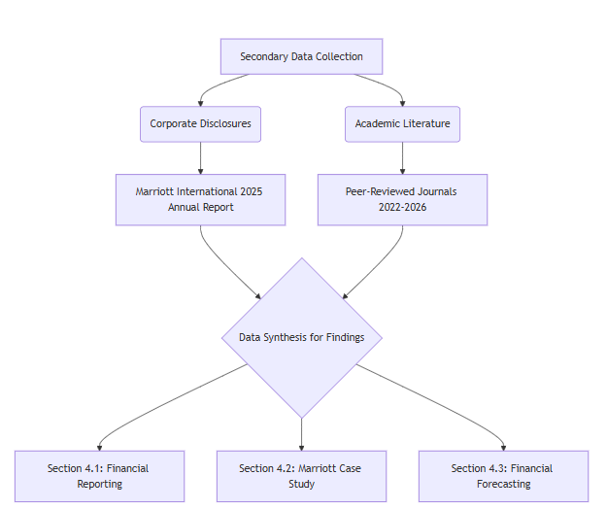
Figure 3.1: Secondary Data Collection and Research Funnel
(Source: Self-Created)
As shown in Figure 3.1, peer-reviewed validity and industry specific relevance are the main focus of the data collection funnel that guarantees a sound basis of the further results.

3.3 Data Analysis
Analytical framework uses a tri-fold approach to analyze the collected data and provide a direct answer to the assignment objectives. First, the thematic analysis will be used to examine the scholarly literature to identify the recent trends in hospitality accounting, including a systematic review of cost management in food and beverage (Ruiz-Fernandez et al., 2025) and human resource cost optimization (Krisnadewi et al., 2026). Second, the quantitative data obtained about Marriott International are subject to strategic operational analysis in order to analyze the efficiency metrics in the context of theoretical frameworks. Lastly, the principles of predictive modelling are considered to the forecasting and break-even results, incorporating the principles of investment viability, cost behaviour asymmetry (de Melo et al., 2022), and five-year projections (Ridwan et al., 2025) to evaluate the viability of new hospitality ventures appropriately.

4. Findings

4.1 Financial Accounting and Reporting in Hospitality

4.1.1 Managing Profitability and Liquidity through Reporting
For a company in the hospitality sector, financial accounting emerges as the most important tool for converting the intricate processes within the business into quantifiable measures of profit and liquidity. Because of the responsiveness of the industry to changes in seasons as well as the unequal ratio between the overheads, high-quality management accounting principles are the first thing to consider for addressing the problem structurally and ensuring its solvency (Campos et al., 2022). This is because the precision and dependability of the financial reporting system will be improved thanks to high-quality accounting. In its turn, the reporting quality will determine the effectiveness of hotels in meeting their liquidity requirements while still making investments in the capital (Alrabei et al., 2023). Failure to have stringent reporting will result in misallocation of the assets by hospitality companies, which will eventually affect their competitiveness and lead them out of business in a relatively unstable market environment.

4.1.2 The Triad of Financial Statements and Industry Standards
Hospitality financial reporting has its architectural base on three main documents, namely, the Income Statement, the Balance Sheet, and the Cash Flow Statement. In a bid to ensure the high comparability of the different properties and international territories, the industry uses the Uniform System of Accounts of Lodging Industry (USALI). Another crucial aspect is to follow the recommendations of the USALI to the letter when going through the process of the financial transparency regardless of the fact that the assimilation of the global regulations is one of the issues that should be addressed in the cases of the local regulatory variances (Elston et al. 2025). It is the empirical foundation of the given financial reports that is needed to determine the performance of the short and long-term asset value.
Financial Statement | Primary Metric | Hospitality Application
Income Statement | Profitability (Net Income) | Evaluates departmental performance (e.g., Rooms vs. Food & Beverage revenue margins).
Balance Sheet | Solvency & Leverage | Assesses the ratio of tangible assets (property) against long-term debt and liabilities.
Cash Flow Statement | Liquidity | Monitors cash reserves necessary for daily operational procurement and payroll.
Table 4.1: Strategic Application of Core Financial Statements in Hospitality
(Source: Self-Created)
Table 4.1 is a culmination of how these statements work in a mutually dependent fashion to provide a holistic view of the financial situation of an organization.
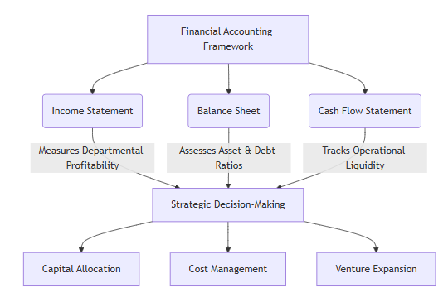
Figure 4.1: Integration of Financial Statements in Hospitality Decision-Making
(Source: Self-Created)
Interdependence of these important financial statements serves as the foundation for strategic planning, as shown in Figure 4.1 below.

4.1.3 Strategic Decision-Making and Governance
Lastly, these mixed financial systems are not mere look backwards regulation policies, but proactive executive strategy instruments. As stated by Avdylaj and Asllanaj (2023), empirical data is provided that proper, real-time accounting information may be vital to the hotel manager in evaluating pricing or assets acquisition or reduction of the operations. In addition, the extrinsic connotation of such reports is highly significant. The principle-based accounting principles inhibit any aggressive earnings management and thereby, increase the credibility of the corporations, besides ensuring that the corporations receive the much-needed external funding or government subsidies during economic uncertainty (Dimitropoulos, 2025). Thus, clear financial reporting is the most significant criterion, which allows relating the daily operations of the hospitality industry to the long-term, sustainable corporate governance according to which the stakeholders might be convinced in the long-term financial orientation of the corporation.

4.2 Cost Control and Management at Marriott International

4.2.1 Operational Efficiency in Big-Cap Operations
It is imperative to develop stringent measures that would enhance the efficiency of operations within such an extensive global portfolio in order to remain profitable at all times. Marriott International is currently operating on an extensive network with more than 1.78 million hotel rooms spread in various international locations. Within such large-capped chain hotels, there are basic measures of achieving success in terms of financial performance, which require that there be minimal variability in overhead costs (Yıldız, 2024). This means that efficient operations at Marriott are achieved through stringent cost control mechanisms (Çelikel, 2025).

4.2.2 Advanced Cost Allocation and Budgeting Strategies
In order to minimize wastage and optimize the utilization of resources, multinational hospitality companies need to evolve to high levels of sophistication in their cost systems (Diavastis, 2025). In the case of Marriott, this is achieved through focusing on its two most costly and variable areas, which include labor costs and procurement costs. The effective management of labor costs is important because the company can reduce its labor costs through the use of predictive labor scheduling and cross training (Krisnadewi et al., 2026).
Cost Center | Independent/Localized Strategy | Marriott International (Big-Cap) Strategy
Food & Beverage | Localized cluster discounts to manage waste (Ranata et al., 2025). | Centralized global procurement leveraging economies of scale.
Human Resources | Reactive shift scheduling based on immediate occupancy. | Predictive human resource cost management (Krisnadewi et al., 2026).
Overhead Tracking | Basic variable cost monitoring using traditional systems. | Advanced cost system sophistication across departments (Diavastis, 2025).
Table 4.2: Comparative Hospitality Cost Control Strategies
(Source: Self-Created)
On the other hand, while smaller or isolated businesses might be forced to employ cluster discounts to control their margins in food and beverages (Ranata et al., 2025), the huge economies of scale possessed by Marriott make it possible for the company to adopt more sophisticated means in minimizing its procurement costs. This is illustrated in Table 4.2.

4.2.3 Impact on Profitability and Long-Term Sustainability
The result of such proactive methods of resource management is the creation of a basis of stable financial performance within the corporation. In 2025, the adjusted EBITDA generated by Marriott totaled 5.38 billion, which is the direct result of efficient budgeting and cost management in the face of volatile market demands. Nevertheless, the latter are not merely essential for short-term financial efficiency; rather, they become a nonnegotiable component of comprehensive sustainability (Velickovic et al., 2023).
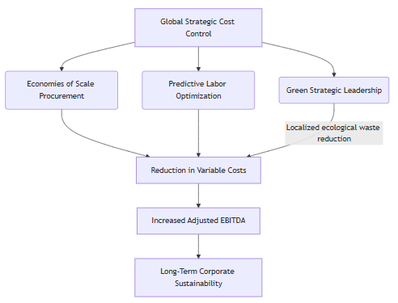
Figure 4.2: Marriott's Integration of Cost Control and Sustainability
(Source: Self-Created)
As shown in Figure 4.2, Marriott interconnects operational management with ecological and financial sustainability through an intricate relationship. For instance, developing skills of green strategic leadership in regional units enables local management teams to creatively manage energy and physical resources more efficiently (Mekdade et al., 2026). Such ecological sustainability in turn becomes the source of reduced operational variable costs, thus proving the interconnection between environmental and financial sustainability.

4.3 Break-Even Analysis and Financial Forecasting

4.3.1 Assessing Financial Viability for New Ventures
To have a complete evaluation of the financial viability of new projects, it is imperative that companies should transcend the limits of traditional accounting practices and adopt financial forecasting techniques. The financial risk associated with the construction of new hotels requires forecasting of the future financial conditions before planning the undertaking of any project. To come up with an appropriate forecasting strategy, it is required that the company must be able to predict its future financial conditions over a number of years using investment analysis tools such as Net Present Value, Internal Rate of Return, and Return on Investment (Ridwan et al., 2025). Financial forecasting helps the management compare its future cash flow position with that of the volatility prevailing in the market environment to ensure that the huge investments made are aligned with organizational objectives.

4.3.2 Cost Behavior: Fixed, Variable, and Asymmetric Dynamics
An integral part of being able to accurately forecast is having a comprehensive grasp of the underlying structures of cost behavior. Break-even analysis usually considers two types of costs: one that comprises fixed costs such as extended rental agreements for long-term property and staff costs related to administration, while the second comprises variable costs based on daily usage such as room costs and local food purchasing (Ranata et al., 2025). For more sophisticated forecasting, one must consider asymmetries in cost behavior. In the case of the hospitality industry, costs have the tendency to be sticky in that the cost structures escalate much more rapidly when there is an increase in income compared to an unforeseen recession (de Melo et al., 2022).
Cost Classification | Defining Characteristic | Hospitality Application & Impact
Fixed Costs | Remain constant regardless of occupancy volume. | Property rent, insurance; creates high operating leverage.
Variable Costs | Fluctuate directly with guest volume and sales. | F&B supplies, hourly wages; dictates the contribution margin.
Asymmetric (Sticky) Costs | Costs resist downward adjustment during low demand. | Management retention during low seasons (de Melo et al., 2022).
Table 4.3: Cost Behavior Classifications in Hospitality Forecasting
(Source: Self-Created)
Table 4.3 identifies these important cost categories and the corresponding structural forecasting implications.

4.3.3 Strategic Application of the Break-Even Point
Application of these intricate cost behaviors in a structured break-even analysis helps determine an exact revenue level at which a hotel business will just manage to survive without losses. This crucial mathematical point, where the overall projected revenues equate with total costs, serves as a benchmark in decision-making strategies (Avdylaj & Asllanaj, 2023). Figure 4.3 shows the structural elements of this break-even line for a typical hospitality business.
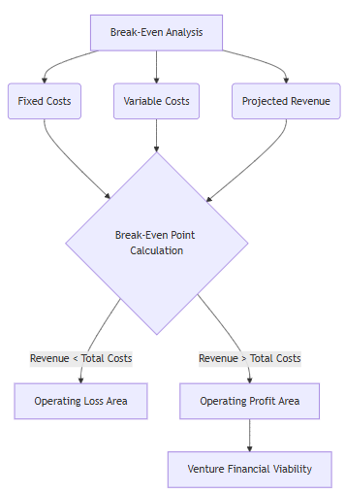
Figure 4.3: Break-Even Trajectory and Cost Volume Profit Analysis
(Source: Self-Created)
Through careful use of these tools, hospitality managers will be able to make well-informed decisions with respect to price setting, staffing issues, and other services. In contrast to conventional budgeting considerations, application of break-even points and sophisticated multi-year financial forecasting helps reduce risks associated with starting a new hospitality business. These approaches allow managers to effectively cope with structural risks associated with starting a new venture and protect themselves from inefficiencies in financial matters, ensuring efficiency in operations worldwide (Yıldız, 2024). Moreover, application of advanced forecasting models allows managers to subject their budgeting strategy to stress testing, which is necessary in order to ensure survival of the venture under unfavorable economic circumstances.

5. Discussion

5.1 Integration of Findings

5.1.1 Interrelationship Between Financial Accounting, Cost Control, and Forecasting
Profitability and liquidity well structured by financial accounting that is basis analysis (Dashkevich et al. 2024). Cost control uses those numerous data to rectify issues and update their operational capability and reduce waste. Forecasting builds up to assume future performance. By accumulating those features act as an integrated financial management system, facilitate the hospitality sector link up between short term efficiency with long term investment in strategic planning and sustainability.

5.1.2 Financial Reporting as the Foundation of Strategic Decision-Making
The income statement, balance sheet along with cash flow statement all of this represent the actual profitability, financial position, and liquidity (Agrawal, 2023). All these are not just reporting tools rather critical inputs for essential decisions. They help to maintain pricing strategies, investment planning, and resource allocation. Active use of these reports enables hospitality managers to take responsibility in data-driven decisions which boost both operational performance and financial stability.

5.1.3 Cost Control as a Driver of Operational Efficiency and Profitability
Findings from Marriott demonstrates that active use of cost allocation, budgeting, and procurement strategies lead to a positive effect on operational efficiency and profit margins (Silvia-Patricia et al. 2024). Advanced cost management programmes enable big farms to optimise resources and minimise waste. Whereas the small hospitality sector can experience limitations to adapt such systems as its high price with complexity. It clearly shows differences in operational efficiency across industry segments.

5.1.4 Forecasting and Break-Even Analysis in Long-Term Financial Sustainability
Managerial focus can be shifted from past performance to future planning through the break-even analysis and financial forecasting (Azra and Azzuhri, 2025). Such tools enable use of financial viability, estimate required revenue levels, and evaluate investment risks. Adding cost behaviour and revenue projections, in the hospitality sector help to take decisions about new ventures, reduce uncertainty, and ensure long-term financial sustainability in such a pressurized market.

5.2 Critical Analysis

5.2.1 Limitations of Financial Accounting in Dynamic Hospitality Environments
Financial accounting operates backward because it only documents previous financial activities without making any forecasts about upcoming events (Kureljusic and Karger, 2024). The hospitality industry faces this challenge because its seasonal demand patterns and unexpected events like pandemic and economic downturns remain impossible to predict. The use of accounting data as the sole source of information creates a situation where organizations experience slower decision processes and lesser ability to handle changes in rapidly evolving business situations which lack certainty.

5.2.2 Challenges in Cost Control Implementation Across Different Hospitality Scales
Larger companies such as Marriott implement cultured cost management systems but smaller hospitality businesses face obstacles because they cannot afford to implement these methods which require specialized knowledge (Hansen et al. 2025). These systems require technology, expertise and scale, which may not be accessible for all. The excessive cost control standardisation process decreases operational flexibility because it prevents business from creating quick responses to market and consumer demands.
.2.3 Constraints of Forecasting and Break-Even Models in Uncertain Markets
Forecasting and break-even analysis depend on demand, cost and revenue assumptions, which do not apply to volatile hospitality markets. Demand unpredictability, fluctuating costs, and the presence of sticky costs reduce accuracy. The planning tools provide useful planning assistance but they do not eliminate all future uncertainties. Managers should use these instruments with care because they need to combine them with adaptable decision-making methods for effective results.

5.2.4 Trade-Off Between Profitability and Liquidity
The hospitality industry faces a major financial management challenges which requires executives to find the optimal balance between profitability and liquidity. The pursuit of profitability through operational activities leads to cash shortages which create liquidity threats while organizations need to maintain their liquid assets.

5.3 Implications for Management

5.3.1 Adoption of Integrated Financial Management Systems
Managers are advised to embrace integration approach, that is, integrate financial accounting, cost control as well as forecasting instead of applying them individually. Accounting gives information, cost control enhances efficiency, and forecasting helps in planning the future (Sanakal, 2023). Wholesome financial approach enables greater co-ordination of operations and plans. This integration assists hospitality companies to better their decision-making process, risk management, as well as short-term performance, and long-term sustainability.

5.3.2 Enhancing Decision-Making Through Real-Time Financial Reporting
Hospitality managers ought to abandon the old fashioned non dynamic financial reports to real time reporting systems. Monitoring the financial performance on a continuous basis is made possible by the use of digital dashboards and data analytics (Adekunle et al. 2023). This will enable faster finding of cost, revenue, and cash flow issues. Real-time insights enhance decision-making responsiveness and contribute to rapid and more informed decision-making in dynamic and competitive hospitality market conditions.

5.3.3 Strategic Cost Management and Resource Optimization
In order to enhance precision of cost allocation, managers ought to employ modern cost management models like the Activity-Based Costing and predictive labour management. These methods aid in determining the drivers of costs and maximising the usage of resources (Chen, 2025). Hospitality companies can improve their profitability by concentrating on lowering waste and increasing efficiency of their operations. Strategic cost management helps in the enhanced management of the variable expenditure as well as enhancing the performance of the finances.

5.3.4 Strengthening Financial Planning and Risk Management
Financial forecasting and break-even analysis should help hospitality firms to plan new projects and business expansion. The tools are used to approximate the future revenues, costs, as well as risks. Scenario planning may also be used and stress testing to manage uncertainty and market volatility by managers. This would increase financial resiliency and that investment decisions are derived to correspond with business long-term goals.

5.3.5 Balancing Short-Term Performance with Long-Term Sustainability
Profitability, liquidity and sustainability were the three elements that managers need to balance financial decision making. Only concentrating on short-term profits can lead to weakening cash flow, whereas the excess liquidity can hamper growth opportunities. The balanced strategy provides financial stability and is geared towards long-term development. To be sustainable in their financial management, there is a need to ensure congruency between short term performance objectives and strategic planning in order to remain competitive and resilient in the hotel business.

6. Conclusion

6.1 Linking with Objectives
Objective 1: To critically examine how financial accounting can be used to manage profitability and liquidity in the hospitality industry
This goal has been realised through the examination of the translation of operational activities in measurable indicators of profitability and liquidity through financial accounting (Isibor et al. 2022). The research revealed that structured reporting enhances control in finance as well as stability. It became clear that proper accounting will make it easier to manage cash and track profits, yet it has to be combined with other tools and overcome industry-specific issues related to demand fluctuations and uncertainty.
Objective 2: To determine the significance of key financial statements in the provision of effective decision-making in hospitality management
This has been achieved by showing how the income statement, balance sheet, and cash flow statement aid in managerial decision making. The results indicated that the statements contain vital information on the performance, financial position, and liquidity. We knew that they are not merely reporting tools, but also strategic tools that inform decisions on pricing, investment and allocation of resources in hospitality management.
Objective 3: To discuss the cost control and cost management strategies applied by Marriott International
This goal has been attained by analyzing Marriott cost control measures such as advanced cost allocation, budgeting and procurement strategies. The paper revealed the efficiency and profitability of these methods at a high scale level. It became known that cost management is the key to the successful operations but it is applied differently by firms since they differ in terms of size, resources, and technological capabilities (Olajide et al. 2022).
Objective 4: To evaluate the use of break-even analysis and financial forecasting in evaluating the financial feasibility of hospitality firms
This has been achieved by assessing the extent to which break-even analysis and financial forecasting help in making investment and planning decisions. The research revealed that the tools are useful to evaluate financial viability, estimate the amount of revenue required, and have risks under control. It was realized that although forecasting enhances better planning and eliminates uncertainty, it is sensitive to proper assumptions, and should be used flexible in the dynamic market environment.

6.2 Recommendations for Future Research
1. Exploration of Real-Time Financial Technologies
In future areas, there are several areas to focus on including how real time financial reporting systems can improve decision making in hospitality. This paper effectively highlights the limitations of traditional accounting, reflects the need for exploring how technology improves responsiveness and financial accuracy.
2. Comparative Analysis Across Different Hospitality Scales
Future studies must focus on comparing financial management practices among large chains like Marriott and small or medium sized hospitality firms. This can help in gathering deeper information into the scalability and adaptibility of cost control and financial strategies throughout different diverse operational contexts.
3. Advanced Forecasting Models in Uncertain Environments
Future study must target on improving many adaptive forecasting models that account for demand volatility, changing cost structures. This can develop the reliability of financial planning tools in high dynamic hospitality markets.

References
Adekunle, B. I., Chukwuma-Eke, E. C., Balogun, E. D., & Ogunsola, K. O. (2023). Developing a digital operations dashboard for real-time financial compliance monitoring in multinational corporations. International Journal of Scientific Research in Computer Science, Engineering and Information Technology, 9(3), 728-746. https://www.researchgate.net/profile/Bolaji-Adekunle/publication/390113766_Developing_a_Digital_Operations_Dashboard_for_Real-Time_Financial_Compliance_Monitoring_in_Multinational_Corporations/links/67e0bd6a35f7044c928271a8/Developing-a-Digital-Operations-Dashboard-for-Real-Time-Financial-Compliance-Monitoring-in-Multinational-Corporations.pdf
Adetayo, A. R., Abosede, A. F., Olajumoke, O. R., & Aderemi, A. (2025). A Comparative Study of Traditional and Activity-Based Costing Methods for Cost Allocation in Business Practices. International Journal of Innovative Scientific Research, 3(2), 14-18. https://ijisr.net/ijisr/article/view/81
Agapito, D., & Sigala, M. (2024). Experience management in hospitality and tourism: reflections and implications for future research. International Journal of Contemporary Hospitality Management, 36(13), 57-76. http://dx.doi.org/10.1108/IJCHM-11-2023-1722
Agrawal, S. (2023). The role of financial statements in understanding a company’s financial position and preparing and analyzing such statements. International Journal of Social Science & Economic Research, 8(07), 1833-1846. https://ijsser.org/2023files/ijsser_08__136.pdf
Alrabei, A. M., Jawabreh, O., & Abdullah Saleh, M. M. (2023). Accounting Information and Role It on Financial Reports Quality in Jordanian Hotels, and Social Performance as a Mediating Effect. International Journal of Sustainable Development & Planning, 18(7). https://doi.org/10.18280/ijsdp.180732
Avdylaj, A., & Asllanaj, R. (2023). The impact of accounting on business decision-making: A case study of the hotel industry in Kosovo. Multidisciplinary Science Journal, 6(6), 2024100. https://doi.org/10.31893/multiscience.2024100
Azra, A., & Azzuhri, M. (2025). Break-Even Point Analysis and Sales Planning for Financial Strategy Optimization. Jurnal Kewirausahaan dan Inovasi, 4(1). https://jki.ub.ac.id/index.php/jki/article/download/466/263
Barbakadze, K. (2024). Priorities of financial management of liquidity and profitability. Georgian Scientists, 6(2), 51-56. https://journals.4science.ge/index.php/GS/article/view/2748
Campos, F., Gomes, C., Cardoso, L., & Lima Santos, L. (2022). Management accounting practices in the hospitality Industry: The Portuguese background. International Journal of Financial Studies, 10(4), 88. https://doi.org/10.3390/ijfs10040088
Campos, F., Lima Santos, L., Gomes, C., & Cardoso, L. (2022). Management accounting practices in the hospitality industry: A systematic review and critical approach. Tourism and Hospitality, 3(1), 243-264. https://doi.org/10.3390/tourhosp3010017
Çelikel, F. (2025). Strategic Management in Hospitality Businesses: The Trajectory of Competitiveness and Operational Efficiency. İzlek Akademik Dergi, 7(2), 11-28. https://doi.org/10.53804/izlek.1587479
Chen, B. (2025). Leveraging Advanced AI in Activity-Based Costing (ABC) for Enhanced Cost Management. Journal of Computer, Signal, and System Research, 2(1), 53-62. https://www.gbspress.com/index.php/JCSSR/article/download/68/61
Dashkevich, N., Counsell, S., & Destefanis, G. (2024). Blockchain financial statements: innovating financial reporting, accounting, and liquidity management. Future Internet, 16(7), 244. https://www.mdpi.com/1999-5903/16/7/244
de Melo, J. A. S., Marques, K. C. M., Wencel, S. L. S. S., & Abbas, K. (2022). Asymmetric cost behavior in competitor analysis: study through public information. Revista Contemporânea de Contabilidade, 19(52), 95-111. https://doi.org/10.5007/2175-8069.2022.e83004
Diavastis, I. E. (2025). What Drives Cost System Sophistication? Empirical Evidence from the Greek Hotel Industry. Journal of Risk and Financial Management, 18(7), 401. https://doi.org/10.3390/jrfm18070401
Dimitropoulos, P. E. (2025). Principle-based accounting standards and earnings management in private hotel firms: The impact on government subsidies. Advances in accounting, 68, 100812. https://doi.org/10.1016/j.adiac.2025.100812
Dimitrova, T. (2025). Certain highlights on the major changes in the uniform system of accounts for the lodging industry 12th revised edition. Economics and Computer Science, 11(2), 13-18. https://eknigibg.net/ojs/index.php/ecs/article/view/28
Elston, J. N., Coelho, L. M. R., & Peixinho, R. M. T. (2025). Show me the money: A systematic literature review on financial transparency and USALI’s global adoption challenges. International Journal of Hospitality Management, 131, 104312. https://doi.org/10.1016/j.ijhm.2025.104312
Hansen, D. R., Mowen, M. M., & Heitger, D. L. (2025). Cost management. Cengage Learning. https://www.academia.edu/download/87154865/Cost_Management_Hansen_and_Mowen.pdf
Huang, J., & Anuar, A. B. (2026). A New Energy-Saving Management Framework for Hospitality Operations Based on Model Predictive Control Theory. Tourism and Hospitality, 7(1), 23. https://doi.org/10.3390/tourhosp7010023
Hutsaliuk, O., Bondar, I., Zhurylo, I., & Dub, V. (2024). Economic strategizing and integration management of hotel and restaurant business enterprises in the hospitality industry system. https://doi.org/10.12958/1817-3772-2024-4(78)-82-90
Isibor, N. J., Ibeh, A. I., Ewim, C. P. M., Sam-Bulya, N. J., & Martha, E. (2022). A financial control and performance management framework for SMEs: Strengthening budgeting, risk mitigation, and profitability. International Journal of Multidisciplinary Research and Growth Evaluation, 3(1), 761-768. https://www.allmultidisciplinaryjournal.com/uploads/archives/20250312174231_MGE-2025-2-055.1.pdf
Krisnadewi, K. A., Sudana, I. P., Widanaputra, A. A. G. P., Listi, M. L., & Handayani, N. P. D. (2026). Sustainability in the hotel industry through human resource cost management. Social Sciences & Humanities Open, 13, 102577. https://doi.org/10.1016/j.ssaho.2026.102577
Kureljusic, M., & Karger, E. (2024). Forecasting in financial accounting with artificial intelligence–A systematic literature review and future research agenda. Journal of Applied Accounting Research, 25(1), 81-104. https://www.emerald.com/jaar/article-pdf/25/1/81/9475781/jaar-06-2022-0146.pdf
Marriott.gcs-web.com (2025). “Marriott International 2025ANNUAL REPORT”. Retrieved from: https://marriott.gcs-web.com/static-files/9cf0e9b0-bbfa-48a6-9e21-ffbdbc4b2d78 (Retrieved on: 7th April 2026)
Mekdade, I., Hamouda, N., Abbas, B. A. H., Jasim, S., Mohammed, D. J. M., & Aljaeed, S. A. (2026). The Role of Green Strategic Leadership Capabilities in Creating a Green Climate for Creativity: Evidence from Marriott Hotels in Qatar. Journal of Chinese Human Resources Management, 17(1), 98-119. https://doi.org/10.47297/wspchrmWSP2040-800506.20261701
Nasir, M. E., & Gunawan, I. (2025). Optimizing cost control in the hospitality sector: A comprehensive study of food and beverage management. Daengku: Journal of Humanities and Social Sciences Innovation, 5(1), 1-8. https://jpabdimas.idjournal.eu/index.php/daengku/article/view/3233
Nguyen, L. T. M., Le, D., Vu, K. T., & Tran, T. K. (2023). The role of capital structure management in maintaining the financial stability of hotel firms during the pandemic—A global investigation. International Journal of Hospitality Management, 109, 103366. https://www.sciencedirect.com/science/article/pii/S0278431922002328
Olajide, J. O., Otokiti, B. O., Nwani, S., Ogunmokun, A. S., & Iyanu, B. (2022). Integrating Financial Strategy with Operational Cost Structures in Manufacturing Cost Management Models. Journal of Frontiers in Multidisciplinary Research, 3(1), 372-377. https://www.researchgate.net/profile/Adebanji-Samuel-Ogunmokun/publication/392726157_Integrating_Financial_Strategy_with_Operational_Cost_Structures_in_Manufacturing_Cost_Management_Models/links/68570e00e8fa0f5c28259b27/Integrating-Financial-Strategy-with-Operational-Cost-Structures-in-Manufacturing-Cost-Management-Models.pdf
Patsatsia, A. (2024). Capital Investment Planning in Renewable Energy in Hospitality Sector: Strategy and Evaluation. https://www.theseus.fi/handle/10024/855837
RANATA, P. B. A. S., DAMAYANTI, T., & MARENI, N. K. (2025). Implementation of Food Procurement with Cluster Discounts to Increase Food Cost Efficiency in Hotels X. Journal of Governance, Taxation and Auditing, 3(4), 430-436. https://doi.org/10.38142/jogta.v3i4.1621
Ridwan, S., Syah, T. Y. R., Kustiawan, U., & Nofierni, N. (2025). Financial planning and investment feasibility analysis based on five-year projections using ROI, NPV, IRR, and financial ratios. Journal La Bisecoman, 6(2), 489-506. https://doi.org/10.37899/journallabisecoman.v6i2.1970
Ruiz-Fernández, A., Bonilla-Priego, M. J., Nájera-Sánchez, J. J., & Pelechano-Barahona, E. (2025). Mapping cost management research in the restaurant industry: A systematic review and research agenda. Tourism and Hospitality Research, 14673584261439038. https://doi.org/10.1177/14673584261439038
Sanakal, A. P. (2023). The Future of Management Accounting: AI Enhanced Cost Control Using ERP. IJRESM, 4, 11-12. https://www.researchgate.net/profile/Abhishek-Sanakal-2/publication/392519431_The_Future_of_Management_Accounting_AI-Enhanced_Cost_Control_Using_ERP/links/6846c734df0e3f544f5dbbc2/The-Future-of-Management-Accounting-AI-Enhanced-Cost-Control-Using-ERP.pdf
Silvia-Patricia, D., Camelia-Elena, C., & Iulian, P. (2024). Pricing Strategies In Hospitality. Analyzing Courtyard By Marriott’S Policies And Their Impact On Occupancy Rates. Romanian Economic and Business Review, 19(4), 43-52. https://rebe.rau.ro/REBE-WI24.pdf#page=43
Velickovic, G., Stanojevic, J., & Veselinovic, M. (2023). Managing Financial Performance toward Achievements in Sustainability Prospects: Comparative Analysis of the e-Commerce and Hospitality Industries. Journal of Risk and Financial Management, 16(9), 395. https://doi.org/10.3390/jrfm16090395
Yıldız, B. (2024). Determinants of Financial Efficiency and Performance in Big-Cap Chain Hotels. Ekonomi Politika ve Finans Araştırmaları Dergisi, 9(2), 254-270. https://doi.org/10.30784/epfad.1452277

Appendices

Appendix A: Marriott International 2025 Financial Highlights
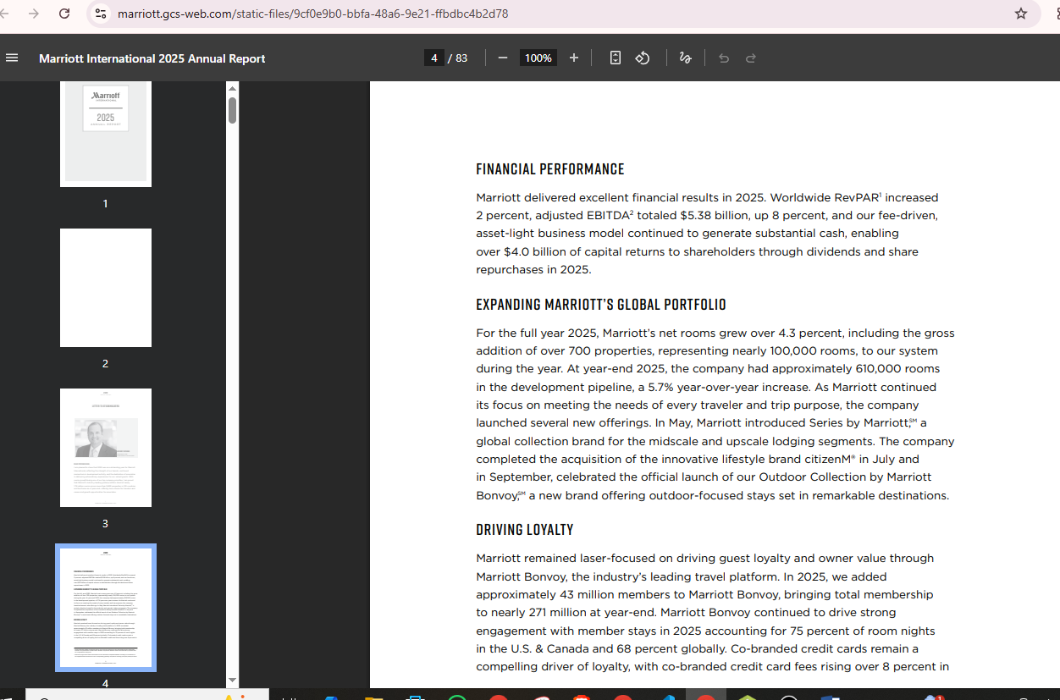
Figure A.1: Marriott International 2025 Annual Report Summary
(Source: Marriott International 2025ANNUAL REPORT)

Appendix B: Search Strategy and Methodology Log
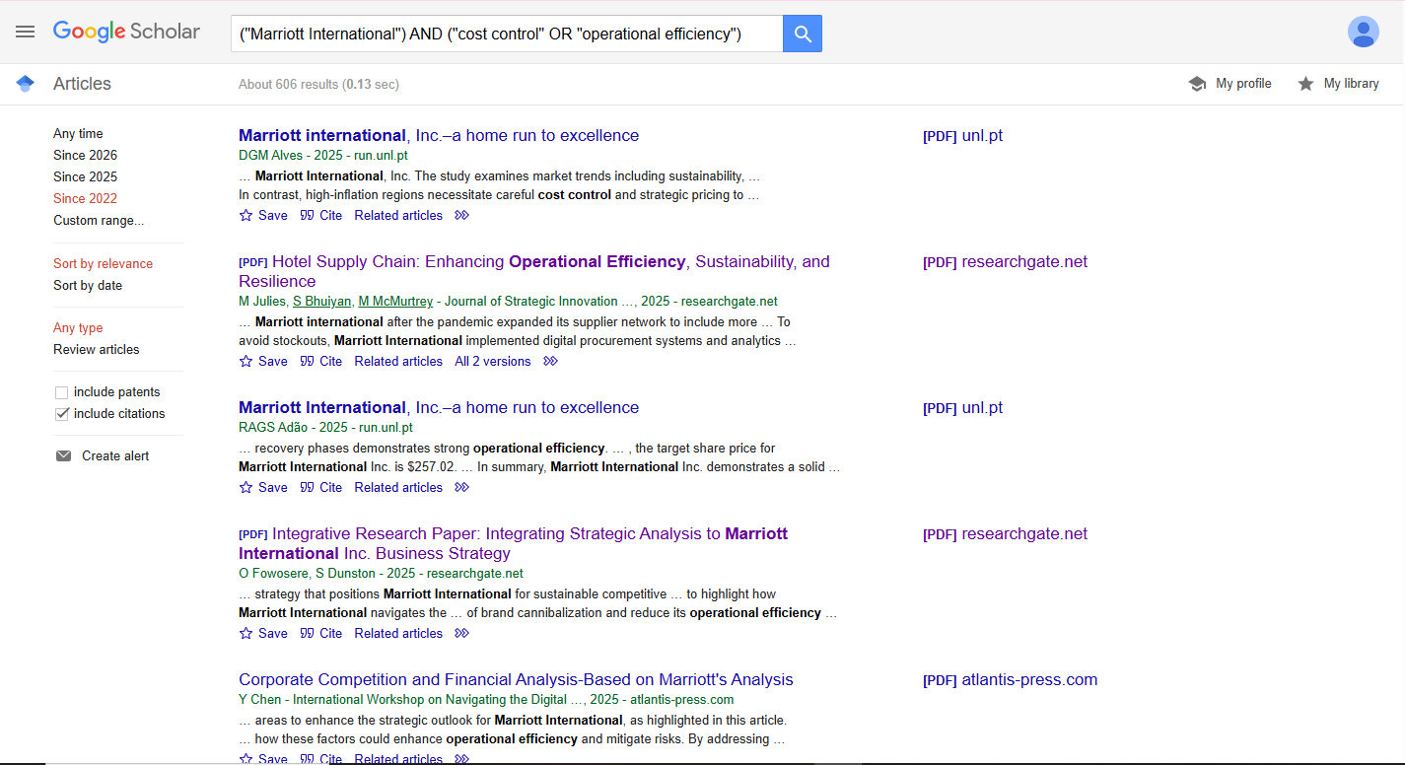
Figure B.1: Systematic Literature Search via Google Scholar
(Source: Google Scholar)

