
Data Analytics for Business
Predictive Analytics and Machine Learning in Supply Chain and Operations
Student name: Rajkumar Kantibhai Donga
Student ID : HMH26006

Abstract
This paper will critically assess the potential of predictive analytics and machine learning (ML) to help businesses streamline their supply-chain processes and enhance cost-efficiency, operational responsiveness and reliability in customer fulfilment. Through a second method of qualitative research, the paper summarises the introduction of scholarly and industrial findings and business information analysing AI-based demand prediction, dynamic pricing mechanisms, predictive maintenance, automated inventory mechanisms and supply-chain observation. Amazon, Walmart and Zara/Inditex are considered as case examples of supply-chain management based on data. These findings indicate that AI and ML have the potential of improving on the responsiveness of demand and inventory decisions, efficiency and reliability of fulfillment operations by integrating historical, real-time and customer data. However, to achieve the implementation, the data quality process, technological infrastructure, and cybersecurity, governance, and appropriate human control are needed. The paper forms an integrated AI-enabled operational model, integrating the data infrastructure, predictive analytics, automated decisions, operational procedures and/or feedback. It proposes the application of AI in stages, in the first stage trusted data infrastructure, predictive applications of high value are deployed and then proceed to enhance operations through automation.

Table of Contents
1. Introduction 5
1.1 Background to AI in Supply Chain and Operations 5
1.2 Problem Statement 5
1.3 Aim and Objectives 6
2. Literature Review 6
2.1 Conventional Forecasting and Its Limitations 6
2.2 Machine Learning-Based Predictive Forecasting 7
2.3 AI in Supply Chain and Operations 8
2.4 AI-Based Supply Chain Visibility and Customer Fulfilment 10
2.5 Theoretical and Conceptual Perspective 10
3.1 Research Approach 11
3.2 Data Sources 11
3.3 Case Study Selection 11
3.4 Analysis Method 12
3.5 Methodological Limitations 12
4. Findings 13
4.1 AI-Driven Demand Forecasting 13
4.2 AI Applications and Operational Performance 13
4.3 Amazon Case Study 14
4.4 Walmart Case Study 15
4.5 Zara/Inditex Case Study 16
4.6 Customer Fulfilment Reliability and Satisfaction. 17
5. Discussion 18
5.1 Cost Optimisation vs Operational Agility. 18
5.2 AI Visibility and Customer Fulfilment 19
5.3 Limitations and Risks of Predictive ML 19
5.4 Unified Framework for AI-Enabled Operational Workflow 20
6. Conclusion 22
6.1 Key Findings 22
6.2 Strategic Implications 23
6.3 Final Recommendation 23
Reference List 24

1. Introduction

1.1 Background to AI in Supply Chain and Operations
Machine Learning (ML) and Artificial Intelligence (AI) are emerging to revolutionize supply-chain and operational management by providing organisations with the ability to analyse vast quantities of data, recognize patterns, and aid automated decision-making. Global sourcing, interdependence between suppliers, and developing customer tastes and demands for delivery have accelerated the development of the modern supply chain. Volatile demand and supply, inflation, and uncertainty only add to the difficulty of appropriate inventory, production, and logistics planning. Consequently, organisations are also moving towards equipping themselves with traditional forecasting methods, predictive analytics and real-time data-driven systems, which are more suited to respond to emergent situations more swiftly.

1.2 Problem Statement
Conventional forecasting approaches tend to be comprehensive in terms of historical data usage, mean, and fairly constant assumptions. Such approaches can fail in the event of a spike and shrinkage in demand or when supply and logistics get disrupted due to unexpected situations. They may also find it difficult to capture the intricate interrelations of pricing, customer behaviour, promotions, weather, and the market environment. The prospect of overcoming these limitations is big data: The use of ML-based predictive models opens the perspective of transforming different and real-time data. They may need time to work, but they will work as soon as the data is good and the technological infrastructure and its adequate implementation are available.

1.3 Aim and Objectives
The aim of the study is to critically evaluate how predictive analytics and ML can optimise supply-chain workflows while improving cost efficiency, operational agility, and customer fulfilment reliability.
Objectives:
- To examine inadequacies of conventional forecasting approaches in a volatile marketplace.
- To determine the role of machine learning in demand prediction and operational decision-making.
- To identify the impact of AI applications, including dynamic pricing, predictive maintenance, and automatic inventory control, on cost optimisation and operational agility.
- To determine the relationship between AI-based supply-chain visibility and customer fulfilment reliability and satisfaction.
- To compare Amazon, Walmart, and Zara as exemplars of data-driven supply-chain management.
- To introduce a single AI-based platform to organize infrastructure and operational processes.

2. Literature Review

2.1 Conventional Forecasting and Its Limitations
Traditional supply-chain forecasting is usually based on past demand, moving averages, exponential smoothing, regression, and fixed inventory assumptions. Although these methods could be applied when the market situation is comparatively stable, the dependence on historic patterns does not allow them to react to sudden changes in demand and supply. The risk of uncertainty is further heightened by the uncertainty that exists in volatile markets with changing customer preferences, inflation, disturbances, and unpredictable purchase behaviour. According to Kagalwala et al. (2025), traditional forecasting approaches can be ineffective in the more complex context of the supply chain because they cannot work with multiple types of information, which can change rather rapidly. Therefore, predictive methods with very high reliance on historical averages may respond with inadequate forecasting in case of a change in the structure or whenever there is a sudden shock. This shortcoming has prompted organisations to set up predictive analytics and machine learning (ML) methods that can highlight more intricate relationships in extensive datasets.

2.2 Machine Learning-Based Predictive Forecasting
Prediction using ML is more adaptive because it applies algorithms to identify patterns with reference to the historical and real-time information. Approaches can include time-series models and neural networks, supervised learning, and ensemble methods. Wang et al. (2024) show that Long Short-Term Memory (LSTM) networks can overcome limitations of traditional recurrent neural networks in sequential prediction, showing how more sophisticated models can help to recognize more intricate temporal dependencies. Similarly, Islam et al. (2024) ascertain the applicability of hybrid ML techniques to augment the forecasting of demand and strategic decision-making in retail stores. These models are able to include sales, pricing, promotions, customer behaviour, inventory, and logistics information in supply chains.
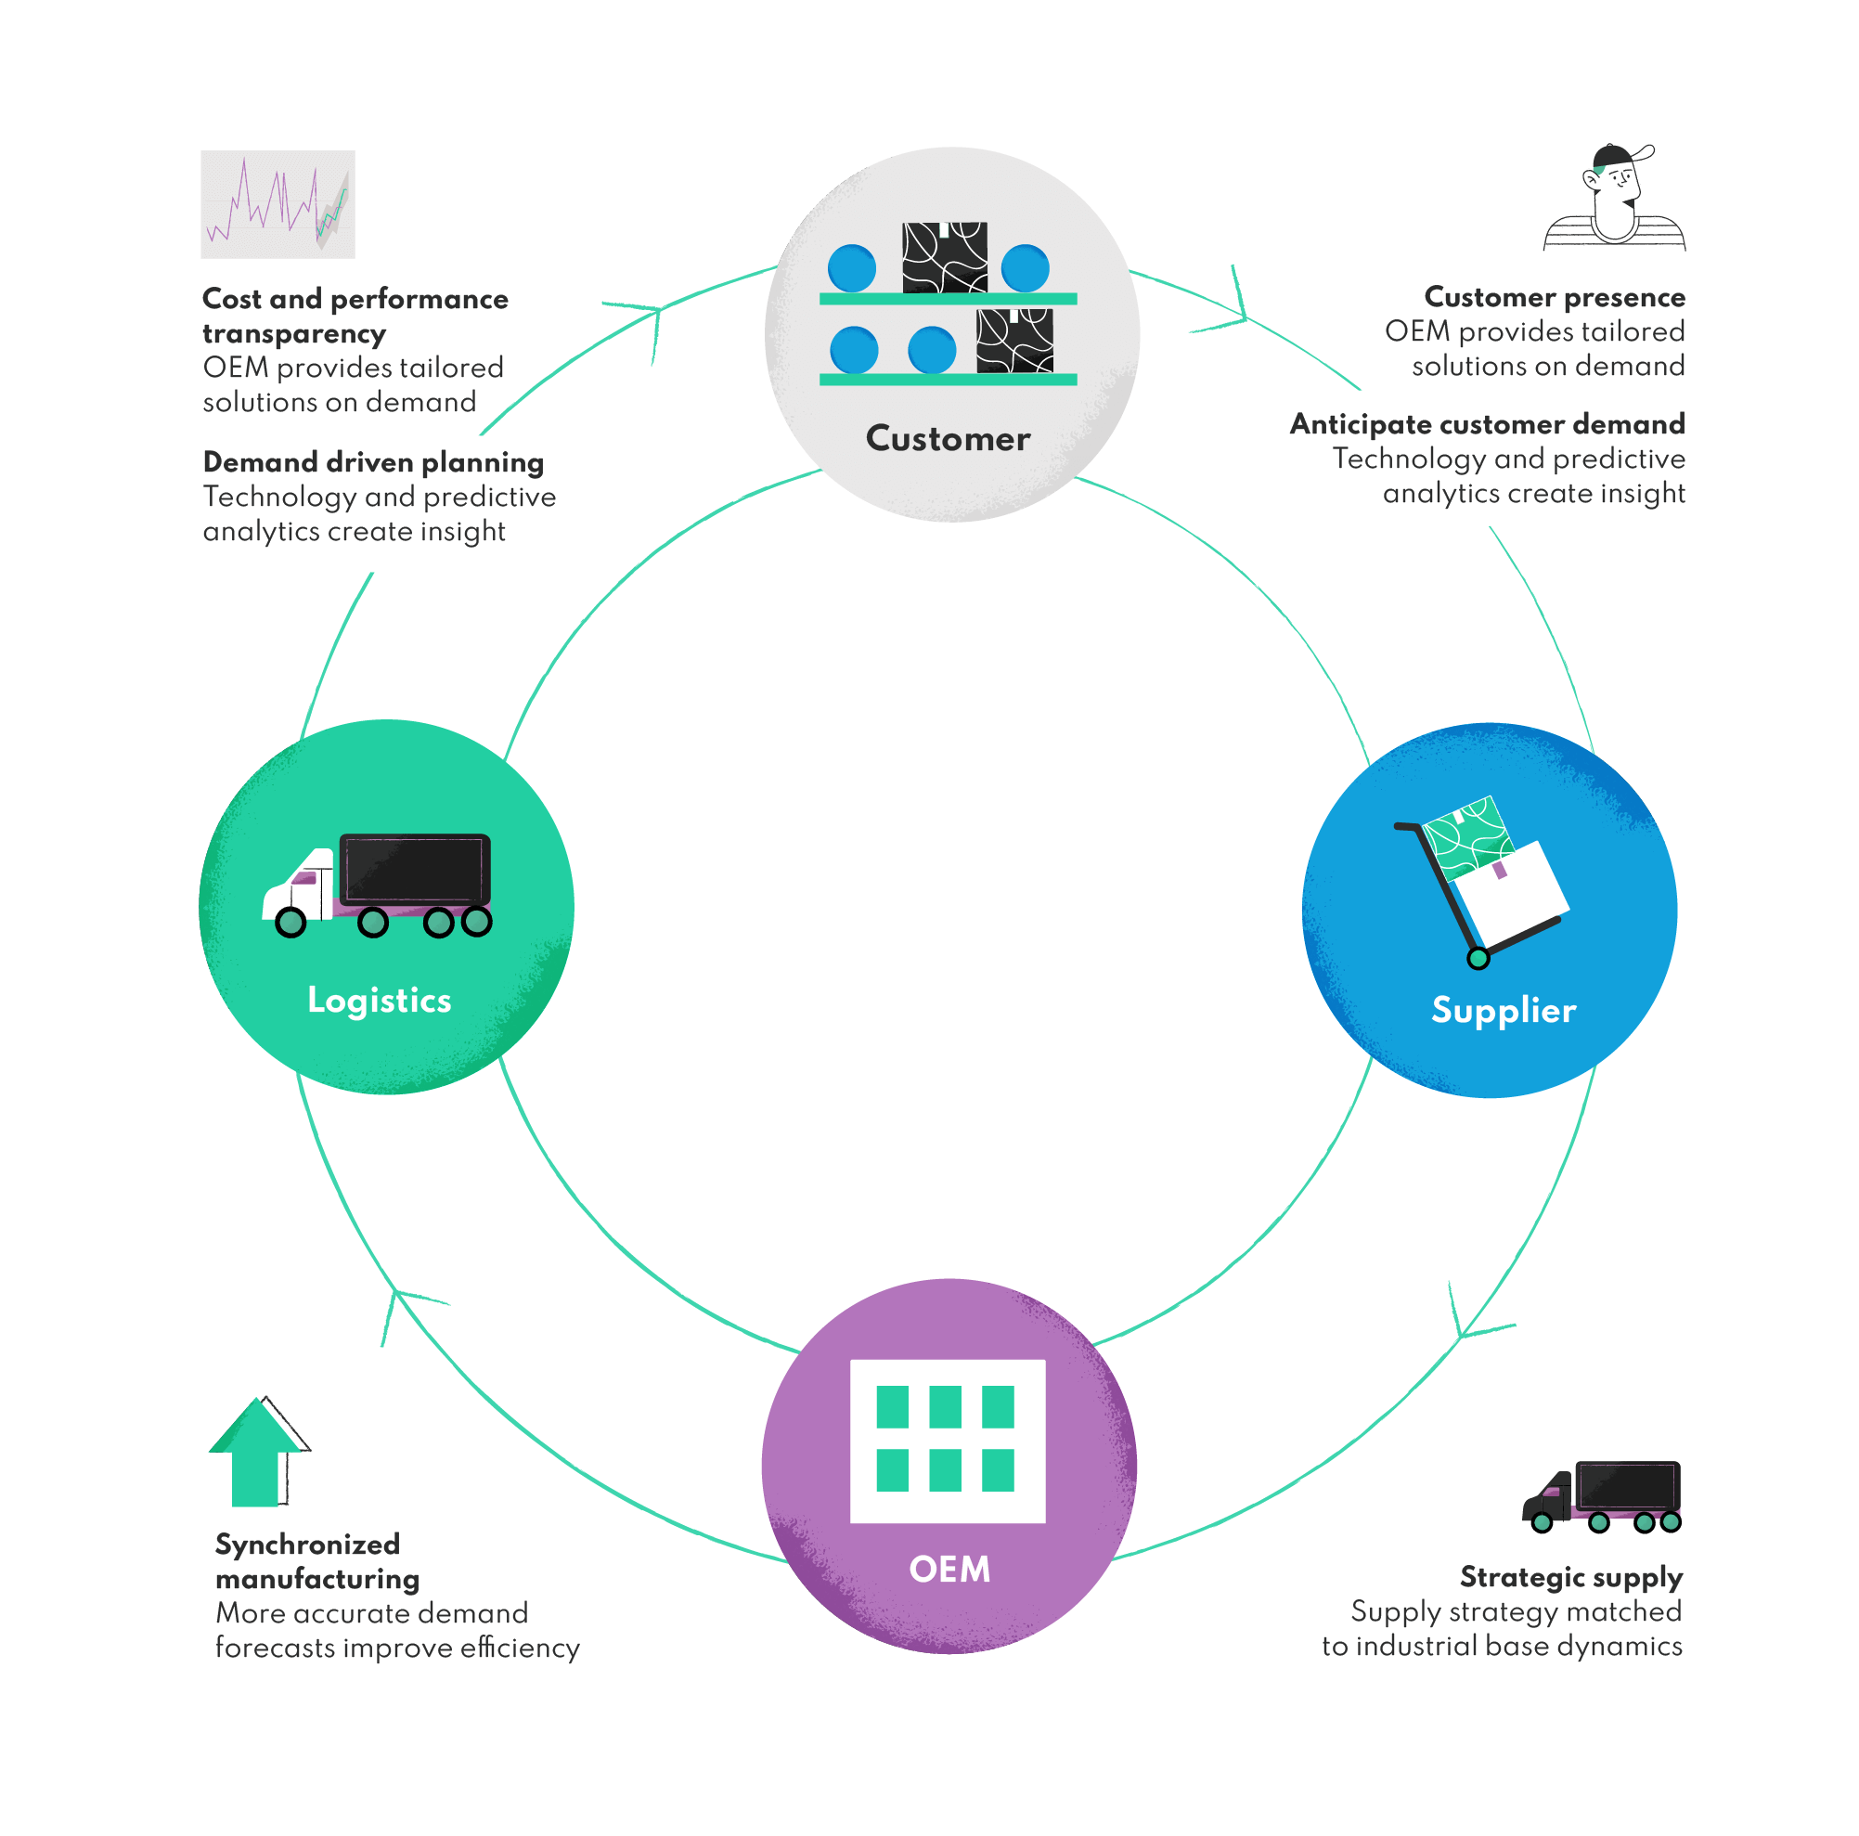
Figure 1: Machine Learning-Based Predictive Forecasting in Supply Chain and Operations
(Source: Owczarek, 2024)

2.3 AI in Supply Chain and Operations
AI can be applied in various functional areas. The forecasting of demand with the help of AI can also improve planning of production and procurement by identifying the changing demand trends. Kagalwala et al. (2025) emphasize the importance of AI and ML in fortifying demand forecasting, whereas Verma (2024) associates AI-based predictions with inventory control and dynamic optimisation. Dynamic pricing can be used to set prices faster using demand, market, and inventory information, and can be more valuable in helping maximise revenues and inventory utilisation. The same is touched upon by Kaul (2023), who speaks of the amalgamation of predictive analytics and dynamic pricing and real-time inventory management. Predictive maintenance can also analyze the condition of equipment and sensors on the equipment to identify potential failures before they have to halt the work to minimize downtime and maintenance costs. Lastly, automated inventory management has the capacity to benefit replenishment, stock-level decisions, and resource allocation. According to Riad et al. (2024), AI has the potential to improve the supply chain, which relates to its ability to optimise and become more responsive to the organisation.
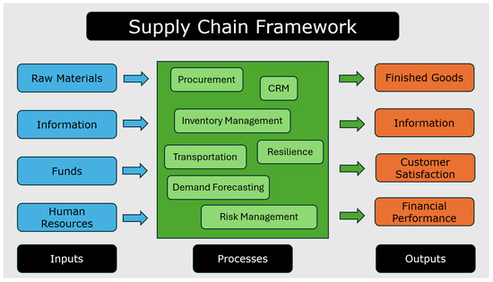
Figure 2: AI application in supply chain
(Source: Daios et al., 2025)

2.4 AI-Based Supply Chain Visibility and Customer Fulfilment
The AI-driven visibility links the information of logistics, inventory, procurement, and customer-facing processes so that the organisations can note the change and cope with it more quickly. Demand sensing, shipment tracking, exception reporting, and inventory can be assisted by predictive analytics. Pathak et al. (2026) expand upon the linkage scheme that exists between predictive analytics, procurement visibility and customer satisfaction and it implies importance of avenues of information in achieving customer-oriented efficiency in the supply-chain. Improved visibility can therefore lead to increased fulfilment reliability since there is less doubt about whether the products will be available, orders, and delivery.

2.5 Theoretical and Conceptual Perspective
The Dynamic Capabilities view is a valuable approach to describing AI-driven supply chains since organisations should sense the environment, leverage opportunities, and redesign resources with regard to uncertainty. Riad et al. (2024) suggest introducing the AI component into supply chain operations to promote resilience and optimisation. Also, Babu (2026) suggests a single AI model that would include intelligent decision support, secure data management, and scalable enterprise architecture. This perspective is based on the fact that the deployment of AI will fail without moving beyond single-use cases; organisations will need to set up integrated infrastructure, regulation, data management processes, and operational cycles.
3. Methodology

3.1 Research Approach
This report exemplifies a second-level qualitative research study, as it aims to critically evaluate the feasibility of deploying predictive analytics and machine learning (ML) within the supply chain and operational management (Cheong et al., 2023). The research design is appropriate in that the research aims to integrate the available scholarly literature as well as business data, rather than conducting primary research on organisations and employees. The academic literature is critically discussed in order to determine the potential, advantages, and disadvantages of AI-based forecasting, inventory management, dynamic pricing, predictive maintenance, and supply-chain visibility.

3.2 Data Sources
Peer-reviewed journal articles, academic publications, conference papers, corporate reports, corporate publications, and reputable industry and technology reports are used to obtain evidence. Recent AI, ML, predictive analytics, and supply-chain-management innovations have been emphasized in the literature. Sources are evaluated based on how much they are relevant to the research objectives, their credibility, their latest point in time, and their contribution to the knowledge of AI-powered transformations in operations.

3.3 Case Study Selection
Amazon, Walmart, and Zara/Inditex are selected as examples of cases because all of them are large, data-driven organisations and use technology to support demand forecasting, inventory, logistics, and responsive business processes. Their practices do provide concrete evidence on how predictive analytics could be investigated to optimise costs, agility, and customer fulfilment in their operations. Most, but not all, of the cases are comparatively used but are not the foundation of the statistical generalisation.

3.4 Analysis Method
The data is themed based on seven dimensions such as predictive, inventory, operational efficiency, operational agility, supply-chain visibility, customer fulfilment, and infrastructure integration. Findings of the study grounded in the scholarly literature are harmonized with the selected cases of the firms to develop the common benefits, implementation challenges, and strategic implications. Another aspect on which AI technologies can be synchronized by implementing a single working platform is also evaluated in the analysis.

3.5 Methodological Limitations
There are a number of limitations to the secondary research method. To start with, the report is going to be based on the accessibility and quality of published materials available, so any erroneous or incomplete published data can impact the findings (Denniss et al., 2023). Second, the case studies done on businesses could stick to successful AI implementations and have scanty information on failures, financial or performance problems. Third, Amazon, Walmart and Zara are massive and, therefore, their AI systems might not be directly applicable to smaller organisations with limited financial and technological capabilities. Lastly, the qualitative methodology fails in quantifying the use of AI on supply-chain performance. The findings, then, must be considered evidence-based analytical observations, as opposed to ones that can be generalised.

4. Findings

4.1 AI-Driven Demand Forecasting
The facts highlight that forecasting by AI can boost the responsiveness of the supply chain by synthesizing areas of historical data and operational data in real time. Amazon Web Services emphasizes the need for digital and physical transformation to enhance the resilience of the supply chain, especially via connected data and technology-powered decisions (Wishart, 2024). Changing demand signals and operational information can be used more continuously by predictive systems compared to traditional forecasting in order to avoid using predetermined historical assumptions. The Amazon warehouse operations demonstrate how AI might help in pinpointing the location of inventory and completing choices by performing comparisons of a huge volume of information (Li, 2024). Likewise, AI-based inventory management at Walmart applies data to predict the needs of its products and aid inventory availability when there are times of fluctuating and heightened demand (Musani, 2023). The results indicate that demand sensing based on AI can minimise uncertainty and allow organisations to react faster to fluctuating customer buying behavior.

4.2 AI Applications and Operational Performance
The findings indicate that AI affects supply-chain performance through several interconnected applications:
AI Application | Main Operational Benefit | Cost Impact | Agility Impact
Demand forecasting | Improved prediction of future demand | Lower waste and stockout costs | Higher responsiveness
Dynamic pricing | Adjustment of prices to market conditions | Improved revenue and inventory utilisation | Rapid market response
Predictive maintenance | Early identification of equipment problems | Lower unexpected maintenance and downtime costs | Higher equipment availability
Automated inventory | More accurate stock and replenishment decisions | Lower excess inventory and holding costs | Faster replenishment
The evidence then indicates that AI cannot be considered a cost-cutting technology only. It is also gifted with operational value as it promotes quick responsiveness of firms to market and supply chain alterations. Real-time inventory is especially crucial to the work of omnichannel operations since proper inventory data would assist in making more effective fulfilment decisions and minimize the gap between reported and actual stock (Awayco.com, 2025).

4.3 Amazon Case Study
Amazon shows the complete use of AI in the operation of warehouses, inventory, and fulfilment. Li (2024) mentions AI applications in Amazon's warehouse management, such as the employment of data-driven systems to aid inventory and operational choices. Digital and physical transformation is another aspect of supply-chain resilience highlighted by Amazon Web Services (Wishart, 2024). To find the required inventory positions, as well as to plan the logistics and operations at the warehouse, demand can be studied with AI-enabled operations. The integration can also aid in optimisation of costs by improved utilisation of resources and reduced movement of inventory that is not productive. Simultaneously, predictive and automated systems help operational agility due to the opportunity of changing decisions depending on the changes in demand and supply conditions. Amazon thus shows one way in which AI can be integrated into interrelated operational activities and not just one activity that involves forecasting.
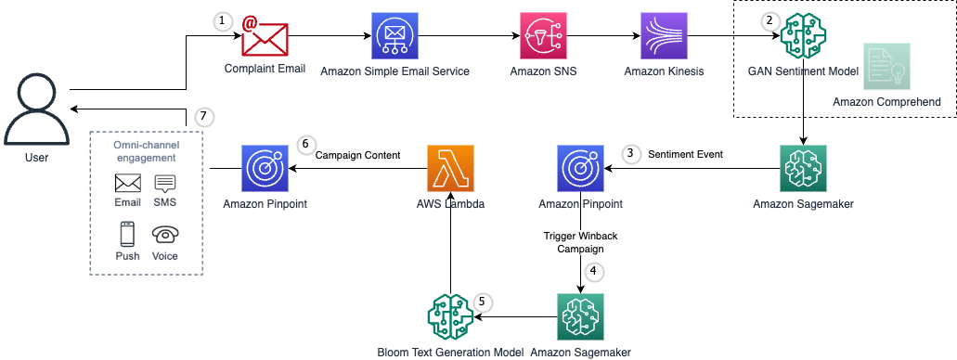
Figure 3: Application of AWS in Amazon
(Source: Nguyen & Giorgini, 2023)

4.4 Walmart Case Study
One more case of AI-guided inventory control is provided by Walmart. According to Musani (2023), Walmart's AI-based inventory system is said to aid in predicting the needs of their products as well as in enhancing inventory stock, especially at times of high demand. The utilization of information among stores and supply-chain activities will allow more appropriate replenishment choices in reaction to the real and anticipated demand. This method can minimize the chance of inventories being out of stock as well as enabling more effective allocation of inventory. This is especially applicable to omnichannel retail, as customers expect that the products they can see online are available in stores or through delivery options. Live inventory freedom therefore helps in operational advantages and reliability in fulfilment (Awayco.com, 2025).
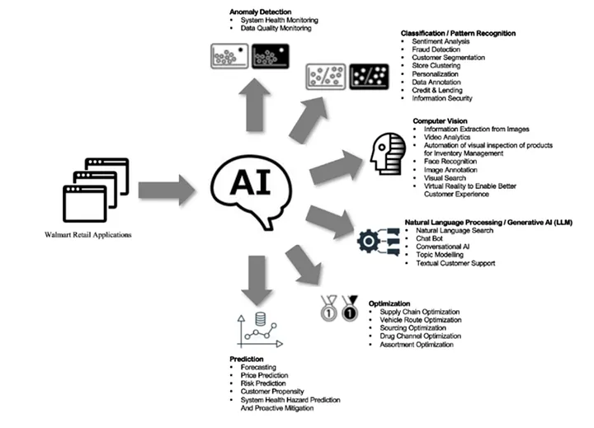
Figure 4: Use of AI in Walmart
(Source: Vengal, 2023)

4.5 Zara/Inditex Case Study
Agility can also be seen in the case of Zara; it is essential in dealing with data-driven retailing. Existing information suggests that Zara leverages data insights to tie customer and store data with supply and inventory decisions (G, 2024). The application of data and technology to offer more responsiveness to fashion demand is also explored relative to AI in Zara's supply chain (Asia, 2024). Rather than still relying on long-term forecasts, fast access to market information can help make shorter decisions and flexible placement of inventory. Zara thus demonstrates the example of data-driven supply chains placing an emphasis on responsiveness and shorter lead times at the same time as pricing.

Figure 5: Use of data-driven technology for Zara
(Source: G, 2024)

4.6 Customer Fulfilment Reliability and Satisfaction.
The results reveal that AI-based supply-chain visibility would be able to achieve customer satisfaction via enhancing product availability, accuracy of orders, and reliability of delivery (Li, 2024). The more inventory and logistics information is provided and updated, the more other organisations make better decisions on fulfilment and the less the risk of stockouts or erroneous availability information. Walmart's AI-supported inventory processes, not to mention Amazon's (understandable) fulfilment processes, represent the predictive information that correlates inventory decisions to customer-facing results (Musani, 2023). The degree of customer satisfaction, however, also depends not only on technological visibility but on the organisation's ability to reflect the information in an expeditious and correct way. Therefore, with an efficient integration of predictive analytics, inventory and logistics processes, AI has greater potential for fulfilment reliability.

5. Discussion

5.1 Cost Optimisation vs Operational Agility.
The practice of Amazon, Walmart and Zara has shown that AI can be used not only to maximise cost reduction, but also to increase operational agility, with more balance than with the maximum reduction in cost. Amazon's predictive analytics can assist in the location of inventory, distribution, and fulfilment in warehouses, which can reduce redundant movements and operational costs and maintain a prompt response to changes in demand (Li, 2024). The inventory control at Walmart, which is partially controlled by AI, also ensures that demand and replenishment forecasting and product availability are interconnected (Musani, 2023). Nonetheless, Zara offers a case study of how being agile is critical because responsiveness in inventory decisions can be utilized using quicker customer and store-wide access to information (G, 2024). Unwarranted reduction of inventory can reduce holding costs, but raise the exposure to stockouts. In this sense, AI should be able to enhance inventory and resource management and afford a certain degree of flexibility to face unexpected disruptions.

5.2 AI Visibility and Customer Fulfilment
AI-powered visibility offers a valuable linkage between customer outcomes and operational data. The direction can be seen because visibility equates to the right inventory information and, therefore, the better the allocation, the better the fill will be, and fewer stockouts and delays will also work wonders and achieve a better customer experience. The case of Amazon and Walmart with their integrated fulfilment activities and AI-inspired inventory optimisation reveals how predictive data could help to connect inventory-based decision-making and fulfilment operations. Pathak et al. (2026) also illustrate the relationship between predictive analytics and procurement visibility and customer satisfaction. However, visibility is not the only criterion that can be used to ensure satisfaction, since the speed of delivery, the quality of the products, and the responsiveness of the service also affect the customer experience.

5.3 Limitations and Risks of Predictive ML
Although it has its potential, predictive ML poses a number of operational and managerial risks. Poor predictions may be caused by the quality of the data used in the prediction or incompleteness of the data, or by model drift, which can lead to poor performance when customer behaviour changes or there is a change in the market. Companies also have to take care of cybersecurity, privacy, and explainability of the automated decision. The legacy ERP, inventory, and logistics systems obstruction can contribute to the implementation complexity and cost. The agents might need to acquire new analytical and technical capabilities to utilize and follow AI engines. Moreover, excessive dependence on automated judgments could be an issue since the training data does not reflect anomalous cases.

5.4 Unified Framework for AI-Enabled Operational Workflow
The developed framework integrates data infrastructure, predictive analytics, automated decisions, and operational processes in one continuous process per the literature and experience of Amazon, Walmart, and Zara.
Stage | Infrastructure / Process | AI Function | Operational Outcome
1. Data Infrastructure | ERP, CRM, POS, IoT sensors, warehouse and logistics systems, external market data | Collects operational, customer, and market information | Comprehensive data availability
2. Data Integration | Cloud/data platform, data cleaning, validation, and real-time processing | Integrates structured and unstructured information | Consistent and timely information
3. Predictive AI Layer | Demand, inventory, pricing, and equipment data | Demand forecasting, predictive maintenance, dynamic pricing, and inventory prediction | Improved prediction and early risk identification
4. Decision & Automation Layer | AI decision-support and workflow systems | Automated replenishment, routing, scheduling, maintenance alerts and pricing recommendations | Faster operational decisions
5. Operational Workflow Coordination | Procurement → Production → Inventory → Warehousing → Logistics → Delivery | Coordinates decisions across interconnected functions | Reduced delays, waste, and resource duplication
6. Customer Outcome | Product availability, order and delivery information | Supports fulfilment monitoring and exception management | Improved fill reliability, availability and customer satisfaction
7. Feedback Loop | Customer feedback, sales, operational and performance data | Model evaluation, retraining and continuous learning | Continuous improvement and adaptation
The framework thus considers AI as a combined operational capacity as opposed to a single forecasting instrument. Human supervision is still needed, particularly for special cases, strategic decision-making, and high-impact automated suggestions. This will enable organisations to integrate cost advantages realised with Amazon and Walmart with the promptness exhibited by Zara without compromising data governance and operational control.

6. Conclusion

6.1 Key Findings
This report has demonstrated that in cases of unstable supply-chain environments, traditional deterministic forecasting could be irrelevant since it draws on historic trends and uniform assumptions. Machine learning enables greater capability of analysing diverse datasets and dynamic data, enabling quicker, responsive forecasting of demand and operational decision-making. AI-based applications that are used in demand forecasting, dynamic pricing, predictive maintenance, and automated inventory management could be effective in optimising costs and improving operational agility. The importance of AI-based supply-chain visibility can also be explained by the fact that correct and timely information will be useful to allocate the inventory better, ensure the reliability of fulfilment, and improve customer satisfaction. The supply-chain management references of Amazon, Walmart and Zara represent different features of AI-powered supply-chain management. Amazon depicts the level of AI as integrated into inventory, warehousing, and fulfilment; Walmart exemplifies availability and replenishment of inventory as extremely data-driven; and Zara underlines the significance of fast market responsiveness.

6.2 Strategic Implications
Organisations that utilize AI should not treat it as the same thing we do when discussing automation technology. The ability to integrate data infrastructure, human expertise, operational processes, governance, and continuous learning is needed to ensure sustainable operational benefits. It is anticipated that AI systems will complement managerial judgement and hold the pertinent tracking, data quality and cybersecurity evaluations.

6.3 Final Recommendation
It is advisable to implement AI in phases, with the initial prediction application and data infrastructure being reliable and high value, then extend to automated operational coordination. The practice may enable organisations to be more effective and, equally, offer the ability to be flexible and under human control.

Reference List
Asia, I.H. (2024). How Does Zara Use AI to Revolutionize Its Supply Chain? [online] LinkedIn.com. Available at: https://www.linkedin.com/pulse/how-does-zara-use-ai-revolutionize-its-supply-chain-bpb5c.
Awayco.com. (2025). The Role of Real-Time Inventory in Omnichannel Success. [online] Available at: https://www.awayco.com/blogs/the-role-of-real-time-inventory-in-omnichannel-success.
Babu, G.S., (2026). Unified AI Framework for Intelligent Decision Support Secure Data Governance and Scalable Enterprise Architecture. International Journal of Engineering & Extended Technologies Research (IJEETR), 8(1), 222-228. https://ijeetr.com/index.php/ijeetr/article/download/1011/937
Cheong, H.I., Lyons, A., Houghton, R. & Majumdar, A., (2023). Secondary qualitative research methodology using online data within the context of social sciences. International Journal of Qualitative Methods, 22, 16094069231180160. https://journals.sagepub.com/doi/pdf/10.1177/16094069231180160
Daios, A., Kladovasilakis, N., Kelemis, A. & Kostavelis, I. (2025). AI Applications in Supply Chain Management: A Survey. Applied Sciences, [online] 15(5), 2775. https://www.mdpi.com/2076-3417/15/5/2775
Denniss, E., Lindberg, R. & McNaughton, S.A., (2023). Quality and accuracy of online nutrition-related information: a systematic review of content analysis studies. Public health nutrition, 26(7), pp.1345-1357. https://www.cambridge.org/core/services/aop-cambridge-core/content/view/4E28F7A056AA8CB4A19F9E5DF0B095C2/S1368980023000873a.pdf/div-class-title-quality-and-accuracy-of-online-nutrition-related-information-a-systematic-review-of-content-analysis-studies-div.pdf
G, S. (2024). Zara’s Fashion Revolution Through Data Insights. [online] Medium. Available at: https://medium.com/thedeephub/zaras-fashion-revolution-through-data-insights-28f8fa728a0f.
Islam, M.T., Ayon, E.H., Ghosh, B.P., Shahid, R., Rahman, S., Bhuiyan, M.S. & Nguyen, T.N., (2024). Revolutionizing retail: A hybrid machine learning approach for precision demand forecasting and strategic decision-making in global commerce. Journal of Computer Science and Technology Studies, 6(1), 33-39. https://alkindipublisher.com/index.php/jcsts/article/download/6510/5683
Kagalwala, H., Radhakrishnan, G.V., Mohammed, I.A., Kothinti, R.R. & Kulkarni, N., (2025). Predictive analytics in supply chain management: The role of AI and machine learning in demand forecasting. Advances in Consumer Research, 2, 142-149. https://acr-journal.com/article/predictive-analytics-in-supply-chain-management-the-role-of-ai-and-machine-learning-in-demand-forecasting-886/
Kaul, D. (2023). AI-driven real-time inventory management in hotel reservation systems: Predictive analytics, dynamic pricing, and integration for operational efficiency. Emerging Trends in Machine Intelligence and Big Data. https://www.academia.edu/download/131654943/AI_Driven_Real_Time_Inventory_Management.pdf
Li, Z. (2024). Review of Application of AI in Amazon Warehouse Management. Advances in Economics, Management and Political Sciences, [online] 144(1), 1–8. https://www.researchgate.net/publication/387711589_Review_of_Application_of_AI_in_Amazon_Warehouse_Management
‌Musani, P. (2023) Decking the aisles with data: How Walmart's AI-powered inventory system brightens the holidays. Walmart Global Tech. https://tech.walmart.com/content/walmart-global-tech/en_us/blog/post/walmarts-ai-powered-inventory-system-brightens-the-holidays.html
Nguyen, T. & Giorgini, B. (2023). Building Generative AI into Marketing Strategies: A Primer | Amazon Web Services. [online] Amazon Web Services. Available at: https://aws.amazon.com/blogs/messaging-and-targeting/building-generative-ai-into-marketing-strategies-a-primer/.
Owczarek, D. (2024). Predictive Analytics in Supply Chain Management. Boosting Supply Chain Analytics with AI. [online] nexocode. Available at: https://nexocode.com/blog/posts/predictive-analytics-in-supply-chain-analytics/.
Pathak, D.N., Yadav, R.K. & Singh, H., (2026). Predictive Analytics and Procurement Visibility: A Big-Data-Driven Approach to Customer Satisfaction in Supply Chain Management. https://pdfs.semanticscholar.org/bf98/e5b82471519be29499315ef63318d73b2b63.pdf
Riad, M., Naimi, M. & Okar, C., (2024). Enhancing supply chain resilience through artificial intelligence: developing a comprehensive conceptual framework for AI implementation and supply chain optimization. Logistics, 8(4), 111. https://www.mdpi.com/2305-6290/8/4/111
Vengal, T. (2023). Machine Learning Platform at Walmart. [online] Medium. Available at: https://medium.com/walmartglobaltech/machine-learning-platform-at-walmart-b06819825ef7.
Verma, P., (2024). Transforming supply chains through AI: demand forecasting, inventory management, and dynamic optimization. Integrated Journal of Science and Technology, 1(3). https://www.researchgate.net/profile/Pradeep-Verma-23/publication/385098771_Transforming_Supply_Chains_Through_AI_Demand_Forecasting_Inventory_Management_and_Dynamic_Optimization/links/67167d9f035917754c125b54/Transforming-Supply-Chains-Through-AI-Demand-Forecasting-Inventory-Management-and-Dynamic-Optimization.pdf
Wang, J., Hong, S., Dong, Y., Li, Z. & Hu, J., (2024). Predicting stock market trends using LSTM networks: overcoming RNN limitations for improved financial forecasting. Journal of computer science and software applications, 4(3), 1-7. https://mfacademia.org/index.php/jcssa/article/download/100/83
Wishart, M. (2024). Digital and physical transformation for supply chains resiliency | Amazon Web Services. [online] Amazon Web Services. Available at: https://aws.amazon.com/blogs/supply-chain/digital-and-physical-transformation-for-supply-chains-resiliency/.

‌

