

A Study on Relationship Selling in Tourism and Hospitality

Student Name:Anhaddeep Singh

Executive summary
The study aims to look at the strategic role that relationship selling has in the ability to build long-term customer loyalty in the tourism and hospitality environment by comparing and contrasting relationship and transactional selling with an emphasis on empathy, trust and loyalty programmes in order to create repeat customers. Using insights gained from some of the leading hotel companies and travel agencies, this study puts forward the view that it is primarily through modern technology and personal involvement that strong customer relationships may be developed. The secondary data used consists of reports and journals from the hospitality industry, highlighting and analysing current trends, forms of relationship selling and barriers to its implementation in an international arena. The discussion is slanted towards how technology can be employed to create and support the human element, and lead to sustainability in loyalty, that induces customer loyalty and increased profits.
Table of Contents
1. Introduction 4
2. Literature Review 5
2.1 Principles of Relationship Selling vs. Transactional Selling 5
2.2 Role of Empathy, Trust and Loyalty Programs 6
2.3 Case Studies: Hotels and Travel Agencies 7
2.4 Recommendations for long-term engagement 8
2.5 Theoretical perspectives 9
3. Methodology 11
3.1 Data Collection Methods 11
3.2 Data Analysis Techniques 11
3.3 Ethical Considerations 11
4. Findings 12
5. Discussion 14
5.1 Integration of Relationship Selling into Modern Sales Strategies 14
5.2 Balancing Technology and Human Interaction in Service Delivery 16
5.3 Challenges in Implementing Relationship Selling in Global Hospitality Markets 17
6. Conclusion 18
References 20

1. Introduction
The tourism and hospitality industry is intrinsically focused on the customer, based on service quality, interpersonal relationships and customer satisfaction, which, as always, greatly influence business success. In this highly competitive environment, businesses are more aware of the need to move away from the usual transactional sales orientation and adopt an approach that is more based on relationships (Rosário & Casaca , 2023). Transactional selling is primarily concerned with immediate goals, more specifically, closing sales or achieving revenue goals in the short term. This filtered approach often does not develop long-term customer commitment. In contrast, relationship selling is based on a long-term partnership with customers through establishing trust, demonstrating empathy and providing tailored solutions to customers' needs (Hussain et al., 2024). This selling philosophy is more aligned with the expectations of today's travellers who seek meaningful, tailored experiences and who appreciate businesses that acknowledge their preferences and loyalty.
Relationship selling in the tourism and hospitality industry involves awareness of the individual customer's needs, expectations, attitude to service and further needs beyond the current service. Hotels, airlines and travel agencies might have to include in their packages special tailored programmes, emphasise the personal touch and look to the development of loyalty towards the individual traveller, towards rewarding repeat visitations through frequent business plans programmes (Polat et al., 2024). Empirical studies have proved that businesses that follow the relationship selling orientation markedly improve their customer retention rates, additional repeat bookings, together with increased brand advocacy, all of which accentuate the strategic advantage of this orientation over a purely transactional philosophy.
The proliferation of digital technologies has further augmented the sales processes of the sector. Online booking systems, mobile applications and the Customer Relationship Management (CRM) systems available to businesses within the tourism and hospitality industry, enables companies to monitor customer preferences, purchasing patterns and frequentations. Through detailed analysis of this data, relationships can be enhanced by means of personalised communication techniques, targeted promotional activity and proactive service delivery in order to enhance the effectiveness of relational selling (Pfajfar et al, 2022). The introduction of other digital forms of communication and selling must be combined with a human element, since empathy and emotional intelligence will remain key elements of trust and loyalty.
The resultant implications for customer engagement will also be analysed. Case studies will be employed from major hotel chains and travel agents to support the findings (Hussain et al., 2024). Strategic recommendations and frameworks will have been developed for the implementation of effective relationship selling techniques, with particular reference to their capacity to sustain competitive advantage and also enhance customer loyalty in this highly dynamic experience-driven industry.

2. Literature Review

2.1 Principles of Relationship Selling vs. Transactional Selling
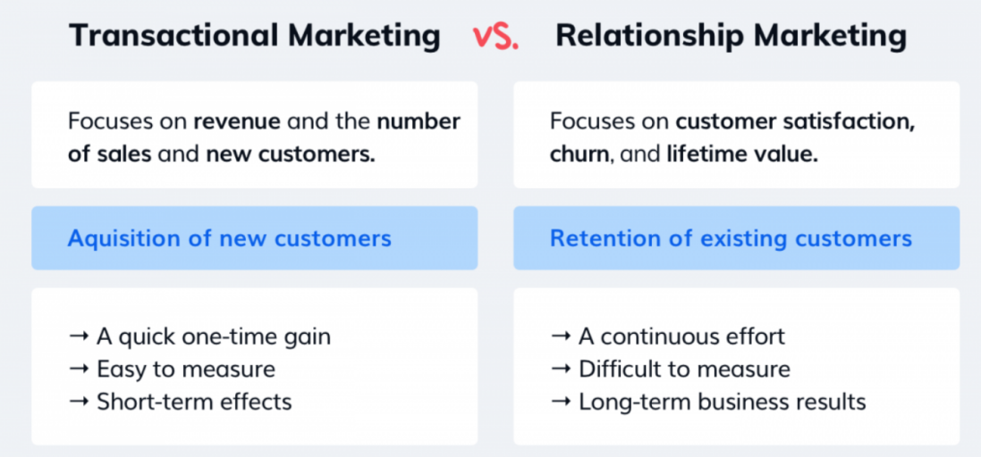
Figure 1: Relationship Selling vs. Transactional Selling
Source: (Rajnerowicz, 2024)
Focus and Objectives
Transactional selling is more focused on short-term sales results. The goal is to make the deals fast, and sometimes they do not have to think about the long-term interaction with the customer. Measures of success are short-term, i.e. revenue made, bookings, or instant customer conversion. In comparison, relationship selling is more focused on long-term value-generation through establishing continuous interaction and customer loyalty. It is not only meant to make a one-time sale, but to build long-term customer relationships that lead to repeat business, referrals and brand promotion (Negassa & Japee, 2023). This inherent distinction in focus influences sales strategies to be developed and implemented in tourism and hospitality institutions.
Customer Interaction and Customer Retention
With transactional selling, the interaction is normally short-lived and product-oriented. Sales representatives emphasise selling services or packages, benefits, and persuading customers to buy immediately. Minimal effort is made towards getting to know the customer's needs or preferences. Relationship selling, puts a stronger focus on individual communication. Sales professionals are active listeners, are empathetic and customise services to a certain need (Salem, 2021). This would create trust, emotional bonds and customer satisfaction, that would translate to long-term loyalty.
Added Value, Loyalty and Trust
Transactional selling is also dependent on price, convenience or promotions to affect buying decisions, and loyalty is incidental. Trust forms the basis of relationship selling. Organisations can create repeat engagement by creating value consistently, predicting customer needs, and using loyalty programs. The reward and reinforcement of the relationship is achieved with the help of the tools such as loyalty programs, one-on-one offers and proactive communication, that makes customers feel that they will get some benefits after one purchase (Rosário & Casaca , 2023). This strategy enhances brand loyalty and encourages long-term development in the very competitive tourism and hospitality industry.

2.2 Role of Empathy, Trust and Loyalty Programs
Customer Engagement Empathy
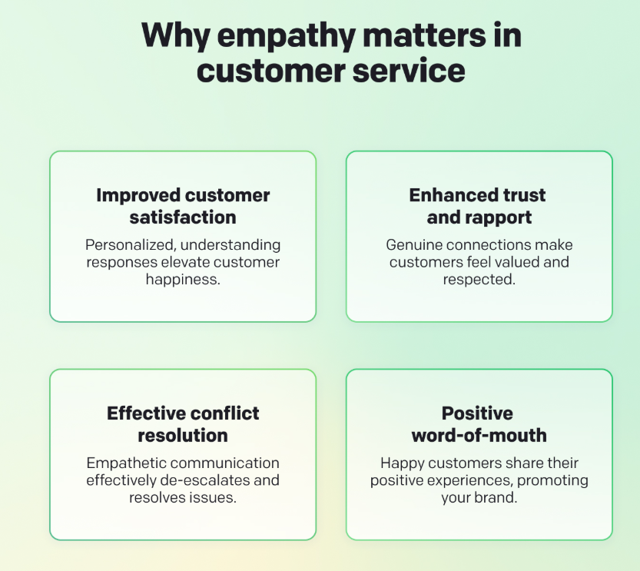
Figure 2: Customer Engagement Empathy
Source: (Masternak, 2024)
Empathy is one of the pillars of relationship selling, especially in the tourism and hospitality industry, where the experience of the customers is very personal. Salespeople with empathy listen to their customers, learn their likes and wants, and eagerly anticipate customer needs. Emotions are unique, and when properly managed, these emotions can help businesses develop meaningful experiences that are memorable. To give an example, when hotel employees realise that there is a special type of room or a particular diet that a guest prefers, it can greatly contribute to satisfaction (Joviando & Kurniawati, 2022). Sympathetic interaction enhances emotional attachment, that leads to recurrent visits and favourable word of mouth, that helps in long-term loyalty.
Developing Customer Relationships
Customer relationships can be sustained only through trust. Trust in relation selling is built when organisations make promises that they keep, have transparent communication, and uphold the quality of their products. Customers will be keen on repeating the use of brands that they trust, and in purchasing in the tourism and hospitality sector, the uncertainty as to the manner in that services are provided may affect the purchase decision (Stoyanova-Bozhkova et al., 2020). The perceived risk is decreased because of trust, and the customer's confidence in the selection of a service provider is enhanced and that is used to build a stable, long-term relationship, that goes beyond the individual transactions.
Reinforcement Tools Loyalty Programs
Loyalty programs are also used as strategic measures to strengthen the relationship established by empathy and trust. Organisations motivate repetitive usage and enhance emotional bondage to customers by providing rewards, exclusive deals or personalised promotions. For example, point-based programs are utilised by hotel chains and airlines to encourage clients to make frequent bookings, whereas travel agencies might provide clients with tiered membership opportunities to retain them (Bardukova, 2023). Loyalty programs, when combined with personalised interactions, increase customer satisfaction besides increase revenue, that makes the organisation appear attentive, reliable, and customer-centric.

2.3 Case Studies: Hotels and Travel Agencies
Marriott International: Personalised Guest Experiences
Marriott International is a successful example of relationship selling, as it provides personalised experiences to guests. The Bonvoy loyalty program tracks preferences for guests for room type, amenities, and dining preferences, so staff can provide personalised services. Personalised communication and acknowledgement of returning guests fosters trust and emotional ties so that episodic visitors are turned into loyal clientele (Guo, 2025). The Marriott example shows how empathy and data-based practices increase both customer satisfaction and long-term engagement in a relationship-selling strategy.
Hilton Hotels: Blending technology with people interactions
Hilton Hotels merges digital “tools” and human interaction as a way of enhancing its customer relationships. Under the Hilton Honours program, they use the mobile app for individualised offers, make reservations much easier, and provide for a more personalised approach for direct communication with hotel staff. The technology provides efficiencies and useful data, while Hilton emphasises touch points like speaking with guests by name and fulfilling special requests (Negassa & Japee, 2023). The blend of both digital efficiencies and people’s empathy breeds trust and loyalty in the relationship selling model in what is a very competitive hospitality market.
Expedia Group: Relationship Selling in Travel Agencies
As the premier online travel agency, Expedia employs relationship marketing approaches by using loyalty awards, individualised suggestions, and responsive customer care. Their rewards program, Expedia’s Rewards for repeat customers provides points for repeat customer sales. They offer exclusive deals and suggestions on travel destinations that are based on customers’ prior travel experiences. Customer support personnel utilise empathetic communication in order to quickly and efficiently resolve problems for customers, breeding trust and satisfaction (Ciftci et al., 2022). The Expedia relationship model highlights how travel agencies blend successfully the use of digital tools with a relational strategy in order to continue long-term customer engagement in an inherently hostile industry.

2.4 Recommendations for long-term engagement
Customer Relationship Management (CRM) Framework
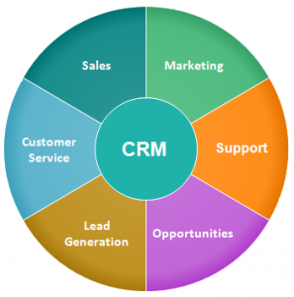
Figure 3: Customer Relationship Management (CRM) Framework
Source: (Cass Software, 2013)
A strong CRM framework is essential to foster long-term commitment within tourism and hospitality. CRM systems allow personalised communication, focused promotions and proactive delivery of services, hence customers feel valued. Hotels and travel agencies segment customers based on loyalty, spending habits or frequency of travel and build offers around them (Dewnarain et al., 2021). The implementation of CRM enables organisational feedback to be collected consistently, allowing the organisation to modify service and deal with problems quickly, establishing trust with customers and repeating commitment.
Loyalty and Reward Framework
Loyalty initiatives provide systematic ways to encourage repeated business. Good frameworks incorporate a points-based system, awarding benefits in stages and catered expectations of rewards, that help to form emotional connections with customers. A customer incentive system like one with stages will usually provide a range of exclusive benefits or upgrades, to customers who succeed in getting to higher levels of membership in the incentive system. High customer value. If the organisation distribution the awards within the system, it will in length provide customers with added satisfaction (Chen et al., 2021). By rewarding people for engaging people, organisations can nurture the person's commitment to having year-long relationships.
Experience Centric Engagement Framework
The experience-centric engagement framing concentrates on the overall journey of the customer, that is not a transaction-based relationship. Organisations look to create memorable and personalised experiences at every level of touch, which they must engage in with the customer from the sale to the follow-up after service. These experience-centric engagement frameworks must be combined with opportunities provided with digital end performance, that facilitate mobility for more exercise production and production of real-time communication if required (Webb et al., 2022). By embedding trust, empathy, and responsiveness in every interaction, the experience-oriented framework makes it so that customers equate that brand with reliability and care, that drives loyalty and continues engagement over long periods of time.

2.5 Theoretical perspectives
Relationship Marketing Theory Overview
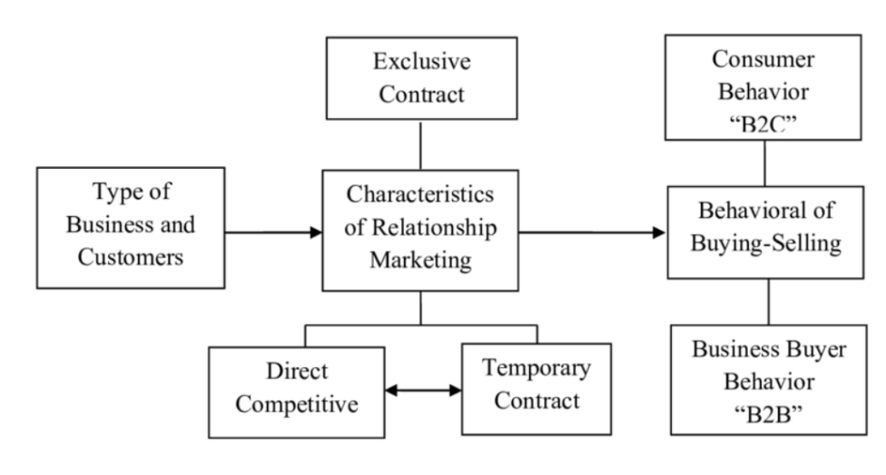
Figure 4: Relationship Marketing Theory
Source: (Trihatmoko, 2018)
Relationship Marketing Theory states that the focus is not to make a sale to a customer for that one time and have the relationship end there but sale emphasis is to create a long-term relationship with a customer where customer satisfaction is the main goal. This leads to long-term loyalty and profitability for the customer and the supplier (Salem, 2021). It stresses the importance of understanding customer needs, personalising services, and creating emotional involvement, through enduring relationships based on trust, commitment and mutual value created and delivered. It is important for commercial establishments to have an idea of how and when to establish that relationship using relationship marketing techniques of communication (Joviando & Kurniawati, 2022). This goal would provide an advantage to that organisation over those that do not engage in sales but seek other approaches.
Trust and Commitment in Customer Relationships
One of the tenets, if not the most salient point of Relationship Marketing Theory, is that trust and commitment are essential to have in all customer relationships if their goal is to have those relationships be of a continued or durable nature. Organisations must be involved without fail in reliably delivering the results aimed by the management. Customers develop commitment in understanding what their continuing relationship will mean to them over time based on those definitions (Bardukova, 2023). The customer must perceive there is some gain, some value that is worth the price of the continuing relationship by virtue of the experiences created and maintained.
Application of Relationship Marketing in Tourism and Hospitality
Relationship Marketing Theory has its operational focus in loyalty programs, Customer Relationship Marketing (CRM), and experience-based involvement. By means of the aforementioned techniques, organisations can profile customers, analyse their preferences and credit them with personalised sales offerings, while pre-empting their needs and enhancing relational capabilities. In the case of groups such as Marriott and Hilton, hotels can utilise CRM methods and customer loyalty programs to provide feedback for repeat guests and thereby test continuous involvement (Webb et al., 2022). For travel agencies, tailored suggestions and proactive assistance can be utilised to facilitate customer satisfaction.

3. Methodology

3.1 Data Collection Methods
Data for this study were obtained from secondary sources only to investigate sales management and relationship selling in the tourism and hospitality industry. Industry reports, academic journals, research articles and case studies of leading hotel groups and travel agencies were used as secondary data (Mayring, 2021). Industry reports produced trends in the marketplace, consumer behaviour and consumer loyalty strategies, while academic journals provided academic constructs and empirical research on relationship selling and transactional selling. Through case studies, it was possible to ascertain how relationship selling is applied practically, highlighting the successful strategies and the problems faced by organisations. Information was sustained from online information bases, such as Google Scholar, while industry-specific sources were also used (Kumara, 2022). This enabled a thorough conceptual understanding of both theoretical and practical use, and therefore resulted in no primary data collection being necessary; the study is located well within existing literature and evidence from authoritative sources.

3.2 Data Analysis Techniques
The data collected from secondary sources, i.e. industry reports, academic journals, research articles and case studies, was subjected to qualitative content analysis. This involves a systematic examination, classification and interpretation of textual information to recognise patterns, themes and insights associated with relationship selling within tourism and hospitality (Stoyanova-Bozhkova et al., 2020). Crucial parameters such as empathy, trust, loyalty systems and digital engagement strategies were extracted. Comparisons were made with multiple sources. Comparative analysis was used to test for differences in relationship and transactional selling approaches, while thematic synthesis highlighted patterns of best-selling strategies and practices of hotel groups and travel agencies (Kuckartz & Radiker, 2023). The data was presented in a structured format, logically organised and evidence-based in its findings and theoretical perspectives, allowing a complete understanding of current sales management practices without the need for new data.

3.3 Ethical Considerations
Ethical considerations must be taken into account before and during the research process. This research received data from secondary sources of information from such areas as journals, industry reports, articles and case studies. All sources used were properly referenced and attributed to ensure that there was no plagiarism and that academic integrity was present (Hasan et al., 2021). Only those items obtained from credible public documents were used, respecting the rights of intellectual property and the rules of copyright. Further examination of ethical research practice was conducted with particular examination of sources about their reliability and accuracy, with the intention of conclusions or recommendations being based on valid evidence (Kumara, 2022). Aiding the transparency of research, credibility and a necessary respect for original authors and subjects of study was maintained.

4. Findings
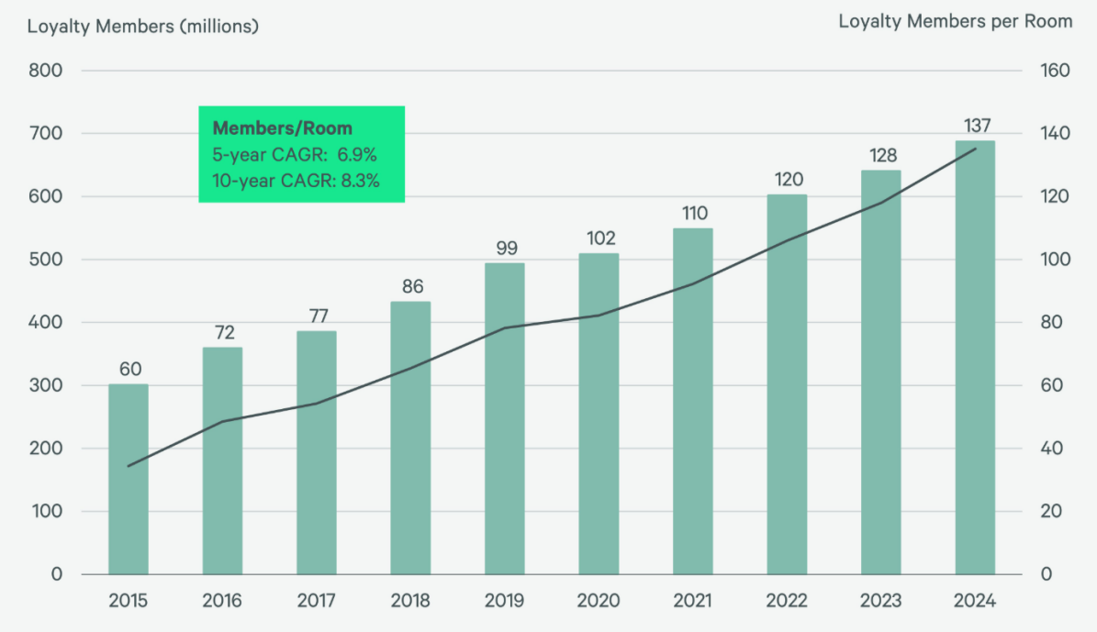
Figure 5: Graph of Customer Loyalty and Retention in Hospitality
Source: (CBRE, 2025)
The significant growth in the influence of loyalty programs on hotel bookings in 2024 is illustrated in the graph above. The total enrollment in loyalty programs grew by 14.5 per cent to more than 675 million, far in excess of the increase in total room numbers of 6.7 per cent, demonstrating the considerable expansion of these programs (Ciftci et al., 2022). The number of members per available room increased by 7.4 per cent to 137, respectively, demonstrating further how well loyalty programs increase occupancy. Revenue and liability from loyalty programs also achieved the post-pandemic peak levels of USD 1.2 billion and USD 2.4 million, respectively, growing at nearly equal rates of 8.3 per cent and 8.4 per cent, that indicates financial stability. This is contrasted with a decrease in liability per member of 5.3 per cent to USD 17.85 and 11.3 per cent of the average daily rate, which suggests that while accumulation of points by members is low, it operates to provide adequate incentive for repetition of bookings by clients (CBRE, 2025). The conclusion from the graph above is clearly evident that loyalty programs are a significant contributor to ongoing occupancy and revenue advancement in the hotel and lodging industry.
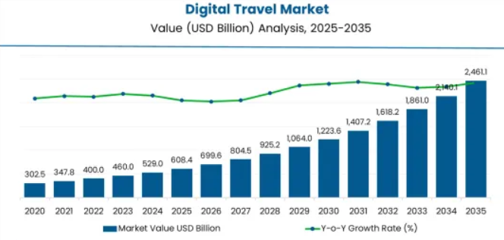
Figure 6: Graph of Digital Engagement and CRM Effectiveness in Travel Industry
Source: (Shah, 2025)
The rapid growth and impact of digital engagement and managerial techniques of customer relationship management in the travel industry are illustrated in the graph above. In the year 2025, the value of the digital travel market is USD 608.4 billion, of which the largest portion of its business, consisting of international travel, is valued at 59 per cent, emphasising the need for successful targeting of global customers through effective media (Pfajfar et al., 2022). This digital travel market is predicted to grow to USD 2,461.1 billion by the year 2035, that shows a compound annual growth rate (C.A.G.R.) of 15 per cent, indicating and emphasising the increased use and dependence on sophisticated digital instruments and systems of customer relationship management for the purposes of increasing customer engagement (Shah, 2025). The effective use of customer relationship techniques by efficient management of travel companies can enable those businesses to ensure a more effective accumulation of individual members’ preferences, personalising offers, promoting customer loyalty and encouraging the repeat booking of future travel by the individual.
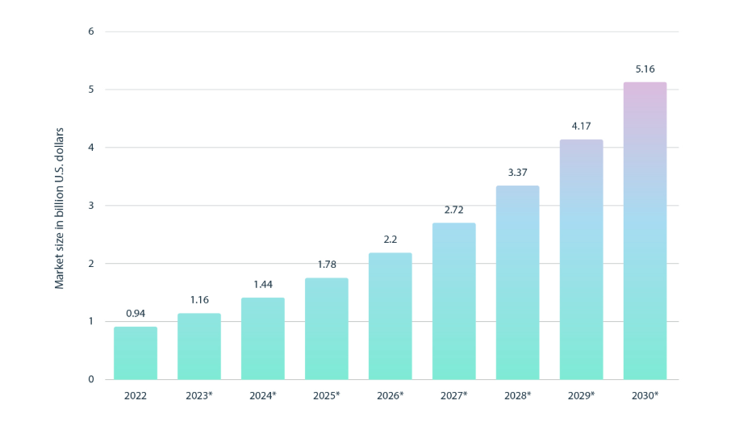
Figure 7: Graph of Effect of Empathy and Personalization on Customer Satisfaction
Source: (Intellias, 2024)
The graph depicts the increasing power of personalisation on customer satisfaction levels in the hospitality industry. As the global personalisation software market is expected to exceed USD 5 billion by 2030, hotels and travel companies are utilising technology more every day to provide personalised experiences (Intellias, 2024). The data reveal a strong correlation between these various personalisation initiatives (i.e., customised room preferences, targeted offers, personalised communication) and higher satisfaction scores from their guests. Satisfaction levels have improved steadily over the past few years as digital tools allow hotels to obtain and analyse customer data more effectively. A personalised presence creates emotional bonds, elevates perceived service levels and increases repeat visits (Webb et al., 2022). Overall, the graph indicates a strong pattern for higher levels of customer satisfaction and loyalty as hospitality businesses invest more funds in personalising technologies, that should establish for them a long-term competitive advantage in a service-oriented industry.

5. Discussion

5.1 Integration of Relationship Selling into Modern Sales Strategies
Shifting from Transactional to Relationship-Oriented Approaches
The tourism and hospitality industry has also witnessed a marked change in the use of selling strategies away from transactions to relationship processes. Traditional selling concentrated primarily on closing immediate bookings without reference to the customer relationship over the long term. The selling strategies today are more aimed at knowing individual preferences, creating individualised experiences, and developing continuous involvement in the relationship. This change is consistent with changes in consumer attitudes, which show that today’s travellers long for adventure and authenticity, emotional connections, and individualised hospitality (Denga et al., 2022). If the relationship selling ideas are adopted by hotels, airlines, and travel agencies, loyalty can be developed, satisfaction improved, and sales increased in what is the most competitive business.
Leveraging Data and Technology for Personalisation
The other side of relationship selling is the use of tools and technology such as Customer Relationship Management (CRM) systems, data banks, and artificial intelligence to manage the hospitality relationship. These technological advances allow the hospitality industry to gather, analyse, and collate the customers’ needs and preferences as well as make specific offers. For instance, hotel chains can utilise CRM systems to offer specific personal promotions to guests or anticipate the needs of guests before arrival at the hotel (Hasan et al., 2021). The incorporation of technology into the relationship selling process through knowledge, shared with the customer, fosters long-term loyalty and emotional involvement, giving due weight to personalised service skill.
Creating Value through Continuous Engagement
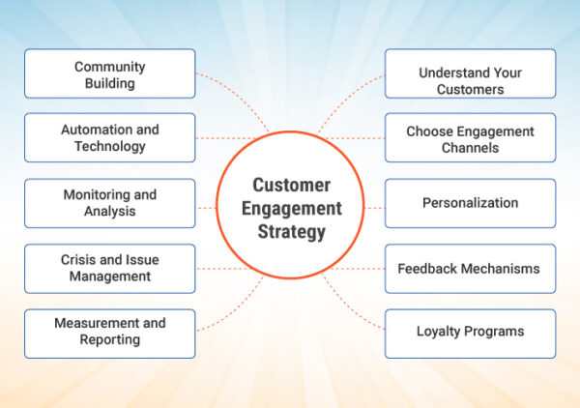
Figure 8: Creating Value through Continuous Engagement
Source: (Alam, 2023)
Current sales strategies incorporate relationship selling by emphasising continuous post-purchase engagement. Beyond the initial sales, hospitality brands now have relationships with their sales through their loyalty plans, systems of feedback, and constant communication. For example, personalised directed messages after a stay or exclusive rewards membership encourage circular interactions. This engagement model helps customers become brand advocates, offering sustained growth (Wang et al., 2021). Relationship selling becomes a permanent process, making its contributions to the reputation of the brand, increasing lifetime customer value increasing competitive position in the global tourism and hospitality marketplace.

5.2 Balancing Technology and Human Interaction in Service Delivery
Role of Technology in Enhancing Customer Experience
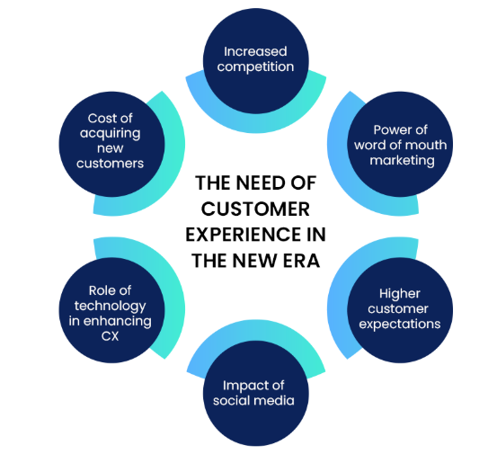
Figure 9: Role of Technology in Enhancing Customer Experience
Source: (Successive Technologies, 2024)
Technology has become indispensable in the delivery of services in the tourism and hospitality sector. Online booking systems, mobile check-ins, AI-driven chatbots, and personalised recommendations are some of the technologies that facilitate smooth interaction and dealings with customers. The introduction of technology enables companies to collect data, understand customer preferences and implement personalisation on a scale unsurpassed in the past. Various hotel chains have enhanced the guest experience post-reservation to the stage of feedback after the hotel stay through the use of CRM, various systems, and mobile applications (Mandić et al., 2023). Hence, technology contributes not only to convenience but also supports the concept of relationship selling through enhanced data-driven interaction.
Significance of Human Touch and Empathy
As much as technology continues to improve, there is no substitute for human interaction in the hotel business sector. Personal warmth, empathy and emotional intelligence all assist in developing a memorable guest experience. Customers seem to favour human personalised contact, such as personal greetings or other thoughtful gestures, over computerised responses. Such emotional connections tend to build up trust and loyalty, that are two essential elements involved in relationship selling (Denga et al., 2022). A good delivery of service in the travel business sector needs a balance between technological efficiency combined with the human touch, that makes it possible for the digitalised methods to enhance instead of replacing the human contact.
Achieving the Right Balance for Competitive Advantage
Companies that effectively combine the correct use of technology and human contact can have an enormous competitive advantage. For instance, organisations such as Hilton and Marriott will have to employ technology in the form of AI systems, where it will be easy to determine customer needs. The employees should be empowered to understand the importance of adding that human touch. This hybrid model will allow companies to not only present an efficient service but also keep that necessary emotional contact, that is required for customer satisfaction and loyalty in the long term (Kapur & Williams, 2025). In the changing world of tourism and hospitality, it is these required realities that are felt essential in achieving sustainability and further growth in a relationship-oriented business.

5.3 Challenges in Implementing Relationship Selling in Global Hospitality Markets
Cultural Diversity and Service Expectations
Customers in the tourism and hospitality market may have very different cultural backgrounds and, therefore expectations about communication and service. For example, Western customers may prefer efficiency and independence, whereas Eastern customers may favour individual attention or respect. The diversity of cultural experience makes it impractical to adopt a uniform approach to relationship selling (Aktoty, 2025). Hospitality professionals must therefore make a thorough study of local markets, with a view to formulating relationship selling strategies that ensure that there is a high degree of cultural sensitivity and inclusivity exemplified, while still striving to achieve relatively uniform standards in terms of brand values.
Balancing between Global Standardisation and Local Personalisation
Global hospitality brands invariably experience stress between retaining uniformity of corporate procedures and the provision of locally personalised experiences. The growth of global corporate uniformity is the guarantee of confirmed brand reliability, but uniformity, if taken to extremes, makes impractical personalisation, that is the essence of relationship selling. For instance, international hotel chains have to be able to employ loyalty schemes, language facilities and guest experience systems that they can modify for regional needs without tending to blur the identity of brands (Hasan et al., 2021). This will require flexible operational systems and locally empowered teams that are aware enough to understand and react to the needs of the customer.
Technological and Resource Constraints
Investing in technology, data management, and skilled staff is necessary for implementing relationship-selling techniques. Limited availability of sophisticated CRM systems or trained personnel in developing tourism markets can reduce the effectiveness of one-to-one contact. Safeguarding the privacy of the data held and effective adherence to regional laws, such as obtaining user consent as required by GDPR, can complicate implementation (Mandić et al., 2023). Effective training for staff, adequacy of the digital infrastructure and the ethical generation of data should form the focus of hospitality organisations involved in this area, ensuring that relationship selling is consistent with operational effectiveness, and creating enduring trust among consumers.

6. Conclusion
This study has discussed how technology and relationship selling have been integrated in the global tourism and hospitality sector and how both of them can be used together to boost customer engagement, loyalty and personalisation of services. The results indicate that intelligent technologies (data analytics, customer relationship management software and personalisation software.) have revolutionised customer relationships and allowed hospitality companies to predict customer needs and provide smooth and personalised customer experiences.
The capability to gather and transform customer information offers a good basis for predictive marketing and loyalty-building strategies as the digital tools are becoming highly advanced. The analysis also showed that technology is not enough to ensure permanent customer relationships. Human interaction is what grounds the hospitality experiences, and this brings trust, empathy and personal relationships. The most successful brands will be those ones which will be able to unite AI-driven personalisation with that human touch and emotional intelligence, in such a way that the customers will not only feel valued but also valued.
The global problems of the implementation of the relationship-selling models that were mentioned in the study included cultural diversity, discrepancies in the areas of regulatory issues, and technological disparity between the regions. To address these issues, localised strategies and the continuous training of employees can help overcome these problems and align the standards of the provided services with the expectations of the customers. The entire concept of technology is the future of tourism and hospitality, and can supplement meaningful relationships instead of acting as a substitute for the human touch. The integration of intelligent tools and emotionally engaging dispensations of services can help companies to secure the economic development of sustainable growth.

References
Aktoty. (2025). IMPLEMENTATION OF INTERNATIONAL SALES AND MARKETING MANAGEMENT STANDARDS IN THE HOSPITALITY INDUSTRY. Холодная наука, 13. https://cyberleninka.ru/article/n/implementation-of-international-sales-and-marketing-management-standards-in-the-hospitality-industry
Alam, M. (2023, September 11). What is Customer Engagement? Definition, Importance, Model, Strategies and Examples. IdeaScale. https://ideascale.com/blog/what-is-customer-engagement/
Bardukova, L. (2023). Navigating the Hospitality Horizon: Current Trends and Strategies for Customer Attraction and Retention in the Hotel Industry. ELECTRONIC JOURNAL "ECONOMICS and COMPUTER SCIENCE, 2. http://eknigibg.net/Volume9/Issue2/spisanie-br2-2023_pp.88-103.pdf
Cass Software. (2013, November 1). STAR Framework: CRM | Cass Software. Cass Software | Affordable Software Solutions for Home and Business. https://www.cass-software.co.uk/star-framework-crm/
CBRE. (2025, April 14). Hotel Loyalty Programs Continue to Prove Their Value: Key findings from 675 million members. Hospitality Net. https://www.hospitalitynet.org/news/4126703.html
Chen, S., Han, X., Bilgihan, A., & Okumus, F. (2021). Customer engagement research in hospitality and tourism: a systematic review. Journal of Hospitality Marketing & Management, 30(7), 871–904. https://www.tandfonline.com/doi/abs/10.1080/19368623.2021.1903644
Ciftci, Katerina Berezina, & Çihan Çobanoğlu. (2022). Online Travel Agencies in Hotel Distribution: Game on! 10(2), 26–32. https://journals.sagepub.com/doi/abs/10.1177/216499872201000201
Denga, E. M., Vajjhala, N. R., & Rakshit, S. (2022). Relationship Selling as a Strategic Weapon for Sustainable Performance. Sales Management for Improved Organizational Competitiveness and Performance. https://www.igi-global.com/chapter/relationship-selling-as-a-strategic-weapon-for-sustainable-performance/308920
Dewnarain, S., Ramkissoon, H., & Mavondo, F. (2021). Social customer relationship management: a customer perspective. Journal of Hospitality Marketing & Management, 30(6), 1–26. https://www.tandfonline.com/doi/abs/10.1080/19368623.2021.1884162
Guo, X. (2025). Case analysis of e-commerce marketing strategy in hotel industry: taking Marriott as an example. Journal of Applied Economics and Policy Studies, 18(5), 81–85. https://direct.ewa.pub/journal/jaeps/article/view/24623
Hasan, Rana, Chowdhury, Dola, & Rony. (2021). Ethical considerations in research. https://www.researchgate.net/profile/Moustaq-Karim-Khan-Rony/publication/364406105_Ethical_Considerations_In_Research/links/67b6f077645ef274a489bbb6/Ethical-Considerations-In-Research.pdf
Hussain, M., Javed, A., Khan, S. H., & Yasir, M. (2024). Pillars of Customer Retention in the Services Sector: Understanding the Role of Relationship Marketing, Customer Satisfaction, and Customer Loyalty. Journal of the Knowledge Economy, 16. https://link.springer.com/article/10.1007/s13132-024-02060-2
Intellias. (2024, August 29). Personalization in Hospitality: Best Practices, Key Components, and Real-Life Examples. Intellias. https://intellias.com/personalization-in-hospitality-industry/
Joviando, J., & Kurniawati. (2022). The Effects of Overall Service Quality, Customer Value, Customer Trust, and Customer Satisfaction on Customer Loyalty in the Hotel Industry. Jurnal Ekonomi Bisnis & Entrepreneurship, 16(2), 156–169. http://jebe.stiepas.org/index.php/jebe/article/view/205
Kapur, P., & Williams, J. D. (2025). Balancing Efficiency and Human Touch: The Role of AI and Robotics in Hospitality. Artificial Intelligence, Machine Learning, & Robotics in Business, 1(1), 49–51. https://journals.flvc.org/aimlrb/article/view/138286
Kuckartz, & Radiker, S. (2023). Qualitative Content Analysis. SAGE. https://www.torrossa.com/gs/resourceProxy?an=5543071&publisher=FZ7200
Kumara, A. S. (2022, April 1). Researching with Secondary Data: A brief overview of possibilities and limitations from the viewpoint of social research. Mpra.ub.uni-Muenchen.de. https://mpra.ub.uni-muenchen.de/id/eprint/112639
Mandić, D., Panić, A., & Šain, M. Č. (2023). Automated service delivery in hotels: balancing efficiency and human interaction for optimal guest satisfaction. Automated Service Delivery in Hotels: Balancing Efficiency and Human Interaction for Optimal Guest Satisfaction, 1(1). https://icemit.vpsblace.edu.rs/index.php/icemit/article/view/4
Masternak. (2024). 5 Ways to Show Empathy in Customer Service. HelpDesk. https://www.helpdesk.com/blog/empathy-in-customer-service/
Mayring, P. (2021). Qualitative Content Analysis : A Step-by-Step Guide. Qualitative Content Analysis, 1–100. https://www.torrossa.com/it/resources/an/5282250
Negassa, G. J., & Japee, G. P. (2023). The Effect of Bonding, Responsiveness and Communication on Customer Retention: The Mediating Role of Customer Satisfaction. Journal of Relationship Marketing, 22(2), 1–17. https://www.tandfonline.com/doi/abs/10.1080/15332667.2023.2191111
Pfajfar, G., Shoham, A., Małecka, A., & Zalaznik, M. (2022). Value of corporate social responsibility for multiple stakeholders and social impact – Relationship marketing perspective. Journal of Business Research, 143(4), 46–61. Sciencedirect. https://www.sciencedirect.com/science/article/pii/S0148296322000613
Polat, E., Çelik, F., Ibrahim, B., & Gursoy, D. (2024). Past, present, and Future Scene of Influencer Marketing in Hospitality and Tourism Management. Journal of Travel & Tourism Marketing, 41(3), 322–343. https://www.tandfonline.com/doi/abs/10.1080/10548408.2024.2317741
Rajnerowicz. (2024). A Quick Guide to Relationship Marketing [Best Ideas & Examples]. Tidio. https://www.tidio.com/blog/relationship-marketing/
Rosário , A., & Casaca , J. A. (2023). Relationship Marketing and Customer Retention - A Systematic Literature Review. Studies in Business and Economics, 18(3), 44–66. https://sciendo.com/pdf/10.2478/sbe-2023-0044
Salem, S. F. (2021). Do Relationship Marketing Constructs Enhance Consumer Retention? An Empirical Study Within the Hotel Industry. SAGE Open, 11(2), 215824402110092. https://journals.sagepub.com/doi/abs/10.1177/21582440211009224
Shah. (2025). Digital Travel Market. Www.futuremarketinsights.com. https://www.futuremarketinsights.com/reports/digital-travel-sector-outlook
Stoyanova-Bozhkova, S., Paskova, T., & Buhalis, D. (2020). Emotional intelligence: a competitive advantage for tourism and hospitality managers. Tourism Recreation Research, 47(4), 1–13. https://www.tandfonline.com/doi/abs/10.1080/02508281.2020.1841377
Successive Technologies. (2024, February 12). Integrating Advanced Technology into Customer Experience Strategy for Enterprises. Successive Digital. https://successive.tech/blog/integrating-advanced-technology-into-customer-experience-strategy-for-enterprises/
Trihatmoko. (2018). The Relationship Marketing Theory . https://www.researchgate.net/figure/The-Relationship-Marketing-Theory_fig1_326561907
Wang, X., Jiang, M., Han, W., & Qiu, L. (2021). Do Emotions Sell? The Impact of Emotional Expressions on Sales in the Space‐Sharing Economy. Production and Operations Management, 31(1). https://journals.sagepub.com/doi/abs/10.1111/poms.13527
Webb, T., Cho, S. R., & Legg, M. (2022). Customer Lifetime Value: A Data Science Approach for Hospitality Applications. International Journal of Gaming, Hospitality and Tourism, 2(1). https://www.ijght.org/index.php/light/article/view/46

