Tourism and Culture: A Comparative Study of Berlin, Germany, and Amsterdam, Netherlands
Student Name: Mansi Dhanjal
Student ID: DE240028
Subject: Basic Tourism
Submission Date: 14 February 2025
Institution Name: European Institute of Innovation, Entrepreneurship and Technology
Abstract
This paper presents a comparative analysis of the cultural landscapes and tourism of Berlin, Germany, and Amsterdam, Netherlands. Both cities serve as cultural capitals of their respective nations, each with distinctive historical narratives and modern attractions. Through examination of their historical contexts, cultural offerings, and tourism approaches, this study focuses on how these European metropolises balance their rich heritage with contemporary urban life.
Table of Contents
- Introduction
- Historical and Cultural Background
- Tourism Highlights in Berlin
- Tourism Highlights in Amsterdam
- Cultural Comparison
- Tourism Strategies and Impact
- Conclusion
- References
Introduction
This comparative study examines tourism and cultural differences in Berlin, Germany, and Amsterdam, Netherlands, two prominent European urban destinations. This assessment aims to analyse how these cities leverage their unique historical and cultural assets to promote tourism and represent their national identities on the global stage.
I selected Berlin and Amsterdam for their distinctive yet complementary urban characteristics. Berlin represents a city of transformation, marked by its complex 20th-century history and ongoing reinvention. Amsterdam embodies a different narrative of cultural preservation, rooted in its maritime heritage and progressive social traditions. Both cities offer compelling case studies in urban tourism development.
Tourism serves as a critical platform for cultural exchange, helping these cities narrate their historical trajectories, showcase contemporary creativity, and engage with global audiences. By attracting millions of international visitors annually, Berlin and Amsterdam function as cultural ambassadors, translating their local experiences into global understanding.
Urban tourism in Europe is characterized by cities that seamlessly blend historical significance with modern culture. Berlin and Amsterdam stand as prime examples each offering unique perspectives on how European cities can preserve their heritage while evolving into modern cultural hubs. This report explores their distinct approaches to cultural tourism and urban development. bxyzabcdefghijklmnopqrs
Historical and Cultural Background
The cities of Berlin, Germany, and Amsterdam, the Netherlands, each represent distinct cultural narratives that have moulded their identities over centuries, and they serve as testaments to Europe's rich and urban history. From a tiny trading community to the focus of world events in the 20th century, Berlin has undergone significant changes throughout its history. The Prussian era, the horrific Nazi years, the Cold War split, and the eventual reunification are all included in its history. Berlin's current character as a city of resiliency, creativity, and diverse vibrancy has been shaped by its turbulent past.
Amsterdam's story is different but just as interesting. Once a little fishing village, the city gained international renown during the 17th-century Dutch Golden Age. It became a diverse hub with liberal ideals and individual liberty as a result of its maritime history and commercial skills. Amsterdam has always been a shining example of social progressivism, contributing significantly to social, political, and artistic movements.
Despite their different paths, both cities have a lot in common. They are dynamic museums of historical memory, where past hardships and victories are actively incorporated into modern urban life rather than just being preserved. Berlin and Amsterdam have successfully transformed their complicated pasts into compelling tales of cultural rebirth, drawing tourists from all over the world who are enthralled by their capacity to face historical obstacles and emerge as dynamic, progressive metropolises.
Their cultural landscapes reflect deep commitments to celebration, innovation, and social tolerance. Berlin's streets tell stories of division and reunion through preserved Wall sections and memorial sites, while Amsterdam's canal rings and historic architecture whisper tales of maritime glory and resistance. These cities are more than geographical locations—they are dynamic cultural expressions, continually reinterpreting their identities for new generations of residents and visitors alike.
Tourism Highlights in Berlin
Historical Monuments in Berlin:
Brandenburg Gate: Once a symbol of division during the Cold War, the Brandenburg Gate now serves as an emblem of peace and unity in Germany. The Brandenburg Gate is one of Berlin's most important monuments, a landmark, and a symbol with over two hundred years of history. Hardly any other sight is on so many tourist selfies as the great sandstone gate in the heart of the city. The Brandenburg Gate used to be a memorial of division - after the construction of the Berlin Wall, it was located in a restricted area and could not be visited by East or West Germans. Located in the heart of Berlin, this neoclassical monument is a must-visit for its historical significance and stunning architecture. It's a reminder of the city's turbulent past and its enduring spirit.
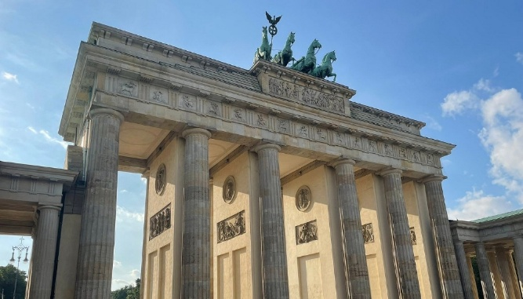
Brandenburg Gate. (2024). Tripadvisor.
Berlin Wall and East Side Gallery: The Berlin Wall, which once divided the city, now stands as a poignant reminder of Germany's divided past. The East Side Gallery, a 1.3-kilometer-long section of the wall, is an open-air gallery featuring over 100 paintings by international artists. It captures the hope and resilience that accompanied the fall of the wall and continues to inspire visitors with its vibrant artwork. At 1316 meters long, the open-air art gallery on the banks of the Spree in Friedrichs Hain is the longest continuous section of the Berlin Wall still in existence. Immediately after the wall came down on 9 November 1989, 118 artists from 21 countries began painting the East Side Gallery, and it officially opened as an open-air gallery on 28 September 1990. Just over a year later, it was given protected memorial status.
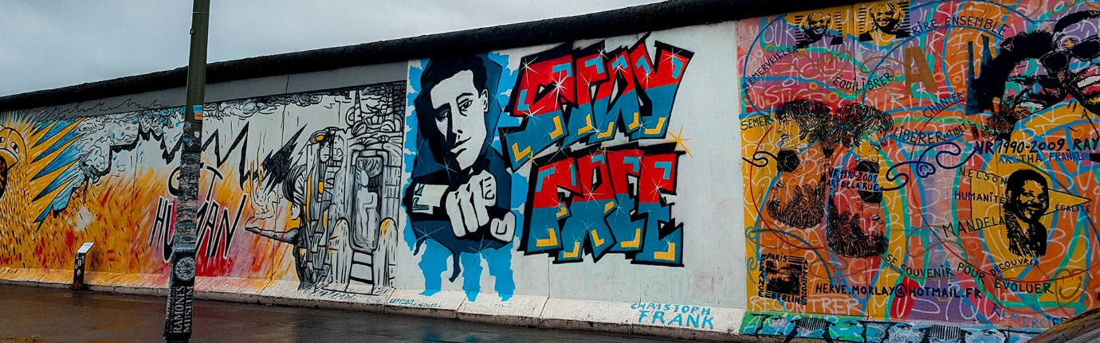
Store, M. (2019, July 11). East Side Gallery - einst die Berliner Mauer | Big Bus Tours.
Reichstag Building: A fantastic blend of historical architecture and modern design, the Reichstag Building is the seat of the German Parliament. The building's iconic glass dome, designed by architect Sir Norman Foster, offers a panoramic view of Berlin and symbolizes transparency and democracy. It's a great spot to learn about Germany's political history while appreciating its innovative design. The Reichstag is an internationally recognizable symbol of democracy and the current home of the German parliament. Every year, thousands of guests visit the Reichstag - and with good reason: It is not often that you can enjoy such an amazing panorama while, just beneath your feet, the political decisions of tomorrow are being made. Both as an architectural wonder and a historical testimony, the Reichstag has an important role to play in Berlin.
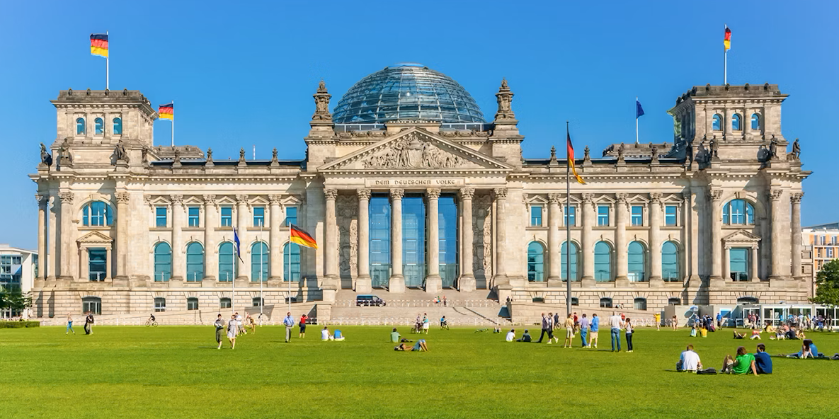
Essential Travel Guide to visiting Reichstag Berlin. (2024, July 18).
Museums and Art in Berlin:
Museum Island: Designated as a UNESCO World Heritage site, Museum Island hosts five of Berlin's most famous museums: the Altes Museum, Neues Museum, Alte Nationalgalerie, Bode Museum, and Pergamon Museum. Each institution offers a treasure trove of art and artifacts, making it a paradise for history buffs and art lovers. The island's architectural beauty adds to the immersive cultural experience.
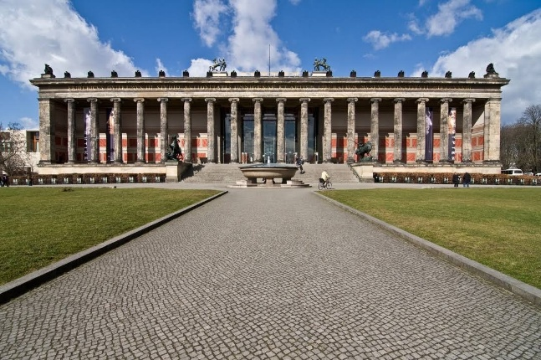
Kulturbesitz, S. P. (n.d.). Altes Museum.
Cultural Events of Berlin:
Berlinale (Berlin International Film Festival): As one of the most prestigious film festivals in the world, Berlinale is an annual celebration of cinema that attracts filmmakers, actors, and cinephiles from across the globe. Held in February, the festival screens a diverse array of films, from mainstream to independent, making it a key event on the cultural calendar.
Music Festivals: Berlin's music scene is diverse and vibrant, with festivals catering to a wide range of genres. From the pounding beats of techno at the Berlin Atonal Festival to the classical elegance of the Berlin Philharmonic's open-air concerts, there's something for every music enthusiast. These festivals not only celebrate music but also highlight Berlin's unique cultural tapestry.
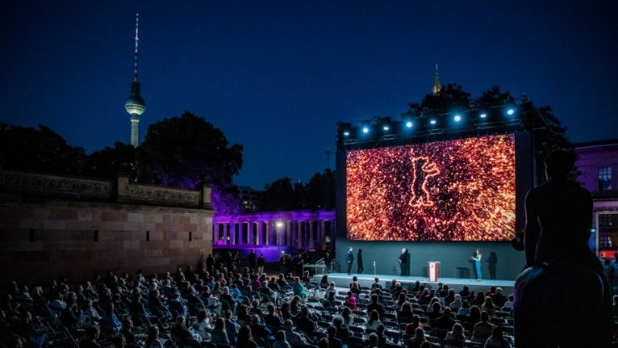
| Berlinale | Archive | Yearbooks | YearBooks.
Nightlife in Berlin: Berlin’s Club Culture is known for its legendary nightlife; Berlin offers an unparalleled clubbing experience. At the heart of this vibrant scene is Bergheim, often considered one of the best clubs in the world. Renowned for its techno music, strict door policy, and marathon parties that can last well into the next day, Bergheim represents Berlin's pleasure-seeking and inclusive nightlife. Whether you're a partygoer or just curious, Berlin's nightlife promises a memorable experience balanced with history, culture, and a touch of exhilarating chaos.
Tourism Highlights in Amsterdam
Canal Cruises: Amsterdam's iconic canals, a UNESCO World Heritage Site, offer a picturesque way to explore the city. Whether you take a guided tour or rent your boat, cruising the canals is a must-do activity. The city's historic buildings and charming bridges look stunning from the water, especially at night when the lights reflect beautifully on the water.
Rijksmuseum: This national museum houses an impressive collection of Dutch art and history, including works by Rembrandt, Vermeer, and other masters. The museum's grand architecture and vast collection make it a fascinating place to spend a few hours.
Anne Frank House: A deeply moving experience, the Anne Frank House is the former hiding place of Anne Frank and her family during World War II. The museum offers a poignant look into the life of Anne Frank and the history of the Holocaust.
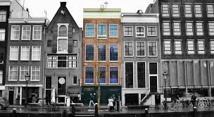
Cvanstolk. (2021, March 25). Anne Frank House – Amsterdam, Netherlands
Van Gogh Museum: Art enthusiasts will love the Van Gogh Museum, which showcases the works of Vincent van Gogh and his contemporaries. The museum offers a comprehensive look at the artist's life and works, making it a must-visit for fans of his art. It houses the paintings done by master artist Vincent Van Gogh and is mind-boggling. Every work of him has been displayed carefully, and one can appreciate the artifacts and the efforts of the museum. If one is travelling in Amsterdam, then it's a must-visit place.
Jordaan Neighbourhood: Wander through the charming Jordaan district, known for its narrow streets, historic buildings, and vibrant atmosphere. This area is filled with independent art galleries, antique shops, and cozy cafes, offering a glimpse into Amsterdam's past and present.
The Jordaan is a charming neighbourhood in Amsterdam with picturesque canals, historic buildings, and a lively local vibe. Highlights include the Noordermarkt, Anne Frank House, and numerous cafes and art galleries. Don't miss the Dutch apple pie and local cheeses. A must-visit for its beauty, history, and culture.
Dam Square:
Dam Square represents the historical and geographical centre of Amsterdam, embodying centuries of Dutch political, social, and cultural history. Originally constructed in the 13th century as a dam on the Amstel River, the square has transformed from a functional water management site to a vibrant urban space symbolizing Dutch national identity.
Culturally, Dam Square functions as a dynamic public space where historical significance meets contemporary urban life. It hosts numerous events, from national celebrations and royal ceremonies to public demonstrations and street performances. The square attracts millions of tourists annually, offering a microcosm of Amsterdam's social and architectural heritage.
Modern Dam Square balances historical preservation with urban dynamism, embodying Amsterdam's ability to maintain cultural heritage while remaining a living, evolving public space.
Hein, A. (2024, February 6). Dam Square, Amsterdam. Amsterdam Tourist Information.
Red Light District: Amsterdam's Red-Light District represents a complex intersection of cultural heritage, social policy, and urban tourism. Rooted in the city's maritime history, this neighbourhood has evolved from a sailors' quarter to a globally recognized symbol of Amsterdam's progressive social approach. Unlike typical tourist destinations, the district embodies the city's commitment to personal freedom, regulated sex work, and pragmatic social policies.
Contemporary challenges include managing gentrification, balancing tourism with resident experiences, and continuously redefining the neighbourhood’s cultural significance. The Red-Light District represents more than a tourist attraction—it's a dynamic urban space reflecting Amsterdam's ongoing social experiments, commitment to individual rights, and pragmatic approach to complex human experiences.
Cultural Comparison
Both Berlin and Amsterdam are cities rich in history, culture, and vibrancy, each offering a unique set of experiences for residents and visitors alike. However, there are some interesting similarities and differences that define their cultural scenes.
Cultural Differences
Berlin:
Historical Depth: Berlin is submerged in history, with landmarks that narrate tales from the Prussian Empire through World War II and the Cold War. Monuments like the Brandenburg Gate, Berlin Wall, and Reichstag Building are pieces of evidence of its complex past.
Art and Music Scene: The city is a hub for contemporary art, with areas like Mitte and Kreuzberg hosting numerous galleries. Berlin's music scene is diverse, prominently known for its techno and electronic music, with legendary clubs like Bergheim.
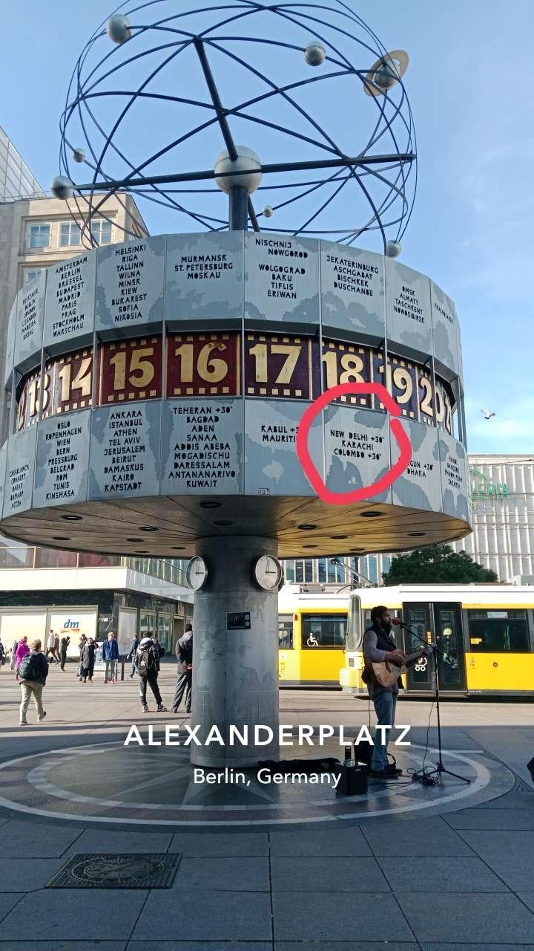
Alexander Platz Berlin, Germany
Cultural Mix: Berlin is incredibly multicultural, with a significant immigrant population contributing to its diverse culinary scene, festivals, and day-to-day life. This melting pot adds to its dynamic cultural fabric.
Amsterdam
Canal Life: Amsterdam's unique network of canals defines the city's landscape, offering pretty views and a different pace of life. The canals are a UNESCO World Heritage Site and a significant part of the city's charm.
Art and Museums: Amsterdam boasts world-class museums such as the Rijksmuseum, Van Gogh Museum, and Anne Frank House, drawing art lovers and history enthusiasts alike. The city's artistic heritage is deeply entangled with its identity.
Bike Culture: Amsterdam's bike culture is legendary. It's one of the most bike-friendly cities in the world, and cycling is a way of life for most residents. The extensive network of bike lanes provides a sustainable and scenic way to explore the city.
Cultural Similarities
Liberal Attitudes: Both Berlin and Amsterdam are known for their liberal and open-minded attitudes. They are progressive cities celebrated for their acceptance and diversity. This is reflected in their policies, social norms, and overall cultural vibe.
Vibrant Nightlife: Both cities boast vibrant nightlife scenes tailored to various tastes, from electronic music clubs and intimate jazz venues in Berlin to varied bars and dynamic nightclubs in Amsterdam.
Creative Hubs: In each city, there is a robust creative sector. Berlin’s contemporary art galleries and music festivals complement Amsterdam’s rich museum offerings and thriving art districts like Jordaan.
Berlin and Amsterdam, while distinct in their cultural expressions and experiences, share a common thread of embracing their histories and shaping progressive, dynamic futures. Whether you’re wandering through Berlin’s artistic streets or biking along Amsterdam’s scenic canals, both cities offer a taste of Europe’s eclectic charm.
Tourism Strategies and Impact
Berlin and Amsterdam represent two distinctive approaches to urban tourism, each shaped by their unique historical and cultural contexts. Berlin's tourism strategy emerges from its transformation narrative, leveraging its complex history as a powerful attraction. The city positions itself as a global destination of creativity, attracting approximately 13.8 million (approx.) visitors annually who are drawn to its raw, experimental cultural landscape. Its economic approach focuses on promoting creative industries, historical sites, and alternative urban experiences, generating around €13.7 billion (approx.) in annual tourism revenue.
Amsterdam's tourism strategy contrasts sharply, emphasizing controlled and sustainable visitor experiences. With nearly 19 million (approx.) annual visitors and an economic contribution of €87 billion (approx.), the city has implemented sophisticated management techniques to preserve its cultural authenticity. Amsterdam actively works to distribute tourist traffic, limit short-term rentals, and balance economic benefits and residents' quality of life.
Both cities share the fundamental goal of showcasing their cultural heritage while managing urban tourism challenges. Berlin's approach is more dynamic and experimental, inviting travellers to engage with its ongoing narrative of reinvention. Amsterdam, conversely, offers a more regulated experience that emphasizes the preservation of its historic canal networks, museums, and liberal cultural traditions.
The strategic differences reflect deeper cultural characteristics: Berlin represents continuous transformation and resilience, while Amsterdam embodies measured progress and historical continuity. Their tourism models demonstrate how cities can leverage their unique identities to attract global visitors, each creating compelling narratives that extend beyond traditional tourist experiences.
Despite their differences, both cities successfully transform their complex histories into vibrant, attractive destinations, proving that urban tourism can be both economically significant and culturally meaningful.
Conclusion
Berlin and Amsterdam exemplify distinctive models of urban tourism, each revealing profound insights into how cities can transform historical narratives into vibrant visitor experiences. Their approaches reflect not just tourism strategies, but broader cultural philosophies of remembrance, innovation, and societal progression.
Berlin represents transformation—a city where historical complexity becomes a dynamic attraction. Its tourism model demonstrates how urban destinations can reinvent themselves, turning painful historical memories into opportunities for cultural dialogue and understanding. The city's ability to attract global travellers stems from its authenticity, offering experiences that are simultaneously educational, provocative, and deeply human.
Amsterdam embodies preservation and calculated evolution, showcasing how a city can maintain cultural integrity while adapting to global tourism pressures. Its strategic approach of managing visitor experiences while protecting local character provides a nuanced template for sustainable urban tourism.
Key Comparative Insights:
- Both cities leverage cultural heritage as primary tourism assets
- Historical narratives serve as powerful attraction mechanisms
- Sustainable tourism requires balancing economic and social considerations
- Urban identity can be a strategic tourism resource
While their strategies differ, Berlin and Amsterdam share a fundamental commitment: transforming urban spaces into meaningful cultural experiences. They demonstrate that successful tourism transcends mere economic transactions, becoming a platform for cross-cultural understanding and dialogue.
Their models offer valuable lessons for global urban destinations: tourism can be a powerful mechanism for cultural expression, historical reflection, and mutual understanding when approached thoughtfully and strategically.
References
- Amsterdam Residents and Their Attitude Towards Tourists and Tourism. (2016). Philosophy, Communication, 25.
- EV, D. Z. F. T. (2024, January 25). Berlin – the city where anything is possible - Germany Travel.
- East Side Gallery. (n.d.). visit Berlin.
- Newberry, C. (2024, July 25). The essential guide to visiting Amsterdam. Travel.
- Leshem, A. (2020). The social dilemma of Berlin's booming tourism industry. Social Science Works.
- New tourism in the New Berlin. (2007). In World Tourism Cities (1st ed., p. 22). Routledge.
- Oyp. (2023). Amsterdam: Exploring Culture & Traditions. Over Your Place.
- Redefining Amsterdam as a tourist destination. (1988). Annals of Tourism Research, 25(1).
- "Stop Being a Tourist!" New Dynamics of Urban Tourism in Berlin. (2013). International Journal of Urban and Regional Research, 38(4).
- Understanding how Amsterdam City tourism marketing addresses cruise tourists' motivations regarding culture. (2017). Tourism Management Perspectives, 29.
- Urry, J., & Larsen, J. (2019). The Tourist Gaze 3.0.

