EUROPEAN INSTITUTE OF INNOVATION ENTREPRENEURSHIP AND TECHNOLOGY

A COMPARATIVE ANALYSIS OF TOURISM PROMOTION STRATEGIES IN PARIS AND BARCELONA

STUDENT NAME: RAJAT RANA
Student Id: DE240026

Table of Contents
1. Introduction 3
2. Main Methodology 4
2.1 Research Design 4
2.2 Data Collection Methods 5
3. Analysis Tools Used 8
3.1 SWOT Analysis: 8
3.2 Comparative Analysis Framework: 8
3.3 Qualitative Data Interpretation 10
4. Findings and Discussion 10
4.1 Tourism Promotion in Paris 10
4.2 Tourism Promotion in Barcelona 13
5. Conclusion and Recommendations 16
References 20
Appendices 24
Appendix 1: Eiffel Tower 24
Appendix 2: The Louvre 25

1. Introduction
Purpose of the Study
The purpose of this research is to compare strategies that lead to tourism promotion in Paris and Barcelona. Both cities equally are important to global tourism because each has attributes and tourism offerings peculiar to them. Visiting Paris, the city of culture and its famous landmarks, or Barcelona, which offers its modernist buildings, Mediterranean climate, and dynamic way of life, is a dream of millions of people. This study aims to examine how and to what extent these cities utilize digital marketing, sustainable tourism activities, and high points of interest like landmarks to attract different tourists. For this reason, understanding the way that these strategies play out will be of great value in understanding how these cities attain success in promoting tourism, and in providing recommendations for improving their strategies. The research will contribute to a broader understanding of effective and sustainable tourism marketing strategies by examining different methods that each city has used.
Choice of Cities
Their role in the global tourism market makes Paris and Barcelona perfect cities for comparison. Tourists from every corner of the globe visit both cities to experience their unique cultural features and renowned tourist attractions (Cárdenas-García and Alcalá-Ordoñez, 2023). Paris is known for its strong art, fashion, cuisine, and landmarks like the Eiffel Tower, the Louvre Museum, Notre Dame Cathedral, and many other historical sites. In contrast, Barcelona is famous for its modernist architecture, especially works of Antoni Gaudi, in addition to its warm Mediterranean climate, vibrant city life, and other customs (Patrichi, 2023). The comparison between these two cities allows for an evaluation of marketing promotional activities geared towards both cultural and contemporary tourism marketing. This will enhance understanding of how marketing is done in everyday life and how the thick tourism context addresses sustainability issues (Saragih et al., 2024).
Significance of Tourism Promotion
Both Paris and Barcelona relied heavily on tourism to fuel their local economies. The tourism sector makes a sizeable portion of their GDP by providing employment opportunities which in turn instigates further economic development. Apart from the economy, tourism branding actually improves the reputation of these cities as it markets them as centers of culture, history, and leisure to foreign tourists (Balasubramanian et al., 2022). Both of these cities are under constant pressure in the international tourism market to improve their promotional policies while patronizing their culture and being sustainable (Arumugam et al., 2023). These cities’ efforts to promote tourism are likely to have ramifications not only on the economy but also on the preservation of culture and balanced development. This means that examining their approaches to tourism marketing will provide important insights for other cities trying to promote tourism (Deb et al., 2024).
Methodology Overview
This study will be based entirely upon secondary data such as government documents, tourism data, advertisement brochures, and academic journals. For this research, secondary data is especially appropriate as it sheds some light on the tourism policies of Paris and Barcelona. The analysis will conduct a comparative analysis of the marketing strategies’ prominent features, including marketing tools, clientele, and tourism services offered. In addition, the factors that are said to exert influence on each city’s tourism promotion strategies of Paris and Barcelona will be evaluated through a SWOT analysis (Saragih et al., 2024). In this manner, the action taken by the cities and other strategic elements regarding the city’s marketing and tourism incorporation will be evaluated and practical steps to improve them will be proposed.

2. Main Methodology

2.1 Research Design
Comparative Analysis:
This research pursues a comparative analysis of the tourism marketing strategies of Paris and Barcelona from a marketing perspective. As one of the more developed methods of analysis, this approach will most definitely provide more insight into how these two cities with different tourism features self-promote as tourist destinations. This framework will emphasize important aspects like the marketing mix, the targeted population, and the range of tourism products each city markets (Hanna et al., 2021). Due to its historical sites and cultural significance, Paris leverages its art, fashion, and cuisine to captivate tourists, particularly those from the cultural and luxury sectors. In contrast, Barcelona promotes its local culture alongside the Mediterranean beauty and stunning architectural works like Sagrada Familia. This comparative analysis will illustrate how each city exploits its particular assets to capture tourists and position itself in the competitive international tourism market (Mele et al., 2021). This research will look into the promotional techniques in tourism used by both cities focusing on how tools like digital advertising, influencer marketing, and international conventions are geared towards appealing to certain classes of tourists. The comparative analysis will find out the important features of competitive region tourism marketing in both cities which will help to explain why they are successful (Armutcu et al., 2023).
SWOT Analysis:
A SWOT analysis will be incorporated into the analysis to assess the strengths, weaknesses, opportunities, and threats of every city’s tourism promotion strategy. SWOT analysis is an important method that will assist each city in the marketing of their tourism products, such as the brand value of Paris and the focus on sustainable marketing in Barcelona (Saragih et al., 2024). In this analysis, Paris’s cultural pieces of de resistance like the Eiffel Tower and Barcelona’s favorable climate are two aspects of a city’s strategy that will be examined (Nezha et al., 2021). Moreover, the cities’ over-tourism will also be discussed (Hindustantimes, 2024). A portion of the analysis that will be conducted on the city’s existing strategies is expansion to emerging economies and the pursuit of digital tourism as an opportunity (Balasubramanian et al., 2022). Lastly, global political instability, as well as competition from different tourist destinations, are threats that will be analyzed, and these serve as the comprehensive difficulties each city has concerning tourism promotion (Cárdenas-García and Alcalá-Ordoñez, 2023).

2.2 Data Collection Methods
Secondary Data:
The research will utilize information relating to tourism promotion strategies for Paris and Barcelona obtained from government reports, advertising, academic publications, and media articles as sources of data. This study intends to make use of secondary sources because they provide pre-analyzed information that is reliable and sourced from reputable experts making it possible to study the trends and results without incurring the burden of expensive and lengthy primary data collection (Saragih et al., 2024).
a) Government Reports on Tourism Statistics:
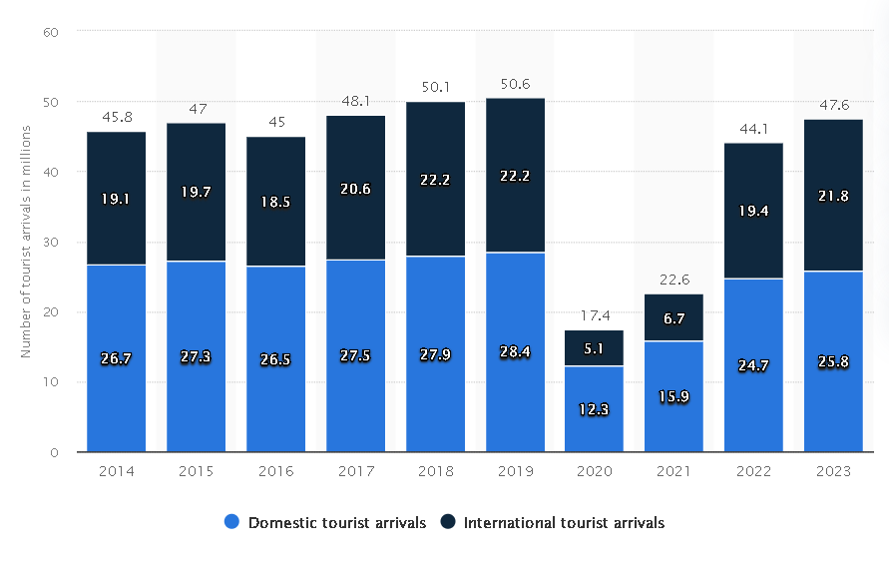
Figure 1: The Key Figures for Tourism in Paris 2023
(Source: Statista, 2023)
The government reports will be significant sources of information because they will provide data on the number of visitors, the amount spent, tourism trends, and the demographics of those visited. For instance, reports like “The Key Figures for Tourism in Paris 2023” and tourism information from Statista (2024) will come in handy for quantifying the tourism inflow and the visitor structure of each city as Paris and Barcelona (Parisjetaime, 2023). Such reports will reveal the results of marketing tourism and its economic effect in Paris and Barcelona.
b) Promotional Materials:
Brochures, websites, and social media ads aimed at promoting tourism in specific cities will be studied to see how each city tries to draw in tourists. Paris, for instance, leverages landmarks and high-end products in its advertising campaigns, while Barcelona focuses on promoting sustainable tourism (Global-ecoforum, 2022; Barcelonaturisme, 2023). These materials reveal valuable qualitative aspects of the branding strategies employed by the cities and their targets, which could be specific tourist niches such as eco-tourists or luxury tourism.
c) Academic Articles and Research Studies:
Academic literature will also be important for this research. Among the literature, Mele et al.’s (2021) works on the promotion of cultural tourism through social media as well as Cardenas-Garcia and Alcala-Ordonez’s (2023) studies on the effects of sustainability in tourism development will inform on Paris and Barcelona’s tourism promotion practices. This secondary data assists in placing the marketing strategies within the wider context of academic literature regarding tourism promotion.
d) Media Coverage of Key Tourism Events and Initiatives:
Examination of the media coverage of notable happenings in both cities will be done to ascertain the tourism marketing element external influence phenomenon.
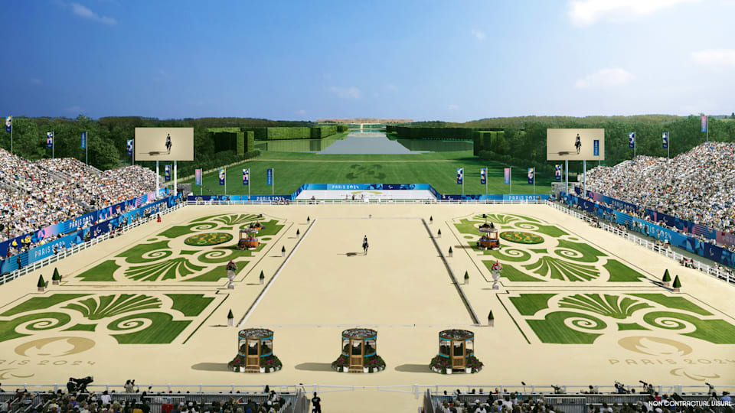
Figure 2: The Paris 2024 Olympic Games
(Source: Olympics.com, 2023)
For example, the Paris 2024 Olympic Games which millions are expected to visit will surely impact the city’s tourism strategies in the coming years (Paris, 2024). In the same way, Barcelona’s attempts to address overtourism via public policy and community participation have a wide media coverage which allows us to understand better the effectiveness of its tourism strategies (Reasonstobecheerful, 2023; Hindustantimes, 2024).
Rationale for Secondary Data:
Using secondary data is beneficial for this research because the method enables extensive and thorough analyses of tourism promotional activities performed by different organizations at a lower cost. The information is already available as it has been collected, analyzed, and published by credible institutions that can be used for comparison. The data collection done previously regarding the tourism promotional activities in Paris and Barcelona makes it possible to perform an in-depth analysis of the strategies employed by the two cities without collecting primary data (Saragih et al., 2024). Moreover, by accessing government, academic, and media sources, secondary data provides many different angles to analyze tourism promotional strategies within these two cities. The approach assists in digging deeper into the promotion activities and evaluating the effectiveness of the work done in the two cities.

3. Analysis Tools Used

3.1 SWOT Analysis:
The SWOT analysis has a specific role in the evaluation of the tourism promotion strategies of Paris and Barcelona. It will classify the primary strengths, weaknesses, opportunities, and threats of each city in such a way as to provide information about the best and the most efficient strategies adopted as well as those which require improvement. For example, Paris is famous for its Eiffel Tower and the Louvre which chiefly draw cultural and luxury tourists from all over the world (Nezha et al., 2021). On the other hand, Barcelona has a strength in its modernist Mediterranean style complemented by beach tourism which attracts diverse groups including eco-tourists and general leisure tourists (Simas et al., 2021). The SWOT analysis will reveal weaknesses like excessive tourism and dependency on seasons which are detrimental to the tourist experience in these cities. For Paris, opportunities may rest on increasing its digital presence and catering to new markets, while Barcelona may further take advantage of the city’s sustainable tourism strategies (Cárdenas-García and Alcalá-Ordoñez, 2023). Lastly, the assessment will include threats such as rivalry from other European cities and possible political volatility (Nezha et al., 2021).

3.2 Comparative Analysis Framework:

Figure 3: Comparative Analysis Framework
(Source: Self-Developed)
The comparative analysis framework will focus on several key aspects, allowing for an in-depth comparison of the tourism promotion strategies in Paris and Barcelona.
- Target Audiences
Analyzing the demographics of each city allows one to critically assess the promotional measures put in place: Paris, for instance, focuses on art lovers, cultural tourists, and high-end luxury travelers, taking advantage of its art-rich galleries and high-value services. Meanwhile, Barcelona focuses on a wider spectrum of tourists, including eco-tourists, cultural tourists, as well as beach holidaymakers (Benjamin et al., 2021; Li and Du, 2021) The study will evaluate the marketing strategies adopted by each city for these selected audiences.
- Marketing Channels
Paris and Barcelona make use of both traditional and digital marketing tools. Paris heavily promotes its famous monuments and culture through social media channels and international tourism fairs (Armutcu et al., 2023). Barcelona is more sophisticated in its integration of social media and influencer campaigns, along with public-private partnerships designed to promote sustainable tourism (Deb et al., 2024). The comparison will determine the effectiveness of the various channels in reaching diverse audiences.
- Tourism Products and Experiences
Paris specializes in heritage tourism as it provides various products in cultural tourism such as museums, historical visits, and gastronomy (Pappalepore and Gravari-Barbas, 2022). In contrast, Barcelona seems to offer a more complex range of tourism products, including architectural tourism with Gaudi’s works, beach tourism, and even active cycling and walking tours (Simas et al., 2021). This part of the analysis will look at how each city markets its products and how that relates to the behavior of the visitors.
- Public-Private Partnerships
Working together with both public and private sectors like hotel chains, tour companies, and local businesses aids in the advancement of tourism in both cities. For instance, Paris is connected with international travel agencies to capture high-spending visitors, whereas Barcelona cooperates with local businesses in promoting responsible tourism (Hindustantimes, 2024; Azazz et al., 2021). This will look at the impact of these relationships in sustaining tourism practices.

3.3 Qualitative Data Interpretation
In order to comprehend the secondary qualitative data, a systematic coding method will be employed to identify and elucidate the marketing achievement, sustainability measures, and tourist engagement themes. The brochures, social media postings, and advertisements will be analyzed on how effective they are to the selected audience. The analysis will shed light on the measures that successfully capture the interest of the tourists and the extent to which sustainability affects tourism promotion in both cities (Armutcu et al., 2023; Mele et al., 2021). The research seeks to reveal what messages are constructed by the understanding tourism branding of the cities in the qualitative data which will in turn explain the rationality behind their promotional strategies.

4. Findings and Discussion

4.1 Tourism Promotion in Paris
Tourism Strategy Overview
Frequently indicated as “the City of Light,” Paris is famous worldwide for its historical and cultural sites like the Eiffel Tower, The Louvre Museum, and Notre Dame Cathedral. The tourism promotion strategy of Paris leverages deeply its cultural heritage, rich in art, history, and gastronomy. Paris is one of the most visited cities in the world and receives a variety of travelers, including high-end tourists, art lovers, and those looking to go on a romantic getaway (Balasubramanian et al., 2022).
The promotion of city tourism has been hinged on premium luxury experiences, which put emphasis on top tier art museums, fine restaurants, and exclusive shopping places. By marketing the Eiffel Tower and the Louvre, Paris manages to position itself as a global icon of beauty, culture, and romance (Global-ecoforum, 2022). France has a comprehensive marketing programs of Paris as a touristic destination which combines advertising through the Internet and printed materials, social media campaigns, and participation in international tourism exhibitions. The focus is to sell the destination throughout the world and especially in high-income countries during all seasons (Parisjetaime, 2023). The city’s advertising campaigns are focused on establishing it as a cultural hub in order to attract tourists with interests in art, history, and everything Paris has to offer. These measures are especially geared towards positioning Paris as a necessary stop on the map for those hoping to enjoy its world-renowned culture, beautiful romantic atmosphere, and exquisite cuisine.
Key Promotional Channels
Paris applies integrated marketing communications, which blends online and offline marketing through social media advertising and partnerships with global travel agencies to increase international tourist traffic. The city tourism authority is active on all major social media platforms like Instagram, Twitter, and Facebook, where they post beautiful photographs of famous monuments, cultural activities, and other local attractions for the world to see (Statista, 2024). In this manner, Paris reaches out to travelers across the globe, providing them with tailored information and experiences that target various tourist groups. Online campaigns have paid ads with travel blogs, interactive websites, and influencer partnerships which aim to attract potential visitors. Marketing via the internet enables Paris to focus on particular tourist segments like art lovers, gourmet tourists, and romantic couples, and customize the messages (Paris, 2024). Such campaigns are targeted throughout the year to cover niche segments during major events including the Paris Fashion Week, Fête de la Musique, and other exhibitions at the Louvre, all of which cater to specific cultural and lifestyle tourists. Besides its digital marketing initiatives, Paris takes part in international tourism trade fairs like the World Travel Market (WTM) in London and the International Luxury Travel Market (ILTM) in Cannes, where the city can interact directly with tourism professionals, tour operators, and prospective visitors. These trade fairs enable Paris to make connections and build relationships with the key players in global tourism that shape and market the city to an elite and significant audience (Global-ecoforum, 2022).
SWOT Analysis for Paris
A SWOT analysis helps identify the key strengths, weaknesses, opportunities, and threats within Paris’ tourism promotion strategy.
- Strengths:
Paris’ primary strength is its cultural heritage and its standing as a global tourist hub. The city has some of the most recognizable features such as the Eiffel Tower, the Louvre, and the Musée d’Orsay which are important symbols of Paris and are known globally and have significance from cultural and historical perspectives as well (Balasubramanian et al., 2022) [Referred to Appendix 1 and 2]. The city’s image is also highly sophisticated and is attractive to affluent travelers because of luxury shopping, world-famous restaurants, and events like Paris Fashion Week. These branding necessities have ensured that Paris continues to remain one of the most frequented tourist destinations in the world for several decades.
- Weaknesses:
One of the major problems that Paris has is over-tourism, particularly in its crowded tourist areas. Every year, millions of travelers visit Paris which causes overcrowding at the Eiffel Tower, the Louvre, as well as Montmartre, which negatively impacts the experience of the visitors and burdens the local infrastructure (Cárdenas-García and Alcalá-Ordoñez, 2023). In addition, Paris is known for being extremely expensive which makes the city less friendly towards budget travelers. The city’s high expenses may restrict its popularity among younger travelers and affordable tourists which may reduce the volume of visitors.
- Opportunities:
Paris can expand its strategy for promoting tourism in a number of ways. New economic growth from Asian markets poses a novel opportunity for Paris as China and India continue to flourish economically. Citizens in these countries are now increasingly interested in traveling abroad. (Erdoğan et al., 2022). In addition, virtual tourism can engage audiences from geographically distant regions who cannot travel to Paris. Offering virtual tours of iconic landmarks and cultural events would help increase the brand value of Paris which will boost tourism in the city. The recovery from the pandemic also provides an avenue for Paris to revise its tourism strategies by incorporating a greater focus on safe and environmentally conscious travel options.
- Threats:
Paris faces stiff competition from well-known European cities like London, Rome, and Barcelona for the tourists’ attention. These cities also have their own cultural offerings and popular sights which can attract visitors away from Paris (Nezha et al., 2021). In addition, political upheavals like the recent protests and riots in France threaten the tourism image of the city. Any semblance of political turmoil will always affect tourist movement, especially from those groups that prefer visiting calm and peaceful locations (Nezha et al., 2021). To complicate matters further, Paris’s current reality of over-tourism requires the city to find an appropriate balance between guest hospitality and the quality of service provided to tourists.

4.2 Tourism Promotion in Barcelona
Tourism Strategy Overview
Barcelona is a Mediterranean gem featuring mosaics of modernist architectural buildings and a rich cultural scene; it has positioned itself as one of Europe’s most attractive tourist destinations. Its promotional strategy is focused on capturing the attention of tourists by marketing its art, history, and modern beach resort amenities, with the intention of attracting different types of tourists such as cultural, beach, sport, and urban tourists (Patrichi, 2023). Alongside the other marvels of Spanish design and history, the city is known for Antoni Gaudi’s Sagrada Familia and Park Guell which cater to the interests of history and design students. The Mediterranean is also an added bonus for tourists who sunbathe because the region offers year-round appeal. Barcelona has aimed in the last few years to position itself as a city with a cultural offer that coexists with leisure and modern sports tourism.
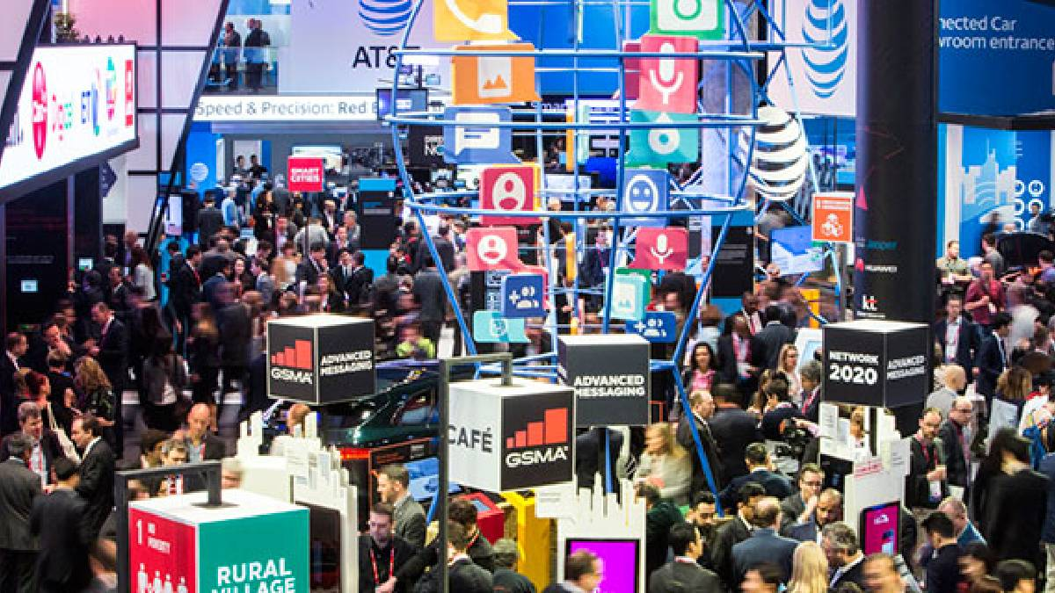
Figure 4: Mobile World Congress
(Source: India TV News, 2024)
Events like the Mobile World Congress which is one of the largest technology trades in the world, and the city’s strong sports culture, particularly the popular global football team FC Barcelona, greatly contribute to tourism. Moreover, the marketing of the city’s food scene, local festivals, and historical sites help solidify Barcelona’s reputation as a complex tourist destination (Reasonstobecheerful, 2023). The marketing strategy related to tourism in Barcelona is composed of various aspects: digital marketing, influencer marketing, and participation in global tourism events. The city features multi-faceted marketing activities. It does not only promote cultural heritage sites, but also advertises modern tech, sports tourism, and nightlife to appeal to a wide audience around the globe (Barcelona, 2020).
Key Promotional Channels
Barcelona has managed to employ a multichannel approach to attract tourists to the city. The city’s tourism body, Barcelonaturisme, has accomplished considerable progress in the sustainable aspect of tourism through the promotion of green hotels, eco-friendly tourism, electric scooters, and bike rentals (Barcelonaturisme, 2023). These initiatives also correlate with the worldwide shift towards sustainable tourism and the growing concern about the environmental impact on the tourism industry altogether (Saragih et al., 2024).
Besides sustainability, sports legacies form the backbone of the tourism approach of Barcelona. The football culture of the city spearheaded by FC Barcelona has made sports tourism a vital component of the city’s offerings. Major international events like the Mobile World Congress serve to not only brand Barcelona as a center of global business and technology but also entice people from all over the world to come and partake in Barcelona’s sporting culture (Roadgenius, 2025). Such events help the city mark its presence on the world stage, proving its dedication to international business and tourism while also showcasing the innovation, infrastructure, and sports zeal of the city. Additionally, the city of Barcelona has effectively harnessed the potential of social media marketing through influencers which captures the attention of tech-friendly tourists. Influencers regularly showcase their visits to Barcelona’s culturally and traditionally synonymous landmarks as well as the lively city on platforms such as Instagram and YouTube. As a result, the city has successfully remained popular with younger travelers as their marketing tactic combines tourism with lifestyle leisure activities (Reasonstobecheerful, 2023).
SWOT Analysis for Barcelona
A SWOT analysis of Barcelona’s tourism promotion strategy reveals several strengths, weaknesses, opportunities, and threats that impact the city’s tourism landscape.
- Strengths:
Barcelona is well-known for its architectural and climatic features, as well as its sporting activities. The city is endowed not only with Gaudí’s modernist architectural features but also with a beach. These combine to provide an advantage in attracting cultural and beach tourists. The Mediterranean climate guarantees tourism throughout the year (Patrichi, 2023). In addition, the football culture represented by the famous FC Barcelona boosts the city’s brand, thus promoting Barcelona globally as a sports tourism destination. All of them build the city’s brand and tourism appeal, expanding international name recognition and attracting a wide range of tourists.
- Weaknesses:
Barcelona, despite its numerous benefits, encounters serious issues with over-tourism for particular seasons. The continuous arrival of millions of tourists every year has caused congestion in famous spots such as Las Ramblas and Park Guell, undermining the visitor experience and straining local infrastructures (Simas, et al., 2021). In addition, the seasonal tourism dependency puts pressure on the city during off-peak months when the activity is insufficient and the local businesses struggle to remain viable. This form of seasonal dependency makes it hard for the city to ensure tourist presence during all seasons.
- Opportunities:
Barcelona has several avenues to further improve its tourism marketing strategy, especially within the sustainable tourism and niche tourism markets. The escalating worldwide demand for eco-tourism is a big chance for the city to enhance its green tourism marketing with environmentally friendly hotels and low-impact transport services (Saragih et al., 2024). Moreover, the city should take advantage of its increasing notoriety for sports tourism by capitalizing on the Mobile World Congress and FC Barcelona international matches to draw in new tourist demographics. Barcelona’s increasing health and wellness tourism represents another promotional opportunity to market its beaches and spas as the Mediterranean style of relaxation and well-being.
- Threats:
The tourism sector of Barcelona is highly vulnerable to numerous external factors. Changes in the economy on both a global scale and a local scale can impede the city’s potential to obtain international visitors if, for instance, disposable income or travel expenditure suffers a decline (Hindustantimes, 2024). Furthermore, within some local communities, especially those that have suffered the consequences of overtourism such as the Gothic Quarter and El Raval, there is increasing anti-tourism sentiment which has erupted in the form of protests demanding greater restrictions on the permissibility of short-term rentals and mass tourism (Hindustantimes, 2024). The protection of these issues is of utmost importance for the future of Barcelona’s tourism sector.

5. Conclusion and Recommendations
Summary of Findings
Both Paris and Barcelona have successfully attracted tourists using differing methods. Paris tends to focus on cultural and historical features such as the Eiffel Tower and the Louvre Museum to attract elite tourists. These features are blended in with luxury, art, cuisine, and romance which the city has to offer to tourists which aid in painting Paris’s promotion strategies (Balasubramanian et al., 2022; Parisjetaime, 2023). Barcelona, on the other hand, emphasizes the Mediterranean climate, modern design, and cultural activities while also focusing on sustainability. The city takes pride in its environmentally friendly policies which include green hotels as well as green modes of transportation (Barcelonaturisme, 2023; Reasonstobecheerful, 2023). In addition, Barcelona’s pride in sports, showcased by the success of FC Barcelona and other events such as the Mobile World Congress, makes it favorable for both sports and business tourists (Roadgenius, 2025). Both cities have a problem that is almost identical to each other and that is the problem of over-tourism. While Paris suffers from crowding at its popular sites, Barcelona faces the same problem, although it receives more visitors relative to its popular attractions in the summer season. Therefore, these cities are paying more attention to sustainable tourism to cope with these problems and make sure that these cities are sustainable in the long term. The Paris and Barcelona case shows how these cities are becoming increasingly sensitive to the impact of mass tourism on the environment and society which is encouraging them to adopt less destructive forms of tourism (Deb et al, 2024; Simas et al, 2021).
Recommendations for Paris
- Continue to emphasize sustainability in tourism promotion:
Even if Paris has crafted a solid image owing to its cultural and historical allure, it still needs to integrate sustainability measures into its tourism strategies. Marketing green initiatives, such as eco-hotels, sustainable restaurants, low-emission transportation, and others will help the city capture the market of environmentally friendly travelers. Moreover, Paris could also promote its efforts to sustainably manage, within the context of the modern day, the preservation of its rich cultural heritage, making the city more attractive to the omnibus tourism market. (Erdoğan et al., 2022)
- Target emerging markets and eco-tourism:
Paris has the chance to benefit from developing economies, especially with regard to Asia and Latin America. By targeting promotion through the digital marketplace as well as partnerships with local travel agencies, new tourist markets can be accessed. Moreover, the ecosystem of eco-tourism provides the opportunity for Paris to market not only its signature attractions but also its parks, gardens, and other green tourism activities. Advertisements on such attributes with the help of sustainable travel agencies can help Paris reach a broader audience (Erdoğan et al., 2022).
- Promote lesser-known cultural sites:
To relieve the strain on over-crowded landmarks such as the Eiffel Tower and the Louvre, Paris should try to market smaller known cultural sites and neighborhoods. Compared to other places, Montparnasse, Belleville, and the Canal Saint-Martin are less visited while still offering rich cultural experiences. By doing so Paris stands to gain more balanced tourist visitation across the city’s attractions, which in turn decreases the burden on certain central sites as well as fosters tourism sustainability (Nezha et al, 2021).
Recommendations for Barcelona
- Promote off-season tourism:
During the summer months, Barcelona is known for receiving a heavy footfall of tourists which culminates in overcrowding. This poses a problem to the local infrastructure. In order to alleviate this issue, the city should advertise off-season tourism and encourage travelers to visit during pleasant spring or autumn months when there are fewer people. With targeted marketing efforts, Barcelona can make itself available as a year-round destination and host special events and promotions during the off-peak season (Simas et al., 2021).
- Increase digital and social media presence for niche markets:
Barcelona has to increase its social media presence on platforms like Instagram to attract eco-friendly tourists. The city can also take advantage of the growing eco-tourism, cultural tourism, and sports tourism niche markets. Many travelers are far more eco-conscious these days and Barcelona can take advantage of that through its marketing campaigns. Sustainable transport options, organic green hotels, and local cuisine are just some of the initiatives that can be extracted from Barcelona’s eco-friendly initiatives (Saragih et al., 2024). If targeted the right way, these services can greatly enhance the city’s social media campaigns.
- Enhance public-private partnerships to improve tourism infrastructure:
In order to tackle the problems brought about by over-tourism and seasonal fluctuations, Barcelona should strengthen its collaboration with local and international businesses. Public-private partnerships could focus on infrastructure improvements needed in the field of tourism, such as the development of sustainable transport, waste management systems, and less crowded tourist zones. These collaborations could also support efforts such as the “Barcelona Sustainable Tourism” plan which seeks to manage tourism successfully (Pappalepore and Gravari-Barbas, 2022). Strengthened collaborations like this will help minimize the adverse effects of tourism in the city, while at the same ensuring that the city continues to offer experiences and services to the highest standards.

References
Armutcu, B., Tan, A., Amponsah, M., Parida, S. and Ramkissoon, H., 2023. Tourist behaviour: The role of digital marketing and social media. Acta psychologica, 240, p.104025.
Arumugam, A., Nakkeeran, S. and Subramaniam, R., 2023. Exploring the factors influencing heritage tourism development: a model development. Sustainability, 15(15), p.11986.
Azazz, A.M., Elshaer, I.A. and Ghanem, M., 2021. Developing a measurement scale of opposition in tourism public-private partnerships projects. Sustainability, 13(9), p.5053.
Balasubramanian, S., Sethi, J.S., Ajayan, S. and Paris, C.M., 2022. An enabling framework for blockchain in tourism. Information Technology and Tourism, 24(2), pp.165-179.
Balasubramanian, S., Sethi, J.S., Ajayan, S. and Paris, C.M., 2022. An enabling framework for blockchain in tourism. Information Technology and Tourism, 24(2), pp.165-179.
Barcelona, 2020. Barcelona Tourism for 2020: A collective strategy for sustainable tourism, https://ajuntament.barcelona.cat/turisme/sites/default/files/barcelona_tourism_for_2020.pdf
Barcelonaturisme, 2023. Sustainable Tourism Strategy, https://barcelonaturisme.com/uploads/web/bst/EstrategiaTurismeSostenibleBarcelonaTurisme23-25_ENG.pdf
Benjamin, S., Bottone, E. and Lee, M., 2021. Beyond accessibility: Exploring the representation of people with disabilities in tourism promotional materials. In Justice and Tourism (pp. 153-171). Routledge.
Bunghez, C.L., 2021. The emerging trend of niche tourism: Impact analysis. Journal of Marketing Research and Case Studies, 2021, p.134710.
Cárdenas-García, P.J. and Alcalá-Ordoñez, A., 2023. Tourism and development: the impact of sustainability—comparative case analysis. Sustainability, 15(2), p.1310.
De Matteis, F., Notaristefano, G. and Bianchi, P., 2021. Public—Private partnership governance for accessible tourism in marine protected areas (MPAs). Sustainability, 13(15), p.8455.
Deb, S.K., Nafi, S.M. and Valeri, M., 2024. Promoting tourism business through digital marketing in the new normal era: a sustainable approach. European Journal of Innovation Management, 27(3), pp.775-799.
Erdoğan, S., Gedikli, A., Cevik, E.I. and Erdoğan, F., 2022. Eco-friendly technologies, international tourism and carbon emissions: Evidence from the most visited countries. Technological Forecasting and Social Change, 180, p.121705.
Global-ecoforum, 2022. Paris Tourism Strategy 2022, https://www.global-ecoforum.org/wp-content/uploads/2018/06/Paris-Tourism-strategy-2022.pdf
Hanna, S., Rowley, J. and Keegan, B., 2021. Place and destination branding: A review and conceptual mapping of the domain. European Management Review, 18(2), pp.105-117.
Hindustantimes, 2024. Barcelona battles overtourism: Locals push back as tourist numbers soar, https://www.hindustantimes.com/lifestyle/travel/barcelona-battles-overtourism-locals-push-back-as-tourist-numbers-soar-101728901216247.html
India TV News, 2024. Mobile World Congress 2024 set to start from February 26: Here’s what you can expect. https://www.indiatvnews.com/technology/news/mobile-world-congress-2024-set-to-start-from-february-26-here-s-what-you-can-expect-2024-02-23-918326
Khalid, U., Okafor, L.E. and Burzynska, K., 2022. Do regional trade agreements enhance international tourism flows? Evidence from a cross-country analysis. Journal of Travel Research, 61(6), pp.1391-1408.
Li, S. and Du, S., 2021. An empirical study on the coupling coordination relationship between cultural tourism industry competitiveness and tourism flow. Sustainability, 13(10), p.5525.
Mele, E., Kerkhof, P. and Cantoni, L., 2021. Analyzing cultural tourism promotion on Instagram: a cross-cultural perspective. Journal of Travel and Tourism Marketing, 38(3), pp.326-340.
Nezha, M., Rossi, A., El Khalidi, K., Pavel, A.B., El Ouaty, O. and Fekri, A., 2021. A SWOT Analysis to understand the impact of tourism industry on the Three pillars social Economy and Environment. In SHS Web of Conferences (Vol. 119, p. 04004). EDP Sciences.
Olympics.com, 2023. Olympic Games Paris 2024: 6 million tickets sold. https://www.olympics.com/en/news/olympic-games-paris-2024-6-million-tickets-sold
Pappalepore, I. and Gravari-Barbas, M., 2022. Tales from two cities: COVID-19 and the localisation of tourism in London and Paris. International Journal of Tourism Cities, 8(4), pp.983-999.
Paris, 2024. Paris 2024 Games: 11.2 million visitors to Greater Paris!, https://www.paris.fr/en/pages/paris-2024-games-11-2-million-visitors-to-greater-paris-28160
Parisjetaime, 2023. The key figures for tourism in Paris in 2023, https://events.parisinfo.com/adherents/le-tourisme-a-paris_chiffres-cles_2023.pdf
Patrichi, I.C., 2023. The Phenomenon of Over-Tourism in a Post-Pandemic Context. Case of Barcelona. Romanian Economic and Business Review, 18(2), pp.69-76.
Petroman, C., 2021. Types of luxury tourism consumers. Quaestus, (18), pp.312-320.
Reasonstobecheerful, 2023. Barcelona’s ‘Bold Strategy’ to Quell the Tourism Crisis, https://reasonstobecheerful.world/barcelona-fighting-overtourism/
Risfandini, A., 2024. Sustainable Tourism Implementation In Indonesia: Emphasizing Green Tourism, Community-Based Tourism, and Local Empowerment. Barista: Jurnal Kajian Bahasa dan Pariwisata, 11(01), pp.58-67.
Roadgenius, 2025. Barcelona Tourism Statistics, https://roadgenius.com/statistics/tourism/spain/barcelona/
Saragih, J.R., Riadi, R., Saragih, R., Purba, T., Sidabukke, S.H., Simarmata, M.M., Sinaga, R. and Chalik, A.A., 2024. Assessing Tourism Object Management Towards Sustainable Tourism Development Strategy: A SWOT Analysis. International Journal of Sustainable Development and Planning, 19(8).
Simas, T.B., Oliveira, S.A.L.C.D. and Cano-Hila, A.B., 2021. Tourismophobia or touristification? An analysis of the impacts of tourism in Poblenou, Barcelona. Ambiente Construído, 21(3), pp.117-131.
Statista, 2023. Tourist arrivals in Paris and Île-de-France from 2010 to 2022. https://www.statista.com/statistics/1365173/tourist-arrivals-paris-ile-de-france/
Statista, 2024. Leading tourist attractions in Barcelona, Spain in 2022, based on number of visitors, https://www.statista.com/statistics/457335/barcelona-s-most-visited-tourist-attractions-spain/
Statista, 2024. Number of tourist arrivals to Paris and the Île-de-France region in France from 2014 to 2023, by type of tourist, https://www.statista.com/statistics/1365173/tourist-arrivals-paris-ile-de-france/
Statista, 2024. Number of visitors to the Louvre Museum in Paris, France from 2003 to 2023, https://www.statista.com/statistics/247419/yearly-visitors-to-the-louvre-in-paris/
Thaha, A.R., Maulina, E., Muftiadi, R.A. and Alexandri, M.B., 2021. Digital marketing and SMEs: a systematic mapping study. Library Philosophy and Practice, 2021, pp.1-19.
Ummar, R., Shaheen, K., Bashir, I., Ul Haq, J. and Bonn, M.A., 2023. Green Social Media Campaigns: Influencing Consumers’ Attitudes and Behaviors. Sustainability, 15(17), p.12932.
Yıldırım, S., Yıldırım, D.Ç., Aydın, K. and Erdoğan, F., 2021. Regime-dependent effect of tourism on carbon emissions in the Mediterranean countries. Environmental Science and Pollution Research, 28(39), pp.54766-54780.

Appendices

Appendix 1: Eiffel Tower
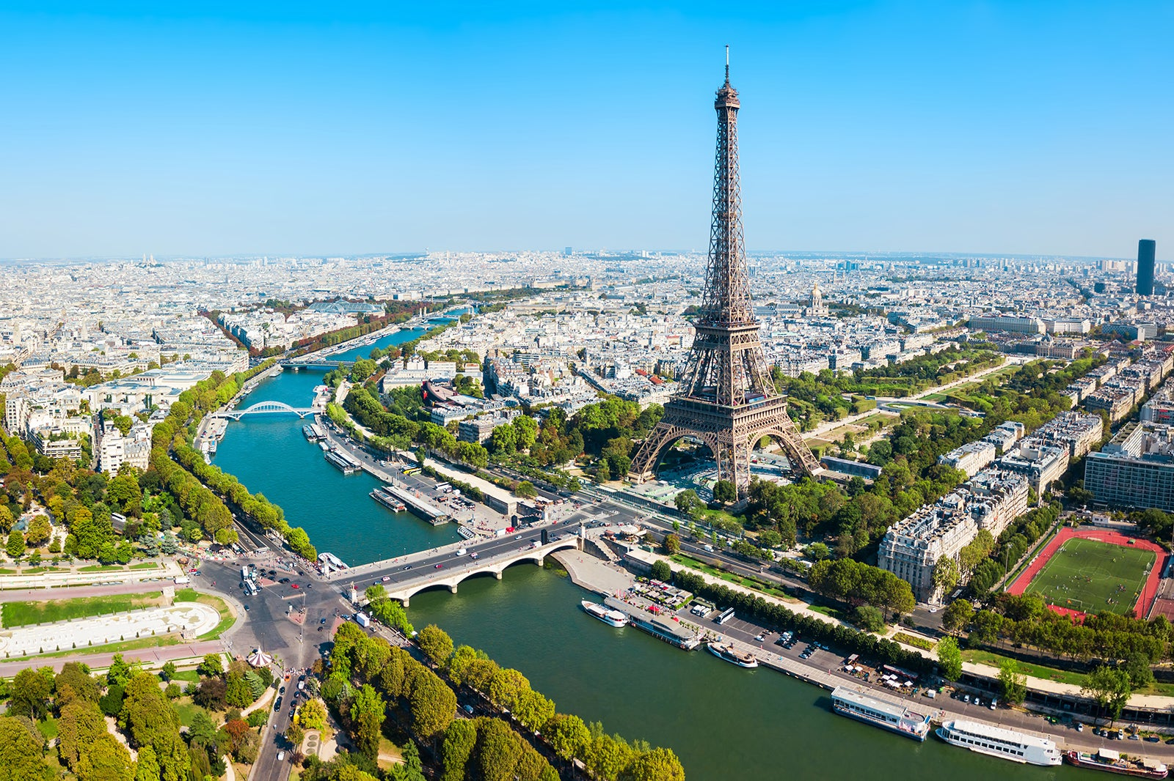
(Source: https://www.dbsexperience.com/blog/paris-history-and-overview)

Appendix 2: The Louvre
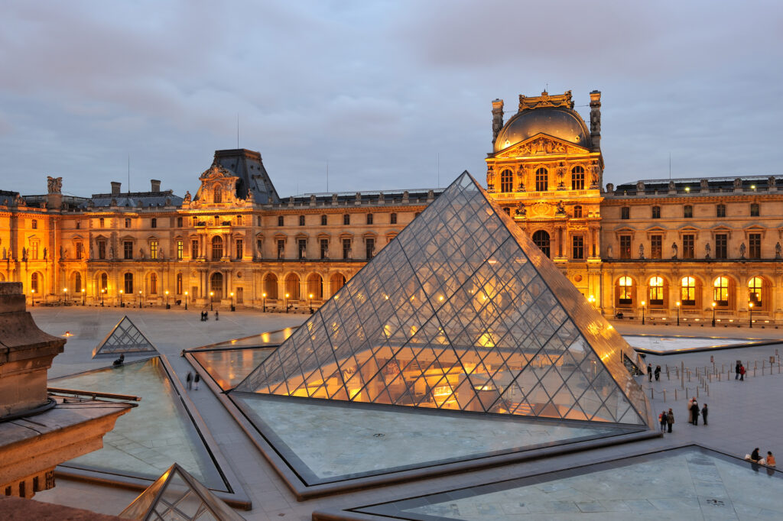
(Source: https://www.relaisdulouvre.com/en/le-louvre-museum-prepare-your-visit-tips/)

