

The Marketing Mix: Price in Tourism Services

Arvinder Singh
Student ID : DE240016
1st semester : Prof. Mr. Mahmoud Abdou
Due Date : 28th February 2025

Table of Contents

Introduction 3
The Role of Pricing in Tourism 4
Pricing Strategies in Tourism 5
Cost-Based Pricing 5
Value-Based Pricing 5
Competition-Based Pricing 6
Dynamic Pricing 7
Bundled Pricing 7
Factors Affecting Pricing in Tourism 7
Challenges in Tourism Pricing 8
Discussion 9
Case Studies: Successful Pricing Strategies in Tourism 9
Ethical Concerns in Tourism Pricing 9
Conclusion 10
References 11

Introduction
The principles of the marketing mix depend on pricing to drive customers' desires create profits for the business and shape sector leadership. Tourism operators set their prices to bring in customers and handle expenses simultaneously. Pricing decisions matter most in tourism because they need to deal with visitor preferences plus both regular and worldwide economic changes (Murodova, 2024).
Destinations and service providers use pricing as a powerful tool to create the correct market value positioning for their products. When businesses offer lower prices they make travel available to more customers while increased prices create the feeling of exclusive luxury. After COVID-19 tourism businesses adopted new strategies to align with customer behavior changes that involved offering both pleasure-related and combined pricing deals (Al-Moustafa et al., 2023).
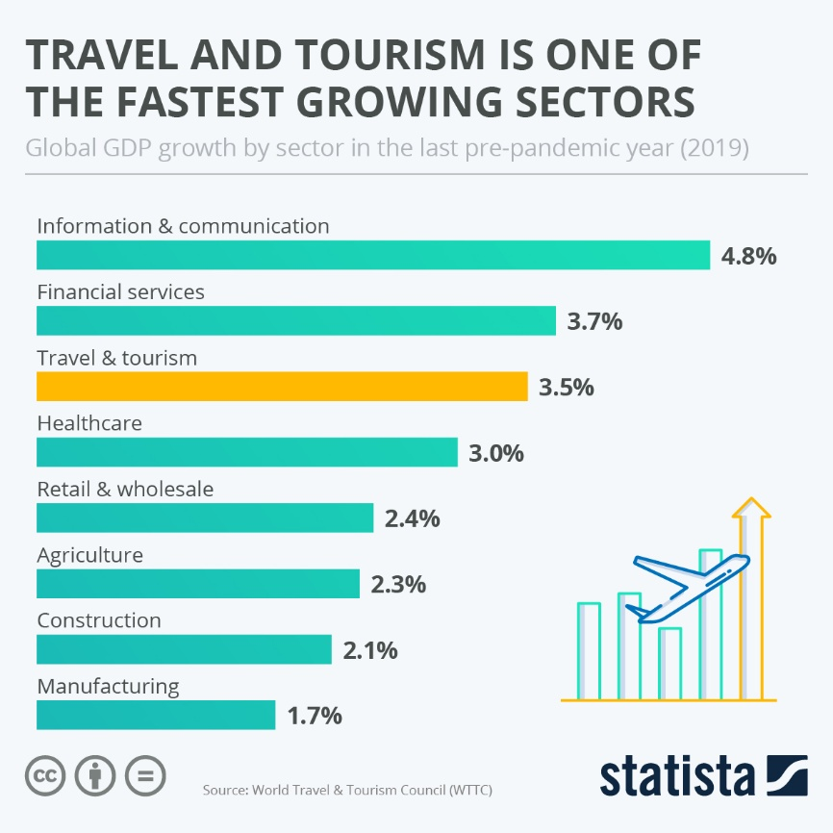
Figure 1: High Growth in Tourism Sector
Source: (Hinton, 2023)
Tourism firms use several standard pricing approaches that match their business needs: dynamic pricing, value-based pricing, and competitive pricing. Businesses that charge one price to locals but a different price to tourists use this approach frequently yet customer backlash follows (Marpaung&Manurung, 2023). When deciding on the correct pricing strategy tourism operators achieve better profits and pleased customers at the same time.

The Role of Pricing in Tourism
Destinations and services grow in popularity based on prices because travelers use them to determine how affordable and desirable a place or service will be. Tourism operators who set lower prices reach more budget travelers while higher prices attract tourists interested in luxury. Tourism businesses rely on dynamic pricing systems because these methods help them achieve higher room occupancy and sales results according to Murodova's review (2024). Research findings by Esquivias et al. (2021) demonstrated that price changes influence different kinds of travelers differently as low-income tourists react strongly to price changes compared to high-income tourists.
Customers link affordable rates to lower service standards so they may see less expensive rooms as valued choices. Luxury resorts charge high rates to display first-class services but budget destinations charge little as their main selling point. How well tourists feel something is worth its price directly affects what they pick when they decide to travel (Tiwari 2024). To boost bookings tourism operators use discount deals and package offers under the principles of psychological pricing (Radukića et al., 2023).
A location can only compete worldwide with effective pricing strategies. Tourists gravitate towards cheaper locations while expensive destinations win them over when they deliver exclusive memorable services. Research shows that simply being cheaper than other destinations fails to produce more tourism revenue because brand image and service excellence also affect success (Stojanović et al., 2021). Businesses that engage in strong price rivalry bring financial problems to the whole sector by setting prices too low (Radukića et al., 2023).

Pricing Strategies in Tourism
Businesses that use the right pricing methods can earn more money while gaining market advantage and drawing guests to them. These represent the primary pricing tactics that companies apply in the tourism industry today.

Cost-Based Pricing
Businesses develop their service prices by adding a profit edge to product delivery expenses. This business model permits total expense coverage including accommodations housing and payrolls while remaining prosperous. This pricing approach has limited response to shifting market trends and competitor rates since it depends solely on costs (Murodova, 2024).

Value-Based Pricing
Value-based pricing depends on what customers believe a service should cost instead of its production costs. In luxury tourism business models prices of special resorts and adventures reflect their unique experiences and customer willingness to spend money (Tiwari, 2024). This method lets businesses make more profits but demands extensive knowledge about customers and built-up branding work.
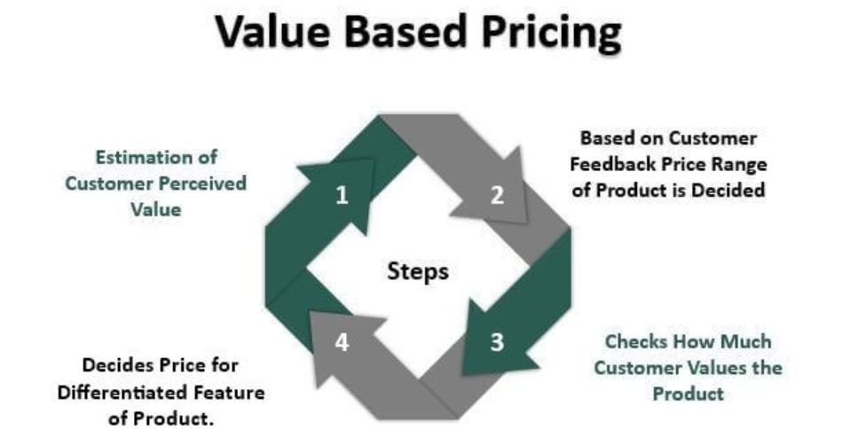
Figure 2: Value-Based Pricing Explanation
Source: (Shakti, 2020)

Competition-Based Pricing
Right now prices depend on what competitors charge in the market. Tourism companies running hotels and airlines track market prices to set their rates that will compete with rivals. Only businesses that use this tactic effectively to shape their brand presence will face price competition that hurts profitability (Kochevoy et al., 2024).
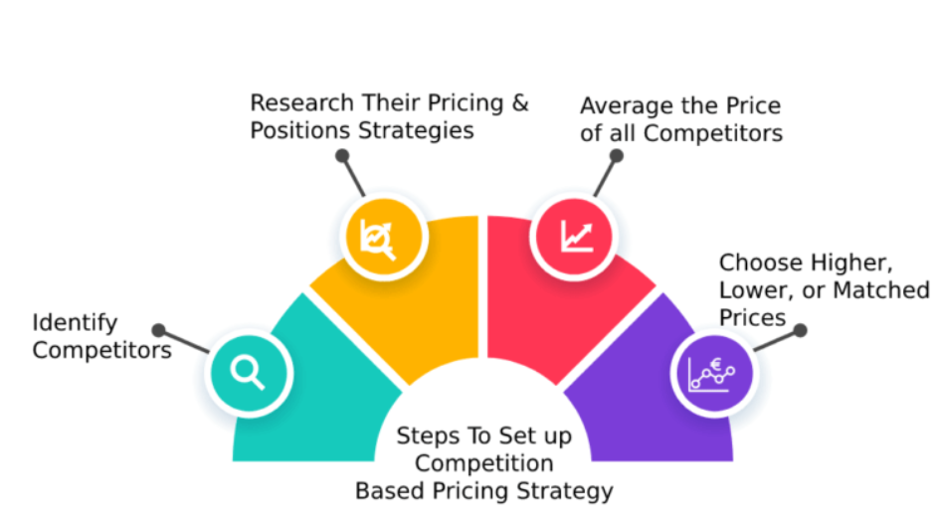
Figure 3: Competition-Based Pricing
Source: (Malhotra, 2022)

Dynamic Pricing
Dynamic pricing systems alter prices according to how many customers want services at any given moment. Tourism companies use dynamic pricing to find the best price point through their booking systems while working with historical usage data to increase profits. During busy times companies benefit most but customers view this practice as unreasonable according to Kish (2024).

Bundled Pricing
Pricing bundles create better deals that include flight tickets plus accommodation plus tour package discounts. This strategy makes services seem better valued and makes customers want to buy more services. Resorts and travel agencies bundle offers to create interesting holiday deals based on the research by Lin et al. (2020).
A business must pick and adapt pricing methods to match customer habits and market competition to achieve its goals.

Factors Affecting Pricing in Tourism
Tourism pricing depends on what occurs inside or outside the industry to shape how customers respond to business expenses and marketplace strength.
When tourism demand rises in peak seasons hotel managers charge more and offer discounts during low periods to bring in guests. The report by Xie (2020) confirmed that an economic slowdown causes tourists to alter their travel habits so businesses need adjustable price options to manage these changes.
Destinations that draw large numbers of tourists, especially capital cities and cultural centers set higher rates because visitors show strong interest. The accessibility to transportation networks plus popular attractions along with safety standards help companies decide their pricing decisions.
Tourism prices change with the swallowing of money by tourists while operators face the impact of trading rate increases. Study findings demonstrate price-conscious tourists have strong responses to weakened currencies both when they seek out foreign destinations as well as when they choose to stay at home (Mohammadzadeh & Tash, 2020).
Government rules about taxes visa terms and market support affect the complete expenses of the tourism industry. Initiating taxes on expensive hotel rooms creates higher costs yet using tax benefits helps travel companies lower prices for buyers (Murodova, 2024).
Customer groups best react to specific pricing techniques in separate ways. Budget-friendly tourists want excellent offers while wealthy travelers care most about being unique. Companies adjust their pricing plans based on what produces the highest earnings.

Challenges in Tourism Pricing
Firms applying strategic price techniques have different issues that affect their financial health and lasting business success.
Strong market competition pushes companies to cut prices for sales but this strategy harms their ability to stay profitable. Such pricing methods decrease brand strength and destroy long-term profitability even though they can work well short term (Tiwari, 2024).
Guests tend to feel annoyed when organizations make immediate price changes without warning them. Guests who find prices unfair tend to cancel reservations and give bad ratings (Kish, 2024).
Tourism pricing in every corner of the world changes when global health emergencies, disasters, and down economies happen. COVID-19 caused extreme price declines because travelers stayed home and government travel rules were enforced (Lypchuk&Vyslobodska, 2021).
Tourism industry businesses need to understand these elements to develop stable future pricing plans.

Discussion
Companies today find dynamic pricing to bring them the best results among all tourism pricing methods. A business can increase sales during busy periods and stay occupied by decreasing prices during slow times for better earnings (Liu et al., 2023). Bundled products and hedonic pricing choices have grown since the pandemic because they make customers feel more valued in their tourism experiences (Al-Moustafa et al., 2023).

Case Studies: Successful Pricing Strategies in Tourism
Major tourist hotels employ price segmentation to serve distinct guest groups through separate rates for guests who book directly with the hotel or through agents plus companies. Research on high-end hotels confirmed how blended competitor-and-season pricing led to better customer loyalty and business success (Murodova, 2024). Research from Kool et al. (2022) proved that web travel websites use demand-based pricing to grow sales while keeping visitors satisfied.

Ethical Concerns in Tourism Pricing
The ethical problems in pricing depend on charge differentiation methods and price shifts that usually frustrate customers and harm brand reputation. Scientists prove that tourism customers dislike sudden big price changes because they think they are dishonest (Zhang &Xin, 2024). Research about dual pricing practices between tourists and locals has increased because it creates ethical problems for the industry (Al-Badarneh et al., 2023).
Dynamic pricing works well today but companies need to hire ethics teams to reassure both tourists and countries that support the tourism industry.

Conclusion
Tourism service providers need solid pricing strategies because these affect customer demands while shaping market competition and industry reputation. A business can achieve better profitability while keeping customers satisfied through various ways like dynamic, value-based, and bundled pricing systems. Dynamic pricing shows excellent results because companies use it to set prices automatically according to current demand changes (Murodova, 2024).
A successful business for the tourism industry depends on creating and implementing the right pricing plan. The strategy protects businesses from financial problems while making customers feel safe and helping these firms retain their advantages over competitors. To maintain good consumer ties companies need to address the ethical risks of charging different prices to customers and making prices seem unreasonable (Al-Moustafa et al., 2023).
Tourism pricing will adjust through artificial intelligence computer systems that change rates automatically plus travelers can request unique trip packages that also comply with eco-friendly cost methods (Ke, 2024). The tourism industry continues to develop so companies need to use data to improve their pricing plans but also need to maintain open and fair practices.

References
Al-Badarneh, M., Maaiah, B., Alkilany, S., Ababneh, A., & Ababneh, M. (2023). Ethical Practices and Tourists’ Behavioral Intentions: The Case of European Potential Tourists. Deleted Journal, 11(11). https://doi.org/10.21608/shedet.2023.318772
Al-Moustafa, S. S., Hassan, T. H., Saleh, M. I., Helal, M. Y., Salem, A. E., & Khaled Ghazy. (2023). Unlocking Tourism’s Potential: Pricing Strategies for the Post-COVID Renaissance. Sustainability, 15(19), 14400–14400. https://doi.org/10.3390/su151914400
Esquivias, M., Sugiharti, L., Rohmawati, H., Setyorani, B., &Anindito, A. (2021). TOURISM DEMAND IN INDONESIA: IMPLICATIONS IN A POST-PANDEMIC PERIOD. GeoJournal of Tourism and Geosites. https://doi.org/10.30892/gtg.37329-731.
Hinton, T. (2023, April 3). Infographic: Travel and tourism is one of the fastest growing sectors. Statista Infographics. https://www.statista.com/chart/29637/travel-and-tourism-gdp-growth/
Ke, W. (2024). Tourism Demand Forecast and Future Market Trend Research. Advances in Politics and Economics, 7(2), p202. https://doi.org/10.22158/ape.v7n2p202
Kish, G. (2024). FEATURES OF PRICING STRATEGIES AS A FACTOR INCREASING THE COMPETITIVENESS OF HOTEL INDUSTRY ENTERPRISES. Market Infrastructure, 79. https://doi.org/10.32782/infrastruct79-37
Kochevoy, M., Kolesnіk, O., & Vlasova, H. (2024). PRICING AS A MARKETING PLANNING TOOL. Economic Scope. https://doi.org/10.32782/2224-6282/190-50
Kool, S., Westerlaken, R., & Suleri, J. (2022). Dynamic pricing and perceived fairness: a case study at a hotel on the West Frisian island of Vlieland, The Netherlands. Research in Hospitality Management, 12(2), 143–150. https://doi.org/10.1080/22243534.2022.2133071
Lin, X., Zhou, Y.-W., Xie, W., Zhong, Y., & Cao, B. (2019). Pricing and Product-Bundling Strategies for E-commerce Platforms with Competition. European Journal of Operational Research, 283(3). https://doi.org/10.1016/j.ejor.2019.11.066
Liu, Y., Wang, M., & Qin, Y. (2023). Comparative Analysis of Dynamic Pricing Strategies for Online Hotel Bookings: A Case Study of Luxury Hotels in Major Tourist Destinations. Frontiers in Management Science, 2(5), 44–49. https://doi.org/10.56397/fms.2023.10.06
Lypchuk, V., &Vyslobodska, H. (2021). CERTAIN ASPECTS OF FORMATION OF DEMAND FOR MARKET OF TOURIST SERVICE. Market Infrastructure, 61. https://doi.org/10.32843/infrastruct61-10
Malhotra, S. (2022, December 17). Competition Based Pricing A Complete Guide. 𝗍һᥱKᥱᥱ⍴І𝗍sіm⍴ᥣᥱ. https://www.thekeepitsimple.com/competition-based-pricing/
Marpaung, N., &Manurung, R. K. (2023). The Effect of Dual Pricing and Promotional Strategies on Traders Income in Tourism Villages, Samosir Regency. Indonesian Journal of Business Analytics, 3(5), 1775–1790. https://doi.org/10.55927/ijba.v3i5.5529
Mohammadzadeh, A., & Tash, M. N. S. (2020). Investigating the Uncertainty of Government Economic Policies on Inbound Tourism in Iran. New Global Studies, 0(0). https://doi.org/10.1515/ngs-2020-0025
Murodova, N. (2024). TOURISM PRICING STRATEGIES. European International Journal of Multidisciplinary Research and Management Studies, 4(4), 216–222. https://doi.org/10.55640/eijmrms-04-04-34
Radukića, S., Jovanovića, S., Petrović-Ranđelović, M., Kostić, Z., &Ilića, I. (2023). Relationship between price competitiveness, tourist arrivals, and tourism receipts in European countries. Serbian Journal of Management, 18(1), 153–165. https://doi.org/10.5937/sjm18-34886
Shakti, V. (2020, May 16). Value Based Pricing (Definition, Examples) | How it Works?WallStreetMojo. https://www.wallstreetmojo.com/value-based-pricing/
Stojanović, I., Puška, A., Osmanović, N., & Maksimović, A. (2021). Effects of Price Competitiveness on Tourism Performance under Different Economic Conditions. Tourism, 69(4), 543–558. https://doi.org/10.37741/t.69.4.5
Tiwari, G. (2024). Unveiling the Dimensionality of Pricing Strategy in the Tourism Industry: An Exploratory Factor Analysis. Journal of Interdisciplinary Studies, 12(1), 93–111. https://doi.org/10.3126/jis.v12i1.65451
Xie, J. (2020). The economic determinants of tourism seasonality: A case study of the Norwegian tourism industry. Cogent Business & Management, 7(1). https://doi.org/10.1080/23311975.2020.1732111
Zhang, X., & Xin, J. (2024). Analyzing Price Discrimination in Tourism Through Tripartite Evolutionary Game Theory: A Focus on Value Co-Creation. SAGE Open, 14(3). https://doi.org/10.1177/21582440241286286

