ASSIGNMENT 1

Structure of Tourism Markets

Submitted by: Jashanpreet Singh

1. Unique Characteristics of Tourism Services and Their Impact on Management and Marketing
Tourism services are different from physical products because they are largely intangible and are consumed while they are being produced. These characteristics create special challenges for tourism managers and marketers. Five important characteristics are as follows:
1. Intangibility
Tourism services are intangible, meaning they cannot be physically touched, tested, or stored before purchase. For example, a tourist cannot experience a hotel stay or sightseeing tour before actually buying it.
Effect on management and marketing:
Tourism businesses need to reduce customers' uncertainty by providing photographs, videos, virtual tours, reviews, brochures and detailed descriptions. Hotels, travel agencies and tour operators also focus on branding and reputation to communicate the expected quality of the experience.
2. Inseparability
Tourism services are generally produced and consumed simultaneously. The tourist and the service provider often need to be present at the same time. For example, a tourist's experience of a guided tour depends on interaction with the guide.
Effect on management and marketing:
Employee behaviour becomes extremely important. Tourism managers must recruit, train and motivate employees because their communication, attitude and professionalism directly influence customer satisfaction. Marketing therefore often highlights service staff and the overall customer experience.
3. Perishability
Tourism services cannot be stored for future use. An empty hotel room tonight or an unsold airline seat on a particular flight represents lost revenue that cannot be recovered later.
Effect on management and marketing:
Tourism businesses use demand-management techniques such as seasonal pricing, discounts, advance bookings and special packages. Hotels may offer lower prices during off-season periods and higher prices during peak periods to balance demand and capacity.
4. Heterogeneity/Variability
Tourism services are variable because their quality can differ according to the employee, time, location and customer. Two tourists staying in the same hotel may have different experiences depending on the staff interaction or circumstances.
Effect on management and marketing:
Managers need service standards, employee training, customer feedback systems and quality-control procedures. Marketers must avoid making unrealistic promises and should communicate the actual service experience accurately.
5. Lack of Ownership
Tourists generally do not obtain ownership of the tourism product. They purchase the right to use a service temporarily. For example, a hotel guest pays for accommodation for a particular period but does not own the room.
Effect on management and marketing:
Tourism businesses must focus on creating value through experiences rather than ownership. Marketing therefore emphasizes comfort, enjoyment, memories, convenience and unique experiences. Loyalty programmes and personalized services can encourage repeat purchases.
Conclusion
The characteristics of intangibility, inseparability, perishability, heterogeneity and lack of ownership make tourism management different from the management of physical goods. Successful tourism businesses therefore need effective service-quality management, trained employees, demand management and experience-oriented marketing.
References:
- Kotler, P., Bowen, J. T., & Makens, J. C. (2017). Marketing for Hospitality and Tourism. Pearson.
- Middleton, V. T. C., Fyall, A., Morgan, M., & Ranchhod, A. (2009). Marketing in Travel and Tourism. Butterworth-Heinemann.
- UN Tourism. (n.d.). Glossary of Tourism Terms.

2. Tourism Destination: Amritsar
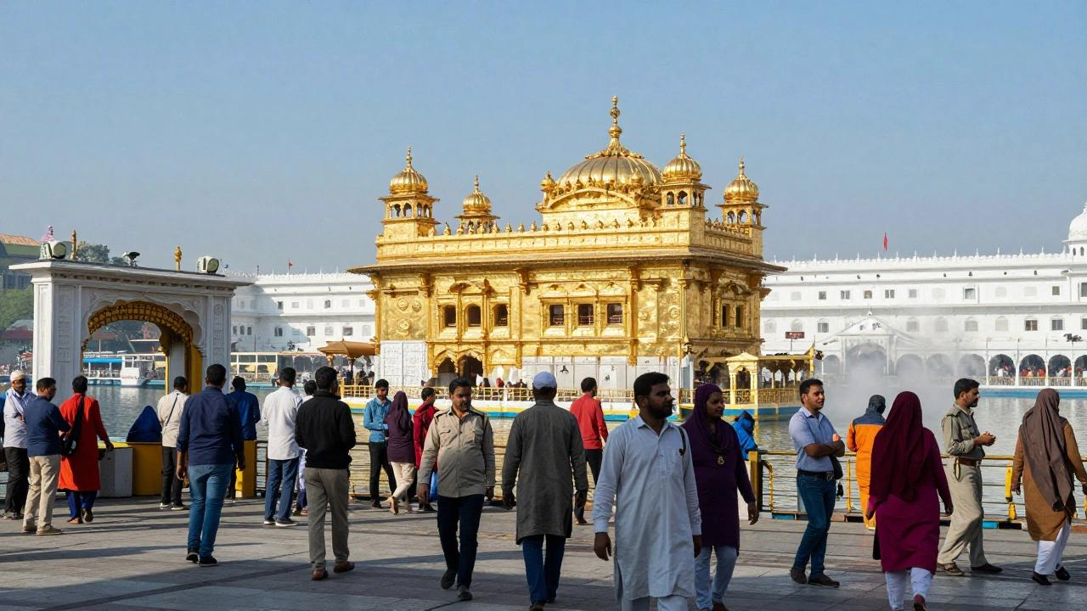
THE GOLDEN TEMPLE, AMRITSAR
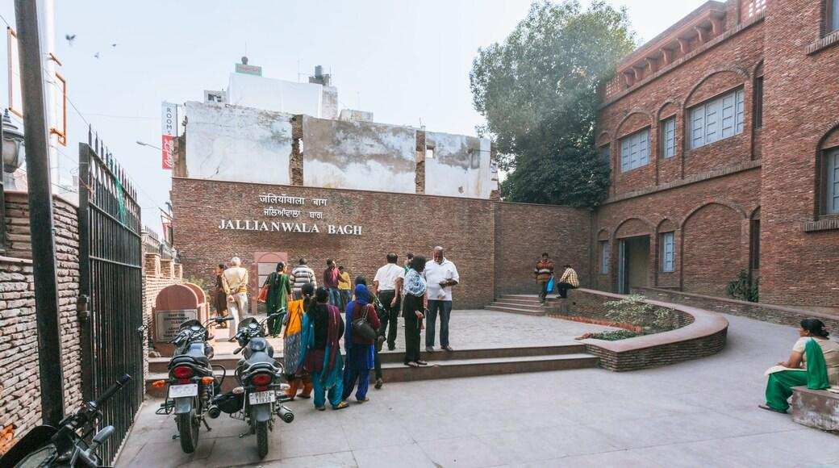
THE JALIANWALA BAGH, AMRITSAR
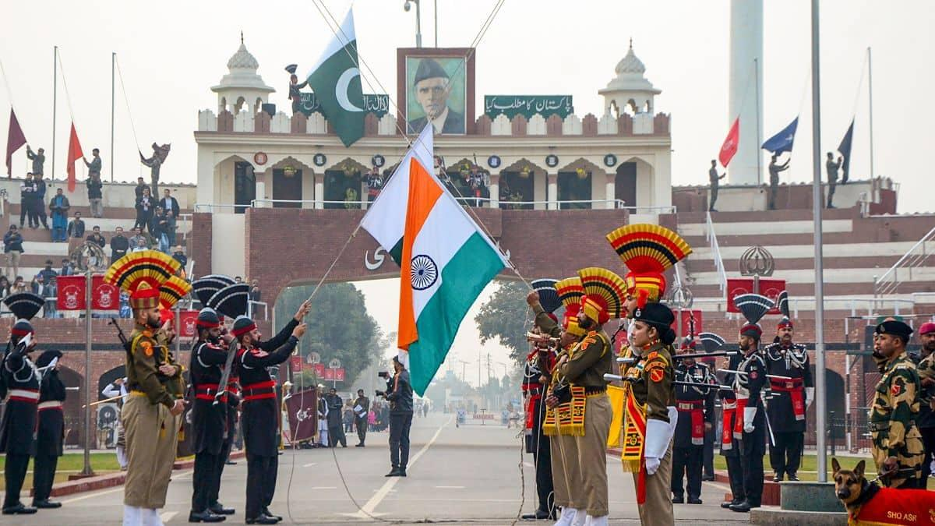
THE WAGAH BORDER, AMRITSAR

Introduction
Amritsar, Punjab, is one of India's important cultural and religious tourism destinations. It attracts domestic and international tourists because of its religious heritage, historical attractions, Punjabi culture, food and proximity to the India–Pakistan border.
A. Tourism Products and Services Offered
Amritsar provides a diverse range of tourism products and services, including:
- Religious tourism: The Golden Temple (Sri Harmandir Sahib) is the city's major attraction and an important Sikh pilgrimage site.
- Heritage and historical tourism: Attractions such as Jallianwala Bagh and historical areas around the old city attract visitors interested in India's history.
- Border tourism: The Attari–Wagah border ceremony is a popular attraction for tourists.
- Cultural tourism: Visitors experience Punjabi traditions, music, architecture, festivals and local lifestyle.
- Food tourism: Amritsar is known for dishes such as Amritsari kulcha, lassi and various Punjabi preparations.
- Accommodation and hospitality: Hotels, guesthouses, homestays and religious accommodation provide lodging facilities.
- Transport and tour services: Taxis, auto-rickshaws, buses, travel agencies, tour operators and local guides support tourist movement.
- Shopping: Tourists purchase Punjabi clothing, handicrafts, religious items and local food products.
B. Main Tourism Suppliers
The major suppliers supporting tourism in Amritsar include:
- Accommodation providers – hotels, guesthouses, homestays and other lodging establishments.
- Transport providers – airlines, railways, buses, taxis, auto-rickshaws and car-rental services.
- Travel agencies and tour operators – organize sightseeing tours, transportation, accommodation and packages.
- Restaurants and food businesses – provide local and international cuisine.
- Attraction and heritage-site authorities – manage important tourist attractions and visitor facilities.
- Local guides and artisans – provide interpretation, cultural experiences and locally produced goods.
These suppliers collectively form the destination's tourism supply chain.
C. Target Tourist Market
Amritsar serves several tourist segments:
- Domestic religious tourists, particularly visitors travelling to the Golden Temple.
- International Sikh diaspora, who visit religious and ancestral heritage sites.
- Domestic leisure and cultural tourists interested in Punjabi culture, history and food.
- International tourists interested in Indian history, religion and culture.
- Family tourists and group travellers visiting multiple attractions.
- Heritage and food tourists seeking cultural experiences and authentic local cuisine.
Conclusion
Amritsar's tourism industry is based on a combination of religious, historical, cultural, culinary and border tourism. Its wide range of suppliers enables the destination to serve different tourist segments. Effective coordination among accommodation providers, transport operators, attractions, restaurants and government authorities is important for providing a satisfactory visitor experience.
References:
- Ministry of Tourism, Government of India. (n.d.). India Tourism.
- Punjab Tourism. (n.d.). Tourism in Punjab.
- Sri Harmandir Sahib. (n.d.). The Golden Temple.
- Incredible India. (n.d.). Amritsar, Punjab.

