Puneet Bali
DE240329
B.A tourism and recreation, EIIET, Berlin
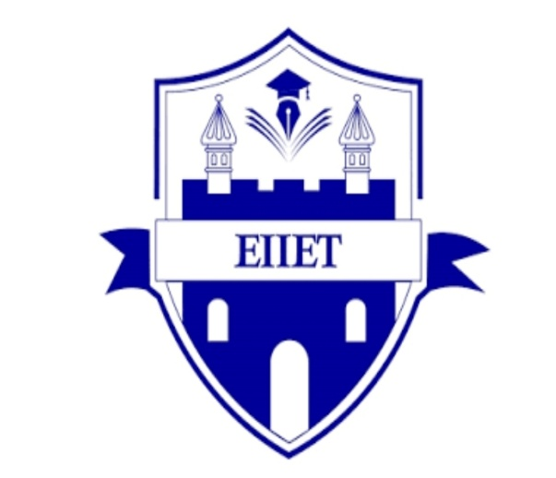
Tourism law and legislation
UNWTO Membership and Full Membership Criteria
Tourism ranks among the fastest-growing sectors globally, significantly boosting employment, cultural exchange, and sustainable development. The United Nations World Tourism Organization (UNWTO), a UN specialized agency, is central to advancing responsible, sustainable, and inclusive tourism worldwide. Since its establishment in 1975, the UNWTO has served as a platform for countries and organizations to collaborate on tourism policies, share expertise, and drive innovation in the sector.
A key aspect of the UNWTO is its membership structure, which determines how countries, territories, and organizations participate in shaping global tourism policies. Membership is divided into full members, associate members, and affiliate members, each with specific rights and responsibilities.
Full members, who are typically sovereign states, have the greatest influence in the organization, including voting rights in the General Assembly and the ability to actively shape international tourism initiatives. Associate members include non-sovereign territories or regions with some autonomy in tourism matters, while affiliate members encompass private sector organizations, educational institutions, and non-governmental entities.
- Eligibility: Open to all sovereign states.
- Criteria: Must formally adopt the UNWTO Statutes and accept its obligations.
- Approval: Existing states (those in IUOTO when statutes adopted) join automatically; others need General Assembly approval (two-thirds majority).
- Endorsement: The state guarantees the candidate entity (if applicable) meets UN standards (no human rights abuses, forced labor, etc.) and complies with local laws.
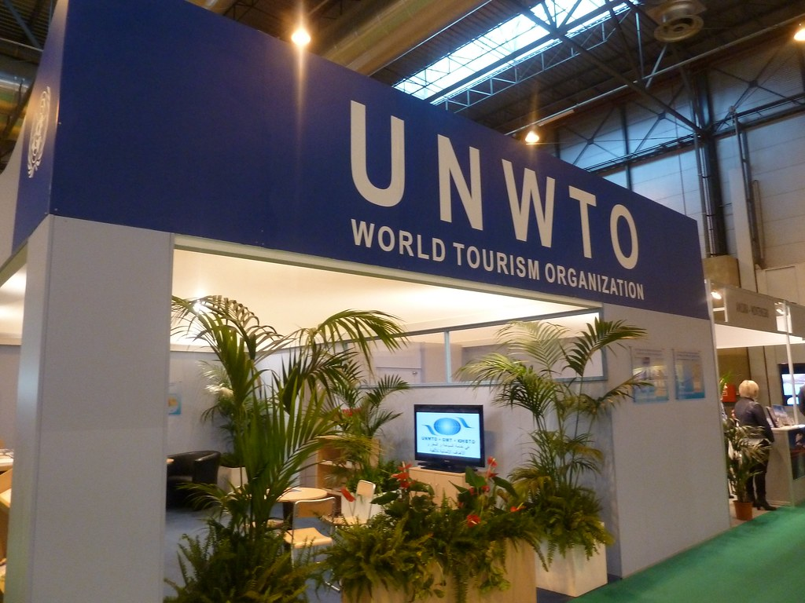
This Photo by Unknown Author is licensed under CC BY-NC-ND

Full Membership of UNWTO
Full membership in the UNWTO is for recognized sovereign countries. To become a full member, a country must agree to the UNWTO Statutes and have its application approved by the General Assembly. Full members contribute financially to support UNWTO activities, research, and global programs.
Full members have voting rights and can take part in all UNWTO decisions. They can access international tourism networks, data, and research, which help improve national tourism policies. They can also collaborate on global projects, share best practices, and benefit from programs that promote sustainable tourism. Examples of full members include France, Japan, Brazil, India, and Spain.
Full membership is important because it allows countries to influence global tourism policies, support sustainable development, and encourage cultural exchange. It helps countries align their tourism strategies with international standards and work with others to promote responsible and inclusive tourism.
Key Takeaway
The UNWTO structure ensures broad participation, from nations to businesses, focused on promoting sustainable, responsible, and accessible tourism globally, with states acting as key guarantors for private sector members.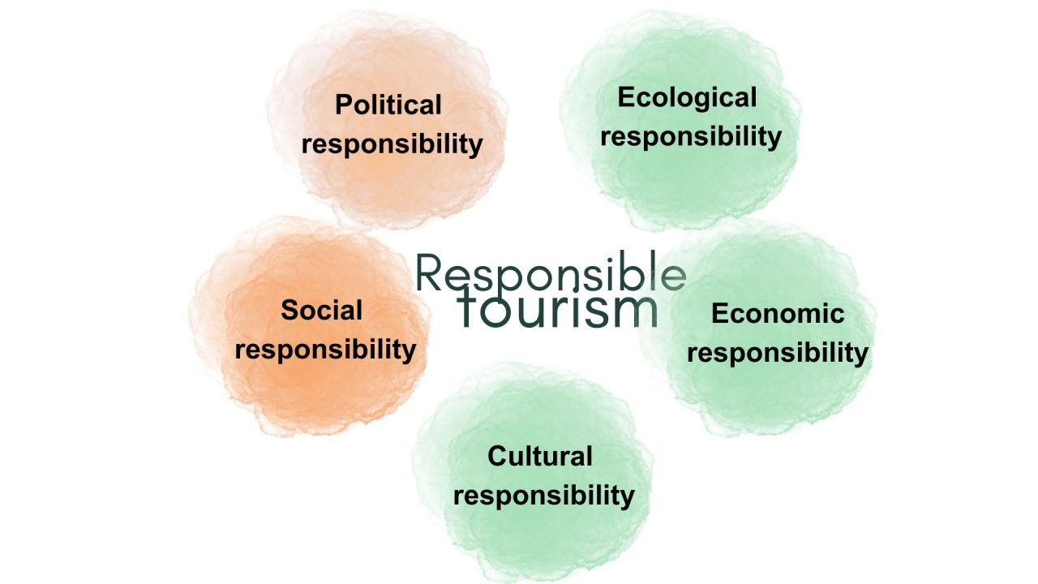
This Photo by Unknown Author is licensed under CC BY

Reference
Dredge, D., & Jenkins, J. (2011). Stories of Practice: Tourism Policy and Planning. Routledge. (Chapter 2 discusses UNWTO membership and governance structures.)
Sharpley, R., & Telfer, D. J. (2015). Tourism and Development: Concepts and Issues. Channel View Publications. (Explains how UNWTO supports member states in policy-making.)

