European Institute of Innovation, Entrepreneurship and Technology
Assessment Type: Project report
Title: Option 1: Price Elasticity, Market Equilibrium, and Dynamic Pricing in Tourism

Name-Satwinder kaur
Student ID- satwinder6015

Executive Summary
This report is a critical analysis of how price elasticity, market equilibrium and dynamic pricing are relevant in the determination of the performance of the tourism business. It focuses on airlines and hotels and particularly in the German tourist market. The two elasticities considered in the analysis are the Price Elasticity of Demand (PED) and Income Elasticity of Demand (YED) in the luxury travel industry and low-priced hospitality. It will also look at the effect of inflation, exchange rates and government policies on tourism pricing and demand. Lufthansa and Accor are utilized in order to assess dynamic pricing as a price management and capacity management tool. Nevertheless, price adjustments may spark issues regarding fairness, transparency and customer trust. The report recommends the use of human judgment in combination with forecasting and pricing technology of demand within tourism managers. Good communication on pricing and regular gauging of customer satisfaction should also be in place in order to create a balance between profitability and long-term sustainability of demand.
Table of Contents
1. Introduction 4
2. Microeconomic Analysis & Market Structure 4
2.1 Understanding Price Elasticity of Demand (PED) in Tourism 4
2.2 Factors Affecting PED in Luxury Travel and Budget Hospitality Markets 6
2.3 Income Elasticity of Demand (YED) and Tourism Consumption 8
2.4 Market Equilibrium and Price Mechanisms in Tourism 10
3. Macroeconomic Environment & Policy Impact 13
3.1 Impact of Inflation on Tourism Pricing 13
3.2 Exchange Rates and International Tourism Demand 14
3.3 Government Policies and Tourism Market Stability 15
4. Empirical Data & Case Study Analysis 16
4.1 Case Study 1: Dynamic Pricing in Airlines 16
4.2 Case Study 2: Dynamic Pricing in Hotels 18
4.3 Consumer Surplus, Deadweight Loss and Customer Perception 20
5. Strategic Implications for Tourism 20
5.1 Benefits of Dynamic Pricing for Tourism Businesses 20
5.2 Challenges and Consumer Perception Issues 21
5.3 Managerial Recommendations 21
6. Conclusion & Recommendations 22
References 23

1. Introduction
Tourism players have a high level of competition in the marketplace; prices which impact customer demand directly affect your revenues and long time sustainability. Airlines and hotels are forced to change prices based on how consumer tastes change, their seasonal wants and income and market conditions. In this respect the concept of price elasticity of demand (PED), income elasticity of demand (YED) and market equilibrium can be seen as issues that need to be understood as they are not always adequate to respond to price changes equally across the tourism segments. Increasing digital technology has also changed the conventional fixed-pricing to fluctuating pricing principles where companies are adopting real-time information to modify prices as per demand and supply (Reddypogu & Prasad, 2025). Revenue management is becoming a more popular tool among German tourist companies in the airline industry and hotel operators in order to increase capacity use and revenues. Nonetheless, the new regular price modifications can affect the perception of fairness and value among the customers.
This report is a critical analysis of the effects of price mechanisms, consumer behaviour and concerns about the elasticity of demand on the tourism market equilibrium and revenue strategies. It analyses the use of dynamic pricing using airline and hotel case analysis and offers managerial suggestions as to the ways of striking the balance between profit and customer demand over the long term.

2. Microeconomic Analysis & Market Structure

2.1 Understanding Price Elasticity of Demand (PED) in Tourism
Price Elasticity of Demand (PED) is the responsiveness of the quantity demanded of a product needed in tourism to price variations. It determines the degree of responsiveness of customers to changes in price and it aids businesses in knowing whether an increase or a decrease in price will enhance revenues (Shojaeddini et al., 2024). PED is significant in tourism markets since airlines, hotels and travel companies are prone to changing demand conditions. Even a slight price rise will result in a significant decline in bookings when there are numerous alternatives (Williams, 2022). As a result other services will adopt a slow change in demand as they are viewed by customers as having to be performed or as very useful.

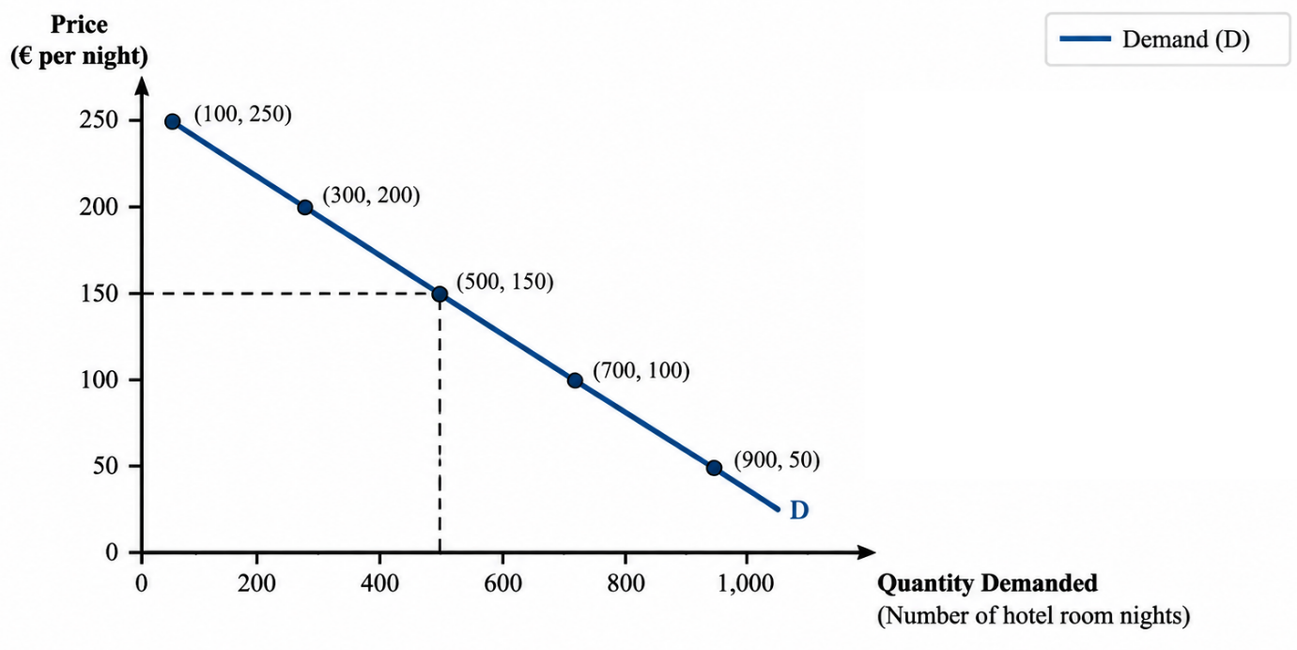
Figure 1: Demand curve for tourism services
Source: (Self-developed)
Figure 1 shows the trend between the price and the quantity demanded in the tourism markets. The downward-sloping demand curve indicates that as prices fall, the number of customers seeking tourism services, including hotel rooms increase. This relationship assists companies to be sensitive to prices of the customers and implement appropriate strategy of taking price depending on customer elasticity of demand.
There are a number of factors that influence tourism demand, which dictate the price sensitivity level. The presence of substitutes is one of the important factors as travellers have time to compare various airlines, destinations and accommodation providers to make decisions (Çakar et al., 2025). To illustrate this, a customer travelling in Europe might take the option of Lufthansa or other airlines or rail transit due to the price variations. This implies that leisure travellers can be more flexible in their demand, making it susceptible to becoming more elastic due to airline demand. PED is also dependent on the purpose of travel. Business travellers are generally less price sensitive as their decisions about travelling are usually based on schedules, meetings and necessities of their operations and not necessarily only on the cost of the tickets (Crosby et al., 2025). Conversely, leisure tourists might postpone travel, change to cheaper options or travel less frequently in case the prices go up (Bursa, 2024). Thus, the tourism companies need to recognize various segments of customers prior to implementing pricing strategies. Elasticity also has differences that arise due to seasonality. The level of elasticity of demand can reduce during peak seasons, when there are fewer options available to customers, such as holidays and major events. Nonetheless in periods of low demand, companies might require reduced prices in order to lure their customers.

2.2 Factors Affecting PED in Luxury Travel and Budget Hospitality Markets
Luxury Travel Market
Customer income, perceived value and brand reputation are some of the factors that affect price elasticity of demand in luxury travel. Service quality, exclusivity and personalised experience are what luxury travellers are looking at more than just price (Christodoulides et al., 2025). This could lead to less price elasticity in demand since customers might have an opinion that a higher price indicates superior value. An illustration is that in cases of exclusivity in services, good reputation, and quality services, a premium hotel brand is able to sustain a higher room rate. However price changes do not entirely impact luxury tourism. Customers can be influenced by economic uncertainty, changes in consumer confidence and competition from other luxury providers (Harba et al., 2021). Travellers with high income can also have comparison about various destinations and services and then transform into spending. Hence, luxury enterprises have to consider the tradeoff between high prices and ongoing enhancement of customer experience.
Budget Hospitality Market
The customers are more sensitive to price variance and high price elasticity is characteristic of budget hospitality. Visitors within this category tend to negotiate the charges of accommodation, discounts and the alternative alternatives prior to making a reservation. Um et al. (2025) recommends that even minor shifts in room prices can impact demand because clients have the ability to quickly alternate between low-end hotels, hostels and short-term rental services. High levels of substitutes in this market have a significant influence on elasticity. For example, in Germany low-cost hotels compete with low-cost accommodation providers and online booking solutions, which will raise the number of customers having freedom of choice. With the heightened competition, businesses might be forced to adopt competitive pricing approaches to reach out to price-sensitive customers.
Aspect | Luxury Travel Market | Budget Hospitality Market
Customer focus | Quality, exclusivity and unique experiences | Affordability and value for money
Price sensitivity | Lower PED due to higher perceived value | Higher PED due to strong price comparison
Key factors | Brand reputation, service quality and income level | Price, discounts and available alternatives
Pricing approach | Premium pricing with personalised services | Competitive pricing to attract customers
Table 1: Luxury Travel vs Budget Hospitality Market
Source: (Self-developed)
Segmentation focuses on customers in the tourism industry to enable them to understand the various demand reactions. Quality and experience may justify higher prices for luxury travellers whereas cost-effective customers might be more focused on cost.

2.3 Income Elasticity of Demand (YED) and Tourism Consumption
The income Elasticity of Demand (YED) is a concept that describes the effect of raising or reducing consumer income on the demand of tourism products and services. It assists companies to realize that customers are either spending more or less in traveling as their finances vary. The tourism industry is predominantly regarded as an income-elastic sector as holidays, overseas tourism and quality lodging are frequently affected by the levels of disposable income (Nguyen, 2021). The YED of luxury travel tends to be positive and high, as it rises sharply as the income of consumers goes up. The premium airlines, the luxurious hotels and exclusive experiences offered to higher-income customers can cost more. In a period of economic uncertainty though, this segment can face slow demand as customers might not take pricey holidays or might switch to cheaper options. The YED of budget hospitality markets is usually low when compared to luxury tourism since these markets involve customers who are more concerned with affordability (Stråle, 2022). When there is sluggish growth in income demand, the demand for budget hotels might not decline since travellers do not entirely shun travelling but seek lower prices. This opens possibilities for low-end providers in adverse economic times.
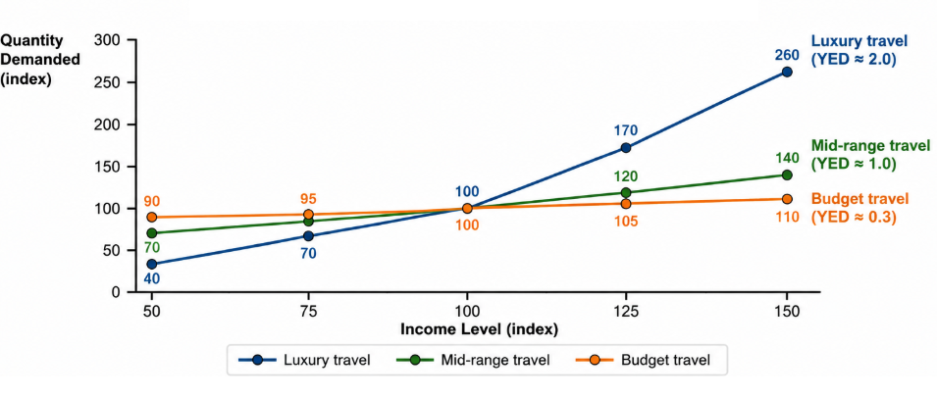
Figure 2: Comparison among luxury, mid-range and budget travel
Source: (Self-developed)
The above graph shows the correlation of income levels with tourism demand in various segments of the market. For luxury travel, the elasticity of income is very high and when income goes up, demand also increases drastically. The changes in income are more sensitive to mid-range travel and less sensitive to budget travel. This emphasizes the fact that premium tourism consumption is most sensitive with respect to income growth as opposed to budget services. Pricing and marketing strategies can be designed by tourism businesses under YED understanding (Nelson et al., 2021). Luxury providers get an opportunity to work on value-adding and customised services, whereas it only allows the budget operators to concentrate on cost-efficiencies and affordability. Income demand variation analysis is therefore useful in terms of enabling companies to react to varying group customers and the dynamic economic environment.

2.4 Market Equilibrium and Price Mechanisms in Tourism
Market equilibrium is a condition that arises when customers need an amount of tourism services and businesses provide the same amount at a given price. In tourism this position may vary rapidly as the demand is influenced by the seasons, holidays, events and customer income. At peak times when there is an increase in demand for rooms in hotels and reserved seats on airlines, the demand curve moves to the right (Alrawabdeh, 2021). This results in a greater equilibrium price in cases where the available capacity is not able to increase at the same rate.
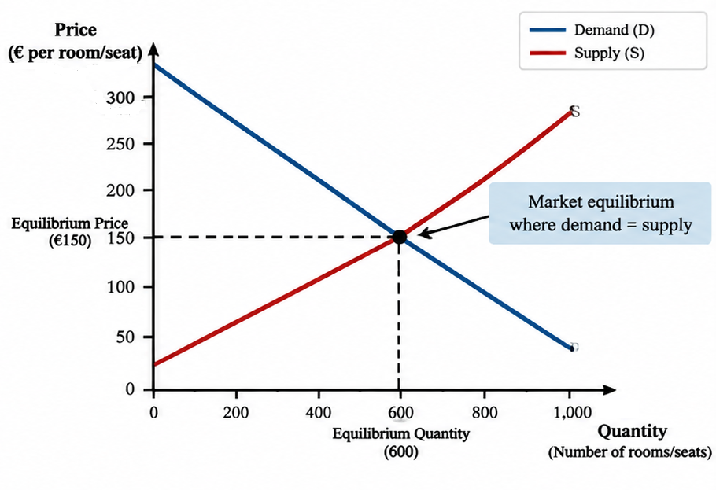
Figure 3: Tourism Market Equilibrium
Source: (Self-developed)
Demand and supply of tourism intersect at point F in figure 1 that forms an equilibrium price and quantity of 600 rooms/seats at the price of €150. At this level, companies can be able to sell available capacity without overcapacity or deficiency. This equilibrium can assist tourism companies to charge on the basis of prevailing market demand.
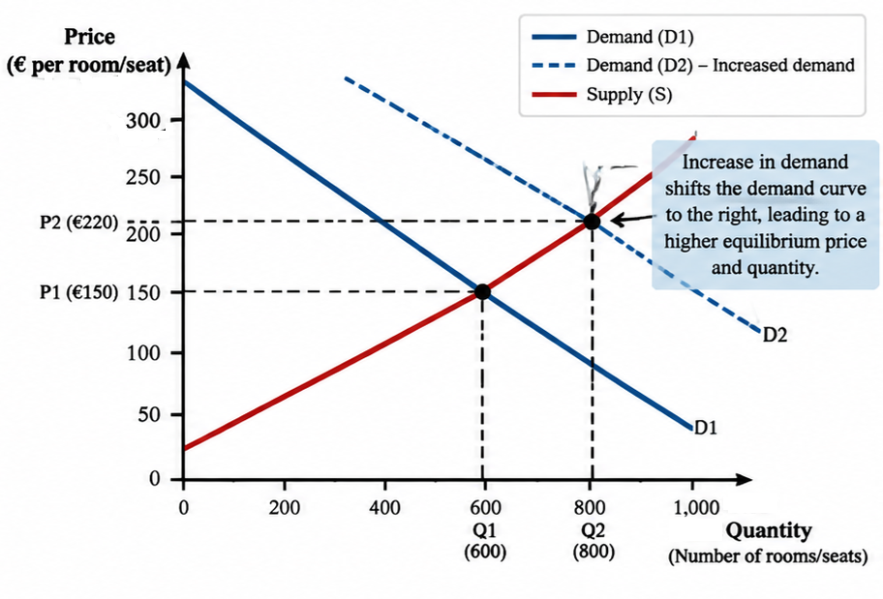
Figure 4: Increase in Tourism Demand During Peak Periods
Source: (Self-developed)
Fig. 4 illustrates that the demand curve D1 changes to D2 as a result of peak-season demand. The growth in the number of customers increases the equilibrium price to €220 instead of €150, and the quantity to 600 to 800 rooms/seats. With the peak season, tourism business owners have the opportunity to charge higher prices and maximise their revenue as they manage the limited capacity.

3. Macroeconomic Environment & Policy Impact

3.1 Impact of Inflation on Tourism Pricing
Inflation also has an impact on the pricing of tourism by raising the operating costs of the airlines, hotels and other tourism establishments. Natural price increases in the cost of fuel, energy, food, labour and maintenance tend to make companies push prices higher to maintain profit margins (Ghosh, 2023). However, with a higher price, customer demand is also decreased particularly among price sensitive travellers and pricing decisions are made more complex. A pertinent example is Germany which offers pressure on inflation on tourism-related services. By August 2026, the level of inflation in Germany had reached 2.9%, the highest it had been since April (Trading Economics, 2025). The price of package holidays rose by 4.6% and restaurant and accommodation services rose by 3.8 % over the same year (Destatis, 2025). These increases place a strain on the hotels and travel operators since the cost of inputs may also increase and the selling price has to be increased.
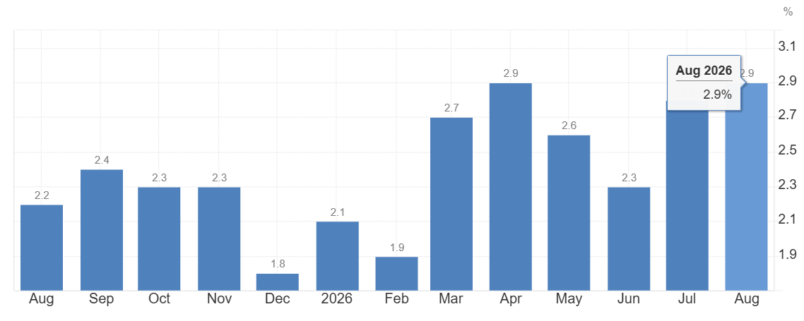
Figure 5: Inflation rate in Germany
Source: (Trading Economics, 2025)
Dynamic pricing is another aspect of tourism that is affected by inflation. The frequency of price adjustments in hotels and airlines is also likely to increase in response to fluctuating costs and demand. As an illustration, in times of high operating costs, companies can apply the method of demand based pricing so that when demand is strong there are high costs to be recovered and when demand is low the prices are reduced (Jullien & Sand-Zantman, 2021). Thus, tourism companies should strike a balance between the cost recovery measures and affordability of customers to ensure long-term demand and competitiveness.

3.2 Exchange Rates and International Tourism Demand
Exchange rates have an impact on international tourism as they dictate the cost of travelling internationally (Tung & Thang, 2022). This is because as the euro depreciates with the domestic currency of a tourist, Germany can be cheaper for the tourist. Hotels, restaurants and local attractions will thereby be able to receive an improved demand. However, fluctuations in exchange rates can also lead to an increase in the expenses of travelling abroad among the citizens of Germany. International tourism is still important to Germany. In 2025, 83.8 million foreigner overnights or 16.8% of the total overnights. This was 1.8% lower than 2024 (Destatis, 2026).
The fall cannot be attributed solely to exchange rates, as Germany was a host of the UEFA Euro 2024 that had brought more foreigners to the country the previous year (Chen, 2024). Exchange rates also influence the demand for tourism besides events, prices of travel and destination appeal. There was also quite a bit of international air travel. The airport of Munich also retained its tenth position as one of the busiest airports in Europe, receiving 43.4 million passengers in 2025 (Munich Airport, 2025). Hotels and airlines have to monitor currency variations when working with foreign-based clients so as to apply dynamic prices.
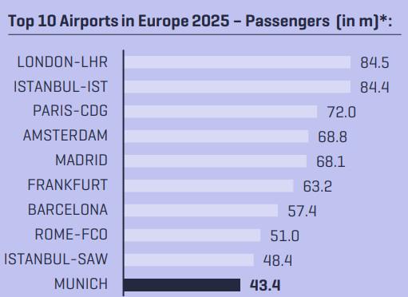
Figure 6: Top 10 airports in Europe 2025
Source: (Munich Airport, 2025)

3.3 Government Policies and Tourism Market Stability
Government policies determine the stability of the tourism market by determining the cost of businesses, competition, consumer confidence and aggregate demand situations. The tourism industry in Germany is developed in a controlled landscape in which policies and other issues like taxation, transport infrastructure and sustainability issues have a direct impact on pricing decisions. Effective policies will contribute to stabilization of the market, but sudden changes in the regulations may increase new costs for businesses (Braunerhjelm, 2022). Tourism support and recovery measures in Germany after it faced economic shocks are one of them. Government of Germany has provided support programmes on platforms such as the German National Tourist Board (GNTB) to create international tourism need and market Germany as a destination (Borzyszkowski, 2023). The significance of such activities is that tourism firms are normally put under outside strain like inflation, evolving travelling behaviour and global rivalry.
The regulations help in deterring all types of unfair competition in the market and assist in the maintenance of competitive tourism markets in which airlines and hotels have not been able to exercise extreme market power by trying to dictate order-around prices. The policies of sustainability are gaining in importance as well. In the short term, environmental policies can make business more costly within the tourism industry (Baloch et al., 2023). This is because they might force them to make investments on energy efficiency and other environmental conservation mechanisms.

4. Empirical Data & Case Study Analysis

4.1 Case Study 1: Dynamic Pricing in Airlines
A good example of businesses that apply dynamic pricing is working in airlines since seats are a perishable and limited product. Once a flight has passed the unsold seats will not yield any further revenue. Thus, air companies modify ticket costs depending on the demand and the booking trends, the remaining space and the readiness of the customers to pay (Abdella et al., 2021). The strategy will help the airlines to make more profits whenever there is high demand and gain more customers whenever there is low demand. Revenue management practice is applied in the Lufthansa German airline where the price of different customer markets is adjusted. The airline applies demand forecast systems and pricing systems to control seat availability and fare categories. In 2025, Lufthansa Airlines transported 65,706 thousand passengers, with a load factor of 83.4% and a revenue of €17.1 billion (Lufthansa Group, 2025).
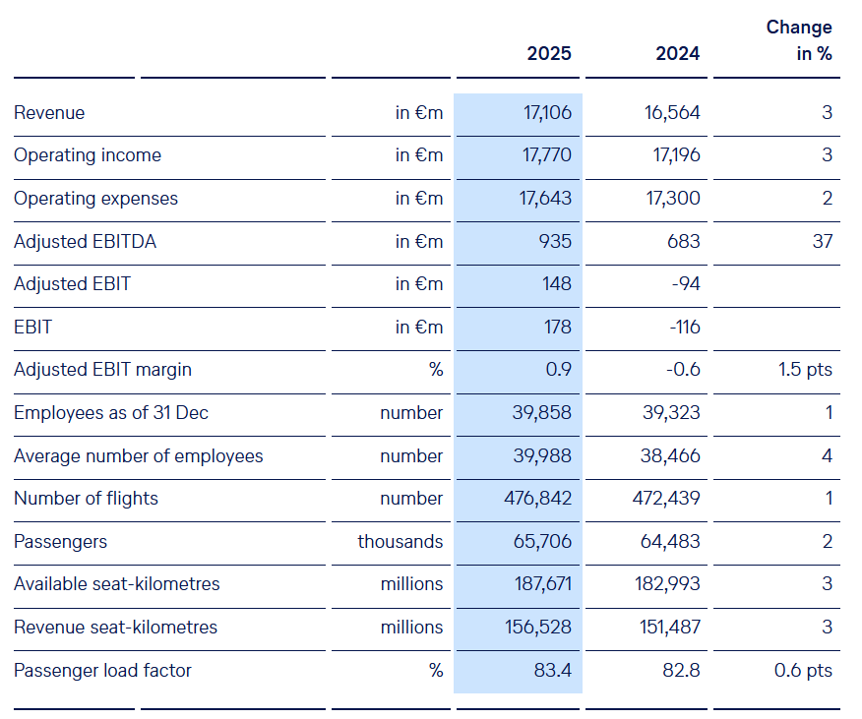
Figure 7: Comparison of key figures of Lufthansa (2024 vs 2025)
Source: (Lufthansa Group, 2025)
The large load factor means that the company has a chance to maximise the utilisation of the seats. However, the choice of pricing is vital as extremely low fares will result in increased passenger volumes and reduced profits. With dynamic pricing, Lufthansa is able to differentiate customers based on price sensitivity (Meyer et al., 2025). Travellers on business, booking nearer to travel days might be ready to pay higher prices since they have fewer options. Leisure travellers are further ahead in time and they are likely to be price sensitive. Fare classification helps the airline to get more money by having customers willing to pay in different classes. However, dynamic pricing raises perception problems on the part of the customers (Nunan & Di Domenico, 2022). Changing prices frequently can lead travellers to believe that some people are being unjust in terms of price and when they see varying prices charged on the same flight.
This has the ability to impact on customer satisfaction and trust. The airlines have to thus strike a compromise between revenue maximisation and effective communication and perceived justice. The effectiveness of dynamic pricing can be affected by extrinsic factors as well. Lufthansa stated that its passenger revenue operations have increased by 3% to 15.7 billion Euro in 2025, and profits dropped by 2.1% due to the stricter price pressure in Europe and the impact of exchange rates (Lufthansa Group, 2025). This underlines the fact that market forces cannot be completely eradicated at the cost of dynamic pricing.

4.2 Case Study 2: Dynamic Pricing in Hotels
Hotels are incorporating dynamic pricing, as inventory of the rooms is not unlimited and they do not have storage to be sold at a later time. By not recording a room in a certain night, the revenue will be lost forever. Therefore, hotel businesses are sensitive to demand and charge of individual rooms based on the number of persons accommodated in the hotel, observing changes in reservation and season and local events (Guizzardi et al., 2022). This strategy assists the hotels to enhance its revenue generation whilst dealing with varying customer demand. The revenue management systems are used at the Munich-based German hotels that are managed by Accor and run under brands such as ibis, Novotel and Mercure. Accor reported that its Revenue per Available Room (RevPAR) has increased 4.2% in 2025, which can be explained by the fact that prices have improved and the organization operates very well. The group had revenue of 5.639 billion euros in 2025 and had 5,836 hotels and 881,427 rooms all over the world (Accor, 2026).
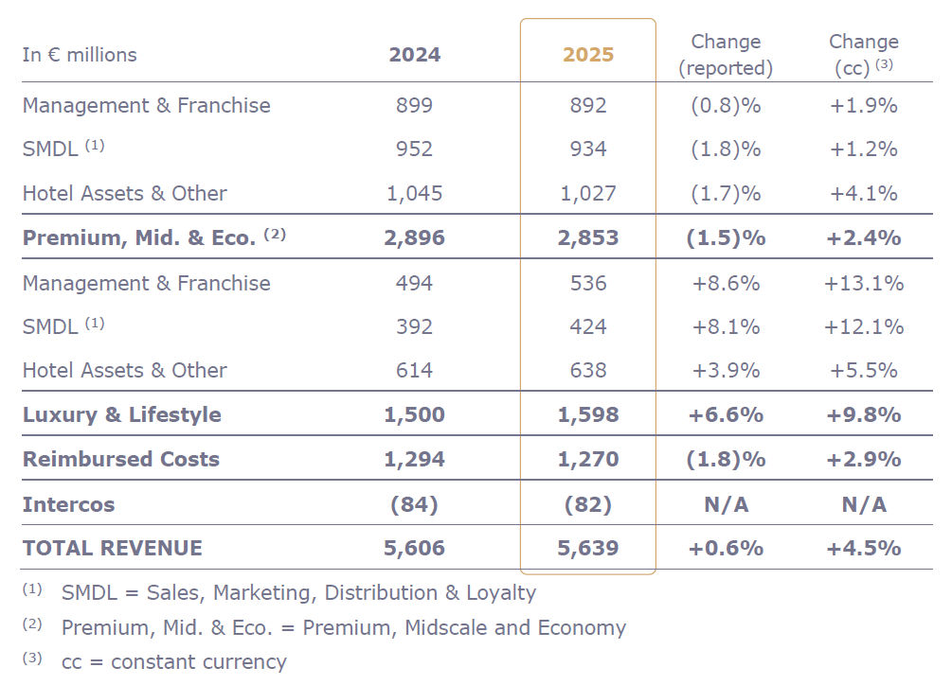
Figure 8: Comparison of key figures of Accor (2024 vs 2025)
Source: (Accor, 2026)
Dynamic pricing can be described to mean offering customers different prices to accommodate their demand and booking behaviour. Considering this, a hotel at Berlin can set higher room rates during major events, trade fairs or high tourist seasons since demand is greater and people have no alternative. Default promotion offers or lowering prices are appropriate when demand is low to stimulate demand and boost occupancy (Lima Santos et al., 2024). Nonetheless, hotel dynamic pricing brings about the same customer perception challenges as airline pricing. The visitors would be interested in knowing why a given room would be of different prices on various days. It can affect confidence and brand loyalty in case the changes in prices seem unfair to the customers.

4.3 Consumer Surplus, Deadweight Loss and Customer Perception
The approach to dynamic pricing has the ability to transform the allocation of benefits of tourism transactions between customers and businesses. Consumer surplus is created when they are required to pay less than maximum price. Dynamic pricing also enables airlines and hotels to achieve massive demand and charge a high price (Williams, 2022). Pricing becomes an issue when the price is too high and customers that will purchase the service are pushed out. This may decrease the positive transactions and it can also add to deadweight loss, based on how pricing impacts the market quantity. This problem can worsen when the capacity is limited at large events or at times of the season.

5. Strategic Implications for Tourism

5.1 Benefits of Dynamic Pricing for Tourism Businesses
Dynamic pricing offers some of the benefits for tourism firms as prices can be modified depending on the demand and behaviour of the customer in the market. One of the biggest strengths is the maximisation of revenues because airlines and hotels can set premium prices at the peak of the demand period as well as set low prices during the low seasons. This assists companies to enhance revenue with the use of scarce assets, like airline seating and hotel rooms, which cannot be hoarded and used in the future. Improved capacity utilisation is the other benefit. With the system, tourism enterprises can utilize it as a means of adjusting prices, as dictated by the occupancy and booking patterns, allowing it to attract more clients during low demand and avoid cases of overcapacity. Customer behaviour and the trends in the market are also aided by dynamic pricing as the business is able to study customer behaviour and trends in the market prior to making pricing decisions (Nowak & Pawłowska-Nowak, 2024). German airlines and hotels, such as Lufthansa and Accor also have the benefit of using dynamic pricing to react to the evolving travel trend and competition.

5.2 Challenges and Consumer Perception Issues
As good as it is in revenue management dynamic pricing presents a myriad of problems to the tourism businesses. Perception of fairness by the customers is one of the critical issues. Customers have the potential to feel that pricing is not just and even defective when they see different prices on the same seat on the plane or room at the hotel. This may decrease the trust and have a negative impact on brand reputation. Complexity of pricing systems is another challenge. Dynamic pricing demands precise information, cutting-edge technology and a competent workforce to examine demand trends (Varriale et al., 2025). The inability to make the right forecasts may lead to inappropriate pricing, loss of revenues or low levels of customer satisfaction. Smaller tourism enterprises can also have problems as the advancement of pricing technologies involves huge investments.

5.3 Managerial Recommendations
Dynamic pricing is an adaptable revenue instrument that managers of tourism are supposed to resort to in case of high demand instead of merely raising prices. First of all, airlines and hotels should continuously analyze the trends regarding booking, capacity, seasonality and price sensitivity to customers (Angelini et al., 2025). This would aid managers in determining prices based on facts about what is really going on in the market and eliminate the chances of losing customers who are particularly sensitive to price variations. In addition, managers should increase price transparency. The company should clarify the terms of fare to the customers before they conclude a booking including the policy of cancellation and any penalty that may arise.
Furthermore, human judgement must be added to automated systems in pricing in the tourism business. Algorithms are able to handle a significant volume of demand data. Unusual price increase during major events or supply shortages should be reviewed by managers. Finally, the managers will have to measure the financial and the customer end results. Performance of revenue, occupancy, load factor, average prices and complaints, satisfaction and re-bookings should be evaluated.

6. Conclusion & Recommendations
The role of price elasticity, market equilibrium and dynamic pricing in the determination of the revenue strategies in tourism businesses has been discussed. The discussion shows that the reaction of the customers to pricing varies among market segments. Price elasticity tends to be less strong among luxury travellers since the perceived value is greater and stronger among budget travellers who tend to be more sensitive to price increases and alternative products. Dynamic pricing has become an important strategic path of airlines and hotels owing to its capability to control the constrained capacity and improvement in the expression of revenue. However, short-term gains of the business in terms of revenues are not supposed to be regarded as the only angle in the tourism business. Frequent changes in prices that are not evident may result in loss of customer confidence and long-term relationships. As a result, businesses should use dynamic pricing in a more open manner and consider the perceptions of the customers as well as profitability. Tourism managers should invest in the right system of demand forecasting, review of customer behaviour conducted frequently and application of technology coupled with judgement of the managers. A moderate pricing policy will help the tourism sector not only to become profitable, but also to be sustainable in terms of demand and consumer retention.

References
Abdella, J. A., Zaki, N. M., Shuaib, K., & Khan, F. (2021). Airline ticket price and demand prediction: A survey. Journal of King Saud University Computer and Information Sciences, 33(4), 375-391. https://doi.org/10.1016/j.jksuci.2019.02.001
Accor (2026, February 19). Full-Year 2025 Results Solid results above 2025 guidance . epresspack. Accor. https://press.accor.com/full-year-2025-results-solid-results-above-2025-guidance/?lang=eng
Alrawabdeh, W. (2021). Seasonal balancing of revenue and demand in hotel industry: the case of Dubai City. Journal of Revenue and Pricing Management, 21(1), 36. https://doi.org/10.1057/s41272-021-00290-6
Angelini, G., Costa, M., & Guizzardi, A. (2025). Complex data in tourism analysis: A stochastic approach to price competition. Big Data Research, 40, 100520. https://doi.org/10.1016/j.bdr.2025.100520
Baloch, Q. B., Shah, S. N., Iqbal, N., Sheeraz, M., Asadullah, M., Mahar, S., & Khan, A. U. (2023). Impact of tourism development upon environmental sustainability: a suggested framework for sustainable ecotourism. Environmental science and pollution research, 30(3), 5917-5930. https://doi.org/10.1007/s11356-022-22496-w
Borzyszkowski, J. (2023). National tourism organisations (NTOs) in OECD countries and partner economies. Folia Turistica, 61, 177-198. https://doi.org/10.5604/01.3001.0054.2893
Braunerhjelm, P. (2022). Rethinking stabilization policies; Including supply-side measures and entrepreneurial processes. Small Business Economics, 58(2), 963-983. https://doi.org/10.1007/s11187-021-00520-6
Bursa, B. (2024). Mode choice and value of time on long-distance vacation trips. Transportation Research Record, 2678(12), 1691-1705. https://journals.sagepub.com/doi/abs/10.1177/03611981241252837
Çakar, K., Morrison, A. M. and Gowreesunkar, V. G. (2025). Substitution effects in tourism and hospitality: influential factors, examples, and propositions. Tourism Recreation Research, 50(7), 1852-1861. https://doi.org/10.1080/02508281.2024.2423410
Chen, J. (2024). The economic benefits of hosting major football tournaments: UEFA European Championship and Copa America as examples. In SHS Web of Conferences (Vol. 207, p. 01008). EDP Sciences. https://doi.org/10.1051/shsconf/202420701008
Christodoulides, G., Chatzipanagiotou, K., Baker, J., & Buhalis, D. (2025). Conceptualizing and measuring customer luxury experience in hotels. Journal of Travel Research, 00472875251363846. https://journals.sagepub.com/doi/abs/10.1177/00472875251363846
Crosby, P., Thompson, D., & Best, R. (2025). Air travellers’ attitudes towards carbon emissions: Evidence from the Google Flights interface. Journal of Sustainable Tourism, 33(12), 2669-2692. https://doi.org/10.1080/09669582.2024.2412161
Destatis. (2025, January 16). CORRECTION: Inflation rate at +2.2% in 2025. Federal Statistical Office. https://www.destatis.de/EN/Press/2026/01/PE26_019_611.html?
Destatis. (2026, February 11). Tourism in Germany in 2025: Record number of overnight stays expected again. Statistisches Bundesamt. https://www.destatis.de/DE/Presse/Pressemitteilungen/2026/02/PD26_046_45412.html
Ghosh, J. (2023). The social consequences of inflation in developing countries. The Economic and Labour Relations Review, 34(2), 203-211. https://doi.org/10.1017/elr.2023.11
Guizzardi, A., Ballestra, L. V., & D'Innocenzo, E. (2022). Hotel dynamic pricing, stochastic demand and covid-19. Annals of Tourism Research, 97, 103495. https://doi.org/10.1016/j.annals.2022.103495
Harba, J. N., Tigu, G., & Davidescu, A. A. (2021). Exploring consumer emotions in pre-pandemic and pandemic times. A sentiment analysis of perceptions in the fine-dining restaurant industry in Bucharest, Romania. International Journal of Environmental Research and Public Health, 18(24), 13300. https://www.mdpi.com/1660-4601/18/24/13300
Jullien, B., & Sand-Zantman, W. (2021). The economics of platforms: A theory guide for competition policy. Information Economics and Policy, 54, 100880. https://www.sciencedirect.com/science/article/pii/S0167624520301244
Lima Santos, L., Gomes, C., Malheiros, C., Crespo, C., & Bento, C. (2024). Factors influencing hotel revenue management in times of crisis: Towards financial sustainability. International Journal of Financial Studies, 12(4), 112. https://www.mdpi.com/2227-7072/12/4/112
Lufthansa Group (2025). Lufthansa Airlines. Lufthansagroup.Com. https://report.lufthansagroup.com/2025/annual-report/en/combined-management-report/business-segments/passenger-airlines-business-segment/lufthansa-airlines/
Meyer, F., Kauermann, G., Alder, C., & Cleophas, C. (2025). Modeling price-sensitive demand in turbulent times: an application to continuous pricing: F. Meyer et al. Journal of Revenue and Pricing Management, 24(2), 153-177. https://doi.org/10.1057/s41272-024-00478-6
Munich Airport (2025). Annual Traffic Report 2025. Flughafen München. https://www.munich-airport.de/_b/0000000000000040405430bb6a02cec2/annual-traffic-report-2025.pdf
Nelson, K. M., Partelow, S., Stäbler, M., Graci, S., & Fujitani, M. (2021). Tourist willingness to pay for local green hotel certification. Plos one, 16(2), e0245953. https://doi.org/10.1371/journal.pone.0245953
Nguyen, H. Q. (2021). Elasticity of tourism demand by income and price: Evidence from domestic tourism of countries in ASEAN. Cogent Social Sciences, 7(1), 1996918. https://doi.org/10.1080/23311886.2021.1996918
Nowak, M., & Pawłowska-Nowak, M. (2024). Dynamic pricing method in the e-commerce industry using machine learning. Applied Sciences, 14(24), 11668. https://www.mdpi.com/2076-3417/14/24/11668
Nunan, D., & Di Domenico, M. (2022). Value creation in an algorithmic world: Towards an ethics of dynamic pricing. Journal of Business Research, 150, 451-460. https://doi.org/10.1016/j.jbusres.2022.06.032
Reddypogu, V. B., & Prasad, U. D. (2025). Generative AI-powered dynamic pricing in e-commerce: A comparative analysis with traditional pricing models. Journal of Statistics and Management Systems, 29(1), 51-68. http://dx.doi.org/10.47974/JSMS-1447
Shojaeddini, E., Alonso, E., & Nassar, N. T. (2024). Estimating price elasticity of demand for mineral commodities used in Lithium-ion batteries in the face of surging demand. Resources, Conservation and Recycling, 207, 107664. https://doi.org/10.1016/j.resconrec.2024.107664
Stråle, J. (2022). Household level heterogeneity in the income elasticities of demand for international leisure travel. Tourism Economics, 28(8), 2154-2175. https://journals.sagepub.com/doi/abs/10.1177/13548166211033406
Trading Economics (2025). German inflation rate confirmed at 1-1/2-Year low. TRADING ECONOMICS. Tradingeconomics.Com. https://tradingeconomics.com/germany/inflation-cpi
Tung, L. T., & Thang, P. N. (2022). Impact of exchange rate on foreign tourist demand: Evidence from developing countries. GeoJournal of Tourism and Geosites, 45(4), 1579-1585. https://doi.org/10.30892/gtg.454spl06-977
Um, T., Lee, M., Chung, N., & Roh, T. (2025). Do digital disruptors turn the lodging industry into a battleground? Exploring the impact of Airbnb on small accommodations through a panel data analysis. Journal of Hospitality and Tourism Technology, 1-26. https://www.emerald.com/jhtt/article/doi/10.1108/JHTT-01-2025-0065/1320532
Varriale, V., Cammarano, A., Michelino, F., & Caputo, M. (2025). Critical analysis of the impact of artificial intelligence integration with cutting-edge technologies for production systems. Journal of Intelligent Manufacturing, 36(1), 61-93. https://doi.org/10.1007/s10845-023-02244-8
Williams, K. R. (2022). The welfare effects of dynamic pricing: Evidence from airline markets. Econometrica, 90(2), 831-858. https://doi.org/10.3982/ECTA16180

