Assignment 2

The Role of Human Resource Management in Enhancing Employee Engagement: A Case Study of Four Seasons Hotels and Resorts

Executive Summary
This report focuses on the strategic importance of Human Resource Management (HRM) in creating engagement of employees in Four Seasons Hotels and Resorts. In an intensely competitive and service-driven hospitality sector, Four Seasons has established a worldwide brand basing its image on the excellent service quality with a solid employee-focused culture. The aim of the research was to examine the value of the HRM practises in employee engagement and organisational performance within the luxury hospitality industry.
The report uses three main theoretical models, including the Employee Engagement Theory by Kahn, the Social Exchange Theory and the Service-Profit Chain Model to assess the impact of recruitment, training, leadership, empowerment and employee well-being programmes in increasing the level engagement. The results have shown that Four Seasons is strategic in aligning its HR practises with its philosophy of the Golden Rule that promotes psychological meaningfulness, mutual commitment, and service standards. This alignment improves motivation among the employees, lowering their turnover and their customer loyalty.
The project report has found that HRM in Four Seasons is not an administrative matter but a strategic source of competitive advantage. It is suggested that leadership development should be strengthened, digital HR tools should be used, and well-being programmes should be expanded. Altogether, the report reveals that employee engagement is an essential key to service excellence and profitability maintenance in the long run in the luxury hospitality industry.

Table of Contents
1. Introduction 5
1.1 Background 5
1.2 Rationale 5
1.3 Aim 6
1.4 Objectives 6
1.5 Research Questions (RQs) 7
1.6 Project significance 7
1.7 Summary 7
2. Literature Review 8
2.1 Introduction 8
2.2 Hospitality HRM practises, recruitment, training and performance management 8
2.3 HRM and Employee Engagement 9
2.4 Theoretical Foundations 10
2.4.1 Employee Engagement Theory of Kahn 10
2.4.2 Social Exchange Theory (SET) 10
2.4.3 The Service-Profit Chain Model 11
2.5 Research Gap 11
2.6 Summary 12
3. Methodology 13
3.1 Research Design 13
3.2 Research Approach 13
3.3 Data Collection 13
3.4 Data Analysis 14
3.5 Ethical Issues and Limitations 14
4. Findings 15
4.1 Training and Development: The Ritz-Carlton’s Strategic Investment in Human Capital 15
4.2 Employee Engagement at Four Seasons Hotels and Resorts 16
4.3 HR Strategy at Marriott International 18
5. Discussion 19
5.1 Key HRM Practices at Four Seasons Hotels and Resorts 19
5.2 HRM Practices and Their Influence on Employee Engagement 20
5.3 Employee Engagement and Guest Satisfaction in Luxury Hospitality 21
5.4 Alignment of HRM Strategies with Organisational Goals 22
6. Conclusion 23
6.1 Concluding remarks 23
6.2 Recommendations 24
6.3 Future Scope 24
References 25
Appendices 30
Appendix A: Theoretical framework summary 30
Appendix B: Key HRM Practices at Four Seasons Hotels and Resorts 31
Appendix C: Alignment of HRM with organisational strategy 32

1. Introduction

1.1 Background
The hospitality business is a competitive and service-based sector in which the performance of the employees has a direct effect on customer satisfaction and success of the organisation (Yoopetch, Nimsai & Kongarchapatara, 2021). Since hospitality services are intangible and interactive, employees play the pivotal role in ensuring consistency and quality experience of guests. Nevertheless, the industry has had a very high turnover of employees, rigorous working conditions and growing customer demands. In high-end hospitality, these tensions are even higher in the sense that personalised service and emotional connection are a point of difference. Consequently, proper Human Resource management practises play a crucial role in enhancing employee engagement, enhancing service quality as well as maintaining a competitive edge in global hotel organisations.

1.2 Rationale
Employee engagement has become an important aspect that determines performance delivery in hospitality industry (Budur & Poturak, 2021). The studies indicate that involved employees always have increased commitment, motivation and discretionary effort that directly impact on the satisfaction of the guests and reputation of the brand. Although it is a very crucial aspect, most hospitality organisations have been faced with disengagement, burnout, and high staff turnover as a result of long working hours, emotional labour requirements, and fewer career developmental opportunities.
Strategic HRM practises adopted by luxury hospitality brands, therefore, should extend beyond administrative roles to play an active role in addressing the welfare of the employees, their career growth and dedication to the organisation. Four Seasons Hotels and Resorts is a perfect example of such a study due to its service culture worldwide and a high level of focus on employee-oriented management (Four Seasons 2024). The philosophy of the company known as Golden Rule focuses on respect, empowerment and internal promotion and makes the employees one of the major contributors to the business success (Four Seasons 2022).
The analysis of Four Seasons prompts a more comprehensive interpretation of the ways in which HRM policies could be aligned with the organisational objectives to develop an engagement process, improve the efficiency of the operations, and build the customer loyalty. The project report is thus pertinent in filling the gaps in theoretical and practical research in the management of human resource in the hospitality sector.

1.3 Aim
This project report will examine how HRM contributes to employee engagement in Four Seasons Hotels and Resorts and assess the implications of HRM practises on the performance of organisations in the luxury hospitality industry.

1.4 Objectives
- To discuss the major HRM practises adopted at Four Seasons Hotels and Resorts.
- To examine the role of recruitment, training, performance management and leadership in employee engagement.
- To determine the correlation between employee engagement and guest satisfaction in luxury hospitality.
- To critically evaluate ways that the HRM strategies have been aligned to the service excellence objectives of the organisation.

1.5 Research Questions (RQs)
- What is the effect that HRM practises in Four Seasons Hotels and Resorts have on employee engagement?
- How can leadership help in motivating and satisfying employees?
- What is the relationship between employee engagement and service quality and customer loyalty in luxury hospitality?
- How well are HRM strategies connected with the strategic goals of Four Seasons?

1.6 Project significance
The research will add both theoretical and practical knowledge on employee engagement in the hospitality industry. In the academic sense, it is a combination of HRM theories and their practical use in a luxury hospitality setting. In practise, the results can guide hospitality managers in developing HR programmes in order to achieve morale enhancement, decreased turnover and service delivery. This project can be used to study the hospitality businesses in pursuit of sustainable competitive advantage by considering Four Seasons as a model organisation with effective people management.

1.7 Summary
The background and the justification to study the HRM practises in Four Seasons Hotels and Resorts have been introduced with the focus on the employee-oriented philosophy of the organisation. The proposed study will be focused on answering the research questions and identifying the way to engage and contribute to the success of the business using well-defined goals and objectives. Through examining the connexion between the HRM practises, the leadership and service outcomes, this study aims at proving that the key ingredient of maintaining excellence in the luxury hospitality industry is the good human resource management.

2. Literature Review

2.1 Introduction
This literature review is a critical analysis of literature on Human Resource Management (HRM) and the engagement of employees in the hospitality industry. It is designed objective-wise to correspond with the purpose of the study and incorporates three major theoretical models: the Employee Engagement Theory that was developed by Khan, the Social Exchange Theory (SET), and the Service-Profit Chain Model. The review concludes with the identification of gaps in the research and a review of the conceptual basis of analysing Four seasons’ Hotels and Resorts.

2.2 Hospitality HRM practises, recruitment, training and performance management
High turnover of employees, labour-intensive operations, and direct contact with the customers are some of the characteristics of hospitality industry (Krishnan & Rathakrishnan, 2025). Consequently, HRM becomes very crucial in the determination of the quality of service and organisational performance. According to Dominique-Ferreira, Rodrigues & Braga, (2022), the recruitment and selection process in the hospitality industry should be concerned not just with the technical skills, but with the attitude, personality, and cultural fit. Emotional intelligence, flexibility and interpersonal competence are needed in service-oriented positions.
Training and development have always been cited as a major force of employee engagement. According to ‌Colakoglu, Chung & Hong (2023) Strategic HRM literature has suggested that continuous learning opportunities can be used to raise the perceived value of employees within the organisation, which makes them more committed to remain in the organisation and less willing to leave. Training in hospitality is usually focused on the standards of services, communication competency, and problem-solving skills. Studies show that, when employees have organised training, they become more confident and more willing to offer quality guest experiences.
The level of engagement is also dictated by the performance management systems. Conventional appraisal scheme emphasising on control and assessment can result in stress and disengagement. Feedback, coaching and empowerment are the current HRM practises where motivation and accountability are encouraged (O'Donoghue & Van Der Werff, 2022). In the luxury hospitality setting, performance management needs to strike the balance between the standardised service quality and the personalised interaction with the guest.
However, Tyagi, (2021) state that HR practises cannot be effective unless organisational culture and leadership can support engagement. This implies that there is a requirement to have theoretical frameworks on how to comprehend the psychological and relational processes of employee behaviour.

2.3 HRM and Employee Engagement
Employee engagement is described as a good, satisfying employment-related experience that is full of energy, commitment, and preoccupation (Holland et al., 2022). Engagement is especially relevant in hospitality contexts as the frontline employee’s shape customer perceptions and brand image directly. Research shows that there is a great association between engagement and less absenteeism, increased productivity, and guest satisfaction.
The engagement is very much influenced by the style of leadership. Transformational leadership, which is a leadership type that is based on inspiration, individual consideration and sharing the vision, has been found to be positively linked to the motivation of employees working in service industries (Kim, Yang and Lee, 2023). Transactional leadership on the other hand that deals with rewards and penalties can be used to make sure that compliance is achieved but this does not guarantee long term engagement (Maundu, Namusonge & Simiyu, 2020).
Another vital factor is the employee well-being. Hospitality is a job with long working hours, emotional labour, and high service levels. Employees can be affected by burnout and thus they become disengaged and turn over without proper support. Thus, the engagement can be maintained only through HRM strategies focused on the psychological safety, recognition, and work-life balance.

2.4 Theoretical Foundations

2.4.1 Employee Engagement Theory of Kahn
The theory by Kahn (1990) envisions engagement as the psychological presence of the employees in their role of work (Albrecht, Furlong & Leiter, 2023). He presents three psychological conditions required to be engaged; meaningfulness, safety and availability.
In hospitality, meaningfulness manifests itself when employees feel that their contributions to an organisation are meaningful and significant. Individualised guest contact can bring intrinsic satisfaction. Psychological safety is present when employees are treated with respect and are supported by the supervisors. Availability is the possession of sufficient emotional and physical resources in order to do jobs well.
The theory by Kahn is most applicable in luxury hospitality which requires emotional attachment and authenticity. Critics however claim that the model lays a lot of emphasis on individual perceptions and it does not attach much importance on structural factors like compensation systems or organisational policies. Therefore, although the internal engagement processes are explained by using the framework by Kahn, it fails to fully understand the organisational reciprocity processes.

2.4.2 Social Exchange Theory (SET)
The Social Exchange Theory (Blau, 1964) assumes that relationships are grounded on mutual exchanges (Wallenburg & Handfield, 2022). When employees in an organisational setting feel supported, fairly treated, and invested by their employer, they will in turn respond by being loyal, committed, and improving performance.
The support is indicated by HRM practises like career development, equitable reward and recognition. These practises are viewed by the employees as investment in their well-being, and emotional attachment and engagement are enhanced. SET is specifically applicable in the hospitality industry because of the high turnover rates; the employees would feel not valued and are more inclined to leave the organisation (Wallenburg & Handfield, 2022).
One of the weaknesses of SET is that it is based on the assumption of rational reciprocity. Hospitality emotional work does not necessarily involve calculated exchange patterns. However, SET still is a potent explanation of the way through which the HR policies contribute to commitment and trust.

2.4.3 The Service-Profit Chain Model
Service-Profit Chain (Heskett et al., 1994) is a strategy that offers a perspective between employee satisfaction and customer loyalty and profitability (Adeinat & Kassim, 2019). This model suggests that service quality within the organisation results in the satisfaction of employees, which increase service value and in the long run results into growth in revenues.
This theoretical framework has been extensively used in the study of hospitality since the experience of the guests directly depends on the performance of the employees. Employees who are engaged will tend to deliver personalised experience, which will result in repeat business through the development of memorable experiences (Adeinat & Kassim, 2019).

2.5 Research Gap
Even though a lot of research has been conducted on the subject of HRM and employee engagement, there are a number of gaps. To begin with, a large number of studies are quantitative and show the level of engagement, but they lack detailed examination of the functioning of HR strategies in the context of a particular organisation. Second, the research is limited to adopt the psychological, relational, and strategic theories in one case study. Third, the research does not pay enough attention to the luxury hospitality organisation, where service standards and emotional labour expectations are quite different as compared to other industries.
In particular, although Four Seasons is often mentioned as the example of service excellence, not many academic researches use various theoretical perspectives to critically examine its HRM practises. The majority of the discourses are descriptive and not analytical. Consequently, research is required where existing theories, including the model suggested by Kahn, SET, and Service-Profit Chain, are applied to determine the extent to which established HRM practises can lead to long-term engagement of employees in the luxury hospitality industry.

2.6 Summary
This literature review has discussed HRM practises and engagement to employees in the hospitality industry and the significance of recruitment, training, leadership, and well-being programmes. The theoretical frameworks to offer a multidimensional perspective on the engagement fill psychological, relational, and strategic levels are Kahn Employee Engagement Theory, Social Exchange Theory, and Service-Profit Chain Model. Although a lot of research has been done, there are still gaps in applying these theories in a case study of luxury hospitality. The solution of these gaps enhances the research base of this research and offers a solid framework of studying HRM practises at Four Seasons Hotels and Resorts.

3. Methodology
The present study is conducted using a case study approach that is qualitative to analyse how Human Resource Management (HRM) contributes to employee engagement in Four Seasons Hotels and Resorts. The methodology is meant to support research aim and objectives, which will facilitate a systematic and academically rigorous research into the issue of HRM practises in a luxury hospitality setting.

3.1 Research Design
It has been chosen as the qualitative case study design because it provides an opportunity to develop the topic of HRM strategies and their influence on employee engagement in one organisation. The case study method is suitable since one can conduct contextual analysis of organisational culture, leadership practises, and HR policies (ANNAMALAH, 2024). Because the research targets Four Seasons specifically, this design will give a detailed information on how HRM is strategically entrenched in its service excellence model.

3.2 Research Approach
The research follows a deductive approach (Pearse, 2019). HRM practises at Four Seasons are analysed using the established theoretical frameworks, including the Employee Engagement Theory developed by Kahn, Social Exchange Theory, and the Service-Profit Chain Model. The method enhances academic rigour because it connects theory and practise and allows critical assessment instead of descriptive reports.

3.3 Data Collection
Only secondary sources of data are used to conduct the study (Ruggiano & Perry, 2019). These will be peer-reviewed journal articles, academic and hospitality industry textbook, hospitality industry reports, and official corporate publications of Four Seasons including sustainability and company culture reports. The secondary research is suitable because of insufficient access to the primary data like employee surveys or interviews. Reliability is achieved by using several reasonable sources and triangulation of information is possible.

3.4 Data Analysis
Thematic analysis has been used to determine the repetitive themes regarding the HRM practises and employee engagement. The thematic areas of recruitment, training, empowerment, leadership and quality of service were identified and discussed using the theoretical frameworks chosen. This approach guarantees the systematic interpretation and critical analysis.

3.5 Ethical Issues and Limitations
Since the research relies on publicly available data, the risks of ethics are low. All the sources are referenced appropriately according to the APA guidelines to maintain academic integrity (Simpson, 2019). Nonetheless, secondary data might restrict access to real-time employee views and results might not be entirely applicable in other contexts other than luxury hospitality. Nevertheless, the methodology offers a strong structure of analysing strategic HRM in Four Seasons despite these restrictions.

4. Findings

4.1 Training and Development: The Ritz-Carlton’s Strategic Investment in Human Capital
The Ritz-Carlton Hotel Company has been used as an example to illustrate the application of approaches to training and development in the luxury hotel, indicating how strategic HRM practises influence employee engagement and service excellence (Tsou et al., 2025). The company offers comprehensive training programmes as part of its world-class service commitment. During the first year, new workers are subjected to over 250 hours of immediate and continuous training, including classroom lessons, on-the-job training, and cultural immersion to grasp the brand Gold Standards (Michelli, 2024). This intensive training guarantees that all members of the staff can deliver high-touch, personalised service with which the brand is synonymous. One of the unique things about the HRM practice of The Ritz-Carlton is employee empowerment, internally known as Ladies and Gentlemen. Employees can spend up to US $2,000 per guest, per incident without managerial consent to address guest issues or improve their experience (Renascence.io, 2026). This independence instils responsibility, promotes active problem-solving, and strengthens the confidence and pride of employees in their jobs.
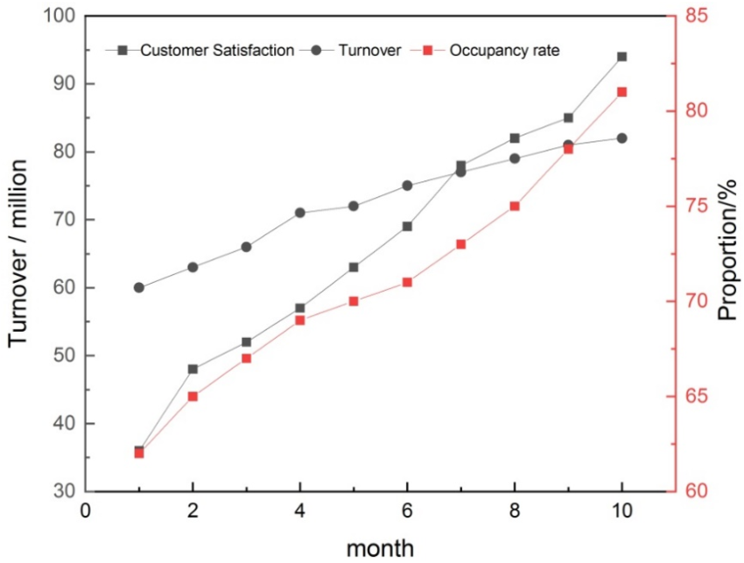
Figure 1: Ritz-Carlton’s Turnover
(Source: ‌Wen & Wang, 2023)
These investments are associated with quantifiable results. The analysis of guest feedback with big data enhanced the quality of services and increased the revenue by 600,000 to 800,000, customer satisfaction by 62% to 82%, and occupancy by 63% to 82% in ten months (Wen & Wang, 2023). High guest satisfaction is also found to be related to engagement practises where properties have frequently achieved higher scores in satisfaction due to the delivery of consistent services by well-trained and motivated employees. The training and development system of the Ritz-Carlton extends beyond technical competencies to create an excellence culture. The intensive training and empowerment activities of the company contribute to employee engagement, turnover, and outstanding guest experiences, demonstrating the HRM strategic importance within luxury hospitality (Tsou et al., 2025).

4.2 Employee Engagement at Four Seasons Hotels and Resorts
The Four Season Hotels and resorts have been known globally due to its unique philosophy of the Golden Rule, which is the foundation of both its service culture and employee engagement strategy. The foundational element of this philosophy is a straightforward yet potent ideology that guests, coworkers or stakeholders (Sułkowski et al., 2024). This is the guiding principle of everyday communication and the basis of mutual respect, understanding, and partnership at Four Seasons in all its operations around the world.
Four Seasons supports its employee involvement and engagement with a powerful internal culture that prioritises people over process and focuses on internal development and ownership (Chakraborty et al., 2024). It aims to recruit people who have a high level of emotional intelligence, who are highly empathetic, capable of self-awareness and social awareness, and puts money on continuous personal and professional growth, enhancing these qualities. Consequently, Four Seasons has been ranked a number of times as an employer of choice; since the 1990s, it has been featured in the 100 Best Companies to Work For list by FORTUNE magazine, a reflection of employee opinion about how well they do their jobs, how much they trust management, and how good colleagues are at work (Prnewswire.com, 2025).
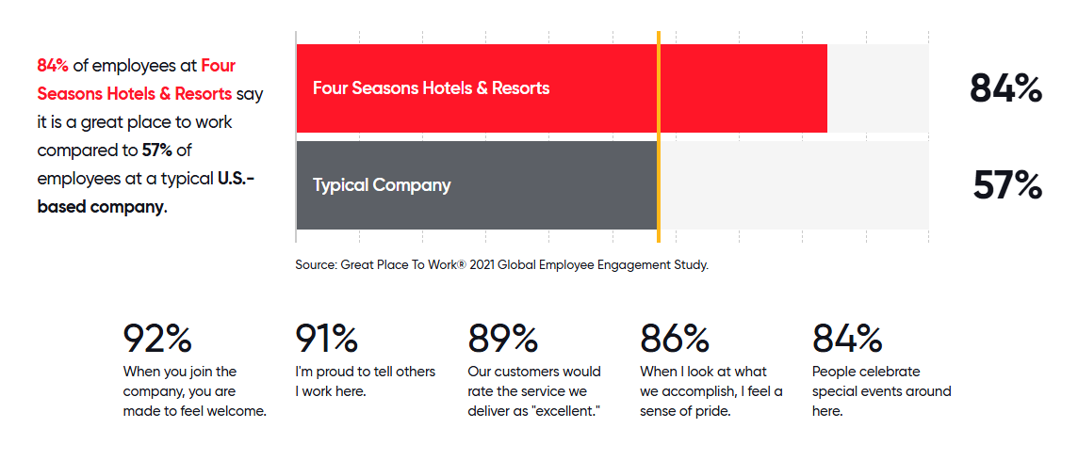
Figure 2: Employee experience
(Source: Greatplacetowork.com, 2019)
The quantitative information also shows a good internal engagement within the organisation. Four Seasons employees who receive the Great Place to Work measures indicate that 84% of employees say it is a great place to work, a much larger figure than the average employer in the U.S. (57%) (Greatplacetowork.com, 2019). The other important aspect of engagement is the internal promotion system and career development pathway of the company that will motivate loyalty and long-term commitment. These systems lead to employee satisfaction as they provide a clear growth potential in the organisation, as opposed to external hiring.

4.3 HR Strategy at Marriott International
The HR strategy of Marriott International is based on the philosophy of “Take care of associate,s and they will take care of the customers.” It is a people-first model that has shaped the organisational culture and human resource management at the company over the past 90 years, which has manifested in its recruitment, development, and retention of talent in its international operations (‌Sec.gov, 2020). This philosophy is not just converse but operationalised in the form of programmes that improve associate engagement, empowerment, and well-being.
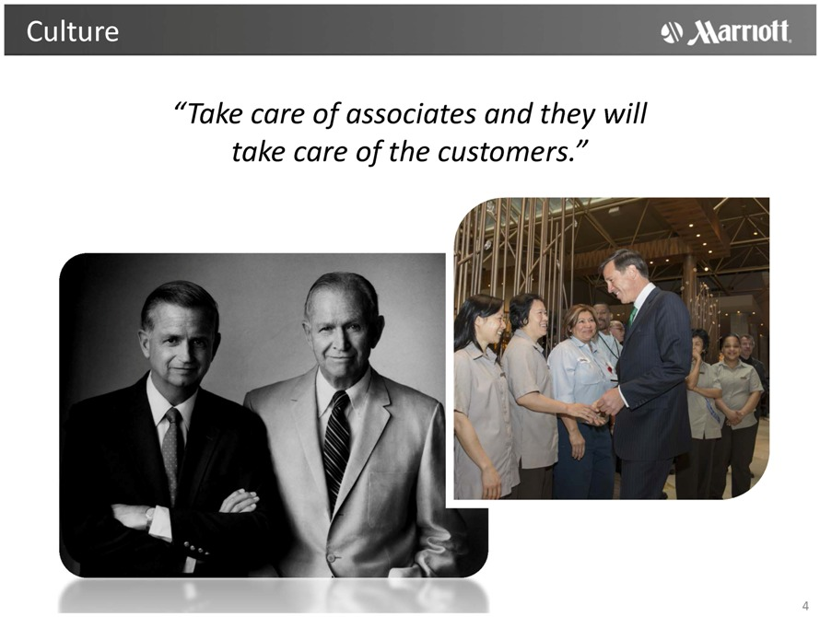
Figure 3: Marriott International’s HR strategy
(Source: Sec.gov, 2020)
One of the pillar projects is the TakeCare movement, an international wellness and engagement programme that aims at promoting physical, mental, and financial health. This programme provides Marriott associates with such resources as mental wellness training, such as the Mind Matters 2.0, an online course that over 2,500 associates have already completed across the world, as of 2024, and local wellness champions, who shape supportive environments within their teams (Marriott.com, 2025). The programme focuses on health holistically, individual resiliency and community building, which strengthens the involvement and loyalty of associates.
Existing programmes like the Emerging Leader Programme assist in developing talent within the company through cross-discipline learning, executive development and strategic assignments; graduates of the programme tend to take on more senior positions (Harrison, 2025). Moreover, talent mobility is facilitated by the data-driven HR systems (e.g., Oracle Cloud HCM) that determine the interests and developmental requirements of the associate and provide a more individualised and transparent career pathway. These human resource policies help to create a strong employer brand that helps in global growth and operational achievement (Trunina et al., 2024). With the focus on associate well-being, leadership growth, and inclusivity, the company creates the conditions of high engagement that support the excellence of the service and strengthen its competitive stance in the global hospitality industry.

5. Discussion

5.1 Key HRM Practices at Four Seasons Hotels and Resorts
The results show that Four Seasons Hotels and Resorts uses a people-centred HRM strategy, which has been characterised by selective recruiting, ongoing training, empowerment, and effective internal promotion channels. The practises identified are consistent with the previous hospitality studies, which emphasise attitude, emotional intelligence, and cultural fit in service jobs (Dominique-Ferreira et al., 2022). The alignment of personal values and organisational culture is achieved by focusing on interpersonal competence and empathy when recruiting employees at Four Seasons.
Theoretically, the Employee Engagement Theory proposed by Kahn can be used to understand the ways in which these practises help to create psychological meaningfulness and safety. The employees believe that they have an important job as there is meaningful interaction with guests, and the respectful leadership and trust-based empowerment would add to their psychological security (Albrecht et al., 2023). In addition, internal promotion systems enhance psychological availability through career security and motivation.
The focus on internal culture prior to the visit by guests underlines the results of Tyagi (2021), who believes that the only way to keep the engagement sustainable is to allow the organisational culture to help employees as a whole. The strategic HRM used in Four Seasons can be compared with transactional HRM models that are prevalent in high turnover hospitality settings, as people-based practises can serve as a long term engagement tool and not a short-term retention instrument.

5.2 HRM Practices and Their Influence on Employee Engagement
Both findings and literature have a strong correlation with the relationship between HRM practises and employee engagement. The initiatives of training, leadership development, and empowerment in Four Seasons and Ritz-Carlton have a direct impact on increased motivation, commitment, and discretionary effort. The process of continuous training helps to enhance the competence and confidence of employees, strengthening their engagement based on the mastery of skills and the clarity of their roles (Colakoglu et al., 2023).
The Social Exchange Theory explains this relationship well. As per SET, positive attitudes and behaviours are returned in response to organisational investment (Wallenburg & Handfield, 2022). Internal promotion, leadership support, and recognition practises are some of the practises that convey organisational commitment, which employees react to by being loyal and performing better.
This relationship is further moderated by leadership style. A transformational leadership approach, which is based on inspiration, individual attention, and empowerment, has proven to be one of the most effective in increasing engagement within hospitality environments (Kim et al., 2023). Transactional leadership, in contrast, is a leadership model that provides compliance without long-term engagement (Maundu et al., 2020). The results indicate that the leadership philosophy of Four Seasons is consistent with the principles of transformational leadership, which fosters greater emotional commitment instead of focusing on extrinsic incentives only.

5.3 Employee Engagement and Guest Satisfaction in Luxury Hospitality
The results show a significant correlation between employee engagement and guest satisfaction, especially in luxury hospitality, where the quality of services is determined by emotional labour and personalised encounters (Chakraborty et al., 2024). Involved employees have a higher chance of showing proactive service behaviours, empathy, and problem-solving skills, which improve the perceptions and loyalty of the guests.
The Service-Profit Chain Model is highly utilised in explaining this relationship (Heskett et al., 1994). According to the model, customer satisfaction, profitability, and service value are the results of service quality within the organisation, which is associated with employee engagement and satisfaction. This framework is evidenced empirically by the Ritz-Carlton example; improvements in revenue, customer satisfaction, and occupancy have increased after HRM interventions have been carried out (Wen & Wang, 2023).
Emotional authenticity is an important distinguishing characteristic in luxury hospitality. Psychologically safe and valued employees are in a better position to provide authentic service encounters (Holland et al., 2022). On the other hand, disengagement and burnout have adverse implications on the consistency of the service and the brand image. Thus, the results support the literature that assigns employee engagement as a strategic source of guest satisfaction instead of an outcome of HR.

5.4 Alignment of HRM Strategies with Organisational Goals
HRM strategies and organisational objectives are aligned in the aspect of the manner in which Four Seasons incorporates employee engagement in its service excellence model. Instead of viewing HRM as an administrative function, the organisation establishes it as a strategic partner in terms of competitive advantage. This is consistent with the literature on strategic HRM, which suggests that people management should be able to support organisational goals in a direct way (Budur & Poturak, 2021).
The theory created by Kahn shows how employees can be engaged by having a sense of meaningfulness and alignment with organisational values (Albrecht, Furlong & Leiter, 2023). The Golden Rule philosophy fortifies this alignment by instilling respect and care in the day-to-day operations. Equally, SET defines the relationship between long term investment in employee well-being, trust and commitment, turnover reduction and service stability.
Service-Profit Chain also serves as an example of the way this strategic alignment is converted into business results. Focusing on employee engagement, Four Seasons reinforces the quality of the services, the loyalty of the guests, and brand equity (Adeinat & Kassim, 2019). Nonetheless, the issues of labour shortages, emotional burnout, and changes in guest expectations demand constant HRM strategy changes. The results, however, affirm that the alignment of HRM and service excellence objectives can help luxury hospitality organisations to maintain performance in a highly competitive world market.

6. Conclusion

6.1 Concluding remarks
This paper discussed how Human Resource Management (HRM) can be used to promote employee engagement in Four Seasons Hotels and Resorts by applying three theoretical models: the Employee Engagement Theory by Kahn, Social Exchange Theory (SET), and Service-Profit Chain Model. The results reveal that luxury hospitality engagement is given in multidimensional aspects, which depend on psychological dispositions, two-way relationships in the organisation, and alignment to business strategy.
In the theoretical viewpoint of Kahn, Four Seasons also improves the psychological meaningfulness, safety, and availability through the development of a respectful service culture and empowerment of the employees to become the owners of the guest experiences. Using the socio-exchange theory, investment in training, career development and recognition of employees by the organisation creates mutual commitment and loyalty. When employees perceive organisational support, they react by performing better and being more commitment. Moreover, the Service-Profit Chain Model verifies the strategic importance of engagement and shows the direct conversion of the quality of internal services to customer satisfaction, brand loyalty, and financial performance.
In general, the research supports the thesis that HRM in luxury hospitality is not the administrative component but is an element of competitive positioning. The engagement of the employees is becoming a psychological state as well as a strategic resource, which maintains service excellence. Four Seasons in their efforts to harmonise the HR practises with the organisational values and service standards illustrates how effective people management is directly related to organisational success in the long term.

6.2 Recommendations
It is suggested that Four Seasons should keep reinforcing its people-focused culture by investing in the superior leadership training programmes and mental health programmes to overcome burnout possibilities in high-demand luxury workplaces. The growth of digital HR tools, i.e. real-time engagement metrics and training platforms tailored to each employee, can be used to further advance employee development. Also, to make sure that the standards of engagement are consistent across the world, it is possible to reinforce diversity, equity, and inclusion strategies at global properties. Four Seasons will be able to maintain a high level of employee motivation, quality of services and competitive advantage in the world hospitality sector by constantly aligning HR strategies to the changing workforce expectations.

6.3 Future Scope
Further studies would also include the use of primary data, including the interviews with employees or the use of engagement surveys, to offer more empirical evidence concerning the HRM practises in Four Seasons. The difference in engagement strategies across different market segments could also be seen through comparative analysis of luxury and mid-scale hospitality brands. Moreover, the research might be conducted in the future to analyse how digital transformation and artificial intelligence influence the engagement of hospitality employees. Further research on cross-cultural differences in HRM practises across international properties would contribute to better insights on how multinational hospitality organisations can achieve service excellence and be able to fit in the local environment.

References
Adeinat, I., & Kassim, N. (2019). Extending the service profit chain: the mediating effect of employee productivity. International Journal of Quality & Reliability Management, 36(5), 797-814. https://www.emerald.com/ijqrm/article-abstract/36/5/797/139433/Extending-the-service-profit-chain-the-mediating?redirectedFrom=fulltext
Albrecht, S. L., Furlong, S., & Leiter, M. P. (2023). The psychological conditions for employee engagement in organizational change: Test of a change engagement model. Frontiers in Psychology, 14, 1071924. https://www.frontiersin.org/journals/psychology/articles/10.3389/fpsyg.2023.1071924/full
ANNAMALAH, S. (2024). The value of case study research in practice: A methodological review with practical insights from organisational studies. Journal of Applied Economic Sciences (JAES), 19(4 (86)), 485-498. https://www.ceeol.com/search/article-detail?id=1295895
Budur, T., & Poturak, M. (2021). Employee performance and customer loyalty: Mediation effect of customer satisfaction. Middle East Journal of Management, 8(5), 453-474. https://www.inderscienceonline.com/doi/abs/10.1504/MEJM.2021.117510
Chakraborty, T., Sharada, V. S., & Anand, R. (2024). Fostering a sense of belonging: A strategic approach to employee engagement. From the Editor’s Desk. https://www.researchgate.net/profile/Nikita-Nille-2/publication/393446840_Importance_of_HR_Analytics_A_Support_System_for_Organizational_Growth/links/686a48f707b3253fd1cc901c/Importance-of-HR-Analytics-A-Support-System-for-Organizational-Growth.pdf#page=9
‌Colakoglu, S., Chung, Y., & Hong, Y. (2023). Employee learning and development from the perspective of strategic HRM. In Smart talent management (pp. 84-106). Edward Elgar Publishing. https://www.elgaronline.com/edcollchap/book/9781802202717/book-part-9781802202717-12.xml
Dominique-Ferreira, S., Rodrigues, B. Q., & Braga, R. J. (2022). Personal marketing and the recruitment and selection process: Hiring attributes and particularities in tourism and hospitality. Journal of Global Scholars of Marketing Science, 32(3), 351-371. https://www.tandfonline.com/doi/abs/10.1080/21639159.2020.1808845
Four Seasons (2022). Our ESG Commitment | Four Seasons for Good. [online] Fourseasons.com. Available at: https://www.fourseasons.com/landing-pages/corporate/esg/our-commitment/.
Four Seasons (2024). Four Seasons History | Four Seasons Luxury Hotels and Resorts. [online] www.fourseasons.com. Available at: https://www.fourseasons.com/about_four_seasons/four_seasons_history/.
Greatplacetowork.com, (2019). Four Seasons Hotels & Resorts. [online] Great Place To Work®. Available at: https://www.greatplacetowork.com/certified-company/1000356 [Accessed 17 Feb. 2026].
Harrison, C. (Ed.). (2025). Leadership and Leadership Development: Critical Perspectives and Contemporary Approaches. Taylor & Francis. https://books.google.com/books?hl=en&lr=&id=LVROEQAAQBAJ&oi=fnd&pg=PA1949&dq=Long-standing+programmes+such+as+the+Emerging+Leader+Program+help+cultivate+managerial+talent+from+within+by+providing+cross-discipline+learning,+executive+mentorship,+and+strategic+roles&ots=WoQAjsuw1U&sig=tsvBBV0xb7yKXa4OkA_LDK_PtHo
Holland, M. L., Brock, S. E., Oren, T., and van Eckhardt, M. (2022). Burnout and Trauma Related Employment Stress. Springer International Publishing. https://link.springer.com/book/10.1007/978-3-030-83492-0
Kim, J. K., Yang, J. J., and Lee, Y. K. (2023). The impact of transformational leadership on service employees in the hotel industry. Behavioral Sciences, 13(9), 731. https://www.mdpi.com/2076-328X/13/9/731
Krishnan, S., & Rathakrishnan, B. (2025). Psychosocial factors contributing to turnover intention among employees in the hospitality industry: A systematic review. Current Psychology, 44(7), 5744-5765. https://link.springer.com/article/10.1007/s12144-025-07550-3
Marriott.com, (2025). ‌Global Progress. Available at: https://serve360.marriott.com/wp-content/uploads/2025/07/2025GlobalProgress.pdf?utm
Maundu, M., Namusonge, G. S., & Simiyu, A. N. (2020). Effect of transactional leadership style on employee engagement. http://41.89.243.34:8080/xmlui/bitstream/handle/123456789/4527/Maundu_EFFECT%20OF%20TRANSACTIONAL%20LEADERSHIP%20STYLE.pdf?sequence=1
Michelli, J.A. (2024). Training the Talented, the Ritz-Carlton Way. [online] Amanet.org. Available at: https://www.amanet.org/articles/training-the-talented-the-ritz-carlton-way/.
O'Donoghue, D., & Van Der Werff, L. (2022). Empowering leadership: balancing self-determination and accountability for motivation. Personnel Review, 51(4), 1205-1220. https://www.emerald.com/pr/article-abstract/51/4/1205/329573/Empowering-leadership-balancing-self-determination?redirectedFrom=fulltext
Pearse, N. (2019, June). An illustration of deductive analysis in qualitative research. In 18th European conference on research methodology for business and management studies (p. 264). https://books.google.co.in/books?hl=en&lr=&id=Uc-hDwAAQBAJ&oi=fnd&pg=PA264&dq=The+research+follows+a+deductive+approach&ots=Mners8Kz1c&sig=tssvIdBSosLzM4_ELCUMOMS7Ny4&redir_esc=y#v=onepage&q=The%20research%20follows%20a%20deductive%20approach&f=false
Prnewswire.com, (2025). Four Seasons Hotels and Resorts Named to FORTUNE List of the ‘100 Best Companies to Work For’. [online] Prnewswire.com. Available at: https://www.prnewswire.com/news-releases/four-seasons-hotels-and-resorts-named-to-fortune-list-of-the-100-best-companies-to-work-for-300046109.html [Accessed 17 Feb. 2026].
Renascence.io. (2026). How The Ritz-Carlton Enhances Customer Experience (CX) Through Personalized Service and Luxury. [online] Available at: https://www.renascence.io/journal/how-the-ritz-carlton-enhances-customer-experience-cx-through-personalized-service-and-luxury [Accessed 17 Feb. 2026].
Ruggiano, N., & Perry, T. E. (2019). Conducting secondary analysis of qualitative data: Should we, can we, and how?. Qualitative social work, 18(1), 81-97. https://journals.sagepub.com/doi/abs/10.1177/1473325017700701
‌Sec.gov. (2020). 425. [online] Available at: https://www.sec.gov/Archives/edgar/data/316206/000119312515396810/d36131d425.htm [Accessed 17 Feb. 2026].
Simpson, A. (2019). Academic integrity, citation, quotation and referencing. The Psychology of Efiective Studying, 75. https://books.google.co.in/books?hl=en&lr=&id=gHatDwAAQBAJ&oi=fnd&pg=PA75&dq=All+the+sources+are+referenced+appropriately+according+to+the+APA+guidelines+to+maintain+academic+integrity&ots=LRvmr-1Wgx&sig=D7Dwf13SsUbbv3Y6P_sBIRLIh2I&redir_esc=y#v=onepage&q&f=false
Sułkowski, Ł., Dacko-Pikiewicz, Z., & Szczepańska Woszczyna, K. (2024). Philosophy and leadership: An evolution of leadership from ancient times to the digital age (p. 269). Taylor & Francis. https://library.oapen.org/handle/20.500.12657/90114
Trunina, I., Pryakhina, K., & Bilyk, M. (2024). Strategic management of a company’s employer brand: experience of international companies. Marketing i menedžment innovacij, 15(3), 71-85. https://savearchive.zbw.eu/bitstream/11159/703164/1/1917113234_0.pdf
Tsou, H. T., Chen, J. S., Mai, T. O., & Jade, N. B. N. (2025). Soft HRM practices fostering service innovations and performance in hospitality firms. Sustainability, 17(3), 895. https://www.mdpi.com/2071-1050/17/3/895
Tyagi, N. (2021). Aligning organizational culture to enhance managerial effectiveness of academic leaders: an interface for employee engagement and retention. International Journal of Educational Management, 35(7), 1387-1404. https://www.emerald.com/ijem/article-abstract/35/7/1387/126891/Aligning-organizational-culture-to-enhance?redirectedFrom=fulltext
Wallenburg, C. M., & Handfield, R. (2022). Social exchange theory. In Handbook of theories for purchasing, supply chain and management research (pp. 267-282). Edward Elgar Publishing. https://www.elgaronline.com/edcollchap/book/9781839104503/book-part-9781839104503-21.xml
‌Wen, X. & Wang, Z. (2023). Big Data Analytics Technology and Applications in Cloud Computing Perspective. Applied Mathematics and Nonlinear Sciences, 0(0). doi:https://doi.org/10.2478/amns.2023.1.00044.
Yoopetch, C., Nimsai, S., & Kongarchapatara, B. (2021). The effects of employee learning, knowledge, benefits, and satisfaction on employee performance and career growth in the hospitality industry. Sustainability, 13(8), 4101. https://www.mdpi.com/2071-1050/13/8/4101

Appendices

Appendix A: Theoretical framework summary
Theory | Key Concepts | Relevance to Employee Engagement | Application to Four Seasons
Kahn’s Employee Engagement Theory (1990) | Psychological meaningfulness, safety, availability | Explains psychological conditions required for engagement | “Golden Rule” culture promotes respect, empowerment, and meaningful work
Social Exchange Theory (Blau, 1964) | Reciprocity, perceived organizational support | Employees reciprocate supportive HR practices with commitment | Training, recognition, and internal promotion create loyalty
Service-Profit Chain Model (Heskett et al., 1994) | Internal service quality → employee satisfaction → customer loyalty → profit | Links engagement to business performance | Engaged employees deliver premium guest experiences leading to brand loyalty

Appendix B: Key HRM Practices at Four Seasons Hotels and Resorts
HRM Practice | Description | Impact on Engagement
Recruitment & Selection | Focus on attitude, cultural fit, service mindset | Ensures alignment with service philosophy
Training & Development | Continuous service excellence and leadership programs | Enhances confidence, competence, and career growth
Empowerment | Employees authorized to resolve guest issues independently | Increases psychological safety and ownership
Performance Management | Feedback-oriented, supportive supervision | Encourages motivation and accountability
Employee Well-being | Respect-based culture and competitive benefits | Reduces turnover and burnout

Appendix C: Alignment of HRM with organisational strategy
Strategic Goal | HRM Strategy | Engagement Outcome | Business Impact
Deliver Luxury Service | Hire service-oriented employees | High emotional commitment | Superior guest experience
Maintain Brand Reputation | Invest in leadership development | Strong internal culture | Consistent global standards
Increase Customer Loyalty | Empower frontline staff | Quick problem resolution | Repeat business & profitability
Sustain Competitive Advantage | Promote internal career growth | Long-term employee retention | Reduced recruitment costs

