Exchange Rates, Inflation and International Tourism Demand: Macroeconomic Risk Management for Türkiye
Fundamentals of Economics – Detailed Project Report
Option 3: Macroeconomic Indicators, Exchange Rates, and Tourism Demand

Student: Student 4 – Name: ____________________
Student ID: ____________________
Module: Fundamentals of Economics
Submission: Academic Year 2026
Main-text word count: 4059

Table of Contents
Executive Summary 3
Introduction 4
Microeconomic Analysis & Market Structure 6
Macroeconomic Environment & Policy Impact 9
Empirical Data & Case Study Analysis 16
Strategic Implications for Tourism 19
Conclusion & Recommendations 22
References 23
Appendices 25

Executive Summary
Türkiye provides a strong case for studying the interaction between exchange rates, inflation and tourism because the country combines a large international visitor economy with a period of pronounced nominal-price and currency adjustment. In 2025, official tourism income reached approximately US$65.23 billion, up 6.8% from the previous year, while the number of departing visitors was about 63.9 million (Turkish Statistical Institute [TURKSTAT], 2026). At the same time, inflation remained elevated despite substantial disinflation from earlier peaks. The International Monetary Fund (IMF, 2026) reported that inflation fell from around 49% in September 2024 to about 31% by December 2025. These simultaneous developments show why a weak domestic currency cannot be interpreted as an unqualified tourism advantage.
Currency depreciation can reduce the foreign-currency price of Turkish accommodation, dining and experiences, shifting international tourism demand outward. Yet depreciation also raises the domestic cost of imported energy, food inputs, technology, finance and capital equipment, and persistent inflation can quickly erode the initial price advantage. Empirical studies of Türkiye find that exchange-rate levels and volatility are relevant to tourism demand, but effects vary by source market, horizon and state of the economy (Akay et al., 2017; Ülker, 2025). The report recommends a macroeconomic risk framework for destination management organisations (DMOs) and hospitality operators: track real rather than nominal competitiveness, diversify origin markets, separate foreign-currency revenue from import-sensitive cost exposure, use rolling inflation/FX scenarios, protect liquidity during monetary tightening, and market value and quality rather than relying on depreciation as the primary source of competitiveness.

Introduction
International tourism is a traded service even though production occurs at the destination. A German, British or U.S. visitor effectively imports a Turkish hotel stay, restaurant meal and local experience. Exchange rates therefore influence the relative price of the trip in the visitor’s home currency. If the Turkish lira depreciates while Turkish prices remain unchanged, the destination becomes cheaper to foreign travellers and demand may increase. If domestic inflation rises rapidly after the depreciation, much of that competitiveness gain can disappear. The relevant variable is consequently the real exchange rate, which adjusts the nominal exchange rate for relative price levels.
Tourism demand is also income-sensitive. International holidays are discretionary for many households, giving tourism a positive income elasticity of demand. Strong growth in source markets can raise arrivals even when destination prices increase; recession abroad can reduce tourism despite a favourable exchange rate. Interest rates matter through both demand and supply. Higher rates can restrain consumer borrowing and investment in source countries, while tight domestic monetary policy raises financing costs for Turkish hotels, airlines and small tourism businesses.
Macroeconomic shocks transmit through multiple channels at once. A currency depreciation may stimulate foreign demand but raise imported input costs. Inflation may increase nominal room revenue while reducing real profit. A higher policy rate may stabilise the currency and improve disinflation credibility, but it can also delay hotel refurbishment and new capacity. Evaluating tourism performance from a single variable can therefore lead to mistaken strategy. Managers need a system that links exchange rates, inflation, interest rates, national income and tourism flows.
This report combines macroeconomic theory with recent official evidence and academic research on Türkiye. It first explains the transmission mechanisms linking currency and inflation to arrivals and expenditure. It then assesses fiscal and monetary policy responses, reviews Türkiye’s recent tourism performance, and develops a practical risk-mitigation strategy for DMOs and hospitality firms. The objective is not to forecast a particular exchange rate; it is to design decisions that remain resilient when exchange rates and the business cycle move unexpectedly.

Microeconomic Analysis & Market Structure

Tourist Demand, Relative Prices and Elasticity
At the firm level, the exchange rate enters demand through the visitor’s effective price. Suppose a hotel charges TRY 8,000 per night. A depreciation of the lira reduces the euro or dollar cost of that room if the nominal TRY price does not immediately adjust. For a price-sensitive traveller comparing Mediterranean destinations, Türkiye may then gain share from Greece, Spain or other substitutes. The size of the response depends on price elasticity and cross-price elasticity: travellers with flexible destination choice respond more strongly than visitors travelling for family, medical or business reasons.
Akay et al. (2017) examine Turkish tourism, exchange rates and income and find that both price competitiveness and income conditions matter for inbound demand. This is consistent with standard demand theory: a destination cannot rely on currency alone when source-market incomes are weak. Managers should therefore avoid treating a depreciation as equivalent to a permanent outward demand shift. It is a relative-price shock whose effect can be amplified or offset by income, security perceptions, aviation capacity and competitors’ own price movements.
Exchange-rate volatility is distinct from the exchange-rate level. A weaker lira may improve expected value, but large unpredictable movements can increase uncertainty for tour operators, conference planners and travellers budgeting in advance. Agiomirgianakis et al. (2014) find evidence that exchange-rate volatility matters for tourist flows into Türkiye. For firms, volatility can also complicate contracting: a hotel may quote group business months ahead while food, energy or equipment costs later move sharply in domestic currency.

Inflation, Costs and the Difference Between Nominal and Real Revenue
High inflation can make nominal tourism performance look stronger than real performance. A hotel that raises its average daily rate by 25% when its relevant costs rise by 35% has higher nominal revenue per room but lower real margin. Similarly, destination tourism income expressed in current U.S. dollars can increase even while some domestic operators face margin pressure. Management accounts should therefore separate price effects, volume effects and real cost growth.
Inflation also changes relative prices within the tourism bundle. Accommodation may be competitively priced in foreign currency while airport transfers, restaurant menus or attraction tickets rise faster. Tourists respond to the total trip budget rather than to the hotel rate alone. If non-room costs escalate, visitors may shorten stays, choose all-inclusive products or reduce discretionary spending. Average expenditure can therefore shift composition even when arrival numbers remain strong.
Uçar and Palta (2026) examine exchange-rate volatility, inflation and average tourist expenditure in Türkiye, reinforcing the importance of analysing spending as well as headcount. A DMO focused only on arrivals may celebrate volume while overlooking declining real yield per visitor or pressure on local purchasing power. The economically relevant objective is sustainable real tourism value added, not the largest possible nominal revenue figure.
Table 1. Macroeconomic shocks and tourism-firm transmission channels in Türkiye
Shock / indicator | Tourism transmission channel | Likely business effect | Managerial hedge
Lira depreciation | Foreign-currency visitors face lower relative destination prices | Arrivals/demand may rise, but imported inputs become costlier | Price in multiple currencies; match FX-sensitive revenue and costs
High domestic inflation | Wages, food, energy and local services rise in TRY | Margin pressure; frequent nominal repricing | Shorter supplier contracts; inflation-linked budgeting
Tight monetary policy | Credit becomes more expensive and domestic demand weakens | Higher financing cost for hotels and SMEs | Prioritise cash flow and phase capital expenditure
Origin-market slowdown | Foreign household income and confidence decline | Lower arrivals or shorter stays | Diversify source markets and customer segments
Energy/oil shock | Air fares and hotel utility costs can rise | Higher trip cost may offset FX advantage | Energy efficiency; scenario-test package affordability

Supply Capacity and Market Structure
Tourism supply is partly fixed in the short run. Hotel rooms, airport slots and destination infrastructure cannot be expanded instantly when a weak currency stimulates demand. Strong inbound demand can therefore raise occupancy and room rates rather than only increasing visitor quantity. Over time, investment can expand capacity, but high interest rates and construction inflation may make that response expensive. The macro environment thus affects both the demand curve and the elasticity of supply.
Market structure also shapes pass-through. A differentiated resort with high international demand may raise TRY prices quickly after depreciation and retain part of the foreign-currency affordability advantage as margin. A small urban hotel in a highly competitive district may be forced to pass more of the depreciation benefit to guests. Firms therefore need property-level estimates of demand and competitive position instead of assuming a uniform national response.

Macroeconomic Environment & Policy Impact

Exchange-Rate Depreciation: Competitiveness and Cost Pass-Through
The textbook competitiveness channel begins with a nominal depreciation. Foreign tourists can obtain more lira per unit of home currency, lowering the foreign-currency price of local services. Demand shifts toward Türkiye if travellers view it as a substitute for destinations whose relative prices have not fallen. The result can be higher arrivals, occupancy and tourism receipts. Hüseyni et al. (2022) find nonlinear effects of real exchange rates on international tourism demand in Türkiye, suggesting that the response can differ across the size or direction of exchange-rate changes.
However, a depreciation also creates imported inflation. Hotels consume imported technology, equipment, beverages and other inputs, while airlines are exposed to fuel and aircraft-related costs often linked to foreign currency. Firms may raise TRY prices to protect margin. As those increases accumulate, the real exchange rate can appreciate even while the nominal lira remains weak. The destination’s price advantage is therefore strongest when domestic inflation is contained.
Bozkurt et al. (2021) analyse tourism-demand and exchange-rate shocks and highlight the value of treating these movements dynamically. For management, the practical implication is to monitor real effective competitiveness rather than the nominal USD/TRY rate. A 20% nominal depreciation alongside 20% higher relative local prices offers little enduring improvement in price competitiveness. Marketing campaigns built around “cheap currency” can become outdated quickly and may weaken destination positioning if value is framed only as low price.

Inflation and Monetary Policy
Türkiye’s disinflation has involved tight monetary conditions. The IMF (2026) described a decline in inflation from very high levels, while the Central Bank of the Republic of Türkiye (CBRT, 2026) continued to report annual consumer inflation above 30% in 2026. Monetary tightening can support the tourism sector indirectly if it stabilises inflation expectations and reduces exchange-rate instability. Greater macro credibility makes it easier for hotels and tour operators to budget, contract and price future seasons.
The near-term cost is expensive credit. Tourism businesses with floating-rate debt or frequent refinancing face higher interest expense. Independent hotels and small operators can be particularly exposed because they have less access to international finance. Projects with long payback periods—energy retrofits, renovations, new rooms—may be postponed. Thus, a policy that improves medium-term price stability can initially slow tourism investment.
The appropriate business response is financial rather than political: stress-test debt service under alternative rates, preserve liquidity buffers and rank capital expenditure by resilience. Projects that reduce imported energy use or operating cost may remain attractive even under higher discount rates because they also hedge inflation. Firms should avoid assuming that strong tourist arrivals guarantee easy refinancing; lenders evaluate cash flow, leverage and macro risk separately.
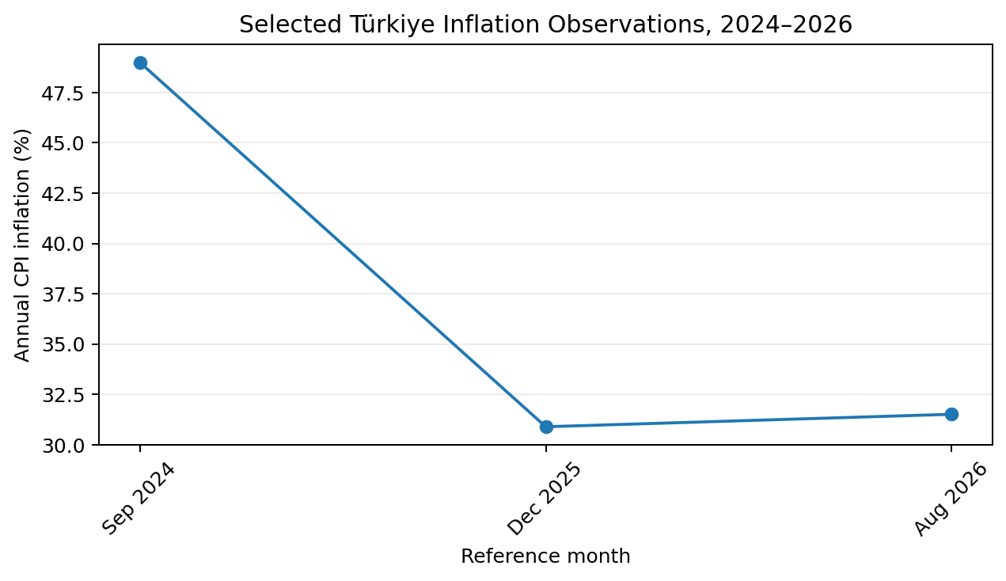
Figure 1. Selected annual CPI observations compiled from IMF and CBRT reporting. The points illustrate disinflation from 2024 levels while inflation remained elevated.

Fiscal Policy and Destination Competitiveness
Fiscal policy affects tourism through taxes, infrastructure and aggregate demand. Public investment in airports, transport, heritage protection and destination services can raise the quality of the tourism product and crowd in private investment. Poorly targeted subsidies, however, can support capacity that is not commercially sustainable or intensify congestion in already successful destinations. The fiscal question is therefore not simply how much government spends on tourism but whether spending raises productivity and destination value.
During a macroeconomic downturn, temporary fiscal support can help viable tourism firms survive a collapse in demand, especially where the shock is external. Support should be targeted and time-limited because permanent transfers can delay restructuring. A DMO can often create greater long-run value through market intelligence, dispersal strategies, workforce development and infrastructure coordination than through across-the-board price subsidies.
The OECD (2025) emphasises broader structural reforms and macroeconomic stabilisation in its survey of Türkiye. For tourism, this implies that durable competitiveness comes from productivity, service quality, connectivity and institutional stability rather than recurrent currency weakness. A destination that depends on depreciation to remain attractive effectively transfers purchasing power away from domestic residents and exposes tourism businesses to volatile costs.

Real Exchange Rates, Pass-Through and Policy Coordination
For tourism strategy, the nominal exchange rate should be converted into a real purchasing-power concept. If the lira depreciates by 25% against an origin-market currency but Turkish tourism prices rise by 20% relative to that origin market, the effective improvement in competitiveness is far smaller than the nominal movement suggests. A DMO can construct an origin-weighted tourism price index using hotel rates, restaurant prices, domestic transport and competing-destination costs. This turns a volatile financial-market number into a measure that is closer to the traveller’s actual decision.
Pass-through is rarely immediate or complete. Some hotels set prices months ahead in euros, some package operators contract allotments for a season, and many local services price only in lira. After depreciation, foreign-currency prices can therefore fall quickly in some channels and barely change in others. Over time, suppliers revise contracts and wages, raising local prices. The time profile matters for elasticity: travellers booking immediately after a currency movement may see a larger bargain than travellers arriving after domestic inflation has adjusted. Empirical results that differ across horizons are therefore economically plausible (Akay et al., 2017; Hüseyni et al., 2022).
This adjustment process also redistributes income within tourism. A hotel with foreign-currency contracts and mainly local costs can initially experience a margin windfall, while a transport company with foreign-currency fuel or leasing costs may face pressure. Employees may experience real-wage losses until wages catch up with inflation. The aggregate tourism balance can look favourable while some participants become worse off. Sustainable destination policy should therefore measure real wages, local supplier conditions and profitability alongside arrivals and receipts.
Monetary and fiscal policy interact with these distributional effects. Tight monetary policy can slow inflation and support currency stability, but high rates increase debt service. Fiscal policy can either reinforce disinflation through disciplined demand management or offset it through excessive stimulus. The OECD (2025) and IMF (2026) both place macro stabilisation and structural reform in the broader context of Türkiye’s medium-term performance. For tourism operators, inconsistent policy signals translate into a higher required return on investment because future costs and demand are harder to forecast.
Policy coordination is especially important for infrastructure. A major airport, rail link or tourism-zone investment raises capacity for many years, so its appraisal should use real rather than nominal cash flows and conservative assumptions about future exchange rates. Temporary currency competitiveness should not be used to justify permanently oversized capacity. Conversely, high current interest rates should not automatically eliminate high-productivity projects whose benefits persist after disinflation. Scenario analysis can separate cyclical financing conditions from long-run demand fundamentals.
Exchange-rate risk can also be managed through revenue design. Properties serving international guests can quote or contract some business in euros or other foreign currencies while ensuring transparent consumer treatment. This creates a natural hedge against imported costs but transfers some currency risk to the customer. The decision should depend on segment norms: group contracts may tolerate fixed foreign-currency pricing, whereas domestic consumers require prices that comply with local rules and expectations. The economic objective is stable margin, not speculative foreign-currency exposure.
A useful stress test combines shocks rather than examining them one at a time. For example, a global oil-price increase can raise airfares and domestic energy costs while a weaker lira raises other imports. Foreign demand may then respond to a mixed signal: local services are cheaper in home currency, but getting to Türkiye is more expensive. Ülker (2025) includes oil prices and uncertainty precisely because single-variable models miss these interactions. Managers should test compound scenarios when setting annual budgets.
The final coordination issue is communication. DMOs that promote Türkiye primarily as “cheap” during depreciation risk attracting highly price-sensitive segments and weakening willingness to pay when the currency normalises. A more durable message emphasises culture, coast, gastronomy, service and connectivity, with relative value as a supporting benefit. This changes the demand curve by reducing perceived substitutability and can make future exchange-rate appreciation less damaging to arrivals.
Measurement should extend to tourism’s terms of trade. If the foreign-currency value of visitor spending rises but the foreign-currency cost of imported energy and equipment rises faster, sectoral purchasing power may deteriorate despite higher receipts. A DMO and industry association can track this ratio as a rough indicator of how much real imported capacity tourism earnings can finance. This prevents policy from equating higher nominal receipts with an unambiguous improvement in sector welfare.
Labour markets add another feedback. High tourism demand raises demand for hospitality workers, while inflation can erode real wages and encourage labour mobility. Firms that repeatedly adjust guest prices but allow real compensation to fall may face turnover and service-quality problems. Workforce indicators therefore belong in the macro dashboard. Maintaining productivity and service quality can preserve willingness to pay more effectively than using currency weakness to compete on price.
Risk governance should assign ownership. Treasury teams can manage currency and interest-rate exposure; revenue teams can monitor foreign-currency price positioning; procurement teams can track import-sensitive costs; and strategy teams can monitor source-market income and air capacity. A monthly cross-functional review is more useful than a single annual macro forecast because it links indicators to actions and makes assumptions visible.
A practical reporting convention is to restate key commercial metrics in both nominal and real terms. Occupancy, guest nights and physical consumption are already real quantities, but average daily rate, payroll and food cost should be deflated by appropriate indices before year-on-year comparison. This makes it easier to distinguish genuine productivity improvement from inflation. Where the available price index is imperfect, management can still construct internal cost baskets based on the property’s main inputs and use them consistently over time.
The same discipline should apply to investment returns. A project that appears to earn a high nominal return during inflation may deliver a modest real return once replacement costs and financing are included. Capital budgeting should therefore use internally consistent inflation assumptions for revenue, operating cost, terminal value and discount rates. This reduces the risk that macro volatility creates the illusion of profitability.

Empirical Data & Case Study Analysis

Türkiye’s 2025 Tourism Performance
TURKSTAT reported tourism income of US$65.230749 billion in 2025, an increase of 6.8% from the previous year. The number of departing visitors was approximately 63.917 million, up 2.7%, and average nightly expenditure was reported at about US$100 (TURKSTAT, 2026). The fact that tourism income grew faster than visitor numbers suggests that expenditure/yield as well as volume contributed to performance. These aggregates support the view that Türkiye remained highly competitive for international visitors despite a challenging domestic inflation environment.
The data should nevertheless be interpreted carefully. Strong nominal foreign-currency tourism income does not mean every operator experienced equivalent real profit growth. Businesses with high import content or domestic wage pressures may have faced rapid cost increases. Regional performance can also differ sharply between coastal resorts, Istanbul, cultural destinations and smaller cities. A national DMO therefore needs disaggregated dashboards by origin market, region, purpose and expenditure category.
The visitor total also includes different behavioural segments with different exchange-rate sensitivities. Diaspora or family visits, health tourism, package leisure and business travel respond differently to price and income. A fall in the lira may strongly stimulate an optional beach holiday while having less effect on a required business trip. Segment analysis is essential before using the national tourism numbers to set hotel rates or marketing budgets.
Table 2. Selected official Türkiye tourism indicators for 2025
Indicator | 2025 outcome | Year-on-year signal | Interpretation
Tourism income | US$65.23bn | +6.8% | Revenue growth exceeded visitor growth
Departing visitors | 63.917m | +2.7% | High international tourism volume
Average overnight expenditure | About US$100 | Official 2025 measure | Yield per night remains a key quality metric
Inflation (Dec. 2025) | About 31% | Down from 2024 levels | Cost pressure remained significant despite disinflation

What the Evidence Says About Exchange Rates and Tourism Demand
The academic evidence does not support a simplistic “weaker currency always means more tourism” rule. Akay et al. (2017) identify roles for exchange rates and income, while Agiomirgianakis et al. (2014) focus on exchange-rate volatility. Hüseyni et al. (2022) report nonlinear real-exchange-rate effects, and Ülker (2025) uses a quantile approach to examine exchange rates, oil prices and global uncertainty. Together these studies suggest that the effect varies with market conditions and may be stronger in some states of demand than others.
This heterogeneity matters for forecasting. A DMO should not impose one elasticity on every source country. Travellers from a high-income market with many direct flights may respond differently from travellers in a recession or from a market where airfare dominates the total trip cost. A useful forecasting system estimates country-specific or cluster-specific responses and updates them as airline capacity and relative prices change.
Oil prices introduce another interaction. Higher oil prices can raise airfares, particularly on long-haul routes, offsetting a cheaper destination currency. Ülker (2025) explicitly incorporates oil prices and global uncertainty, which is valuable because tourists buy a door-to-door trip, not just a destination basket. The affordability advantage of hotels can be neutralised by expensive access transport.

Scenario Analysis for a Representative Hospitality Operator
Consider a Turkish resort with substantial euro and sterling revenue but TRY wages and a mixture of local and imported supplies. In a depreciation-with-stable-inflation scenario, foreign demand strengthens and the resort can raise TRY prices modestly while remaining attractive in foreign currency. Margin improves. In a depreciation-with-high-inflation scenario, imported beverages, technology and energy rise rapidly; wage pressure follows; the resort must reprice more aggressively and part of the initial demand benefit disappears.
In a disinflation-and-tight-money scenario, currency volatility may moderate but domestic financing remains expensive. The operator should protect liquidity, focus capital spending on high-return energy and digital projects, and avoid excessive leverage. In a foreign-recession scenario, the exchange rate may remain favourable yet arrivals from affected source markets weaken because YED dominates the price effect. The best hedge is a diversified origin-market portfolio rather than a single currency bet.

Strategic Implications for Tourism

Risk-Mitigation Framework for DMOs
DMOs should build a macro dashboard that tracks real effective exchange rates, inflation, air capacity, source-market income, search demand, average length of stay and spend per visitor. The emphasis on real exchange rates is important because nominal depreciation can be misleading when local inflation is high. Alerts should be linked to decisions: a loss of real competitiveness may trigger value-focused marketing or product development rather than indiscriminate discounting.
Market diversification is the second pillar. If one origin market accounts for a very high share of arrivals, a recession, visa change or exchange-rate shift in that market becomes a destination-level shock. A diversified mix across Europe, the Gulf, Asia and other markets reduces covariance in demand. Diversification should be economic rather than purely geographic: source markets with different business cycles, currencies and seasonal travel patterns provide stronger risk reduction.
Third, DMOs should measure yield and resident impact alongside arrival numbers. Strong tourism volume can strain infrastructure, housing and local services, while inflation can make tourism zones expensive for residents. Higher-spending, longer-stay or geographically dispersed visitors can create more value than simply maximising headcount. This aligns macro resilience with sustainable destination management.

Risk-Mitigation Framework for Hotels and Tourism Operators
Hospitality operators should map revenue and costs by currency sensitivity. If a hotel earns significant foreign-currency revenue but imports equipment or services priced in euros or dollars, natural hedging may exist. The uncovered exposure should be managed through contract currency, staged purchasing, forward cover where appropriate and cash reserves. The purpose is not to speculate on the lira; it is to keep operating margin within a tolerable range across plausible exchange-rate paths.
Pricing should use rolling foreign-currency reference checks. A TRY rate increase can appear dramatic domestically but remain stable in euros; the reverse can also occur. Revenue managers should know how the rate appears to the principal origin markets and whether competitors in alternative destinations have also repriced. Packages can protect perceived value by bundling transfers, meals or experiences when headline room rates must adjust for inflation.
Debt management is equally important. When monetary policy is tight, refinancing risk can dominate operating performance. Firms should match loan maturity to asset life, maintain covenant headroom and run interest-rate stress tests. Investment sequencing should favour projects that lower recurring energy and labour costs or clearly raise foreign-currency revenue. Expansion based solely on one unusually strong season can be dangerous when the macro environment is volatile.
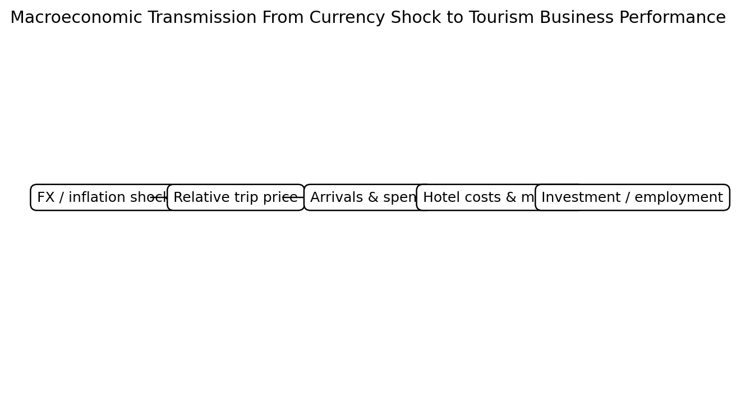
Figure 2. Simplified transmission framework for tourism in a high-inflation, exchange-rate-sensitive economy.

Strategic Positioning Beyond Currency Advantage
The final strategic priority is to compete on quality, not depreciation. Currency weakness can accelerate demand temporarily, but it is not a controllable or socially costless competitive strategy. Hotels and destinations that build reputation, service consistency, safety, culture, gastronomy and high-quality infrastructure can sustain demand when the lira stabilises or appreciates in real terms. This reduces the elasticity of demand with respect to price by making the product less substitutable.
For Türkiye, this means converting periods of strong price competitiveness into repeat visitation and higher-value demand. Visitor data should be used to identify experiences that generate satisfaction and incremental spend, while investment should address bottlenecks that lower service quality during peaks. The stronger the non-price value proposition, the less the destination must rely on macro volatility to fill capacity.

Conclusion & Recommendations
Türkiye’s recent experience demonstrates the dual nature of exchange-rate movements in tourism. Depreciation can make the destination more affordable to foreign visitors and support arrivals, but high inflation can erode the real price advantage and raise operating costs. Interest-rate tightening can support disinflation and macro stability while increasing the financing burden on tourism businesses. Origin-market income, oil prices, air capacity and uncertainty further influence whether exchange-rate changes translate into actual visitor demand. The appropriate framework is therefore multivariable and dynamic.
Official 2025 data show strong tourism income and visitor volumes, but sustainable performance requires attention to real margins and expenditure quality as well as headline growth. DMOs should monitor real competitiveness, diversify source markets and prioritise yield, resilience and resident value. Hospitality operators should map FX exposures, reforecast frequently, preserve liquidity, stress-test debt and use multi-currency reference pricing. Both should treat exchange-rate advantage as a temporary condition rather than a long-run strategy. Türkiye can protect tourism against currency and business-cycle volatility by anchoring competitiveness in productivity, service quality and a diversified demand base.

References
Agiomirgianakis, G., Serenis, D., & Tsounis, N. (2014). Exchange rate volatility and tourist flows into Turkey. Journal of Economic Integration, 29(4), 700–725.
Akay, G. H., Cifter, A., & Teke, O. (2017). Turkish tourism, exchange rates and income. Tourism Economics, 23(1), 66–77. https://doi.org/10.5367/te.2015.0497
Bozkurt, K., Tekin, H. A., & Ergün, Z. C. (2021). An investigation of demand and exchange rate shocks in the tourism sector. Applied Economic Analysis, 29(86). https://doi.org/10.1108/AEA-05-2020-0051
Central Bank of the Republic of Türkiye. (2026). Inflation report 2026-III and consumer price developments. https://www.tcmb.gov.tr/
Hüseyni, İ., Tunç, A., & Çelik, A. K. (2022). The non-linear effect of relative real foreign exchange rates on international tourism demand in Turkey. International Journal of Contemporary Economics and Administrative Sciences, 12(2), 526–541. https://doi.org/10.5281/zenodo.7512133
International Monetary Fund. (2026). Republic of Türkiye: 2025 Article IV consultation (IMF Country Report No. 26/043). https://doi.org/10.5089/9798229038775.002
OECD. (2025). OECD economic surveys: Türkiye 2025. OECD Publishing. https://doi.org/10.1787/d01c660f-en
Turkish Statistical Institute. (2026). Tourism statistics, quarter IV and annual, 2025. https://data.tuik.gov.tr/
Uçar, İ. H., & Palta, G. (2026). The impact of exchange rate volatility and inflation on average tourist expenditures: Empirical evidence from Türkiye. Reforma, 102.
Ülker, B. (2025). Assessing the effects of exchange rates, oil prices and global uncertainty on Türkiye’s tourism demand with a quantile analysis approach. Tourism Academic Journal, 12(1).

Appendices
Appendix A. Selected official statistics used in the report: 2025 tourism income US$65.230749 billion; departing visitors approximately 63.917 million; average overnight expenditure about US$100 (TURKSTAT, 2026).
Appendix B. Scenario logic: the report does not forecast the lira. It uses depreciation, inflation, interest-rate and foreign-income scenarios to identify exposures that DMOs and hospitality operators can manage.

