THE ROLE OF OPERATIONAL EFFICIENCY IN ENHANCING PERFORMANCE WITHIN THE HOSPITALITY INDUSTRY: THE CRITICAL ANALYSIS OF SUPPLY CHAIN MANAGEMENT STRATEGIES, QUALITY MANAGEMENT SYSTEMS AND CAPACITY PLANNING STRATEGIES

Student ID: DE240138

Student Name: Kewal Kumar

Abstract
This report is a critical review of key operations management practices in the hospitality industry, and the key areas of supply chain management, quality management system and capacity management with demand forecasting. The supply chain practices have proved very instrumental in the reduction of costs and quality service delivery, and service delivery and improvement have been maintained at a steady level, even with the standardisation of service delivery. The capacity management and capacity forecast techniques enable the hospitality organisations to equalise the demand and supply, maximise the resources utilisation, and enhance the efficiency of their operations in a dynamic setting.
The study pursues a qualitative research design that uses secondary data because it is feasible to critically analyse the existing theories and real-world practice. The findings indicate that technology and data programs can be successfully combined to improve decision-making and working performance. The issues like the uncertainty in the demand, the costs of implementation, and the variability of the services are still very important issues. The report concludes that to attain customer satisfaction, operational excellence, and long-term sustainability in the hospitality sector, a strategic and integrated approach to operations management is needed.

Table of Contents
1. Introduction 5
1.1 Research Background 5
1.2 Research Problem Statement 5
1.3 Aim and Objectives 6
2. Literature Review 6
2.1 Literature Studies 6
2.2 Critical Assessment 10
2.3 Theoretical Framework 11
2.4 Research Gaps 13
3. Methodology 14
3.1 Research Approach 14
3.2 Research Design 15
3.3 Data Collection Method 15
3.4 Data Analysis Techniques 16
4. Findings 16
4.1 Supply Chain Management in Hospitality Operations 16
4.1.1 Importance of SCM in Hospitality 16
4.1.2 Impact of Cost Reduction, Operational Efficiency and Customer Satisfaction 17
4.1.3 Challenges in Managing Supply Chains in Hospitality Organisations 19
4.1.4 Role of Technology in Enhancing Hospitality Supply Chain Performance 19
4.1.5 Case Studies of Successful Supply Chain Strategies in Hospitality 20
4.2 Quality Management Systems in Hospitality 22
4.2.1 Role of QMS in Hospitality Operations 22
4.2.2 Quality Standards and Frameworks Discussion 23
4.2.3 Relationship Between Quality Management, Customer Satisfaction, and Operational Efficiency 24
4.2.4 Challenges in Implementing QMS in Hospitality 25
4.2.5 Case Studies of Successful QMS Implementation in Hospitality 25
4.3 Capacity Management and Demand Forecasting 26
4.3.1 Importance of Capacity Management in Hospitality Operations 26
4.3.2 Methods and Techniques of Demand Forecasting in Hospitality 27
4.3.3 Role and Impact of Overbooking Strategies 28
4.3.4 Challenges in Achieving Optimal Capacity Utilisation 29
4.3.5 Real-World Examples of Capacity Management and Demand Forecasting 30
5. Discussion 31
6. Conclusion 32
7. References 33

1. Introduction

1.1 Research Background
The hospitality industry is a service-based dynamic industry where efficiency and quality of the services provided is important in gaining a competitive edge. As customers become more and more demanding when it comes to products and services, and as organisations around the world compete in supply chain management, managing quality and capacity planning have become crucial management practices that hospitality organisations are expected to embrace. These will facilitate uniformity, cost control and efficient deployment of resources. The data analytics technology and innovation has also transformed the operation which has enabled organisations to be responsive to dynamism of the market needs (Burgess, Sunmola, & Wertheim-Heck, 2023). In order to impact performance positively and sustain long-term growth in the hospitality sector, there is a need to understand these operational strategies.

1.2 Research Problem Statement
Despite incorporation of some of the operational management practices, a number of the hospitality organisations do not cope effectively even in areas of ensuring uniformity in service provision and customer satisfaction. The performance is poor because of the current problems such as unpredictability in the demand, supply chain interruptions, exorbitant cost of operation and inconsistent quality of its services. The quality management systems and predictive methods can be hindered by budgets, lack of skills, and change resistance. The existence of these obstacles implies the gap between the theoretical models and practice. This paper will thus seek to critically examine these problems and assess the capacities of integrated operational strategies in solving these problems.

1.3 Aim and Objectives
Aim
This study aims to critically analyse key operational management practices in the hospitality industry and evaluate their impact on organisational performance and customer satisfaction.
Objectives
- To analyse the main concepts, elements, and theories connected with the selected assignment concept in hospitality operations.
- To measure how such practices affect the operational efficiency, cost management, and service quality of hospitality organisations.
- To assess difficulties encountered by hospitality business ventures in adopting efficient operational strategies.
- To evaluate real-life examples and case studies to learn practical uses and results in the hospitality industry.

2. Literature Review

2.1 Literature Studies
Importance of Supply Chain Management in the Hospitality Business
The hospitality industry has changed a lot, largely due to increased demand for hygienic and sustainable food and to greater competition, both locally and internationally. This report discusses the situation of the hospitality industry in Pakistan and considers how SCM can be used to improve the performance of firms (Muhammad, 2022). The data were collected using a quantitative research design, with 150 management-level employees working in restaurants in Karachi. The paper examines the relational nature of different GSCM practices on the organisational outcomes and competitive advantage.
The results indicate that SCM is a significant strategic element for hospitality companies in Pakistan. Green purchasing, customer relationship management, and eco-friendly product design practices have a weak-to-moderately significant but statistically significant effect on performance (Muhammad, 2022). The approach of waste management did not make any significant impact, unlike the literature. The research emphasises the value of sustainable practices and gives concrete implications and recommendations on how to enhance the research and future industry performance.
Supply chain management, environmental costs and supply chain performance in the hotel industry: the mediating role of supply chain agility and resilience
The hotel industry is becoming increasingly interested in supply chain management (SCM). Research in this field is still scarce. This research explores how both internal and external SCM practices affect the cost reduction of the environment and how they can contribute to the performance of the supply chain. They obtained data on 370 employees who work in the best hotels in Tehran, Iran, and performed the analysis with the help of structural equation modelling via SmartPLS (Ghaderi et al., 2024). The research aims to understand the role of sustainability practices in sustainability operations and competitiveness.
The results show that both internal and external GSCM measures have a significant and positive influence on cost reduction of the environment. Lower environmental costs, in turn, increase green agility, resilience, and performance of the supply chain (Ghaderi et al., 2024). Environmental cost reduction was found to mediate through the agility and resilience in the relationship with supply chain performance. The analysis outlines that environmental and efficient practices can be beneficial in creating operational results and enhancing supply chain processes used in the hotel sector.
Quality Management in Hospitality Businesses: Theoretical Bases and Modern Methodological Approaches
In the contemporary business environment, Quality Management Systems (QMS) are a critical economic management instrument which is not only consistent with the ISO 9000 family of international standards. This research paper will examine methodology in QMS and how it is implemented and regulated in Ukraine, especially in the restaurant industry. The study examines the integration of QMS in service and production processes using such approaches as logical generalisation, systematic approach, and structural-functional analysis (Rusavska et al., 2025). The combination of industry planning, control and improvement is emphasised as an important component of enterprise management through the ISO 9000 framework, which has a process approach to management as one of its pillars.
The results highlight that the ISO 9000 standards present a systematic basis of successful quality management within the restaurant sector. There is also an analysis of assumed concepts like Total Quality Management (TQM) and the ways they can be combined with the use of ISO standards to create complete management systems. This also recognises the primary motivation factors to adopt QMS, such as efficiency enhancement and customer satisfaction. The research emphasises the need to check preventive measures to prevent service and production non-conformities. ISO 9000 compliance will help businesses to always produce products and services that meet the expectations and standards of the customers.
CAPACITY MANAGEMENT AND PERFORMANCE OF FIVE- STAR HOTELS IN NAIROBI COUNTY, KENYA
This paper has discussed how the performance of the five-star hotels in Nairobi County, Kenya, is affected by capacity management strategies, besides establishing challenges that may impact their implementation. A cross-sectional survey design was chosen, and all 32 five-star hotels were covered with 96 participants selecting top, middle, and lower-level management (Siongok & Nyamwange, 2023). Data collection was done using questionnaires and analysed using descriptive statistics and regression analysis. The paper investigated different demand and supply policies used in the hotel operations.
The results established that inadequate ICT infrastructure, high operational costs, and seasonal change of demand are some of the factors that face the implementation of capacity management. ICT was found to be one of the important enablers of capacity management and better performance. The regression findings indicated that the price management, demand forecasting and outsourcing, reservation systems and capacity sharing positively and significantly influence hotel performance (Siongok & Nyamwange, 2023). The part-time employee usage and expansion options did not have significant relationships, but were positive. The paper concludes that the five-star hotels in Nairobi County perform extremely well with effective capacity management strategies.
Demand forecasting model using hotel clustering findings for the hospitality industry
Tourism is an industry that is growing at a rapid pace due to better economic environments and global connectivity. In order to optimize revenue, hospitality businesses, and to aid the economic planning and development of their sectors, accurate forecasting of tourism demand is crucial. This paper suggests a sophisticated demand forecasting model of the hospitality industry that forecasts the demand of a hotel within a period of up to four weeks per week. The model relies on an Attention-LSTM framework, combining time-series demand data with other features obtained using clustering or neural network methods (Kaya et al., 2022).
The research uses K-Means clustering and embedded neural networks to find the important features of a hotel that determine customer preferences and demand trends. An embedded representation of hotel characteristics of 10 dimensions has been discovered to be especially useful. The proposed model was tested using real-world data from an agency in Turkey that manages tourism and achieved better results than traditional machine learning and deep learning models. Findings demonstrated considerable differences in accuracy, and the mean absolute error and mean absolute percentage error decreased between 3% - 29% (Kaya et al., 2022). This research notes that deep learning and clustering methods are effective in enhancing demand forecasting in the hospitality industry.

2.2 Critical Assessment
Citation (Year) | Findings | Discussion
Muhammad (2022) | GSCM practices moderately improve performance; waste management is insignificant | Highlights sustainability but shows inconsistency with prior research
Ghaderi et al. (2024) | Environmental cost reduction enhances agility, resilience, and performance | Strong mediation model; reinforces the sustainability-performance link
Rusavska et al. (2025) | QMS improves efficiency, consistency, and customer satisfaction | Emphasises a preventive quality approach and integration with TQM
Siongok & Nyamwange (2023) | Pricing, forecasting, and ICT significantly improve performance | Identifies operational challenges like cost and seasonality
Kaya et al. (2022) | AI model improves forecasting accuracy by 3–29% | Demonstrates the value of advanced analytics in decision-making
Table 1: Table of Critical Assessment

2.3 Theoretical Framework
Theory/Concept | Key Elements | Application to Study
Supply Chain Management (SCM) Theory | Information sharing, supplier partnerships, and postponement (Kunrath, Dresch, & Veit, 2023) | Enhances operational efficiency and performance in hospitality
Green Supply Chain Management (GSCM) | Sustainability, eco-design, green purchasing (Feng, Lai, & Zhu, 2022) | Improves environmental and firm performance
Quality Management (ISO 9000/TQM) | Continuous improvement, process approach (Sheppard, 2025) | Ensures service quality and customer satisfaction
Resource-Based View (RBV) | Internal capabilities, ICT, innovation (Lubis, 2022) | Drives competitive advantage and performance outcomes
Table 2: Table of Theoretical Framework
The theoretical framework integrates the key theories in management to describe performance in the hospitality industry. The SCM theory concentrates on information sharing, alliance with suppliers, and postponement to enhance the efficiency of operations (Kunrath, Dresch, & Veit, 2023). The focus of other Quality Management frameworks like ISO 9000 and TQM is on standards of improvement on quality and customer satisfaction through the application of standard procedures (Sheppard, 2025). Resource-Based View (RBV) can be explained as the importance of the resources that companies have (ICT and innovation) in acquiring a competitive edge and offering high-standard performance of the firms in the hospitality sector.

2.4 Research Gaps
- There has been minimal research conducted that incorporates SCM, GSCM, and QMS into a single entity, which is a superpower in terms of the performance of the hospitality industry (Jaboob et al., 2024).
- The unpredictable outcomes of studying waste management influence its impact, with a gap between theory and practice.
- Minimal explanation of how technology (AI, ICT) is applied in SCM within the hospitality industry (Majeed et al., 2025).
- The lack of research on the under-researched role of CRM is attributed to inconclusive or negligible findings.
- Little consideration of external environmental pressures (policy, economic changes) affecting the effectiveness of SCM (Nazir et al., 2024).

3. Methodology

3.1 Research Approach
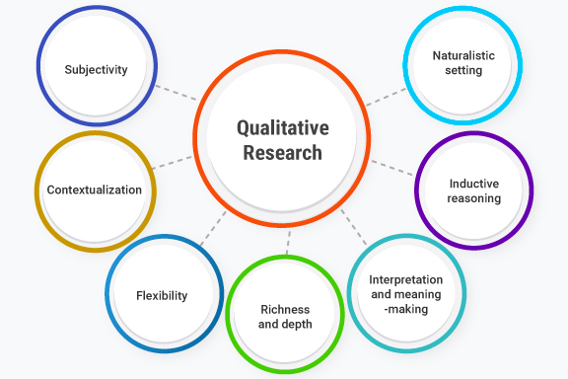
Figure 1: Qualitative Research Design
(Source: Denny & Weckesser, 2022)
This is qualitative research that will inform and critically examine the significant operational management practices in the hospitality industry (Denny & Weckesser, 2022). A qualitative approach will also be appropriate since it enables one to understand the concepts, theories, and practices that are in the industry in more depth than a quantitative approach would. The article concentrates on the context, meaning and critical analysis that are essential in the analysis of complex processes based on services in the hospitality industry. The qualitative approach helps to thoroughly investigate the sources of secondary data, enabling the study to make informative arguments and conclusions (Denny & Weckesser, 2022).

3.2 Research Design
The research is conducted using a descriptive and analytical research approach in order to cogently investigate the identified theme within the framework of hospitality operations (Furidha, 2023). This uses a type of design called descriptive, which gives a concise review of some significant concepts, structures and practices in the business, whereas the analytical section is geared towards a critical review of these variables, hence making it significant to arrive at some meaningful conclusions. The design is organised in the form of a review of scholarly suggestions and industrial illustration, which allows the coherent flow of information (Wolniak, 2023). The approach assists in forming a valid argument and enhances the validity and reliability of research findings.

3.3 Data Collection Method
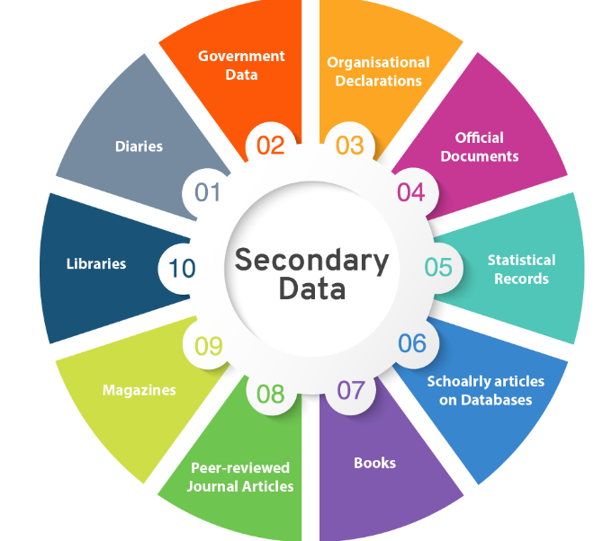
Figure 2: Secondary Data Collection
(Source: Ajayi, 2023)
In the research, the method of collecting secondary data as a way of gathering information is used in analysing data. The data sources used are said to be credible and include the scholarly peer-reviewed academic journals, books, industry reports and credible online sources. The method is suitable because it opens up a wide range of currently available knowledge and information about the operations in the field of hospitality. Through a secondary data collection, the researcher can analyse the available theories, industry trends, and case studies without necessarily doing any data collection (Ajayi, 2023). The diversity and the level of the sources utilized enhance the quality and reliability of the study.

3.4 Data Analysis Techniques
Data analysis in this study is performed through thematic analysis, a qualitative methodology which entails the identification, assessment, and interpretation of patterns in the information collected (Rosairo, 2023). The method can be used to examine the qualitative information in a systematic and methodical manner (Ahmed et al., 2025). The analysis is carried out in an analytical and interpretive manner, linking theoretical perspectives with practical examples. The study gives a complete picture of the subject and justifies coming up with properly argued conclusions by synthesising findings of different sources.

4. Findings

4.1 Supply Chain Management in Hospitality Operations

4.1.1 Importance of SCM in Hospitality
Component | Role in Hospitality Supply Chain | Importance to Operations
Sourcing | Identifying and selecting reliable suppliers for food, beverages, and services (Zong & Guan, 2025) | Ensures consistent quality and supports brand standards
Procurement | Purchasing goods and services at optimal cost and quality | Helps in cost control and maintaining profitability (Mehraliyev, Chan, & Kirilenko, 2022)
Logistics | Managing transportation and delivery of goods | Ensures the timely availability of materials and smooth operations
Inventory Management | Monitoring stock levels and usage (Ganesha & Aithal, 2022) | Prevents shortages, reduces waste, and improves efficiency
Table 3: Table of the importance of SCM in the hospitality industry of Key Components

4.1.2 Impact of Cost Reduction, Operational Efficiency and Customer Satisfaction
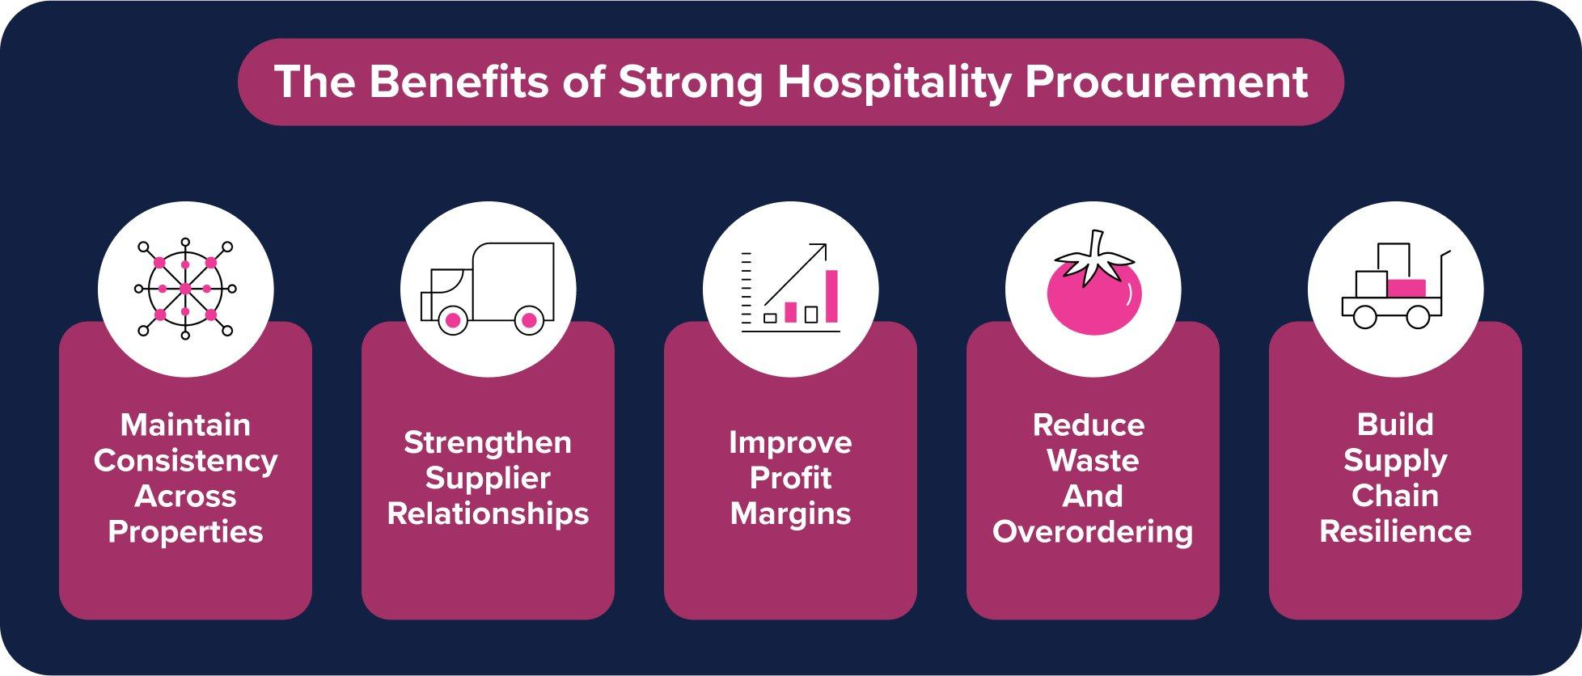
Figure 3: Impact of Supply Chain Efficiency on Hospitality Performance
(Source: Das & Hassan, 2022)
Cost Reduction
The efficient SCM makes the operation cost-effective by optimising procurement, wastage and improved negotiation of supplier contracts. Due to bulk purchasing and good inventory control, high inventory levels and large purchases help to avoid overstocking and spoilage of the goods, particularly perishable goods (Yadav et al., 2023). This has ensured that the hospitality businesses have been profitable to air quality services at competitive prices by making logistics lean, thereby leading to the cost of transportation and storage being minimised.
Operational Efficiency
The SCM enhances the performance of an organisation through the optimisation of the supply of resources at the appropriate moment, the reduction of delays and more coordination between the suppliers and the departments of the organisation (Kristanti & Mranani, 2024). This allows the hospitality organisations to operate without any hassle, with the same smooth operations and utilisation of their resources, thereby improving the overall performance and productivity of the organisation.
Customer satisfaction
Efficient SCM is directly linked to customer satisfaction because it ensures the constant quality of the product and its services. The delivery of the fresh materials and supplies will then be carried out on time without having to postpone the delivery of the fresh product and hospitality supplies required to meet the customers ' needs (Das & Hassan, 2022). An effective supply chain maintains consistency in the menu and service quality to provide a good customer experience, increased loyalty and brand reputation in the competitive world.

4.1.3 Challenges in Managing Supply Chains in Hospitality Organisations
This dynamic and service oriented character of the hospitality organisations such as hotels and restaurants, is a key issue that faces hospitality organisations in the bid to effectively manage their supply chain. The first one is that of perishable goods, where ineffective forecasting/delays can result in considerable wastage and loss. This is also further complicated in inventory planning and procurement decisions by changes in demand, seasonality and customer preferences (Ghaderi et al., 2024). This reliance on numerous suppliers increases the likelihood of quality, price, and delivery schedule fluctuations.
The other significant indicator is the cost-effectiveness of service delivery and high-quality supplies because the increased cost of operations, in addition to supply-side setbacks, can influence profitability (Zong & Guan, 2025). Logistics issues like transport delays and poor infrastructure are also among the factors that hamper it, as they lead to poor, timely delivery of goods. The lack of a high degree of technological integration limits the real-time tracking and coordination of a few hospitality businesses. These issues make strategic planning and management of relations with suppliers obligatory in order to enable uninterrupted functioning and the delivery of services (Ahmed et al., 2025).

4.1.4 Role of Technology in Enhancing Hospitality Supply Chain Performance
Inventory Management Systems
Achieving efficiency in a supply chain largely depends on inventory management systems that make it possible to track the stock level in real-time, minimize wastage, and better meet demand expectations. These systems will assist hospitality businesses to have optimum inventory, especially perishable goods, thus losses could be minimised and availability ensured (Madamidola et al., 2024). Their full potential can also be hampered by high costs of implementation and opposition to technological adoption, particularly in small or medium-sized facilities.
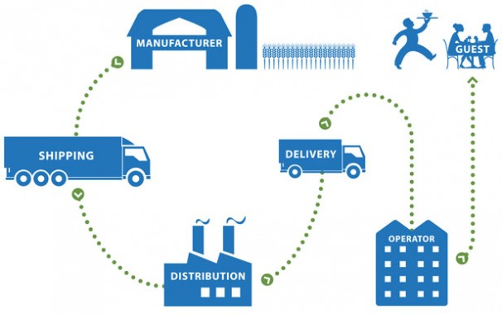
Figure 4: Process of Supply Chain Management in Hospitality Operations
(Source: Das & Hassan, 2022)
Supplier Relationship Management
The SRM systems enhance the partnership between the suppliers and the hospitality business providers as they are reliable, consistent in quality, and deliver on time. SRM facilitates improved communication, monitoring of performance, and strategic alliances, which improve overall performance in the supply chain (Das & Hassan, 2022). The characteristics of extreme reliance on certain suppliers can augment risks in the case of disturbances. The use of SRM systems involves a cost and organisational dedication, and therefore, businesses that have few resources might not be able to implement them.

4.1.5 Case Studies of Successful Supply Chain Strategies in Hospitality
Starbucks: Integrated and Technology-Driven Supply Chain
Starbucks has created a very complex global supply chain through redesigning operations into core activities, including planning, sourcing, manufacturing, and delivery. This has made things a lot easier and decreased the prices of delivery significantly, as well as making it more efficient. The firm operates more than 30,000 stores, yet operates in a well-coordinated and centralised distribution network in more than 80 countries (SFK Corporation, 2024). These AI-enhanced inventory systems enable the inventory to be counted 8 times more often, enhancing the availability of products and decreasing stockouts (Meilani & Ellitan, 2024). These solutions ensure better customer experience, faster replenishment and a certain degree of consistency, which justifies the purpose of the supply chain management, which is based on technology.
Marriott International: Strategic Sourcing and Cost Efficiency
Marriott International has sought to embrace centrally sourced and supplier alliances to streamline its global supply chain. Through its procurement system (Marriott Global Source), this company might be potentially able to save a significant amount of money by enjoying the benefits of bulk purchasing and standardised sourcing. They are said to have saved 10 -15% of procurement costs with these centralised systems, and have also ensured consistency between properties in quality (Horozhankina, Korneyev, & Farzullaev, 2024). Marriott is also working on sourcing sustainably and engaging with suppliers who are long-term, enhancing reliability and operational efficiency (Eschenbrenner et al., 2023). This approach enables the company to embrace great service standards in its thousands of properties, which are spread globally; this is why strategic sourcing and supplier management are adding towards competitive advantage in hospitality operations.

4.2 Quality Management Systems in Hospitality

4.2.1 Role of QMS in Hospitality Operations
The QMS plays a very crucial role in ensuring the continuity of service delivery in the running of a hospitality business by standardising the processes, improving the quality of service and customer satisfaction. QMS systems act as a guide on the standardisation of service delivery in the different departments, such as housekeeping, food and beverage and front office functions (Sayfullayeva, Khamrakulov, & Khamrakulov, 2026). Hospitality organisations can minimise their service inconsistencies and errors by developing clear processes and performance expectations.
The QMS promotes continuous improvement through continuous monitoring, employee feedback and employee training. This will help organisations to detect gaps in service and take corrective measures. This also builds responsibility and uniformity in its staff, enabling its customers to get a dependable quality customer experience (Fonseca et al., 2022). QMS assists in attaining operational efficiencies and brand recognition by implementing transparent and trustworthy hospitality services.

4.2.2 Quality Standards and Frameworks Discussion
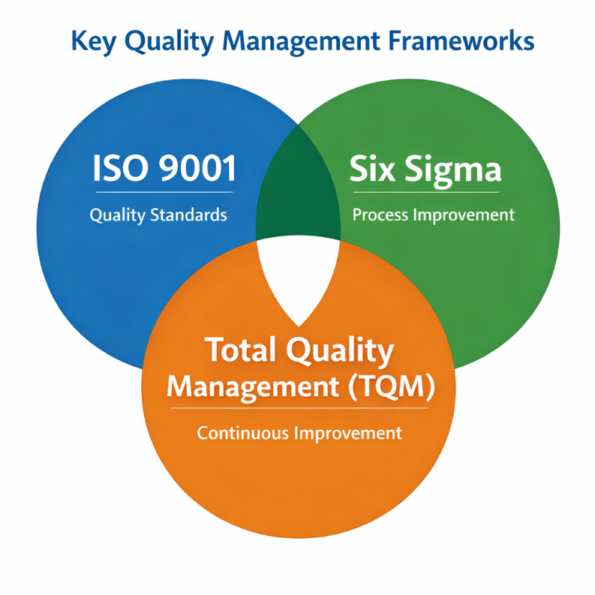
Figure 5: Key Quality Management Frameworks in Hospitality
(Source: Prabhu, VA, & Kumar, 2024)
Framework | Key Features | Application in Hospitality Services
ISO 9001 | International standards focused on quality management systems, process standardisation, and continuous improvement | Ensures consistent service delivery through documented procedures, audits, and customer-focused practices in hotels and restaurants (Fonseca et al., 2022)
Six Sigma | Data-driven methodology aimed at reducing defects and process variation (Ostergllava & Loku, 2024) | Helps improve service efficiency by identifying errors in operations such as order processing, check-in services, and food preparation
Total Quality Management (TQM) | Organisation-wide approach focusing on continuous improvement and employee involvement | Encourages staff participation in quality improvement, enhances service standards, and promotes customer satisfaction across all departments (Prabhu, VA, & Kumar, 2024)
Table 4: Table of Quality Standards and Frameworks Discussion
All of the above frameworks improve consistency of services, efficiency of operations and customer satisfaction with the hospitality organisations.

4.2.3 Relationship Between Quality Management, Customer Satisfaction, and Operational Efficiency
Aspect | Relationship Explanation
Quality Management with Customer Satisfaction | Effective quality management ensures consistent service standards, leading to positive customer experiences and higher satisfaction levels (Nehme, Abouibrahim, & Al Maalouf, 2024)
Quality Management with Operational Efficiency | Standardised processes and continuous improvement reduce errors, save time, and enhance resource utilisation (Qerimi, Bytyçi, & Qerimi, 2023)
Operational Efficiency with Customer Satisfaction | Efficient operations enable faster service delivery and reliability, improving overall guest experience (Suseno et al., 2023)
Table 4: Table of Relationship Between QM, CS, and OE

4.2.4 Challenges in Implementing QMS in Hospitality
- Implementing the frameworks of QMS, i.e., ISO or Six Sigma, demands huge financial investments in education, certification, and upgrades of the system, which is complex to meet the financial requirements of small and medium hospitality businesses (Azmaiparashvili, 2023).
- Quality systems that are implemented might fail due to resistance by the staff to readily adopt new procedures that they are not familiar with, or the fear of the work burden.
- Hospitality services, in contrast to manufacturing, cannot be manufactured, and the service delivery depends on human interaction; it is difficult to have uniformity in the quality of services provided (Idem, 2023).
- In order to maintain QMS standards, the continuity of training needs to be present, which can be destabilised in case of high employee turnover in the hospitality industry (Nehme et al., 2024).

4.2.5 Case Studies of Successful QMS Implementation in Hospitality
Marriott International: Standardisation and Service Excellence
Marriott International has been in a position to implement QMS by standardising the current operating procedures in the operating songs of the global properties. The company employs principles that are close to TQM, which focuses on continuous improvement and consumer feedback. Marriott ensures consistent service delivery through its Spirit to Serve philosophy and designed quality audits (Horozhankina, Korneyev, & Farzullaev, 2024). This has witnessed the organisation registering high customer satisfaction indices and brand loyalty. The processes have been standardised to promote efficiency in operations and reduce errors in services in the thousands of hotels that Marriott owns worldwide.
Taj Hotels: TQM and Customer-Centric Approach
TQM has been successfully adopted by the Indian Hotels Company Limited in order to improve the quality of services and customer satisfaction (Rana, Shameem, & Gupta, 2026). The Taj Group cares about the empowerment of the employees and training them on a regular basis, and personalisation of the guest experience. The quality-driven culture has led to the delivery of high standards of services and recognition as excellent in the hospitality industry globally. QMS has led to improvements in the operations of the company, reduced complaints and increased customer loyalty (Customer Centria, 2026). This has seen the organisation win several quality awards, which have proven that it has a successful quality management system in place.

4.3 Capacity Management and Demand Forecasting

4.3.1 Importance of Capacity Management in Hospitality Operations
The importance of capacity management in the operations of the hospitality business can be memorialised by the need to balance the demand and the available resources (rooms, seating, staff, and services) effectively. In hotels, it involves management of room stocks, prices and occupancy as it helps to maximise revenue collection whilst maintaining high quality of services. Dynamic pricing and demand forecasting technologies enable hotels to dynamically change the room prices within the seasons, events and booking trends (Siongok & Nyamwange, 2023). The restaurants can work with the changing customer flows in an effective way using the capacity with the help of the reservation systems, turnover plans, and staff shifts.
Effective capacity management will enable the prevention of such issues as overbooking, long waiting times, or under-utilisation of resources, which might damage customer satisfaction and profitability. It also facilitates efficiency in operations in that the level of staffing and inventory is proportional to the expected demand. The accurate supply and demand ratio allows hospitality businesses to maximise revenue and minimise operational costs, and allows them to offer a consistent service experience to ensure long-term sustainability and competitive advantage in a very competitive and dynamic industry (Afandy, 2024).

4.3.2 Methods and Techniques of Demand Forecasting in Hospitality
The analysis of past events plays a critical role in demand forecasting in the hospitality industry to forecast future demand trends (Kaya et al., 2022). The companies make comparisons of previous occupancy, reservations, seasonal reports and revenue information to identify trends. Hotels consider seasonal time, weekend trends, and event-based trends to establish future bookings. It is also a promising performance-based forecasting process since it will use actual performance data to make its calculations.
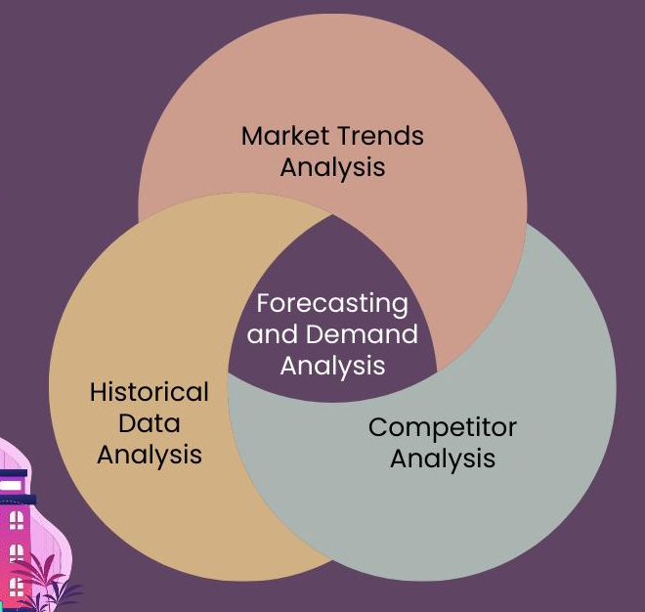
Figure 6: Demand Forecasting Techniques in Hospitality Industry
(Source: Al Jassim et al., 2023)
The analysis of the market trends also plays a significant role in predicting the demand in addition to historical data. Some of the external factors that are followed by hospitality organisations are the economic conditions, tourism trends, price variations of competitors and local or global events (Al Jassim et al., 2023).
In a bid to predict the demand accurately, it is important to understand the behavioural trends of the customers. This involves running an analysis of the booking behaviours, preferences, amount spent and feedback information (Iyengar & Venkatesh, 2024). These insights are integrated, hospitality companies will realise that they provide personalised services, gain increased predictive accuracy and customer satisfaction, as well as attain an optimum operational performance.

4.3.3 Role and Impact of Overbooking Strategies
Aspect | Explanation
Definition | Overbooking involves accepting more reservations than available capacity to offset cancellations and no-shows
Purpose | Helps maximise occupancy and revenue by reducing empty rooms or tables (Suseno et al., 2023)
Application | Commonly used in hotels and airlines, predictive data on cancellations
Risk Management | Requires careful forecasting to avoid service failures and customer dissatisfaction (Sayfullayeva, Khamrakulov, & Khamrakulov, 2026)
Table 5: Table of the Role of Overbooking Strategies in Managing Capacity
Customer satisfaction and profitability are some of the impacts of the overbooking strategies on the operation of a business in the hospitality industry. Along with good management, overbooking is very profitable since the facility utilises the full capacity and any loss due to cancellation or no-shows is reduced (Meilani & Ellitan, 2024). Overbooking may also result in the denial of services, waiting times, and customer dissatisfaction in the case of excessive and improper control. This will damage the brand's reputation and result in the loss of customers. The hospitality businesses should find the equilibrium between accuracy in prognostication and customer service provision to ensure profitability, but not at the expense of customer satisfaction.

4.3.4 Challenges in Achieving Optimal Capacity Utilisation
- Fluctuating demand makes it hard to plan the capacity of the hospitality industry correctly.
- The risks associated with overbooking may lead to service failure and customer dissatisfaction (Lebaka, 2024).
- The underutilisation of resources brings about the loss of revenue and efficiency.
- Poor prediction of the demand affects the inventory and staffing.
- The focus on human resources will most probably cause service delivery gaps.
- The external factors, such as seasonality and unforeseen circumstances, disrupt this balance of operations (Idem, 2023).

4.3.5 Real-World Examples of Capacity Management and Demand Forecasting
Hilton Worldwide: Data-Driven Forecasting and Revenue Management
Hilton has designed better demand forecasting models which combine historical booking data, market factors and up-to-date external factors such as events and weather. These systems help in the optimisation of pricing and staffing decisions, and ensure these capacities are fully exploited. Studies have shown that good forecasting to a great extent enhances the effective coordination of demand and supply, and ultimately results in an improved operational performance (Derowitsch et al., 2025). The new AI-based prediction means that making a forecast will be quicker and more precise, and the hotels will be able to implement a dynamic rate change and optimize hotel reservations.
Airbnb: Dynamic Supply and Demand Matching
Airbnb is equally relying on data analytics and platform forecasting to match capacity to provide supply (hosts), and the variable demand. This platform uses predictive algorithms on price regulation proposals and availability based on the area, seasonality, and behavioural patterns between users. The peculiar feature of this dynamic solution is that it allows flexible growth of capacity in comparison to traditional hotels (Um et al., 2025). Research indicates that the combination of forecasting and supply decisions enhances utilisation and helps in the prevention of stock-outs within the accommodation markets.

5. Discussion
In this analysis of supply chain management, quality management systems, and capacity planning strategies, which play a central role in effective operations management in the hospitality industry. Cost management, consistency of the service, and operational stability are also controlled using efficient supply chain practices, and standardisation and improvement in service delivery are maintained using quality management systems (Burgess, Sunmola, & Wertheim-Heck, 2023). The capacity management and demand forecast enable the organisations to align the resources to the fluctuating demand, thus maximising resource utilisation and maximising profit generation. The findings denote that the adoption of technology that encompasses inventory systems and data-based forecasting tools is an important element of decision-making and operational performance of hospitality businesses.
In evaluating, despite having immense positive gains, such operational strategies are mostly restricted by factors such as high costs, uncertainty in demand, and fluctuation of service variations. In the hospitality industry, change is constant and requires a continuous reply and investment in a well-trained workforce and technology. The efficiency and customer satisfaction have been among the most critical concerns to create a balance since the decisions made during the operations are directly affecting the quality of the service (Lepistö, Saunila, & Ukko, 2024). The organisations and most prominently the hospitality industry should adopt an integrated approach in the strategic approach to performance, where theoretical frameworks are combined with practical applications to achieve the desired sustainable performance.

6. Conclusion
The conclusion made in the discussion is that effective operational management is necessary in order to be successful in the hospitality industry. Growth frontiers such as supply chain, quality management systems, and capacity planning are useful in contributing to efficiency, cost management and consistency in services provided. The combination of well-structured processes and the latest technologies will help hospitality organisations to react well to changing market requirements. The use of data-driven tactics is useful in supporting decision-making, which further allows businesses to optimize the use of resources and establish high standards of service delivery.
The larger context is that the study illuminates the reality that concerns such as uncertainty in demand and implementation barriers will never go away, but through strategic planning and constant improvement, they can be filtered. The organisations whose priorities are placed on innovation, employee training and good relations with their suppliers stand in a more advantageous position of having a competitive advantage. The holistic and dynamic nature of operations management will contribute to long-term growth, customer satisfaction, and offer a certain degree of resilience within the increasingly competitive hospitality environment.

7. References
Afandy, C. (2024). The role of financial leverage and cost management on operational efficiency and earnings stability in hospitality industry in Indonesia. The Eastasouth Management and Business, 3(01), 77-88. Assessed from: https://esj.eastasouth-institute.com/index.php/esmb/article/download/339/277 Assessed on: April 10th, 2026.
Ahmed, S. K., Mohammed, R. A., Nashwan, A. J., Ibrahim, R. H., Abdalla, A. Q., Ameen, B. M. M., & Khdhir, R. M. (2025). Using thematic analysis in qualitative research. Journal of Medicine, Surgery, and Public Health, 6, 100198. Assessed from: https://www.sciencedirect.com/science/article/pii/S2949916X25000222 Assessed on: April 10th, 2026.
Ajayi, V. O. (2023). A review on primary sources of data and secondary sources of data. Available at SSRN 5378785. Assessed from: https://papers.ssrn.com/sol3/Delivery.cfm?abstractid=5378785 Assessed on: April 10th, 2026.
Al Jassim, R. S., Jetly, K., Abushakra, A., & Al Mansori, S. (2023). A review of the methods and techniques used in tourism demand forecasting. EAI Endorsed Transactions on Creative Technologies, 9(4), e1. Assessed from: https://pdfs.semanticscholar.org/1f6f/61268bd23e47d7b6167047ffc8624474ad90.pdf Assessed on: April 10th, 2026.
Azmaiparashvili, M. (2023). Application of ISO standards in hospitality industry and challenges of Georgia. Scientific Collection «InterConf+», (36), 7-16. Assessed from: https://www.academia.edu/download/118779301/4271.pdf Assessed on: April 10th, 2026.
Burgess, P. R., Sunmola, F. T., & Wertheim-Heck, S. (2023). A review of supply chain quality management practices in sustainable food networks. Heliyon, 9(11). Assessed from: https://www.cell.com/heliyon/pdf/S2405-8440(23)08387-1.pdf Assessed on: April 10th, 2026.
Customer Centria (2026), Taj Case Study. Assessed from: https://customercentria.com/case-study-taj/ Assessed on: April 10th, 2026.
Das, S., & Hassan, H. K. (2022). Impact of sustainable supply chain management and customer relationship management on organizational performance. International Journal of Productivity and Performance Management, 71(6), 2140-2160. Assessed from: https://www.emerald.com/ijppm/article-pdf/71/6/2140/1134572/ijppm-08-2020-0441.pdf Assessed on: April 10th, 2026.
Denny, E., & Weckesser, A. (2022). How to do qualitative research? Qualitative research methods. Bjog, 129(7), 1166. Assessed from: https://pmc.ncbi.nlm.nih.gov/articles/PMC9322519/ Assessed on: April 10th, 2026.
Derowitsch, J., Ngo, T., Katt, T., Henning, M., & Soukup, L. (2025). Strategic Audit: Hilton Worldwide Holdings, Inc. Assessed from: https://digitalcommons.unl.edu/cgi/viewcontent.cgi?article=1819&context=honorstheses Assessed on: April 10th, 2026.
Eschenbrenner, B., Zlatic, A., Bechtel, M., Collins, B., Straley, C., & Gubbels, G. (2023). Marriott International: a managerial strategic audit. Assessed from: https://digitalcommons.unl.edu/cgi/viewcontent.cgi?article=1647&context=honorstheses Assessed on: April 10th, 2026.
Feng, Y., Lai, K. H., & Zhu, Q. (2022). Green supply chain innovation: Emergence, adoption, and challenges. International journal of production economics, 248, 108497. Assessed from: https://ira.lib.polyu.edu.hk/bitstream/10397/99399/1/Feng_Green_Supply_Chain.pdf Assessed on: April 10th, 2026.
Fonseca, L. M., Cardoso, M. C., & Nóvoa, M. H. (2022). Motivations for ISO 9001 quality management system implementation and certification–mapping the territory with a novel classification proposal. International Journal of Quality and Service Sciences, 14(1), 18-36. Assessed from: https://www.emerald.com/ijqss/article-pdf/14/1/18/982530/ijqss-02-2021-0031.pdf Assessed on: April 10th, 2026.
Furidha, B. W. (2023). Comprehension of the descriptive qualitative research method: A critical assessment of the literature. Acitya Wisesa: Journal Of Multidisciplinary Research, 1-8. Assessed from: https://www.journal.jfpublisher.com/index.php/jmr/article/download/443/869 Assessed on: April 10th, 2026.
Ganesha, H. R., & Aithal, P. S. (2022). How to choose an appropriate research data collection method and method choice among various research data collection methods and method choices during Ph. D. program in India. International Journal of Management, Technology, and Social Sciences, 7(2), 455-489. Assessed from: https://www.academia.edu/download/100063600/26._How_to_Choose_an_Appropriate_Research_Data.pdf Assessed on: April 10th, 2026.
Ghaderi, Z., Shakori, H., Bagheri, F., Hall, C. M., Rather, R. A., & Moaven, Z. (2024). Green supply chain management, environmental costs and supply chain performance in the hotel industry: the mediating role of supply chain agility and resilience. Current Issues in Tourism, 27(13), 2101-2117. Assessed from: https://www.academia.edu/download/103493266/Green_supply_chain_management.pdf Assessed on: April 9th, 2026.
Horozhankina, N., Korneyev, M., & Farzullaev, R. (2024). Marriott International’s place in international hotel chains. Assessed from: http://scientificview.umsf.in.ua/archive/2024/4_88_2024/6.pdf Assessed on: April 10th, 2026.
Idem, S. R. (2023). The Role of Quality Management Practices on Organizational Performance: A study of selected SMEs in Nigeria’s Hospitality and Tourism industry (Doctoral dissertation, Dublin, National College of Ireland). Assessed from: https://norma.ncirl.ie/6366/1/solomonrichardidem.pdf Assessed on: April 10th, 2026.
Iyengar, M. S., & Venkatesh, R. (2024). Customer preferences while booking accommodation in hotels: Customer Behaviour and Hotel Strategies. Management:(Montevideo), 2, 5. Assessed from: https://dialnet.unirioja.es/descarga/articulo/9870227.pdf Assessed on: April 10th, 2026.
Jaboob, A. S., Awain, A. M. B., Ali, K. A. M., & Mohammed, A. M. (2024). Introduction to operation and supply chain management for entrepreneurship. In Applying Business Intelligence and Innovation to Entrepreneurship (pp. 52-80). IGI Global Scientific Publishing. Assessed from: https://delsuelib.com.ng/ebk/mgt/ent/2024%20Applying%20Business%20Intelligence%20and%20Innovation%20to%20Entrepreneurship.pdf#page=71 Assessed on: April 10th, 2026.
Jawabreh, O., Baadhem, A. M., Ali, B. J., Atta, A. A. B., Ali, A., Al-Hosaini, F. F., & Allahham, M. (2023). The influence of supply chain management strategies on organizational performance in hospitality industry. Appl. Math. Inf. Sci, 17(5), 851-858. Assessed from: https://www.researchgate.net/profile/Abdullah-Baadhem-2/publication/374082925_The_Influence_of_Supply_Chain_Management_Strategies_on_Organizational_Performance_in_Hospitality_Industry/links/650c8871c05e6d1b1c21b5b3/The-Influence-of-Supply-Chain-Management-Strategies-on-Organizational-Performance-in-Hospitality-Industry.pdf Assessed on: April 10th, 2026.
Kaya, K., Yılmaz, Y., Yaslan, Y., Öğüdücü, Ş. G., & Çıngı, F. (2022). Demand forecasting model using hotel clustering findings for hospitality industry. Information Processing & Management, 59(1), 102816. Assessed from: https://www.sciencedirect.com/science/article/pii/S0306457321002909 Assessed on: April 9th, 2026.
Kristanti, D. A., & Mranani, N. A. (2024). The effect of cost reduction as part of supply chain drivers’ element and customer satisfaction on purchasing and logistics performance. Petra International Journal of Business Studies, 7(1), 89-98. Assessed from: https://ijbs.petra.ac.id/index.php/ijbs/article/download/360/135 Assessed on: April 10th, 2026.
Kunrath, T. L., Dresch, A., & Veit, D. R. (2023). Supply chain management and industry 4.0: a theoretical approach. Brazilian Journal of Operations & Production Management, 20(1), 1263-1263. Assessed from: https://www.bjopm.org.br/bjopm/article/download/1263/1025 Assessed on: April 10th, 2026.
Lebaka, E. K. (2024). Overbooking and customer reactions in tourism: Evidence from restaurants. Journal of Tourism Theory and Research, 10(2), 68-74. Assessed from: https://dergipark.org.tr/en/download/article-file/4052796 Assessed on: April 10th, 2026.
Lepistö, K., Saunila, M., & Ukko, J. (2024). Enhancing customer satisfaction, personnel satisfaction and company reputation with total quality management: combining traditional and new views. Benchmarking: An International Journal, 31(1), 75-97. Assessed from: https://www.emerald.com/bij/article-pdf/31/1/75/9456153/bij-12-2021-0749.pdf Assessed on: April 10th, 2026.
Lubis, N. W. (2022). Resource based view (RBV) in improving company strategic capacity. Research Horizon, 2(6), 587-596. Assessed from: https://journal.lifescifi.com/index.php/RH/article/download/85/72 Assessed on: April 10th, 2026.
Madamidola, O. A., Daramola, O. A., Akintola, K. G., & Adeboje, O. T. (2024). A Review of existing inventory management systems. International Journal of Research in Engineering and Science (IJRES), 12(9), 40-50. Assessed from: https://www.researchgate.net/profile/Olugbenga-Madamidola/publication/383947700_A_Review_of_Existing_Inventory_Management_Systems/links/66e34077f84dd1716ce9ccee/A-Review-of-Existing-Inventory-Management-Systems.pdf Assessed on: April 10th, 2026.
Majeed, M., Alhassan, F., Abas, S., & Stanley, C. (2025). Artificial Intelligence on SCM in the Hospitality Sector. In New Age Technology in Supply Chain Management (pp. 1-18). Apple Academic Press. Assessed from: https://www.taylorfrancis.com/chapters/edit/10.1201/9781003605256-1/artificial-intelligence-scm-hospitality-sector-mohammed-majeed-alhassan-abas-stanley Assessed on: April 10th, 2026.
Mehraliyev, F., Chan, I. C. C., & Kirilenko, A. P. (2022). Sentiment analysis in hospitality and tourism: a thematic and methodological review. Assessed from: https://www.emerald.com/ijchm/article/34/1/46/161172 Assessed on: April 10th, 2026.
Meilani, T., & Ellitan, L. (2024). Supply Chain Management Processes and Competitive Advantage: The Case of Starbucks. Assessed from: https://www.researchgate.net/profile/Lena-Ellitan/publication/377574585_Supply_Chain_Management_Processes_and_Competitive_Advantage_The_Case_of_Starbucks/links/65add132f323f74ff1e44cd7/Supply-Chain-Management-Processes-and-Competitive-Advantage-The-Case-of-Starbucks.pdf Assessed on: April 10th, 2026.
Muhammad, A. H. (2022). Importance of green supply chain management in hospitality business: Supply chain management and hospitality business. South Asian Journal of Operations and Logistics, 1(2), 1-15. Assessed from: http://journal.sagpb.com/index.php/SAJOL/article/download/31/25 Assessed on: April 9th, 2026.
Nazir, S., Zhaolei, L., Mehmood, S., & Nazir, Z. (2024). Impact of green supply chain management practices on the environmental performance of manufacturing firms considering institutional pressure as a moderator. Sustainability, 16(6), 2278. Assessed from: https://www.mdpi.com/2071-1050/16/6/2278 Assessed on: April 10th, 2026.
Nehme, M. N., Abouibrahim, M., & Al Maalouf, N. J. (2024). Implementation of total quality management to improve operational efficiency and customer satisfaction in Lebanese industries. Arab Economic and Business Journal, 16(2), 6. Assessed from: https://journals.usek.edu.lb/cgi/viewcontent.cgi?article=1049&context=aebj Assessed on: April 10th, 2026.
Ostergllava, N., & Loku, A. (2024). Analyzing the Impact of Lean Six Sigma Methodology on Service Quality Improvement in the Hospitality Industry. Calitatea, 25(203), 360-367. Assessed from: https://search.proquest.com/openview/190298cfc20452005ffeb26fa7238b3b/1?pq-origsite=gscholar&cbl=1046413 Assessed on: April 10th, 2026.
Prabhu, B. P., VA, N. A., & Kumar, A. (2024). A review on total quality management in the hospitality industry. International Multidisciplinary Journal, 5, 442-451. Assessed from: https://www.advancedagronomyjournal.com/uploads/archives/20240720192025_D-24-71.1.pdf Assessed on: April 10th, 2026.
Qerimi, A., Bytyçi, I., & Qerimi, F. (2023). The impact of total quality management on operational performance. Journal of Governance and Regulation, 12(1), 10-22495. Assessed from: https://papers.ssrn.com/sol3/Delivery.cfm?abstractid=5472526 Assessed on: April 10th, 2026.
Rana, V. S., Shameem, B., & Gupta, B. (2026). Total Quality Management (TQM) in Hospitality: An Interplay of Technology and Service Excellence. In Marketing Strategies for Total Quality Management in Hospitality Excellence (pp. 301-314). IGI Global Scientific Publishing. Assessed from: https://www.igi-global.com/chapter/total-quality-management-tqm-in-hospitality/401542 Assessed on: April 10th, 2026.
Rosairo, H. S. R. (2023). Thematic analysis in qualitative research. Journal of Agricultural Sciences–Sri Lanka, 18(3). Assessed from: https://jas.sljol.info/articles/10526/files/64f33f9912a52.pdf Assessed on: April 10th, 2026.
Rusavska, V., Zavadynska, O., Honchar, L., & Holubets, I. (2025). Quality Management in Restaurant Businesses: Theoretical Bases and Modern Methodological Approaches. Socio-Cultural Management Journal, 8(1), 23-45. Assessed from: http://socio-cultural.knukim.edu.ua/article/download/336355/325186 Assessed on: April 9th, 2026.
Sayfullayeva, Z., Khamrakulov, M., & Khamrakulov, G. (2026). IMPLEMENTATION OF A QUALITY MANAGEMENT SYSTEM IN HOTEL SERVICES IN MODERN CONDITIONS. PROSPECTS AND MAIN TRENDS IN MODERN SCIENCE, 3(30), 79-81. Assessed from: https://internationalconf.org/index.php/spain/article/download/2171/1620 Assessed on: April 10th, 2026.
SFK Corporation (2024), Starbucks Supply Chain Management: Optimizing Global Coffee Distribution Through Risk Mitigation and Sustainable Practices. Assessed from: https://sfkcorp.com/starbucks-supply-chain-management-optimizing-global-coffee-distribution-through-risk-mitigation-and-sustainable-practices/?utm Assessed on: April 10th, 2026.
Sheppard, H. (2025). Quality Management. WIT Transactions on The Built Environment, 9. Assessed from: https://www.witpress.com/Secure/elibrary/papers/MAR95/MAR95009FU.pdf Assessed on: April 10th, 2026.
Siongok, W. C., & Nyamwange, O. (2023). Capacity management and performance of five-star hotels in Nairobi County, Kenya. International Academic Journal of Human Resource and Business Administration, 4(2), 378-394. Assessed from: http://www.iajournals.org/articles/iajhrba_v4_i2_378_394.pdf Assessed on: April 9th, 2026.
Suseno, B. D., Sugianto, E., Purnamasari, E., & Supriadi, A. (2023). Analysis of the application of operational management in manufacturing companies in Bandung city: The effect of production efficiency, product innovation, and customer satisfaction on financial performance. West Science Journal Economic and Entrepreneurship, 1(11), 535-546. Assessed from: https://www.researchgate.net/profile/Bambang-Suseno/publication/376228203_Analysis_of_the_Application_of_Operational_Management_in_Manufacturing_Companies_in_Bandung_City_The_Effect_of_Production_Efficiency_Product_Innovation_and_Customer_Satisfaction_on_Financial_Performan/links/656f2e83a760eb7cc7506649/Analysis-of-the-Application-of-Operational-Management-in-Manufacturing-Companies-in-Bandung-City-The-Effect-of-Production-Efficiency-Product-Innovation-and-Customer-Satisfaction-on-Financial-Perform.pdf Assessed on: April 10th, 2026.
Um, T., Lee, M., Back, K. J., & Chung, N. (2025). Does Airbnb matter to the domestic tourism market? Empirical evidence from Airbnb supply and tourism demand in South Korea. Tourism Management Perspectives, 58, 101381. Assessed from: https://www.sciencedirect.com/science/article/pii/S2211973625000467 Assessed on: April 10th, 2026.
Wolniak, R. (2023). The concept of descriptive analytics. Zeszyty Naukowe. Organizacja i Zarządzanie/Politechnika Śląska, (172), 699-715. Assessed from: https://bibliotekanauki.pl/articles/58908850.pdf Assessed on: April 10th, 2026.
Yadav, S., Chowdary, M., Veeramani, G., Celia, B. R., Pal, S., & Prakash, O. (2023). Impact of supply chain management on the Indian SME operational effectiveness. Journal of Informatics Education and Research, 3(2), 1582-1588. Assessed from: https://www.researchgate.net/profile/Subharun-Pal/publication/375282259_Impact_of_Supply_Chain_Management_on_the_Indian_SME_Operational_Effectiveness/links/6545a2acb1398a779d59fd5b/Impact-of-Supply-Chain-Management-on-the-Indian-SME-Operational-Effectiveness.pdf Assessed on: April 10th, 2026.
Zong, Z., & Guan, Y. (2025). AI-driven intelligent data analytics and predictive analysis in Industry 4.0: Transforming knowledge, innovation, and efficiency. Journal of the knowledge economy, 16(1), 864-903. Assessed from: https://link.springer.com/article/10.1007/s13132-024-02001-z Assessed on: April 10th, 2026.

