Planning and Management of Sustainable Tourism Spaces
Assignment 7


Title:
Sustainable Conservation and Management of Museum Island, Berlin: A UNESCO World Heritage Analysis

Student Name:
Harpreet singh

Student ID:
DE240148

Table of Contents
1. Introduction 3
2. Outstanding Universal Value (OUV) 3
3. Criteria for Inscription 4
4. Authenticity and Integrity 5
5. Conservation Strategy 6
5.1 Main Threats / Risks 6
5.2 Risk Factor Matrix 6
5.3 Mitigation Actions 6
6. Conclusion 7

1. Introduction
Museum Island (Museumsinsel) is located in the heart of Berlin, Germany, on the northern part of the Spree Island. It is home of Altes Museum, Neues Museum, Alte Nationalgalerie, Bode-Museum and Pergamonmuseum which are ranked among the world’s most famous museums. They were constructed between 1824 and 1930. The architectural complex is a 19th-century conception which sought to embody the Enlightenment ideal of making art, history and science accessible to all. The promotion of education and culture in a unique urban setting is given by the museums illustrating the evolution of human civilization and artistic achievement. Museum Island is included on the United Nations Educational, Scientific and Cultural Organization (UNESCO) World Heritage List since 1999 as it was important to the development of modern museum architecture and artistic modernism. At Present, it attests to Europe’s intellectual heritage and creative vision, leading towards its recognized OUV (Wolfschmidt, 2021).

2. Outstanding Universal Value (OUV)
Museum island in Berlin is an outstanding universal value which is a masterpiece of cultural and architectural achievement that reflects the enlightenment dream of knowledge as a public good. Five monumental buildings make up the museum complex: the Altes Museum, Neues Museum, Alte Nationalgalerie, Bode-Museum, and Pergamonmuseum, all built from 1824 to 1930. They mark the progressive development of the museum as a piece of architecture where architecture brings together art, history and science to educate society and honour humanity’s creativity (Wolfschmidt, 2021).
The site design exhibits the evolution of museum architecture from the 19th century neoclassical idea to the early 20th century granite- and concrete- functionalist and modern approach. The Altes Museum, designed by Karl Friedrich Schinkel, was the first expression of a public museum which would inspire civic enlightenment and engagement, a building reflecting Enlightenment ideas. The task relating to the information was advanced with the construction of each building, incorporating developments in space design, display mechanism and architecture. Museums construct an uninterrupted urban and intellectual landscape that resonates with the history of knowledge evolution and its democratization (Hassan, Zerva, & Aulet, 2021). The museum structures and their contents have a relationship described as the organic relationship that is the other key descriptor of the Outstanding Universal Value. The design of every museum took a particular culture's collection into account in order for the displays to fit. The way of integrating function and design shows a deeper understanding of how space can influence the learning experience of the visitor. Museum Island is a testament to cultural identity. It depicts how architecture and the arts may display human creativity and a sense of belonging in our communities. The Los Angeles Central Library is a world-class library. It and its architectural design enhances the city’s thermal economy.
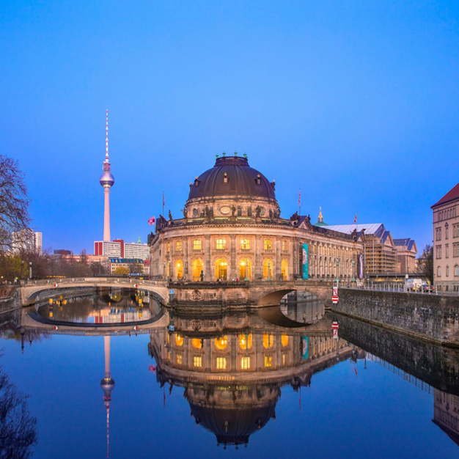
Figure 1: Panoramic view of Museum Island, Berli

3. Criteria for Inscription
In 1999, the Museum Island in Berlin was added to UNESCO’s World Heritage List for exhibiting significant progress in architecture or technology, which is capable of reflecting an important stage in human history, in addition to many other important factors. The site is an example of human creativity, value exchange, worldwide museum design, and urban design (Ubertazzi, 2020).
Criterion (ii) states that man-made structures, such as buildings, etc. exhibit changes to a certain extent. In this decor the social functions of museums, as institutions for public education are now relevant. The changing European intellectual and aesthetic ideas are reflected in the classical, Renaissance and modern architectural forms that are on display on Museum Island. Karl Friedrich Schinkel, One of the most prominent artists of early nineteenth century, was responsible for designing this museum. According to Von Schorlemer, Maus, and Schmermer (2020), it established a model for the contemporary museum as a public service and motivated like developments in Europe and beyond.
Criterion (iv) identifies Museum Island as an outstanding example of a museum complex and civic planning. The ensemble's unity from the Altes Museum to the Pergamonmuseum exemplifies how architecture and urban planning can bring a project together over the course of one century. The enormous effort has succeeded in sensitively incorporating a common cultural site in a beautiful city. The Neues Museum’s recent restoration, which balances original materials with contemporary intervention, strengthens cultural memory continuity whereas the Pergamonmuseum’s monumental exhibits emphasise the architectural scale and ambition of early 20th century museology. The combination of preservation, innovation and public participation is in line with the sustainability goals of UNESCO in terms of heritage management.
Thus, Museum Island fulfills both criteria through its role as a living example of the humanistic values of education, artistic excellence, and sustainable cultural development.

4. Authenticity and Integrity
- According to a UNESCO, authenticity describes the truthfulness in the origin of a particular site’s cultural expressions (materials, design, traditions and spirit), whereas integrity describes the wholeness and completeness of the heritage property (Gullino & Larcher, 2013). The OUV of a site remains genuine and undisturbed through time as a result of these concepts, which are helpful.
- Authenticity in Museum Island: The materials, design and original function of Museum Island give it a high level of authenticity with respect to the original state and intention of the site. The Neues Museum restoration, finishing in 2009 by David Chipperfield, aligned most historic remains with modern interventions. The continuity is thus visible between past and present, though without a copy of the original. Khalaf (2020) argues that the continuity of cultural value is a better indicator of authenticity than reconstruction – an approach in lived heritage that resonates with UNESCO’s Nara Document on Authenticity (1994).
- Integrity and Protection: The site’s integrity is best demonstrated by the inclusion of all five museums, along with their setting in the property. Berlin’s heritage preservation law and the buffer zone which allows for visual and spatial coherence with the city protect the site. The physical and functional unity of the composition still convey the 19th-century idea of a “cultural city core”, that is able to safeguard its integrity of building and meaning (Gullino & Larcher, 2013)

5. Conservation Strategy

5.1 Main Threats / Risks
- Climate Change (Heat and Flooding): Significant dangers are posed to Museum Island by climate change, notably temperature extremes, irregular precipitation and flood hazards from River Spree. Berlin’s urban water systems are highly vulnerable to heavy rainfall and heatwaves, which can damage historical structures and destabilize foundations” (Arndt and Heiland, 2024). Rising humidity levels also put indoor collections and wall paintings at risk.
- Visitor Pressure (Over-tourism): Millions of visitors each year are causing wear on the surfaces, overcrowding and reducing the delicate interiors. According to Lazaro Ortiz and Jiménez de Madariaga (2021), cultural heritage tourism is valuable. However, it could endanger the intangible meaning and physical endurance of heritage if not sustainable.
- Construction and Refurbishment Disruptions: Continuous work like the renovation of Pergamonmuseum can result in vibrations, dust and damage. Sustainability of heritage can be integrated with other development activities having it for managing heritage.
- Urban Development Pressures: Expansion projects in the Spree and surrounding urban areas can influence the visual setting of the island. Coordinated heritage impact assessments are required at both the site of the ensemble and the surrounding buffer zone.

5.2 Risk Factor Matrix
Threat | Likelihood | Impact | Overall Risk
Climate change (heat/flood) | High | High | Very High
Over-tourism | High | Medium | High
Construction risks | Medium | Medium | Medium
Urban development | Medium | Medium | Medium
Museum Island’s outstanding universal value is addressed through the risks matrix. The major threat of climate change is the long-term impact it has on building materials and on the environment. Construction and urban development exert medium risk, which require continuous supervision like over-tourism. The combination of these factors reflects the need for adaptive management that brings together climate resilience, visitor management, and heritage-sensitive urban planning (Arndt & Heiland, 2024; Wagner & Lorente, 2025).

5.3 Mitigation Actions
- Climate Adaptation Measures: Improve storm water management with blue green infrastructure rain garden permeable pavement once a drain. Arndt and Heiland (2024) states that adaptive hydrological planning in the Spree basin prevents flood damage and stagnating water near the foundations of heritage buildings.
- Visitor Management: Timed entry systems and guided routes will enable visitors to access the James-Simon-Galerie orderly. According to Lazaro Ortiz and Jiménez de Madariaga (2021), the principles of UNESCO for sustainable cultural tourism are compliant and at the same time facilitate the preservation of intangible heritage values.
- Construction Governance: Enable the restoration procedures to take place without any delays through strict scheduling. Environmental assessments for the long-run viability of sites (Jang, 2021).
- Flood Prevention and Monitoring: According to Wagner and Lorente (2025), introducing real-time monitoring systems for the Spree river and flood barriers as well as early warning systems and coordinated water quality monitoring will reduce the risk of destruction.

6. Conclusion
Museum Island is a cultural monument which brings together art, architecture, and education in a unitary urban context. The site's Outstanding Universal Value is to embody the ideas of the Enlightenment with innovative architecture as well as human creativity’s safeguard. The site is maintained by delicate restoration and sustainable management to ensure authenticity and integrity. Climate change, tourism pressure, and urban development do require constant monitoring. We should take steps that would improve the beach historical significance, as well as help that culture and education to continue for many future generations.

References
Arndt, S., & Heiland, S. (2024). Current status of water-related planning for climate change adaptation in the Spree river basin, Germany. Natural Hazards and Earth System Sciences, 24(12), 4369-4383. https://nhess.copernicus.org/articles/24/4369/2024/nhess-24-4369-2024.html
Gullino, P., & Larcher, F. (2013). Integrity in UNESCO World Heritage Sites. A comparative study for rural landscapes. Journal of Cultural Heritage, 14(5), 389–395. https://doi.org/10.1016/j.culher.2012.10.005
Hassan, M. A. E., Zerva, K., & Aulet, S. (2021). Brand Personality Traits of World Heritage Sites: Text Mining Approach. Sustainability, 13(11), 6142. https://doi.org/10.3390/su13116142
Jang, H., & Mennis, J. (2021). The Role of Local Communities and Well-Being in UNESCO World Heritage Site Conservation: An Analysis of the Operational Guidelines, 1994–2019. Sustainability, 13(13), 7144. https://doi.org/10.3390/su13137144
Khalaf, R. W. (2020). Authenticity or continuity in the implementation of the UNESCO World Heritage Convention? Scrutinizing statements of outstanding universal value, 1978–2019. Heritage, 3(2), 243-274. https://www.mdpi.com/2571-9408/3/2/15
Lazaro Ortiz, S., & Jiménez de Madariaga, C. (2021). The UNESCO convention for the safeguarding of the intangible cultural heritage: a critical analysis. International Journal of Cultural Policy, 28(3), 1–15. https://doi.org/10.1080/10286632.2021.1941914
Ubertazzi, B. (2020). Culture, sustainable development and UNESCO. Pravovedenie, 4. https://heinonline.org/hol-cgi-bin/get_pdf.cgi?handle=hein.journals/pravd2020&section=5
Von Schorlemer, S., Maus, S., & Schmermer, F. (Eds.). (2020). UNESCO World Heritage and the SDGs-Interdisciplinary Perspectives. Technische Universität Dresden. https://www.academia.edu/download/94767244/353950786.pdf
Wagner, O., & Lorente, A. (2025). Assessment of and Response to Climatic Impacts on Water Quality in Berlin. EGUsphere, 2025, 1-12. https://egusphere.copernicus.org/preprints/2025/egusphere-2025-488/
Wolfschmidt, G. (2021). Cultural heritage of observatories in context with the IAU–UNESCO initiative: Highlights in the development of architecture. In Advancing cultural astronomy: Studies in Honour of Clive Ruggles (pp. 291-314). Cham: Springer International Publishing. https://link.springer.com/chapter/10.1007/978-3-030-64606-6_15

