Planning and Management of Sustainable Tourism Spaces
Assignment 3



Title
Planning and Management of Sustainable Tourism Spaces: Berchtesgadener Land (Bavaria, Germany)
Prepared By
Harpreet Singh
Student ID
DE240148

Introduction
Sustainable tourism development requires careful planning and management to balance protecting the environment and culture while also sharing economic benefits. Germany is leading sustainable destination governance, mainly through its national parks and its UNESCO biosphere reserves. The Berchtesgadener Land in Bavaria is a prime example of an area where natural riches like Lake Königssee and the Watzmann massif, steeped in alpine farming and culture. Zoning, sustainable mobility and participatory governance that makes communities part of the decision, making process (Böhn, 2021). Socioeconomic monitoring can support these goals; it ensures tourism contributes to livelihoods and regional development and does not place undue ecological pressures (Job et al., 2021). This assessment looks at how Berchtesgaden displays best practice plans for sustainable tourism.

Q1. Destination Evaluation: Planning and Management of Natural & Cultural Resources (Berchtesgadener Land, Germany)
Berchtesgadener Land in Bavaria is a UNESCO Biosphere Reserve and home to Berchtesgaden National Park. Its planning integrates conservation, culture, and community in sustainable tourism, yet visitor pressure, climate change, and development demands challenge long-term balance and protection.
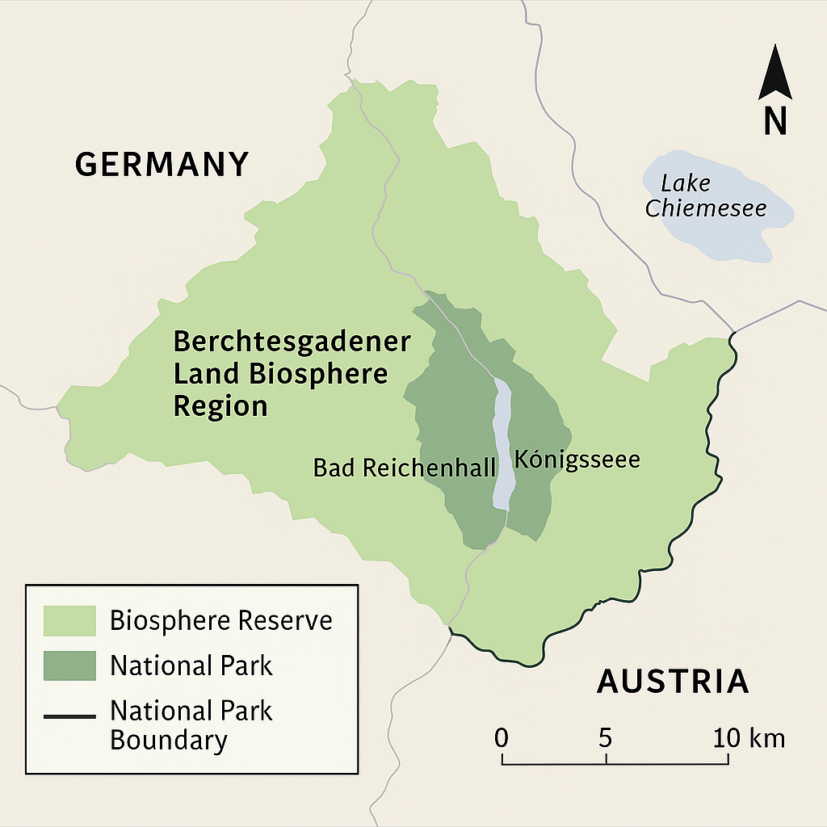
Figure 1 Map of Berchtesgadener Land showing National Park boundaries and Biosphere zones)

Governance and Planning Framework
Tourism planning in Berchtesgadener Land is underpinned by multi-level governance, involving local municipalities, the National Park Authority, the Bavarian state government, and UNESCO’s biosphere office. The park adopts a zoning system, dividing land into core zones (strict nature protection), buffer zones, and transition areas where human activity is allowed. This aligns with the “let nature be nature” principle central to German national parks (Böhn, 2021). Such frameworks aim to preserve wilderness areas while allowing cultural practices like Alpine farming to continue. Participatory approaches are increasingly used to integrate local communities in decision-making, improving acceptance of tourism development and reducing conflicts (Herntrei & Jánová, 2023).
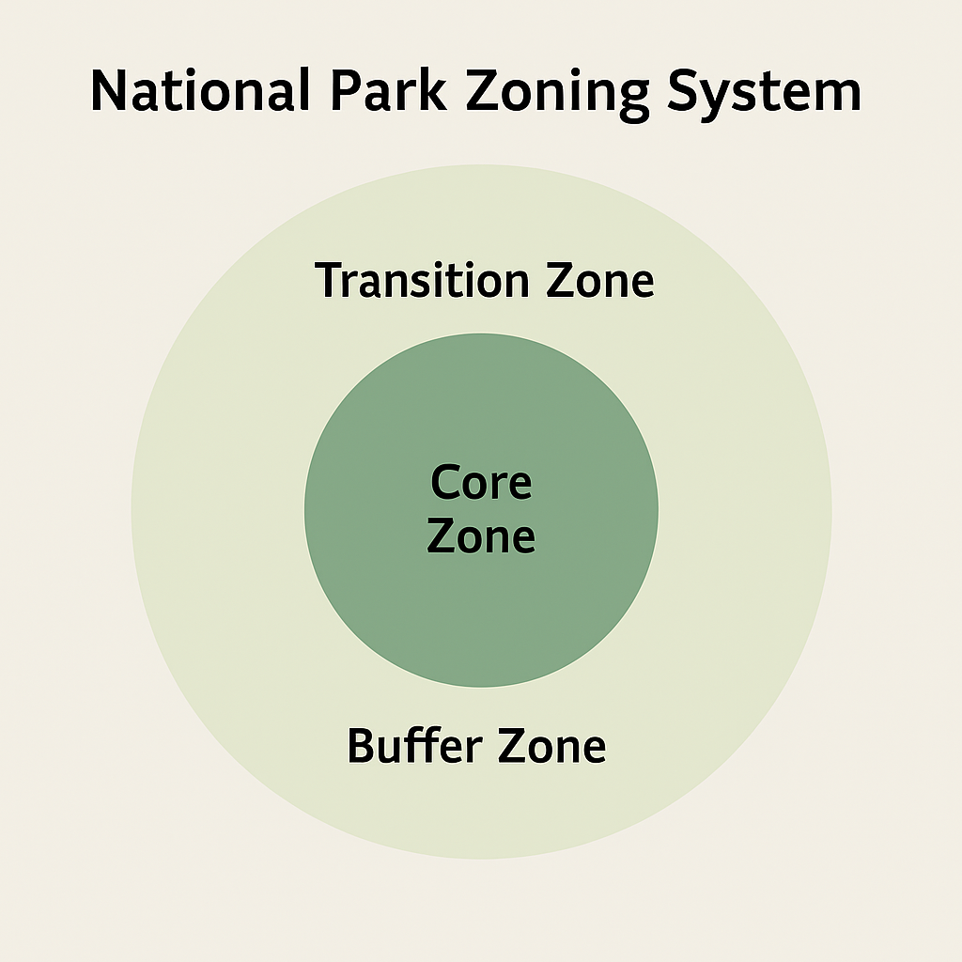
Figure 2 Diagram of National Park zoning system — core, buffer, and transition zones

Natural Resource Management
The Berchtesgaden National Park’s mountainous terrain, dominated by the Watzmann massif and Königssee lake, is highly sensitive to ecological changes. Park managers apply scientific monitoring systems to guide tourism flows and conservation measures. Recent studies have modelled snow cover dynamics in open and forested areas to predict how climate change will affect seasonal tourism, skiing, and biodiversity (Storebakken et al., 2025). Such data-driven planning ensures that future tourism strategies remain adaptive to shifting environmental conditions. Additionally, traditional methods like limiting infrastructure development in the core zones protect biodiversity hotspots. Visitor centers and interpretative trails are concentrated in buffer zones to reduce ecological pressure.

Cultural Landscape and Heritage
Beyond natural assets, Berchtesgaden represents a living cultural landscape shaped by Alpine farming, salt mining heritage, and long-standing traditions. Alpine pastures (Almen) are central to both agricultural production and tourism. However, their future is contested between agricultural continuity and tourism intensification (Wanner et al., 2021). The biosphere reserve framework supports sustainable farming practices and connects them with tourism through regional food branding, farmer’s markets, and cultural festivals. This integration prevents the abandonment of traditional land uses while offering visitors authentic experiences. It also reflects the shift from “overtourism” to sustainability governance, where tourism development emphasizes heritage protection and cultural identity (Herntrei & Jánová, 2024).
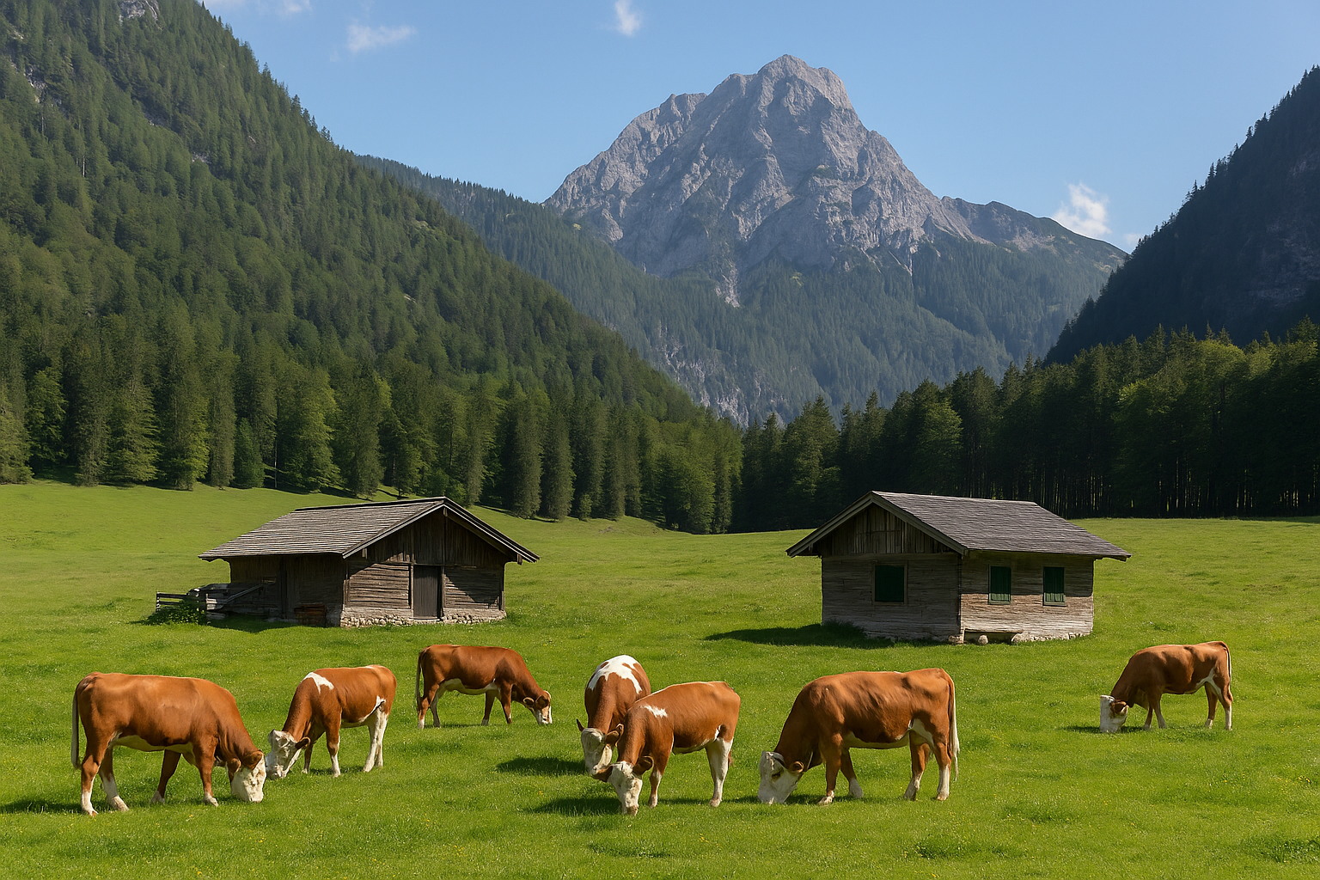
Figure 3 Photo of traditional Alpine pasture huts with cattle grazing in Berchtesgaden

Visitor Management and Mobility
One of the most innovative features of Berchtesgaden’s tourism planning is its mobility management system. The use of electric boats on Lake Königssee since 1909 illustrates long-standing low-impact tourism practices. More recently, strategies have aimed at reducing tourist car traffic, which poses environmental and social challenges in narrow Alpine valleys. Comparative research highlights that Berchtesgaden, along with other UNESCO biosphere reserves, applies measures such as park-and-ride systems, shuttle buses, and visitor caps to reduce car dependency (Detmer, 2022). Despite these measures, seasonal peaks still lead to congestion and parking shortages. To counter this, authorities encourage public transport use and promote digital tools that spread visitors across lesser-known routes and attractions.

Socioeconomic Monitoring and Community Benefits
Tourism in Berchtesgadener Land provides significant economic benefits. Socioeconomic monitoring in Bavaria’s national parks shows that tourism contributes to regional employment, local business viability, and population stability in rural areas (Job et al., 2021). More recently, studies of Germany’s biosphere reserves confirm that tourism has a positive economic impact, though distribution of benefits can be uneven (Majewski et al., 2025). This demonstrates the need for management strategies that ensure revenues support not only the tourism industry but also cultural conservation and community well-being. Mechanisms such as “Biosphere Partner” certification schemes link local businesses directly to sustainability principles, ensuring communities see tangible benefits.
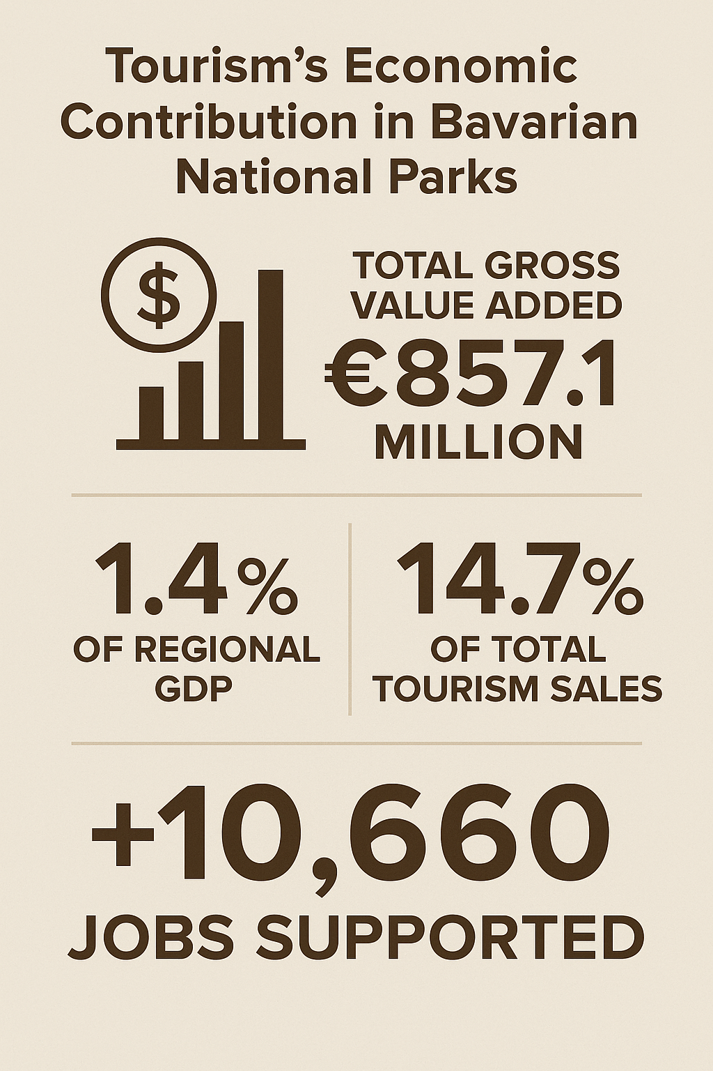
Figure 4 Infographic showing tourism’s economic contribution in Bavarian national parks

Challenges: Overtourism and Climate Change
While Berchtesgaden is often celebrated as a model of sustainability, it is not immune to overtourism. High visitor numbers, particularly during summer and pandemic years, have stressed trails, waste management systems, and public spaces. Scholars emphasize that Alpine regions must shift from growth-focused tourism to sustainability governance, prioritizing ecological thresholds and community acceptance (Herntrei & Jánová, 2024). Climate change presents another challenge. Warming temperatures shorten snow seasons, affecting winter tourism and increasing the risk of landslides and biodiversity loss. Integrating climate models like openAMUNDSEN into planning helps anticipate risks and redesign tourism calendars around more resilient activities (Storebakken et al., 2025).

Recommendations for Improvement
- Strengthen Capacity Controls: Introduce dynamic visitor caps and online booking systems for hotspots such as Königssee boat tours and Watzmann trails. This would limit congestion and enhance visitor experience.
- Expand Sustainable Mobility: Further develop regional transport integration by offering discounted combined tickets for rail, buses, and park entry, building on existing car traffic reduction strategies (Detmer, 2022).
- Climate Adaptation Strategies: Implement nature-based solutions (reforestation, slope stabilization) to adapt to climate-induced risks. Expand winter diversification strategies such as eco-education tours and wellness tourism.
- Community Revenue Sharing: Ensure a proportion of tourism revenue is reinvested into Alpine farming preservation and cultural programs, balancing tourism with traditional livelihoods (Wanner et al., 2021).
- Enhanced Participatory Governance: Deepen participatory mechanisms that include farmers, small business owners, and residents in shaping tourism development, thus increasing acceptance and resilience.
Berchtesgadener Land exemplifies sustainable tourism through strong governance, mobility innovation, and cultural heritage preservation, yet faces overtourism and climate risks. Adaptive, participatory strategies with low-carbon solutions and equitable benefits ensure lasting conservation-tourism balance.

Q2. Key Elements for Successful Destination Development — The “5 A’s” with German Examples
There are elements that interact to make the destination attractive and accessible for visitors that visit it. In tourism projects, what we know as the 5 A’s are attractions, accessibility, amenities, image, and ancillary services. If we balance the elements for the visitor experience of the destination, it can ensure the quality of the experience. In addition, it must not jeopardize what is culturally and naturally important to the destination. In Germany, especially Berchtesgadener Land, these features show how sustainable management can fulfill economic, environmental and social goals. We will go through all the 5 A’s in this section using German examples and research evidence.

Attractions
Attractions form the foundation of destination development. They include natural landscapes, cultural heritage, and recreational opportunities that motivate tourists to visit. In Berchtesgaden, attractions range from Lake Königssee and the Watzmann massif to cultural icons like salt mines and Alpine pastures. Alpine pastures (Almen) are critical not only for agricultural production but also as unique tourism experiences, combining gastronomy, cultural festivals, and scenic landscapes (Wanner et al., 2021).
Research suggests that the value of attractions lies not only in their intrinsic appeal but also in how they are framed within governance systems. Germany’s approach—through national parks and biosphere reserves—ensures attractions are preserved under the principle of “let nature be nature” (Böhn, 2021). This strategy positions attractions as both ecological treasures and visitor draws. The planning of attractions also reflects the shift from overtourism toward sustainability governance, where tourism development prioritizes ecological thresholds and heritage protection (Herntrei & Jánová, 2024).
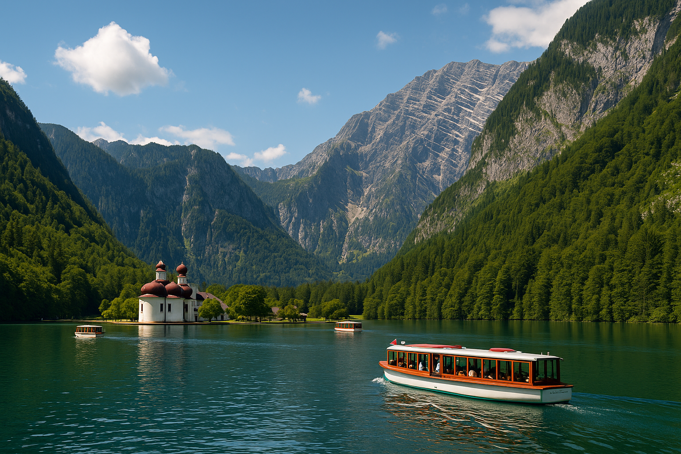
Figure 5 Scenic image of Lake Königssee with electric boats in operation

Accessibility
Accessibility refers to how easily visitors can reach attractions and navigate within a destination. In Germany, accessibility is often planned to balance visitor demand with environmental protection. For example, the electric boats on Lake Königssee illustrate how mobility solutions can be both sustainable and iconic. Accessibility also includes reducing private car use, which has long been a challenge in Alpine valleys.
Research on mobility in protected areas highlights that strategies such as park-and-ride systems, shuttle buses, and integrated public transport are increasingly used in Berchtesgaden and other Alpine reserves to reduce congestion and emissions (Detmer, 2022). Climate-related modelling also informs accessibility strategies, as snow cover and seasonal changes influence visitor flows and infrastructure needs (Storebakken et al., 2025). By linking transport infrastructure with visitor caps, accessibility in German destinations ensures both environmental sustainability and visitor satisfaction.
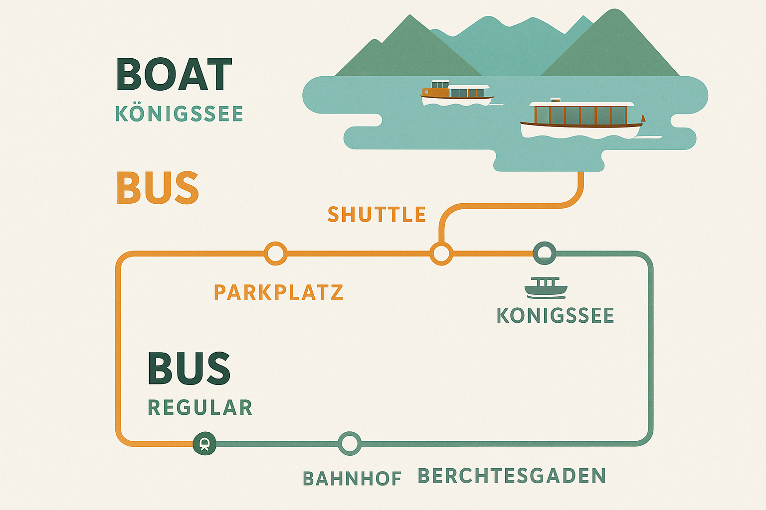
Figure 6 Diagram of integrated transport system — shuttle, bus, and boats in Berchtesgaden

Amenities
Amenities include the facilities and services that support visitors’ needs, such as accommodation, restaurants, and interpretive infrastructure. In Berchtesgaden, amenities are closely linked with cultural landscapes. For instance, the integration of Alpine farming into the tourism economy provides locally sourced food, farmer’s markets, and traditional huts for overnight stays. This blending of agriculture and tourism sustains the local economy and preserves rural traditions (Wanner et al., 2021).
Socioeconomic monitoring research shows that well-designed amenities contribute to employment and improve the viability of small businesses in rural regions (Job et al., 2021). Moreover, biosphere reserves promote “partner certifications” to ensure that amenities align with sustainability principles. This means that lodging and dining options are expected not only to meet visitor comfort but also to demonstrate environmental responsibility. Amenities thus function as an extension of the destination’s identity, combining service quality with sustainability.
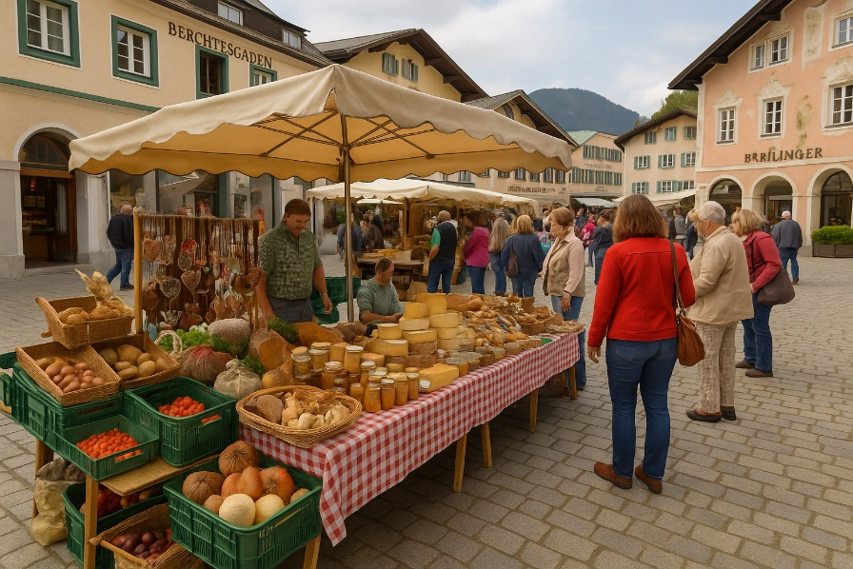
Figure 7 Photo of a farmer’s market in Berchtesgaden showcasing local food and crafts

Image
The image of a destination plays a critical role in attracting visitors and sustaining its reputation. A strong image is built through branding, communication, and alignment between what visitors expect and what they experience. Germany’s protected areas enjoy a powerful image of being authentic, natural, and sustainable. The UNESCO Biosphere Reserve status enhances this image by providing international recognition. Herntrei & Jánová, (2023) highlight how participatory approaches in Bavaria strengthen destination acceptance and image, as residents feel their identity and culture are respected (Herntrei & Jánová, 2024). Similarly, Majewski et al., (2025) note that tourism’s economic impacts in biosphere reinforce a positive reputation when benefits are visible to local communities (Majewski et al., 2025). This creates a cycle where sustainable practices feed into positive branding, which in turn attracts responsible tourists.

Ancillary Services
Ancillary services include the supporting systems that ensure tourism operates smoothly—such as governance structures, monitoring, safety, and training. In Berchtesgaden, ancillary services are particularly evident in the socioeconomic monitoring of tourism impacts and the use of participatory governance mechanisms. Job et al., (2021) show how park–people relationships are tracked to understand community acceptance and visitor trends, helping authorities adjust policies (Job et al., 2021). Laner, et al., (2021) emphasize the importance of planning systems for open spaces in Alpine regions, where tourism intersects with agriculture, conservation, and community development (Laner, et al., 2021).
Similarly, Omizzolo, et al., (2022) argue for mainstreaming open spaces in transnational spatial planning to harmonize policies across the Alps. Such frameworks enable German destinations to coordinate ancillary services across scales—from local ranger services to EU-supported spatial governance (Omizzolo, et al., 2022). Berchtesgadener Land shows how the 5 A’s—attractions, accessibility, amenities, image, and ancillary services—work together for sustainable tourism. Natural sites, cultural assets, mobility solutions, UNESCO branding, and strong governance balance ecology, culture, and economy, offering a model for Alpine destinations worldwide.

Conclusion.
Regarding sustainable tourism, remnants of the Nazi era, attractive offers, and a growing demand to experience nature and culture. Various pedestrian-friendly designs, integrated natural elements, and community facilities empower the community to partake in governance through participatory governance. The lake Königssee and the alpine pastures are protected yet support economic development. Overtourism and climate change are challenges, but adaptive management and inclusive planning can provide a way forward. In all, Berchtesgaden is a best practice of the integration of the 5 A's of destination development into a holistic strategy for sustainable tourism.

Reference
Böhn, D. (2021). National park in Germany: Let nature be nature–But which nature?. International Journal of Geoheritage and Parks, 9(1), 30-35.
Detmer, M. T. (2022). Existing approaches to reduce touristic car traffic in Protected Areas using the example of the UNESCO Julian Alps Biosphere Reserve/Slovenia and UNESCO Berchtesgaden Biosphere Reserve/Germany (Doctoral dissertation, Hochschule für nachhaltige Entwicklung Eberswalde).
Herntrei, M., & Jánová, V. (2023). Sustainable destination development in bavaria: Increasing tourism acceptance by applying participatory approaches?. Tourism in Southern and Eastern Europe..., 7, 155-175.
Herntrei, M., & Jánová, V. (2024). The Changing Perspective in the Course of Time. From Overtourism to Sustainability Governance: A New Tourism Era.
Job, H., Bittlingmaier, S., Mayer, M., von Ruschkowski, E., & Woltering, M. (2021). Park–People Relationships: The Socioeconomic Monitoring of National Parks in Bavaria, Germany. Sustainability 2021, 13, 8984.
Laner, P., Ranzoni, M., & Omizzolo, A. (2021). Current governance and planning systems for open spaces in pilot sites.
Majewski, L., Bittlingmaier, S., Frieser, A., Woltering, M., & Job, H. (2025). Evaluating the economic impact of tourism in Germany’s Biosphere Reserves. Tourism Geographies, 1-21.
Omizzolo, A., Laner, P., & Favilli, F. (2022). Mainstreaming Open Spaces functions in Spatial Planning: A priority criteria list for harmonised transnational open space planning in the Alps. In 61st ERSA Annual Congress.
Storebakken, B., Rottler, E., Warscher, M., & Strasser, U. (2025). Modelling of the Seasonal Snow Cover Dynamics for Open and Forested Areas in the Berchtesgaden National Park (Germany) Using the openAMUNDSEN Mountain Snow Cover Model. Hydrological Processes, 39(7), e70197.
Wanner, A., Pröbstl-Haider, U., & Feilhammer, M. (2021). The future of Alpine pastures–Agricultural or tourism development? Experiences from the German Alps. Journal of Outdoor Recreation and Tourism, 35, 100405.

