Marketing Fundamentals
Designing the Extended Marketing Mix (7 Ps) for Sustainable Hospitality
A Project Report on an Eco-Resort and Sustainable Hotel Chain Case Context

Option 2: Designing the Extended Marketing Mix (7 Ps) for Sustainable Hospitality
Submitted as part of the Marketing Fundamentals Assessment

Executive Summary
This report proposes a new 7 Ps marketing mix for a sustainable business in the form of an extended "eco-resort" type hotel by proposing an eco-resort type of sustainable hotel. Concerning demand, it is growing rapidly, and as proof of sustainability becomes increasingly established, certified hotels earn more than non-certified counterparts (Velaoras et al., 2025). The report examines macro-environmental trends and consumer trends and segments, positions the brand, and then applies Product, Price, Place, Promotion, People, Process, and Physical Evidence one by one. The findings suggest that the certified buildings achieve energy savings ranging from 15% to 40% and up to 30% in water conservation under certification, as presented in this paper through the cases of Radisson Blu Athens, Novotel Amsterdam City, and the Proximity Hotel. Green-marketing research output has increased almost threefold since 2015, from 90 to 291 papers/year (Kumar et al., 2025), indicating that it is now a mainstream commerce-related issue rather than a niche. The report concludes with a 12-month roadmap for implementation along with an indicative breakdown of the budget, and a KPI framework to guide implementation and five actionable recommendations.

Table of Contents
1. Introduction 2
2. Market & Consumer Behaviour Analysis 3
2.1 Macro Trends in Green Marketing 3
2.2 Environmental and Resource Pressure 4
2.3 The Intention-Behaviour Gap 4
2.4 Willingness to Pay 5
3. Segmentation, Targeting and Positioning (STP) 6
3.1 Segmentation 6
3.2 Targeting 7
3.3 Positioning 7
4. Extended Tourism Marketing Mix (7 Ps) 9
4.1 Product 9
4.2 Price 10
4.3 Place 11
4.4 Promotion 11
4.5 People 12
4.6 Process 13
4.7 Physical Evidence 14
4.8 The 7 Ps Integrated Matrix 15
5. Implementation, Budgeting & KPIs 16
5.1 Twelve-Month Roadmap 16
5.2 Indicative Budget Allocation 16
5.3 KPI Framework 17
6. Conclusion & Recommendations 17
References 19

1. Introduction
Tourism is a sector that has shown a great recovery since the pandemic and, currently, sustainability has become the key to the marketing of this return. Aji et al. (2026) map the swift growth of green marketing research in tandem with this recovery. Although many other variables are added, Kennedy et al. (2022) seem to demonstrate that classic marketing-mix theory continues to be a base today, both with regard to destinations and hotels.
The actual environmental price of tourism accommodation. Hotels have great energy, water, and material needs, as well as contributing significantly to global carbon emissions (Velaoras et al., 2025). Shin et al. (2026) state that the attitude towards ESG has shifted from a compliance "afterthought" to a "strategic driver," and that this has become the fashion in the hospitality sector. This is linked with leadership studies and, given the UN Sustainable Development Goals (SDGs), sustainability is as much a leadership issue as it is a marketing problem (Nguyen et al., 2025).
For this report, a pretend eco-resort or sustainable hotel chain is highlighted. It uses the extended 7 Ps framework: Product, Price, Place, Promotion, People, Process, and Physical Evidence. Each P is explored through up-to-date research from the industry and academic sectors and based on actual certification case data. The report also provides a conclusion, a budget guide, KPI targets, and a clear roadmap of recommendations, while inline there are examples of good practice such as Six Senses, Soneva, and Intrepid Travel.
The rest of the paper goes as follows. In Section 2, the macro trends and the consumer behaviour shall be reviewed. The Segmentation, Targeting and Positioning is presented in Section 3. In Section 4, the 7 Ps are expanded upon. A roadmap of implementation is provided in Section 5, along with budget and KPIs. The recommendations are provided at the end of Section 6.

2. Market & Consumer Behaviour Analysis

2.1 Macro Trends in Green Marketing
In this study, Wang et al. (2023) employed bibliometric analysis to perform a mapping of the green marketing research that appeared between 1991 and 2021. Kumar et al. (2025) continued this by reviewing the Scopus-indexed studies in 2025, with a total of 2061 studies using topic modelling. According to their data, this is an increase in the number of papers published over the years: 90 (2015) to 291 (2024) (Kumar et al., 2025), as depicted in Figure 1. Least surprisingly, India accounted for the highest number of publications, reaching 323 (Kumar et al., 2025). Of the studies reviewed, 126 of them were found in the journal Sustainability (Kumar et al., 2025). This rise indicates that green marketing is no longer a marginal research and business topic but rather a mainstream one.
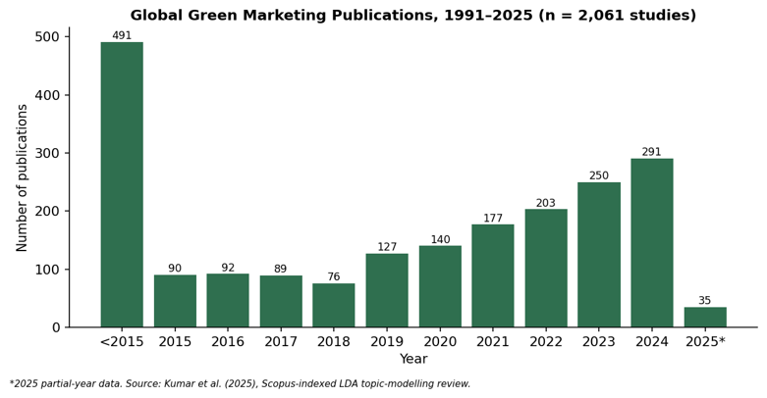
Figure 1: Global green marketing publication growth, 1991-2025
(Source: Kumar et al. (2025))
So too is the regulatory pressure. Widyastuti et al. (2024) report the increase in the legal trend of disclosure in green marketing in Indonesia. International developments are moving in the same direction, according to VY (2026), which says several governments are no longer considering green claims as just a voluntary matter but rather a consumer-protection issue.

2.2 Environmental and Resource Pressure
Hotels are by their nature resource-consuming. The study of Khalil et al. (2024) shows that after nearly eight years, the three greatest areas of environmental impact still cited by stakeholders in the hotel sector are energy, water, and waste management. In a seminal study on the correlates of avoidable food waste, Kouroupi and Aiosi (2026) point out that there are “sustainability gaps” in everyday activities, including hotel breakfast buffets. Waste quantities are also significant at a broader economy level: Since the 1950s, ~8.3 billion tonnes of plastic have been produced and only about 9% of it has ever been recycled (Kumar et al., 2025; citing Greenpeace estimates). This large amount of waste material is part of the reason why more and more guests are sceptical of hotel sustainability claims.
One approach to sustainable tourism design that has been recommended is moving from one-off audits to continuous monitoring and reporting of resource flows by virtue of data from relevant sources (Alsahafi et al., 2023). Such continuous sustainability management based on data is becoming en vogue in top resorts.

2.3 The Intention-Behaviour Gap
Not all of those who are conscious of the environment book green. Khan et al. (2024) refer to this as "the intention-behaviour gap in sustainable hospitality" as they found guests saying how ‘green’ they valued whilst booking, but the actual booking choice favoured location and price over the green certificate. In 2022, García-Salirrosas and Rondon-Eusebio discovered that the decision to make Green purchases is not just based on eco-labels, but it heavily relies on the perceived quality of the product. Cheng et al. (2026) attribute this gap to the lack of strategic orientations within hospitality companies and suggest that it is not the apathy of consumers that needs to be reduced; it is the lack of communication. A review of circular-economy marketing drawn from a survey of 15 projects agrees that, according to Paiva (2025), the vague sustainability qualities of the projects are a pitfall for otherwise satisfactory circular practices.

2.4 Willingness to Pay
Consumers act differently when it's certified. Eco-conscious travelers, especially the younger generation, are willing to pay more when a hotel receives a certification, according to a study by Velaoras et al. (2025). Regarding this, ecotourists were also found to be willing to spend more on the hotel as well as its surrounding environment. Ecolabel-certified hotels reported a 10% revenue growth associated with their sustainability-minded customers (Velaoras et al., 2025). This is supported by Kholijah (2024), who found that the implementation of green business in hotels can be found where green and good economic performance are not a dichotomy, but are coordinated. The demand side evidence is summarised in Table 1.
Evidence area | Finding | Source
Publication growth | Papers per year rose from 90 (2015) to 291 (2024) | Kumar et al. (2025)
Plastic waste | 8.3bn tonnes produced since 1950s; ~9% recycled | Kumar et al. (2025)
Revenue premium | EU Ecolabel hotels: +10% annual revenue | Velaoras et al. (2025)
Intention-behaviour gap | Stated values often do not convert to bookings | Khan et al. (2024)
Economic-environmental link | Green practices improve both cost and revenue lines | Kholijah (2024)
Table 1: Summary of demand-side evidence for sustainable hospitality marketing.

3. Segmentation, Targeting and Positioning (STP)
 | Deep-green eco-tourist | Aspirational green traveller | Digital nomad | Luxury sustainability seeker
Demographics: Age | 30-65 | 22-40 | 25-45 | 35-70
Demographics: Gender | Both | Both | Both | Both
Demographics: Occupation | Retirees, NGO workers | Young professionals | Remote / freelance workers | Executives, HNWIs
Geographic | N. Europe, Australasia | Urban centres, global | Global digital hubs | Global luxury markets
Psychographic: Social status | Values-driven | Trend-conscious | Independence-driven | Status-conscious
Psychographic: Lifestyle | Slow travel, nature-focused | Social-media active | Flexible, long-stay | Exclusive, experience-seeking
Estimated market share | 20% | 35% | 30% | 15%
Table 2: STP Analysis Overview
(Source: Self-Developed)

3.1 Segmentation
There is no point in relying merely on the classic demographic segmentation in the world of sustainable hospitality. The adolescent Maianto et al. (2024) suggest that there is a need to overlay psychographic factors (e.g., environmental values, lifestyle) onto more basic age/income segments. Nguyen et al. (2025) further note that internal leadership commitment influences which external segments may be targeted by a hotel; without commitment, there will be no authenticity of leadership.
The four segments resulting from merging the literature are deep-Green eco-tourists, aspirational green travellers, digital nomads, and luxury Sustainability seekers. Their key features are given in Table 3.
Segment | Core motivation | Price sensitivity | WTP for certification
Deep-green eco-tourist | Environmental values first | Low | High
Aspirational green traveller | Social image, trend-following | Medium | Medium
Digital nomad | Flexibility and connectivity | Medium-high | Low-medium
Luxury sustainability seeker | Exclusivity plus ethics | Low | Very high
Table 3: Segmentation matrix for sustainable hospitality demand

3.2 Targeting
There is a risk of losing credibility when making targeting decisions. Akgün and Bütüner (2025) conclude that brands which go after the wrong segment in green communication risk losing their credibility and consequently, the overall brand. Osiako (2022) notes that fuzzy targeting undermines the credibility of whole-category green claims in more than one property. Based on the evidence of willingness to pay, this report suggests that the luxury sustainability seeker and the deep-green eco-tourist are the first personae to consider for a new eco-resort model.

3.3 Positioning
Positioning should be authentic as well as visible proof. When it comes to what constitutes a genuinely green hotel, placing forward credible, verifiable green criteria, the managers of the hotels themselves come out at the top of the list, according to Akel and Noyan (2024).
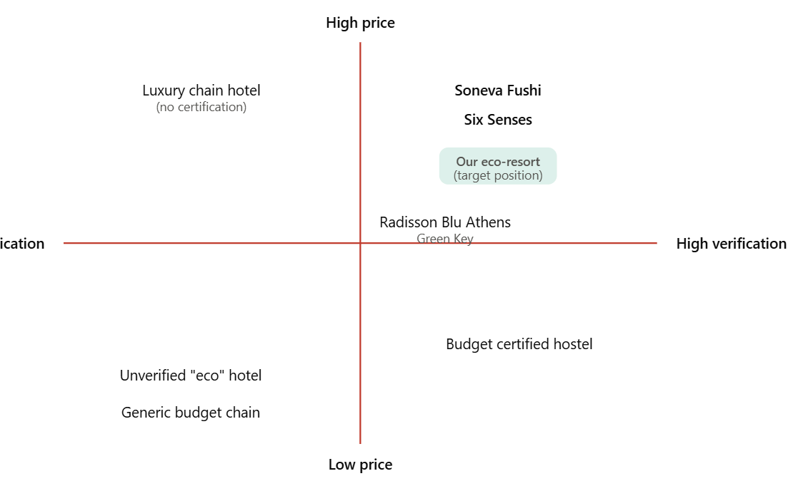
Figure 2: Positioning Map
(Source: Self-Developed)
A price-level positioning map allows for a simple correlation of price level and verified sustainability performance. Companies like Soneva Fushi fall in the “high price, high verification” bubble. Budget properties that do not verify their ‘eco' language sit within the quadrant 'low verification', where Osiako (2022) notes that consumer trust quickly breaks down when just one claim is disputed. An additional positioning lens is provided by Sarvinoz Atoevna et al. (2025): hotels may be developed or repurposed near a sporting mega-event, as the sustainability legacy can prove to be an authentic positioning story when these are documented independently of the hotel itself.

4. Extended Tourism Marketing Mix (7 Ps)

4.1 Product
Product design starts with the actual product. Duliński et al. (2025) demonstrate that adaptive reuse of existing hotel structures substantially decreases embodied carbon generation and retains the architectural identity, in comparison to new construction. Alotaibi and Azam (2026) provide a geographic viewpoint of existing practices of sustainable facilities in hotels such as passive cooling systems, low-carbon materials, and grey water recycling. Yfantidou et al. (2025) emphasize the importance of roof gardens as a low-cost solution that not only enhances local ecological values but also guest wellbeing scores. The two are inextricably linked. From linen-reuse programmes to on-site renewable energy, green operational practices directly influence guest satisfaction levels, according to Khalil et al. (2024).
Element | Initiative | Supporting evidence | Target outcome / KPI
Building & design | Adaptive reuse of existing structures | Duliński et al. (2025) | Lower embodied carbon per room
Energy systems | Renewable retrofit: solar, efficient HVAC | Alotaibi & Azam (2026) | 20-40% energy cost reduction
Certification | LEED / EarthCheck / Green Key | Velaoras et al. (2025) | Verified sustainability credentials
Wellbeing features | Roof gardens & green infrastructure | Yfantidou et al. (2025) | Improved guest wellbeing scores
Table 4: Product Overview
(Source: Self-Developed)

4.2 Price
Designed to be sustainable, what is the right price for a hospitality service that needs to cost more than traditional services to cover new investments and support a way of life that must be paid for? Where guests are confident in the certification, they can often be willing to pay more for certified hotels. Energy savings of up to 20% are achieved by energy efficiency calculations only in ISO 14001: certified hotels (Velaoras et al., 2025). These savings can underwrite a reduced headline room rate or be used for further sustainability investment. For instance, the energy costs in a LEED Platinum certified hotel like the Proximity Hotel are 40% lower and water costs are 30% lower than in a similar conventional hotel (Velaoras et al., 2025). These numbers illustrate that a sustainable pricing strategy isn't just about applying the green premium; it's also a cost-efficiency move that preserves margin.
Element | Initiative | Supporting evidence | Target outcome / KPI
Premium positioning | Certification-linked room-rate premium | Velaoras et al. (2025) | +10% revenue (EU Ecolabel case)
Efficiency-based savings | ISO 14001 energy management | Velaoras et al. (2025) | Up to 20% lower energy costs
Value communication | Transparent cost-benefit messaging | Khan et al. (2024) | Closes the intention-behaviour gap
Tiered pricing | Segment-based rate tiers | García-Salirrosas & Rondon-Eusebio (2022) | Captures WTP variation across segments
Table 5: Price Overview

4.3 Place
One of the most tenuous trade-offs in hotel marketing continues to be distribution. As Mathaba et al. (2026) explain in their cross-sector review of the marketing mix, platform decisions have a material impact on reach and cost, which can be transferred to the hospitality sector and hospitality distribution. Direct booking provides the hotels with complete guest information and better margins. All online Travel Agencies (OTAs), including Booking.com and Expedia, usually benefit from an industry-driven commission of around 15-25%, which directly impacts the sustainability budget (Staah, 2025). The comparative results of the two channels are presented in Table 6.
Channel | Typical cost | Guest data control | Reach | Best strategic fit
Direct booking (website/CRM) | Low, mainly technology and marketing cost | Full | Limited to existing audience | Repeat and loyal eco-guests
OTA (Booking.com, Expedia) | ~15-25% commission per booking | Minimal | Very high, global | New-guest acquisition
Table 6: Direct booking vs. OTA distribution trade-offs
(Source: Staah (2025))
In terms of practical application, OTAs should be viewed by hotels as a channel to acquire more business, whereas direct booking should be regarded as a loyalty and margin acquisition channel, with hotels slowly and steadily shifting share toward direct booking as more brand trust is gained (Staah, 2025).

4.4 Promotion
Nowadays, digital means are the main protagonists of hospitality promotion. Yet AI agents are also growing as a means to personalise hospitality marketing content en masse, and augmented reality is becoming a way to allow a prospective visitor to ‘preview’ sustainable resort features before booking and to decrease the perception of the risk of an unfamiliar green claim (Dwivedi et al., 2025; Tom Dieck et al., 2024). As Kumar et al. (2025) highlight, AI and Blockchain combined with IoT are transforming green-marketing communication not only in hospitality but also in various other sectors.
There's real greenwashing potential, however, when it comes to promotion. However, according to the latest study conducted by Akgün and Bütüner (2025), vague green claims severely affect brand trust more than no claim. Osiako (2022) suggests the need to start consumers with third-party verified claims, and not with self-declared claims. In the same manner, outside of hospitality, Akude et al. (2025) demonstrate that firm-verified green marketing activities demonstrate a consistent dip in sustainability-performance outcomes over unverified green marketing activities in manufacturing firms. Certification logos and interventions measured in a sustainable resort should therefore be positioned prominently in the promotion of a sustainable resort.

4.5 People
Any sustainability promise is undermined by staff behaviour. This study revealed that Green HRM practices have a significant predictive power on green innovation performance among firms (Bindeeba et al. 2025). Alreahi et al. (2022) validate that structured green HRM in hotel has a positive effect on regulatory compliance and staff morale. Mahran and colleagues (2025) are explicit that sustainability leadership translates directly into results for the hospitality industry, such as leadership commitment being necessary before any claim is made to guests. López et al. (2025) put sustainable leadership within the context of a governance mechanism in the scope of ESG, as opposed to being a soft or optional add-on. Educating employees to explain what a certification means for guests makes the People element a form of promotion all on its own.
Element | Initiative | Supporting evidence | Target outcome / KPI
Recruitment & culture | Sustainability-aligned hiring | Mahran et al. (2025) | Leadership-driven green culture
Training | Certification literacy programmes | Alreahi et al. (2022) | Improved compliance & morale
Green HRM systems | Formal HRM sustainability policies | Bindeeba et al. (2025) | Higher green innovation performance
Governance | Sustainability leadership as ESG mechanism | López et al. (2025) | Stronger organisational accountability
Table 7: People Perspective Overview

4.6 Process
Process refers to the actual provision of the service on a day-to-day basis. In their paper “The Paradigm of the Hotel Breakfast Buffet: High-Level Insights into the Food Waste Problem and Digital Pre-Ordering” (Kouroupi and Aiosi, 2026), the authors illustrate that the hotel breakfast buffet is a substantial contributor to food waste and that digital pre-ordering is far from the complete solution. Smart-hotel technology, ranging from automated HVAC systems to occupancy sensors, is examined by Akel and Noyan (2024), and the study reveals that improvements in process efficiency do not conflict with guest experience. Continuous data-driven monitoring of operational processes has been called for over periodic manual monitoring by Alsahafi et al. (2023). An example developed by Cheng et al. (2026) makes the circular economy connection to resilient improvements for hospitality businesses during resource-price volatility more tangible.

4.7 Physical Evidence
Most often, the first and most trusted sustainability clue is physical evidence, from the guest perspective. Duliński et al. (2025) state that visible and honest building materials convey authenticity to a greater extent than any brochure statements. After conducting a study published in Environmental Health and Sustainability by Yfantidou et al. (2025), the researchers conclude that the presence of visible green infrastructure, in this case a roof garden, significantly contributes to the wellbeing scores of the guests while staying in the case study's rooms. This is confirmed by real case data. In the study by Velaoras et al. (2025), the Green Key-awarded Radisson Blu Athens saw a 15% reduction in energy consumption and a 10% reduction in water consumption after undertaking visible retrofit measures. Over the last 5 years, Novotel Amsterdam City achieved a 25% reduction in energy consumption across the sites and a 20% reduction in water consumption through the implementation of ISO 14001 (Velaoras et al., 2025). Under Price above, the building material of the Proximity Hotel in Europe is recycled at 87%, and more than 40% of the materials come from within 500 miles of the construction site (Velaoras et al., 2025). The resource savings results per property are illustrated in Figure 2 for comparison between three certified properties.
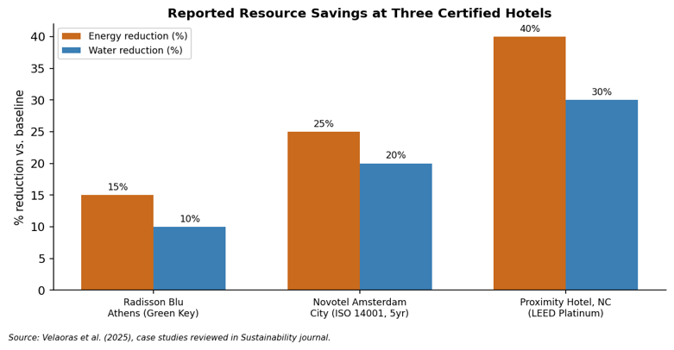
Figure 3: Reported energy and water savings at three certified hotels
(Source: Velaoras et al. (2025))
These are the sort of actual, tangible data physical evidence should display on site (via signage and guest information packs) rather than conceal itself in an annual sustainability report.

4.8 The 7 Ps Integrated Matrix
All seven elements are summarised into the sustainable eco-resort implementation matrix (Table 8).
Product | Price | Place | Promotion | Process | People | Physical Evidence
Adaptive-reuse eco-resort design | Certification-linked premium pricing | Direct-first booking strategy | Third-party verified claims only | Circular waste management | Green HRM and staff training | Visible green infrastructure (roof gardens)
Renewable energy retrofit | ISO 14001: up to 20% energy cost savings | OTA channel: 15-25% commission | AI-personalised digital campaigns | Smart HVAC and occupancy sensors | Certification literacy for guest-facing staff | On-site signage of measured savings
LEED / EarthCheck certification | EU Ecolabel: +10% annual revenue | Loyalty programme to build repeat stays | AR previews of resort features | Continuous data-driven monitoring | Leadership-led sustainability culture | Honest, adaptive-reuse architecture
Table 8: 7 Ps integrated matrix for a sustainable eco-resort

5. Implementation, Budgeting & KPIs

5.1 Twelve-Month Roadmap
A mid-size eco-resort requires a 12-month time plan. The certification audit and initial staff training occur in Months 1-3 (Alreahi et al., 2022). The physical part of the retrofit work is carried out in months 4-6, following the guidelines of Duliński et al. (2025) and Yfantidou et al. (2025). The 7th, 8th, and 9th months are for the digital promotion relaunch, which will be based on the verified claims as mentioned in Osiako (2022), and the customisation is going to be performed using the mentioned Artificial Intelligence tools in Dwivedi et al. (2025). In that period, 10-12 months for distribution rebalancing towards direct bookings in accordance with the channel logic of Staah (2025).

5.2 Indicative Budget Allocation
Budget category | Share of sustainability budget
Certification and audit | 20%
Physical retrofit | 35%
Staff training and green HRM | 15%
Digital promotion and AI tools | 20%
Distribution and loyalty technology | 10%
Table 9: Indicative sustainability budget allocation

5.3 KPI Framework
Financial KPIs should include occupancy rate, the average daily rate, and direct-booking share (Staah, 2025). The energy and water consumption should be measured on a per-occupied-room basis in the operational KPIs, with the energy consumption lying between the certified-hotel case energy reduction ranges seen in the data (Velaoras et al., 2025). Guest-experience KPIs should be observed with other measures besides those discussed, such as NPS and repeat booking rate, which are tied to the willingness-to-pay evidence mentioned in Section 2 (Velaoras et al., 2025). KPIs for the workforce should include training completed (shown as % of total workforce) and turnover (shown as % of total workforce), as identified in the green HRM evidence by Bindeeba et al. (2025). These are outlined in realistic target ranges in Table 10.
KPI category | Metric | Target range | Evidence base
Financial | Direct-booking share | +10-15 percentage points/year | Staah (2025)
Operational | Energy use per occupied room | -15% to -40% vs. baseline | Velaoras et al. (2025)
Operational | Water use per occupied room | -10% to -30% vs. baseline | Velaoras et al. (2025)
Guest experience | Net Promoter Score | +5-10 points | Yfantidou et al. (2025)
Workforce | Staff turnover | -10% year on year | Bindeeba et al. (2025)
Table 10: KPI framework with illustrative target ranges

6. Conclusion & Recommendations
Successful Sustainable Hospitality marketing is best when used as a holistic solution. There needs to be synergy amongst certification, pricing, distribution, promotion, people, process, and physical evidence rather than it being asynchronous work. (Velaoras et al., 2025; Kumar et al., 2025). There is now a fair amount of evidence to support this practice. According to Kumar et al. (2025), there are more than 290 papers in 2024, whereas only slightly less than 100 papers in 2015 were published on green marketing. While consumer willingness to pay is real, it is dependent on trust and not solely on green language (Khan et al., 2024; García-Salirrosas & Rondon-Eusebio, 2022).
From this analysis of the data come five recommendations:
- Follow one recognised, third-party audited certification first, and pursue more certifications in layers over time (Velaoras et al., 2025).
- Make an active effort to rebuild direct bookings as a strategy to mitigate substantial OTA commissions, which are presently 15-25% (Staah, 2025).
- Do invest in Green HR management and training of employees before beginning external marketing.
- To refrain from risking greenwashing, use physical proof and measurable results instead of slogans as the primary promotional material (Duliński et al., 2025; Akgün & Bütüner, 2025).
- Monitor KPIs quarterly and share the fact-based data directly with guests rather than making claims, closing the intention-behaviour gap identified by Khan et al. (2024).

References
Aji, A. A., Yulisetiarini, D., Sudaryanto, S., & Paramu, H. (2026, July). Green Marketing in the Digital Economy Era: A Systematic Literature Review and Bibliometric Analysis of Emerging Trends and Future Research Directions. In Proceeding International Conference on Economics, Business and Information Technology (Vol. 7, No. 2, pp. 741-761). https://ic.itsm.ac.id/index.php/icebit/article/download/191/173
Akel, G., & Noyan, E. (2024). Exploring the criteria for a green and smart hotel: insights from hotel managers' perspectives. Journal of Hospitality and Tourism Insights, 7(5), 2992-3012. https://www.researchgate.net/profile/Goekhan-Akel/publication/377410426_Exploring_the_criteria_for_a_green_and_smart_hotel_insights_from_hotel_managers%27_perspectives/links/661914c5f7d3fc28744e473d/Exploring-the-criteria-for-a-green-and-smart-hotel-insights-from-hotel-managers-perspectives.pdf
Akgün, V. Ö., & Bütüner, R. (2025). THE concept of green marketing and Brand practices in the context of sustainability. Türkiye Mesleki ve Sosyal Bilimler Dergisi, 6(16), 38-56. https://dergipark.org.tr/en/download/article-file/4223804
Akude, D. N., Akuma, J. K., Kwaning, E. A., & Asiama, K. A. (2025). Green marketing practices and sustainability performance of manufacturing firms: Evidence from emerging markets. Nature Environment and Pollution Technology, 24(1), 1-16. https://www.researchgate.net/profile/Derrick-Akude-2/publication/389527746_Green_Marketing_Practices_and_Sustainability_Performance_of_Manufacturing_Firms_Evidence_from_Emerging_Markets/links/67d4277de62c604a0dd97d02/Green-Marketing-Practices-and-Sustainability-Performance-of-Manufacturing-Firms-Evidence-from-Emerging-Markets.pdf
Alotaibi, Z., & Azam, F. (2026). Sustainable Hotel Facilities: Trends, Challenges, and Opportunities. Journal of Natural Remedies, 1(1), 260-272. https://jnrjournal.com/index.php/jnr/article/download/16/12
Alreahi, M., Bujdosó, Z., Kabil, M., Akaak, A., Benkó, K. F., Setioningtyas, W. P., & Dávid, L. D. (2022). Green human resources management in the hotel industry: A systematic review. Sustainability, 15(1), 99. https://www.mdpi.com/2071-1050/15/1/99
Alsahafi, R., Alzahrani, A., & Mehmood, R. (2023). Smarter sustainable tourism: data-driven multi-perspective parameter discovery for autonomous design and operations. Sustainability, 15(5), 4166. https://www.mdpi.com/2071-1050/15/5/4166
Bindeeba, D. S., Tukamushaba, E. K., Bakashaba, R., & Atuhaire, S. (2025). Green human resources management and green innovation: a meta-analytic review of strategic human resources levers for environmental sustainability. Discover Sustainability, 6(1), 650. https://link.springer.com/content/pdf/10.1007/s43621-025-01444-x.pdf
Cheng, K. W., Yong, J. Y., Lin, W. L., & Yusliza, M. Y. (2026). Sustainable consumption in hospitality: the nexus between circular economy, strategic orientation, and economic resilience—a bibliometric analysis. Future Business Journal, 12(1), 78. https://link.springer.com/content/pdf/10.1186/s43093-026-00782-0.pdf
Duliński, W., Taczalska-Ryniak, A., Zawada-Pęgiel, K., & Bystroń, M. (2025). Architectural Sustainability Through Adaptive Reuse: Design Challenges and Opportunities in the Transformation of Mid-to-Late 20th Century Hotel Buildings in Poland. Sustainability, 18(1), 119. https://www.mdpi.com/2071-1050/18/1/119
Dwivedi, Y. K., Helal, M. Y. I., Elgendy, I. A., Albashrawi, M. A., Hughes, L., Shawosh, M., ... & Jeon, I. (2025). Artificial intelligence agents and agentic systems in hospitality and tourism: challenges, opportunities and research agenda. International Journal of Contemporary Hospitality Management. https://ro.ecu.edu.au/cgi/viewcontent.cgi?article=7960&context=ecuworks2022-2026
García-Salirrosas, E. E., & Rondon-Eusebio, R. F. (2022). Green marketing practices related to key variables of consumer purchasing behavior. Sustainability, 14(14), 8499. https://www.mdpi.com/2071-1050/14/14/8499
Kennedy, P. S. J., Tobing, S. J. L., & Toruan, R. L. (2022). Marketing strategy with marketing mix for Lake Toba tourism destination. Journal of Sustainable Tourism and Entrepreneurship (JoSTE), 3(3), 157-174. http://repository.uki.ac.id/12079/1/Marketingstrategywithmarketingmix.pdf
Khalil, N., Che Abdullah, S. N., Haron, S. N., & Hamid, M. Y. (2024). A review of green practices and initiatives from stakeholder’s perspectives towards sustainable hotel operations and performance impact. Journal of Facilities Management, 22(4), 653-682. https://www.researchgate.net/profile/Siti-Haron-2/publication/366017453_A_review_of_green_practices_and_initiatives_from_stakeholder%27s_perspectives_towards_sustainable_hotel_operations_and_performance_impact/links/694023717e61d05b530f979d/A-review-of-green-practices-and-initiatives-from-stakeholders-perspectives-towards-sustainable-hotel-operations-and-performance-impact.pdf
Khan, N., Acuti, D., Lemarie, L., & Viglia, G. (2024). The intention-behaviour gap in sustainable hospitality: a critical literature review. International Journal of Contemporary Hospitality Management, 36(5), 1627-1646. https://researchportal.bath.ac.uk/files/311407009/IJCHM_Preprint.pdf
Kholijah, S. (2024). Analysis of economic and environmental benefits of green business practices in the hospitality and tourism sector. Involvement International Journal of Business, 1(1), 60-74. https://ejournal.agungmediapublisher.com/index.php/iijb/article/download/7/3
Kouroupi, N., & Aiosi, V. (2026). Hotel Breakfast Buffets at the Experience–Sustainability Interface: Food Waste, Guest Experience, and the Limits of Digital Enablement. Tourism and Hospitality, 7(9), 268. https://www.mdpi.com/2673-5768/7/9/268
Kumar, S., Sharma, C., Mishra, M. K., Sharma, S., & Bhardwaj, V. (2025). Smart, sustainable, and green: the digital transformation of green-marketing. Discover Sustainability, 6(1), 388. https://link.springer.com/content/pdf/10.1007/s43621-025-01242-5.pdf
López, S. M. C., Guerra, I. R., & Pernas, J. B. (2025). Sustainable leadership as a governance mechanism in the ESG era: A systematic review of organizational transformation in the hospitality sector. Merits, 5(4), 22. https://www.mdpi.com/2673-8104/5/4/22
Mahran, K., Albarrak, H., Ibrahim, B. A., & Elamer, A. A. (2025). Leadership and sustainability in tourism and hospitality: a systematic review and future research agenda. International Journal of Contemporary Hospitality Management, 37(7), 2219-2242. https://eprints.soton.ac.uk/501263/1/Finaldraft5.2.25_1_-2-34.pdf
Maianto, T., Yuntina, L., Yosepha, S. Y., Kamsariaty, K., & Wijanarko, B. (2024). Green marketing of analysis: Branding, positioning and eco-friendly products (literature review). Greenation International Journal of Tourism and Management, 2(3), 136-148. https://research.e-greenation.org/GIJTM/article/download/197/168
Mathaba, R. L., Roux, A. T., Wannenburg, E. M., & Serra, P. (2026). From Fundamentals to Innovation in the Sport Marketing Mix Across Platforms for United Nations Sustainable Development Goal 3: Good Health and Well-being. Annals of Applied Sport Science, 14(1), 0-0. http://aassjournal.com/files/site1/user_files_dbc6fd/therese-A-11-2446-2-fb6ec43.pdf
Nguyen, G. N., Wechtler, H., & Lai, P. H. (2025). Mapping leadership studies to the achievement of sustainable development goals in tourism and hospitality: A systematic literature review and future research agenda. Journal of Hospitality and Tourism Management, 65, 101351. https://www.sciencedirect.com/science/article/pii/S1447677025001275
OSIAKO, P. (2022). Concept of green marketing in environment conservation: A literature review. Environmental and Toxicology Management. https://www.academia.edu/download/107205238/1780.pdf
Paiva, T. (2025). A systematic review of driving sustainability through circular economy marketing: insights and strategies for green marketing innovation. Encyclopedia, 5(2), 61. https://www.mdpi.com/2673-8392/5/2/61
Sarvinoz Atoevna, T., Canós-Darós, L., & Osorio-Acosta, E. (2025). Green and resilient hotel operations through mega-event legacies. Frontiers in Sports and Active Living, 7, 1604131. https://www.frontiersin.org/journals/sports-and-active-living/articles/10.3389/fspor.2025.1604131/pdf
Shin, H., Jo, Y., Lee, S., Park, J., Cho, J., & Kim, H. (2026). ESG for sustainability in hospitality and tourism: A theoretical and practical review with a future research agenda. Journal of Travel Research, 65(1), 3-36. https://journals.sagepub.com/doi/pdf/10.1177/00472875251363629
Staah, (2025), “THE 7Ps OF HOTEL MARKETING: What Every Modern Hotelier Must Know”, available at: https://www.staah.com/blogs/the-7ps-of-hotel-marketing-what-every-modern-hotelier-must-know/
tom Dieck, M. C., Han, D. I. D., & Rauschnabel, P. A. (2024). Augmented reality marketing in hospitality and tourism: a guide for researchers and managers. International Journal of Contemporary Hospitality Management, 36(13), 97-117. https://www.emerald.com/ijchm/article-pdf/36/13/97/9535180/ijchm-09-2023-1513.pdf
Velaoras, K., Menegaki, A. N., Polyzos, S., & Gotzamani, K. (2025). The role of environmental certification in the hospitality industry: Assessing sustainability, consumer preferences, and the economic impact. Sustainability, 17(2), 650. https://www.mdpi.com/2071-1050/17/2/650
Vy, T. T. (2026). Bridging the Gap in Green Marketing Research: A Global Overview and a Roadmap for Vietnam. https://www.ijssr.com/wp-content/uploads/journal/published_paper/volume-3/issue-2/IJSSR30906.pdf
Wang, S., Liu, M. T., & Pérez, A. (2023). A bibliometric analysis of green marketing in marketing and related fields: From 1991 to 2021. Asia Pacific Journal of Marketing and Logistics, 35(8), 1857-1882. https://repositorio.unican.es/xmlui/bitstream/handle/10902/31910/APJML2023.pdf?sequence=3
Widyastuti, I. T., Hidayat, D., & Hermawan, A. (2024). Comprehensive Analysis and Literature Review of Green Marketing in Indonesia: Trends, Methods, and Challenges. eCo-Buss, 7(1), 719-730. https://jurnal.kdi.or.id/index.php/eb/article/download/1315/826
Yfantidou, G., Papaioannou, A., Patsi, C., Spyridopoulou, E., & Melegkou, M. (2025). Roof Gardens: A Green Solution for Ecology, Community, and Wellbeing. Encyclopedia, 6(1), 7. https://www.mdpi.com/2673-8392/6/1/7

