MODULE NAME: ADVANCED LEGAL CHALLENGES IN TOURISM

TOPIC: CRISIS MANAGEMENT LEGAL STRATEGY FOR A
TRAVEL AGENCY

STUDENT NAME: MANSI DHANJAL
STUDENT ID: DE240028

Table of Contents
1. Introduction 3
2. Business Model of a Travel Agency 3
2.1 Overview of travel agency operations 3
2.2 Key stakeholders 4
2.3 Revenue Streams and Contractual Obligation 5
3. Crisis Preparedness Strategy 5
3.1 Identifying potential crises 6
3.2 Risk assessment and mitigation measures 7
3.3 Crisis response planning 7
4. Legal Obligations During Crises 8
4.1 Consumer protection laws 8
4.2 Contractual obligations 9
4.3 Employment laws during crises 10
4.4 Data protection and cybersecurity compliance 10
5. Crisis Communication Strategy 11
5.1 Internal communication protocols 11
5.2 External communication 11
5.3 Handling legal disclosures and media inquiries 12
6. Case Studies and Best Practices 12
6.1 Examples of travel agencies managing crises effectively 13
6.2 Lessons learned from past industry crises 13
7. Conclusion 14
References 15

1. Introduction
Philosophically speaking, the travel industry is plagued by numerous crises, such as natural calamities, pandemics, cybercrimes, and vendor failures (Beirman, 2021). These disruptions affect operations, finances, and customer trust. Effective crisis management, through proactive planning, risk assessment, and organized plans, ensures business continuity, compliance with laws, and protection of customers from potential damages during such scenarios. This report outlines a legal strategy for managing crises in a travel agency. It discusses the agency's business model, crisis preparedness, and legal obligations. Guidelines for consumer protection, contract compliance, and data security are also offered, highlighting communication strategies that maintain stakeholder confidence in times of adversity. This report investigates crisis preparedness through risk identification, mitigation measures, and response planning. It would also assess the core legal obligations to be included in the analysis, such as consumer protection, contracts, employment regulation, and cybersecurity. More importantly, the report highlights the internal and external communication channels where travel agencies cope with crises in compliance.

2. Business Model of a Travel Agency

2.1 Overview of travel agency operations

Figure 1: Traditional brick-and-mortar and online travel
(Source: Mahjub, 2024)
Travel agencies employ two supreme versions: traditional brick-and-mortar and online travel agencies (OTAs) (Mahjub, 2024). Traditional agencies provide in-person services, bespoke travel planning, and direct client service. They serve customers seeking individually crafted itineraries and tutelage. On the contrary, OTAs utilise web platforms to lay out automated booking options, cost-plus pricing, and wide-ranging travel options, tempting perceptive customers. Both versions generate profits through commissions from air service, hotel, and tourism agencies, a processing fee, tour planning and cancellations. Strategic alliance and outstanding deals with travel operators further extend the income stream.
The growing digitalization in the industry has given rise to increased dependence on automation, artificial intelligence, and business analytics to enhance customer experiences (Subhadra et al., 2024). Although digital agencies face malicious activity and data compromise, conventional agencies must balance technological advancement with client service excellence while executing strong precautionary measures and strategies to channel industry hurdles. There is an expanding trend of composite models that combine the convenience of digital reservations with the tailored service of traditional agencies—the preference between online and brick-and-mortar tour agencies relies on personal choices and tour needs. Digital agencies outshine in convenience and price comparison, while brick- and- mortar agencies provide customised service and expert counsel.

2.2 Key stakeholders
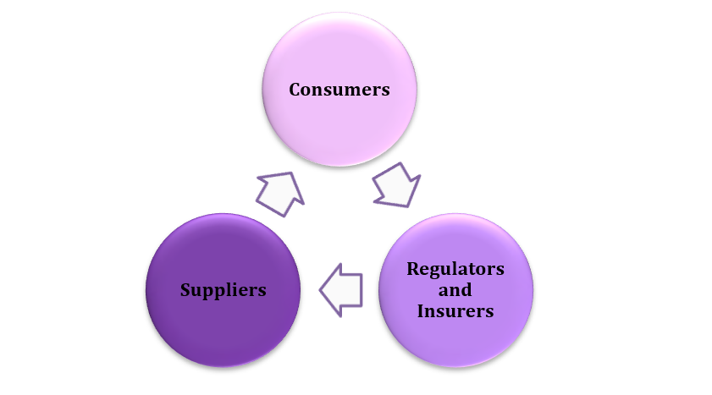
Figure 2: Key Stakeholders
(Source: Self-Created)
Consumers: A travel bureau’s key associates are essential in its activities and problem management. Customers need easy booking protocols, transparent refund policies, and impactful communication, especially during travel massacres. Ensuring customer goodwill is vital for brand perception.
Suppliers: Airlines, Hotels and trip generators rely on tour agencies for reservations and deals. Provider failure can drastically affect agency activities. Trip agencies must acquiesce to local and international protocols, consumer protection policies, and health and safety cautions.
Regulators and Insurers: Non-compliance can cause legal punishments (Simpson & Evens, 2024). Insurers lay out pecuniary protection through trip insurance, liability coverage, and business etiquette guidelines, reducing monetary risks along with crises. A well-executed crisis governance plan must contemplate the interests of all collaborators to certify legal compliance, business strength and customer delight. Productive partnerships and transparent legalised agreements with providers and insurers are crucial for diminishing risks and maintaining easy operations during crises.
In an age of plentiful digital information, the role of a tour agency is to establish trust and assurance (Elshaer et al., 2024). Assuring consumers that they feel safe in their trip plans and that the trip bureau will help if any problems arise is a key factor in success. Successful travel bureaus can efficiently navigate the industry's difficulties, prioritise key holders and consumer needs, and welcome new changes.

2.3 Revenue Streams and Contractual Obligation
Tour agencies earn profits through service charges, commission from providers, and sales of tour packages (Chen, 2024). Revenue streams and contractual obligations also generate revenue. Corporate collaborations and superior consumer services generate revenue again.
Legal covenants with providers define accountability regarding cost, accessibility, and quality of service. Travel agencies must also adhere to refund terms, customer protection laws, and answerability agreements. Superior force clauses alert and save agencies from monetary losses due to unanticipated crises like natural calamities and pandemics. Ensuring lawfully sound agreements assists trip agencies in overcoming risk possibilities, carrying out commitments, and sustaining economic hardship in any problematic matter.

3. Crisis Preparedness Strategy

3.1 Identifying potential crises
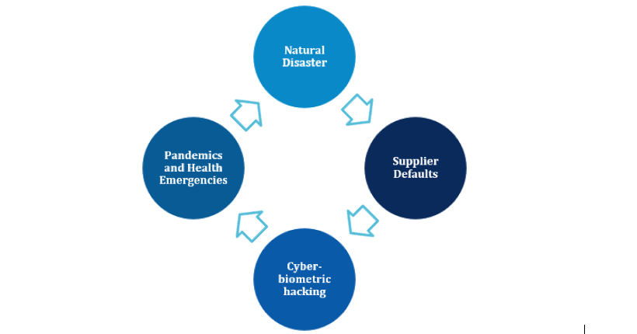
Figure 3: Potential Crises
(Source: Self-Created)
A travel agency can be put under several crises, which can paralyse its operation and even cause disaster in its revenue system and customer trust.
Natural Disaster: Major travel entities are disrupted during earthquakes, hurricanes, or floods (Harrington, 2021). These often result in flight cancellations, unsafe hotel conditions, or closures, requiring travel agents to rebook or refund their customers. These agencies must coordinate with suppliers and insurers to minimise the financial impact of these events.
Pandemics and Health Emergencies: Health emergencies, such as the COVID-19 pandemic, have given rise to observations of their devastating effects on the travel industry. Travel agencies should be adept enough to abide by the evolving norms and flexible cancellation policies so that each health-related travel advisory is relayed to customers quickly.
Cyber-biometric hacking: As the whole business is inclined to move to digital platforms, it is being affected by travel hackers, phishing attacks, and ransomware threats (Paraskevas, 2022). Such an occurrence would lead to customer data breaches, which could end in payment of damages or loss of confidence from clients, as well as fines from investigations. Strong measures have to be taken against cyber criminality.
Supplier Defaults: Airlines, hotels, and even tour operators may succumb to financial distress or, in some cases, demise and, therefore, cancel their services and refund some money. Contingency plans and contractual arrangements for safeguarding the customers will be needed to protect both in Default situations (D'Onfro, 2021).
Once identified, proactive measures can be taken to address these potential crises, thus reducing the impact of money loss, legal liabilities, or operational hindrances.

3.2 Risk assessment and mitigation measures
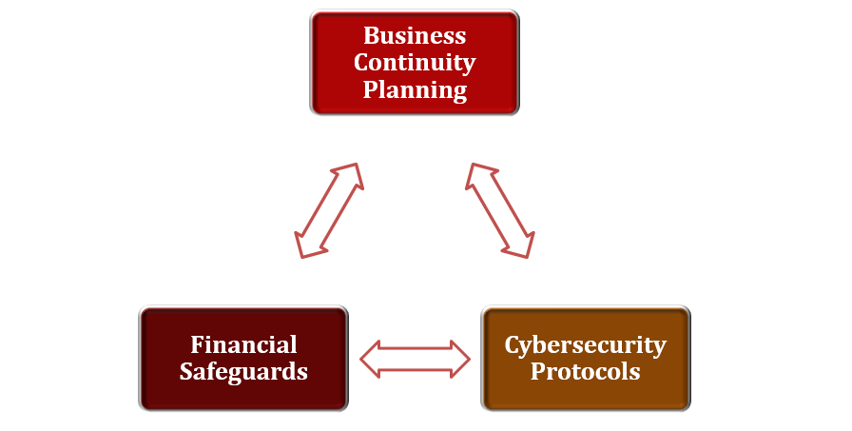
Figure 4: Risk assessment and mitigation measures
(Source: Self-Created)
Business Continuity Planning: Travel agencies should set up backup supplier networks to provide alternate travel options in case of disruptions (Patel, 2023). Keeping all the service providers happy helps diminish dependency on any one supplier.
Financial Safeguards: Agencies must ensure that travel insurance policies cover crises such as trip cancellations, supplier failures, and emergency evacuations. Financial reserves and insurance protect agencies against unforeseen liabilities.
Cybersecurity Protocols: Investment in data security management systems and compliance with data security laws, such as the GDPR, can help reduce the risk of cyberattacks (Lee, 2021). The organization should perform frequent cybersecurity audits and train employees on data security to keep everyone up-to-date with compliance requirements and risk reduction.

3.3 Crisis response planning
It can be beneficial in ensuring smooth disruption handling by travel agencies and significantly reduce probable incurred financial and legal risks. They include establishing internal crisis management teams to oversee emergency responses associated with those crises, developing employee training about crisis protocols, and formulating customer-centric communication strategies through which customers will be updated clearly as expected in case of emergencies. Suppliers, insurers, and regulators must be brought into coordination so that travel agencies can manage cancellations, refunds, and legal obligations effectively.
Internal Crisis Management Teams: Travel agencies must appoint crisis response teams to handle emergencies from legal, financial, or operational perspectives (Ravazzi, 2022). These teams coordinate with suppliers, insurers, and regulators.
Employee Training on Emergency Protocols: Employees must undergo periodic training on handling travel disruptions, refund policies, and crisis communication. They must be equipped to handle customer concerns and regulatory compliance efficiently.
Customer Communication Plans: Timely and transparent communication is critical in times of crisis (Erickson, 2024). Agencies should establish structured plans to notify customers about cancellation policies, refund procedures, and alternative travel arrangements.

4. Legal Obligations During Crises

4.1 Consumer protection laws
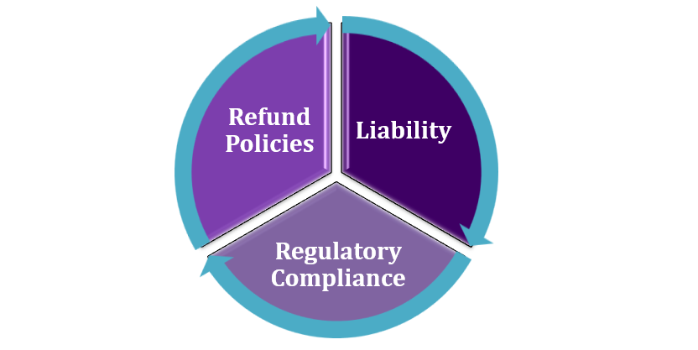
Figure 5: Consumer protection laws
(Source: Self-Created)
Refund Policies: Travel agencies must comply with refund regulations, such as the European Union Package Travel Directive, which demands refunds for package holiday cancellations within 14 days (Wukoschitz, 2025). This is similar to refund and replacement arrangements that U.S. and UK consumer laws require agencies to follow in case of trip cancellations.
Liability: Trip cancellation, failure to book flights, and claims for damages are within the purview of the relevant laws governing these agencies. Failure to pay refunds or give enough compensation would result in actions such as reputational loss, fines, and other forms of regulatory penalties.
Regulatory Compliance: To make this applicable, the government must impose travel restrictions, quarantine requirements, and measures on travel agencies during health crises like COVID-19 (Worsnop, 2025). This means protection under the law and minimising financial losses. Compliance with consumer protection legislation helps travel agencies boost their credibility, avoid fines, and earn customers' loyalty with time.

4.2 Contractual obligations
Supplier Agreements: Contracts with suppliers such as airlines, hotels, and tour operators are critical for travel agencies, particularly in crises (Florido-Benítez, 2024). Well-structured supplier agreements assure clear terms of refunds, cancellations, and alternative travel arrangements in case of disruption. They assign each party their responsibility, ensuring transparency between them to minimise disputes. Without clear contractual terms, the travel agency risks losing finances, damaging its relations with suppliers, and facing legal action by customers seeking refunds.
Force Majeure Clauses: Among the essential provisions in a contract is the occurrence of force majeure, which is a clause that gives protection to travel agencies from having to offer refunds or minimise exposure from claims due to unforeseen circumstances that prevent performance of travel arrangements, such as natural disasters, pandemics, or political turmoil. An ideal force majeure clause can suspend, alter, or cancel out contracts without penalty (Beļčikova, 2024). This clause removes liability on the travel agency's side due to acts of God and reduces refund obligations and legal risk.
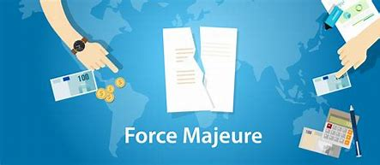
Figure 6: Force Majeure Clauses
(Source: Beļčikova, 2024)
Travel agencies should tighten their legal positions concerning supplier agreements because they must have clear terms in their force majeure clauses, refund policies, and alternative co-bookings. Continuity in contract review and consultation with lawyers keeps an agency abreast of changing regulatory and industry standards.

4.3 Employment laws during crises
Travel crises pose immense financial and operational challenges for travel agencies and may require adjustments to manpower. Agencies must engage in due diligence to adhere to employment legislation and labor regulation while keeping businesses afloat. Any mishaps in managing layoffs and breaches of workplace health and safety can drag employers into legal disputes, damage reputations, and incur sanctions.
Staff Layoffs and Redundancies: Economic downturns, travel restrictions, and declining demand may force redundancies (Salsabilla, 2024). Any redundancy process must comply with national labor laws stipulating notice periods, severance pay, and consultation. Failure to follow these rules will leave an employer open to wrongful termination claims and lawsuits by affected employees. Communication throughout the process and the fair selection of employees for redundancy will mitigate litigation risks and preserve morale within the remaining workforce.
Workplace Safety Regulations: During health crises like pandemics, agencies must institute measures protecting employees. These will likely include working from home, sanitizing workplaces, social distancing, and providing personal protective equipment. These acts ensure that the employer secures protection under the Occupational Safety and Health (OSH) laws while ensuring employees' health (Erikson and Rosin, 2025). Employers failing to comply with the freeway standards may face fines and lawsuits or be forced to shut down temporarily.

4.4 Data protection and cybersecurity compliance
Data protection and cybersecurity are crucial for travel agencies as they handle personal, sensitive information in payments and bookings. These safeguard the agencies against legal risks and uphold customers' trust.
Compliance with Data Protection Laws: Any travel agency must follow legal frameworks such as the General Data Protection Regulation (GDPR) in the EU, the California Consumer Privacy Act (CCPA) in the USA, and any similar statute across the globe. These laws make provisions for obtaining the customer's consent for their information in complete understanding, secure storage and processing, and transparent privacy policies (Oyewole et al., 2024). Neglecting them can spell fines, actions, and reputational damage.
Best Practices for Cybersecurity: Agencies should invest in encryption technologies, multi-factor authentication, and frequent audits to prevent data breaches (Abikoye and Agorbia-Atta, 2024). Such protocols also protect against hacking, phishing attacks, and unauthorised access. According to legal requirements, Containment and customer notifications form part of the incident response strategy in unfortunate cases of cyber outside events.

5. Crisis Communication Strategy

5.1 Internal communication protocols
Creating Crisis Management Teams
For value-added crisis management, travel agencies should create a crisis management team with clearly defined roles and responsibilities (Comes, 2024). The team should include legal advisors, operational managers, PR specialists, and IT security specialists for a well-rounded approach to crisis management. Their affiliate duties include defining the crisis's criticality level, formulating measures to address it, and coordinating actions across all departments. When agencies have a designated crisis team, they can make informed, rapid decisions and give correct directions to their staff during critical situations.
Employee Communication Strategies
Keeping employees informed about changes in the status of crises requires constant and open communication (Moşteanu, 2024). Agencies can keep employees abreast via email briefs, internal newsletters, and virtual meetings to provide timely updates. The organization of clear response measures into what, when, and how would ensure that employees are on board regarding roles and responsibilities transformed towards customer-oriented approaches, safety assurance, and operational adjustments necessary in crisis surroundings. An informed workforce boosts crisis preparedness across the board and decreases internal uncertainty.
Decision-Making Structures
Travel agencies should have established decision-making mechanisms enabling quick and efficient action to avoid delays in responding (Achanta, 2025). Predefined escalation procedures help senior management prioritize urgent matters and delegate responsibilities efficiently. As agencies hurry decisions, their decisions would ensure timeliness in crises and keep critical decisions within the confines of legality and regulations.

5.2 External communication
Public Relations Strategy
An effective public relations strategy tailored to the crisis is necessary to manage reputation and customer confidence (Mizrak, 2024). Travel agents must engage in transparent, empathetic, and accountable behaviours relative to the disruption. Press releases should be factually based, credit the agency with the actions taken, and highlight trade-offs in proactive solutions. Recognizing the customer's problem and presenting a way forward can undermine any negative speculation and help enhance brand equity. Pursuing crisis-specific PR would also afford protections under consumer acts that ensure that updates on refunds, cancellations, and alternate travel arrangements are communicated promptly.
Social Media and Engagement with Customers
Social media platforms allow for the swift dissemination of communication related to a crisis, enabling real-time assessment of customer feedback and public sentiment (Moses Alabi, 2024). Travel agencies must monitor customer concerns and respond to any inquiries while seeking to counter misinformation. A communication response is better undertaken through devoted social media teams backed with automated chatbot support for a consistent messaging approach. Professional engagement with customers can build confidence and avert hysteria. Any communication should also consider pre-approved legal and corporate policy compliance responses.
Press Statements and Media Briefings
A designated spokesperson must address all media inquiries for consistency in format and to retain legal credibility (Singh, 2024). Press statements should be factual and contain all pertinent information, including regulatory considerations. Agencies should be careful to avoid speculation and provide only facts that have been established to retain credibility. Media briefings would give a structured update to journalists to reduce misinterpretation marginally.

5.3 Handling legal disclosures and media inquiries
Legal disclosures and media relations have to be handled closely to avoid misinformation and any ensuing lawsuits (Spytska, 2024). Travel agencies must ensure all public statements are made in all respects according to law, avoiding misleading allegations that might mean fines or damage to reputation. A dedicated legal team should vet all press releases, customer notices, and public statements before release. During media interaction, spokespersons should render accurate, factual, and verifiable information without speculating. To ensure uniformity, agencies should also prepare template responses. With continued prioritization of legal accuracy and proactive media engagement, agencies will be better able to manage public opinion and reduce legal liabilities in risk situations, thus salvaging brand reputation.

6. Case Studies and Best Practices

6.1 Examples of travel agencies managing crises effectively
Examples of Travel Agencies Managing Crises Effectively: The travel industry is intrinsically unsafe to several crises, such as native reversal, epidemic, diplomatic risk, and arsonist attack. Crisis supervision is decisive not only for customer trust and business progression but also for the protection of pilgrims. Many travel agencies have given an idea of a crisis management scheme exposing how proactive measures and quick actions can reduce the effect of those events. The agencies have grown overreaching crisis plans, highlighting elasticity, good communication and rapid decision making.
1. The COVID-19 Pandemic: A worldwide retardation causes badly in worldwide travel industries (Ityonzughul, 2023). Expedia and TUI groups managed their crisis valuably by making short changes in their booking policies, giving their customers more flexibility to reschedule trips without heavy fines, and making them happy by providing the best safety protocol and launch sanitation arrangement. This not only lowers passengers’ bitterness but also assists them in retaining loyal passengers’ trust.
2. Natural Disasters: The 2001 Gujarat earthquake tested the crisis management ability of many travel agencies. Another example is Airbnb’s response to Hurricane Katrina in the USA (Fussell, 2021). They played a vital role in crisis management by making a short-term living place possible, which gave displaced people a roof.
3. Diplomatic risk and Terrorism: When it comes to political trouble and terrorist threats, maintaining traveller trust is difficult. AMEX Global Business Travel has set guidelines for this. They execute the newest traveller tracing options and crisis reporting protocols, get real-time updates and support to the affected area, and successfully lower risks and ensure prompt assistance (Bafna, 2025). In Australia, Flight Centre has been commending its feedback to world terrorist attacks. The agency holds down a job enterprising rerouting procedure and makes customers safe by providing real-time updates. Their ability to adapt briskly to progressing conditions helped to stop possible threats to their clients.

6.2 Lessons learned from past industry crises
The travel industry has encountered various crises, such as epidemics or natural disasters, political instability, and cyber threats (Drammeh, 2024). Each crisis has imparted lessons on effective crisis management strategies, providing agencies with tools to manage future disruptions. Restructuring policies in the context of flexibility has been another key lesson. During the COVID-19 pandemic, travel agencies that adapted swiftly to flexible booking, refund, and rescheduling policies would cultivate more customer trust and loyalty. Actions taken by companies such as Expedia and TUI have shown that proactive measures can temper bad feelings and mitigate financial loss. A significant takeaway is real-time communication and transparency. Agencies that provided real-time updates with unambiguous travel advisories and support via web platform and social media were able to pacify their customers and build credibility. Investing in technology and risk assessment tools has proven worthwhile. AMEX Global Business Travel and Flight Centre have successfully installed traveler-tracking systems and rapid-response protocols to facilitate quick decision-making during crises. Collaboration with governments, insurers, and local authorities plays a significant role in making contingency plans and providing financial protection (Majka, 2024). Agencies that value safety, flexibility, and communication will be better equipped to weather the industry's challenges and recover more effectively.

7. Conclusion
An efficient crisis management framework for travel agencies encompasses legal strength, foresight in risk assessment, and clarity of communication strategy. They shall always be prepared for natural disasters, cyber threats, or supplier failures within the regulations. An organized plan decreases financial risks, builds customer trust, and helps ensure business continuity in the long run. Legal contravention of consumer protection laws, agreements with clients, and data security regulations could lead to litigation against the agency, along with financial losses and harm to reputation. Therefore, a travel agency must focus on risk mitigation, ensure legally binding agreements when required, and maintain ethical business conduct in the interest of its stakeholders and customer base so that it can respond to crises. Travel agencies should adopt Crisis management plans fully, with guidelines for risk mitigation and compliance establishment. Furthering the causes of internal and external communication is also essential for transparency and gaining the trust of stakeholders.

References
Abikoye, B., and Agorbia-Atta, C. (2024). Securing the Cloud: Advanced Solutions for Government Data Protection. World J. Adv. Res. Rev, 23, 901-905.
Achanta, S. V. (2025). AI in Public Services: Analysing AI-Driven Tools in Healthcare, Education, Transportation, and Safety. In AI Driven Tools for Sustainable Public Administration (pp. 113-152). IGI Global Scientific Publishing.
Bafna, N. (2025). Crisis Management and Sustainable Destination Recovery. Educohack Press.
Beirman, D. (2021). Tourism crises and destination recovery.
Beļčikova, D. (2024). The effect of COVID-19 on force majeure clause in international commercial contracts: its impact on public procurement in Latvia.
Chen, C. J. (2024). Advertising fee as a new supply chain coordination approach between hotels and online travel agencies. Journal of Hospitality and Tourism Insights, 7(4), 2422-2441.
Comes, T. (2024). AI for crisis decisions. Ethics and Information Technology, 26(1), 12.
D'Onfro, D. (2021). Error-resilient consumer contracts. Duke LJ, 71, 541.
Drammeh, F. Y. (2024). Managing tourism during the COVID-19 pandemic. A systematic review of crisis management in the tourism industry. Cogent Social Sciences, 10(1), 2311955.
Elshaer, I. A., Alyahya, M., Azazz, A. M., Ali, M. A. S., Fathy, E. A., Fouad, A. M., ... & Fayyad, S. (2024). Building digital trust and rapport in the tourism industry: a bibliometric analysis and detailed overview. Information, 15(10), 598.
Erickson, S. (2021). Communication in a crisis and the importance of authenticity and transparency. Journal of Library Administration, 61(4), 476-483.
Erikson, M., and Rosin, A. (2025). Protection of the occupational health and safety of teleworkers. European Labour Law Journal, 20319525241309242.
Florido-Benítez, L. (2024). The cybersecurity applied by online travel agencies and hotels to protect users’ private data in smart cities. Smart Cities, 7(1), 475-495.
Fussell, M. R. (2021). " Airbnb Go Home:" Tourism Frictions and Short-Term Rentals in New Orleans. Louisiana State University and Agricultural & Mechanical College.
Harrington, R. D. (2021). Natural disasters, terrorism, and civil unrest: crises that disrupt the tourism and travel industry-a brief overview. Worldwide Hospitality and Tourism Themes, 13(3), 392-396.
Ityonzughul, T. T. (2023). The 2004 Indian Ocean Tsunami and the economies of some of the affected countries. LWATI: A Journal of Contemporary Research, 20(1), 214-228.
Lee, I. (2021). Cybersecurity: Risk management framework and investment cost analysis. Business Horizons, 64(5), 659-671.
Mahjub, A., (2024). Looking into the Influence of the E-services cape Conceptual Model in Bangladeshi online travel industry and understanding the customer influence in building trust among customers.
Majka, M. (2024). The Crucial Role of Insurance in Risk Mitigation Strategies.
Mizrak, K. C. (2024). Crisis management and risk mitigation: Strategies for effective response and resilience. Trends, challenges, and practices in contemporary strategic management, 254-278.
Moses Alabi, A. F. (2024). The Strategic Management of Corporate Reputation in a Social Media-Driven World.
Moşteanu, N. R. (2024). Adapting to the unpredictable: Building resilience for business continuity in an ever-changing landscape. European Journal of Theoretical and Applied Sciences, 2(1), 444-457.
Oyewole, A. T., Oguejiofor, B. B., Eneh, N. E., Akpuokwe, C. U., and Bakare, S. S. (2024). Data privacy laws and their impact on financial technology companies: a review. Computer Science & IT Research Journal, 5(3), 628-650.
Paraskevas, A. (2022). Cybersecurity in travel and tourism: a risk-based approach. In Handbook of e-Tourism (pp. 1605-1628). Cham: Springer International Publishing.
Patel, K. R. (2023). Enhancing global supply chain resilience: Effective strategies for mitigating disruptions in an interconnected world. BULLET: Jurnal Multidisiplin Ilmu, 2(1), 257-264.
Ravazzi, S. (2024). Improvisation and Emergency Management.
Salsabilla, A. P. (2024). The Impact of Mass Layoffs in Several Companies in ASEAN Countries Due to COVID-19: Global Economic Decline and Countries' Anticipation of the Outbreak (Singapore & Thailand). Journal of Public Policy Analysis, 1(2), 39-54.
Simpson, S. S., & Evens, J. (2024). Corporate environmental non-compliance and the effects of internal systems and sanctions. In Research Handbook on Environmental Crimes and Criminal Enforcement (pp. 36-67). Edward Elgar Publishing.
Singh, D. P. (2024). Media Policies of the Armed Forces, Media Interactions, Challenges to National & Defence Security, Restrictions and Future Directions. Media Interactions, Challenges to National & Defence Security, Restrictions and Future Directions (December 25, 2024).
Spytska, L. (2024). Practice-based methods of bringing to legal liability for anonymous defamation on the Internet and in the media. Social and Legal Studios, 1(7), 202-209.
Subhadra, P. S., Kalaivani, A., Markan, R., Kumar, R., Natarajan, S., & Rajalakshmi, M. (2024). Rise of Artificial Intelligence in Business and Industry. Journal of Informatics Education and Research, 4(2).
Worsnop, C. Z. (2025). International Border Restrictions During COVID-19 as Global Health Security Theatre. British Journal of Political Science, 55, e48.
Wukoschitz, M. (2025, March). Insolvency protection for package holidays–development, CJEU case law and the new Commission proposal. In ERA Forum (pp. 1-12). Berlin/Heidelberg: Springer Berlin Heidelberg.

