Financial Reporting and Managerial Decision Making
M02 Accounting and Finance
MBA Project Report
Option 1: Financial Reporting and Managerial Decision Making

Table of Contents
Abstract
1. Introduction
2. Literature Review
3. Methodology
4. Findings
5. Discussion
6. Conclusion
References
Appendices

Abstract
This report critically examines how financial reporting supports managerial and strategic decision making in contemporary organisations. It argues that accounting information has practical value when it is reliable, comparable and interpreted in relation to business model, risk, strategy and stakeholder expectations. The report first explains the purpose of financial reporting and then analyses how the income statement, balance sheet, cash flow statement and financial ratios convert transactions into evidence for planning, control, performance evaluation and external accountability. The discussion uses accounting theory, standard setting concepts and current company evidence from Microsoft and Apple to show that reporting is not a mechanical compliance exercise. It is a decision system that affects resource allocation, investor confidence, lending assessment, operational discipline and strategic learning. The analysis also recognises limitations. Financial statements are historical, estimates can be judgmental, and ratios can mislead if they are treated as answers rather than questions. The central conclusion is that managers use accounting information best when they combine statement analysis with non financial indicators, ethical judgement and forward looking interpretation. Proper financial reporting therefore improves performance not because numbers automatically create value, but because disciplined reporting makes economic reality visible enough for managers and stakeholders to question, compare and decide.

1. Introduction
Accounting and finance are often presented as technical support functions, yet their strategic importance is much wider. Managers make decisions under uncertainty, and accounting information reduces that uncertainty by organising financial consequences into a structured language. A sales expansion, a price reduction, a new borrowing plan or a cost saving programme may sound attractive in operational terms, but its business value cannot be assessed without evidence on profit, liquidity, assets, liabilities, cash flows and risk. Financial reporting provides that evidence through recognised statements, notes and analysis. Its purpose is not simply to record the past. It also supports planning, control, accountability and the evaluation of future choices.
The assignment brief requires a detailed project report on the role of accounting and finance in managerial decision making and organisational performance. This report addresses Option 1, Financial Reporting and Managerial Decision Making. The core argument is that financial reporting becomes strategically useful only when managers understand both the strengths and the limitations of accounting numbers. The income statement helps assess revenue growth, margin quality and cost behaviour. The balance sheet helps evaluate financial position, liquidity, leverage and asset intensity. The cash flow statement shows whether profit is being converted into cash. Ratio analysis then links these statements into interpretable measures of profitability, efficiency, solvency and market confidence.
This report also adopts a critical position. Accounting numbers are not neutral facts that speak for themselves. They are shaped by recognition rules, measurement choices, estimation uncertainty, business model differences and managerial judgement. This does not make financial reporting weak. It means that managers need technical skill and ethical discipline when interpreting financial information. IFRS and FASB conceptual frameworks emphasise useful information for investors, lenders and creditors, especially information that is relevant and faithfully represented (IFRS Foundation, 2018; Financial Accounting Standards Board, 2024). For internal managers, the same qualities matter because decisions are only as sound as the information base on which they rest.
The report is organised into 7 main parts. The literature review examines accounting theory and the decision usefulness of financial reporting. The methodology explains the secondary research approach. The findings analyse the main statements, ratios and stakeholder uses. The discussion evaluates real world managerial relevance, using Microsoft and Apple as examples. The conclusion summarises the implications for managers seeking to improve planning, control and business performance.

2. Literature Review
The decision usefulness perspective is central to modern financial reporting. It argues that financial reports should provide information that helps users make economic decisions about resources. Standard setting frameworks therefore focus on investors, lenders and other creditors because these users often cannot demand private information directly and must rely on general purpose reports (IFRS Foundation, 2018; Financial Accounting Standards Board, 2024). This external focus is also relevant internally. Managers may have access to more detailed management accounts, but external financial reports provide a disciplined summary of organisational performance that can be compared across time and with competitors.
Classic accounting research shows that accounting information affects capital market judgement. Ball and Brown (1968) demonstrated that reported earnings contain information that is associated with security price movements. Beaver (1968) also showed that earnings announcements affect investor behaviour. These studies matter for managerial decision making because they confirm that accounting outputs influence external perceptions of value and risk. A manager who treats reporting as merely administrative misunderstands how deeply financial communication affects the cost of capital, investor confidence and organisational credibility.
Financial reporting also reduces information asymmetry. Healy and Palepu (2001) argue that disclosure and financial reporting help address the gap between corporate insiders and external capital providers. This gap is not eliminated because managers still possess private knowledge about strategy, operations and future prospects. However, audited statements, notes and management commentary reduce uncertainty and allow stakeholders to evaluate performance more consistently. In practical terms, good reporting can support funding access, creditor confidence and governance oversight. Poor reporting can increase suspicion, reduce valuation quality and damage trust.
The literature also stresses that accounting information must be interpreted rather than accepted mechanically. Dechow, Ge and Schrand (2010) explain that earnings quality depends on whether earnings reflect current performance and are useful for predicting future performance. High reported profit is not automatically good if it comes from one off gains, aggressive revenue recognition, unsustainable cost cutting or underinvestment. Managers therefore need to examine the quality of earnings, not only the amount of earnings. This is especially important in industries where revenue is subscription based, inventory cycles are long, or non cash estimates are material.
Financial statement analysis literature emphasises the need to connect accounting numbers to business model, industry context and risk. The CFA Institute (2026) explains that financial analysis involves understanding the business model, financial performance, financial position, economic environment and industry conditions. It also notes that ratios, percentages and changes support comparison, but interpretation remains essential. A current ratio, for example, may indicate liquidity strength in one sector and inefficient asset use in another. A high operating margin may reflect strong pricing power, but it may also reflect temporary cuts in research, training or maintenance.
Managerial accounting and strategic control literature also connects reporting to performance management. Kaplan and Norton (1996) argue that financial measures remain important, but they need to be balanced with customer, internal process and learning indicators. This is a useful warning for financial reporting. The income statement and balance sheet provide essential indicators, but they often show results after operational causes have already occurred. Managers should therefore use financial reporting alongside lead indicators such as customer retention, quality defects, innovation pipeline, employee capability and supply chain reliability.
A further theoretical issue is stewardship. Financial reporting is not only about predicting future cash flows. It also enables owners, boards, creditors and regulators to assess whether managers have used resources responsibly. Stewardship matters because managers act as agents who control resources that belong to others. Agency theory suggests that monitoring mechanisms are needed when ownership and control are separated (Jensen and Meckling, 1976). Financial reports support that monitoring by showing how assets were used, how obligations changed and whether performance was achieved without excessive risk.
The literature therefore supports a balanced conclusion. Financial reporting is valuable because it creates a structured, comparable and auditable information base. However, its value depends on interpretation quality. It is strongest when managers combine financial statement analysis with operational evidence, ethical judgement and an understanding of the business model. It is weakest when ratios are applied mechanically, when short term profit is prioritised over sustainable value, or when management uses reporting discretion to obscure rather than explain economic reality.

3. Methodology
This report uses a qualitative secondary research methodology. The method is appropriate because the assignment asks for a critical examination of financial reporting and decision making rather than for a primary survey or experiment. The sources include accounting conceptual frameworks, academic literature on financial reporting, financial statement analysis resources, and recent corporate annual reporting evidence. The analysis applies these sources to explain how accounting information supports managerial and stakeholder decisions.
The report uses Microsoft and Apple as real world examples because both companies publish detailed financial reports, operate at significant global scale and show how financial statement information informs strategic interpretation. Microsoft is used to show how revenue, operating income and net income trends can communicate business performance over time. Apple is used to show how segment reporting, gross margin, operating margin, liquidity, leverage and capital allocation information can support strategic and stakeholder analysis. These examples are not treated as investment advice. They are used as illustrative evidence of how financial reporting data can be interpreted.
The analysis follows 4 steps. First, the main purposes of financial reporting are identified from theory and standards. Second, the major financial statements are examined in relation to managerial decisions. Third, ratios and stakeholder uses are evaluated. Fourth, the real world examples are interpreted critically to show the usefulness and limits of financial reporting. This methodology is suitable for the assignment because it links theory, tools, critical analysis and examples, which are the main assessment criteria.
Statement or tool | Main decision value | Managerial question supported
Income statement | Profitability, margin and cost behaviour | Are revenue growth and cost control producing sustainable operating performance?
Balance sheet | Liquidity, solvency, assets and capital structure | Does the organisation have enough financial flexibility for its strategy?
Cash flow statement | Cash conversion and funding movement | Is accounting profit being converted into usable cash?
Ratios | Comparison across time, peers and targets | Which performance area requires deeper investigation?
Table 1. Main financial reporting tools and managerial decision value.
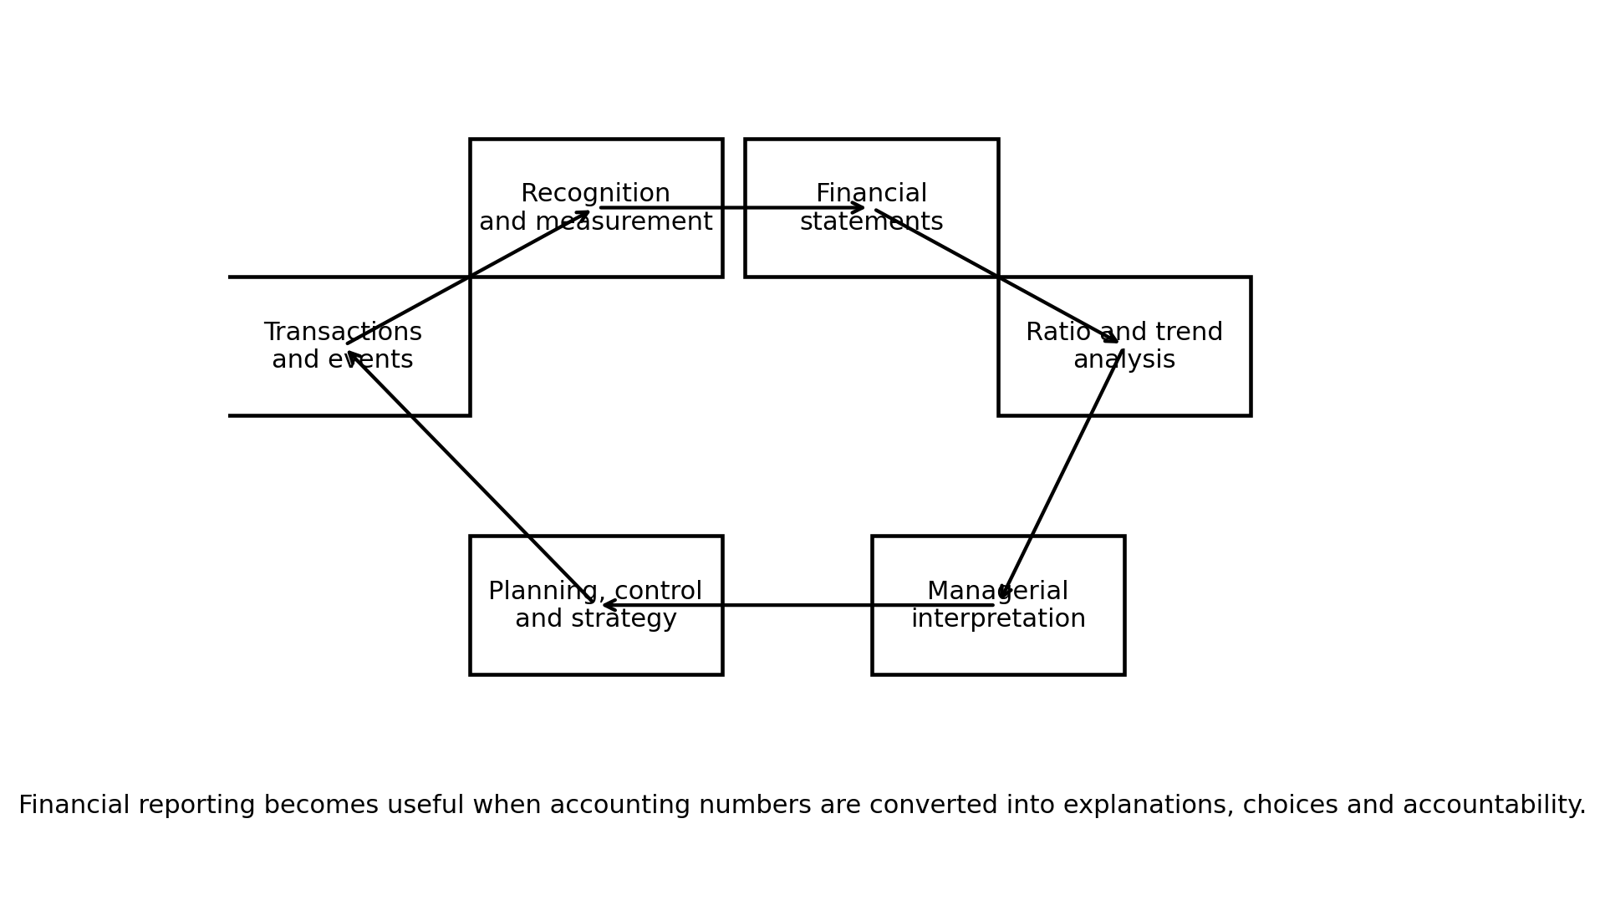
Figure 1. Financial reporting information cycle. Source: Author developed from accounting decision usefulness concepts.

4. Findings
The first finding is that financial reporting supports decision making by converting diverse economic activities into common categories. Sales contracts, payroll, inventories, leases, debt, tax payments and capital expenditure are different operational events, yet financial reporting translates them into income, expenses, assets, liabilities, equity and cash flows. This translation allows managers to compare activities that would otherwise be difficult to evaluate together. It also allows senior leaders to ask disciplined questions about profitability, liquidity, solvency and efficiency.
The income statement is especially useful for assessing performance. It shows whether the organisation is generating revenue, controlling costs and producing profit from operations. Managers use it to evaluate product lines, pricing strategy, cost structure, margin pressure and the effects of growth. However, the income statement must be interpreted carefully. Profit includes accruals, estimates and non cash items. Revenue can rise while cash collection weakens. Operating income can improve because of efficiency or because of underinvestment. Therefore, the income statement supports decisions when it is analysed with the balance sheet, cash flow statement and operational context.
The balance sheet supports decisions about financial position. It shows assets controlled by the entity, obligations owed to others and residual equity. Managers use it to assess liquidity, working capital, asset utilisation, borrowing capacity and financial flexibility. Creditors examine the balance sheet to judge whether the firm has enough assets and cash generating capacity to repay debt. Investors examine it to understand capital intensity, leverage and risk. Yet the balance sheet also has limits. Some valuable resources, such as internally generated brand, data, employee knowledge and customer relationships, may not be recognised fully as assets. This means that balance sheet analysis must be supplemented by strategic and non financial evidence.
The cash flow statement is critical because it tests whether accounting profit is supported by cash. It separates operating, investing and financing flows. Operating cash flow indicates whether the core business generates cash. Investing cash flow shows expenditure on assets, acquisitions and financial investments. Financing cash flow shows borrowing, debt repayment, dividends and share repurchases. Managers use this statement to assess liquidity, capital expenditure capacity and dividend sustainability. A profitable firm can still experience distress if cash conversion is weak. Conversely, a firm with temporary accounting losses may remain viable if operating cash flow is strong and investment is deliberate.
Ratio analysis integrates statement information. Profitability ratios such as gross margin, operating margin and net margin assess value capture. Liquidity ratios such as the current ratio and quick ratio assess short term payment capacity. Solvency ratios such as debt to equity and interest coverage assess financial risk. Efficiency ratios such as inventory turnover and asset turnover assess how well assets support sales. Market ratios such as earnings per share and price earnings ratios connect accounting performance to investor expectations. The main strength of ratios is comparability. Their main weakness is simplification. Ratios can reveal a question, but they rarely provide the full answer.
Financial reporting also supports different stakeholders in different ways. Managers use accounting data for planning, budgeting, variance investigation and control. Investors use it to assess profitability, growth, risk and valuation. Creditors use it to assess repayment capacity and covenant risk. Employees may use it to evaluate organisational stability and reward prospects. Suppliers use it to judge payment reliability. Regulators use it to assess compliance and transparency. This wide use explains why reporting quality is not a narrow accounting issue. It affects the wider trust system around the organisation.
Stakeholder | Information used | Decision supported
Managers | Margins, cash flow, working capital, segment results | Planning, budgets, control and strategic resource allocation
Investors | Profit, growth, risk, cash flow and return measures | Buy, hold, sell and valuation decisions
Creditors | Liquidity, leverage, interest cover and cash generation | Loan approval, pricing and covenant monitoring
Employees and suppliers | Stability, profitability and cash strength | Employment confidence, negotiation and credit terms
Regulators | Compliance, transparency and governance evidence | Monitoring, enforcement and market confidence
Table 2. Stakeholder use of accounting information.
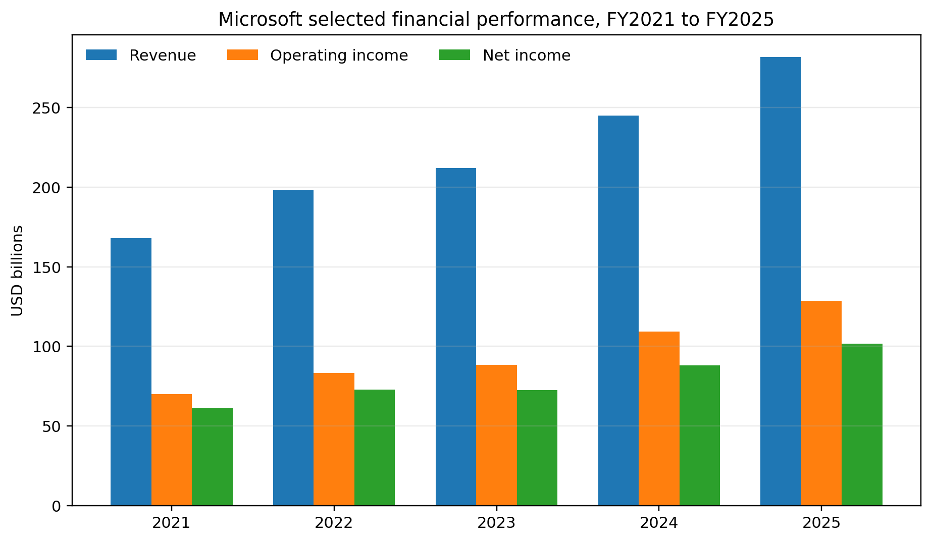
Figure 2. Microsoft selected financial performance, FY2021 to FY2025. Source: Microsoft annual reports and 2025 annual report.

5. Discussion
The real managerial value of financial reporting can be seen when statement analysis is connected to strategic interpretation. Microsoft provides a clear example. Its 2025 annual report states that revenue reached USD 281.7 billion and operating income reached USD 128.5 billion, with Azure surpassing USD 75 billion in revenue (Microsoft, 2025). These numbers are not only historical results. They help managers, investors and creditors assess whether cloud and artificial intelligence investment is translating into scalable operating performance. The rising revenue and operating income trend shown in Figure 2 indicates that growth was accompanied by strong operating leverage. For managers, that evidence supports continued investment in high demand cloud infrastructure, while also raising questions about capacity cost, data centre risk and future margin sustainability.
Apple provides another example of how financial reporting supports strategic interpretation. Its 2025 Form 10 K reports total net sales of USD 416.161 billion, operating income of USD 133.050 billion and net income of USD 112.010 billion (Apple Inc., 2025). These figures show a highly profitable business, but the reporting detail makes the analysis more useful. Segment reporting shows that the Americas generated the largest net sales, followed by Europe and Greater China. For managers, this information can guide regional pricing, distribution, marketing investment and risk planning. If a region underperforms, the decision response may involve product mix, channel strategy, macroeconomic analysis or supply chain adjustment rather than a simple cost cut.
Apple also illustrates the importance of margin analysis. Its 2025 total gross margin percentage was 46.9 percent, while services gross margin was 75.4 percent (Apple Inc., 2025). The difference between product and services margins helps managers understand why services growth is strategically important. A shift in mix toward services may improve profit quality and recurring revenue, but it also exposes the business to platform regulation, App Store scrutiny and customer retention risks. Financial reporting therefore highlights strategic opportunity and strategic vulnerability at the same time.
Cash flow information provides a further decision layer. Apple reported operating cash flow of USD 111.482 billion in 2025, share repurchases of USD 90.711 billion and dividends of USD 15.421 billion (Apple Inc., 2025). These data help stakeholders judge whether capital returns are supported by cash generation. For managers, the decision question is not simply whether cash was available. It is whether returning cash to shareholders created more value than using that cash for acquisition, research, supply chain resilience, debt reduction or sustainability investment. Financial reporting does not answer this question automatically, but it provides the evidence for a disciplined debate.
The stakeholder perspective shows why financial reports must be credible. Investors use financial statements to estimate future earnings and cash flows. Creditors use them to assess default risk. Managers use them to justify strategy. If reporting is inaccurate or opaque, all these decisions are weakened. Ethical reporting is therefore central to managerial responsibility. Earnings manipulation, aggressive estimates, excessive non GAAP adjustments or selective disclosure may create short term appearance, but they damage long term trust. This is especially important because users may not have direct access to internal data. The credibility of published accounting information reduces uncertainty in the wider capital market and business network.
However, the discussion must also acknowledge limitations. Financial reporting is historical and periodic. Managers often need real time operational data before the annual report is published. Accounting standards also require judgement. Depreciation, impairment, revenue recognition, provisions, fair value estimates and tax positions can all involve assumptions. In addition, traditional financial statements may understate intangible assets and human capital. Technology businesses often create value through data, ecosystems, software capability and brand trust, but not all of this appears fully on the balance sheet.
A further limitation is that ratios can encourage shallow benchmarking. A current ratio below 1 may look weak, but in a business with strong cash generation and supplier financing, it may be manageable. A high debt to equity ratio may indicate risk, but it may also reflect efficient financing if cash flows are stable and interest coverage is strong. A high net margin may indicate excellent strategy, but it may also invite regulatory concern or competitive imitation. The correct managerial approach is therefore diagnostic rather than mechanical. Ratios should trigger investigation, not replace judgement.
Financial reporting supports planning by making past performance visible. Managers can compare actual results with budgets, identify unfavourable variances and revise forecasts. It supports control by showing whether resources are being used efficiently. It supports strategy by showing which activities generate cash, margins and return. It supports governance by allowing boards to assess whether managers are acting responsibly. It supports external performance by building investor and creditor confidence. These benefits are strongest when financial reporting is timely, transparent and connected to strategic questions.
The practical implication is that managers should use financial reporting as part of an integrated information system. Figure 1 shows the reporting cycle from transactions through measurement, statements, analysis, interpretation and strategic action. The cycle is important because it shows that accounting value is not created at the point of recording alone. Value is created when accounting information is converted into managerial learning. This means finance teams should not only close the books. They should explain what changed, why it changed, whether it is sustainable and what decisions are required.
In summary, financial reporting improves managerial decision making when it performs 3 functions together. First, it measures performance and position using recognised rules. Second, it communicates that performance to stakeholders in a comparable form. Third, it supports interpretation that links numbers to strategy, risk and accountability. If any of these functions is missing, the quality of decision making falls. Compliance without interpretation becomes ritual. Interpretation without reliable measurement becomes speculation. Strategy without financial accountability becomes unsafe.
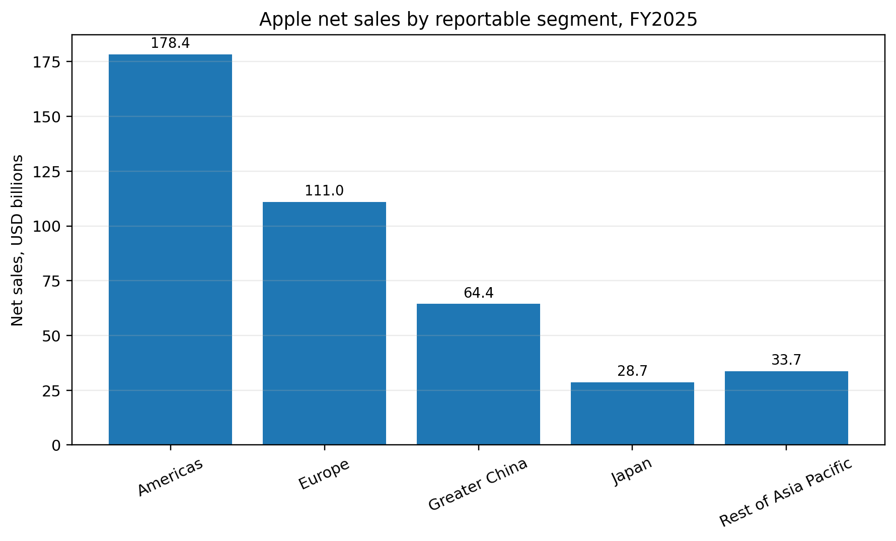
Figure 3. Apple net sales by reportable segment, FY2025. Source: Apple Inc. 2025 Form 10 K.
Selected Apple FY2025 measure | Calculation | Result | Interpretation
Gross margin | 195.201 / 416.161 | 46.9 percent | Strong value capture, supported by services mix and product economics
Operating margin | 133.050 / 416.161 | 32.0 percent | High operating profitability after research and selling costs
Net margin | 112.010 / 416.161 | 26.9 percent | Strong final profit after tax and other items
Current ratio | 147.957 / 165.631 | 0.89 | Low by textbook standards, but must be read with cash generation and business model
Term debt to equity | (12.350 + 78.328) / 73.733 | 1.23 | Significant debt use alongside large operating cash flow
Table 3. Selected Apple FY2025 ratios calculated from reported financial statement data.
Finally, financial reporting supports organisational learning. When managers compare current performance with prior periods, budgets and competitor data, they build a memory of what works and what fails. This learning can shape pricing, capacity planning, customer selection and cost structure decisions. The strongest organisations do not wait for financial reports only to satisfy external users. They use them as structured feedback. The reporting process therefore links accountability with improvement. It creates a disciplined conversation between finance, operations, strategy and governance.
The ethical dimension should also be stressed. Financial reports influence decisions by people who are not always able to verify every number. This creates responsibility for preparers and managers. Aggressive revenue timing, optimistic impairment assumptions, hidden liabilities or selective disclosure can mislead stakeholders even when some technical arguments are available. Ethical reporting requires managers to ask whether the report reflects economic substance and whether a reasonable user would understand the risk. In this sense, high quality reporting is a governance practice as well as an accounting practice.
Digital reporting has increased the speed and usefulness of accounting information. Many organisations now use enterprise resource planning systems, business intelligence dashboards and automated consolidation tools. This means managers can move from annual or monthly reporting to near real time analysis of revenue, margin, working capital and cash. However, faster reporting does not automatically mean better reporting. If data definitions are inconsistent, if dashboards use unaudited numbers without controls, or if managers focus only on easily visible metrics, digital reporting can create false confidence. The quality of the underlying accounting process remains essential.
The control role of reporting is equally important. Without regular financial reporting, managers may continue inefficient activities because operational problems are hidden in aggregate results. A detailed income statement can show which cost categories are rising faster than revenue. A balance sheet can show whether receivables are building up and creating collection risk. A cash flow statement can show whether inventories or supplier payments are absorbing cash. These controls do not replace operational management, but they direct attention to the areas where operational management is required most urgently.
Financial reporting also supports investment decisions inside the organisation. A manager deciding whether to expand a service line, replace equipment or enter a new market needs historical evidence on margins, cash generation and asset use. Past numbers do not guarantee future results, but they create a starting point for forecasts. For example, if a division has rising revenue but falling operating margin, the manager should question whether growth is being bought through discounts or whether costs are scaling faster than sales. If another division has lower revenue growth but strong cash conversion, it may deserve investment because its earnings quality is better.
A further practical issue is the link between financial reporting and budgeting. Budgets translate strategy into expected financial outcomes, while financial reports show whether those expectations were achieved. When actual revenue, cost, margin or cash results differ from budget, managers can investigate the operational cause. The variance may come from volume, price, efficiency, supplier costs, labour use, customer mix or exchange rates. The financial report is therefore a trigger for management action. It does not merely show that performance was above or below target. It helps managers decide whether the target was unrealistic, whether execution failed, or whether the external environment changed.

6. Conclusion
Financial reporting is a core managerial decision tool because it organises economic reality into statements, ratios and disclosures that can be analysed, compared and questioned. The income statement supports performance assessment, the balance sheet supports financial position analysis, and the cash flow statement tests whether profit is supported by cash. Ratio analysis strengthens interpretation, but it must be applied critically. The report has shown that Microsoft and Apple use financial reporting to communicate performance, strategic priorities and resource allocation consequences. The strongest conclusion is that financial reports do not create better decisions by themselves. They create a disciplined evidence base. Managers create better decisions when they interpret that evidence ethically, connect it to operational realities and use it to balance growth, risk, liquidity, stakeholder confidence and long term organisational performance.
Main body word count excluding references: 4,088 words.

References
Apple Inc. (2025). Form 10 K for the fiscal year ended September 27, 2025. United States Securities and Exchange Commission. https://www.sec.gov/Archives/edgar/data/320193/000032019325000079/aapl-20250927.htm
Ball, R., & Brown, P. (1968). An empirical evaluation of accounting income numbers. Journal of Accounting Research, 6(2), 159-178. https://doi.org/10.2307/2490232
Beaver, W. H. (1968). The information content of annual earnings announcements. Journal of Accounting Research, 6, 67-92. https://doi.org/10.2307/2490070
CFA Institute. (2026). Introduction to financial statement analysis. https://www.cfainstitute.org/insights/professional-learning/refresher-readings/2026/introduction-financial-statement-analysis
Dechow, P., Ge, W., & Schrand, C. (2010). Understanding earnings quality. Journal of Accounting and Economics, 50(2-3), 344-401. https://doi.org/10.1016/j.jacceco.2010.09.001
Financial Accounting Standards Board. (2024). Conceptual framework for financial reporting. https://storage.fasb.org/Conceptual%20Framework%20for%20Financial%20Reporting%20%28September%202024%29.pdf
Healy, P. M., & Palepu, K. G. (2001). Information asymmetry, corporate disclosure, and the capital markets. Journal of Accounting and Economics, 31(1-3), 405-440. https://doi.org/10.1016/S0165-4101(01)00018-0
IFRS Foundation. (2018). Conceptual framework for financial reporting. https://www.ifrs.org/issued-standards/list-of-standards/conceptual-framework/
Jensen, M. C., & Meckling, W. H. (1976). Theory of the firm: Managerial behaviour, agency costs and ownership structure. Journal of Financial Economics, 3(4), 305-360. https://doi.org/10.1016/0304-405X(76)90026-X
Kaplan, R. S., & Norton, D. P. (1996). The balanced scorecard: Translating strategy into action. Harvard Business School Press.
Microsoft. (2025). 2025 annual report. https://www.microsoft.com/investor/reports/ar25/index.html
Penman, S. H. (2013). Financial statement analysis and security valuation (5th ed.). McGraw Hill Education.

Appendices

Appendix A. Ratio formula guide
Gross margin = gross profit / revenue. Operating margin = operating income / revenue. Net margin = net income / revenue. Current ratio = current assets / current liabilities. Debt to equity = interest bearing debt / shareholders equity. These formulas should be interpreted with industry context, business model and cash flow evidence.

Appendix B. Source note for company figures
Microsoft figures in Figure 2 are compiled from Microsoft annual reporting for FY2021 to FY2025. Apple figures in Figure 3 and Table 3 are calculated from the Apple 2025 Form 10 K. The report uses these data for academic analysis only.

