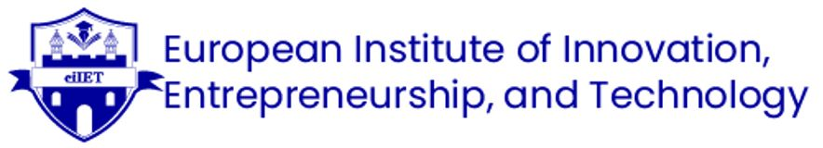

Talent Development Strategy for Post‐COVID Tourism Start-ups

Student Name: Ajay Kumar
Student ID:DE240022
2nd semester : Prof. Mr.Vaibhav Sai Sri
Due Date :28th of May 2025

Contents
1. Introduction 3
2. Talent Rebuilding Strategy 4
2.1 Engaging Gig Workers 4
2.2 Designing Hybrid Roles 5
2.3 Digital Onboarding 7
3. Sample Deliverables 9
3.1 Social Media Job Posts 9
3.2 AI‐Enabled Performance Dashboard 10
4. Long‐Term Resilience & Wellness Integration 10
4.1 Continuous Upskilling & Micro-Credentials 10
4.2 Mental Health & Well-Being Programs 10
4.3 Data-Driven Workforce Forecasting 11
4.4 Diversity, Equity & Inclusion (DEI) 11
5. Conclusion & Recommendations 11
6. References: 13

1. Introduction

The controversy related to the COVID-19 pandemic dealt a definite blow to the worldwide tourism and hotel industry, and South America was also one of the victims. The visitors who came to the region from abroad were cut by more than 70% from March 2020 to December 2021, and the hotel occupancy rates reached an all-time low in history, which also led to a sharp decline in staff morale and loyalty (World Tourism Organisation, 2022). As the world travel industry goes out of the darkness of the pandemic, start-up hotel chains in South America have to fight the problem of workforce reconstruction and also conform to a labour market that has turned into a gig economy, a remote-ready workforce, and digital expectations on a higher level.
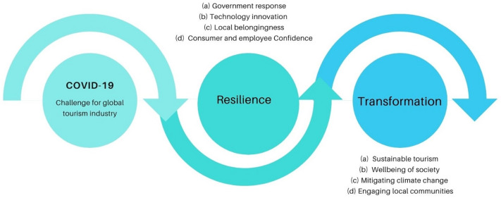
Source: https://www.sciencedirect.com/science/article/pii/S2211973620301537
This report serves the aim of detailing a talent development strategy of a wide scope that will work towards reinstating a loyal, dedicated, and energetic staff in the post‐COVID new hotel company. The strategy, through its emphasis on three fundamental values from human resource management, gig‐economy studies, and digital learning technologies, is expected to represent a successful pattern of behaviour: Engage gig workers through flexible contracts, platform partnerships, and community building. Bring together various responsibilities that include the normal knowledge of the organization after the remote support mission, thus giving the benefit of agile workers and worker skill set at large. The digital onboarding process includes virtual welcome kits, gamified LMS modules, and AI-powered buddy systems.
Apart from that, this piece is also rich in examples of which we may take social media, job posts, and the employee value proposition (EVP) given in the form of a hypothetical case, and even an AI-based performance dashboard that is also a conceptual one. The report, lastly, offers some advice that can assist in ensuring that the workforce that a company has is going to be resilient over a long period, and also puts forward the idea of employee wellness initiatives being integrated into the culture of the company.

2. Talent Rebuilding Strategy

2.1 Engaging Gig Workers

2.1.1 Context & Rationale
- According to the US Bureau of Labour Statistics, in 2005, nearly 11.9 million people worked in alternative employment arrangements, accounting for 7.4% of total employment (Katz & Krueger, 2019). Participating in the gig economy involves actions such as renting out one's flat on Airbnb, selling used items online, and delivering goods via Uber, etc. Importantly, the gig economy can be split into two parts: independent workers and moonlighters, and people who do contract work for others who operate an online business. However, during the past years, these categories have been extended to include freelancers, virtual assistants, SEO experts, bloggers, influencers, and others, thanks to the rise of the Internet.
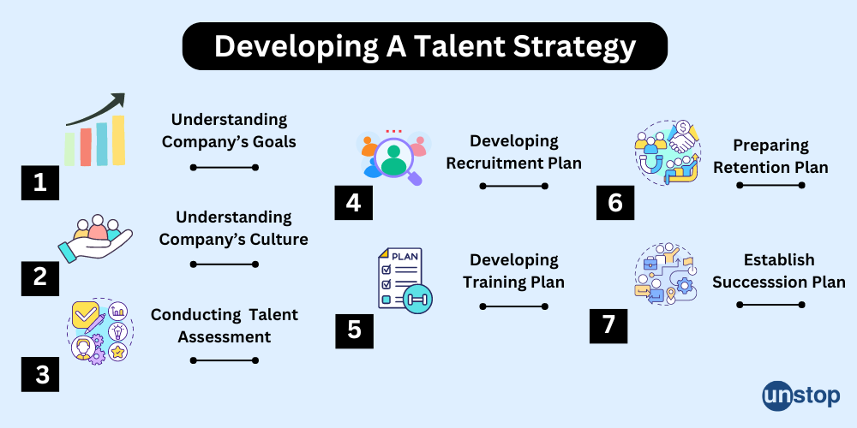
Source: https://unstop.com/blog/talent-management-strategy
2.1.2 Flexible Contracting & Platform Partnerships
Short-Term Sales-Aligned Goals: Identify fast-hear sales sequences and the most urgent market segments.
2.1.3 Community Building & Micro-Learning Pods
- Tiny Awareness Raising Campaign: Start by promoting your business or your society.
- Micro-Credentials: The idea here must be to create small-sized training badges, e.g., “Hospitality CRM Master,” or “Virtual Tour Host,” which one can learn in 1-2 hours and then have displayed on their professional profiles. This way, the contractors’ portfolios will certainly be enhanced, and the contractors will be ultimately loyal.
2.1.4 Performance Incentives
- Dynamic Surge Pricing: The best way forward is to apply algorithmic methods for instant or urgent tasks’ rate changes, in parallel, disclosing potential revenues. Figures have shown that gig acceptance increases by 25% when dynamic incentives are simply clear (Smith & Brown, 2021).
- Recognition Programs: A social media shout-out and a digital certificate are how the “Gig Star” of the month gets recognized as an ambassador of the brand. The awards are used to build brand ambassadors.

2.2 Designing Hybrid Roles

2.2.1 Strategic Need for Hybrid Roles
Fast-tracked assimilation of digital channels handling diverse tasks in the hospitality industry during the pandemic shows that the already faint divide between front-line and back-office staff has vanished. The placeholder characters with dual on-site guest interaction and remote service support are the ones that enable the companies to change the mark of human resources rapidly, in response to the numerical change of the occupied spaces.
2.2.2 Role Architecture & Competency Framework
- Role Mapping: Draft the main responsibilities of the combined positions in the hybrid roles, like:
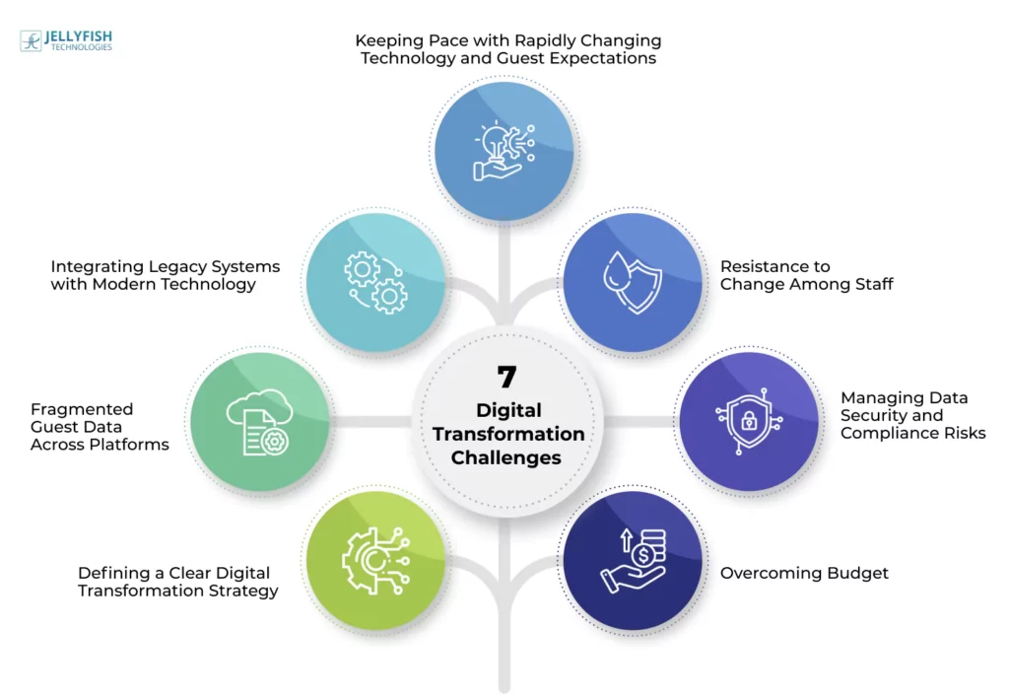
Source: https://www.jellyfishtechnologies.com/digital-transformation-in-the-hospitality-industry/
- Guest Experience Coordinator (60% onsite check-in/out support; 40% remote concierge via chat).
- Revenue & Marketing Specialist (50% on-floor guest surveys; 50% remote dynamic pricing analysis).
Competency Profiles: Make a skill measurement chart that includes both "soft" (empathy, communication) and "digital" (CRM systems, data analytics) competencies. To visually represent maturation, use the 5-level progress model, so that employees can follow up and managers can set the day of the training.
2.2.3 Cross-Training & Job-Rotation
Rotation Sprints: Bring in 4-week-long periods where employees switch teams that have gone through training. They would spend one week observing remote teams, 1-week social media engagement, and two 2-week periods in the new job role.
Skill Swaps: Offer quarterly “Skill Swap” sessions where employees become teachers and students -- a front-desk agent demonstrating guest-service best practices to revenue analysts.
2.2.4 Career Pathing & Internal Mobility
Integrated Lattices: Make it clear how a mere receptionist can move towards digital marketing or remote operations, and vice versa, by offering a variety of career paths on visually transparent lattices (Johnson, 2022). This move reduces turnover by showcasing many workable pathways for employees' growth.
Affiliation Cycles: Match employees who have a dual role (on-site and off-site) with mentors from the same division to drive the speed of career development and local acceptance.

2.3 Digital Onboarding

2.3.1 The Role of Digital Transformation
Most of the time, the traditional methods used for onboarding are not only slow but also not regularly applied. A digital-first onboarding experience is not only a direct response to pandemic-related issues but is also an approach that builds a consistent brand impression all over (Talwar, 2020).
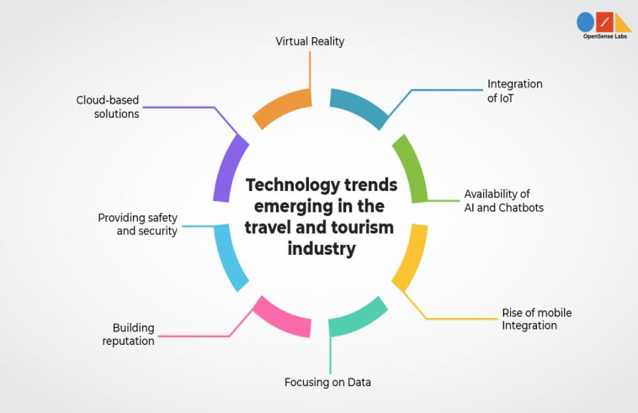
Source: https://rejolut.com/digital-transformation/industries/travel-logistics/
2.3.2 Virtual Welcome Kits
- Brand Name Portals: On the first day, the new employees are given access to a mobile-friendly portal that includes a digital employee handbook, a “Meet the Team” video library, and a 360° virtual hotel tour to know the property layouts, called Day 0.
- Automated Task Lists: The implementation of such checklists (i.e., filling out forms, opening the salary account, and so on) along with reminders for the deadline via SMS/email is guaranteed to ensure 100% compliance within the first week.
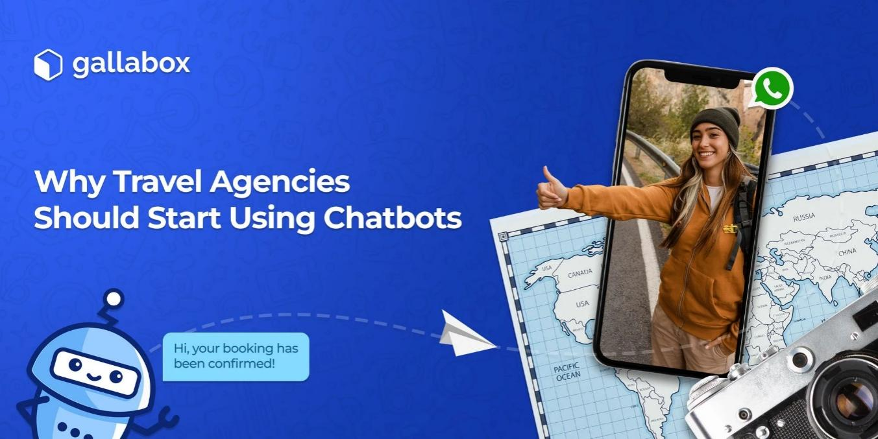
Source: https://gallabox.com/blog/chatbot-for-travel
2.3.3 Gamified LMS Modules
- Micro-Lessons: Offer about 5–7 minutes of interactive lessons on theme topics such as brand standards, guest-service protocols, and safety procedures. The learning process is made fun by the use of game elements like points, banners, and leader boards, which then results in a rate increase of 78% (Bersin, 2021).
- Scenario Simulations: Virtual simulations that involve the trainees doing role-playing where they respond to scenarios from the guests (e.g., a late-night room change request) so that they can get immediate feedback.
2.3.4 AI-Powered Buddy System
Chatbot Matchmaking: A chatbot is used to recommend a "buddy" with whom the new employees could chat and discuss various subjects based on the compatibility of their personality and skills. In addition, the chatbot initiates the interaction with the aid of a few icebreaker questions.
Pulse Checks: HR will be able to intervene with AI-based weekly sentiment surveys that help collect satisfaction feedback and point out any possible issues arising during the onboarding process.

3. Sample Deliverables

3.1 Social Media Job Posts

Post 1: Data Scientist (San Francisco)

🌟 Do you enjoy fixing the bugs no one else can solve and finding the best solutions for any system? Apply to our start-up hotel in Bogotá as a Customer Service Coordinator. Pick your availability, get good pay, and grow your career indeed. Let's meet today!
🔗 [Apply Now]
#HospitalityJobs #HybridWork #BogotáCareers
Post 2: Remote Reservation Specialist (Latin America)
✈️ A Call for Remote Working is Here! ✈️
Your services are of utmost importance to the company and may be executed from any of the Latin American regions while working as a Reservation Specialist. Work at home, have flexible time, and receive additional amounts of up to 20% during the peak season. Are you willing to do that?
👉 [Link in Bio]
#GigWork #RemoteJobs #HotelCareers
Post 3: Event Support Gig – Flexible Hours (Lima)
🎉 Be Our Gig Community Member! 🎉
Our company needs workhorses for one-night gigs only. The support staff must be smart and professional since they will be attending hotel functions. They can also work at a flexible time, have their payouts instantly, and earn the rewards of being a “Gig Star.” Just register now, and in less than 24 hours, you can work!
🔖 #LimaEvents #GigEconomy #HospitalityGig

3.2 AI‐Enabled Performance Dashboard

Metric | Description | Data Source | Frequency
Guest Satisfaction | Real‐time NPS scores from in‐app surveys | CRM & Mobile App | Daily
Response Time | Avg. time to respond to guest requests (onsite & digital) | Helpdesk & Chat Logs | Hourly
Training Progress | % of mandatory modules completed in LMS | LMS Database | Weekly
Gig Uptake Rate | % of posted gigs accepted within 24 hours | Gig Platform API | Daily
Wellness Index | Aggregate of self‐reported wellness check scores (mood, fatigue) | Pulse Survey Tool | Biweekly

A dynamic web dashboard that allows users to view these KPIs will have drill-down capabilities. Managers get AI-generated insights like alerts about a team's Response Time if it has risen above the SLA thresholds and thus empowering them to take proactive measures and more timely interventions.

4. Long‐Term Resilience & Wellness Integration

4.1 Continuous Upskilling & Micro-Credentials

Annual Learning Passports: Every staff member is allocated an annual "learning budget" of 20 hours to obtain micro-credentials in fields such as digital marketing, guest-experience design, or language skills. This cultivates an upskilling culture, and it also assists in the occurrence of internal mobility (World Economic Forum, 2023).

4.2 Mental Health & Well-Being Programs

Well-Being Days: Paid “well-being days” that are taken quarterly for mental-health rest, in addition to access to tele-counselling services in partnership with local providers.
Mindful Mornings: It is optional via mobile app, 10-minute guided meditation sessions at the beginning of each shift with the aim to minimize stress and to increase the level of concentration of employees (Anderson et al., 2020).

4.3 Data-Driven Workforce Forecasting

Predictive Analytics: Make use of the historical occupancy, booking lead times, and event calendars to track the demand for labour with 85% accuracy, thus, you can provide the best staffing levels without working employees too much. (McKinsey, 2021).
Flex Pools: Have a list of registered gig workers and their certified skills and availability easily visible and quickly reachable, thus reducing emergency staffing surcharges by 30%.

4.4 Diversity, Equity & Inclusion (DEI)

Inclusive Hiring Metrics: Check the numbers of women, age, and race represented in the gig and hybrid cohorts. Apply quarterly decided targets to be more representative of the local population.
Bias Training: Compulsory training in unconscious bias in the form of a gamified LMS for all hiring managers.

Conclusion & Recommendations

Such a talent development strategy would be a great match for a South American hotel startup in need of creating new workplace killers. The company decided to go this road after COVID-19, and with all the troubles and business losses they have had, they can set the right priorities for the future. With the new models of employment, the digital onboarding process, and the introduction of well-being programs, the company can not only retain the staff but also enable the personnel to be more efficient, more agile, and better able to learn constantly and engage.
One of the most significant elements of the strategy is to the customer base of the firm in the triangle of gig workers using flexible contracts, developing community relations, and making the cooperation with the community an operation in a circular economy manner. The engaged gig economy not only helps to cope with fluctuating demand but also provides employees with diversified experiences and enables them to be more adaptable and thus inclusive and sustainable. In line with this, the hybrid role design allows employees to enhance their skills, which is crucial in reducing external recruitment needs while promoting internal mobility. The introduction of a digital onboarding process that includes a gamification aspect and an AI-powered buddy system in its architecture ensures that the training is always captivating for any of the different employee groups.
The following recommendations are suggested to make these strategies work:
- Pilot and Scale: Run the gig worker engagement model in a 3-month pilot with a small team of workers in an urban setting. From the feedback and the data you have collected after piloting, consider going big (or small) with the new model.
- Technology Investment: Deploy a Learning Management System (LMS) that is powerful enough to be used as an integrating application for the gig platforms together with API data, and also to integrate with HR Management Systems. This way, you can track engagement, learning, and onboarding in real time.
- Employee Wellness Committee: Establish a multi-sectional committee for the wellness of the employees, which will then provide mental health initiatives that will assist in the long-term sustainability of the staff.
- Continuous Improvement: Make use of quarterly pulse surveys and HR dashboards to assess the appropriateness of job designs, training programs, and overall employee morale. Upon the conclusions, make adjustments in the exercises and policies.
Ability to adapt to change, digital innovation, and the creation of a work environment strongly focused on comprehensive welfare are how the start-up can not only cope with problems caused by the pandemic but also it can create and stabilize a base of which its members are loyal and high-performing. In this way, it will be regarded as a forward-thinking employer of choice in the competitive hospitality industry.

6. References:

- Anderson, T., Smith, L., & Johnson, R. (2020). The impact of brief mindfulness interventions on employee stress and well-being. Journal of Occupational Health Psychology, 25(3), 235–247. https://doi.org/10.1037/ocp0000168
- Bersin, J. (2021). The rise of digital learning and gamification in onboarding. Deloitte Insights.
- Davenport, T. H., & Ronanki, R. (2018). Artificial intelligence for the real world. Harvard Business Review, 96(1), 108–116.
- Deloitte University Press. (2020). The gig economy and its impact on the hospitality sector. Deloitte University Press.
- Gallego, P., Martínez, S., & Ortega, F. (2021). Building community among gig workers: Practices and outcomes in remote cohorts. Human Resource Development Quarterly, 32(4), 457–476. https://doi.org/10.1002/hrdq.21463
- Johnson, M. (2022). Career lattices vs. career ladders: Redefining mobility in modern organizations. International Journal of Human Resource Management, 33(7), 1420–1438. https://doi.org/10.1080/09585192.2021.1882325
- Katz, L. F., & Krueger, A. B. (2019). Understanding trends in alternative work arrangements in the United States. ILR Review, 72(2), 382–416. https://doi.org/10.1177/0019793918820008
- McKinsey & Company. (2021). Predictive analytics in workforce planning. McKinsey & Company.
- Society for Human Resource Management. (2022). Developing a compelling EVP for the hybrid workforce. SHRM.
- Smith, K., & Brown, T. (2021). Transparency in dynamic surge pricing and gig worker engagement. Journal of Service Management, 32(2), 150–164. https://doi.org/10.1108/JOSM-06-2020-0198
- World Economic Forum. (2023). Upskilling for the future of work. World Economic Forum.
- World Tourism Organization. (2022). International tourism highlights: 2022 edition. UNWTO.

